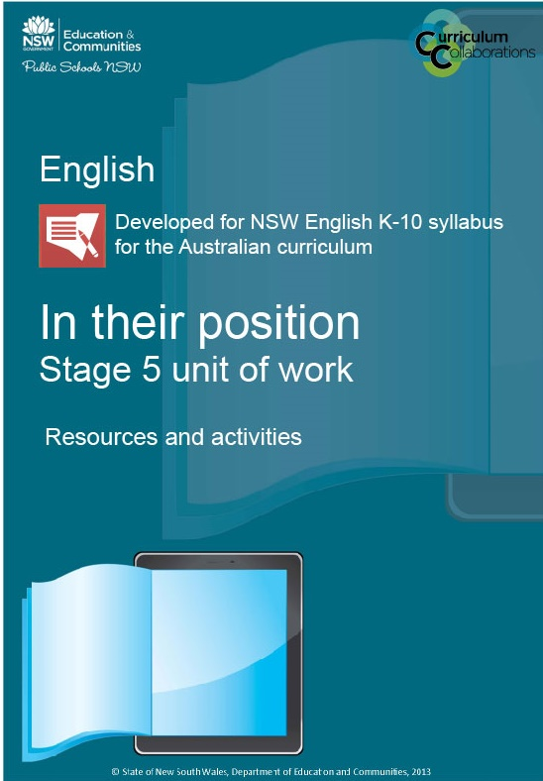

In their position – resources and activities

Table of contents
Resource 1 – scattergram 3
Resource 2 – pre and post-research 5
Resource 3 – list of different perspectives on refugees in Australia 8
Resource 4 – unit outline for students 11
Resource 5 – discussion questions for ‘what’s the difference?’ 12
Resource 6 – discussion questions for “The ABC of SOS” 13
Resource 7 – Media Watch critique 14
Resource 8 – student glossary of persuasive techniques 15
Resource 9 – analytical tool 16
Resource 10 – teacher glossary of persuasive techniques 19
Resource 11 – peer assessment/stimulus 20
Resource 12 – student reflection and evaluation 21
Resource 13 – other recommended resources 23
Outcomes and other elements of the syllabus used in this document are copyright.
English K-10 Syllabus
© NSW Education Standards Authority (NESA) for and on behalf of the Crown in right of the State of New South Wales, 2012

Resource 1 – scattergram
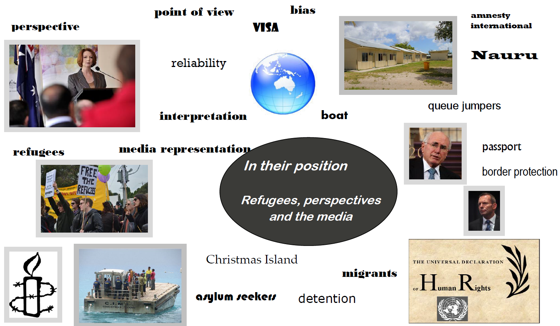

Resource 2 – pre and post-research

Australia, refugees and the world
You are to complete the left-hand column of the table provided below based on your knowledge and understanding of the refugee issue in Australia and the world. This activity will help you to think about the idea of refuges and from where your understanding of the issue comes.
After you have completed this, discuss your answers to Questions 1–4 as a class. Record the correct answers in the right-hand column.
You need to access the UNHCR resource, A year in crises: Global trends 2011 to check the ‘answers’ to questions 5–10. It is accessible using

Pre-research – what do you know/think?
- What is an asylum seeker?
- Someone who chooses to leave their country to seek a better life. They choose where to migrate and they can return whenever they like.
- Someone who comes to Australia legally to work and then overstays their visa.
- Someone who has fled their country of origin due to a well-founded fear of persecution and has applied for protection in another country.
- What is a refugee?
- Someone who has migrated to escape poverty or to improve their standard of living
- Someone who is claiming safety or has migrated for reasons of natural disaster (such as earthquake, drought, famine).
- Someone who has sought protection in another country and has been successful in their application.
- On average, how many asylum seekers come to Australia by boat every year?
- Between 50 000-100 000
- Between 10 000-50 000
- Between 500-5000
- How do most asylum seekers arrive in Australia?

Post-research – what have you found out?
Class discussion

Pre-research – what do you know/think?
Answer these questions based on what you think –
- Which country took the most refugees in 2011? (page 14)

- Name three countries where most refugees come from (page 14)

- In 2011, most asylum seekers came from
- Afghanistan
- China
- Zimbabwe
- In 2011, most asylum seekers sought asylum in
- South Africa
- UK
- Australia
- In 2011, what percentage of world-wide refugees were children (under 18)? (page 3)

- What percentage of “people of concern” to the UNHCR is in Australia (2011)? (pages 38-41)
- 18%
- 8%
- 0.08%

Post-research – what have you found out?
Use your research to find the answers to the questions, based on the statistics provided by the UNHCR.

Resource 3 – list of different perspectives on refugees in Australia
A guide to resources

Organisational perspective
Oxfam Australia
- Oxfam Australia website
- Oxfam Australia webpage on refugees
- Oxfam Australia article on the ‘Walk Together’ event
Amnesty Australia
- Amnesty International Australia website
- Amnesty International webpage on refugees
UNHCR Australia
- UNHCR website
- UNHCR YouTube video – 7PM Project visits UNHCR in Uganda
The Australian Red Cross
- Australian Red Cross website
- Australian Red Cross – refugee week – walk a mile in their shoes
Asylum Seeker Resource Centre
- ASRC website
The Refugee Council of Australia
- Refugee Council of Australia website

Political perspective
John Howard’s Government (Peter Reith, Philip Ruddock, etc.)
- Parliament of Australia website – webpage on boat arrivals in Australia since 1976
- Wikipedia page on immigration detention in Australia
- Wikipedia page on the Pacific Solution
- John Howard’s 2001 Election Policy Speech
- YouTube video – ‘John Howard Children Overboard… remember this?’
- SBS website – overview of the show ‘Go back to where you came from’
Julia Gillard’s Government (Department of Immigration, Chris Bowen, Steven Smith)
- Sydney Morning Herald article on Julia Gillard supporting an experts’ asylum seeker report
- WA Today article on Julia Gillard’s ‘Timor solution’ for asylum seekers
- The Age article – Julia Gillard's Timor solution dog whistles with the best
- The Conversation article – No advantage for Gillard in misguided asylum seeker campaign
- ABC 7:30 Report page on the Immigration Minister responding to the asylum seeker report
Tony Abbott
- YouTube video – Tony Abbott – On Asylum Seekers “Well they put themselves in Indonesia.”
- ABC 7:30 Report video with Scott Morrison
Pauline Hanson
- Pauline Hanson’s One Nation Immigration Policy (summary)
- Pauline Hanson’s One Nation Policy Document – Immigration, Population and Social Cohesion
The Australia First Party
- Australia First Party Calls Action Forum and Protest On Refugee Invasion article
- Australia First Party website

Legal perspective
David Manne
- Sydney Morning Herald article – Meet the Manne who sank the Malaysia plan
- ABC article – ‘High Court slaps down ASIO’s refugee powers’
- The Age article – What we should do now on asylum-seeker policy
Julian Burnside (QC)
- The Conversation article on the Malaysian solution
- The Conversation article on accepting more refugees

Media perspective
Jenny Brockie
- SBS show update – Go back to where you came from – six months on
Allan Asher
- The Canberra Times article on visiting refugee camps
Four Corners
- Four Corners page on people smuggling to Australia
- YouTube video – Asylum – Four Corners
The Daily Telegraph
- The Daily Telegraph article on asylum seekers in Australia
Talkback radio hosts like Alan Jones and Ray Hadley
- The Australian article on Bob Francis being removed from air
- ABC article – Democracy Alan Jones Style
The Green Left Weekly
- A collection of articles on asylum seekers
The Chaser team
- YouTube video – Hamster Wheel – Politics With Cats: Refugees
- YouTube video – CNNNN The Firth Factor Refugees

Individual perspective
Captain of a newly-arrived asylum seeking boat
- Al Jazeera article on people smugglers
Worker at detention centres such as Nauru, Christmas Island, Villawood, Baxter or Curtin
- YouTube video – Christmas Island Detention Centre Video Tour
- The Australian article on Christmas Island
- ABC 7:30 Report video on the Christmas Island detention centre
A newly-arrived refugee
- YouTube video – Rethink Refugees
Indonesian government
- The Conversation article – Not our problem: the Indonesian perspective on asylum seekers
- YouTube video – 8-Bit Immigration (Hungry Beast)
- Sydney Morning Herald article – Indonesians impatient on asylum seeker backlog
Sri Lanka
- UNHCR page on Sri Lanka
- ABC article on fears asylum returnees with face persecution
Afghanistan
- Sydney Morning Herald article – 2.7 million flee violence, politics

Resource 4 – unit outline for students

In their position Stage 5, Year 9

Purpose of this unit of work

Key questions of focus of the unit

Syllabus outcomes
- Outcome 5C – A student thinks imaginatively, creatively, interpretively and critically about information and increasingly complex ideas and arguments to respond to and compose texts in a range of contexts.
- Outcome 7D – A student understands and evaluates the diverse ways texts can represent personal and public worlds.
- Outcome 9E – A student purposefully reflects on, assesses and adapts their individual and collaborative skills with increasing independence and effectiveness.

What you will learn
- What you will discover and learn about –
- What you will be doing –

How you show what you know and can do (assessment)
- Assessment of what you already know –
- Assessment as you are learning –
- Assessment of what you have learned –

Evaluation

Resource 5 – discussion questions for ‘what’s the difference?’
When considering multimodal texts, the visual, text and layout components interact with each other to create a specific message and meaning.
- Who produced this poster?
- What is the purpose of this poster?
- Describe the logo of the composer. How does it indicate the kind of perspective the organisation may have towards refugees?
- What do you think the people who designed this poster are trying to suggest by using identical Lego figures? Why did they use this visual technique rather than use actual images of refugees and us?
- Why has the poster been laid out in the way it has, with the images taking up two-thirds of the text, and the written component only one-third?
- What are they trying to show by putting labels underneath the figures? What kind of labels/language is used? What connotations do they have? Do you think these words are used to include/embrace or exclude/reject refugees?
- What words have been given emphasis by using bold or italic font? Why do you think that these particular words have been emphasised?
- According to the written text, what is one difference between refugees and “you and me”?
- How does the UNHCR suggest that you can help refugees? Is the use of the word “want” in the last line of the poster important? What would happen if we changed the wording of this sentence to “To support the efforts of the UNHCR…”, “Go to (this web address to support…” or “You must support the efforts…”?
- Who do you think is the intended audience of this poster? How do you know this?
- What attitudes towards refugees are the UNHCR encouraging people to adopt in this poster? How does the poster put us in this position? What attitudes towards refugees is the poster trying to prevent occurring? How does the poster make us feel that this way of seeing refugees is not right?
- What devices have been used in the poster to position us? These techniques may be visual, written or layout features? Add these to your glossary.
Activities have been adapted from ‘Teacher’s notes’

Resource 6 – discussion questions for “The ABC of SOS”
In multimodal texts such as newspaper articles, the visual, text and layout components interact with each other to create a specific message and meaning.
- Who produced this article?
- What is the purpose of this article?
- Who is the intended audience?
Layout
- Is the way in which the article has been laid out on the page important? What does the layout of the front page suggest are the key aspects of this story?
- The article appears on page 1 and page 8 of the Daily Telegraph, 27/7/2012. Is the type and detail of information on page 1 different from that on page 8? Explain your answer and suggest why this is.
- How has the article been structured in terms of its content? How does this value certain aspects of the article?
Written
- What is the tone of this article and how can you tell?
- What words are used to describe asylum seekers and their situation? What connotations do these words have or what do they suggest about asylum seekers? Are they used to include/embrace, exclude/reject or present a neutral attitude towards asylum seekers?
- The article discusses the Indonesian rescue of an asylum seeker boat on 26 July, the arrival of two more boats at Christmas Island on 26 July and the fact that the Australian Human Rights Commission is encouraging the Government to alter their policy towards asylum seekers. What can we understand about the composer’s perspective through their connection of these three separate events/ideas?
- Whose comments on this event were provided in the article? How have they been represented?
- Consider this statement: “When they realised he had alerted Indonesian authorities and not Australian ones, the asylum seekers sounded panicked and stressed they wanted to be rescued only by Australian authorities”. What does the article want to think about the asylum seekers after reading this sentence? Is there any other way that we could interpret this sentence?
Visual
- What images have been used in this article and how do they add meaning to the article?
- How does the ripped paper text box on page 1 and the photograph on page 8 position us to view asylum seekers?
- What devices have been used in the article to position us: these techniques may be visual, written or layout feature. Add these to your glossary.
- What attitudes towards asylum seeker issues are The Daily Telegraph/Gemma Jones encouraging people to adopt in this article? How does the article put us in this position?

Resource 7 – Media Watch critique
Media Watch is an ABC program that critiques the media especially the ways in which newspaper, magazines, radio and television programs misrepresent the facts on important issues. The Media Watch program, Today Tonight’s ‘False facts fuel fear’, analyses the way a particular episode Today Tonight dealt with the issue of asylum seekers. Watch the Media Watch episode and complete the following table which compares the original Today Tonight segment with the critiques of that segment on Media Watch.
Term | Definition | Today Tonight | Media Watch
Spoken | Language used to describe asylum seekers and their situation Other aspects of spoken presentation eg voice, facial expression, tone
Visual | Setting, background, framing, camera angle etc

Resource 8 – student glossary of persuasive techniques
Fill out the following table
Name of Techniques | Definition | Examples

Resource 9 – analytical tool
Investigate how texts represent Asylum Seekers/refugees

Title

Type of Text

Composer

Medium

Target audience

Purpose

When I read, view or listen to this text, I have these thoughts and feelings about refugees.
Some words and phrases used to describe refugees, their behaviour, character and situation.
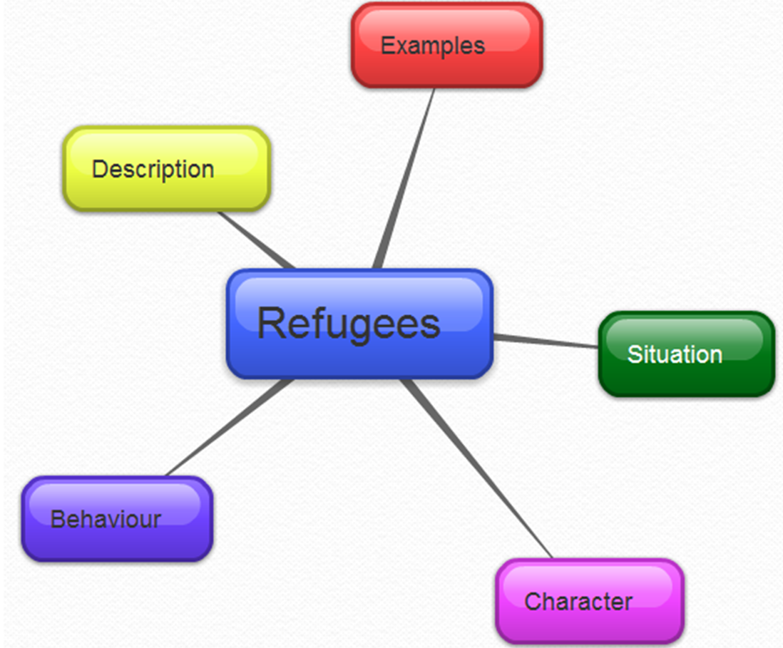

Asylum seeker
What are the main ideas or messages presented in the text?

What is the context in which this text was created?

Does it invite you to respond in a particular way? Does it persuade you to agree or disagree with what it says? How do you know?

Whose interests or point of view are dominant?

What are the main ideas or messages presented in the text?

What to look for:
- subtle and overt biases: distortions, inaccuracies, omissions, stereotyping, undue emphasis
- representations that are fragmented, emphasising only parts while excluding the whole
- tokenism as an attempt to address inclusion.
Identify particular techniques used to convince us of a certain view of asylum seekers/refugees. These techniques may involve language (spoken or written), visual or sound elements. For each technique you identify, provide an example and discuss its effects.
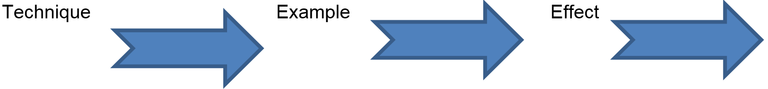
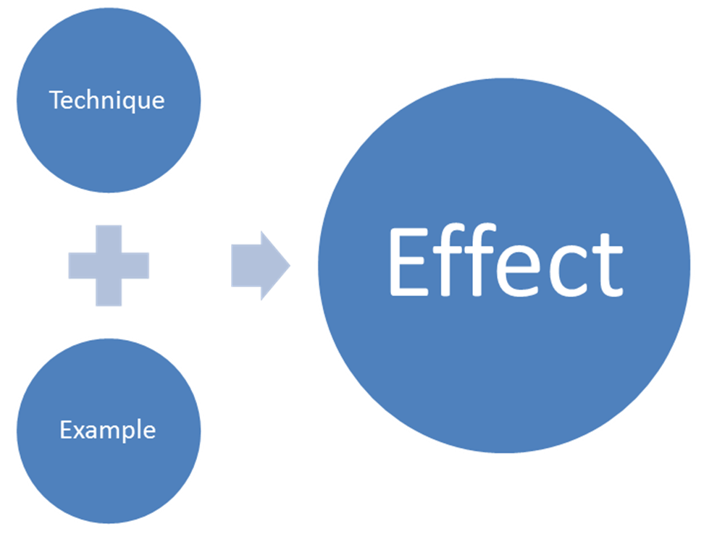

Resource 10 – teacher glossary of persuasive techniques
Please note this is not an exhaustive list and some techniques are applicable to different forms.

Written/spoken elements
Tests which include written/spoken elements: newspaper articles, novel extracts, editorials, websites
- repetition
- emotive language
- inclusive/exclusive language
- hyperbole / overstatement
- rhetorical questions
- generalisations
- evidence: statistics, reports, graphs, experts
- metaphors
- imperative language
- analogy
- anecdote
- tone/voice
- appeals to: a sense of justice, family values, group loyalty, patriotism, financial well-being, tradition and custom, self-interest, fear
- clichés
- connotations
- reason and logic
- give selected information
- omit important/relevant information
- facts as opinions
- subjective/objective language
- bias
- stereotypes
- alliteration/puns

Written/spoken elements
Texts which include visual elements: cartoons, television documentaries, photographs, film, websites
- framing – camera angles / shots
- symbolism – colour, objects, shapes, setting, costume, size, texture
- body language – facial expression, gesture, stance, make-up, position
- lighting – tone, shadow, light, dark, contrast,
- bias
- caricature
- selective use of images
- cropped images
- composition/lay out – proximity, positioning, foreground/background
- inclusions/omissions
- vectors
- rule of thirds
- sound (diegetic/non-diegetic): music, dialogue, silence
- stereotypes
- salience
- gaze: offer/demand
- tone
- juxtaposition

Resource 11 – peer assessment/stimulus
What perspective on refugees and asylum seekers is presented?

List one visual and one language technique used by this group to position you to accept the perspective.
Visual
Language
Feedback strip
Group

Today, you did well on

One thing you could work on improving is

Next time you could try

Resource 12 – student reflection and evaluation
Three skills I have further developed are
1
2
3
I could use these skills
Name one situation within school

Name one situation outside of school

It is important to read texts with a critical eye because

Think about – functioning in a group, creating the multimedia presentation, analysing texts for meaning, utilising information technology, contributing to class discussions, providing a point of view, presenting to the class, operating independently – then complete the following sentences–
I feel confident when…

but I find it difficult when

and need more help with

How successful do you think your group was in conveying the perspective of your individual, organisation or government? Please circle one:
- Highly
- Moderately
- Slightly
Provide one reason for your decision

Next time I will

Complete the PMI chart

Plus
What I enjoyed about the unit

Minus
What I did not like about the unit

Interesting
What I would like to find out more about

Resource 13 – other recommended resources
Speech
Power, P (2010) Australian attitudes to the acceptance of refugees, Summary of speech given to ‘Racism revisited: Anti-racism leadership and practice’ Conference, Murdoch University, Perth, 20 March
Scholarly article
Leach, M & Mansouri, F (2003) ‘Strange words: refugee perspectives on government and media stereotyping’, Overland, vol. 172, pp. 19–26
Opinion piece
The Refugees are coming!, edited version originally published in Frankie, no. 43, Sept–Oct 2011 http://www.benjamin-law.com/2011/09/the-refugees-are-coming/
Newspaper
Jones, G & Hudson, P (2012) ‘Offshore processing of asylum seekers could begin within months, PM says’, Herald Sun, News Limited Network, 15 August http://www.heraldsun.com.au/news/tent-cities-for-new-refugees/story-e6frf7jo-1226449752006
Review
Go back to where you came from, http://newmatilda.com/2012/09/03/can-one-tv-show-shift-refugee-policy
Poetry
Godrej D (ed.) (2009) Fire in the soul: 100 poems for human rights, New Internationalist Publishing, ISBN 1906523169
http://www.poetrylibrary.edu.au/poets/shapcott-thomas-w/seven-refugee-poems-0752016
Short story
Duyal, Y (ed.) (2012) Paper boats: an anthology of short stories about journeys to Australia, part of the New Paper series, Cambridge Secondary Education, ISBN 1107608880
Podcast
Interview between Alison Carabine and David Manne, ABC Radio National, 29 March 2010 http://www.abc.net.au/radionational/programs/breakfast/representing-refugees/3112322
Websites
The Conversation: site featuring articles concerning refugees from the Australian media with analysis and comment provided by the university and research sector: http://theconversation.edu.au
Refugee Council of Australia, ‘Books and novels on refugees and asylum seeker issues: http://www.refugeecouncil.org.au/r/list-bk.php (excellent list of resources for teachers)
Welcome to Australia: for those who have come across the seas: http://www.welcometoaustralia.org.au/index.php
Videos
‘African refugees in Australia’, Compass: http://www.sanctuaryaustraliafoundation.org.au/refugee-stories/martins-story/
Australia by boat – no advantage, advertising campaign produced by the Australian Department of Immigration as part of the No to people smuggling initiative: www.youtube/user/notopeoplesmuggling
‘Being a refugee’, 60 Minutes: https://tonylenguyen.wordpress.com/interviews/being-a-refugee/
Q & a stopping the boats, 7 July, 2011: http://www.abc.net.au/tv/qanda/txt/s3260762.htm
The Leaky boat documentary, 2001: http://bleyzie.wordpress.com/2012/07/03/eye-ball-opinion-on-immigration-and-asylum-seekers-part-v-where-and-how-it-all-began/; classroom notes: http://www.abc.net.au/tv/documentaries/downloads/leakyboat_background.pdf.
Villawood mums, http://thestoriesproject.com.au/archives/villawood-mums/
Non-fiction
Dechian, Millar & Sallis (2004) Dark dreams: Australian refugee stories, Wakefield Press, ISBN 1862546290
Multimodal texts
Darfur is dying, interactive game accessible via TaLe
Asylum exit: http://www.sbs.com.au/asylumexitaustralia/
Programming resources
Programming ideas that could be adapted for older students: http://www.globalwords.edu.au/units/Refugees_UPY6_html/index.html
Resource pack based on Go back to where you came from (2012): http://www.sbs.com.au/goback/schools/resources/series/1
Getting started with Moodle
http://docs.moodle.org/23/en/Teaching_with_Moodle
http://moodle.org/about/

