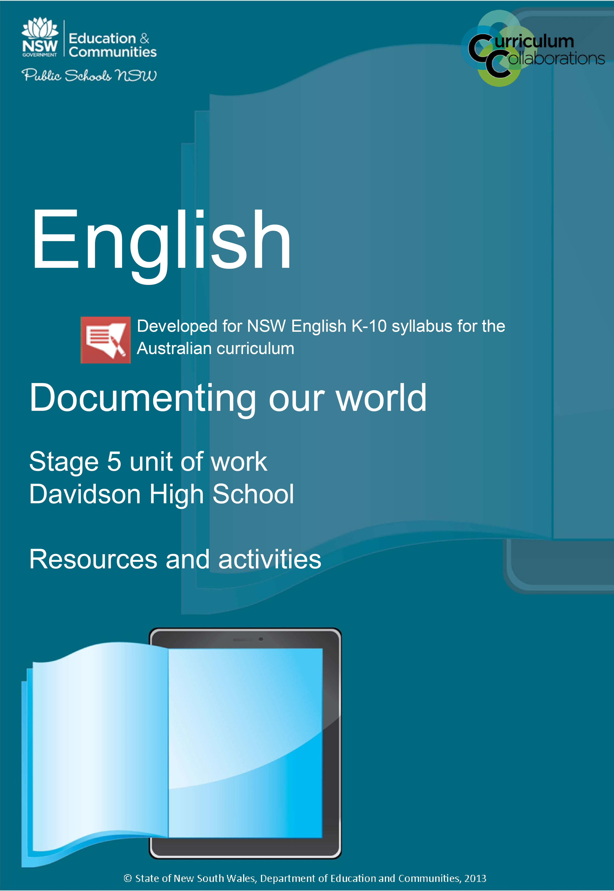

Documenting our world – table of contents
Powerful like a documentary? 5
Discover 5
Create 5
Share 5
Some things you will learn 5
KWL chart 6
Project calendar 7
Week 1 7
Week 2 7
Week 3 7
Film quiz 8
Cloze passage 12
Documentary metalanguage 13
Documentary modes 15
Poetic 15
Expository 15
Observational 15
Participatory 15
Reflexive 15
Performative 16
Environmental sustainability 17
The Cove 19
Bowling for columbine – post-viewing 20
Head Heart 20
Think, pair, share 22
What makes ‘The Cove’ a powerful documentary? 23
STEEL paragraph scaffold 24
Grammar of essays 24
Bowling for Columbine 25
Who is Michael Moore? 25
Features of documentaries 26
Vox pops 26
Elicit 26
Veracity 27
Gravitas 27
Implicitly (adverb) 27
Persona 27
Surreptitious 28
Verisimilitude 28
Insidious 28
Antithetically 29
Ostensibly 29
Credence 30
Glossary of terms for analysing documentaries 31
Documentary essay – feedback 33
Peer assessment 1 33
Peer assessment 2 33
Essays and grammar 34
Nominalisation 34
Grammatical theme 34
Documentary essay – marking criteria 36
Documentary quiz 37
Documentary essay – feedback (blank) 39
Peer assessment 1 39
Peer assessment 2 39
Storyboard 40
What makes the documentary ‘Bowling for Columbine’ powerful? 42
Project essentials checklist 43

Powerful like a documentary?

Discover
- The features and conventions of the documentary form
- The Cove directed by Louie Psihoyos
- Bowling for Columbine directed by Michael Moore

Create
- In a team of three, plan, script, storyboard, edit and publish a 3 minute documentary on an issue of your own choosing
- Write a collaborative essay on the documentaries The Cove and Bowling

Share
- Your documentary will be shared with an audience of friends, family and invited experts at an evening screening
- Your documentary will be published on the school’s YouTube channel
Due –

Some things you will learn
- features and conventions of documentary texts
- how to manage your time and work to a deadline
- the process of design: generating ideas, refining ideas, developing a draft, seeking feedback & editing
- HOM: 1, 10, 11, 15

KWL chart
What I know | What I wonder/want to know | What I learned

Project calendar
Project: Start date:

Week 1
Monday | Tuesday | Wednesday | Thursday | Friday

Week 2
Monday | Tuesday | Wednesday | Thursday | Friday

Week 3
Monday | Tuesday | Wednesday | Thursday | Friday

Film quiz
1. What shot type is used in the example below?
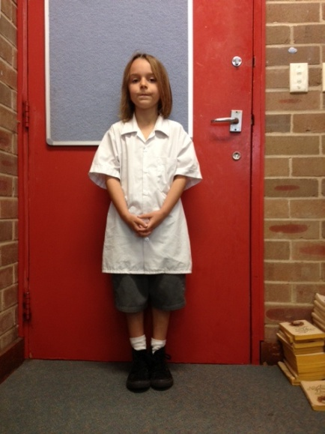
- Long shot
- Medium shot
- Close-up
- Extreme long shot
2. What shot type is used in the example below?
- Medium long shot
- Medium shot
- Close-up
- Big close-up
3. What shot type is used in the example below?
- Extreme close-up
- Big close-up
- Close-up
- Extreme long shot
4. What shot type is used in the example below?
- Long shot
- Medium shot
- Close-up
- Extreme long shot
5. What shot type is used in the example below?
- Extreme long shot
- Long shot
- Medium long shot
- Medium shot
6. What shot type is used in the example below?
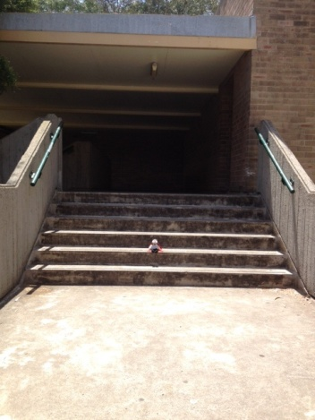
- Extreme long shot
- Big close-up
- Close-up
- Medium close-up
7. What shot type is used in the example below?
- Long shot
- Extreme close-up
- Close-up
- Medium long shot
8. Which camera angle is being used in the example below?
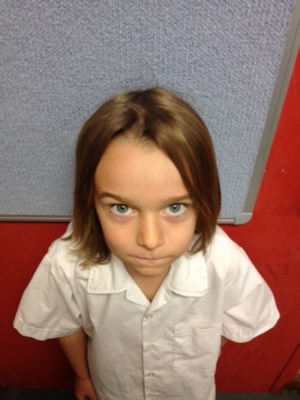
- High angle shot
- Low angle shot
- Canted
- Overhead shot
9. Which camera angle is being used in the example below?
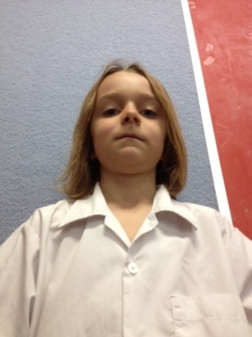
- High angle shot
- Low angle shot
- Eye-level shot
- Bird’s-eye shot
10. Which camera angle is being used in the example below?
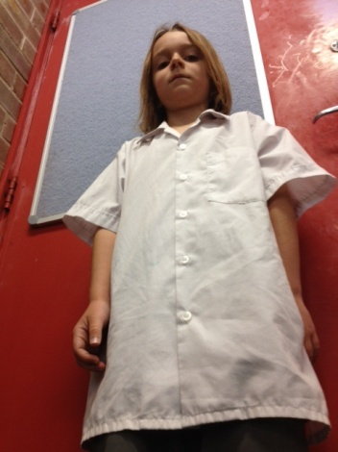
- High angle shot
- Low angle shot
- Eye-level shot
- Worm’s eye shot
11. Which camera angle is being used in the example below?
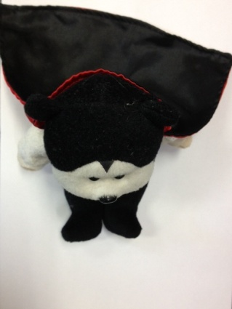
- Worm’s-eye shot
- Low angle shot
- Eye-level shot
- Overhead shot
12. Which camera angle is being used in the example below?
- Canted
- Low angle shot
- Eye-level shot
- Bird’s-eye shot
13. Which camera angle is being used in the example below?
- High angle shot
- Low angle shot
- Eye-level shot
- Canted
14. What camera movement technique would be used in a chase scene?
- Tracking shot
- Title
- Panning
- Dolly shot
What type of camera movement would be used to reveal the setting of a scene
- Tracking shot
- Tilt
- Panning
- Dolly shot

Cloze passage
Fill in the spaces in the sentences below using words below

Backlighting
Panning
zooming
tilt
high key
low key
tracking

In the camera does not move; the lens is focused down from a long shot to a close-up whilst the picture is still being shown.
is a vertical movement of the camera (up or down) while the camera mounting stays fixed.
involves the camera itself being moved smoothly towards or away from the subject.
In a shot the camera swivels (in the same base position) to follow a moving subject.
lighting is bright and relatively low in contrast.
lighting creates pronounced shadows and dramatic contrasts.
produces a ‘halo’ effect around the edges of the subject.

Documentary metalanguage
Fill out the table below
Technical term | Definitions

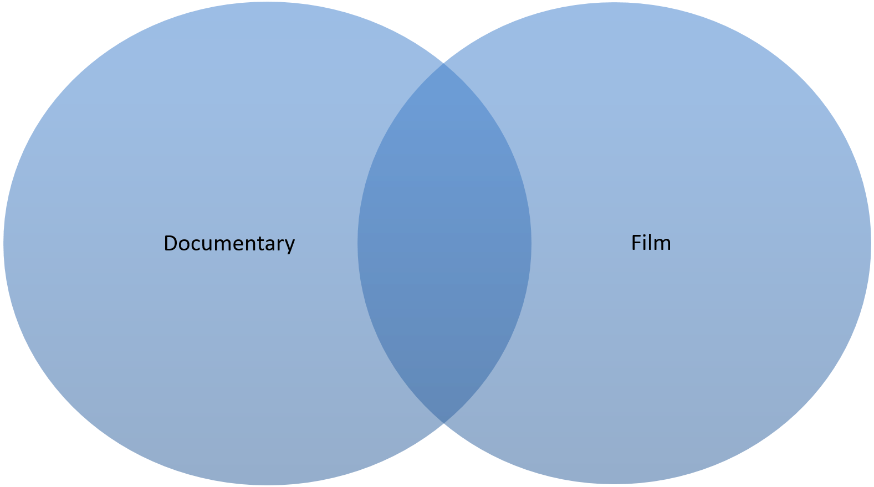

Documentary modes

Poetic
Poetic documentaries, which first appeared in the 1920’s, were a sort of reaction against both the content and the rapidly crystallising grammar of the early fiction film. Well-rounded characters—'life-like people'—were absent; instead, people appeared in these films as entities, just like any other, that are found in the material world. The films were fragmentary, impressionistic, lyrical. Their disruption of the coherence of time and space—a coherence favoured by the fiction films of the day—can also be seen as an element of the modernist counter-model of cinematic narrative. The ‘real world’ was broken up into fragments and made to look pretty for film.

Expository
Expository documentaries speak directly to the viewer, often in the form of an authoritative commentary employing voiceover or titles, proposing a strong argument and point of view. These films are rhetorical and try to persuade the viewer. The (voice of God) commentary often sounds ‘objective’. Historical documentaries in this mode deliver an unproblematic and ‘objective’ account and interpretation of past events.

Observational
Observational documentaries attempt to simply and spontaneously observe lived life with a minimum of intervention. Filmmakers who worked in this sub-genre often saw the poetic mode as too abstract and the expository mode as too didactic. The first observational docos date back to the 1960’s. Often this mode of film got rid of voice-over commentary, scripted dialogue and music or re-enactments. The films aimed for immediacy, intimacy and revelation of individual human character in ordinary life situations.

Participatory
Participatory documentaries believe that it is impossible for the act of filmmaking to not influence or alter the events being filmed. What these films do is try to act as a participant observation. Not only is the filmmaker part of the film, we also get a sense of how situations in the film are affected or altered by his/her presence. The encounter between filmmaker and subject becomes a critical element of the film.

Reflexive
Reflexive documentaries don’t see themselves as a transparent window on the world. Instead they draw attention to their own constructedness (being deliberately constructed by someone) and the fact that they are representations. How does the world get represented by documentary films? This question is central to this sub-genre of films. They prompt us to question the authenticity of documentary in general. It is the most self-conscious of all the modes and is highly skeptical of ‘realism.’ (Realism presents itself as being an accurate account of events).

Performative
Performative documentaries stress subjective experience and emotional response to the world. They are strongly personal, unconventional, perhaps poetic and/or experimental and might include hypothetical enactments of events designed to make us experience what it might be like for us to possess a certain specific perspective on the world that is not our own, e.g. that of people living in poverty or soldiers at war. This sub-genre might also lend itself to certain groups (e.g. women, ethnic minorities, gays and lesbians, etc) to ‘speak about themselves.’

Note
Of course, these categories are not meant to be definitive. Instead, they can serve as a valuable.
Modified (with permission) from – http://girishshambu.blogspot.com.au/2006/12/six-types-of-documentary.html and http://en.wikipedia.org/wiki/Documentary_mode.

Environmental sustainability
Way to reflect on the documentary film genre and the various approaches within it. It’s common for a particular film to be a hybrid of two or more modes, with one of them perhaps being 'dominant.'
Environmental sustainability involves making decisions and taking action that are in the interests of protecting the natural world, with particular emphasis on preserving the capability of the environment to support human life. It is an important topic at the present time as people are realising the full impact that businesses and individuals can have on the environment.
Environmental sustainability is about making responsible decisions that will reduce humanity’s negative impact on the environment. It is not simply about reducing the amount of waste you produce or using less energy, but is concerned with developing processes that will lead to human activity becoming completely sustainable in the future.
Currently environmental sustainability is a topical issue that receives plenty of attention from the media and from different government departments. This is a result of the amount of research going into assessing the impact that human activity can have on the environment. Although the long-term implications of this serious issue are not yet fully understood, it is generally agreed that the risk is high enough to merit an immediate response.
Human activity can potentially cause damage to all areas of the environment. Some of the common environmental concerns include:
- damaging rainforests and woodlands through logging and agricultural clearing
- polluting and over-fishing of oceans, rivers and lakes
- polluting the atmosphere through the burning of fossil fuels
- damaging prime agricultural and cultivated land through the use of unsustainable farming practices.
Environmental sustainability forces people to look beyond making short-term gains and look at the long-term impact they are having on the natural world. You need to consider not only the immediate impact your actions have on the environment, but the long-term implications as well.
Modified from http://toolkit.smallbiz.nsw.gov.au/part/17/86/371 © State of New South Wales through NSW Trade & Investment.
Herman Daly was one of the early pioneers of ecological sustainability and proposed three key ideas as he assessed the problem of sustainability from the perspective of maintaining natural capital.
Sustainability addresses the ongoing capacity of Earth to maintain all life. Sustainable patterns of living meet the needs of the present without compromising the ability of future generations to meet their needs. Actions to improve sustainability are both individual and collective endeavours shared across local and global communities. They necessitate a renewed and balanced approach to the way humans interact with each other and the environment.
© Australian Curriculum, Assessment and Reporting Authority (ACARA) Creative Commons 4.0
‘The Cove’ is a 2009 documentary following activists, free divers, and filmmakers on their mission to breach a remote cove in Taiji, Japan. View the film’s synopsis and filmmaker overview for a summary of some of the key components of the film.
SBS’ Simon Foster’s four-and-a-half star review of The Cove can also be read for an understanding of the film.

The Cove
Scenes:

Camera work/editing

Ideas/emotions

Narrative

Music/sound-effects

Bowling for columbine – post-viewing
Scenes:

Head Heart

Camera work/editing

Ideas/emotions

Narrative

Music/sound-effects

Tip
In your answers below, underline the central noun that sums up what you thought or felt. This process is called ‘abstraction’. For example:
I felt sympathy for the trapped dolphins. I thought about the hypocrisy of gun laws.

What did this documentary make you think about?
How did the documentary make you think about this?

What emotions did this documentary make you feel?
How did the documentary make you feel this?

Think, pair, share
Fill out the table
What’s the issue/question/topic? | What do I think about it? | What does my partner think? | What will we share?

What makes ‘The Cove’ a powerful documentary?
Fill out the table
What – ideas that make the documentary powerful | How – techniques that make the documentary powerful

STEEL paragraph scaffold

Grammar of essays

Normalisation – (N)
Verbs to show effect – (V)
Connective – (C)
Technicality – (T)

Statement  What ideas is the focus of this paragraph? | Technique  What technique is being used to say this in the text? | Example  What is an example of this technique being used? | Effect  What does this technique make you think, feel or imagine relating to the ideas of the text? | Link  Why is this idea important to people in the world? Restate the main idea of the paragraph.
The devastation (N) and destruction (N) caused by war is being protested against by Wilfred Owen in his poem, Dulce et Decorum est. | The simile (T) | “Bent double, like old beggars under sacks, Knock-kneed, coughing like hags, we cursed through sludge”, | Creates (V) a disturbing image of the young soldiers transformed into weary, old men as a result of their experiences in the war. | Wars continue to wage around the world, resulting in the needless deaths of many young people. Owen masterfully crafts a series of images in his poem that reveal the true devastation and destruction caused by war.
 | (Furthermore) (C)  The use of onomatopoeia (T) | “If you could hear, at every jolt, the blood, Come gargling from the froth-corrupted lungs”, | Captures (V) an horrific aural image of painful death and evokes sympathy for the young soldiers who suffer such a tragic fate.

Bowling for Columbine
Bowling for Columbine is a documentary written, produced, and directed by Michael Moore. The film’s synopsis highlights the nature of firearms in the United States of America.

Who is Michael Moore?
View Michael Moore’s information on WiseGeek.

Features of documentaries
All documentaries are didactic. Some are informative, but most are actually polemical.
Didactic – designed to teach, usually with some moral reason.
Polemical – something persuasive or attacking, usually in a controversial manner.
Documentaries gain their power (i.e., their ability to persuade) through the assumption that they are telling the truth. However, documentaries are probably more manipulative than fiction.
Below is an overview of nine key features of documentaries that help give them the power to persuade viewers.
- If we count reality as the truth, placing a camera into the mix removes it one step from reality.
- If the documentary has interviews (whether you hear the filmmaker or not) this is another step away from reality. Not only are the filmmakers shaping reality by asking the questions, they’re forcing the interviewees to think of and say things they may not usually focus on.
Often documentary-makers (and television producers) ‘shoot the script’. Before they go out with the camera, they have an idea of who they are going to interview. If these are to be vox pops, they will often go to socio-economic and geographical areas where they know they will get the responses appropriate to the narrative they’re constructing. When there, they will then target people who they believe will look appropriate for what they want (thus, casting).
Even if the interviewees are to be the subject of the piece, they have already been cast, due to the interest they’ve produced in the filmmakers’ minds. That is, they arrange interviews with people who they already know will say what the doco makers want them to say.
The questions asked will then be phrased to elicit the appropriate responses, and – if need be – cut, so the answers stand out as statements on their own. These interviews are essentially false, as most people act without reflection. Simply talking about it later makes all the actions appear premeditated. Interviewers will also alternate between ‘closed’ questions – questions which can be answered by single words (usually, “yes” or “no”), and ‘open’ questions which invite more elaborate answers. Often closed questions will be given to interviewees known to be abrupt, so they come across even.

Vox pops
Interviews taken of seemingly ‘randomly’ selected people to demonstrate the ‘average’ person’s opinion of a subject

Elicit
To draw out a reaction. (Not to be confused with illicit – illegal)
- A voiceover, while it helps convince the viewers of the truth, is essentially unrealistic. This makes it a further step from the truth.
We don’t get narrations in real life (as much as it would make meeting new people easier). A narrator adds information but also gravitas to a situation. The narrator is chosen to emphasise certain qualities that is to be transferred onto the subject of the piece.
The God-voice is a narrator whom we never actually see. Because we never see the embodiment of that voice, we never really put our mistrust of human foibles onto the speaker and tend to believe what is said almost implicitly. Occasionally, the voice doesn’t belong to a god, but instead a celebrity. The purpose of this is to transfer the personality of the celebrity to the subject of the documentary.
A documentary with the filmmaker as protagonist doesn’t have this trust, but the narration usually only occurs in the documentary after the protagonist’s persona is established and, while we may not fully trust them, we at least empathise with them, which is sometimes more effective. A separate person who is not the filmmaker but is obviously employed to be nothing but a talking head for the documentary is less effective as they are too obviously scripted. It doesn’t help that it can’t be done without the vast majority of the population thinking of Troy McClure.
Occasionally there is no verbal narration at all and the exposition is provided via written code. Often the written code is in a serif font meant to emulate novels or newspapers. It symbolises truth (particularly white or black print) and is effective convincing the viewer of the documentary’s veracity. One drawback to this is that there is no one there for the audience to empathise with, so there is no journey to experience.

Veracity
Truth, accuracy

Gravitas
Dignity, solemnity

Implicitly (adverb)
Without question; also – what is implied

Persona
(term used primarily in non-fiction texts) the personality created by the narrator
- The act of filming reality – framing, choosing an angle, choosing a camera distance – automatically moves it a further step from reality.
A camera-operator has to stand somewhere. It is very easy to get cynical and over-analytical about how a situation (particularly an interviewee) is filmed. The first thing a viewer should do when seeing a scene being filmed is ask: “Can this be filmed in any other way?” If so, then there might be a more surreptitious motive.
Obviously, all cinematographic techniques are just as effective at portraying subjects in documentaries as in the feature films they are usually associated with. Occasionally it is best to keep in mind that sometimes the subjects are just as aware of the techniques as the filmmakers: politicians often position themselves on steps to force the camera-operators to look up at them.
Hand-held camera movement is obviously more common in a documentary than a film. Often feature filmmakers will use this technique to lend their film more verisimilitude. Occasionally a documentary maker will exaggerate this quality of their genre. Often, a camera that shakes will transfer the chaos of the camera movement onto the subject. This chaos can then be interpreted as instability of the character’s mental state.

Surreptitious
Secret, sneaky, usually with implications that trouble could result from being found out (not necessary illegal)

Verisimilitude
The appearance of reality in a fiction text; realism.
- Re-enactments may be helpful for the visual medium of a documentary, but it’s a further step away from reality, as the footage comes from someone’s memory, filtered through their own prejudices.
If a documentary means to examine a historical incident, or an incident that wasn’t filmed, they have the choice to use re-enactments. These re-enactments are used for either entertainment or illustration purposes. Regardless, they go through the same level of manipulation that film uses, so their accuracy must always be called into question. Some documentaries, such as Touching the Void, are almost entirely re-enactments. The question is then to be asked: What is the difference between a documentary and a docudrama?
Other examples of re-enactments are a lot subtler and, by extension, more potentially insidious. These are variations on the ‘noddies’. Noddies are the shots of interviewers taken after the interview is over. One camera is positioned on the interviewee throughout the interview; when the interviewee leaves, the camera is moved to face the interviewer; then the interviewer goes through the range of reactions they would have (or should have) gone through – such as laughing, looking concerned or nodding in agreement. They are then later edited into the interview.
It was an accepted part of the interview process until Michael Moore’s infamous interview with Charlton Heston as the climax of Bowling for Columbine. In it, Moore holds a picture of shooting victim up and asks Heston if he is going to apologise to her family. The shots alternate between Moore holding the picture and an over-the-shoulder shot of Heston’s reactions. The two shots would have been impossible to stage simultaneously; Moore’s wavering responses to the questioning of the shots didn’t help clarify the issue. When he finally did admit that the secondary shots of Moore holding the picture were inserted later, too many doubts were raised. There is no evidence that Moore did in fact hold up the picture and because of the overlapping vocals, there is no real evidence that what we heard in the final production was what was actually said.

Insidious
Crafty, sneaky, leading slowly into harm.
- Editing the process, deciding what to include, what to leave out – selection of detail – takes it another huge step away from the truth.
On average, a documentary has a shot ratio of 70:1. This means for every hour of final footage, seventy hours of film has been left out – that’s almost three whole days of unused footage.
Priority will be given to any footage that reinforces the filmmaker’s intended themes. Almost as effective is the selective editing used by the filmmakers to order shots to position the viewer. This is the most obvious example of juxtaposition, used to either contrast the differences between two objects, or antithetically, create a link between the two. This is an effective method of promoting their themes, but it is also a good way of creating humour.
Someone once said that fiction was real life with the boring bits cut out. Isn’t that what a documentary is as well?

Antithetically
Directly opposing
- Turning the documentary into a narrative with all the elements associated with narratives takes another step away from reality.
Humans are storytellers. They like to tell stories and learn through stories. Documentary makers know this and often construct their documentaries around a narrative even if it doesn’t exist.
Any documentary that has a filmmaker as protagonist is essentially a narrative. Our hero goes on a journey of discovery, regardless of how expository in nature the information discovered is. The information is usually presented in this way because otherwise viewers will find the information too dull to sit through.
Michael Moore is perhaps the most manipulative user of this structure. Regardless of what his documentaries are ostensibly about, he will always make the documentary into a narrative about his journey of discovery – regardless of how much he knew beforehand. In Bowling for Columbine, he sets up Charlton Heston, president of the NRA, as a villain, the film culminating in a showdown with the two archetypes.
This natural narrative – of a person’s journey of discovery – is actually extremely artificial as it has been decided upon before the shooting begins and, if something fails to conform to that script, it is changed in editing.
Added to the simple structure are the other features of narratives – conflicts and antagonists. Often conflicts will be over-inflated and some characters will be characterised in such a way to appear to be villainous – almost the antithesis of our hero.

Ostensibly
Apparently; what something claims or is purported to be.
- Other post-production elements, such as music, will also add a level of unreality.
Music is just as effective at positioning an audience in documentaries as it is in film. Thus it is often used to set the scene or to affect the credibility of a subject. Often it is just the tone that is effective, but occasionally the song is chosen for its name. Most times, music is played not for its name but its sound.
Other post-production elements include written code. Even when it is not used as a substitute narrator, written code can also position the audience. This can be as simple as identifying a character and their title or profession in a documentary, or can be used more effectively.
- Using archival footage adds at least another three steps away from the truth. The archival footage is taken from other sources which have gone through the same process of the documentary. And yet this adds extra ‘proof’ to its story.
Often experts are chosen to add credibility to the story the documentary maker is telling. More effective than this is the use of archival footage. This is seen as adding credibility, as it appears to be showing the events as it happened. It also attempts to add proof to the documentary’s story by relying on the borrowed credibility of another source. After all, television news shows are credible, newspapers more so. In a pinch, a website will do.
However, the source can be just as unreliable as the documentary itself, particularly when an actual title of the source it not shown.

Credence
Belief; related to credibility

Glossary of terms for analysing documentaries
Authenticity
The belief that the world represented on screen is as the reporter/documentary director discovered it and has not been modified.
Cinema vérité
French for "film truth," applied to documentaries in which there is a truthful live encounter between the reporter and the subject.
Commentary
A narrative voice in the documentary that articulates an explicit argument.
Demonstrative proof
Emphasis on making evidence persuasive, albeit not necessarily accurate.
Editing
The juxtaposition of two or more shots to create a meaningful relationship between them. Editing is extremely important in a documentary, establishing both its credibility and aesthetics.
Framing
The organisation of the shot’s contents with respect to its outer borders.
Interrotron
A device that functions simultaneously as a camera and teleprompter-like projector, to capture an interview subject's close up responses to questions posed during interviews.
Intertitle
Text that appears periodically on screen to provide information such as the date, time and location of an event or identify the person on screen.
Long take
A continuous single shot of unusually long duration which eliminates the need to edit the scene.
Masked interview
An interview in which the reporter/documentary director is both off-camera and unheard.
Observational mode
Emphasising the reporter’s/documentary maker’s engagement in observing and documenting a subject’s daily life and circumstances with an unobtrusive camera.
Participatory mode
Documentary film in which the emphasis on the interaction between the reporter/director and the subject.

Performative mode
In a documentary, where the emphasis is on the reporter’s/director’s subjective attitude or personal engagement with a subject, shown to evoke audience reaction.
Perspective
In documentary filmmaking, the selection and arrangement of sounds and images to tacitly convey or imply a particular point of view about a subject.
Poetic mode
The formal structural organisation that emphasises visual associations and impressionistic descriptive passages, tonal and rhythmic qualities in a documentary film, and de-emphasises strictly linear or logical sequencing.
Realism
Where the documentary film's emphasis is on the subject's state of mind and psychological outlook.
Shot
A single uninterrupted moving image that is recorded with a static or mobile camera.
Voice of authority
Someone whom we hear whose narrative voice represents the film.
Voiceover
An off-camera narrative voice that comments about the images on screen.
(Modified with permission of the author Leith Daniel, Dean of Faculty – English, Servite College, Perth)

Documentary essay – feedback

Peer assessment 1
Criteria | Didn’t | Tried | Did
1. Have you demonstrated a strong conceptual understanding of the documentary?
2. Did you relate each of your arguments to the essay question?
3. Is your argument outlined clearly in the introduction?
4. Do you name the text and its director in your introduction?
5. Does your argument build to a logical conclusion? (cause and effect)
6. Did you give enough evidence (quotes and/or descriptions) for each of your arguments?
7. Did you use the STEEL paragraph structure for each paragraph?
8. Did you start each paragraph with a strong conceptual statement? (nominalisation; grammatical theme)
9. Have you used correct punctuation and spelling?
Medals – main strengths

Missions – improvements needed for this essay

Peer assessment 2
Criteria | Didn’t | Tried | Did
1. Have you demonstrated a strong conceptual understanding of the documentary?
2. Did you relate each of your arguments to the essay question?
3. Is your argument outlined clearly in the introduction?
4. Do you name the text and its director in your introduction?
5. Does your argument build to a logical conclusion? (cause and effect)
6. Did you give enough evidence (quotes and/or descriptions) for each of your arguments?
7. Did you use the STEEL paragraph structure for each paragraph?
8. Did you start each paragraph with a strong conceptual statement? (nominalisation; grammatical theme)
9. Have you used correct punctuation and spelling?
Medals – main strengths

Missions – improvements needed for this essay

Essays and grammar

Nominalisation
Essay writing provides a great opportunity to learn about nominalisation and grammatical theme when you brainstorm and write your theses and lines of arguments. Both of the grammatical features are used in all kinds of essays: personal essays, literary analysis essays or topical essays.
Academic writing often uses nominalisations. The process of nominalisation turns verbs (actions or events) into nouns (things, concepts or people). The writing is now no longer describing actions, it is focused on objects or concepts.

Example
Produce (verb) becomes production (noun)
Aware (verb) becomes awareness (noun)
Nominalisation is important because very often English essays are about concepts and concepts are often abstract nouns such as ‘depression’ or ‘rebellion’.

Tip
This video on writing a thesis as an example of how nominalisations can help make your writing sound more academic.

Clause
A grammatical unit that refers to a happening or state (e.g., ‘The netball team won.’ [happening]; ‘The cartoon is an animation.’ [state])

Grammatical theme
Definition: In a clause, the theme comes in first position and indicates what the sentence is about. Theme is important at different levels of text organisation. The topic sentence serves as the theme for the points raised in a paragraph.
In an essay, the opening statement is the theme of a paragraph. In the statement itself, the theme is usually a nominalisation (see above) or an abstract noun.

Task
Generate a list of ‘technical’ words appropriate to your essay topic: Think about what makes documentaries powerful. These might be words you have learnt from your research, during class or from watching the documentaries. Look at the class-created ‘Documentary glossary’ and your own critical viewing notes for words or phrases you have used to describe documentaries and the techniques used to make them powerful. Some key words might be: bias, persuasion, context, perspective, representation, manipulation.
Try to use each ‘technical’ word in a separate sentence answering your essay question. Try to place the word near the beginning of your sentence. See the example below (note the key word is first in this sentence):
Context plays and important role in the impact that a documentary has on a viewer.

Documentary essay – marking criteria
Criteria | Skilful | Effective | Sound | Limited | Elementary
Addresses the essay question | Highly developed, complex and personal response to the question outlined in introduction and developed in body of essay. | Well-developed, thoughtful and personal response to the question outlined in introduction and developed in body of essay. | Sound response to the question outlined in introduction and somewhat developed in body of essay. | Limited response to the question outlined in introduction and poorly developed in body of essay. | Required elements are missing or incomplete.
Understands how composers use features of texts | Skilful use of the STEEL paragraph structure to demonstrate a sophisticated understanding of what makes a documentary powerful. | Effective use of the STEEL paragraph structure to demonstrate a well-developed understanding of what makes a documentary powerful. | Sound use of the STEEL paragraph structure to demonstrate an understanding of what makes a documentary powerful. | Attempts to use elements of the STEEL paragraph structure to demonstrate a developing understanding of what makes a documentary powerful. | Required elements are missing or incomplete.
Composes a sustained argument supported by textual evidence | Composes a sophisticated, logical and sustained argument supported by detailed and relevant textual evidence. | Composes a logical and sustained argument supported by detailed textual evidence. | Composes an argument supported by textual evidence. | Attempts to compose an argument supported by some textual evidence. | Required elements are missing or incomplete.
Uses language and structure of an essay | Skilful control of the language and structure of an essay – beginning each paragraph with thoughtful conceptual statements. | Effective control of the language and structure of an essay – begins most paragraphs with conceptual statements. | Sound control of the language and structure of an essay – some paragraphs begin with conceptual statements. Some errors. | Attempts to use the language and structure of an essay – fails to use conceptual statements. Includes frequent errors. | Required elements are missing or incomplete.

Documentary quiz
1. What does the ‘S’ in ‘STEEL’ stand for?

2. Name the director of ‘Bowling for Columbine’.

3. Name three of the ‘six modes of documentary film’.

4. Name three film techniques used in documentaries to shape meaning

5. List three abstract nouns that sum up the main ideas in ‘Bowling for Columbine’.

6. List three abstract nouns that sum up the main emotions evoked by ‘The Cove’.

7. Name three documentary techniques that are used to communicate ideas in ‘Bowling for Columbine’.

8. Name three documentary techniques that are used to evoke emotions in ‘The Cove’.

9. What does the ‘T’ in STEEL stand for?

10. What does the ‘L’ in STEEL stand for?

11. In no more than 100 words, answer this question – what makes a documentary powerful?

Documentary essay – feedback (blank)

Peer assessment 1
Criteria | Didn’t | Tried | Did
Medals – main strengths

Missions – improvements needed for this essay

Peer assessment 2
Criteria | Didn’t | Tried | Did
Medals – main strengths

Missions – improvements needed for this essay

Storyboard
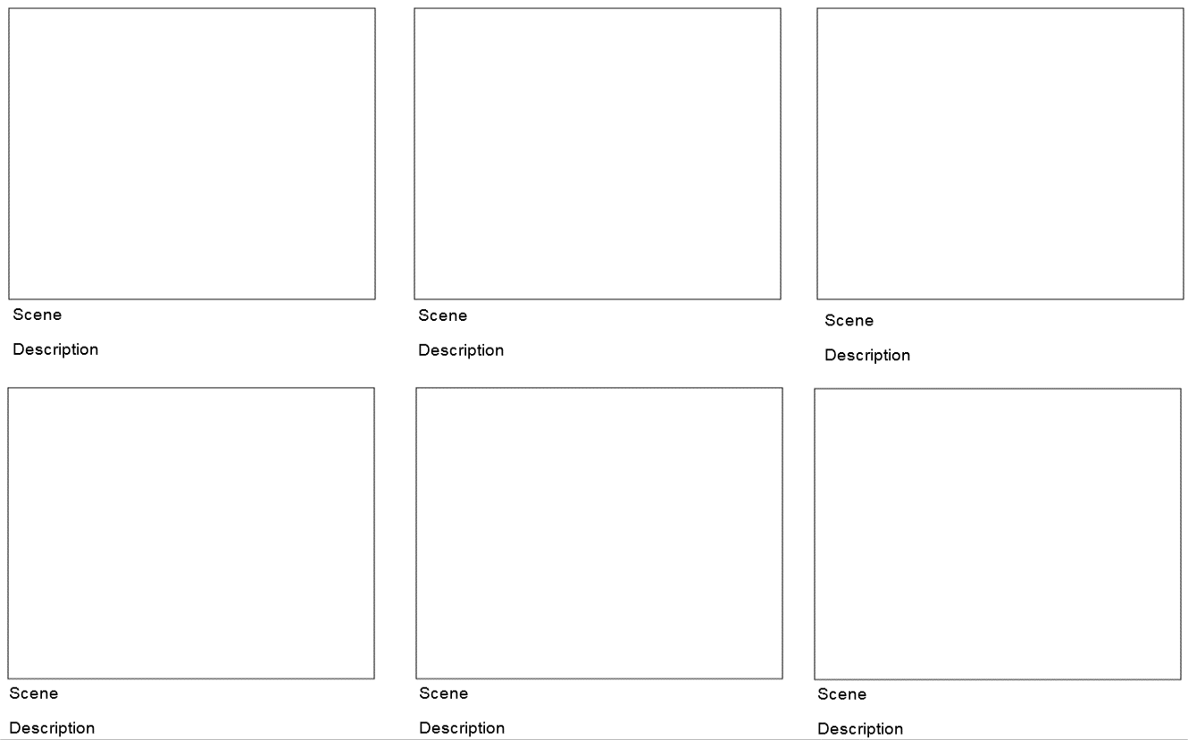
Location

Date

Scene/shot | Time code-in | Time code-out | Description/comments

What makes the documentary ‘Bowling for Columbine’ powerful?
Fill out the table
What – ideas that make the documentary powerful | How – techniques that make the documentary powerful

Project essentials checklist
Does the project | Yes | No | Not sure
Focus on significant content and authentic issues
Students learn important subject matter content and address problems and issues from the world outside the classroom
Organise activities around a driving question or challenge
Students find the complex, open-ended question or challenge to be a meaningful focus for their work
Establish a need to know and do
Students are brought into the project by an entry event that captures interest and begins the inquiry process
Engage students in inquiry
Students think deeply and ask further questions as they generate answers and solutions
Require innovation
Students generate new answers and/or create unique products in response to the driving question or challenge
Develop 21st century skills
Students build critical and creative thinking, collaboration and presentation
skills that are taught and assessed
Encourage student voice and choice
Students, with guidance from the teacher, make decisions that affect the course of the project
Incorporate feedback and revision
Students use feedback to improve their work and create high quality products
Conclude with a public presentation
Students exhibit products or present solutions and explain their work to others and respond to content- and process-focused questions

http://www.imdb.com/title/tt0310793/synopsis?ref_=tt_stry_pl
http://www.wisegeek.com/who-is-michael-moore.htm#lbimages
http://www.youtube.com/playlist?list=PLYrEX0iYtIIs-ZPcwYKsxNT_207-iKmdM

