English S3 student workbook –Connotation, imagery and symbol
Name:
Class:

Lesson 1
During this activity you will learn to:
- recognise and explain creative language features used in imaginative texts
- understand that figurative language engages audiences emotionally in a text.

1.1 Speaking and listening
Complete ‘tuning into senses’ activity.
Sit back to back with a partner, in total silence, and write down everything you can hear for two minutes.
Compare your list with your partner.
Choose some of the sounds to discuss in descriptive detail. For example: car driving past- the motor had a low rumbling sound.

1.2 Connotation, imagery and symbol
Students view the ‘connotation, imagery and symbol’ video.
After viewing, answer the following questions:

What is connotation?
________________________________________________________________________________________________________________________________________________________________________________________________________________________________________________________________________________________________
What is imagery?
________________________________________________________________________________________________________________________________________________________________________________________________________________________________________________________________________________________________
What is symbol?
________________________________________________________________________________________________________________________________________________________________________________________________________________________________________________________________________________________________
You may use the example provided in the video or develop your own example.

1.3 Connections
Think of a story or movie that you have connected with emotionally. Write a short summary of the story or movie, focusing on the parts you had a strong connection with.
Write about how the language of the text has caused your emotional reaction.
Summary of the movie or book:
________________________________________________________________________________________________________________________________________________________________________________________________________________________________________________________________________________________________________________________________________________________________________________________________________________________________________________________________________________________________________________________________________________________________________________________________
Was your reaction caused by vivid imagery? Provide an example.
________________________________________________________________________________________________________________________________________________
Does the text use language with strong positive or negative connotation? Provide an example.
________________________________________________________________________________________________________________________________________________
Is there strong symbolism and deeper meaning?
________________________________________________________________________________________________________________________________________________

1.4 Reflection
How will understanding connotation, imagery and symbol help me as a text responder?
How will understanding connotation, imagery and symbol help me to become a better composer of texts?

Lesson 2
During this activity you will learn to:
- recognise and explain creative language features used in imaginative texts
- understand that figurative language engages audiences emotionally in a text.

2.1 Speaking and listening - The sea
Listen to the audio version of the poem ‘The Sea’ from The School Magazine.
As you listen to the poem, sketch an image that comes into your mind from the imagery in the poem.
Add nouns, adjectives and verbs to describe your sketch.

2.2 Video response
Review the connotation, imagery and symbol video.
Why do composers choose to use connotation, imagery and symbol?
________________________________________________________________________________________________________________________________________________________________________________________________________________________________________________________________________________________________________________________________________________________________________

How and why do you think certain words develop a connotation?
________________________________________________________________________________________________________________________________________________________________________________________________________________________________________________________________________________________________________________________________________________________________________

2.3 Emotional response
Think about the text you wrote about in learning activity 1.3, about your emotional connectedness to a text.

Answer the following questions:
Why did the composer of the text intend for you as the responder, to have this emotional response?
________________________________________________________________________________________________________________________________________________________________________________________________________________________________________________________________________________________________________________________________________________________________________
Do you think that everyone who reads/views this text will have the same response? Why/why not?
________________________________________________________________________________________________________________________________________________________________________________________________________________________________________________________________________________________________

2.4 Reflection
Why do people have different emotional responses to texts?

Lesson 3
During this activity you will learn to:
- recognise and use sensory description to build atmosphere in writing
- use aspects of text to innovate and create own texts.

3.1 Speaking and listening
Alliteration is when several words beginning with the same sound are used in a sentence for effect.
A simile is a figure of speech that directly compares two different things. The simile is usually in a phrase that begins with the words ‘as’ or ‘like.’
Speak with an adult to collaboratively describe 3 weather events using alliteration. For example: The wind was whipping widely in the wild.
- rain
- heatwave
- sunshine
Describe the weather using a simile. For example: The wind hissed and roared like dragons. The wind made the doors rattle like snare drums.
You may record yourself voicing your alliteration and simile for online submission to your teacher.

3.2 Senses brainstorm
Reread or listen to the poem ‘The Sea’ from The School Magazine.
Complete the ‘senses brainstorm’ below, identifying the senses that are used to develop the descriptive imagery in the poem.
Identify what can be heard, seen, smelt, tasted and felt based on The Sea poem.
Senses brainstorm
Senses | Evidence from poem
See
Hear
Smell
Taste
Feel

3.3 Senses brainstorm - location
Select a location. For example, the school playground.
Complete the ‘senses brainstorm’ activity from 3.2 again using this new location. You will brainstorm what can be heard, seen, smelt, tasted and felt based on the selected location.

Senses brainstorm
Senses | Location selected:
See
Hear
Smell
Taste
Feel

Use the structure of the poem ‘The Sea’ to commence writing your own poem using the location and information from your senses brainstorm.
________________________________________________________________________________________________________________________________________________________________________________________________________________________________________________________________________________________________________________________________________________________________________________________________________________________________________________________________________________________________________________________________________________________________________________________________________________________________________________________________________________________________________________________________________________________________________________________________________________________________________________________________________________________________________________________________________________________________________________________________________________________________________________

3.4 Reflection
How does using information from the senses help build a clear image from a text?

Lesson 4 – words with positive and negative connotations
During this activity you will learn to:
- use sensory description to build atmosphere in writing
- recognise and use language to invite connotation.

4.1 Speaking and listening
Draw a picture of your ultimate bedroom.
Use all the senses to describe the bedroom to an adult using as much detail as possible, without showing them the picture you have drawn.
Ask for feedback from the adult about whether your description allowed them to build a mental picture of the bedroom.

4.2 – Positive and negative connotations
Reread the poem ‘The Sea’ from The School Magazine.
The poem describes the sea with a positive tone.
Identify the language used in the poem that evokes a positive connotation. Then replace the language evoking a positive emotional response with words that may have a negative connotation.

Connotations
Positive connotation | Negative connotation

4.3 Describing known place
You will write one descriptive paragraph about a known place. For example, the gentle waves in the ocean or wide, open fields, using words with positive connotation.
You will use the senses to guide the descriptive imagery.
________________________________________________________________________________________________________________________________________________________________________________________________________________________________________________________________________________________________________________________________________________________________________________________________________________________________________________________________________________________________________________________
You will now write a second paragraph about the same place using words that evoke a negative connotation.
________________________________________________________________________________________________________________________________________________________________________________________________________________________________________________________________________________________________________________________________________________________________________________________________________________________________________________________________________________________________________________________________________________________________________________________________________________________________________________________________________

4.4 Reflection
Why do some words invite a positive connection and some a negative connection?

Lesson 5 – symbolism in narrative
During this activity you will learn to:
- develop and use symbolism in text to evoke an emotional connection.

5.1 Speaking and listening
You will speak with a partner to describe a location in your local area. For example: beach, river, rainforest, park, walking track.
You will say a descriptive word or phrase beginning with 5 - 8 letters of the alphabet to describe the location, without naming the place.
Your partner can use the clues to work out the location. Swap roles.
For example:
A – amazingly clear
B – beautifully cool
C – calming

5.2 Rain Sonata
You will read or listen to the story ‘Rain Sonata’ from The School Magazine.
After reading, answer the following questions:
Why has the author chosen to use music from the glass piano to bring on the rain?
________________________________________________________________________________________________________________________________________________________________________________________________________________________________________________________________________________________________What is the symbolism of the glass castle and piano in contrast with the dry landscape?
________________________________________________________________________________________________________________________________________________________________________________________________________________________________________________________________________________________________Why do you think the sheet music stopped halfway through playing the piece of music?
________________________________________________________________________________________________________________________________________________________________________________________________________________________________________________________________________________________________What connection has been made between the speed and tempo of the music and the level of rain that is falling? Support your answers through evidence in the text.
________________________________________________________________________________________________________________________________________________________________________________________________________________________________________________________________________________________________

5.3 Symbolism
Complete these sentences, using the symbolism idea of a human behaviour or activity causing something to occur in nature or the built environment. For example, skipping through the bush trail caused the undergrowth to bloom or stamping through their hallway caused city buildings to shake.
Dancing in the dirt ________________________________________________________
________________________________________________________________________Swinging from the tree branch _______________________________________________
_______________________________________________________________________
Shouting into the valley ____________________________________________________
_______________________________________________________________________
Jumping on the bed _______________________________________________________
_______________________________________________________________________
Smashing through the waves________________________________________________
_______________________________________________________________________
Create your own:
________________________________________________________________________________________________________________________________________________________________________________________________________________________

5.4 Reflection
How does using a symbol to represent something else in a text create interest for the reader?

Lesson 6 - symbol
During this activity you will learn to:
- identify language features in imaginative text which serve to meet the purpose of the text
- develop and use symbolism in text to evoke an emotional connection.

6.1 Speaking and listening
You will select and define three of the following words from the text ‘Rain Sonata’:
leaden, mentor, unity, unison, parched, falter, scarcely, weary, diminished, tempo
Explain the meaning of each word to an adult and use the word in a sentence.
You may use a dictionary to help define the word.

6.2 Connotation, imagery and symbols
Reread ‘Rain Sonata’ from The School Magazine.
Complete the table below identifying figurative language techniques used in the text, ‘rain Sonata’.
Connotations
Technique | Definition and example | Example in Rain Sonata
Adjective | An adjective is a word that describes an animal, person, thing, or thought.  For example: fluffy, smooth, pink
Alliteration | Alliteration is a repetition of consonant sounds at the beginning of words.  For example: Bouncing Ben believes…
Simile | A simile is a figure of speech that directly compares two different things.  For example: The pillow was as fluffy as a white cloud floating across the sky.
Positive language | White, gleamed
Negative language | Booming, flashed
Personification | When you give an animal or object qualities or abilities that only a human can have.  For example: the leaves waved in the wind.

6.3 Description or poem
Review the symbolism you developed in lesson 5.3.
Select one to build upon and create a short description or poem.
________________________________________________________________________________________________________________________________________________________________________________________________________________________________________________________________________________________________________________________________________________________________________________________________________________________________________________________________________________________________________________________________________________________________________________________________________________________________________________________________________________________________________________________________________________________________________________________________________________________________________________________________________________________________

6.4 Reflection
Did you connect with the symbols used in the text ‘Rain Sonata’?
How will understanding this text and the symbolism used by the composer help you to become a better writer?

Lesson 7
During this activity, you will learn to:
- explore, discuss and appreciate connections between Dreaming stories and contemporary Aboriginal and Torres Strait Islander life.

7.1 Speaking and listening
Your teacher will show you images of everyday symbols (including fast food logos, street signs)
Explain what these everyday symbols mean to you.
What do they mean to other people?
Why are symbols used?
Discuss the colours that have been used in these symbols and the size of the symbols.
What commonalities are noticed?
What impact do these colours have?

7.2 Aboriginal symbols
Students view traditional Aboriginal symbols.
Where have you seen these symbols before? ________________________________________________________________________________________________________________________________________________
There is no written language for Australian Aboriginal people. In order to share their important stories through the generations, it is shown by symbols/icons through their artwork.
Watch the ‘Indigenous storytelling’ video.

Why are symbols used in Aboriginal art?
________________________________________________________________________________________________________________________________________________

Why do you think symbols could vary across Aboriginal nations?
________________________________________________________________________________________________________________________________________________

Are the symbols the same in artworks and on rock carvings? Why/Why not?
________________________________________________________________________________________________________________________________________________

What colours do you often see in traditional Aboriginal paintings? Why do you think these colours are used?

7.3 Personal symbols
Individually or as a class, create symbols for familiar nouns (house, playground, classroom, teacher, friends, letterbox, path, flowers, dog, bike).

Select an event from the previous day and write a recount.
________________________________________________________________________________________________________________________________________________________________________________________________________________________________________________________________________________________________________________________________________________________________________________________________________________________________________________________________________________________________________________________________________________________________________________________________Draw your event, using the symbols you created, don’t use written words.

- Recount the above event using the symbols you have developed. Verbally retell your event or journey to a peer.

7.4 Reflection
Why are Aboriginal symbols important? Why have they endured for such a long time?
Why are symbols important in our lives?
What symbols are universal and can be understood all over the world?

Lesson 8
During this activity you will learn to:
- understand how deliberate language choice can position a reader to respond in a certain way
- make language choices to achieve the purpose of own texts.

8.1 Speaking and listening
Think of a place you enjoy visiting. For example, a pool, court, park, house.
You will play ‘descriptive word bounce’ with a partner, taking it in turns to say a word to describe the place.
The game continues until players cannot think of any more words.
You are encouraged to use all senses when thinking of words to describe the place.
Swap roles.

8.2 Orange juice advertisement
View orange juice advertisement below.
"Florida Citrus Commission - Whee–it's Vitamin 'C'!" by Curator: Shannon Coffey is licensed under CC BY-NC 2.0
Why do you think the boy is shown looking happy and smiling?
________________________________________________________________________________________________________________________________________________________________________________________________________________________
What is the advertisement literally trying to sell? _______________________________________________________________________
What is the advertisement figuratively trying to sell? _______________________________________________________________________
How will this product supposedly make you feel? _______________________________________________________________________________________________________________________________________________
What does the colour orange symbolise to you?
________________________________________________________________________________________________________________________________________________________________________________________________________________________

8.3 Everyday item
When composing advertisements, advertisers use connotation and symbolism to urge the responder to feel a certain way and therefore want to engage with their product.

Select a common, everyday item in your home, such as a washing basket, dinner plate.
Focusing on words with connotation and symbolism, you will develop a scenario that would evoke a positive feeling in the responder, in order to promote the products use.
You will represent the scenario visually in a print type advertisement or write a description of the scenario suitable to be read for a radio advertisement. You might like to record your advertisement.

8.4 Reflection
Why do you think connotation and symbolism is such an important part of advertising? Can you think of other advertisements and the deliberate connotations they have created?
How do you think composers know which symbols and connotations are going to be useful to evoke the desired emotional response in the responder?

Lesson 9
During this activity you will learn to:
- identify the ways in which figurative language in texts creates interest for the reader.

9.1 Speaking and listening
Find a space to relax, close your eyes and listen to the guided imagery recording. Alternatively you can have an adult read the script to you.
After listening to the guided imagery, sketch an image of the scene you imagined below:

9.2 Word play
Read the article ‘Play with your words’ from The School Magazine.
Answer the following questions:

What are some examples from the texts, of words composers have ‘made up’ to symbolise something?
________________________________________________________________________________________________________________________________________________________________________________________________________________________________________________________________________________________________
How do we know what the words mean?
________________________________________________________________________________________________________________________________________________________________________________________________________________________________________________________________________________________________
What are some of the reasons explored in the text for composers to ‘make up’ new words?
________________________________________________________________________________________________________________________________________________________________________________________________________________________________________________________________________________________________
Make up a word yourself. What does it mean?

9.3 Favourite activity
Select a favourite pastime or activity.
Examples could include: Lego building, swimming, knitting, drawing, reading, bike riding.
Use the planning scaffold to develop imagery and symbolism as well as nonsense language to describe your favourite pastime activity.

Favourite activity or pastime: ________________________________________________

Similes that can be used to describe this pastime:
________________________________________________________________________________________________________________________________________________________________________________________________________________________
Personification that can be used to describe this pastime:
________________________________________________________________________________________________________________________________________________________________________________________________________________________
Nonsense words that can be used to describe this pastime:
________________________________________________________________________________________________________________________________________________________________________________________________________________________
Adjectives that can be used to describe this pastime:
________________________________________________________________________________________________________________________________________________

9.4 Reflection
What do you enjoy when thinking of imagery and symbols to represent meaning?
Is this a good way to share your connection with something and how it makes you feel?

Lesson 10 – creating texts
During this activity you will learn to:
- identify and discuss how own texts have been structured to achieve their purpose
- understand, interpret and experiment with the use of imagery in imaginative texts, poetry and songs, eg similes, metaphors, personification and sound devices such as alliteration
- critically reflect on the effectiveness of their writing.

10.1 Speaking and listening
Read aloud the article ‘Play with your words’ from The School Magazine.
Reflect on your text monitoring skills during reading and identify strengths and areas for improvement in reading (2 stars and a wish).
2 stars (2 things you did well)

1 wish (1 thing you could work on, to demonstrate improvement in next time)

10.2 Describing activity
You will incorporate the imagery and language developed in lesson 9.3 to write a descriptive paragraph about your pastime activity.
In 9.3, you used a scaffold to identify figurative language for your favourite past time. In this activity, you are using the planning scaffold to write a paragraph about your favourite pastime (including similes, alliteration, metaphors, adjectives).
________________________________________________________________________________________________________________________________________________________________________________________________________________________________________________________________________________________________________________________________________________________________________________________________________________________________________________________________________________________________________________________________________________________________________________________________________________________________________________________________________________________________________________________________________________
Share your writing with an adult and use the questions on the next page to lead a discussion to reflect on whether the text has achieved its purpose of evoking an emotional response in the responder.

10.3 Reflection questions
What were the devices you used in your text to evoke an emotional response and connection with the responder?

What was the emotional connection and response you wanted the responder to feel when engaging with your text?

Did your descriptive text evoke the desired emotional response in the responder?

Are there enhancements you could make to your text to make this connection stronger?

How has learning about connotation, imagery and symbol helped you to become a better writer?
My Record of Texts
‘Texts’ includes sound, print, film, digital and multimedia. It’s the way we communicate. So that means it can be a book, text message, podcast, play, website and even a movie. When we talk about text, it could be any of these communications.
Record the title of each text you engage with (or if it is a novel, you might like to record each chapter title).
Record of Texts
Date | Title | Type of text | Independent or shared | Notes
1 April | The Barber Shop Scissor Twister | comic | Shared with dad | I recommend this comic because it is funny. Dad did funny voices.

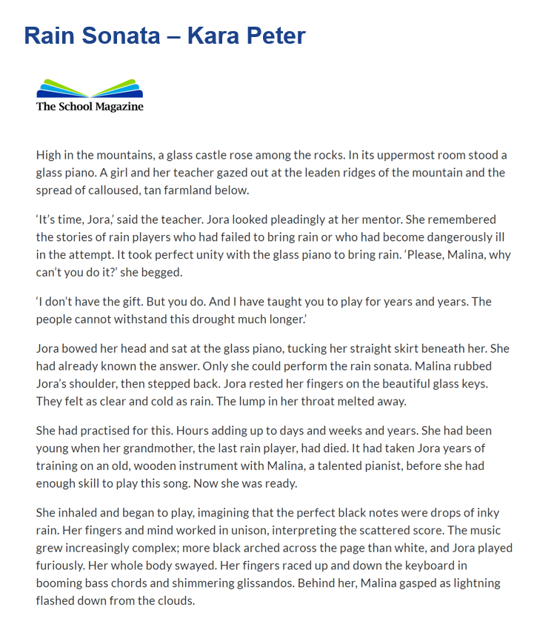

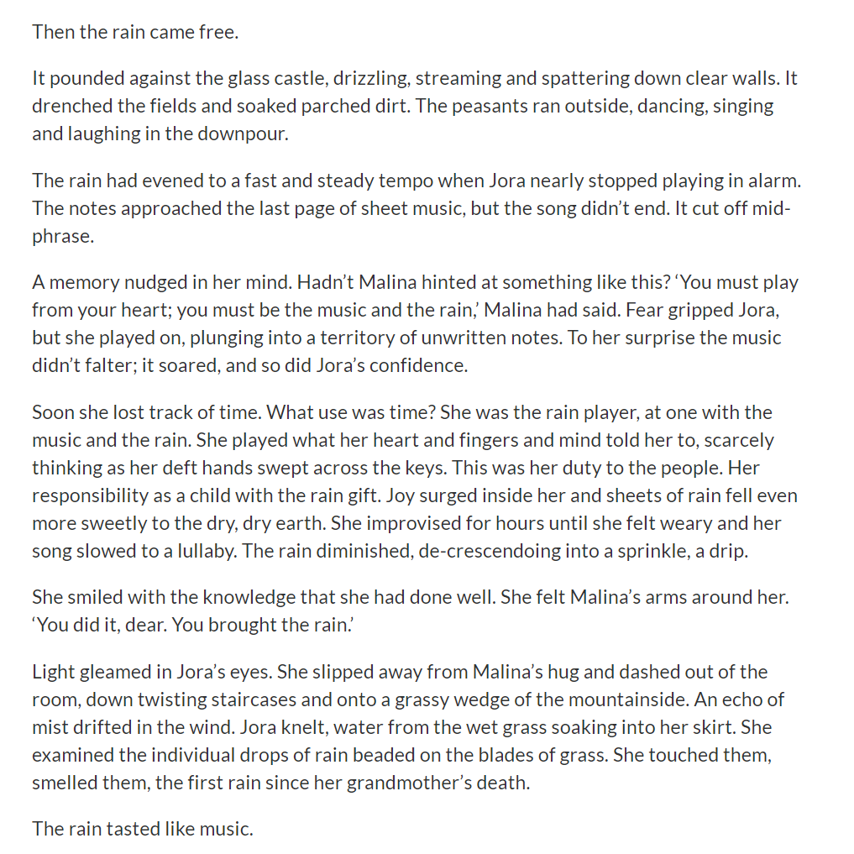
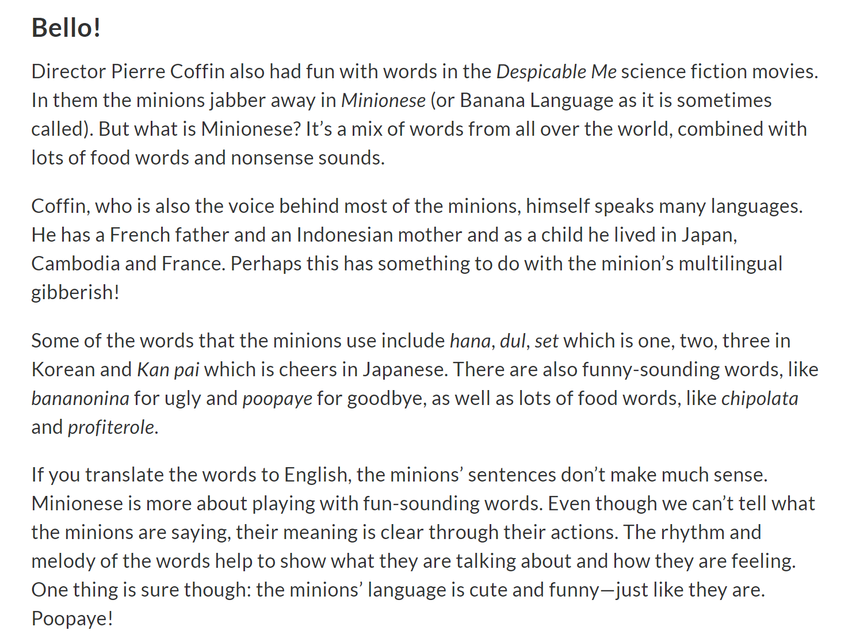
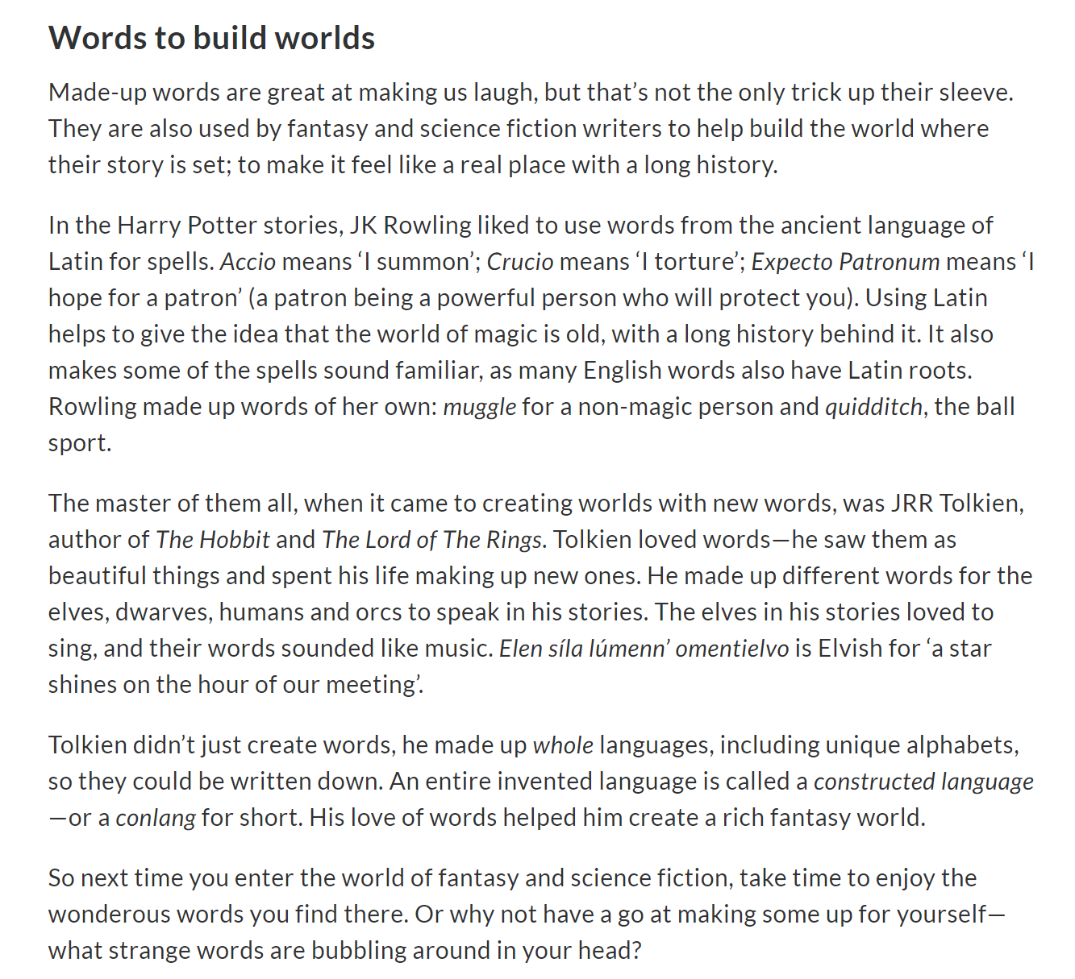

Imagery recording script – Melissa Gillon
Imagine you are walking toward the waterfall, carefully stepping along a peaceful, empty bush track. The sun is hot and the air is warm as you breathe deeply into your lungs.
You can hear rushing water ahead. You can smell the freshness of the water and the mossy damp rocks. The air is warm and you can hear the soft breeze rustling through the leaves of the trees.
You walk along a worn and dusty track, edging closer to the waterfall. As you come to the bush clearing, you see the crystal clear water of the tranquil lagoon before you.
You step out of the bush track and onto a smooth rock shelf. The rock has been warmed by the strong summer sun. Imagine sliding off your thongs, and stepping across the warm rock platform toward the water.
Listen to the water rushing over the jagged cliff face and into the lagoon. Hear the sweet song of the whistling birds playing in the surrounding tree branches.
Smell the clean water. You gaze again toward the bright blue-green water of the lagoon. Enjoy the constant sound of the water rushing down from above.
Imagine yourself walking toward the water, over the smooth warm rocks. You are very hot. As you step from the rock platform, the cool wetness of the lagoon touches your hot skin, giving you goose bumps.
Your toes gently come to rest on the smooth coloured pebbles that cover the lagoon floor. You look out across the rippling water and notice the glistening reflection from the sun overhead.
As you step forward, your feet and ankles begin to sink into the water, cooling your whole body from the heat of the sun with its relaxing temperature. You walk further into the water if you want to, swim if you want to. Enjoy the lagoon for a few minutes.
Now you are feeling calm and refreshed. You walk back out of the water and onto the rock platform. Spread across the rock is a soft towel. You walk toward the towel and lay down feeling the warmth of the sun already drying and warming your now cooled skin.
You close your eyes and listen to the sounds of the bush, the buzzing of the cicadas, the song of the birds and the gushing of the water into the lagoon.

