Word Chains
Understands the meaning of sentences can be enriched through the use of noun groups
Name –
Word Chains are a means of using interesting vocabulary in your writing, on a particular topic. Start with a noun, for example, shoes. Place a picture (photo or drawing) in the middle of the circle, then surround the noun, shoes, with interesting, related adjectives that describe the noun, shoes. Eg:
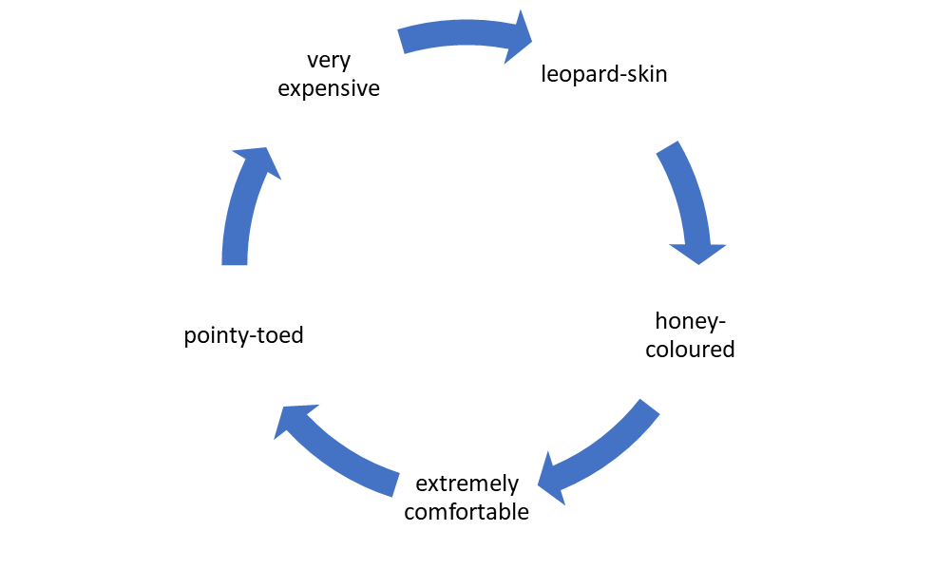

Adding adjectives before the noun in a sentence provides additional information to the reader, making your writing more interesting.

​Eg: These are my very expensive, pointy-toed, leopard-skin shoes.

Now, it’s your turn. The poem, Sock Monster, by Beverley McWilliams is all about socks. Make a word chain below, describing your favourite socks. Place a photo or drawing of your socks in the middle of the circle and surround your socks with interesting adjectives that describe them.

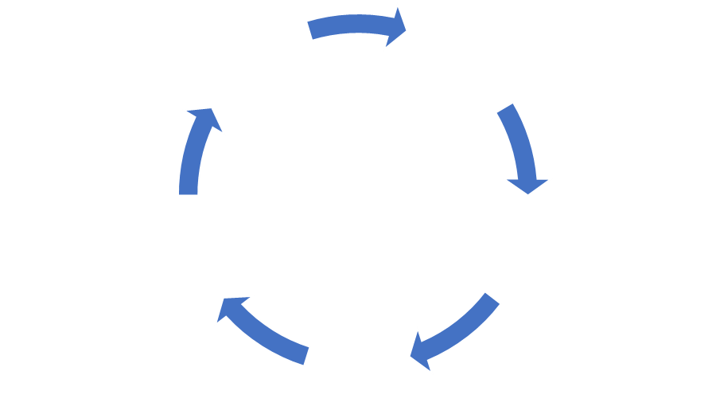

Build noun groups by placing relevant adjectives in front of the noun – usually 3 will suffice (the rule of threes)​.

- These are my ___________, ___________, ___________ socks.

- These are my ___________, ___________, ___________ socks.

- These are my ___________, ___________, ___________ socks.

