S2 - Student English workbook Narrative
Name:
Class:

Overview
During this sequence of learning you will explore what narrative is and why it is important to understand it for your reading, writing and in everyday life.

Resources
Every day you:
- will need an adult so you can discuss your work. Your adult can explain tasks for you and you can explain concepts and tasks to them. Your adult will also check your work and can help you if you need it.
- will need access to stationery. This will include pens, coloured pencils, textas, highlighters, scissors and glue.
- will need to use the workbook your teacher has sent home with you, or some paper.
- are expected to complete a reading task, and a writing task.
- are expected to write neatly and present your work just as well as you would at school. Your teacher’s bookwork expectations are also expected at home too.
You are encouraged to engage with a wide range of texts. This means non-fiction, fiction, across a variety of subjects, forms and features. We know texts to be: books, novels, decodable texts, poems, plays and short stories, but it can also be an advertisement, a comic, an ad or serial on TV, a catalogue or a menu. Texts can also be spoken and viewed, like movies, podcasts and speeches.

Activity 1

Task a – vocabulary
You will have 5 minutes to make as many words as you can using 5 consonants and 3 vowels.
Record your answers below.
________________________________________________________________________________________________________________________________________________________________________________________________________________________________________________________________________________________________________________________________________________________________________________________________________________________________________________________________________________________________________________________

Task b – reading
Your teacher or adult will select a text for you to read.
Remember everything you have been taught by your teacher when reading, including fluency (smooth reading) and expression.
Finished? Tell your adult what the text was about. Was it fiction or non-fiction? How did you know? If it was fiction – who were the characters? What happened? Did anything interesting happen? If it was a non-fiction text, what was the topic? What new information have you learnt? Does knowing this change your thinking?
Record the title of the text that you have read below (and include it on your Record of text sheet at the back of this workbook):

________________________________________________________________________

Task d – understanding narrative
Read or listen to an adult read the script of the narrative video included below. As you read, think about these questions.
- What is narrative?
- Why is narrative useful?
- How can understanding ‘narrative’ help me?
As you read or listen, highlight the sections of the script that you think help answer the questions.
NARRATIVE VIDEO SCRIPT
INT. CLASSROOM – DAY
MR CRANNA is drawing in his sketchbook as STUDENT 1 runs in shocked and horrified, clutching their head.
STUDENT 1
Help! It’s drawn blood!
Mr Cranna looks up from his sketch book.
MR CRANNA
What has?
STUDENT 1
Out there!
STUDENT 1 points O/S. MR CRANNA looks in the direction STUDENT 1 is pointing.
MR CRANNA
Where?
STUDENT 1
It flew down!
MR CRANNA
What flew down? From where? You’re not making any sense.
STUDENT 1
Why not?
MR CRANNA
Because you haven’t told me what’s happened in a way I can understand. Your thoughts aren’t organised and I can’t make sense of them.
STUDENT 1
How do I make you understand?
MR CRANNA
Why don’t you try telling me what happened in a narrative form?
SFX: record scratch. STUDENT 1 looks to camera, thoroughly confused.
STUDENT 1
Er, what’s narrative?
CLOSE ON MR CRANNA as he addresses camera.
MR CRANNA
Narrative is the way we organise thoughts and make sense of things that happen to us or to other people.
WIDE ON MR CRANNA.
STUDENT 1
Can you help me make what happened to me into a narrative?
MR CRANNA
Sure. Why don’t you start by telling me where you were when this happened?
STUDENT 1
I was in the park.
MR CRANNA
Okay, So the narrative takes place in the park.
Mr Cranna draws a picture of Student 1 in the park. He blue tacks it on the wall behind him.

MR CRANNA
Got it! What where you doing in the park?
STUDENT 1
I was skipping with the skipping rope under the big gum tree.
MR CRANNA
Okay…
Mr Cranna draws a picture of Student 1 skipping with a rope under a big gum tree. He blue tacks the picture on the wall.
MR CRANNA
Okay, what happened next?
STUDENT 1
Something hit me on the head. I was bleeding. It really hurt.
Mr Cranna draws a picture of Student 1 clutching their head and blue tacks it on the wall behind him.
MR CRANNA
How did you feel?
STUDENT 1
I was freaked out. It was such a shock. I didn’t know what had hit me!
Mr Cranna draws a picture of Student 1 looking up at the tree in shock and blue tacks it on the wall behind him.
MR CRANNA
Hmm, did you hear anything before you were hit?
STUDENT 1
I heard a swooshing, whooshing, flapping sound. Then a squawk and smack! Something hit me on the skull!
MR CRANNA
Interesting…
Mr Cranna draws a picture of Student 1 hearing a swooshing flapping sound while skipping the rope. He blue tacks the picture on the wall behind him.
Mr Cranna looks at all the pictures on the wall and starts arranging them into order.
MR CRANNA
So you were in the park, skipping with a rope under the big gum tree. Then you…
He moves the picture of STUDENT 1 hearing the flapping sound to be third in the sequence.
MR CRANNA
…heard a swooshing, wooshing flapping sound and smack, something hit you on the head but we don’t know what. It hurt, so you clutched your head and then you felt shocked because you didn’t know what had hit you.
STUDENT 1
That’s right!
MR CRANNA
I wonder what it was… When did this happen?
STUDENT 1
Today. At lunchtime.
MR CRANNA
Today, at lunch… what’s special about today? (thinks) Well, it’s spring… you were under a tree… you heard a flapping sound… oh I know!
Mr Cranna draws a picture of a magpie dive bombing STUDENT 1. He blue tacks it on the wall in between the picture of STUDENT 1 hearing the swooshing, and STUDENT 1 clutching their head.
MR CRANNA
You must’ve been pecked by a magpie! It’s spring, which means its nesting season for magpies. They often swoop unsuspecting humans who they think are a threat to their babies. There must have been a magpie nest in the tree you were skipping underneath!
STUDENT 1
Wow, it’s all making sense now!
MR CRANNA
Because you’ve organised your thoughts in a narrative form. You’ve made a story.
Mr Cranna admires his drawings.
MR CRANNA
If it’s spring, someone else might get swooped by a magpie. We should put this narrative in the magazine.
STUDENT 1
But don’t narratives usually have a meaning? Or a moral?
MR CRANNA
Yes…
STUDENT 1
So I guess the moral of my narrative is don’t forget to wear your zip tie hat during magpie season!
STUDENT 1 puts on a helmet covered in zip ties.
MR CRANNA
Excellent!
Mr Cranna looks at his drawings again.
MR CRANNA
This is good inspiration for my next comic. If it hadn’t been a magpie that hit you, I wonder what it could have been…
Mr Cranna takes down the drawing of the dive bombing magpie. They all start thinking…
Use your highlighted sections to write your own definition of ‘narrative’ and why it is important below.
________________________________________________________________________________________________________________________________________________________________________________________________________________________________________________________________________________________________________________________________________________________________________________________________________________________________________________________________________________________________________________________________________________________________________________________________
Challenge: Do you want to do more? See if you can redraw the pictures Mr Cranna drew in the narrative script and put them in the correct order below!

Check your work
Tick each activity that you have completed
- Task a – vocabulary activity
- Task b – writing
- Task c – independent reading
- Task d – understanding narrative

Reflection
Write a paragraph about an event that has changed the way you think about something.
Have you included:
- Where it happened
- When it happened
- Who was there
- What happened
- How this changed your thinking
________________________________________________________________________________________________________________________________________________________________________________________________________________________________________________________________________________________________________________________________________________________________________________________________________________________________________________________________________________________________________________________________________________

Activity 2

Task a – vocabulary
Sometimes newspapers, magazines or news shows want the title of their text to catch your attention. We call these catchy titles ’headlines’. They are short and snappy! Can you improve the titles below to make them shorter and to grab attention? You might want to find new words by asking your adult or looking in a thesaurus. You have 5 minutes to create the best headlines you can. Ready? Set, GO!
Elephant found in school yard
_______________________________________________________________________
Magpies are protective because they are nesting
_______________________________________________________________________
People get sick from food
_______________________________________________________________________
Farmers need dogs to help with sheep
_______________________________________________________________________
Computers stopped working in schools
_______________________________________________________________________

Task b – reading
Your teacher or adult will select a text for you to read.
Remember everything you have been taught by your teacher when reading, including fluency (smooth reading) and expression.
Finished? Tell your adult what the text was about. Was it fiction or non-fiction? How did you know? If it was fiction – who were the characters? What happened? Did anything interesting happen? If it was a non-fiction text, what was the topic? What new information have you learnt? Does knowing this change your thinking?
Record the title of the text below and include it in your record of texts (at the back of this workbook).
____________________________________________________________________

Task c - narrative presents a view of the world
Read the transcript from the BTN website about ’Magpie season’ that accompanies this workbook.
Even though ‘Magpie season’ is clearly a news report (in other words a non-fiction text) it is still structured as a narrative to keep us interested. Narratives always present a view of the world.
In other words, narrative includes some things and leaves out others.
One way to explore what is included or left out is to think about who gets to ‘tell’ their story and who might not be included.
Use the transcript to retell the narrative that the following people or groups share with us in ‘Magpie season’.

Matt’s narrative
________________________________________________________________________________________________________________________________________________________________________________________________________________________________________________ The children’s narrative (Fatick, Marco, Ella, Jay, Sienna and Sam)
________________________________________________________________________________________________________________________________________________________________________________________________________________________________________________ The magpies’ narrative
________________________________________________________________________________________________________________________________________________________________________________________________________________________________________________ Who’s story is shared with us the least? _______________________________________
Why do you think the author made that story less powerful?
________________________________________________________________________________________________________________________________________________
Can you think of a group, person or animal who was left out of this news report that the author might have included? How might the news report have changed if they were included?
________________________________________________________________________________________________________________________________________________

Why do you think the author used narrative to engage the audience in this text?
________________________________________________________________________________________________

Check your work
Tick each activity that you have completed
- Task a - vocabulary task
- Task b - independent reading
- Task c - narrative presents a view of the world (‘Magpie season’)

Reflection
Think about what you have learnt so far about narrative. Use this structure to guide your reflection.
3
things I learnt today
2
things I want to know more about
1
question I still have

Activity 3

Task a – vocabulary
Find an advertisement. This may be a print ad or an ad on television.
Choose a word that you are not familiar with and answer the following questions:
The word is: ____________________________________________________________
I think it means: __________________________________________________________
Clues I used: ____________________________________________________________
Dictionary definition: ________________________________________________________________________________________________________________________________________________It makes me think of: ______________________________________________________
Put it in a sentence: ________________________________________________________________________________________________________________________________________________

Task b – reading
Your teacher or adult will select a text for you to read.
Remember everything you have been taught by your teacher when reading, including fluency (smooth reading) and expression.
Finished? Tell your adult what the text was about. Was it fiction or non-fiction? How did you know? If it was fiction – who were the characters? What happened? Did anything interesting happen? If it was a non-fiction text, what was the topic? What new information have you learnt? Does knowing this change your thinking?
Record the text that you have read below, and also add it to the record of texts at the end of this workbook:
________________________________________________________________________

Task c – reading ‘Stinky Sid’
Read ‘Stinky Sid’, by Zoe Disher, a narrative that accompanies this workbook.
Identify the orientation, complication/s and resolution. Using the highlighters or pencils, highlight the sections in the text which indicate this using 3 different colours and a label.
Find and highlight in another colour the description of the setting in the orientation. Look further in the text to identify and highlight words or phrases that provide more information to the setting description. Can you make a clear picture in your head of the setting?

Below write the words and sentences that help you to create a clear picture of the setting for this narrative.
________________________________________________________________________________________________________________________________________________________________________________________________________________________________________________________________________________________________________________________________________________________________________________________________________________________________________________

Check your work
Tick each activity that you have completed
  - Newspaper article vocabulary
  - Independent reading
  - Reading 'Stinky Sid'

Reflection
Share with an adult the structure of a narrative. Remember to share why structure is important to help the audience.
- What is usually included in the orientation? (setting, characters, time)
- Can you think of a text where it does not start with an orientation?

Activity 4

Task a – vocabulary
Look out your window or door. What do you see?
Describe this to an adult. Remember to use adjectives and imagery.
You should be using language that helps the adult build a clear 'picture' in their mind.

Task b – reading
Your teacher or adult will select a text for you to read.
Remember everything you have been taught by your teacher when reading, including fluency (smooth reading) and expression.
Finished? Tell your adult what the text was about. Was it fiction or non-fiction? How did you know? If it was fiction – who were the characters? What happened? Did anything interesting happen? If it was a non-fiction text, what was the topic? What new information have you learnt? Does knowing this change your thinking?
Record the title of the text that you have read below and in your record of texts at the end of this workbook.
________________________________________________________________________

Task c – imagery in ‘Stinky Sid’
‘When Sid came into the house, flowers dropped their petals and the paint peeled off the walls. Bert’s feathers dropped out and fell in his birdseed.’
Discuss with an adult, the images the words created in your mind from the above passage.
What feelings does this imagery provoke?
_______________________________________________________________________
What do you think is the purpose of this imagery? What impact does it have on the reader?
_______________________________________________________________________________________________________________________________________________________________________________________________________________________________________________________________________________________________________________________________________________
Use imagery to describe an object, family member or pet. This can be written below or shared with an adult.
________________________________________________________________________________________________________________________________________________________________________________________________________________________________________________________________________________________________

Task d – punctuation in ‘Stinky Sid’
There are 19 exclamation marks used in Stinky Sid. That’s way more than usual…Why did the author, Zoe Disher, use so many?
What do you think is the purpose of the exclamation marks in ‘Stinky Sid’?
_______________________________________________________________________________________________________________________________________________________________________________________________________________________________________________________________________________________________

Check your work
Tick each activity that you have completed
- Vocabulary activity
- Independent reading
- Imagery in ‘Stinky Sid’
- Exclamation marks in ‘Stinky Sid’

Reflection
Consider how the choices the author made contribute to the mood and feeling of ‘Stinky Sid’.
Who is telling the story of Stinky Sid?
________________________________________________
Could the story be told by the dog? ________________________________________________
Who else could tell this story? ________________________________________________
If they told the story, how might it change the mood or feeling of the narrative? ________________________________________________________________________________________________

Activity 5

Task a – visual stimulus (description)
Describe the image below to an adult in your house.
Remember to use great adjectives and imagery.
Try using a simile where you compare one thing to another.
- Example of a simile: The house was as dark as the night sky without any stars.
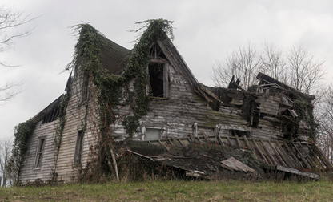
"Dec Drive 2016" by Anthony is licensed under CC BY-ND 2.0
Share your description by writing it below.
________________________________________________________________________________________________________________________________________________

Task b – reading
Your teacher or adult will select a text for you to read.
Remember everything you have been taught by your teacher when reading, including fluency (smooth reading) and expression.
Finished? Tell your adult what the text was about. Was it fiction or non-fiction? How did you know? If it was fiction – who were the characters? What happened? Did anything interesting happen? If it was a non-fiction text, what was the topic? What new information have you learnt? Does knowing this change your thinking?
Record the text that you have read below and in your Record of texts:
________________________________________________________________________

Task c – writing
Show what you know about narrative. Write your own!
Remember to include:
- include an orientation, including characters, setting and time
- a complication
- a resolution
- use imagery to ‘paint’ a picture with words
Look carefully at the picture. Who might live there? Why? What problem might happen that effects them?
Once you have a plan, get writing and share the world of your story!

Title: ______________________________________
by _______________________
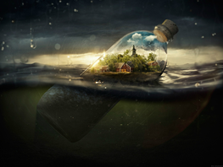_______________________________________________________________________________________________________________________________________________________________________________________________________________________________________________________________________________________________________________________________________________________________________________________________________________________________________________________________________________________________________________________
________________________________________________________________________________________________________________________________________________________________________________________________________________________________________________________________________________________________________________________________________________________________________________________________________________________________________________
________________________________________________________________________________________________________________________________________________________________________________________________________________________________________________________________________________________________________________________________________________________________________________________________________________________________________________________________________________________________________________________________________________________________________________________________________________________________________________________________________________________________________________________________________________________________________________________________________________________________________________________________________________________________________________________________________________________________________________________________________________________________________________________________________________________________________________________________________________________________________________________________________________________________________________________________________________________________________________________________________________________________________________________________________________________________________________________________________________________________________________________________________________________________________________________________________________________________________________________________________________________________________________________________________________________________________________________________________________________________________________________________________________________________________________________________________________

Check your work
Tick each activity that you have completed.
  - Description using visual stimulus
  - Independent reading
  - Independent writing task

Reflection
Reread your narrative to someone else. Show them where you have included:
- an orientation, including characters, setting and time
- a complication
- a resolution
Explain to them what imagery is and where you used it in your narrative. Why did you use it there?
What would you improve when you are writing next time?

Activity 6

Task a – editing task
Pay close attention. There is something wrong with this narrative!
Can you fix the punctuation, spelling and grammar so it makes sense? Use a highlighter to locate them all and write corrections next to the text.

A Teacher’s Lament … or a story about a run-in with a wombat
By Lorri Bev
a few short years ago, i was teeching in country nsw, not far from our nashinal capital, canberra My job envolved traveling between schools, supporting teachers to Deliver exiting English
lessons for studnets
Won clear chilli, winter moning, not long arfter daybrake, I was driving along a meandering country rode. i felt a sence of deep piece with my surroundings, like i was one with the
enviroment.
i was almost hipnotized by shards of
pail sunlight that glistened like jewels in the early
morning lite. clearly, I shoud have been paying
better attenshon to the road ahed…
(Spoiler alert: the wombat was okay)
If you would like to read the rest of the story, without any errors, it is available accompanying this workbook. Ask your teacher if you can’t find it.

Task b – reading
Your teacher or adult will select a text for you to read.
Remember everything you have been taught by your teacher when reading, including fluency (smooth reading) and expression.
Finished? Tell your adult what the text was about. Was it fiction or non-fiction? How did you know? If it was fiction – who were the characters? What happened? Did anything interesting happen? If it was a non-fiction text, what was the topic? What new information have you learnt? Does knowing this change your thinking?
Record the text that you have read below and in your Record of texts:
________________________________________________________________________

Task c – word chain
Read the poem ‘Sock Monster’ by Beverley McWilliams from The School Magazine, that accompanies this workbook.
You will construct a word chain describing your favourite socks.

Word Chains
Word chains are a means of creating interesting vocabulary to use in your writing. Start with a noun, for example, ‘shoes’. Place a picture (photo or drawing) in the middle of the circle, then surround the noun, ‘shoes’, with interesting, related adjectives that describe the noun, shoes. Below is an example word chain for these particular shoes.
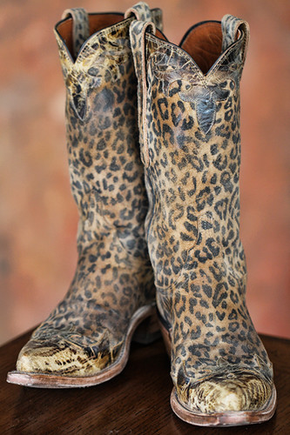
"leopard boots" by She Paused 4 Thought is licensed under CC BY-NC-ND 2.0

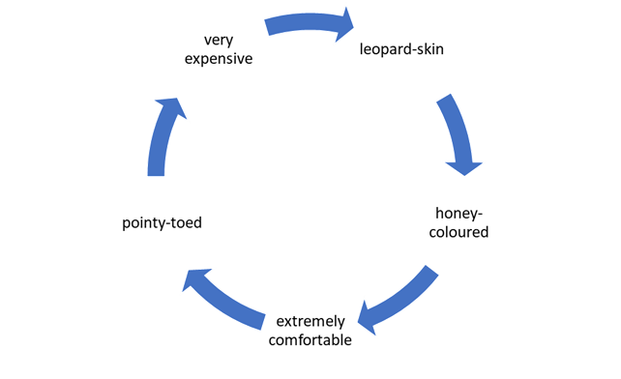

Adding adjectives before the noun in a sentence makes your writing more interesting.
For example: These are my very expensive, pointy-toed, leopard-skin shoes.
Now, it’s your turn. The poem, ‘Sock Monster’ by Beverley McWilliams is all about socks. Make a word chain below, describing your favourite socks. Place a photo or drawing of your socks in the middle of the circle and surround your socks with interesting adjectives that describe them.

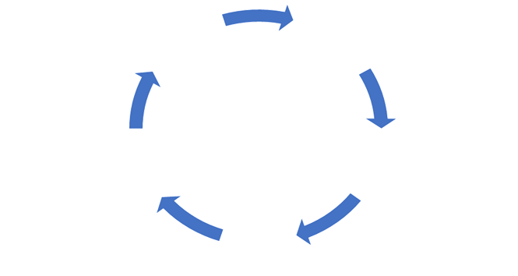
Build noun groups by placing relevant adjectives in front of the noun – usually no more than three.
- These are my ___________, ___________, ___________ socks.

- These are my ___________, ___________, ___________ socks.

- These are my ___________, ___________, ___________ socks.

Check your work
Tick each activity that you have completed
- Editing task
- Independently read
- Word chain activity

Reflection
Discuss with an adult or write your thoughts:
- Can poetry be a narrative?
- Who are the characters in the text ‘Sock monster’ by Beverley McWilliams?
- Where is the setting written in the?
________________________________________________________________________________________________________________________________________________________________________________________________________________________________________________________________________________________________________________________________________________________________________________________________________________________________________________________________________________________________

Activity 7

Task a – word cline
A word cline is a scale of words that go from weak to strong.
We can use a word cline to think through our language choice in speaking and writing. When we use just the right word to describe something we create more engaging texts
We can choose our words carefully to inform our readers exactly what we mean. This word cline is an example of weather.
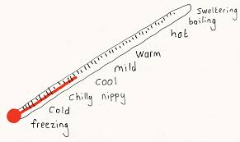
In the poem, ‘A Hairy Tank’, the poet, Jenny Blackford, suggests that the wombat in the poem is large, like a tank. Complete the word cline below, starting with the word ‘big’ at the bottom and add more complex and interesting words for big as you move up the cline towards the tip of the arrow.
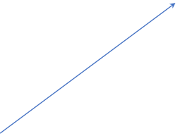

Task b – reading
Your teacher or adult will select a text for you to read.
Remember everything you have been taught by your teacher when reading, including fluency (smooth reading) and expression.
Finished? Tell your adult what the text was about. Was it fiction or non-fiction? How did you know? If it was fiction – who were the characters? What happened? Did anything interesting happen? If it was a non-fiction text, what was the topic? What new information have you learnt? Does knowing this change your thinking?
Record the text that you have read below and in the record of texts at the end of this workbook.
________________________________________________________________________

Task c – imagery in poetry
Read “A Hairy Tank’ by Jenny Blackford, illustrated by Heidi Cooper Smith, which accompanies this workbook. As you read highlight examples of imagery you enjoy. Have a go at writing some similar examples of imagery here.
For example: ‘a wombat is a hairy tank’ could become ‘a giraffe is a beam of sunlight’ or ‘a horse is a whisper of wind’.
________________________________________________________________________________________________________________________________________________
Challenge: Do you know what we call it when we say one thing ‘is’ another in writing or speaking?
________________________________________________________________________

Check your work
Tick each activity that you have completed
- Word cline
- Independently reading
- Writing

Reflection
Using just the right word is a powerful way to communicate. Share some of your favourite new words below and why you like them.
________________________________________________________________________________________________________________________________________________________________________________________________________________________________________________________________________________________________________________________________________________

Activity 8

Task a – reading
Your teacher or adult will select a text for you to read.
Remember everything you have been taught by your teacher when reading, including fluency (smooth reading) and expression.
Finished? Tell your adult what the text was about. Was it fiction or non-fiction? How did you know? If it was fiction – who were the characters? What happened? Did anything interesting happen? If it was a non-fiction text, what was the topic? What new information have you learnt? Does knowing this change your thinking?
Record the text that you have read below and in the record of texts included at the end of this workbook.
________________________________________________________________________

Task b – poetry writing
Read the poem, “A Hairy Tank’ by Jenny Blackford that accompanies this workbook.
Select an animal you would like to write about, and write down its characteristics, thinking of an inanimate object to compare it to e.g. a snake can be compared to a garden hose, an elephant to a bus, a horse to a table, an owl like a computer, a Labrador like a doorstop, a cat like a mirror...
The goal is to write a poem. Experiment writing their own poetry, using figurative language and rhyme.

Choose an animal you would like to write about. Write down some characteristics.
For example: A cat! It is
- a hunter
- slinky
- clever
- shiny
- small (or big depending on if it is hunting you!)
Now, compare it to a non-living thing… A cat flows like a river. You can use these ideas in your poem.
Your animal _______________________
It is:
- __________________
- __________________
- __________________
- __________________
- __________________
- __________________
Now, compare your animal to a non-living thing: __________________________________________________________________________________________________________________________________________

Title:_____________________________________
By ________________
________________________________________________________________________________________________________________________________________________________________________________________________________________________________________________________________________________________________________________________________________________________________________________________________________________________________________________________________________________________________________________________________________________________________________________________________________________________________________________________________________________________________________________________________________________________________________________________________________________________________________________________________________________________________________________________________________________________________________________________________________________________________________________________________________________________________________________________________________________________________________________________________________________________________________________________________________________________________________________________________________________

Check your work
Tick each activity that you have completed
- Reading
- Writing a poem

Reflection
How is my poem a narrative?
Read your poem aloud to an adult and explain to them how you know it is a narrative.
Remember to talk about:
- the use of narrative to communicate ideas in an organised way
- how narrative is recognisable but changes in different kinds of texts
- narrative structure (orientation, complication, resolution)
- character, setting and imagery

Activity 9

Task a
Look carefully at the image below. What words could you use to describe it really well?
- Without letting them see it, describe the image to an adult. Try to use great words to create a clear picture in their mind of this image.
- Show the image to them and ask them to describe it in lots of detail.
- See if you can combine your description with their description to create a great picture in your audience’s mind
When you are happy with your description you can write it below.
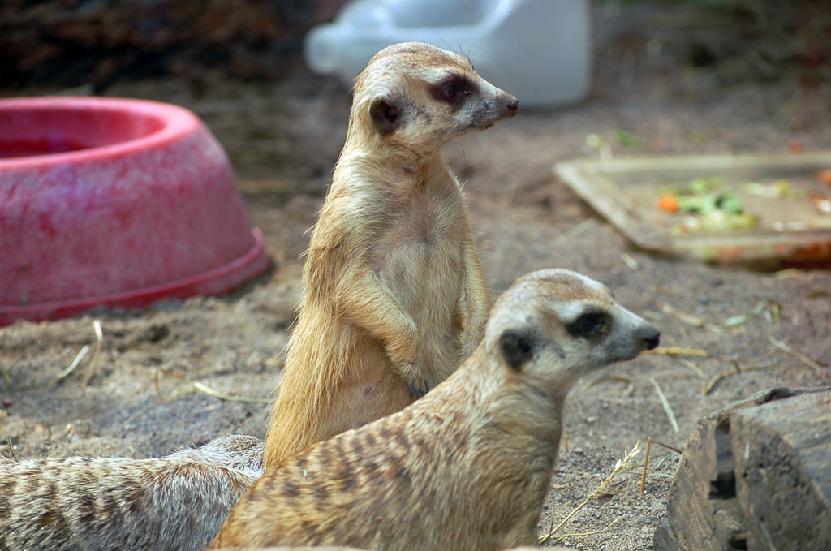"DSC_0149a" by LladyYas is licensed under CC BY-NC 2.0
________________________________________________________________________________________________________________________________________________________________________________________________________________________________________________

Task b – reading
Your teacher or adult will select a text for you to read.
Remember everything you have been taught by your teacher when reading, including fluency (smooth reading) and expression.
Finished? Tell your adult what the text was about. Was it fiction or non-fiction? How did you know? If it was fiction – who were the characters? What happened? Did anything interesting happen? If it was a non-fiction text, what was the topic? What new information have you learnt? Does knowing this change your thinking?
Record the text that you have read below and in your record of texts, at the end of this workbook.
________________________________________________________________________

Task c -

Venn diagram
You can use a venn diagram to help organise what is the same and what is different about two things.
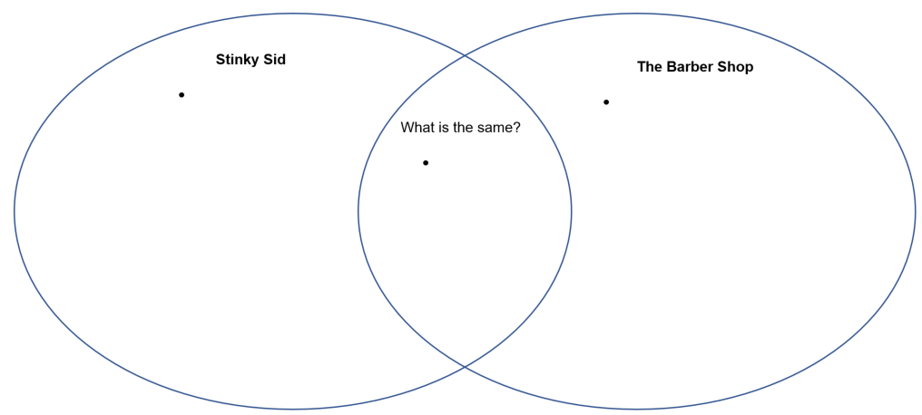

Check your work
Tick each activity that you have completed
- Task a – vocabulary
- Task b – independent reading
- Task c – ‘The Barber Shop’ by Andrew Cranna

Reflection
Narrative is both recognisable and different depending on the kind of text. Discuss the questions below with an adult. See if you can share your thinking below each question.
Why might it be useful to understand how narrative is both recognisable and different depending on the kind of text? Consider what changes in the way we create and understand narrative in non-fiction texts, novels or comics.
________________________________________________________________________________________________________________________________________________________________________________________________________________________________________________________________________________________________________________________________________________________________________________________________Can you think of another kind of text where narrative is both recognisable and different from a novel? What would be different?
________________________________________________________________________________________________________________________________________________________________________________________________

Activity 10

Task a – reading
Your teacher or adult will select a text for you to read.
Remember everything you have been taught by your teacher when reading, including fluency (smooth reading) and expression.
Finished? If this was a fictional piece of text, tell your adult what the text was about – Who were the characters? What happened? Did anything interesting happen? If it is a non-fiction text, what was the topic? What new information have you learnt? Has it changed the way you think about something?
Record the text that you have read below and in your record of texts at the end of this workbook:
________________________________________________________________________

Task b – retelling your narrative as a comic
Look at the ’The Barbershop’ by Andrew Cranna from The School Magazine. It accompanies this workbook. You are going to re-create, as a comic, the orientation from the narrative that you wrote in Activity 5.
BEFORE you start look closely at ‘The Barber Shop’ and consider:
- The size and shape of the boxes. Why do they change? What shapes and sizes might work to retell your story?
- How does the author and illustrator, Andrew Cranna, show who is speaking? How does he show the order in which characters speak?
- How does Andrew explain where and when things happen in his comics?
Discuss your thinking with an adult and explain the choices that you would like to make to recreate your story.
Create your comic orientation in the space below. When you are finished draw an arrow neatly from the side and label choices in your comic design you would like your teacher to notice.

Title:_______________________________________
By ___________________________

Check your work
Tick each activity that you have completed.
- Task a – reading
- Task b – retelling your narrative orientation from Activity 5 as a comic

Reflection
Think about what you have learnt about narrative and your work in this book. Discuss these questions with an adult.
- How has your understanding about narrative changed and grown?
- What have you learnt something that will influence the way you read and respond to texts?
- What have you learnt something that influences the way you create texts?
- What have you learnt something that helps you when you are speaking and listening?
Use the two stars and a wish document to guide your reflection
Star  Something that went well! | Star  Something that went well! | Wish  A goal for next time…

Record of texts
‘Texts’ includes sound, print, film, digital and multimedia. It’s the way we communicate. So that means it can be a book, text message, podcast, play, website and even a movie. When we talk about text, it could be any of these communications.
Record the title of each text you engage with (or if it is a novel, you might like to record each chapter title).
Date | Title | Type of text e.g. a poem | Independent or shared | Notes
1 April | The Barber Shop Scissor Twister | comic | Independent | I recommend this comic because it is funny.

