English S2 student workbook –Connotation, imagery and symbol
Name:
Class:

Lesson 1
During this activity you will learn to:
- identify personal experiences that influence your interpretation of texts
- identify that readers interpret texts differently due to differences in personal experiences and background.

1.1 Speaking and listening
You will play ‘Sixty Seconds to Share’.
Select a topic that you are familiar with and would be confident to speak about. For example: dogs, the beach, paddocks, holiday location, soccer.
For 60 seconds, think about the topic and then for another 60 seconds write dot-points.
You will then present a talk to an adult about your chosen topic for a maximum of 60 seconds, using your dot-points as support if needed.

1.2 Sun and face
Watch the connotation, imagery and symbol video.
What idea or feeling do you connote from the word sun?
________________________________________________________________________________________________________________________________________________________________________________________________________________________________________________________________________________________________What imagery can you make from combining ‘sun’ and ‘face’?
________________________________________________________________________________________________________________________________________________________________________________________________________________________________________________________________________________________________How do your personal and cultural experiences lead you to make connections in relation to connotation, imagery and symbol?
________________________________________________________________________________________________________________________________________________________________________________________________________________________________________________________________________________________________

1.3 Rainbow feelings
A simile is when two usually dissimilar things are compared. The comparison often uses the words like or as.
For example: The tree was as green and bright as a frog sitting in the sun.
An adjective is a word that describes an animal, person, thing, or thought. Adjectives include words that describe what something looks like and what it feels like to touch, taste, or smell.
For example: The large, green tree was swaying in the wind.
Look at the image of a rainbow.
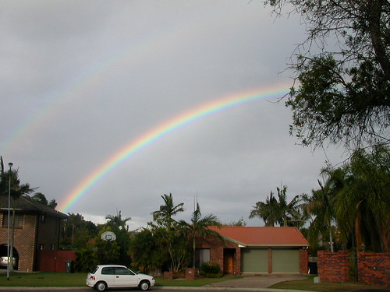
"DSCN2565" by bravo! is licensed under CC BY 2.0
How does this image make you feel?
________________________________________________________________________________________________________________________________________________Create a simile that describes the rainbow. For example: A rainbow is as colourful as a unicorn’s horn.
________________________________________________________________________________________________________________________________________________
List 5 adjectives that describe the rainbow.
________________________________________________________________________________________________________________________________________________
What does a rainbow symbolise for you?
________________________________________________________________________________________________________________________________________________
Write a descriptive paragraph, using the rainbow and the connections you have identified.
________________________________________________________________________________________________________________________________________________________________________________________________________________________________________________________________________________________________________________________________________________________________________________________________________________________________________________________________________________________________________________________________________________________________________________________________

1.4 Reflection
How do your personal experiences impact your interpretation of a text?
Do all people interpret texts in the same way?
Lesson 2
During this activity you will learn to:
- recognise that the interpretation of symbols depends on personal experience
- recognise that colour and colour imagery may symbolise mood
- elaborate on ideas using sequences of sentences.

2.1 Speaking and listening
Oral task
- elaborate on ideas using a short sequence of sentences
- speak in clear sentences
- use vocabulary that is precise.
An adult will show or tell you a colour.
What connotations does the colour gives you?
Justify and elaborate on your answer. Add an experience that relates to the feeling and the colour.
Does everyone have the same feeling associated with each colour?
Why or why not?

2.2 I see, I think, I wonder
Prior to reading the text ‘You Can Have Mine’ from The School Magazine, look at the illustration of the caterpillar and read the title of the text.
You can have mine.
Illustrated by Cheryl Orsini
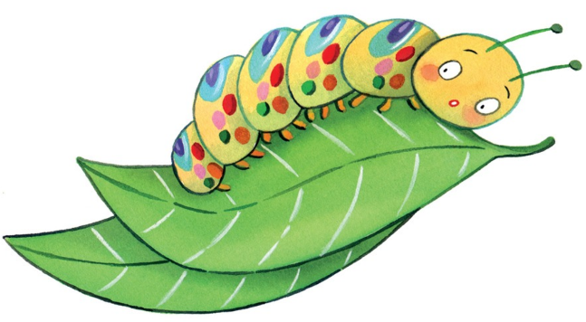
Complete the ‘I see, I think, I wonder’ activity.
I see. I think, I wonder
I see  What do you see? | I think  What do you think might happen? | I wonder  What does it make you wonder?
Now read or listen to the text ‘You Can Have Mine’.
After reading, reflect on your ‘I see, I think, I wonder’” responses and add any additional information to it.

2.3 Colour connotations
Colours can symbolise or connote emotions. Colours can have negative connotations and positive connotations.
Read the text, ‘You can have mine’
What colours are mentioned in the text and what emotions do they connote?
________________________________________________________________________________________________________________________________________________________________________________________________________________________________________________________________________________________________View ‘The colour monster’ video.
Reflect on a memory that is positive for you. It may have been exciting or an adventure. Attribute a colour to that.
What was the memory?
________________________________________________________________________________________________________________________________________________________________________________________________________________________What colour can you attribute to this memory and why?
________________________________________________________________________________________________________________________________________________________________________________________________________________________

2.4 Reflection
How can colour represent mood?
How do your interpretations of a text change before, during and after you read it, and what elements of the text alter your interpretations?

Lesson 3
During this activity you will learn to:
- recognise the use of figurative language in texts, e.g. similes and discuss their effects
- experiment with figurative language (similes) when composing texts to engage an audience
- incorporate figurative language (similes) into spoken and written texts.

3.1 Speaking and listening – similes
object + colour adjective + object + imagination = simile!
Remember to use the word like or as to describe the object. For example: flower, red and apple. The flower was dark red, like a freshly picked Red Delicious apple. You can choose any word from each column to create your similes.
Make sure your sentences makes sense!
Share your similes orally with your teacher or record yourself so that your teacher can hear your similes.
Similes
object | colour | object
cat | grey | jewellery
flower | gold | ocean
snake | blue | banana
puddle | yellow | unicorn
pencil | black | apple
bike | white | cactus
car | green | snow
letterbox | pink | fairy floss
rug | multi-coloured | night

3.2 Similes in text
View the ‘similes’ video.
Similes can be used to create a rich picture of a character which helps the audience engage with the text.
Read or listen to the text ‘You Can Have Mine’ in The School Magazine.
Identify the similes in the text. What do these similes tell the reader about the character?
Similes
Simile from text | What does it tell the reader about the character?
‘green and shiny like emeralds’ | Toad was upset that he didn’t look like the other toads in his family. He felt that green was a prettier and superior colour.

What imagery is created through the use of these similes and what was the author’s purpose in creating them?
________________________________________________________________________________________________________________________________________________________________________________________________________________________________________________________________________________________________

3.3 Similes
Select a character from the text, ‘You can have mine’.
Think about and record the traits of that character. These traits should include appearance and personality traits.

Character
Appearance | Personality
Similes to describe the character:
________________________________________________________________________________________________________________________________________________________________________________________________________________________________________________________________________________________________________________________________________________________________________________________________________________________________________________

3.4 Reflection
How do similes enhance the imagery in a text?

Lesson 4 – imagery and rhyme
During this activity you will learn to:
- use images to reinforce ideas in written texts
- identify and experiment with rhyme as one language feature often used by poets
- adopt elements from other texts to experiment with in your own writing.

4.1 Speaking and listening
Rhyme is a popular literary device in which the repetition of the same or similar sounds occurs in two or more words, usually at the end of lines in poems or songs.
Here is an example: sky, pie, fly, cry, apply.
Select a word from the following list and in 20 seconds, say as many rhyming words as possible.
List of words to select from:
- beach
- sky
- tell
- book
- pen
- chord
- flute
- share
- line
- wide

4.2 A dessert sky
Prior to reading, look at the illustration accompanying the text, ‘A dessert sky’ from The School Magazine.
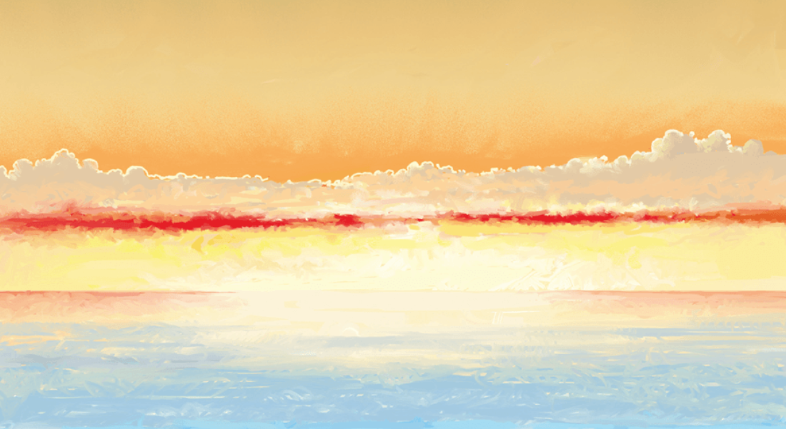Dessert sky by Matt Otley is licensed under CC BY 4.0
Discuss and complete the following questions:
What does this image remind you of?
________________________________________________________________________________________________________________________________________________
What connotations or feelings are provoked by this image?
________________________________________________________________________________________________________________________________________________
What does this image symbolise to you?
________________________________________________________________________________________________________________________________________________

Skim over the poem ‘A dessert sky’ and look at its overall structure. This poem is found at the end of the student workbook.
- circle any interesting or challenging words
- highlight rhyming words within the poem. Where are the rhyming words located?
The word ‘dessert’ has been used to describe the sky.
Why do you think the author has used the word ‘dessert’ when describing a sky?
________________________________________________________________________________________________________________________________________________________________________________________________________________________________________________________________________________________________
Why has the author suggested a sky can be eaten? Why does this imagery work?
________________________________________________________________________________________________________________________________________________________________________________________________________________________________________________________________________________________________
Reread or listen to the text ‘A Dessert Sky’.

4.3 Locations and food
Imagery – the use of figurative language or illustrations to represent objects, actions or ideas
‘Dessert Sky’ is an example of imagery. A creamy, spongy dessert is used as imagery for the sun setting in the sky.
Here is a range of locations and images:
Food and locations
Location | Image | Attribution
bush | 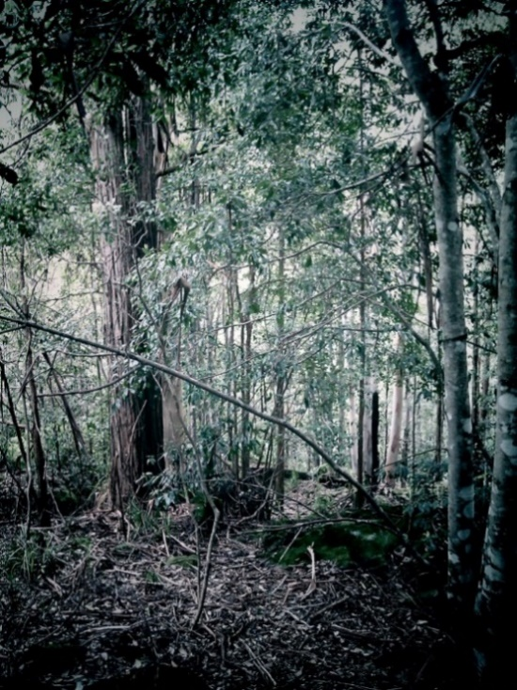 | "under the canopy" by danoxster is licensed under  CC BY-SA 2.0
ocean | 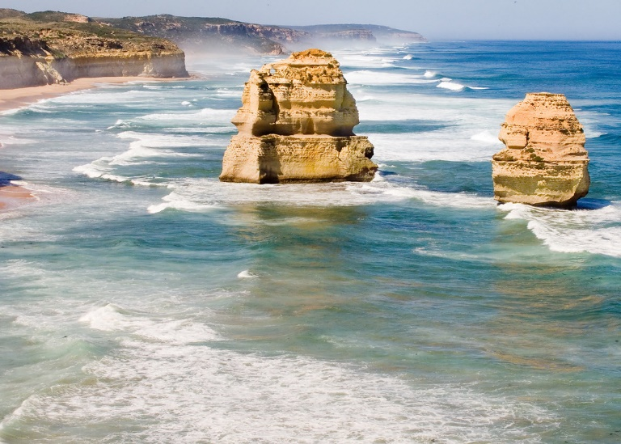 | "Great Ocean Drive-_019+" by Sheba_Also 15.6 Million Views is licensed under  CC BY-SA 2.0
snow-capped mountains | 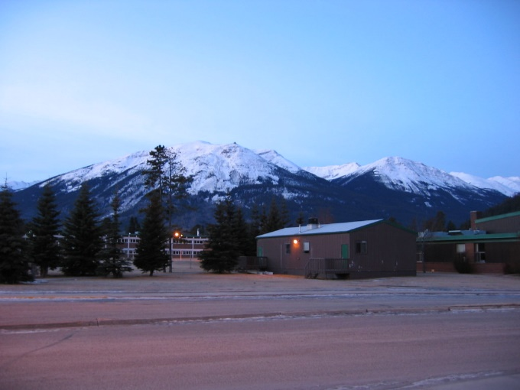 | "The mountains around Jasper" by Ted & Dani is licensed under CC BY 2.0
rocky outcrop | 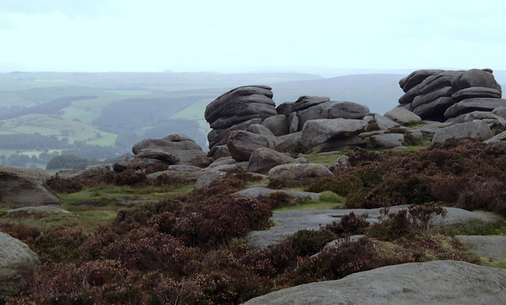 | "On Higger Tor" by Andrew Hill is licensed under  CC BY-SA 2.0
desert | 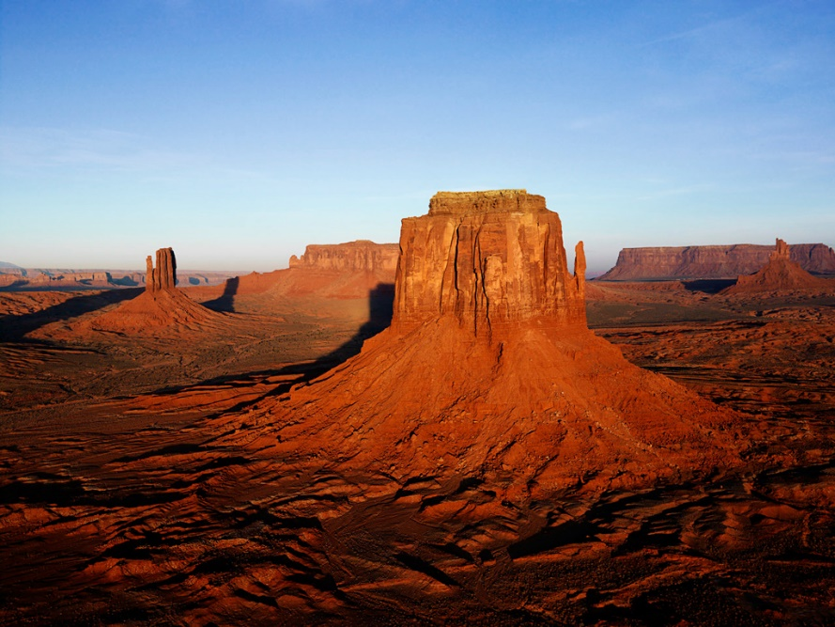 | "Calming Desert Beauty" by Nekros0306 is licensed under  CC BY 2.0
rainforest | 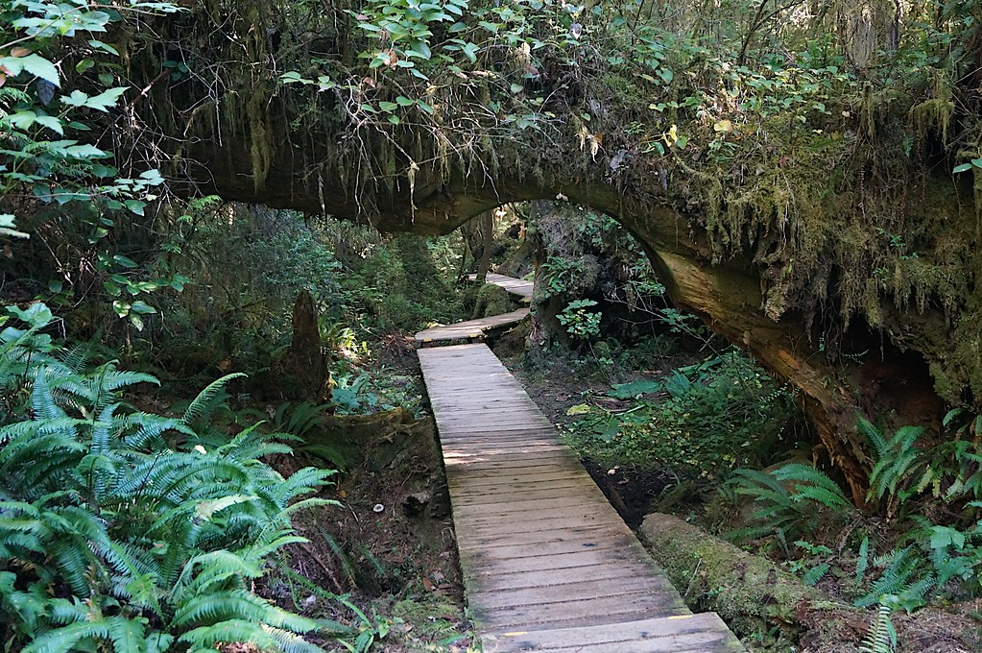 | "On the boardwalk to Hot Springs Cove (16)" by 4nitsirk is licensed under  CC BY-SA 2.0

Food: chocolate, biscuits, casserole, cream, fairy floss, pancake, rice, spaghetti, slushy, lollipop. mashed potato

Create connections using a location and a food.
For example: fairy flossed desert sands, meat casserole mountain sides.
Create three connections with an illustration. Your turn:
________________________________________________________________________________________________________________________________________________________________________________________________________________________________________________________________________________________________

4.4 Reflection
How can images and symbol be used to reinforce ideas in texts?
Does rhyme always add to the effectiveness of poetry?

Lesson 5
During this activity you will learn to:
- identify the purpose of a text, its intended audience, its mode and its medium
- make connections between your own experiences and texts

5.1 Speaking and listening
You can work in pairs
Each pair shares an image and takes 1 minute to look closely at this image. For approximately one minute, one person (describer) describes the image in as much detail as possible, while the partner (listener) looks on.
At the conclusion of the description, the listener gives the describer feedback in the form of ‘two stars and a wish’ (two positives and one thing to work on next time).
Using a different image, students then swap roles and repeat the activity, focusing on addressing the feedback (the wish).

Image 1:
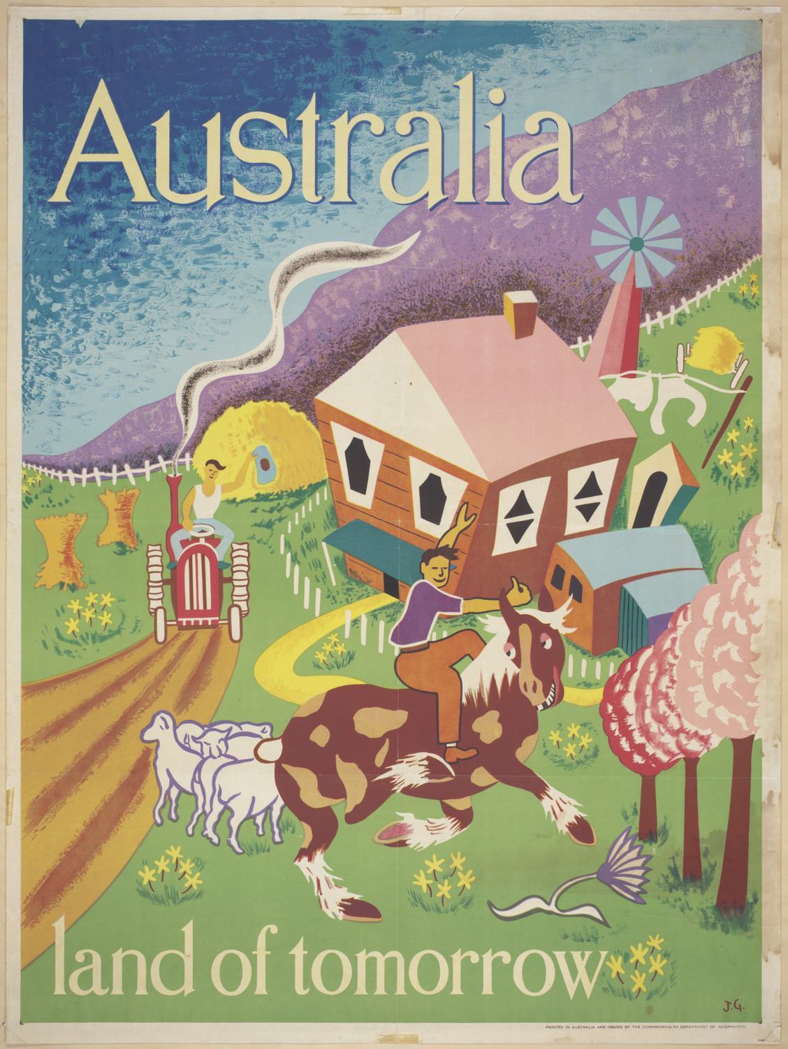
"Poster - Australia Land of Tomorrow, Department of Immigration, circa 1948" is licensed under CC PDM 1.0

Image 2:
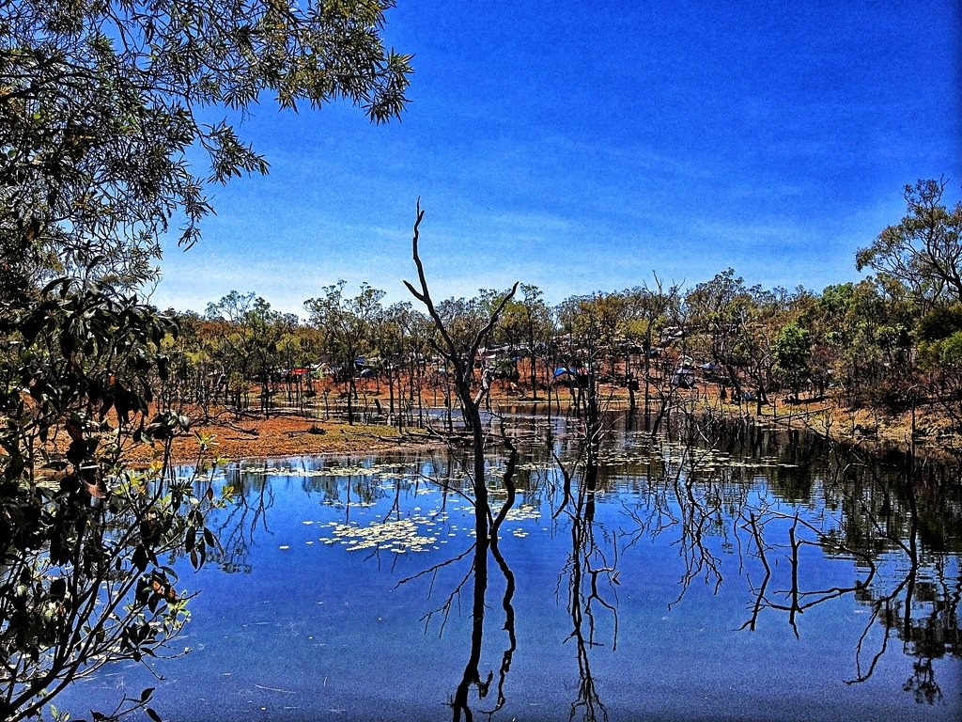
"Eclips festival Cairns Australia" by julia.chapple is licensed under CC BY 2.0

5.2 Soft drink advertisement
Look at the image of a soft drink advertisement from the 1950s.
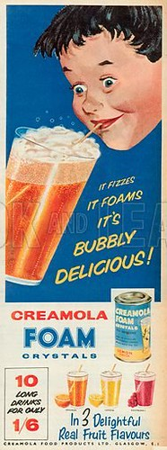
"Creamola Foam Crystals Advertisement, 1958" by Ninian Reid is licensed under CC BY 2.0
Where is your eye drawn? __________________________________________________
How has the creator of the ad focused your attention? ____________________________
________________________________________________________________________
What is the purpose of the ad? ______________________________________________
________________________________________________________________________
Who is the target audience? ________________________________________________
________________________________________________________________________
What do the creators want you to feel? ________________________________________
________________________________________________________________________
How are colours used for impact?____________________________________________
_______________________________________________________________________

5.3 Imagery appeals to the senses
Look at the words ‘delicious’ and ‘delightful’ used in the advertisement and answer the following questions:
How do these words make you feel?
________________________________________________________________________________________________________________________________________________________________________________________________________________________How can an audience connect these words to feelings or experiences?
________________________________________________________________________________________________________________________________________________________________________________________________________________________
Select a food that you like, and an intended audience for your text.
Food: __________________________________________________________________
Audience: _______________________________________________________________
Using the structure from the poster ‘It fizzes, it foams, it’s bubbly delicious’, write a description of the food you selected.
Use no more than 10 words: ________________________________________________________________________________________________________________________________________________
Repeat using a food that you dislike.
5.4 Reflection
How does the intended audience influence the use of language and images in a text?

Lesson 6 - symbol
During this activity you will learn to:
- identify personification within a text
- identify elements of their writing that need improvement and review using feedback from teacher and peers
- use figurative language to describe a noun.

6.1 Speaking and listening
Putting yourself in the ‘shoes’ of another can help you create a great character.
Think of a pet, for example: dog, cat, mouse, fish.
Discuss what the pet:
- feels
- smells
- sees
- hears
- tastes
Refer back to feedback from activity 5.1.

6.2 Retell of Stinky Sid
Listen to or read ‘Stinky Sid’ from The School Magazine.
Discuss the events, the characters and their reactions to Sid’s smell.
Retell your favourite part of the text to another person.
Concentrate on including detail regarding the reactions of characters to Sid’s smell.

6.3 Personification
Watch the video: personification.
Read the descriptions of the actions of the Sid’s stink while he is riding the bus.
‘The stink rolled around the bus.’
‘The stink hit the driver’.
Personification is when you give an animal or object characteristics or abilities that only a human can have.
Why has the author given ‘the stink’ human like characteristics?
________________________________________________________________________________________________________________________________________________
Identify other things the stink could have done. For example: The stink attacked the passengers’ nostrils’
________________________________________________________________________________________________________________________________________________________________________________________________________________________________________________________________________________________________________________________________________________________________________________________________________________________________________________________________________________________________________________________

Innovate on the personified sentences from the text and create another sentence using an object that they personify. For example: ‘The stink rolled around the bus. It was like being in a big hot oven of pong’.
Be sure to include how it moves, what it says, what it thinks and what it feels.
Illustrate your sentence, making your illustration reflect your sentence/s and giving the “stink” personified characteristics.
________________________________________________________________________________________________________________________________________________________________________________________________________________________________________________________________________________________________
6.4 Reflection
How does the use of personification enhance a text?
Can you think of other texts where the literacy device of personification is used?

Lesson 7- onomatopoeia
During this activity you will learn to:
- interpret creative use of language (onomatopoeia)
- recognise the effect of punctuation on meaning
- read texts using appropriate expression, pitch, pause, emphasis.

7.1 Speaking and listening
You will be given an onomatopoeic word and you will describe an event that matches the word.
For example: ‘Bang! The saucepans tumbled out of the cupboard.’
Students are then provided with an event and students provide an onomatopoeic word/s to match the event.

Onomatopoeia words
bang
pow
splash
bark
boo
boom
splash
ribbit
clap
honk
howl

Events
events
storm
bike riding
assembly at school
swimming
kangaroos fighting
birds talking
dogs communicating
someone scaring other people
walking on wet grass
loud music playing
rain and hail

7.2 Oral presentation
You will read a section of ‘Stinky Sid’ aloud to an adult, focussing on using expression, attending to punctuation, such as speech marks, and the onomatopoeias used within the text.

7.3 Onomatopoeia brainstorm
Read or listen to ‘Stinky Sid’ from The School Magazine.
Onomatopoeia is when a word describes a sound and actually mimics the sound of the object or action it refers to when it is spoken.
In the text, the onomatopoeic words of ‘crunch’ and ‘slurp’ are used to create a clear image of the way that Sid is acting while he is on the bus.
Watch the onomatopoeia video and record examples of onomatopoeic words from the video in the space below.
Onomatopoeia

Locate and record the onomatopoeic words in ‘Stinky Sid’ and use the identified words in different sentences.
________________________________________________________________________________________________________________________________________________________________________________________________________________________________________________________________________________________________________________________________________________________________________________________________________________________________________________________________________________________________________________________________________________________________________________________________________________________________________________________________________________________________________________________________________________________________________________________________________________________________________________________________________________________________________________________________________________________________________________________________________________________________________________________________________________________________________________________________________________________________________________________________

7.4 Reflection
How does the use of onomatopoeia enhance a text?
How does punctuation influence the way we read a text?
What elements of oral reading (such as expression, pitch and emphasis) can you focus on to improve reading aloud?

Lesson 8 - alliteration
During this activity you will learn to:
- use current knowledge to build new knowledge
- connect personal experience and cultural background to new knowledge
- identify how authors create a sense of playfulness (alliteration).

8.1 Speaking and listening
Look at the illustrations accompanying the text ‘Will wonders never cease? Doggy Diversity’ in The School Magazine.
Select one dog and verbally describe its appearance and expression to an adult or peer.
You are encouraged to use figurative language including alliteration, similes and onomatopoeia.

8.2 I used to think
Read or listen to ‘Will wonders never cease? Doggy Diversity’.
After reading, complete ‘I used to think’ activity.

I used to think…

Now I think….

Respond to the following questions:

What other dog breeds do you know of? How are they similar and how are they different to each other?
________________________________________________________________________________________________________________________________________________________________________________________________________________________________________________________________________________________________

Reflect on the breed of dog that resonates with you. How is this influenced by your personal experiences and background?
________________________________________________________________________________________________________________________________________________________________________________________________________________________________________________________________________________________________

8.3 Dog alliteration
Watch the video on alliteration.
You will now use alliteration to create sentences or groups of words that describe the chosen dog from item 8.1.
For example:
Corgis are cute, clever and clean who like to cuddle.
________________________________________________________________________________________________________________________________________________________________________________________________________________________________________________________________________________________________________________________________________________________________________________________________________________________________________________________________________________________________________________________________________________________________________________________________________________________________________________________________________8.4 Reflection
Why do authors use alliteration in texts?

Lesson 9 – connotation, imagery and symbol
During this activity you will learn to:
- understand how a range of language features can shape readers’ and viewers’ understanding of subject matter
- plan, compose and review texts
- plan and organise ideas using headings, graphic organisers, questions or mind maps.

9.1 Speaking and listening
Look out your front door, window, room in the house and verbally describe what you see to an adult or peer.
You are encouraged to use figurative language (similes, alliteration, onomatopoeia) to enable the listener to have a clear ‘picture’ of what the space looks like.

9.2 Sentence
Read or listen to ‘Will wonders never cease? Doggy Diversity’ from The School Magazine.
Discuss with a peer the following sentence:
‘If I could choose a breed of dog to symbolise me, I would choose _____ for the following reasons _______.’

9.3 Planning for writing
Topic for writing - If you could be any breed of dog, what breed would you be and why?
Use the following questions and tasks to plan your writing:

The breed of dog you have chosen:
________________________________________________________________________
A simile that describes that dog:
________________________________________________________________________
A sentence with alliteration that describes the dog:
________________________________________________________________________________________________________________________________________________A colour that represents its personality:
________________________________________________________________________
Onomatopoeia that reflects the way it moves or sounds:
________________________________________________________________________________________________________________________________________________The reasons you have selected that breed of dog (size, personality, speed etc).
________________________________________________________________________________________________________________________________________________________________________________________________________________________

You will use your planning template to assist you to write a paragraph on the breed of dog that symbolises you.
________________________________________________________________________________________________________________________________________________________________________________________________________________________________________________________________________________________________________________________________________________________________________________________________________________________________________________________________________________________________________________________________________________________________________________________________________________________________________________________________________________________________________________________________________________________________________________________________________________________________________________________________________________________________9.4 Reflection
How does planning enhance the writing process?
How does personal experience influence writing?

Lesson 10
During this activity you will learn to:
- respond to and appreciate how Dreaming stories form part of an oral tradition for Aboriginal and Torres Strait Islander peoples.

10.1 Speaking and listening
Your teacher will show you images of everyday symbols (including fast food logos, street signs)
Looking at everyday symbols, explain what these everyday symbols mean to you.
What do they mean to other people?
Why are symbols used?
Discuss the colours that have been used in these symbols and the size of the symbols.
What commonalities are noticed?
What impact do these colours have?

10.2 Aboriginal symbols
Look at the Aboriginal symbols.

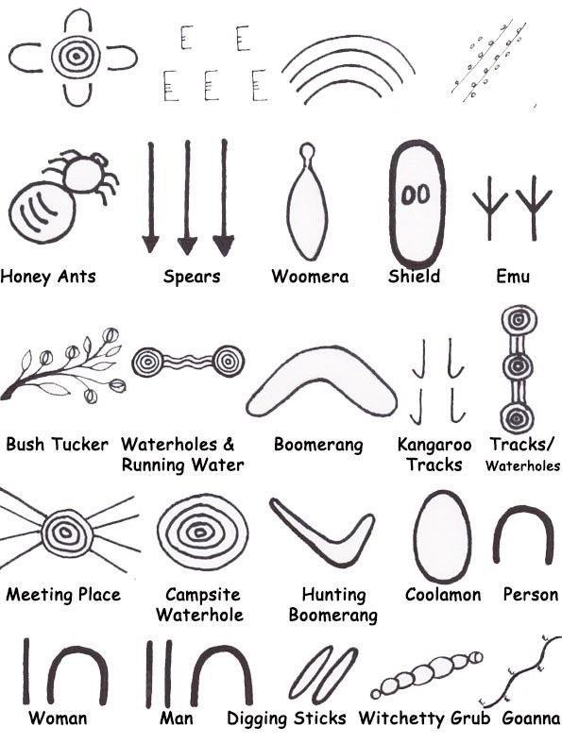
Symbols used in Papunya Central Desert art –
Established on information from “Papunya Tula” by Geoffrey Bardon
Where have you seen these symbols before? ________________________________________________________________________________________________________________________________________________
There is no written language for Australian Aboriginal people. In order to share their important stories through the generations, it is shown by symbols/icons through their artwork.

Watch the ‘Indigenous storytelling’ video.
Why are symbols used in Aboriginal art?
________________________________________________________________________________________________________________________________________________
Why do you think symbols could vary across Aboriginal nations?
________________________________________________________________________________________________________________________________________________
Are the symbols the same in artworks and on rock carvings? Why/Why not? ________________________________________________________________________________________________________________________________________________
What colours do you often see in traditional Aboriginal paintings? Why do you think these colours are used? _______________________________________________________________________________________________________________________________________________
10.3 Personal symbols
Individually or as a class, create symbols for familiar nouns (house, playground, classroom, teacher, friends, letterbox, path, flowers, dog, bike).

Select an event from the previous day and write a recount.
________________________________________________________________________________________________________________________________________________________________________________________________________________________________________________________________________________________________________________________________________________________________________________________________________________________________________________________________________________________________________________________________________________________________________________________________________________________________________________________________________________________________________________________________________________Draw your event, using the symbols you created, don’t use written words.

Recount the above event using the symbols you have developed. Verbally retell your event or journey to a peer
10.4 Reflection
Why are Aboriginal symbols important? Why have they endured for such a long time?
Why are symbols important in our lives? What symbols are universal and can be understood all over the world?

My Record of texts
‘Texts’ includes sound, print, film, digital and multimedia. It’s the way we communicate. So that means it can be a book, text message, podcast, play, website and even a movie. When we talk about text, it could be any of these communications.
Record the title of each text you engage with (or if it is a novel, you might like to record each chapter title).
Record of Texts
Date | Title | Type of text | Independent or shared | Notes
1 April | The Barber Shop Scissor Twister | comic | Shared with dad | I recommend this comic because it is funny. Dad did funny voices.

