English S1 student workbook – Connotation, imagery and symbol
Name:
Class:

Lesson 1
During this activity you will learn to:
- express feelings and opinions about things
- understand how connotation, imagery and symbol are used in writing.

1.1 Speaking and listening
Play ‘What the word makes me feel’. Explain a reaction to each given word.
For example, what do you feel when I say the word ‘sun’? You may respond that you feel happy because when the sun is out, it is warm and you get to play outside.
Possible words to explore include winter, beach, home, rain, park, ice cream, flowers, forest.
Why do some people respond differently?

1.2 What did I learn?
Watch the connotation, imagery and symbol video.
After viewing, write or draw what you have learnt from this video.
You can write in dot points.

1.3 Feelings about image
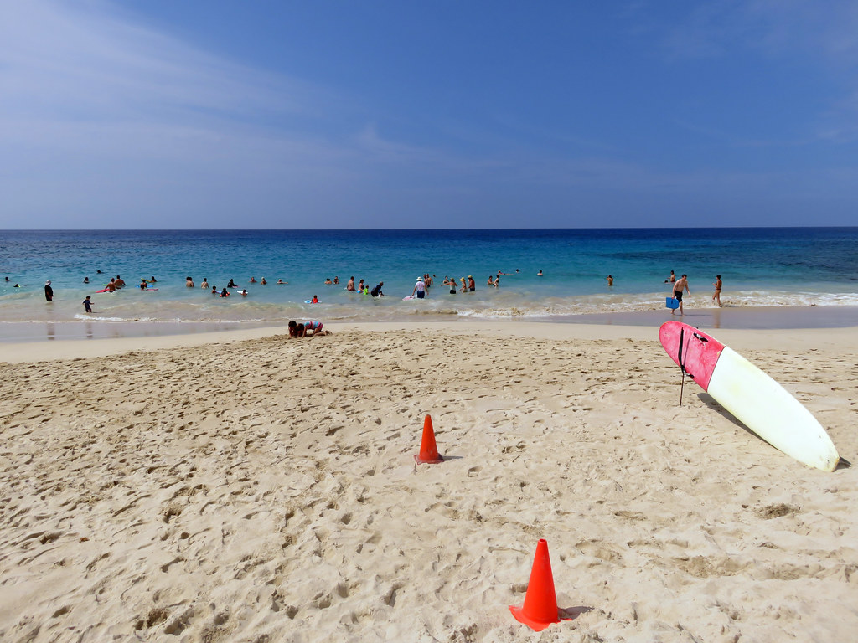
"Magic beach" by pfly is licensed under CC BY-SA 2.0
Write a paragraph about how this image makes you feel (connotations of this image).
The image of a beach is of water, sand and people.
How does the sun, sand and water make you feel? Does it make you feel relaxed and happy or scared and uncertain?
________________________________________________________________________________________________________________________________________________________________________________________________________________________________________________________________________________________________________________________________________________________________________Why do authors sometimes use images in texts? What purpose can they serve?
________________________________________________________________________________________________________________________________________________

1.4 Reflection
How can images and words evoke different feelings for people?

Lesson 2
During this activity you will learn to:
- express feelings and opinions about things
- use antonyms to change the feelings and connotations in a text

2.1 Speaking and listening
Connotations are emotions, feelings, images, or moods that a word brings to mind beyond its literal definition.
Place the listed words into the column of positive, negative or neutral depending on the feelings and moods that are personally evoked.
Explain to an adult why these words were placed in certain columns.
Place these words into a column: relaxed, lazy, bossy, nosy, curious, interested, fit, energetic, healthy, loud, talkative, quiet.

Connotations
Negative | Neutral | Positive

2.2 Colours and title
Look at the image below by illustrator Peter Sheehan from The School Magazine.
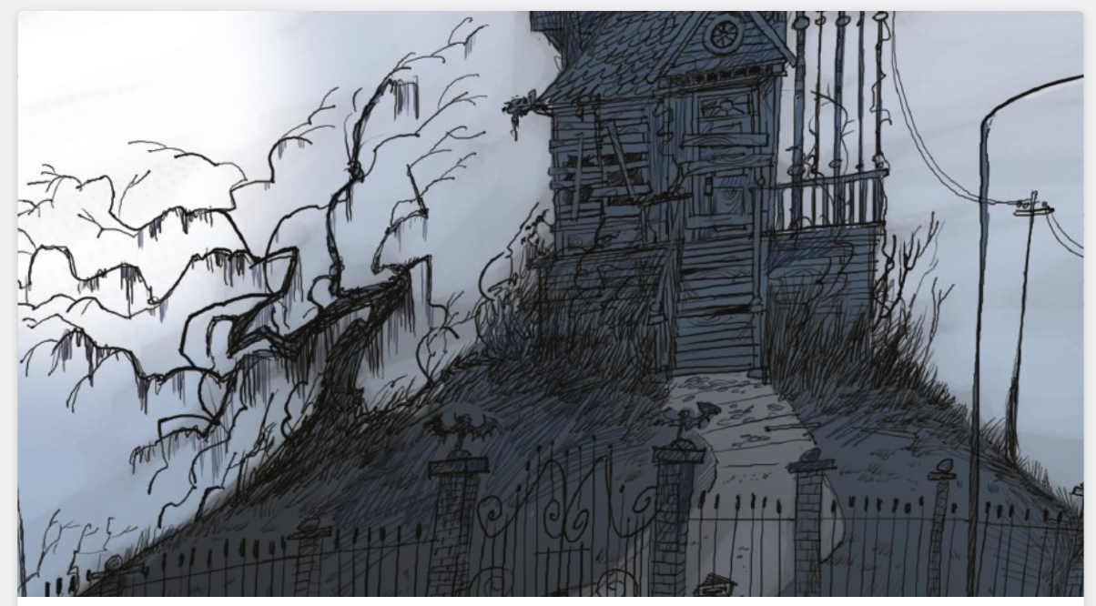
What colours feature in this illustration? _______________________________________
Why do you think the illustrator uses these colours? ______________________________
________________________________________________________________________How do these colours make you feel? _________________________________________
_______________________________________________________________________
Looking at the image, what do you think this poem is going to be about? _______________________________________________________________________
This poem is called Happily Haunted. What do you feel when you hear the word: happily?
_______________________________________________________________________
________________________________________________________________________
What do you feel when you hear the word: haunted? _____________________________
________________________________________________________________________
Read or listen to ‘Happily Haunted’ by Suzy Levison from The School Magazine.

2.3 Substitution of adjectives
Using words from the poem ‘Happily Haunted’, substitute/change selected words with other words that will change the connotation.
For example, here is the original:
I'm dusty, I'm musty
and busting with clutter.
Here is the innovation:
I’m white, I’m bright
and busting with shine.
Your turn. Change the bold words so the reader has a positive feeling when reading the poem. Re-write your poem on the lines provided.
I'm squeaky, I'm creaky
whenever the wind blows.
I'm dreary, I'm eerie
with boards on the windows.
________________________________________________________________________________________________________________________________________________________________________________________________________________________________________________________________________________________________Does the feel of the house change with the new words? What do we feel about the house now?___________________________________________________________________

2.4 Reflection
What impact does colour have on our moods? What do you think of, how do you feel, when you see black and grey? Do pink and yellow stir different connotations for you? What does the colour ‘red’ connote for you? For different cultures and groups, the colour red symbolises very different things.

Lesson 3
During this activity you will learn to:
- use alliteration and onomatopoeia
- identify, reproduce and experiment with rhythmic, sound and word patterns in poems
- recognise and generate one-syllable rhyming words.

3.1 Speaking and listening
Onomatopoeia is when a word describes a sound and actually mimics the sound of the object or action it refers to when it is spoken.

Onomatopoeia words
bang | fizz
oink | sizzle
woof | zoom
ribbit | ring
buzz | snap
Put onomatopoeic words in sentences and share with an adult.
Watch the ‘onomatopoeia’ video by Summer Splash.

3.2 Onomatopoeic words
Read or listen to ‘Happily Haunted’ in The School Magazine.
Record the onomatopoeic words from this poem:

Write a sentence using these words and draw an example of what these words would look like or what objects make these sounds.
Onomatopoeia
Word | Sentence | Drawing

3.3 Onomatopoeia in poetry
Re-watch ‘Onomatopoeia’ video and write all of the onomatopoeia words used in the video. Add other onomatopoeic words you know.

Look at the poem extracts below and underline the onomatopoeic words used.
Water
Water oozes into the puddle
Drizzle-trickle cuts through the dirt
Cackling kookaburras perched up high
Shake drips and drops from their feathery coats.
Nature
The butterflies flutter as they take flight
Bees busily buzz and flit from flower to flower
Snakes slither through the leaves
And birds tweet good morning!

Look at the example provided for a pig. Create your own short poem for a different animal! Example of animals: sheep (baa), horse (neigh), cat (meow) or dog (woof).
Remember poems don’t have to rhyme.
Pig
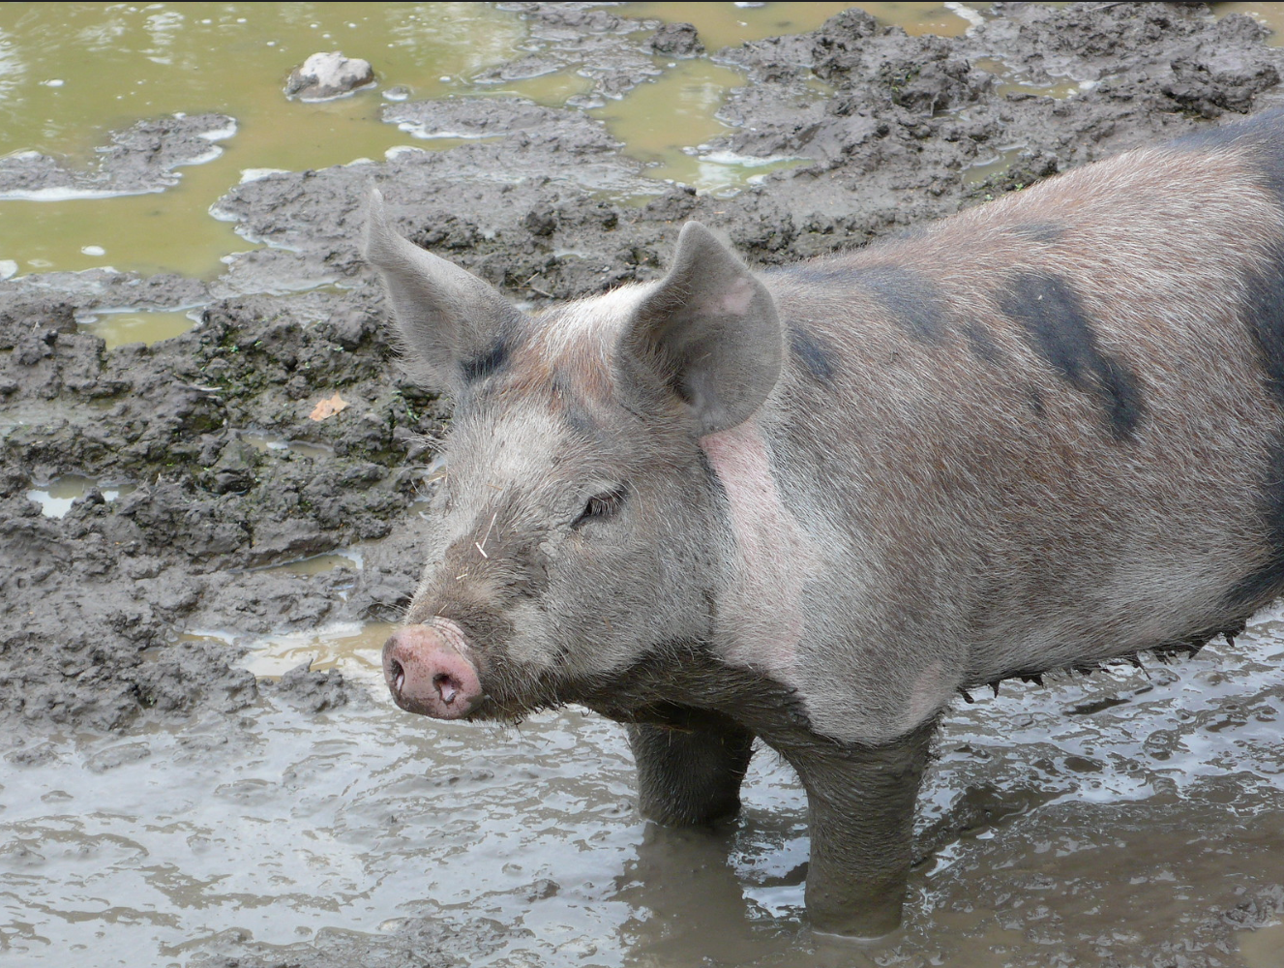
The sow by Peter Lindberg is licensed under CC BY 2.0

The pig likes to roll in the mud
oink, oink, oink, oink
He makes a terrible thud
oink, oink, oink, oink

His curly tail swings and sways
oink, oink, oink oink
he is happiest when he plays
oink, oink, oink oink

Your turn now:
________________________________________________________________________________________________________________________________________________________________________________________________________________________________________________________________________________________________________________________________________________________________________________________________________________________________________________________________________________________________________________________________________________________________________________________________

3.4 Reflection
Why do you think authors use the literary device of onomatopoeia?
What effect does onomatopoeia have on text that is read aloud?

Lesson 4
During this activity you will learn to:
- use similes
- listen to and recite poems, imitating sound patterns including alliteration and rhyme.

4.1 Speaking and listening
Simile – Two unlikely things are compared. The comparison often includes the word ‘like’ or ‘as’
Using the first noun, supply the adjective to compare it to the last noun.
Place the words into a verbal sentence to create a simile. For example: My cheeks are as rosy red as this Red Delicious apple.
Check: does it work? It must make sense.

Similes
noun | You add the adjective/s | noun
cheeks | rosy red | apple
kitten |  | flower
elephant |  | house
clouds |  | fairy-floss
pencil |  | knife
bike |  | bird
car |  | jewel
rug |  | Grandad's hair
tree |  | dancer

4.2 Recite poem
Happily Haunted has a strong beat.
Read ‘Happily Haunted’ aloud to an adult.

4.3 Haunted house simile
Look at the image of the haunted house by illustrator Peter Sheehan. (Activity 2.2)
You may watch ‘Similes’ video for further examples.
Complete the following simile sentences.
The house is as dark as a _____________________________________________.
The house is as dusty as a ______________________________________________.
The stairs are as wobbly as ________________________________________________.
The house creaks like a __________________________________________________.
The house is as empty as ________________________________________________.
Using the simile sentences above as a guide, write a description of the house. Include some similes from above.
________________________________________________________________________________________________________________________________________________________________________________________________________________________________________________________________________________________________________________________________________________________________________________________________________________________________________________

4.4 Reflection
Why do authors use similes?
Do we use similes in our everyday life? Can you think of some examples?

Lesson 5
During this activity you will learn to:
- describe in detail familiar things
- write texts supported by a picture
- reread and edit text for spelling, punctuation and text structure.

5.1 Speaking and listening
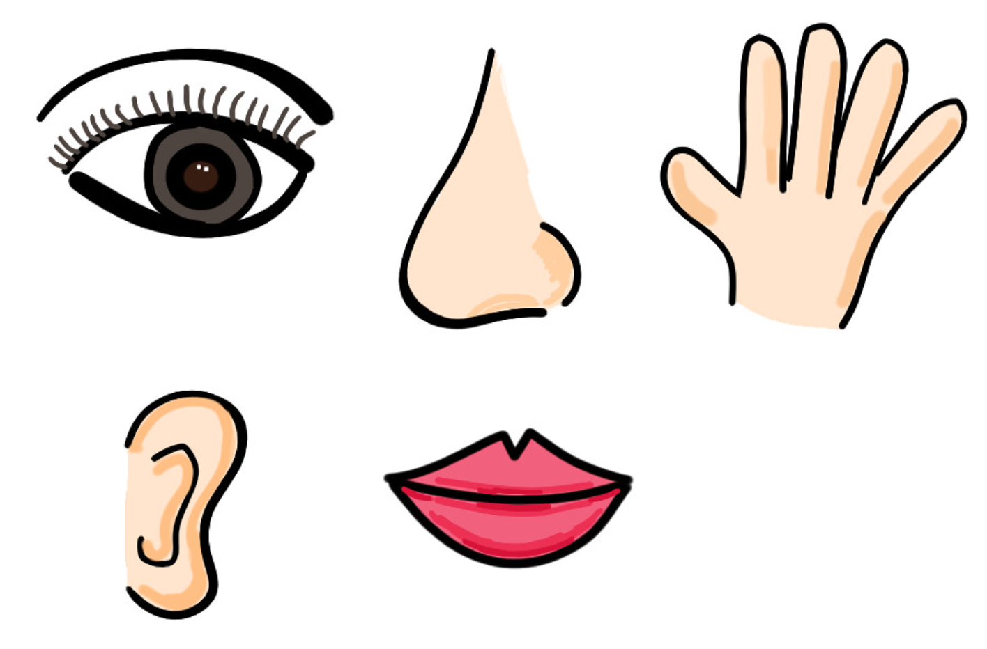
Attribution-ShareAlike 2.0 Generic (CC BY-SA 2.0)
Use your 5 senses and imagination to describe:
- the outback
- a horse
- hairspray
- a roller-coaster
- the circus or a carnival
- a desert
- the main street of a city.

5.2 Senses poem
You will use the five senses to write a poem about the house in ‘Happily Haunted’.
You will write about what the house would smell, look, feel, sound and taste like.
Use alliteration, onomatopoeia and similes in your own poem.

An example of a ‘Senses poem’:
The Beach
I hear waves, smashing into the sand – crash! (onomatopoeia)
I smell salt, sweat and sunscreen (alliteration)
I see sand-castles as beautiful as a painting (simile)
I feel as happy as a clown on stage (simile)
I taste hot chips sprinkled with chicken salt.
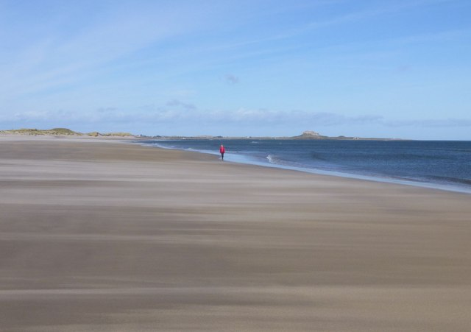
"Ross Back Sands" by Russel Wills is licensed under CC BY-SA 2.0
Your turn to write a senses poem about the house in ‘Happily Haunted’:
I hear __________________________________________________________________
I smell _________________________________________________________________
I see __________________________________________________________________
I feel __________________________________________________________________
I taste _________________________________________________________________
Draw an image of the house:

5.3 Reflection
How does using the five senses when writing, engage the reader?
How does it allow the reader to imagine what the writer is describing? How will this change the way you approach writing now?

Lesson 6
During this activity you will learn to:
- identify and discuss symbols of Aboriginal and Torres Strait Islander culture
- identify and consider the purpose of common symbols in the environment.

6.1 Speaking and listening
Symbols are used throughout our world. Your teacher may provide additional symbols (e.g. from a commercial company)
Look at the symbols here:
- Where have you seen them?
- To whom are they aimed?
- What is the purpose of the symbol?
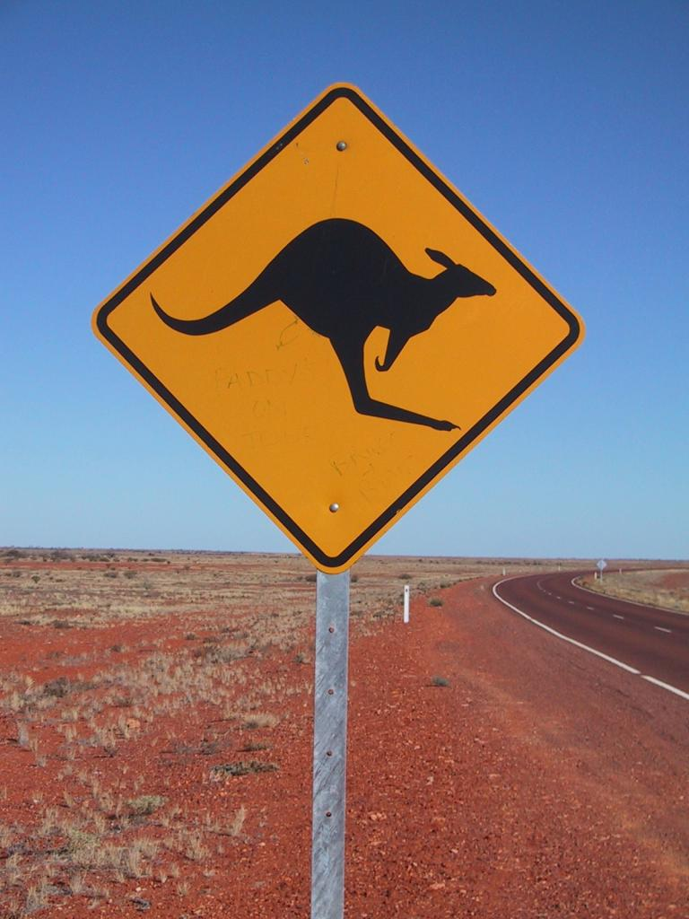
Attribution: Kangaroo sign on the highway jpp Creative Commons Attribution-Share Alike 3.0 Unported
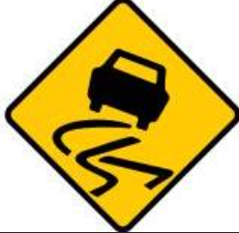
Attribution: Transport for NSW Roads and Maritime Services
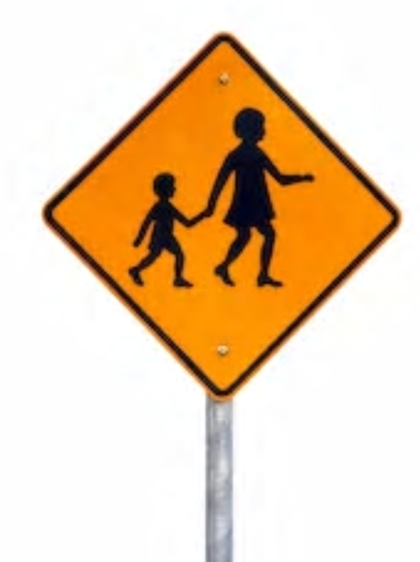
Attribution: Transport for NSW Roads and Maritime Services

Attribution: © State of New South Wales NSW Ministry of Health. For current information go to www.health.nsw.gov.au.

6.2 Traditional Aboriginal symbols
Have a look at the Aboriginal symbols.
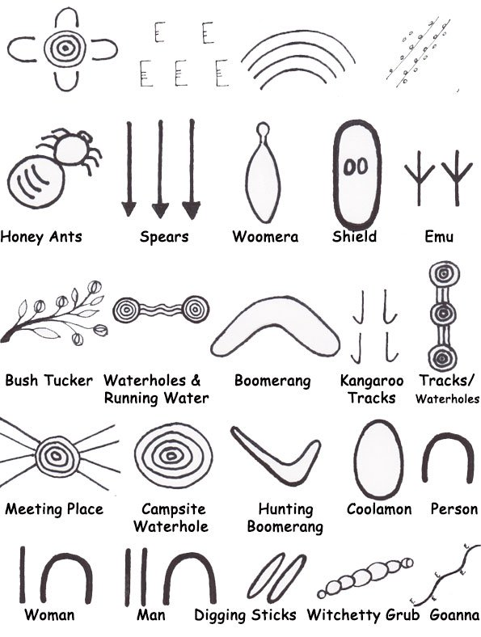
Symbols used in Papunya Central Desert art –
Established on information from “Papunya Tula” by Geoffrey Bardon

Where have you seen these symbols before? ________________________________________________________________________________________________________________________________________________
There is no written language for Australian Aboriginal people. In order to share their important stories through the generations, it is shown by symbols/icons through their artwork.
Watch the ‘Indigenous storytelling’ video.

Why are symbols often used in Aboriginal art?
________________________________________________________________________________________________________________________________________________

Why do you think symbols could vary across Aboriginal nations?
________________________________________________________________________________________________________________________________________________

Are the symbols the same in artworks and on rock carvings? Why/Why not?
________________________________________________________________________________________________________________________________________________

What colours do you see in traditional Aboriginal paintings? Why do you think these colours are used?

6.3 My symbols
You will (individually or as a class) create symbols for familiar nouns (house, playground, classroom, teacher, friends, letterbox, path, toilet block, bubblers, flowers, dog).

Read the following two recounts.
- Yesterday at school I walked from the classroom to the toilets to have a drink from the bubblers. I then went to the oval with my friends to play football. When we finished playing football, we had a play on the playground.
- Yesterday at home I walked out the front door to collect the mail from the letterbox. I walked down the path, passed all the lovely red flowers until I reached the letterbox. The dog from next door ran over to me, so I gave him a pat. There was no mail in the letterbox, so I went back inside my home.
Use the space below to draw a recount of one of the above events using the symbols you have developed. Explain your recount to a peer.

6.4 Reflection
Why are Aboriginal symbols important? Why have they endured for such a long time?
Why are symbols important in our lives?
What symbols are universal and can be understood all over the world?

Lesson 7
During this activity you will learn to:
- use a range of opinion adjectives
- Listen to texts to engage with content
- use imagery and figurative devices appropriately to enhance composition..

7.1 Speaking and listening
Play ‘Silly name game’ with an adult or peers.
Using adjectives and alliteration, name your family members.
Examples could include Neat Natasha, Smart Sam, Clever Catherine. Remember to be kind.

7.2 Class reading and code
Read or listen to Storm by Janeen Brian from The School Magazine.
Imagery refers to how the language used in texts appeals to our senses. Your teacher will create a code that can be signed for each of our senses (e.g. pointing to your nose to show the sense of smell, your eyes for sight, your ears for sound, your mouth for taste and your hands for touch).
As you listen or read each line, point to the part of your body to demonstrate the sense evoked by the language (for “the grey slid and spread,” point to your eyes to demonstrate sight, for “hammered the rain, drove each thick drop” point to your hands to show the sense of touch and for “thunder boomed,” and, “branches screamed,” point to your ears to indicate hearing).

7.3 Visual of a storm
Read or listen to ‘Storm’ from The School Magazine, identifying the alliteration used in the text (slid – spread, wind-whipped).
Draw an image of the storm based on the language used in the poem.
What colours would be used in the visual? What objects would we see?
Label your picture, identifying the objects using alliteration and similes.
For example:
Bridge that is as broken as a Humpty Dumpty (simile)
River as full as Dad on Christmas day (simile)
Broken branches (alliteration)

7.4 Reflection
Why do authors use alliteration and adjectives? How can I incorporate this into my own work?
Where else do we see alliteration and similes used? (songs, both print audio and visual advertisements)

Lesson 8
During this activity you will learn to:
- identify and discuss symbols of Aboriginal and Torres Strait Islander culture and recognise recurring characters, settings and themes in Dreaming stories
- identify, reproduce and experiment with rhythmic, sound and word patterns in poems

8.1 Speaking and listening – Aboriginal art
Discuss with an adult:
- Have you seen traditional Aboriginal art before?
- Why do Aboriginal people often use art to tell their stories? What symbols are used? What story did it tell?
You will look at the artwork ‘Reflections’ by Margaret Adams, or your teacher will provide you with a copy of this artwork.
After looking at the artwork:
- Discuss the symbols that are used and the story that is being told based on these symbols. (Refer to activity 6.2 for Aboriginal symbol information).
- Why do you think particular colours have been used?
‘Reflection’
The artwork referred to is with thanks to the Art Gallery of NSW. Please note that this artwork will need to be prepared for students in a non-digital environment for their student workbook.

8.2 Emotions in poems
You will listen to other poems from The School Magazine, ‘Dragon in the Sky’, ‘The Sweeper’ and ‘Waiting’.
Complete the table below identifying how the reader in each poem communicates the emotion, using pace and tone of their voice. Some example are given.

Emotions in poems
Poem | How emotion is shown
Dragon in the Sky | speaking quickly and trembling on words such as ‘fear’
The Sweeper | sounding like the reader is smiling
Waiting | slowing down on the word ‘waiting’

8.3 Narrative about a storm
Using the poem ‘Storm’ as a stimulus, write the opening paragraph to a narrative.
Introduce additional characters if you need to, however use the imagery created in the poem to grab the audience’s attention in your own narrative.
Set the scene. You will need to describe the location and what the storm looks and sounds like.
You are encouraged to use the five senses and devices of: onomatopoeia, alliteration, adjectives and similes.
Some example starters:
- It was a cold, dark and windy night when…
- Bang! Crash! What was that noise?
- I could hear the rain hitting the roof. It was as loud as my neighbour's dog barking when I am trying to sleep.
- Wet, windy and wild!
________________________________________________________________________________________________________________________________________________________________________________________________________________________________________________________________________________________________________________________________________________________________________________________________________________________________________________________________________________________________________________________________________________________________________________________________________________________________________________________________________________________________________________________________________________

8.4 Reflection
What did you do well when reading your poem today? How did you engage an audience?
What could you work on for next time?

Lesson 9
During this activity you will learn to:
- recognise, discuss and use alliteration and onomatopoeia
- identify key words and their meaning
- use adjectives to add meaning

9.1 Speaking and listening
Take the theme and say as many onomatopoeic words as you can!
Themes:
- animal sounds (baa, woof)
- fire (snap, crackle)
- wind (woosh, swirl)
wrestling or fighting (bam, pow)

9.2 Vocabulary four square
Read ‘The girl from Barellan’ by Neridah McMullin from The School Magazine.
Use the word and definition provided to put the word in a sentence, list synonyms (words similar in meaning) and draw the definition.

Word: Tournament
Definition:  A contest between a number of competitors, competing for a prize. | Sentence:
Synonyms: | Drawing:

Word: Dozes
Definition:  A short, light sleep. | Sentence:
Synonyms: | Drawing:

9.3 Creative word play
Onomatopoeia encourages readers to create a visual in their minds, enhancing a sense of what is happening.
Onomatopoeic examples from ‘The girl from Barellan’:
________________________________________________________________________
What is the impact?
________________________________________________________________________________________________________________________________________________
An adjective is a word that describes an animal, person, thing or thought. Adjectives include words that describe what something looks like and what it feels like to touch, taste, or smell.
List some of the adjectives used in the text ‘The girl from Barellan’ and other adjectives that could be used to describe that noun.
Adjectives
Noun in the story | Adjective used in the story | Other adjectives that could describe that noun
roof | iron | tile, green, smooth
ball | rubber | fluffy, red, round
bat
feet
dust
grass
man
chair
Write your own sentences using these adjectives:
purple
________________________________________________________________________________________________________________________________________________
rough
________________________________________________________________________________________________________________________________________________
spikey
________________________________________________________________________________________________________________________________________________
spotted
________________________________________________________________________________________________________________________________________________
fluffy
________________________________________________________________________________________________________________________________________________
Watch the adjectives video.

9.4 Reflection
Describe what onomatopoeia is and its impact.
Why is being creative with words and language an important skill?

Lesson 10
During this activity you will learn to:
- use alliteration and onomatopoeia
- use adjectives.

10.1 Speaking and listening
Your teacher will provide you with some tongue twisters.
Read some tongue twisters (alliteration).
Challenge yourself to write your own tongue twisters.
For example: The slithering snake slid sideways silently.

10.2 Describing activity
Read ‘The girl from Barellan’.
To help readers connect with the main character, the author describes what Evonne feels and uses imagery to help the reader visualise parts of the story.
Draw the image that is evoked (what you see and feel) from these descriptive sentences:
‘Her bare feet dance and skip in the red dust, swift and quick, reaching and lunging’.
‘Her burning feet interrupt the game and she sprints off, leaping over white spear grass to get across to the tap at the lawn tennis club to cool them down’.

10.3 Describe the setting
Write what the Barellan tennis courts might have sounded like, looked like, felt like and smelt like. You can use dot point to record.
Looked like:
Felt like:
Sounded like:
Smelt like:

Using your brainstormed notes, write a descriptive paragraph about the Barellan tennis courts, creating an image for the reader. Remember to include alliteration, adjectives and onomatopoeia to help the reader visualise the courts.
________________________________________________________________________________________________________________________________________________________________________________________________________________________________________________________________________________________________________________________________________________________________________________________________________________________________________________________________________________________________________________________________________________________________________________________________________________________________________________________________________________________________________________________________________________
Draw an image of the courts:

10.4 Reflection
What is connotation, imagery and symbol?
How does knowing about these devices help you as a reader?
Why will you use these in your own writing?
My Record of Texts
‘Texts’ includes sound, print, film, digital and multimedia. It’s the way we communicate. So that means it can be a book, text message, podcast, play, website and even a movie. When we talk about text, it could be any of these communications.
Record the title of each text you engage with (or if it is a novel, you might like to record each chapter title).
Record of Texts
Date | Title | Type of text | Independent or shared | Notes
1 April | The Barber Shop Scissor Twister | comic | Shared with dad | I recommend this comic because it is funny. Dad did funny voices.

Happily Haunted
poem by Suzy Levinson
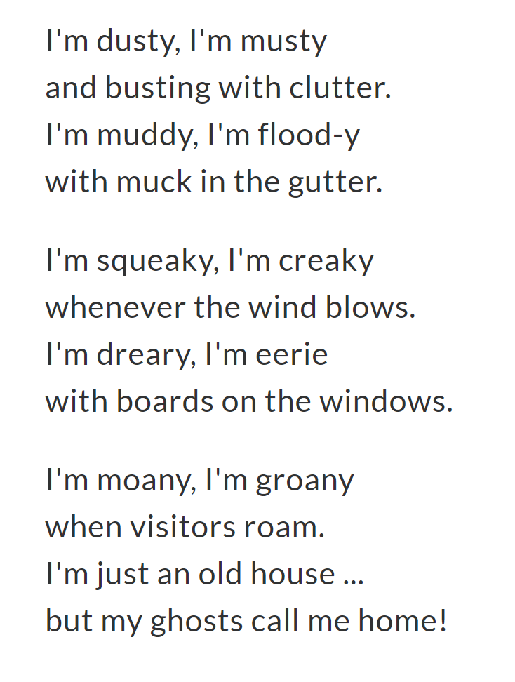

Storm
poem by Janeen Brian
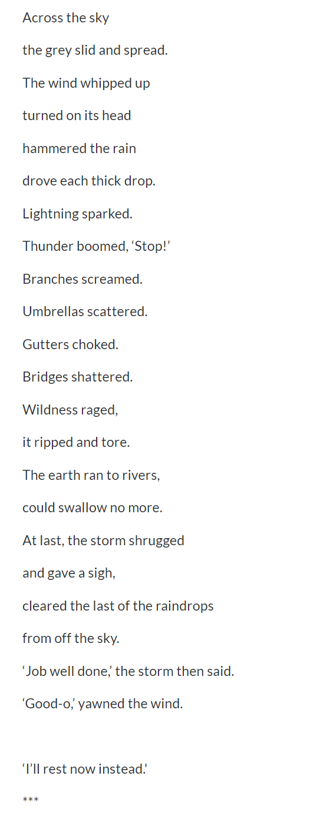

The Girl from Barellan
story by Neridah McMullin
THE OLD MAN leans back in his garden chair. The heat of the day makes the iron roof of the house tick and creak, and the peppercorn trees are alive with the steady buzz of a thousand bees. He half-dozes as he listens.
A little voice travels over the fence to where he’s sitting. ‘One hundred and eight, one hundred and nine, one hundred and ten.’
Evonne comes here every day to hit a rubber ball with a homemade bat against an old chimney wall. She’s six years old and she’s an obsessive ball hitter.
Thwack. Thwack. Thwack.
‘One hundred and eleven, one hundred and twelve, one hundred and thirteen …’
Thwack. Thwack. Thwack.
Evonne plays her own little tournament, in her own little world. Her bare feet dance and skip in the red dust, swift and quick, reaching and lunging. She meets every ball.
She uses a stick to write in the dirt how many times she’s hit the ball on the first bounce. Then she comes back again the next day to better it.
Forehand. Backhand. Volley.
Thwack. Thwack. Thwack.
Skimming backhand; crisp volley—Evonne loves to play.
Her burning feet interrupt the game and she sprints off, leaping over white spear grass to get across to the tap at the lawn tennis club to cool them down.
Flocks of pink–breasted galahs screech and swoop, and then Evonne’s back at the wall again.
Forehand. Backhand. Volley.
Thwack. Thwack. Thwack.
‘She’s got it.’ The old man chuckles. He prides himself as a good judge of the game of tennis.
A woman can be heard asking her older children, Barbara and Larry, to take Evonne with them to tennis.
‘Oh, Mum. She’s too little.’
‘Take her anyway; let her have a go.’
‘She’s too little; they won’t let her play.’
‘I reckon they might,’ she smiles.
* * *
Soon the children are at tennis, doing ‘The drill’. The voice of their coach rings out across the court …
‘Get ready! Back swing! Impact! Spin! Follow-through! Again!’
And they do it again. And again. And again. … so many times that it’s etched like poetry into their memories.
‘Ready! Back swing! Impact! Spin! Follow-through! Again!’
Thirty children move in perfect rhythm and time to the chant of the coach. And among them is a young girl, much smaller than the others …
* * *
The old man leans back in his lounge chair. In the cool of the night, he can hear the buzz of television sets. Lights shine in every window in the town of Barellan. He half dozes as he listens and waits. The town listens and waits for the Wimbledon Women’s Final to begin.
The centre court crowd cheers.
The commentators chatter …
‘And here she is, ladies and gentlemen, she’s a young slip of a girl, an Australian Aboriginal, Miss Evonne Goolagong. Only nineteen years of age … destined to be a champion.’
Evonne’s feet dance and skip on the manicured lawn, swift and quick, reaching and lunging. She hits the ball sweet and hard.
A skimming backhand, a crisp volley. Evonne smiles as she plays.
A sharply angled forehand volley.
She chases down every ball, laughing if she muffs a shot and sorry if she belts an unreturnable ball to her opponent. She covers the court with sublime ease and instinctive movement.
A delicate drop shot.
‘Deuce,’ calls the umpire.
Evonne’s serve is deep and deceptive.
‘Advantage, Miss Goolagong,’ calls the umpire.
Halfway around the world, an old man and a town draw breath and wait and hope with fingers crossed.
A sweepingly beautiful one-handed stroke with top spin deceives her opponent.
‘Game, set and match to Miss Goolagong, from Australia.’
Those who saw her play that day were never the same again. They were captivated by her grace and poise; her serenity lifted their spirits. They felt privileged to witness a young girl play for the love of the game instead of personal gain.
The old man smiles and wipes a tear from his eye, and as he dozes off he is sure he can hear counting …
‘One hundred and fourteen, one hundred and fifteen, one hundred and sixteen …’

