Assessment task 1: Creative writing
Assessment type | Marking Rubric | Stage
Writing (Weighting: 30%) | 25 | 6

Outcomes
EE11-1A, EE11-3C

Values and attitudes
Students will value and appreciate:
- the importance of independent thinking, investigation and experimentation as a key to learning
- the personal enrichment to be gained from a love of English and an appreciation of the diversity and aesthetics of literature
- the power of language to explore and express views of themselves as well as the social, cultural, ethical, moral, spiritual and aesthetic dimensions of human experiences
- the power of effective communication using the language modes of speaking, listening, reading, writing, viewing and representing.

Knowledge and understanding
Through responding to and composing a wide range of complex texts and through the critical study of texts, students will develop knowledge, understanding and skills in order to:
- articulate understanding through speaking, listening, reading, writing, viewing and representing
- craft language to shape meaning and express imaginative, creative, interpretive and critical responses to a range of texts
- express imaginative, creative, interpretive and critical ideas based on sophisticated analysis and theorising about complex texts and values
- express understanding of how cultural, historical and social contexts are represented in critical and creative texts
- reflect on and evaluate their own processes of learning and creativity.

General capabilities
Literacy

Task Description
This task is designed to help students plan, draft, edit and publish a high quality piece of creative writing. Alongside the creative piece, students are also required to submit:
- detailed plans for their creative piece
- at least one earlier draft of their work
- the ‘Feedback Sheet’ (see page 5-6), completed by someone other than a teacher
Use one of the images provided as the basis for the setting of an original narrative that explores the nature of power and morality. Your final piece must be no more than 1500 words.
- Image 1
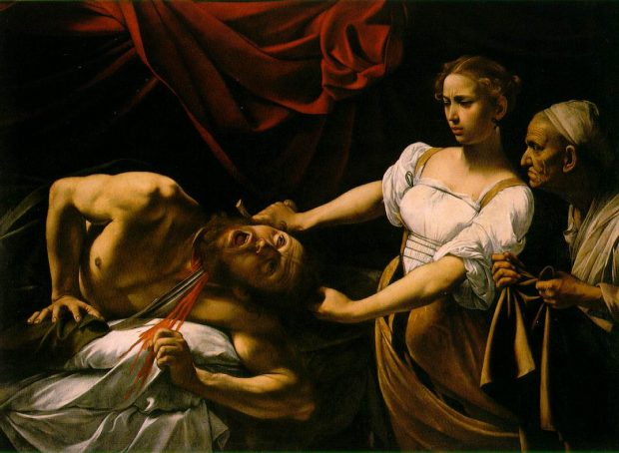
Source: https://athanasiuscm.org/2014/08/05/caravaggios-beheading-of-st-john-the-baptist/
- Image 2
Source: https://www.flickr.com/

- Image 3
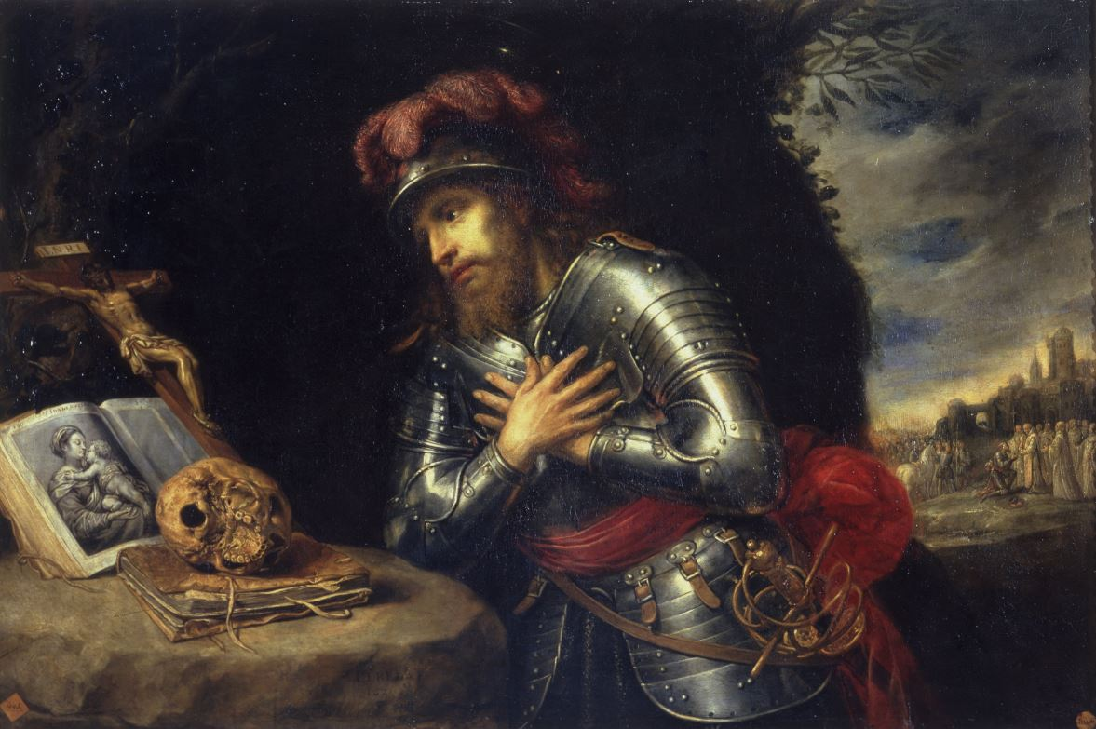
Source: http://www.gettyimages.co.uk/detail/news-photo/saint-william-of-gellone-found-in-the-collection-of-real-news-photo/520723455#saint-william-of-gellone-found-in-the-collection-of-real-academia-de-picture-id520723455

Creative Writing
Marking criteria | Marks
- Demonstrates sophisticated ability to craft a creative piece of writing that insightfully explores the nature of power and morality  - Skilfully integrates the chosen image into the construction of setting  - Demonstrates sophisticated control of language, including skilful use of a wide range of language forms and features | 21-25
- Demonstrates well-developed ability to craft a creative piece of writing that effectively explores the nature of power and morality  - Effectively uses the chosen image in the construction of setting  - Demonstrates well-developed control of language, including effective use of a range of language forms and features | 16-20
- Demonstrates sound ability to craft a creative piece of writing that explores the nature of power and morality  - References the chosen image in the construction of setting  - Demonstrates sound control of language, including some use of language forms and features | 11-15
- Demonstrates developing ability to craft a creative piece of writing that relates to the nature of power and morality  - Attempts to reference the chosen image, possibly not evident in the construction of setting  - Demonstrates developing control of language, possibly including limited use of language forms and features | 6-10
- Demonstrates limited ability to craft a creative piece of writing, possibly without reference to the nature of power and morality  - Little to no attempt to reference the chosen image  - Demonstrates limited control of language, possibly relying on simplistic language forms and features | 1-5
- Presents nothing of relevance to the task | 0

Feedback Sheet
When students receive regular feedback, it gives them the opportunity to develop and refine their written responses. As such, students are asked to nominate a person that they trust to read and edit their writing. This ‘editor’ doesn’t have to be someone who is perfect in the subject of English. Instead it should be someone who cares about the student and is willing to give them a helping hand.
The editor is encouraged to do two things. Firstly, it would be helpful if they could make corrections directly on the piece of writing with a red pen. The following code may help with this process:
- Spelling: Circle and correct misspelled words
- Punctuation: Add punctuation marks or circle punctuation that has been used incorrectly
- Grammar and expression: Use a ‘wriggly’ line to underline sentences that are repetitive, contain incorrect grammar or sound awkward.
- New paragraph: Use a square bracket to indicate where a new paragraph should start
- Additional details: Use an arrow to add additional words or details
Secondly, the editor is encouraged to fill in the following table

Feedback | Needs attention | Good Work | Very Strong | Comments or suggestions
The story is interesting and engaging
The reader follows along with without getting 'lost' or confused
The story is believable and authentic; not clichéd
The key character(s) are believable and show complexity and/or personal growth
The narrative clearly deals with the nature of power and morality & clearly relates to one of the stimuli
Descriptive language is used to make the reader to imagine the characters, settings and events
The sentences flow, moving well from one to the next. There are a variety of sentence types
The paragraphs are well structured and vary in length
There are few errors in grammar, punctuation and spelling

What do you think the student has done well?

What can they do to improve and develop their response?

Editors, please fill in the details below:
Student’s name:
Editor's name:
Relationship to Student:
Date Edited:
Signature of Editor:

