Resource 1 - Head Over Heels – Short film by Timothy Reckart
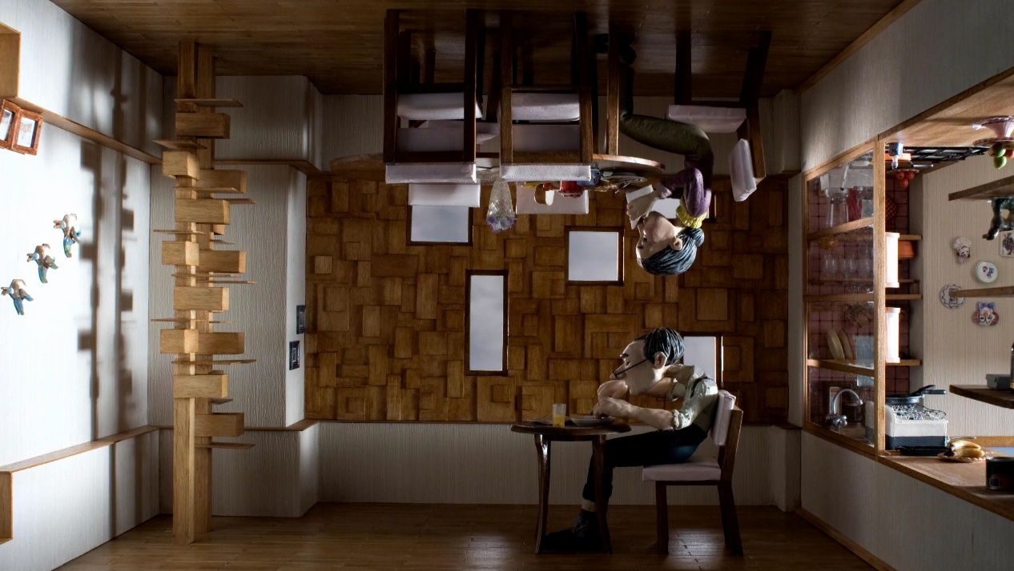
Figure 1 Image accessed from Animation World Network

View
“Head Over Heels”

Read
Timothy Reckart Talks “Head Over Heels” Article

Tim Reckart Talks 'Head Over Heels'
The director, fresh from his Annie Award win for Best Student Film, discusses his Oscar-nominated stop-motion gem.
By Dan Sarto | Friday, February 8, 2013 at 5:29pm
Spend enough time at film festival screenings and you soon realize that some of the best, most innovative and interesting animated shorts made today are student films. You still have to wade through the usual amount of dreck to find the truly outstanding pieces. But by and large, the work being produced by student animators is certainly on par with the work of the vast majority of independent animators you’ll find lurking about today’s animation community, hiding in the shadows as they wait for their renders to finish or their disability checks to arrive.

One of the best animated shorts you’ll find from last year’s crop is one such student piece, Timothy Reckart’s graduate film, Head Over Heels. The only student film among this year’s Oscar nominees, Head Over Heels takes a poignant, funny and remarkably mature look at the inherent struggles that both define and plague relationships. The film’s unique frame of reference – a husband and wife living upside down from each other, separated by gravity – forms the central visual metaphor that has meaning and context within any conflict between two people.
Following in the footsteps of his idol, Nick Park, Timothy did his work at the UK’s National Film and Television School. In fact, his stop-motion graduate film comes exactly 30 years after Mr. Park’s introduction of Wallace and Gromit in his 1982 graduate film. After meeting Timothy and his film’s producer, Fodhla Cronin O’Reilly (pronounced “Fola”) at this year’s Annie Awards, where Head Over Heels took home the Best Student Film award, we had a chance to talk about his film, his first time directing a real crew and the challenges of telling such a compelling story without the benefit of any dialogue.
Dan Sarto: So tell me about the genesis of your film? How did you first come up with the idea?
Timothy Reckart: So, it started with the idea of a husband and wife who are separated by gravity. That encapsulated a lot of ideas that I had been thinking about, things that I thought would be great to address with the film. One of those was the kind of hostile tone that political disagreement has taken on in the US over the past few years. So it appealed to me, because it’s a story about two people who see the world differently, but they still have to find a way to live together. This is an idea that could apply to political, religious, really any sort of ideological disagreement. It was a great metaphor for that. Of course, it’s also directly about marriage. It highlights what I’ve seen with marriages. Personally, I’m not married but the married people in my life have provided great examples of the fact that marriage doesn’t just “happen.” You have to work at it, to “try.” This film is an opportunity to talk about the sacrifice that fuels marriage. The other thing was at the time, I was studying in England and my girlfriend was in New York. So during the animation process, that divide also provided a lot of emotional fuel for all the acting and performances of the puppets.
Once I had settled on this idea, we decided to go with stop-motion because it’s the sort of idea that could just be a metaphor and could work just at the conceptual level. Just having a world of ideas. I wanted it to have realism. I wanted the world to be tangible, for people to feel this upward gravity, that they weren’t watching the film at arm’s length. I wanted people to always be aware of the metaphor but actually remain fully immersed in the here and now of the characters. Ultimately that was why stop-motion was the right medium. It’s got that intense focus on miniatures which exaggerates the textures that all the objects have naturally, that makes everything so immediate and tactile. Also, it’s wonderful because you can do some fun things in-depth. We didn’t have to do everything like a doll house. We could do some high angles, low angles, do some interesting over the shoulder shots, which were actually sort of below the shoulders in a way. Stop-motion was going to be the only way to do it. It was a weird choice though. When we started doing development meetings with the school faculty there was some concern about how the hell we were going to build a set where you can hang the puppets from the ceiling. Are we going to need to flip the set? That kind of thing. Because it’s just not something that people usually do with stop-motion.

DS: No they don’t.
TR: Yeah. It was funny because the one reference I used to show them it could be done was the bit in The Wrong Trousers where Wallace is walking on the ceiling of the art museum. It was great being in England because we had the context of Aardman. I asked a couple contacts there how that was done. [They said] they literally just put it upside down, it was that simple. So we knew we could do it. We needed to find a way to build the set so that we could flip it. The way we ended up doing is was the whole thing was built so it could be taken apart and reassembled without destroying it. That was the set build.
We crew up at the film school with one student from each discipline. We had a production design student, one [handling] editing, composing, sound design and cinematography. The production design student headed up the set build. Over the course of around five months, we built all the props, the sets and the puppets. Then it was time to start animating.

DS: Did you write a script? Did you storyboard? What did you have to work from when you began animating?
TR: Well, I started with an outline. The [story’s] beginning was obvious. I knew the premise that led to the obvious ending. But, there needed to be some way for them [the couple] to come together. So the big push for the story process was how do you get them there? We hashed that out mostly through storyboarding and the animatic, which was a very long process. I think four months. That’s not that long but, you know, it’s only a ten minute film. We went through several drafts, just continually honing the story, trying to get it as short as we could. The other difficult thing was trying to tell the story without using any dialogue. A lot of what we spent time doing was finding visual ways to express various story points. That’s why we did writing and storyboarding rather than a script.

DS: You spent five months building sets and props. How long did it take to animate the film?
TR: Six months of animation. We overlapped with the end of the set build, because once they were finished with the main room we took it into the shooting studio and started animating. We animated for six months, from July to December that year.

DS: Did you do all the animation yourself?
TR: Well, for the most part, I animated. I took two weeks off at one point. We brought in a friend of a friend who has been doing work up in Manchester on various stop-frame TV series. He came in and I had a short vacation.

DS: Looking back on the production, what would you say were the main challenges you faced?
TR: The main challenge was getting the story told precisely, without using words. We came up with one solution in the film that I’m really happy with how it worked…the wedding photo that you see does a lot of work for us…that was a great solution we came up with. It showed that the couple used to be together, but they aren’t now. It also assists the plot by showing that they can argue without having to use words. When they rotate the photo so that it faces their away, it tells us that they disagree about which way is up.
Other challenges were the continual stop-motion production issues. Having a puppet fall apart in the middle of a shot or bumping your elbow on something in the middle of a shot and having to start all over. That always happens.
One thing that I definitely wanted to get right and in the end I was very pleased that we did, was trying to strike the right tone with the film. It starts out as a film about conflict. It begins as a film about a marriage that is really not working. But, you don’t want to say, “Hey, welcome to the film, we are going to be talking about dysfunctional marriage!” So trying to find a way to show these two characters had fallen into a rut with their relationship but still have the tone be fun, that the whole visual metaphor should be fun, that was a difficult balancing act. I think it really came through with the performance of the puppets. The characters are a little bit older, where they have this ornery attitude. It isn’t that they dislike each other but that they know how to push each other’s buttons. Ultimately we toed the line there and managed to make it work. But that was a real challenge.
DS: Had you done any significant stop-motion work prior to making this film? What is your background?
TR: Well, I had done other exercises leading up to this graduation film at the NFTS [National Film and Television School in England] and I did a few solo projects while I was at Harvard. But this was the first film where I directed a crew. This is definitely the first real production that got a full year of my time. But I have been lucky to have some industry experience which was really helpful. I’ve done a couple work placements at Aardman. It was interesting because when you’re just there for a couple of weeks, they aren’t going to give you a shot at animating. They’ve got their crew of animators. But I learned so much having lunch with those guys. I remember having lunch once when one of them explained to me how they animate “snap.” I always struggled with getting it [stop-motion animation] quite as snappy as I wanted. Ian Whitlock, who animated on The Curse of the Were-Rabbit and was animating on The Pirates! at the time, he walked me through it. He was talking about the moment when Wallace opens up the piggy bank in The Wrong Trousers, how that was the moment when Nick Park taught him how to animate “snap.” I used that lesson throughout the animation process.

DS: You say you were at Harvard before you went to the UK. What did you study at Harvard?
TR: I studied history and literature. I knew I wanted to do film when I was getting out of high school. During the college application process, I knew that as a career goal I wanted to do film but I also thought it was worthwhile getting some kind of liberal arts degree. To study content before I studied form…before learning how to tell a story, first I wanted to know about some of the stories already out there. That’s why I studied history and literature at Harvard. But I still kept wanting to make films. I actually got into animation because all of my friends were too busy to act in my video projects. That was how I did it in high school. So I went into animation as a way to make films by myself.

DS: A “DIY” guy.
TR: Yeah. So I was holed up in a closet for the first few projects I did at Harvard. Of course, this NFTS film was hardly a solo project. One of the really great things about directing animation is the opportunity to collaborate with people. I love working with people. I’ve fallen in love with the medium since that marriage of convenience at the beginning.

DS: Right. So with your first real film, you get an Oscar nomination. What was your reaction when you heard the news?
TR: I spent so much energy preparing to be disappointed, preparing to let myself down easy that when we heard the good news, I didn’t really know how to react. I kind of just sat there. I think I was checking to see if they had spelled my name right. Meanwhile, in the background, my brother and my girlfriend were jumping up in the air, whooping and hollering. I looked back and thought, “Oh, that’s what I’m supposed to be doing.” Then I caught on and joined in. But it was such a surprise that it took me a few seconds.

DS: I’m sure it was quite the shock.
TR: Yeah.

DS: Last question. Coming off of this experience, what would you say is the most important thing you learned making this film?
TR: Head Over Heels was a new direction for me. I always wanted to follow in the footsteps of Quentin Tarantino and Tim Burton, to do something that was a little bit more intellectual eye candy. This was the first time that I really buckled down to try and do something that had a genuine emotional payoff for the audience. I guess I saw one too many Pixar films that made me cry and thought, “Good grief, I have to see if I can do that.” Ultimately I think it’s more challenging and it’s really a bigger feat to try to tackle, to attempt to make that connection with the audience. So I think the big lesson from here on in for me is to always try and find that emotional truth in a story and really make sure that’s coming across. That’s what people will come away with. You want to hit them on a gut level. People will forget about a clever movie but I think they really remember how a film made them “feel.” That’s a lot more rewarding to do because it’s much harder to do. I’m going to try and continue in that direction.

Dan Sarto is editor-in-chief and publisher of Animation World Network.

