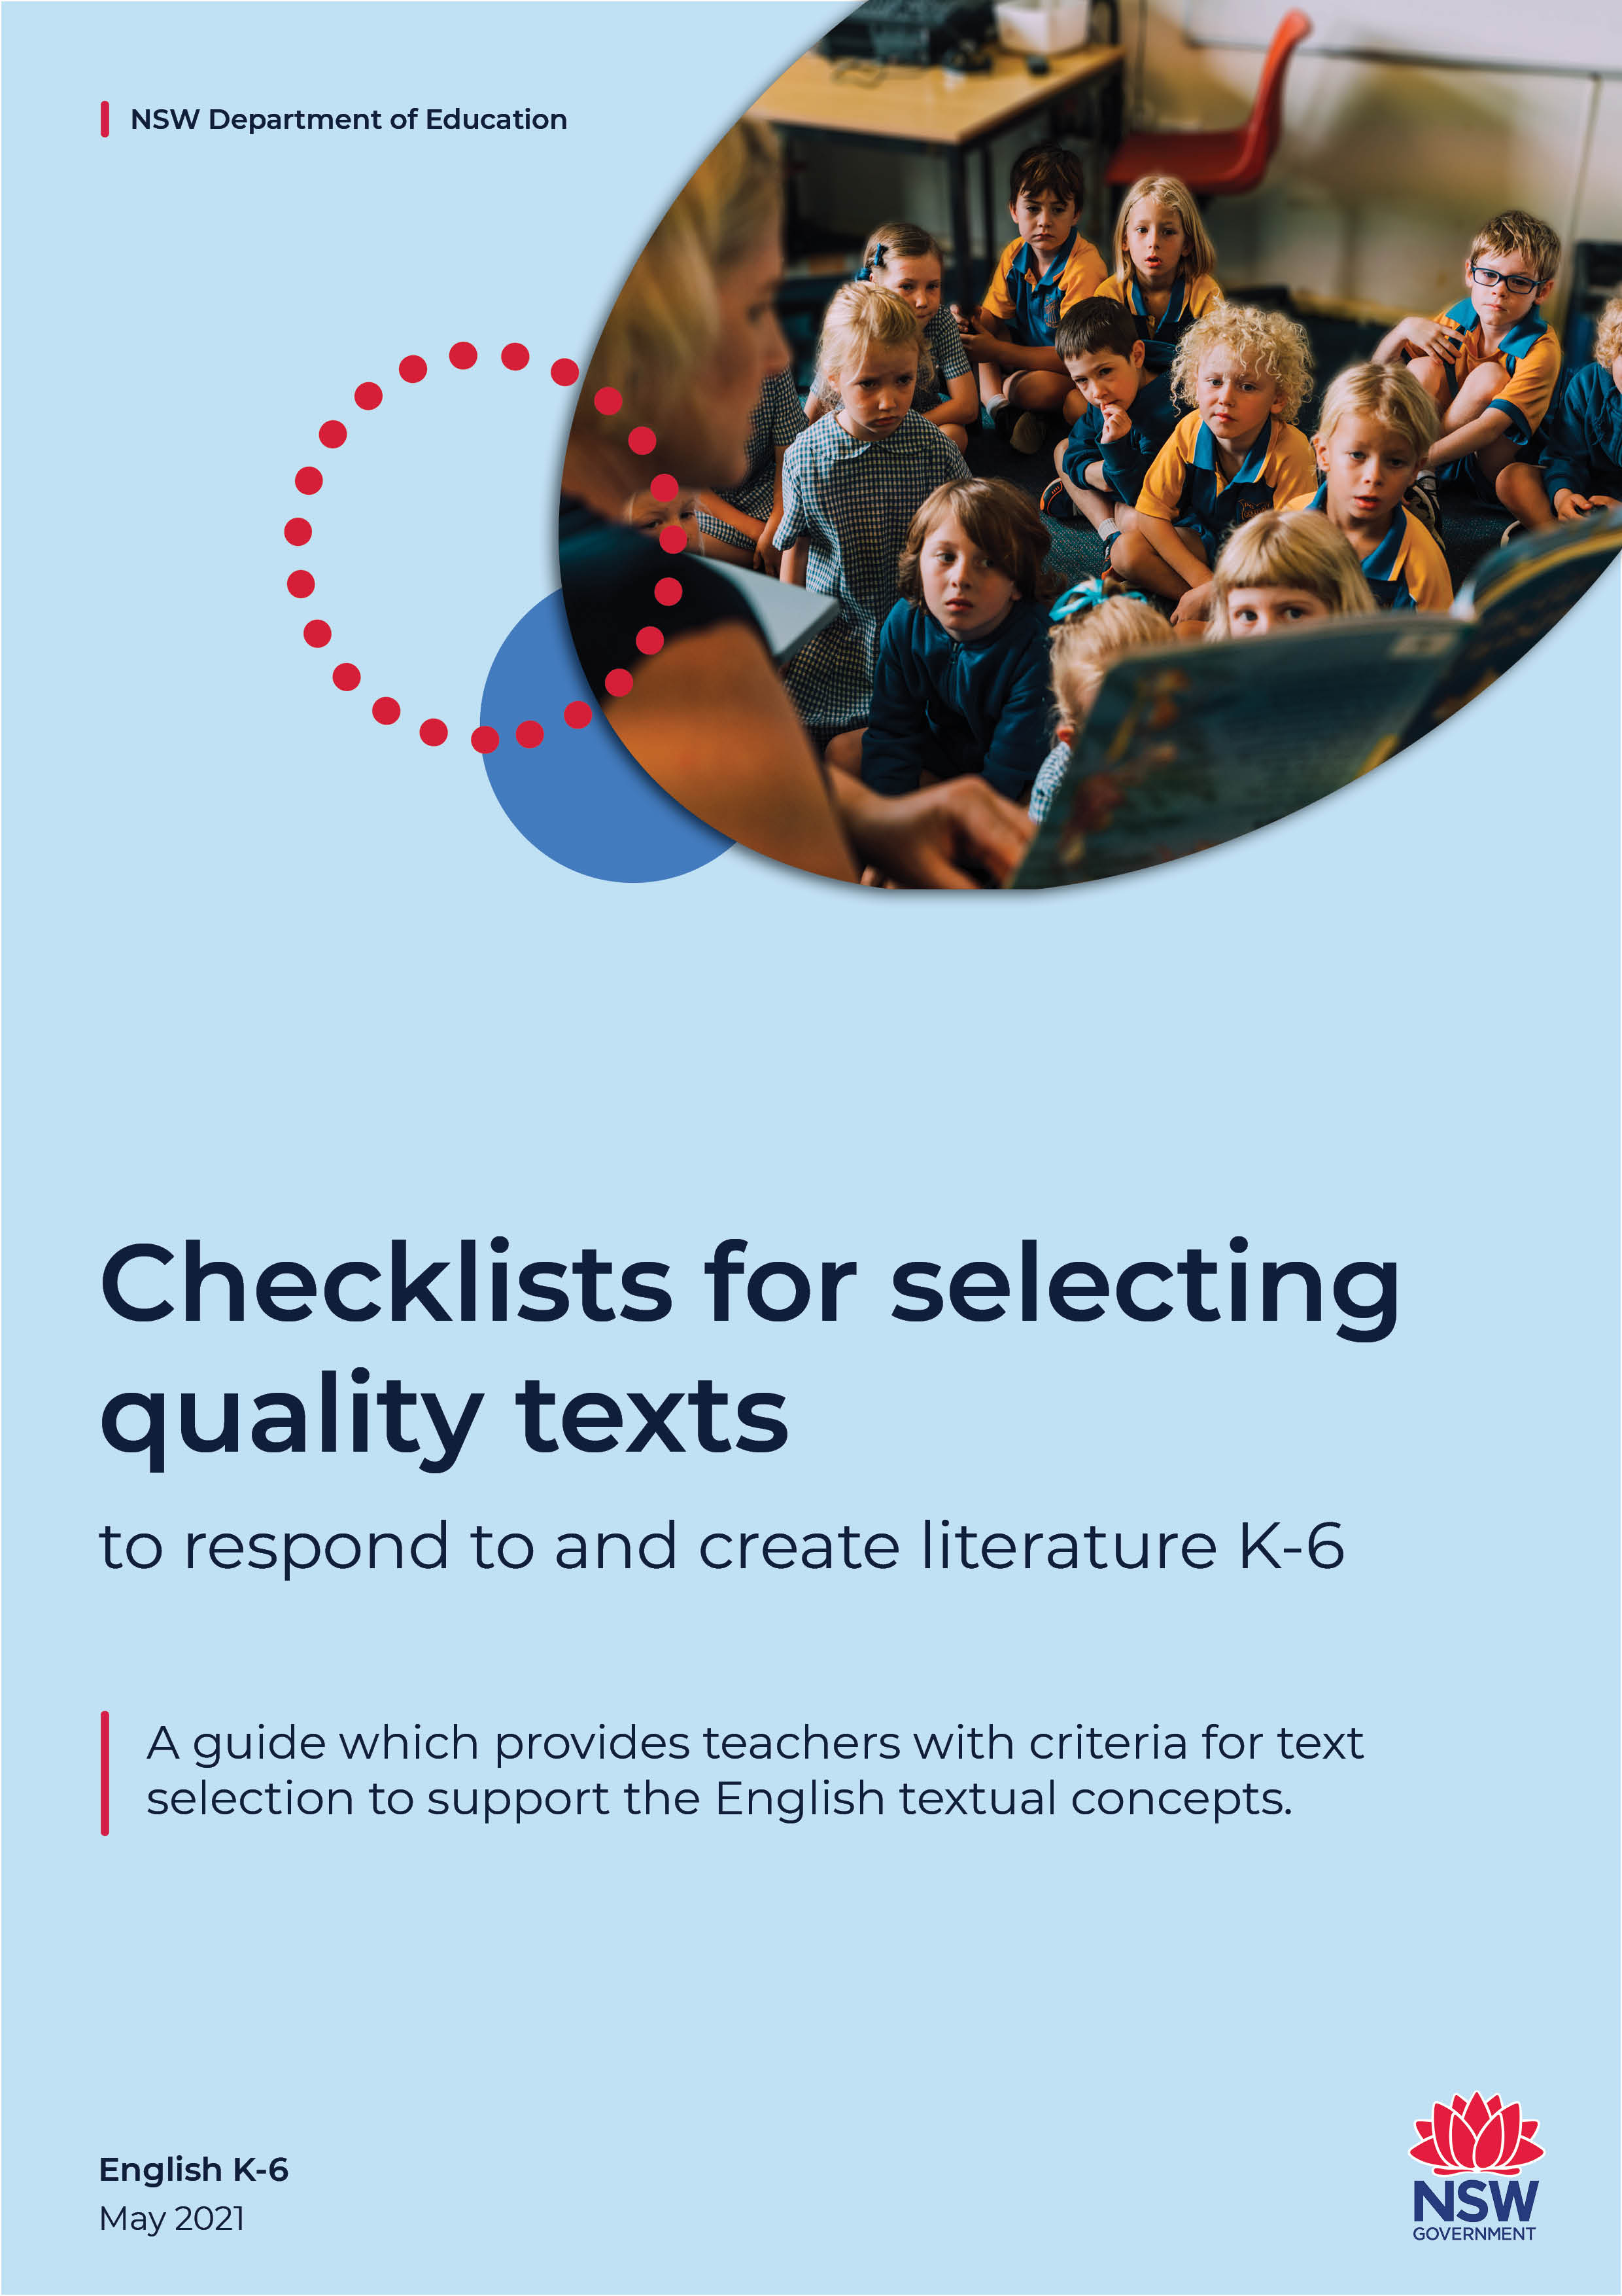

Checklists for selecting quality texts to respond to and create literature K-6
Contents
Checklists for selecting quality texts to respond to and create literature K-6 1
Using quality texts to respond to and create literature 2
What defines quality literature? 3
What are the English textual concepts? 4
Considerations 5
The relationship between the quality text, the teacher and the student 6
English textual concepts checklists to select quality texts 7
Argument 8
Authority 9
Character 10
Code and convention 11
Context 12
Imagery, symbol and connotation 15
Intertextuality 16
Narrative 18
Perspective 20
Point of view 21
Representation 22
Style 23
Theme 24
References and research 25

Using quality texts to respond to and create literature
Central to the study of English in the NSW English syllabus is the study of a wide range of texts. The NESA text requirements for the syllabus are as follows:
In each year students must study examples of:
- spoken texts
- print texts
- visual texts
- media, multimedia and digital texts.
Across a stage of learning, text selection must give students experience of:
- texts which are widely regarded as quality literature
- widely defined Australian literature, including texts that give insights into Aboriginal experiences in Australia
- a wide range of literary texts from other countries and times, including poetry, drama scripts, prose fiction and picture books
- texts written about intercultural experiences
- texts that provide insights about the peoples and cultures of Asia
- everyday and community texts
- a wide range of factual texts that present information, issues and ideas
- texts that include aspects of environmental and social sustainability
- an appropriate range of digital texts, including film, media and multimedia.
From Kindergarten, we select texts for the purpose of learning to read (for example decodable texts) to facilitate literacy skills. We also need, from Kindergarten, to select texts for the purpose of reading to learn in order to gain knowledge about audience, purpose, structures and language features. Quality literature is the best example for this learning to occur. In the writing process, examples of quality literature are exemplars for students to create their own texts.

What defines quality literature?
Reading, viewing, responding to and composing quality literature should be an appealing and pleasing process which provides students with an opportunity to develop an appreciation of the language, linguistics and artistic expression in the text. Responding to and creating quality literature should be enjoyable, challenging and allow students to develop a love of literature.
Quality literature:
- is widely regarded (for example, award winning or classics)
- contains rich language
- has powerful images
- has characters and plot which are engaging and interesting for the students
- will enrich discussion
- is complex with meanings on multiple levels
- can be read and enjoyed more than once, exposing layers each time
- allows the exploration of the literary devices which composers use to communicate, inform, persuade or entertain
- can be examined for their conceptual textuality to develop deep, critical and new ways of thinking
Quality literature allows students to respond to and explore the concepts that are at the core of the subject English and create their own quality texts.

What are the English textual concepts?
Embedded into the content and outcomes of the NSW syllabus, and integral to the study of the subject English, are English textual concepts. They are:
- Argument
- Authority
- Character
- Code and convention
- Context
- Genre
- Imagery, symbol and connotation
- Intertextuality
- Literary value
- Narrative
- Perspective
- Point of view
- Representation
- Style
- Theme
The definition of what each concept is and why it is important is explained in teacher and student user-friendly short videos on our Core concepts webpage. Further information can be found on the English Textual Concepts website.
To design learning for deep understanding of the textual concepts, teachers need to select quality texts which support the study of these concepts. With some quality texts, there may be standout textual elements which are identifiable with a specific concept. However, many quality texts lend themselves to a range of conceptual understanding.

Considerations
Using the Australian Professional Standards for Teachers as a framework, consider:

Know your students and how they learn
- What is the context (students’ backgrounds and needs)?
- What do the students already know about the textual concept/s?
- What do they need to learn next?
- What are their needs when responding to quality literature? When composing?

Know the content and how to teach it
- Is your understanding of the English textual concepts sufficient to enhance the learning outcomes of students? Find information and resources on the Primary Hub and the English Textual Concepts website.
- Will the text enhance the students’ abilities to achieve desired outcomes?

Plan for and implement effective teaching practice
Starting – Begin with knowing which English textual concept/s you are exploring then select specific text/s which align with the concept/s.
Teacher delivery options:
- Could the text be used as a mentor text for student writing?
- Will the entire text be used or a chapter/page/paragraph/sentence/scene?
- Will the text be read by the teacher/students/both?
Teaching strategies:
- Are you modelling reading (aloud) widely and often?
- Are the students reading/viewing/listening widely and often?
The selling point – if you read, discuss and explore quality texts you are passionate about, your passion will come through in your delivery. This will transfer to the students which will deepen their engagement.

The relationship between the quality text, the teacher and the student
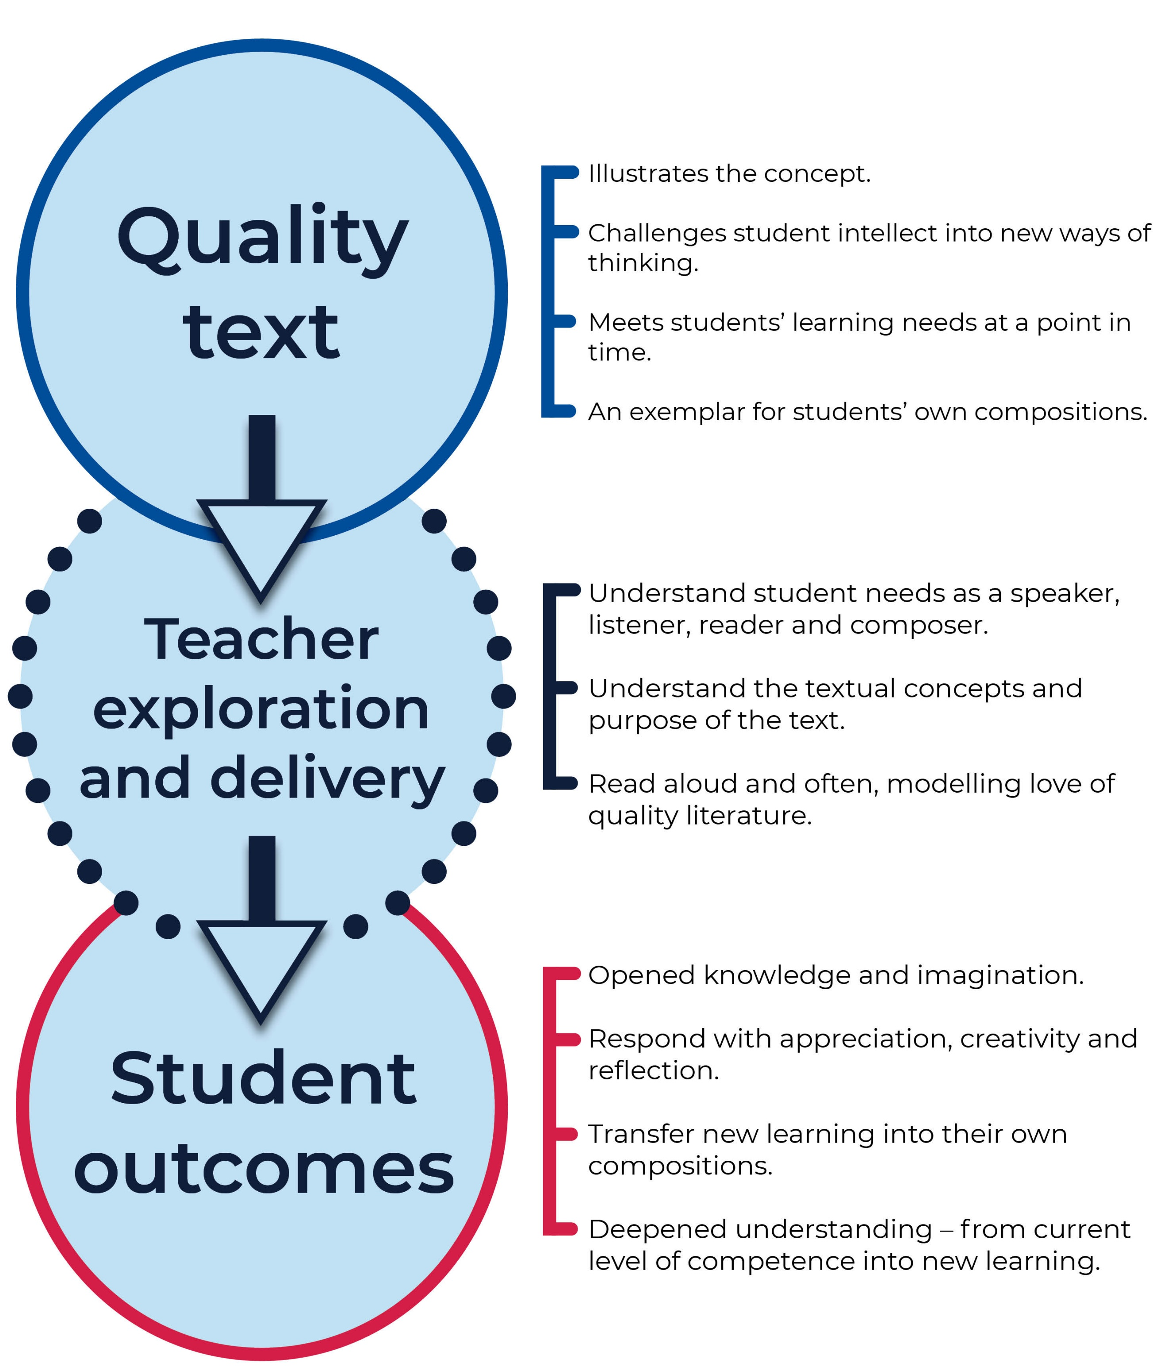
‘The relationship between the quality text, the teacher and the student’ by English K-6 – Curriculum is licensed under CC BY 4.0.

English textual concepts checklists to select quality texts
The following checklists can be used by teachers when selecting quality texts. They indicate the elements at each stage (dependent on timeline of explicit introduction) to support conceptual understanding.

Argument
This concept is explicitly taught from Stage 1. Prior to introducing this concept students should be able to express opinions about texts and issues.

Stage 1
- ideas, information and images are expressed in a clear and logical way
- contain phrases (for example, I think that… We know that…) which project opinion
- reinforce ideas through images
- a sample of different types of texts, modes and media

Stage 2
- opinions are supported by information and ideas which are presented in a structured way
- contain paragraphs which express a single idea
- contain paragraphs which are made up of topic sentences and evidence
- carry a persuasive force through certain language (eg description, modality, aspects of images)

Stage 3
- the argument is guided by the audience, form and purpose
- the argument is presented objectively
- the argument is presented subjectively
- contain language choices (visual, spoken and written) which strengthen the argument
- provide an informed assessment of a range of opinions

Authority
This concept is explicitly taught from Stage 2. Prior to introducing this concept, students understand:
- texts have authors who compose the contents
- authority operates within frameworks
  - expressed differently according to context
  - authors may approach subjects and compositions in different ways
  - responders have a role in making meaning in and through texts.

Stage 2
- clearly demonstrates authority and authorship as different aspects of the text
- allows for varied responses and interpretations and may have more or less validity
- author/s have shaped the interpretation (but may not be able to control it)

Stage 3
- presented in different ways in different contexts
- use of appropriate language, spelling and punctuation strengthens the authority
- clearly expressed and substantiated argument and acknowledgement of accepted authorities
- popularity, as demonstrated through the text, becomes the form of authority
- authority of the text itself is valued and questioned

Character

Early Stage 1
- imaginative text in which characters are visual, verbal and/or aural representations of people in the story

Stage 1
- depict characters with imagined thoughts, words and actions
- multiple texts depicting characters through different modes and media
- reflect lived experiences
- invite positive or negative responses

Stage 2
- represent characters in such a way as to have motives for actions
- characters can be judged by the reader
- characters are judged by the other characters in the text
- characters are judged by the narrator or the composer/author invite an emotional reaction such as identification, empathy or sympathy

Stage 3
- trigger an imaginative response through identification
- complex characters with either a range of characteristics or simple with one salient feature
- characters who change as a result of events or remain unchanged
- depict individual characteristics or be based on stereotype

Code and convention
This concept is explicitly taught from Stage 2. Prior to introducing this concept students understand:
- communication works through agreed code and conventions
- codes and conventions provide structures for making meaning

Stage 2
- language choices have been used to express information and ideas
- structural choices have been used to express information and ideas
- multiple texts whereby codes and conventions vary according to mode, medium and type of text

Stage 3
- multiple texts whereby codes and conventions vary for different audiences and purposes
- choices of language have subtle differences and effects
- choices of design have subtle differences and effects
- multiple texts from each mode which provide a foundation for innovation at all levels (word, sentence, paragraph and whole text levels)

Context

Early Stage 1
- explore social situations with language and actions appropriate to that situation
- depict situations which require specific language and behaviour
- reflect aspects of students’ world
- composed for specific audiences and purposes

Stage 1
- multiple texts with varied purpose and audience to compare the text forms and features to show how the communication of information and ideas varies
- multiple texts with varied modes and medium to compare the text forms and features to show how the communication of information and ideas varies
- different groups and cultures are represented

Stage 2
- enable students to consider the personal, social and/or cultural context of the composer
- enable students to consider their own personal, social and/or cultural contexts as a responder
- more than one example to explore how compositions differ due to audience or purpose
- more than one example to explore how compositions differ due to their mode or medium
- can elicit different responses from students based on their differing immediate contexts

Stage 3
- contain particular forms and language due to their context
- enable students to understand how their own context affects the way they are responding or composing
- can clearly identify: the purpose of the text; the intended audience; the medium; and cultural influences
- reflect culture as a way of living (beliefs, customs, language and values)
- reflect the culture / way of living of the composer
- elicit responses based on the culture / way of living of the students

Genre
This concept is explicitly taught from Stage 2. Prior to introducing this concept students recognise:
- imaginative and informative texts have different features
- particular types of texts can be identified through features and structures

Stage 2
- multiple texts of a particular type which have arisen from similarity of purpose
- multiple texts which are varied in their type according to the mode of their delivery
- multiple texts which are varied in their type according to the medium of their delivery

Stage 3
- multiple texts in the same genre whereby similar functions and ideas give rise to particular expectations
- multiple texts in the same genre whereby similar forms and conventions give rise to particular expectations
- demonstrations of genres not being fixed categories but are adapted for interesting effects

Imagery, symbol and connotation

Early Stage 1
- contain word choices which represent more than the literal
- contain signs and symbols which represent or suggest things
- enjoyable due to imaginative use of language

Stage 1
- contain simple figurative language
- contain word play that appeals to the senses
- contain cultural symbols

Stage 2
- uses imagery to connect with an audience
- use of figurative language effects meaning
- imagery which is expressed through comparisons
- different types of texts and media demonstrating different types of figurative language for different audiences and purposes

Stage 3
- recognisable imagery so engagement produces richer meanings
- imagery prompts evocative comparisons which may add new meanings
- figurative language which extends the meanings of words or compresses ideas through the connections it makes
- multiple examples, in different modes and media, of figurative language which persuades, informs and emotionally engages audiences

Intertextuality
This concept is explicitly taught from Stage 2. Prior to introducing this concept students:
- recognise that stories may be told in different ways
- understand that some texts are connected with, or draw on, other texts

Stage 2
- known stories which have been changed for different situations
- stories with aspects of other stories inserted into them
- stories which allow students to see their own story within it

Stage 3
- appropriation of whole texts for different audiences and purposes
- appropriation of whole texts for different modes and media

Literary value
This concept is explicitly taught from Stage 2. Prior to introducing this concept students understand:
- engagement with texts may be a source of pleasure
- there are specific aspects of texts that enhance enjoyment

Stage 2
- allow students to encounter new ideas
- imaginative texts which are expressions of real world ideas
- provide a source of emotional satisfaction

Stage 3
- several layers of meaning to bring satisfaction to the responder
- allow various ways of interpretation to bring satisfaction to the responder
- valued due to their thought-provoking nature which extends the students’ understanding of the world

Narrative

Early Stage 1
- imagined stories about life experiences
- real stories about life experiences
- multiple stories told through different modes and media
- stories with a clear beginning, middle and end

Stage 1
- stories in which students can enter another world
- stories which have been constructed for a particular audience or purpose
- stories with a clear sequence of events
- stories which have patterns that set up expectations and allow prediction of actions and attitudes
- stories which have a message and evokes feelings
- stories which can be varied in the telling
- stories which present a view of the students’ world

Stage 2
- stories which can be interpreted in various ways
- characters and events which may be depicted differently for different purposes and audiences
- characters and events which may be depicted differently for different modes and media
- stories that may be interpreted through the actions, characters and setting
- stories which present a view of the world

Stage 3
- engage students through recognisable characters, events and places
- engage students through skilful plot development
- engage students through perceptible mood and atmosphere
- engage students through evocative images and imagery that complement the story
- engage students through narrative voice and voices of characters

Perspective

Early Stage 1
- enables students to have different opinions, preferences for and ideas about the text
- enables students to have different opinions, preferences for and ideas about the author

Stage 1
- enables students to share, develop and question their opinions
- enables students to understand that personal experiences and interests shape their opinions and choices

Stage 2
- multiple texts which show different views of the world
- multiple texts which represent views of the world in various ways due to the mode of media
- enables students to recognise that their understanding of the world in the text is shaped by their own personal experience and their own culture

Stage 3
- expresses different perspectives due to the values represented in the text
- expresses different perspectives due to the language used
- allows students to consider and construct a perspective that challenges their accepted ways of thinking
- demonstrates how different perspectives can be adopted for particular purposes

Point of view
This concept is explicitly taught from Stage 2. Prior to introducing this concept students:
- recognise that different voices are represented in texts
- understand that stories are told from a particular point of view
- learn that point of view may be that of a narrator (who tells)
- learn that point of view may be that of a character (who sees, hears)

Stage 2
- enables students to understand that point of view is about who sees, thinks and tells the story
- multiple texts which convey different points of view due to their different modes or media
- the point of view of the text influences students’ interpretation

Stage 3
- fiction and non-fiction texts in which the narrator is inside the story
- fiction and non-fiction texts in which the narrator is outside the story
- the point of view creates a personal relationship with the students to evoke degrees of empathy
- the point of view creates a distant relationship with the students to evoke indifference
- stories which are focalised through the character/s to position the responder in a particular way
- multiple texts in different modes and media in which the point of view is shaped by language choices (eg camera work, editing, voice over, framing, first person, third person)
- enable students to see that the narrator is different from the composer

Representation
This concept is explicitly taught from Stage 1. Prior to introducing this concept students understand that aspects of the real world and of their imagination may be represented in different modes and media.

Stage 1
- multiple texts which depict different representations of the same objects, events, people, emotions and ideas
- multiple texts which depict differences in representation through different contexts, modes and media and the choices within these

Stage 2
- deliberate constructions of representation for particular audiences and purposes
- multiple texts with deliberate constructions of representation which are varied according to the capabilities of the mode or medium
- reflect stereotypic ideas rather than reality
- multiple texts in which representation is varied because of different composers or situations
- varied representations which reflect individual experiences and contexts

Stage 3
- influence or position students to adopt a particular response
- information and ideas are represented symbolically
- multiple texts of different modes whereby the representation in each mode operates according to its own codes and conventions
- representations are adapted for different audiences

Style
This concept is explicitly taught from Stage 2. Prior to introducing this concept students:
- understand that arrangements of words and or images convey information and express feeling and thoughts
- learn that there are possibilities of choice of words
- understand that language and its patterns vary in the different modes and media
- learn that elements of language create effects in particular contexts, modes and media

Stage 2
- clearly depict the ‘rules’ for the development of a particular style
- contain particular words and images specific to a topic
- multiple texts in which words, sentences and images are varied for particular purposes
- multiple texts in which words, sentences and images are varied for particular audiences
- multiple texts in which words, sentences and images are varied for particular effects

Stage 3
- multiple texts whereby the particular styles result from the use of identifiable language features appropriate to each mode and medium
- multiple texts to show how the style creates connections between and among texts
- literary devices such as sound, images and figurative language enhances expression
- multiple texts from the same composer to show how personal style can be cultivated

Theme
This concept is explicitly taught from Stage 2. Prior to introducing this concept students:
- understand that texts can convey a message
- understand that the ideas in texts invite them to reflect on their own behaviour and values
- learn that conveying a message can be the purpose of the text
- learn that the main idea of a text can be a moral

Stage 2
- the ideas in the text can be made into thematic statements that tell us about human experience
- the ideas of the text are suggested through particular details such as events, character behaviour and relationships
- multiple texts which demonstrate how some ideas are so powerful that they reappear in many texts

Stage 3
- allow for interrogation of the thematic statements
- multiple texts on different subjects and topics, but with the same theme as the common thread, to allow students to see how themes are different from subjects or topics
- the theme arises out of the actions, feelings and ideas of people in non-fiction texts
- the theme arises out of the actions, feelings and ideas of characters in fiction texts
- multiple texts in which the same theme is explored in different ways
- relate to social, moral and ethical questions in the real world

References and research
AITSL (Australian Institute for Teaching and School Leadership) (2017). Australian Professional Standards for Teachers, accessed 3 May 2021
Dixon M. (2016) ‘Preparing to work with textual concepts in K-6 English’, Scan 35 (3) 10-21, accessed 31 July 2016
ETA English Teachers Association and NSW Department of Education (2016) English Textual Concepts, accessed 3 May 2021
NESA (NSW Government Education Standards Authority) (2021) Content and text requirements accessed 3 May 2021
Serafini F and Moses L (2014) ‘The roles of children’s literature in the primary grades’, The Reading teacher 67 (6): 465–468
Thomson C (2016) ‘Text selection’, Scan 35 (3) 5-8, accessed 31 July 2016

