Narrative

Student workbook - English ES1
Name:
Class:

You will need
- this workbook
- grey lead pencil
- coloured pencils
- card or paper (make flash cards)
- post it notes (optional)
- text suggested for you to practice your reading from your teacher. These might be decodable text
- picture books for an adult to share with you
- adult assistance.

Lesson 1

Task a - speaking and listening
Look at the picture below. Discuss with an adult:
- What they are doing? Why might they be doing this?
- Where might they live?
- Describe their appearance. What would their fur feel like?
- Do you think the first likes his tail being touched?
- Are they friends? Family?
- What do you think they are saying to each other?
Remember to use full sentences and clear speech.
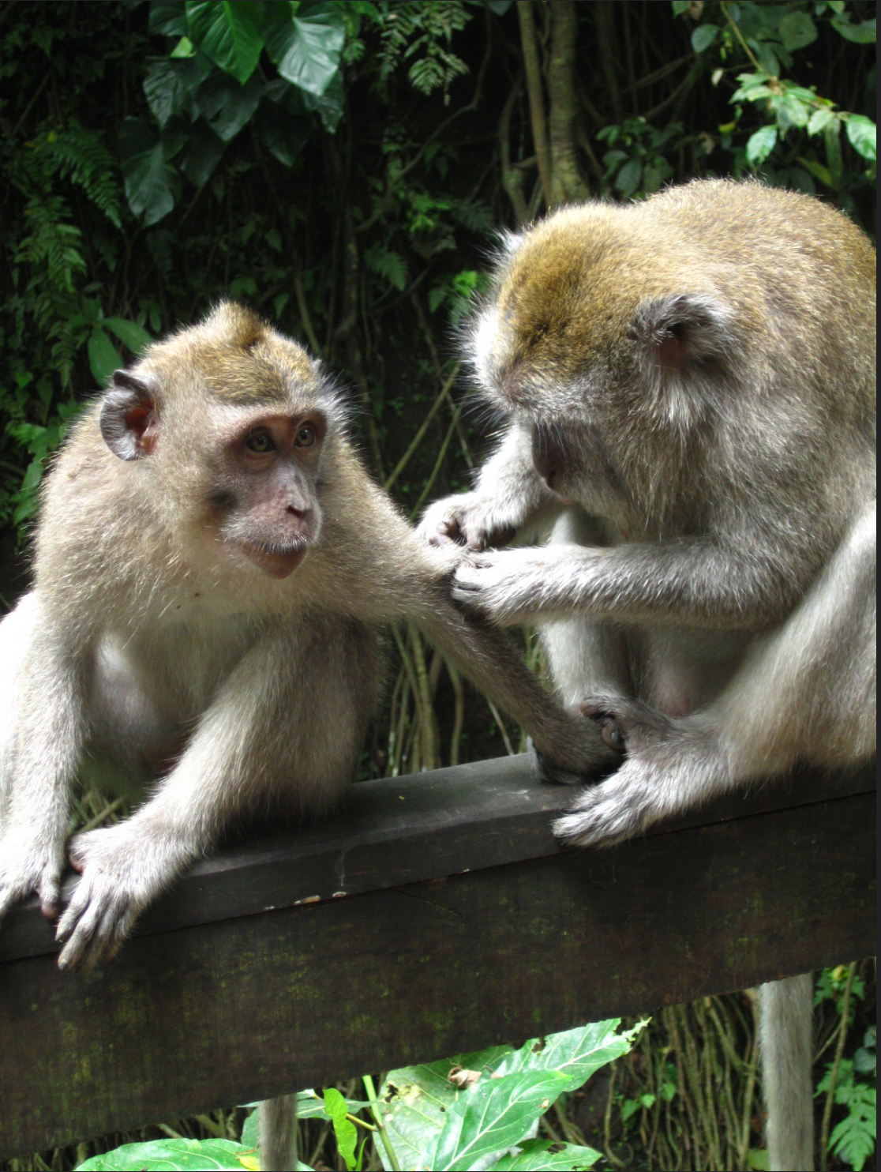

"Monkey grooming - Monkey Forest Bali" by Annie Mole is licensed under CC BY 2.0

Task b - phoneme and grapheme
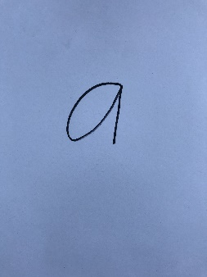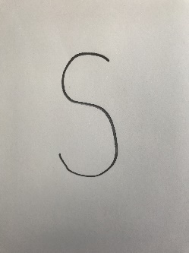
Practice writing the grapheme that represents the phoneme on the paper below.
You can also write on whiteboards. Make sure your pencil grip is correct.
Say the phoneme when writing it. Fill the space!

Task c - high frequency sight words (HFSW)
Practice reading and writing your HFSW.
Write them: in the air, pretend to write them on the floor, on your knee, on your adults back, on paper, on whiteboards, in sand, etc.
Suggested words are:
a
am
on
I
the

Task d - reading
Read a book that your teacher has recommended.
Each time a text is read or shared, ask your adult to include it in My Record of Texts, found at the back of this workbook.

Task e - quality text
Narratives have a beginning that tells us where the story is taking place and who is in it.
An adult will share a text with you and ask some questions so you can talk about the story with them.
Prior to reading: Where do you think this book will be set? How do you know?
During reading: Describe the setting of this story and who is in it.
After reading: Who do you think the author wrote this story for? Who is the audience?
Complete the following activity about setting.

Activity - Setting
The setting is where the story takes place. A story can have more than one setting. Examples: farm, house, forest, beach, bedroom
Task:
- Where did most of the story take place? Describe it to your adult.
- Draw it below
- Have a go at writing about the setting

________________________________________________________________________________________________________________________________________________________________________________________________________________________

Reflection
It may be helpful to record the student’s answers to the following questions.

Ask the student:
Is there a word you don’t know the meaning of?
Show or tell me what it is.
Discuss the word meaning or investigate the word meaning.

Discuss with the student:
What have you learnt in this session?
What did you like about English today?
What did you do well?
What will you try to do next time?

Lesson 2

Task a - phoneme hunt
Students are to name things around the house that have 2, 3 and 4 phonemes. Remember phonemes are the sounds we can hear in words. e.g. c-ar (2 is tricky!), 3 phonemes e.g. kn-i-fe, b-oo-k, 4 phonemes e.g. g-l-a-ss, t-a-b-le.
Students may draw the objects below or an adult can write for them.

2 phonemes
3 phonemes
4 phonemes

Task b - phoneme and grapheme
Practice writing the grapheme that represents the phoneme below. Fill the space with ‘a’ and ‘s’!
You can also write on whiteboards. Make sure your pencil grip is correct.
Say the phoneme when writing it.

Handwriting practice
Practice writing ‘a’ and ‘s’ in the ES1 handwriting booklet, found in the ES1 resource pack.

Task c- high frequency sight words (HFSW)
Ask your adult to write your HFSW on cards or paper to make flash cards.
An adult will flash through the words on the cards as quickly as possible so you can say the word quickly.
Ask your adult to write the words on post-it notes and scatter throughout the house. Read one aloud every time you see it.

Task d - reading
Read a book that your teacher has recommended. This may be a decodable text.
Each time a text is read or shared, ask your adult to include it in My Record of Texts, found at the back of this workbook.

Task e - quality text
Narratives have a beginning that tells us where the story is taking place and who is in it.
An adult will read you a story and ask these questions”
Prior to reading: Where do you think this book will be set? How do you know?
During reading: Describe the setting of this story and who is in it.
After reading: Can you tell me what the problem was in the story?
Record the title of the book on My Record of texts.

Reflection
Ask students:
Was there a word in the shared text you didn’t know the meaning of?
We can find out the meaning of new vocabulary.
Locate the new word and investigate it through a dictionary and discussion.

Lesson 3

Task a – speaking and listening
Look at the picture below. Describe to an adult:
- Where would I find a snowman?
- What is happening to the snowman?
- What would make a snowman melt?
- What other objects could you use to make a snowman’s face?
- What might the snowman be saying? Write it in the speech bubble.
Remember to use full sentences and clear speech.

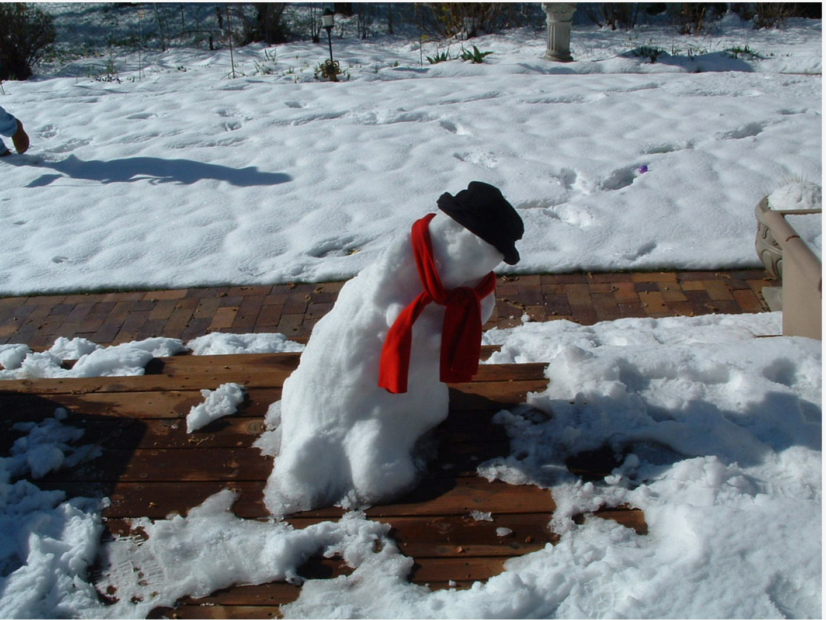
"melting snowman" by IngaMun is licensed under CC BY 2.0

Task b - phoneme and grapheme
Practice writing the grapheme that represents the phoneme on the paper below.
You can also write on whiteboards. Make sure your pencil grip is correct.
Say the phoneme when writing it. Fill the space with ‘t’ and ‘p’.

Segment and blend phonemes together to make words.
The adult to demonstrate slowly, pulling the phonemes together to read a word s-a-t, p-a-t, s-a-p, a-t, t-a-p. Repeat numerous times.
Handwriting practice
Practice writing ‘t’ and ‘p’ in the ES1 handwriting booklet, found in the ES1 resource pack.

Task c- high frequency sight words (HFSW)
Ask your adult to write your words on separate cards and play snap or memory.

Task d - reading
Read a book that your teacher or adult has recommended. This may be a decodable text.
Each time a text is read or shared, ask your adult to include it in My Record of Texts, found at the back of this workbook.

Task e - quality text
Narratives focus: narratives have a middle; a complication. It might be something that the main character wants, or a problem of some sort.
An adult will share this story with you and ask you some questions”
Prior to reading: Where do you think the problem could be about in this story? Why do you think that?
During reading: Describe the problem, the complication in this story.
After reading: Was the big problem in this story resolved? Can you tell me about it, and how it was resolved?
Record the title of the book on My Record of texts.

Reflection
Ask students:
In the text we just shared, is there a word you don’t know the meaning of?
Show or tell me what it is.
Discuss with the student the word meaning or investigate the word meaning.
Discuss with the student:
What have you learnt in this English session?
What did you like about English today? What did you do well?
What will you try harder to do next time?

Lesson 4

Task a – syllable clap
Students clap the amount of syllables in different words. Count how many each time.
For example, the word computer has three syllables, so we clap three times as we say: com-pu-ter (remember every syllable has a vowel phoneme “sound’).
Students to clap out their name and family members (e.g. Ty-ler, Pap-ou), different animals (e.g. el-e-phant), objects around the house (e.g. book, wash-ing)

Task b - phoneme
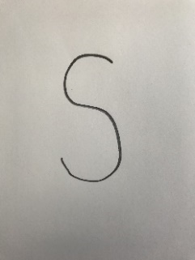
Practice your individual phonemes again.
Go for a walk through the house, find the post-it notes and say each phoneme as they are discovered.
Ask students to write the grapheme as you say the phoneme – s, a, t, p.
Using cards with the phonemes written on them, or magnetic letters, blend them together to read words. E.g. form the words: sat, pat, sap, at, pas. Say each phoneme out loud as you form it, then put it together to read the word.

Task c- high frequency sight words
Lay the cards with your HFSW words out on a flat surface.
Your adult will say the word, you point to the corresponding card.

Task d - reading
Read a book that your teacher has recommended. This may be a decodable text.
Each time a text is read or shared, ask your adult to include it in My Record of Texts, found at the back of this workbook.

Task e - quality text
Narratives focus: narratives have a middle; a complication, it might be something that the main character wants, or a problem of some sort.
An adult will share a quality text with you and might ask”
Prior to reading: Where do you think the problem could be about in this story? Why do you think that?
During reading: Describe the problem, the complication in this story.
After reading: Was the big problem in this story resolved? Can you tell me about it, and how it was resolved?
Record the title of the book on My Record of texts.
Complete the following activity.

Activity - Sequencing drawing
What happened in the text?
Draw what happened at the beginning, middle and end. Label your drawing so it is clear.

Beginning
Middle
End

Reflection
Ask students to reflect on their learning so far.
Ask:
What did you do well today?
What would you like to improve on?
How can I help you achieve that?

Lesson 5

Task a – speaking and listening
Look at the picture below. Describe to an adult:
- What they are doing
- What colour they are, what does their fur feel like?
- What do you think they are picking out from the tail?
- Are they friends? Family?
- Why are they doing this?
Remember to use full sentences and clear speech.
"Monkey grooming - Monkey Forest Bali" by Annie Mole is licensed under CC BY 2.0

Task b - phoneme
Quickly flash each of the cards with the individual phonemes (s, t, a, p), represented by both capital and lower-case. Ask students to call out the phoneme. Students to write the phonemes as the adult says them.
Go for a walk through the house, find the post-it notes and say each phoneme as they are discovered.

Task c- high frequency sight words
Practice writing your sight words.
Write them: in the air, pretend to write them on the floor, on your knee, on your adults back, on paper, on whiteboards, in sand, etc.
Suggested words are:
a
am
on
I
the

Task d - reading
Read a book that your teacher has recommended. This may be a leveled book or a decodable text.
Each time a text is read or shared, ask your adult to include it in My Record of Texts, found at the back of this workbook.

Task e - quality text
Narratives focus: narratives have an end. It may not be a happy ending, but it ends somehow. Usually the problem or complication is resolved.
An adult will read a quality text with you and may ask:
Prior to reading: I wonder what the complication will be in this story. Can you predict what it might be?
During reading: Describe how the problem or complication was resolved and how did the story end?
After reading: Why is it important to have a clear ending? How does a reader feel if the story is not finished properly? Can you think of a different ending for this story?
Record the title of the book on My Record of texts.

Reflection
Ask students to reflect on their learning today.
What do good readers do?
What do you do, when you’re reading, that helps you?
What can we concentrate on tomorrow?

Lesson 6

Task a – rhyming strings
Begin with a one-syllable word (e.g. cat) and students are to verbally generate as many rhyming words as possible until the word is changed.
Example:
Adult: dog!
Student: dog, fog, hog, log, rog, sog
Adult: tree!
Student: tree, me, flea, be, see
Adult: book!
Student: book, look, cook, sook, took...

Task b - phoneme
Quickly flash each of the cards with the individual phonemes (s, t, a, p), represented by both capital and lower-case. Ask students to call out the phoneme. Students to write the phonemes as the adult says them.
Go for a walk through the house, find the post-it notes and say each phoneme as they are discovered.

Task c- high frequency sight words
Practice writing your sight words.
Write them: in the air, pretend to write them on the floor, on your knee, on your adults back, on paper, on whiteboards, in sand, etc.
Suggested words are:
a
am
on
I
the

Task d - reading
Read a book that your teacher has recommended. This may be a leveled book or a decodable text.
Each time a text is read or shared, ask your adult to include it in My Record of Texts, found at the back of this workbook.

Task e - quality text
Narratives focus: narratives have an end. It may not be a happy ending, but it ends somehow. Usually the problem or complication is resolved.
An adult will share a quality text with you and may ask”
Prior to reading: I wonder what the complication will be in this story. Can you predict what it might be?
During reading: Describe how the problem or complication was resolved and how did the story end?
After reading: Why is it important to have a clear ending? How does a reader feel if the story is not finished properly? Can you think of a different ending for this story?
Record the title of the book on My Record of texts.

Reflection
Ask students to reflect on their learning so far.
Ask:
What did you do well today?
What would you like to improve on?
How can I help you achieve that?

Lesson 7

Task a – syllable clap
Students clap the amount of syllables in different words. Count how many each time.
For example, the word computer has three syllables, so we clap three times as we say: com-pu-ter (remember every syllable has a vowel phoneme “sound’).
Students to clap out their name and family members (e.g. Ty-ler, Pap-ou), different animals (e.g. el-e-phant), objects around the house (e.g. book, wash-ing)

Task b – phoneme and grapheme
Quickly flash each of the cards with the individual phonemes (s, t, a, p), represented by both capital and lower-case. Ask students to call out the phoneme. Students to write the phonemes as the adult says them.
Go for a walk through the house, find the post-it notes and say each phoneme as they are discovered.
Now students practice writing them.
Adult: write these phonemes as I say them - s-a-t, read what you wrote…p-a-t, read what you wrote…t-a-p, read what you wrote…s-a-p, read what you wrote etc…
Say each word slowly, segmenting and blending the phonemes so students can clearly hear them.

Task c- high frequency sight words
An adult will flash through the words as quickly as possible.
Write the words on post-it notes and scatter throughout the house, reading it every time you encounter one.

Task d - reading
Read a book that your teacher has recommended. This may be a leveled book or a decodable text.
Each time a text is read or shared, ask your adult to include it in My Record of Texts, found at the back of this workbook.

Task e - quality text
Narratives focus: narratives can be real or imagined. This is not designed to trick the student but to highlight narratives
An adult will retell a personal narrative that (or made up, but sounds real ☺). Ideally the story should start with a clear beginning that sets the scene and introduces the main people. The middle must have a clear problem or complication, that is then resolved with a (hopefully happy) ending.
Your adult might ask you:
Prior to listening: Listen carefully to see if this narrative is real or imagined. How do you think you will know?
During the story: Can you tell me the complication in my narrative?
After the story is told: Was the story I just told you real or imagined? How do you know? Was my narrative complication resolved? Is there a moral to my narrative? Is there anything I can learn from this narrative? Sometimes authors tell narratives so the reader can learn or reflect on something about themselves or the world.

Reflection
Ask students to reflect on their learning so far.
Why do you think we need to learn lessons about ourselves?
Students can write or draw what they have learnt so far about narratives, reading, sounds, and sight words.

Lesson 8

Task a – rhyming strips
Begin with a one-syllable word (e.g. cat) and students are to verbally generate as many rhyming words as possible until the word is changed.
Example:
Adult: dog!
Student: dog, fog, hog, log, rog, sog
Adult: tree!
Student: tree, me, flea, be, see
Adult: book!
Student: book, look, cook, sook, took...

Task b – phoneme and grapheme
Quickly flash each of the cards with the individual phonemes (s, t, a, p) represented by both capital and lower-case. Ask students to call out the phoneme. Students to write the phonemes as the adult says them.
Go for a walk through the house, find the post-it notes and say each phoneme as they are discovered.
Now students practice writing them.
Adult: write these phonemes as I say them - s-a-t, read what you wrote…p-a-t, read what you wrote…t-a-p, read what you wrote…s-a-p, read what you wrote etc…
Say each word slowly, segmenting and blending the phonemes so students can clearly hear them.

Task c- high frequency sight words
Play snap or memory using your sight words.

Task d - reading
Read a book that your teacher has recommended. This may be a leveled book or a decodable text.
Each time a text is read or shared, ask your adult to include it in My Record of Texts, found at the back of this workbook.

Task e - quality text
Narratives focus: narratives can be real or imagined.
Listen to a well-known narrative that is fiction, e.g. a fairy-tale or a nursery rhyme told as a story.
Suggestion: The Three Little Pigs.
The story should start with a clear beginning that sets the scene and introduces the main people. The middle must have a clear problem or complication, that is then resolved with a happy ending (for some).
Prior to listening: Listen carefully to see if this narrative is real or imagined. How do you think you will know?
During the story: Can you tell me the complication in my narrative?
After the story is told: Was the story I just told you real or imagined? How do you know? Was my narrative complication resolved? Is there a moral to my narrative? Is there anything I can learn from this narrative? Sometimes authors tell narratives so the reader can learn or reflect on something about themselves or the world.
Complete the following activity.

Activity - Sequencing drawing
What happened in the text?
Draw what happened at the beginning, middle and end. Label your drawing so it is clear.

Beginning
Middle
End

Reflection
Ask students to reflect on their learning so far.
Ask:
What did you do well today?
What would you like to improve on?
How can I help you achieve that?

Lesson 9

Task a – phoneme isolation and manipulation
Provide a word and ask the student what the new word will be if a phoneme is removed, added or substituted. Words don’t have to make sense. E.g.
Teacher: The word is ‘man’ Say the word.
Student: man
Teacher: Take away the mmm. Now, what is the word?
Student: an
Teacher: Using ‘an’, put ‘p’ at the beginning. Now, what is the word?
Student: pan
Teacher: Using ‘pan’, add ‘s’ to the end?
Student: pans
Teacher: change the ‘a’ in pans, to ‘i’. Now, what is the new word?
Student: pins
Words to manipulate can include: wet (leading to pet, pen, ten, tun, stun) see (leading to be, lee, fee, feet, feep, deep)

Task b – phoneme and grapheme
Quickly flash each of the cards with the individual phonemes (s, t, a, p) represented by both capital and lower-case. Ask students to call out the phoneme. Students to write the phonemes as the adult says them.
Go for a walk through the house, find the post-it notes and say each phoneme as they are discovered.
Now students practice writing them.
Adult: write these phonemes as I say them - s-a-t, read what you wrote…p-a-t, read what you wrote…t-a-p, read what you wrote…s-a-p, read what you wrote etc…
Say each word slowly, segmenting and blending the phonemes so students can clearly hear them.

Task c- high frequency sight words
Lay your sight cards out on a flat surface.
An adult says the word, the student points to the corresponding card.

Task d - reading
Read a book that your teacher has recommended. This may be a leveled book or a decodable text.
Each time a text is read or shared, ask your adult to include it in My Record of Texts, found at the back of this workbook.

Task e - quality text
Narratives focus: narratives can be real or imagined.
An adult retells a personal narrative that is real (or made up, but sounds real). Ideally the story should start with a clear beginning that sets the scene and introduces the main people. The middle must have a clear problem or complication, that is then resolved with a satisfying ending.
Prior to listening: Listen carefully to see if this narrative is real or imagined. How do you think you will know?
During the story: Can you tell me the complication in my narrative?
After the story is told: Was the story I just told you real or imagined? How do you know? Was my narrative complication resolved? Is there a moral to my narrative? Is there anything I can learn from this narrative? Sometimes authors tell narratives so the reader can learn or reflect on something about themselves or the world.

Reflection
Ask students to reflect on the shared text.
Would they like to write a book like that one day?
What do good writers do?
How can they be a good writer too?

Lesson 10

Task a – speaking and listening
Look at the picture below. Describe to an adult:
- The size of the fish
- What colour and size are the fish
- Are they friends?
- Where do you think they are swimming to?

- What might the fish be saying? Write it in the speech bubble.
Remember to use full sentences and clear speech.
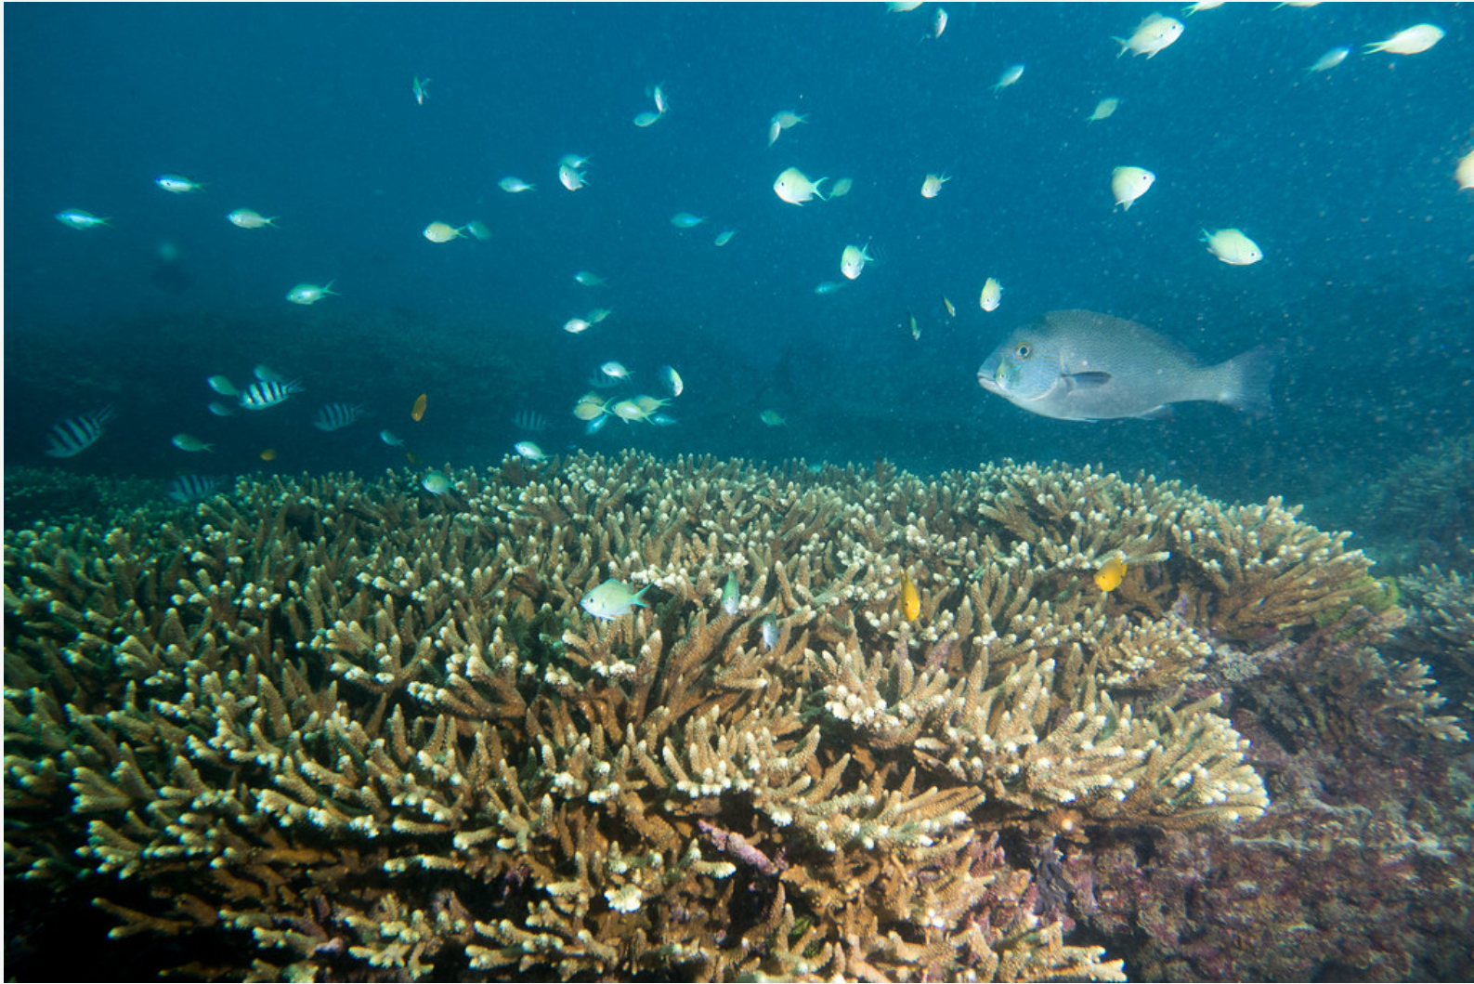

Task b – phoneme and grapheme
Quickly flash each of the cards with the individual phonemes (s, t, a, p) represented by both capital and lower-case. Ask students to call out the phoneme. Students to write the phonemes as the adult says them.
Go for a walk through the house, find the post-it notes and say each phoneme as they are discovered.
Now students practice writing them.
Adult: write these phonemes as I say them - s-a-t, read what you wrote…p-a-t, read what you wrote…t-a-p, read what you wrote…s-a-p, read what you wrote etc…
Say each word slowly, segmenting and blending the phonemes so students can clearly hear them.

Task c- high frequency sight words
‘Take the challenge’ with your sight words.
Flash each card, and with no prompting, ask the student to tell you the word. Fast recall is desired.
Once students have ‘taken the challenge’, the next set of words can now be added to the bank of high frequency sight words.

Task d - reading
Read a book that your teacher has recommended. This may be a leveled book or a decodable text.
Each time a text is read or shared, ask your adult to include it in ‘My Record of Texts’, found at the back of this workbook.

Task e - quality text
Narratives focus: narratives can be real or imagined.
An adult retells a well-known narrative that is fiction, e.g. a fairy-tale or a nursery rhyme told as a story.
Suggestion retelling Red Riding Hood. The story should start with a clear beginning that sets the scene and introduces the main people. The middle must have a clear problem or complication, that is then resolved with a (hopefully happy) ending for some.
Prior to listening: Listen carefully to see if this narrative is real or imagined. How do you think you will know?
During the story: Can you tell me the complication in this narrative?
After the story is told: Was the narrative I just told you real or imagined? How do you know? Was the complication resolved? Is there a moral to this narrative? Is there anything I can learn from this narrative? Sometimes authors tell narratives so the reader can learn or reflect on something about themselves or the world.
Task: Draw the characters from the story. Label the characters with information about their appearance and personality.

Reflection

Ask students to reflect on their learning so far.
Ask:
What did you do well today?
What would you like to improve on?
How can I help you achieve that?

My Record of Texts
‘Text’ is spoken, written and visual communication. It includes sound, print, film, digital and multimedia. It’s the way we communicate. So that means it can be a book, podcast, play, website and even a movie. When we talk about text, it could be any of these communications.
Record the title of each text you engage with (or if it is a novel, you might like to record each chapter title).
Date | Title | Type of text for example a poem | Independent or shared | Notes
1 April | The Barber Shop Scissor Twister | comic | Shared with dad | I recommend this comic because it is funny. Dad did funny voices.

