Quality literature recommendations – Early Stage 1

Understanding and responding to literature
These books have been reviewed to support the implementation of the English K–10 Syllabus.
For further support, please contact english.curriculum@det.nsw.edu.au.
Contents
Understanding and responding to literature 0
Overview 2
Key terminology 3
Mentor concept 3
What is quality literature? 3
Context 5
Identifying context 5
Recommendations 5
Narrative 8
Identifying narrative 8
Recommendations 8
Character 15
Identifying character 15
Recommendations 15
Imagery, symbol and connotation 22
Identifying imagery, symbol and connotation 22
Recommendations 22
Perspective 31
Identify perspective 31
Recommendations 31
References 35
Further reading 36

Overview
The quality literature recommended in this document are printed texts to support teaching and learning for English Early Stage 1 with an explicit focus on the syllabus outcome –Understanding and responding to literature.
Outcome: ENE-UARL-01
Understands and responds to literature read to them.
Content groups: context, narrative, character, imagery, symbol and connotation, and perspective.
Included are details about each text and its suitability for use across different stages of learning. In many instances, a text that is suitable for Early Stage 1 and Stage 1 is also suitable for Stage 2 and Stage 3, with minor adjustments. However, the same cannot be assumed the other way. It is strongly recommended that these texts are read aloud to model effective reading and strengthen students’ personal engagement with texts.
Schools are neutral places for rational discourse and objective study. Discussion allows students to explore a range of viewpoints without advancing the interests of any particular group. All texts should be reviewed by staff prior to classroom use to ensure alignment with the department’s Controversial issues in schools policy. Texts presented to students as part of classroom activities should be:
- age appropriate
- sensitive to student needs
- relevant to the curriculum
- relevant with the school’s purpose and goals
- consistent with the core values outlined in Values in NSW public schools policy.
While quality literature should always be prioritised, a variety of texts should also be used to deepen students’ understanding. Refer to Text requirements in the English K–10 Syllabus for further information.

Key terminology

Mentor concept
Mentor concept – a clearly identifiable textual concept in a text. Exploring a mentor concept increases students’ understanding and appreciation of the text. Identifying the mentor concept allows for effective planning that builds student understanding of reading and writing. The concepts in Early Stage 1 are: context, narrative, character, imagery, connotation and symbol, and perspective.
Supporting concept – complements the mentor concept in the text. It is useful to identify the supporting concepts as including them may enhance student understanding of the text.
Figure 1 – diagram of three concept structure
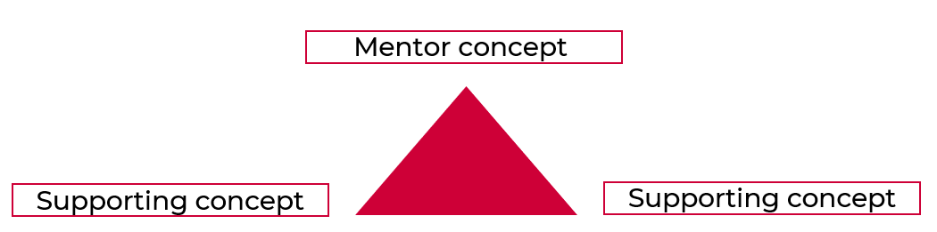

What is quality literature?
To identify the quality literature featured in this resource, we considered the following questions:
- Is the text widely regarded?
- Do the images or graphics extend and enrich the meaning?
- Does the text serve as a model text for students to compose their own text?
- Does the text offer a new insight, open different interpretations and reveal new understandings, provoking rich discussions?
- Does the text prompt critical and creative thinking and an emotional response?
- Does the text provide opportunity to explore new vocabulary?
- Is there figurative language? (for imaginative texts)
- Is there strong characterisation? (for imaginative texts)
- Is the plot or content interesting for my students?
- Does the text support achievement of outcomes?
- Does the structure of the text support learning?
The following quality literature recommendations were sourced from:
- Suggested texts for the English K–10 Syllabus
- Premier’s Reading Challenge texts
- Children’s Book Council of Australia shortlists
- Recommendations by teacher librarians and classroom teachers.
At the time of publishing, all reviewed books listed were available through reputable bookstores. Many books may also be borrowed from local, school or department libraries, such as the Henry Parkes Equity Resource Centre. You can check the availability of these books through your school’s Oliver library. To access and search your library, please go to your portal and add My School Library to your essentials.
The book cover images are displayed under Section 41 of the Copyright Act (1968) (“Fair Dealings”). If you are the copyright owner of one of these images and object to its display, please contact us at: english.curriculum@det.nsw.edu.au.

Context
‘To understand context, we look beyond the text to consider the world in which it was produced and the worlds of its reception. Different contexts can have an effect on the meanings and values of similar content’ – English Textual Concepts and Learning Processes (2016).
To learn more, view Context video (5:23).

Identifying context
To identify texts with the concept of ‘context’, look for texts that:
- explore social situations with language and actions appropriate to that situation
- depict situations which require specific language and behaviour
- reflect aspects of students’ world
- are composed for specific audiences and purposes
- compare the text forms and features through showing how the communication of information and ideas varies
- demonstrate how different groups and cultures are represented.

Recommendations
Use these books to teach students to:
- identify aspects of their own world represented in texts
- identify texts that are composed for specific audiences and purposes
- identify and contrast features of texts that inform, persuade or entertain
- create imaginative or informative texts relating to their own experience, the world or other texts.

All I Want for Christmas is Rain
Author: Cori Brooke Illustrator: Megan Forward
ISBN: 9781925059953 Publisher: New Frontier Publishing Year published: 2020
Stage: Early Stage 1 to Stage 1
Supporting concepts: imagery, symbol and connotation; character
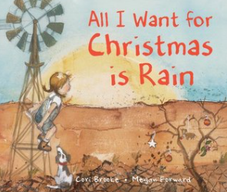

Go Home, Cheeky Animals!
Author: Johanna Bell Illustrator: Dion Beasley
ISBN: 9781760291655 Publisher: Allen and Unwin Children’s Year published: 2016
Stage: Early Stage 1 to Stage 1
Supporting concepts: character; narrative
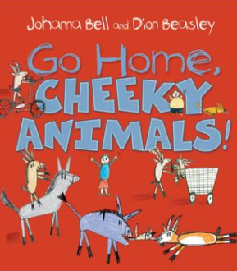

I’m Australian Too
Author: Mem Fox Illustrator: Ronojoy Ghosh
ISBN: 9781742995786 Publisher: Omnibus Books Year published: 2018
Stage: Early Stage 1 to Stage 1
Supporting concept: character
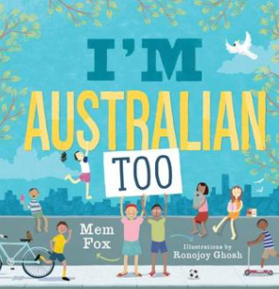

Nannie Loves
Author and illustrator: Kylie Dunstan
ISBN: 9781921504846 Publisher: HarperCollins Publishers Year published: 2018
Stage: Early Stage 1 to Stage 1
Supporting concept: character
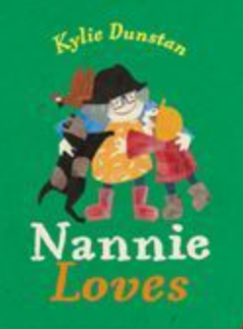

The Patchwork Bike
Author: Maxine Beneba Clarke Illustrator: Van T Rudd
ISBN: 9780734418609 Publisher: Lothian Children’s Books Year published: 2017
Stage: Early Stage 1 to Stage 1
Supporting concept: imagery, symbol and connotation
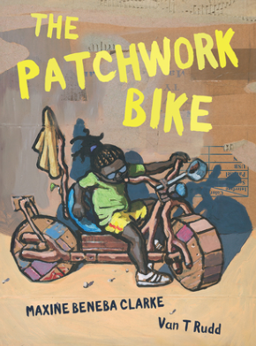

Narrative
‘Narrative is the communication of a sequence of related events into a story. A narrative is usually structured in such a way as to invite responder involvement. Narrative helps us make sense of our lives’ – English Textual Concepts and Learning Processes (2016).
To learn more, view Narrative video (3:51).

Identifying narrative
To identify texts with the concept of ‘narrative’, look for stories that are:
- imagined
- about real life experiences
- told through different modes and media
- structured with a clear beginning, middle and end (but not necessarily sequential)
- inviting students to enter another world
- constructed for a particular audience or purpose
- clearly setting up expectations and allow predictions of actions and attitudes
- provoking an emotional response
- told in multiple ways
- presenting a view of the students’ world.

Recommendations
Use these books to teach students to:
- understand that narrative can be real or imagined
- identify narratives told through a range of modes and media
- identify, discuss and compare the beginning, middle and end in a range of narratives
- experiment with using parts and/or features of a narrative, innovating from a mentor text.

Alexander’s Outing
Author and illustrator: Pamela Allen
ISBN: 9780140554786 Publisher: Penguin Books Year published: 1994
Stage: Early Stage 1
Supporting concept: character
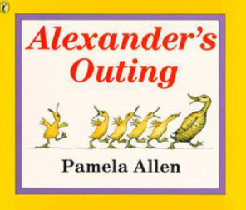

Belinda
Author and illustrator: Pamela Allen
ISBN: 9780140544930 Publisher: Penguin Books Year published: 1994
Stage: Early Stage 1 to Stage 1
Supporting concepts: character; imagery, symbol and connotation
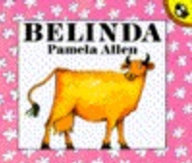

Clancy and Millie and the Very Fine House
Author: Libby Gleeson Illustrator: Freya Blackwood
ISBN: 9781760126681 Publisher: Hardie Grant Egmont Year published: 2016
Stage: Early Stage 1 to Stage 1
Supporting concept: imagery, symbol and connotation
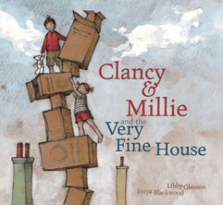

Florette
Author and illustrator: Anna Walker
ISBN: 9780670079414 Publisher: Penguin Australia Year published: 2017
Stage: Early Stage 1 to Stage 1
Supporting concept: imagery, symbol and connotation
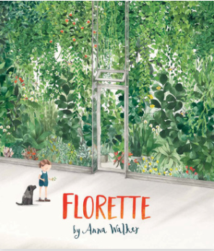

Go to Sleep, Jessie!
Author: Libby Gleeson Illustrator: Freya Blackwood
ISBN: 9781742977805 Publisher: Hardie Grant Egmont Year published: 2014
Stage: Early Stage 1 to Stage 1
Supporting concept: character
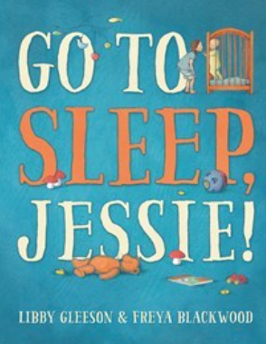

Harold and the Purple Crayon
Author and illustrator: Crockett Johnson
ISBN: 9780747532033 Publisher: Bloomsbury Year published: 1996 (first published 1955)
Stage: Early Stage 1 to Stage 1
Supporting concept: character
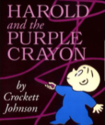

Harriet, You’ll Drive Me Wild
Author: Mem Fox Illustrator: Marla Frazee
ISBN: 9780152045982 Publisher: Houghton Mifflin Year published: 2003
Stage: Early Stage 1
Supporting concept: character
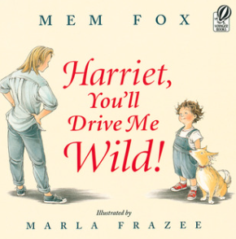

Invisible Me
Author and illustrator: Wendy Binks
ISBN: 9780646562155 Publisher: Stunned Emu Press Year published: 2011
Stage: Early Stage 1 to Stage 1
Supporting concept: character
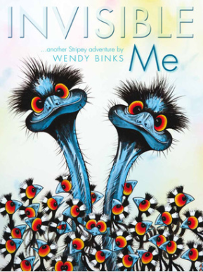

Possum Magic
Author: Mem Fox Illustrator: Julie Vivas
ISBN: 9780152632243 Publisher: HMH Books for Young Readers Year published: 1991
Stage: Early Stage 1 to Stage 1
Supporting concept: character
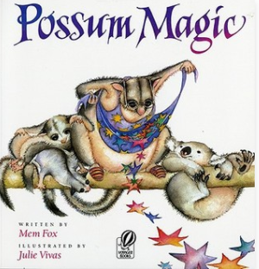

Rainbow Bear
Author and illustrator: Stephen Michael King
ISBN: 9781742997698 Publisher: Scholastic Australia Year published: 2018
Stage: Early Stage 1 to Stage 1
Supporting concept: character
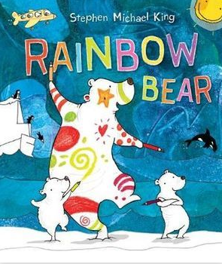

Roller Coaster
Author and illustrator: Marla Frazee
ISBN: 9780152057442 Publisher: HMH Books for Young Readers Year published: 2006
Stage: Early Stage 1 to Stage 1
Supporting concepts: connotation, imagery and symbol; character
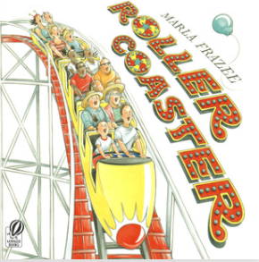

Shoes from Grandpa
Author: Mem Fox Illustrator: Patricia Mullins
ISBN: 9780531070314 Publisher: Scholastic Australia Year published: 2020 (first published 1989)
Stage: Early Stage 1 to Stage 1
Supporting concepts: character; context
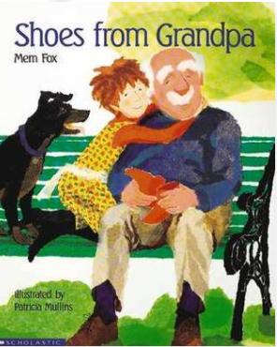

The Relatives Came
Author: Cynthia Rylant Illustrator: Stephen Gammell
ISBN: 9780689717383 Publisher: Aladdin Year published: 1993
Stage: Early Stage 1 to Stage 1
Supporting concept: context
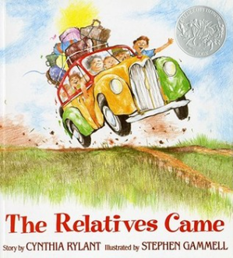

The Unwilling Twin
Author and illustrator: Freya Blackwood
ISBN: 9781460757536 Publisher: HarperCollins Publishers Year published: 2020
Stage: Early Stage 1
Supporting concepts: character; perspective
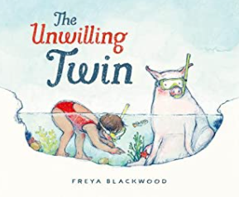

The Very Noisy Baby
Author and illustrator: Alison Lester
ISBN: 9781925475616 Publisher: Affirm Publishers Year published: 2017
Stage: Early Stage 1 to Stage 1
Supporting concepts: character; context; imagery, symbol and connotation
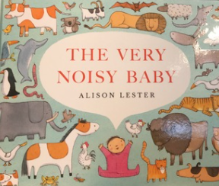

Too Many Elephants in the House
Author: Ursula Dubosarsky Illustrator: Andrew Joyner
ISBN: 9780143785392 Publisher: Penguin Books Australia Year published: 2017
Stage: Early Stage 1 to Stage 1
Supporting concepts: character; perspective
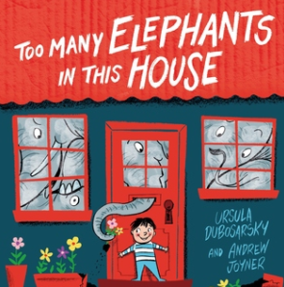

Who Sank the Boat?
Author and illustrator: Pamela Allen
ISBN: 9780140509403 Publisher: Penguin Random House Children’s UK Year published: 1992
Stage: Early Stage 1
Supporting concept: character
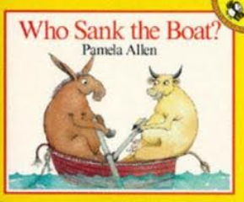

With Nan
Author: Tania Cox Illustrator: Karen Blair
ISBN: 9781921136122 Publisher: Windy Hollow Books Year published: 2012
Stage: Early Stage 1 to Stage 1
Supporting concepts: context; character
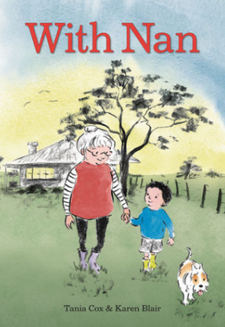

Character
‘Character is a construct of verbal and visual statements about a fictional identity. Analysis of characters contribute to our own personal judgements about self, morals and values’ – English Textual Concepts and Learning Processes (2016).
To learn more, view Character video (2:31).

Identifying character
To identify texts with the concept of ‘character’, look for stories that:
- are imaginative texts
- depict characters visually, verbally or through aural representations
- describe characters with imagined thoughts, words and actions
- represent characters through different modes and media
- reflect lived experiences
- invite positive or negative responses.

Recommendations
Use these books to teach students to:
- use background knowledge to support understanding of characters’ actions in a text
- reason using background knowledge as to why a character has acted in a certain way
- identify and discuss character features and actions
- identify and discuss language used to describe characters in narratives
- share feelings and thoughts in response to characters and actions in texts
- identify and compare characters in a range of texts
- understand that characters in texts are represented by how they look, what they say and do, and their thoughts.

A Bad Case of the Stripes
Author and illustrator: David Shannon
ISBN: 9780439598385 Publisher: Scholastic Bookshelf Year published: 2004
Stage: Early Stage 1 to Stage 1
Supporting concept: narrative
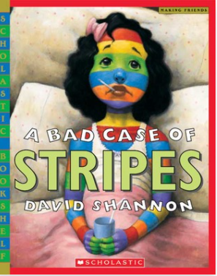

A House of Her Own
Author: Jenny Hughes Illustrator: Jonathan Bentley
ISBN: 9781760121471 Publisher: Hardie Grant Children’s Publishing Year published: 2016
Stage: Early Stage 1 to Stage 1
Supporting concepts: narrative; context
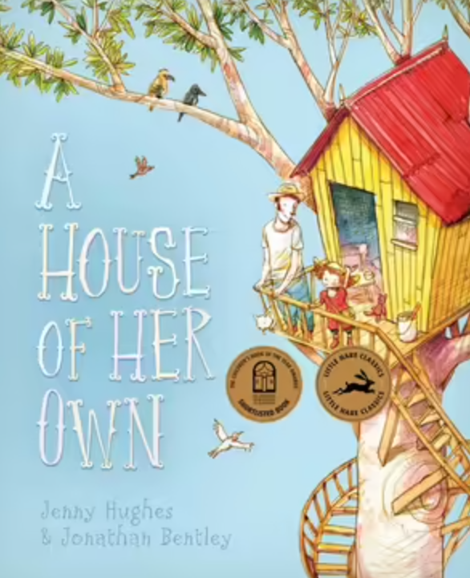

A Walk in the Bush
Author and illustrator: Gwyn Perkins
ISBN: 9781925475531 Publisher: Affirm Press Year published: 2017
Stage: Early Stage 1 to Stage 1
Supporting concepts: context; narrative
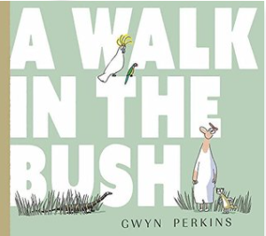

Edward the Emu
Author: Sheena Knowles Illustrator: Rod Clement
ISBN: 9780207170515 Publisher: HarperCollins Publishers Year published: 2018 (first published 1990)
Stage: Early Stage 1 to Stage 1
Supporting concept: narrative
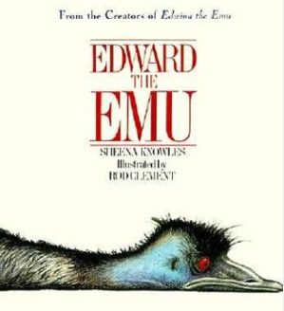

Fearless
Author: Colin Thompson Illustrator: Sarah Davis
ISBN: 9780733330827 Publisher: ABC Books Year published: 2014
Stage: Early Stage 1 to Stage 2
Supporting concepts: narrative; imagery, symbol and connotation
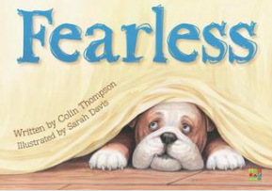

Koala Lou
Author: Mem Fox Illustrator: Pamela Lofts
ISBN: 9780140540635 Publisher: Penguin Books Year published: 1991
Stage: Early Stage 1 to Stage 1
Supporting concept: narrative
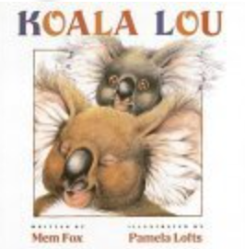

No! Never!
Author: Libby Hathorn Illustrator: Mel Pearce
ISBN: 9780734418913 Publisher: Hachette Australia Year published: 2020
Stage: Early Stage 1 to Stage 1
Supporting concepts: context; narrative
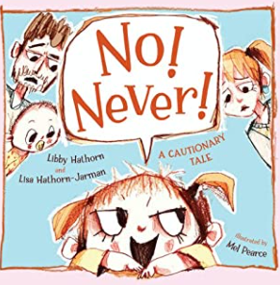

Noni the Pony
Author and illustrator: Alison Lester
ISBN: 9781741758887 Publisher: Allen and Unwin Children’s Year published: 2010
Stage: Early Stage 1 to Stage 1
Supporting concept: narrative
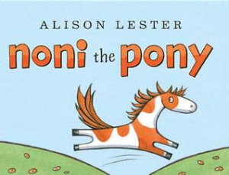

Pig the Pug
Author and illustrator: Aaron Blabey
ISBN: 9781743624777 Publisher: Scholastic Australia Year published: 2014
Stage: Early Stage 1 to Stage 1
Supporting concept: narrative
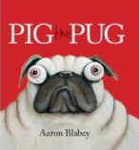

Rodney Loses It!
Author: Gerard Michael Bauer Illustrator: Chrissie Krebs
ISBN: 9781742991900 Publisher: Scholastic Australia Year published: 2017
Stage: Early Stage 1 to Stage 1
Supporting concepts: narrative; context
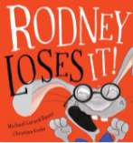

Rose Meets Mr Wintergarten
Author and illustrator: Bob Graham
ISBN: 9780744598292 Publisher: Walker Books Year published: 2004
Stage: Early Stage 1 to Stage 1
Supporting concepts: perspective; narrative
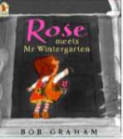

The Dreadful Fluff
Author and illustrator: Aaron Blabey
ISBN: 9780143507000 Publisher: Penguin Books Australia Year published: 2016
Stage: Early Stage 1 to Stage 1
Supporting concept: narrative
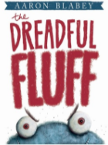

The Gruffalo
Author: Julia Donaldson Illustrator: Axel Scheffler
ISBN: 9780333710920 Publisher: Pan Macmillan UK Year published: 2004
Stage: Early Stage 1 to Stage 1
Supporting concepts: narrative; perspective
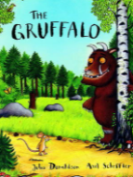

The Snow Wombat
Author: Susannah Chambers Illustrator: Mark Jackson
ISBN: 9781743368435 Publisher: Murdoch Books Year published: 2016
Stage: Early Stage 1 to Stage 1
Supporting concept: imagery, symbol and connotation
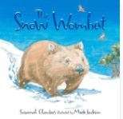

The Terrible Suitcase
Author: Emma Allen Illustrator: Freya Blackwood
ISBN: 9781862919402 Publisher: Scholastic Australia Year published: 2012
Stage: Early Stage 1
Supporting concepts: narrative; perspective
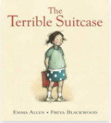

The Very Cranky Bear
Author and illustrator: Nick Bland
ISBN: 9781741691344 Publisher: Orchard Books Year published: 2014
Stage: Early Stage 1 to Stage 1
Supporting concept: narrative
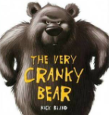

When Billy Was a Dog
Author: Kirsty Murray Illustrator: Karen Blair
ISBN: 9781760631826 Publisher: Allen and Unwin Year published: 2019
Stage: Early Stage 1 to Stage 1
Supporting concept: narrative
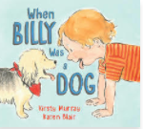

Imagery, symbol and connotation
‘Words and images can extend beyond their literal meaning’ – English Textual Concepts and Learning Processes (2016).
To learn more, view Connotation, imagery and symbol video (6:07)

Identifying imagery, symbol and connotation
To identify texts with the concept of ‘imagery, symbol and connotation’, look for texts that:
- contain word choices which represent more than the literal
- include signs and symbols which represent or suggest things
- are enjoyable due to imaginative use of language
- demonstrate simple figurative language
- contain word play that appeals to the senses
- include cultural symbols.

Recommendations
Use these books to teach students to:
- identify and discuss how creative language and/or symbols enhance enjoyment in texts
- identify how visual cues contribute to the meaning of text
- identify how words and word order influence meaning in texts
- experiment with creative play with language in own texts.

Banjo and Ruby Red
Author: Libby Gleeson Illustrator: Freya Blackwood
ISBN: 9781760127602 Publisher: Hardie Grant Children’s Publishing Year published: 2016
Stage: Early Stage 1 to Stage 1
Supporting concepts: character; narrative
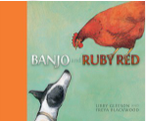

Born to Fly
Author: Patrick Guest Illustrator: Jonathan Bentley
ISBN: 9781761211324 Publisher: Hardie Grant Children’s Publishing Year published: 2022
Stage: Early Stage 1 to Stage 1
Supporting concepts: character
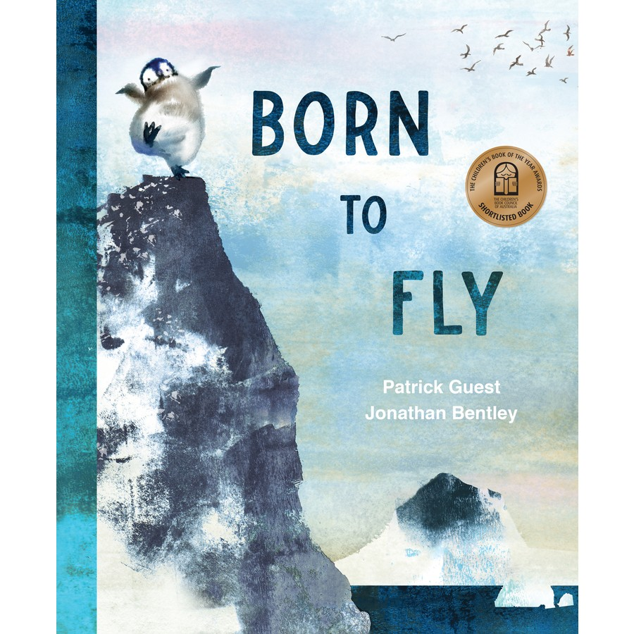

Colour Me
Author: Ezekiel Kwaymullina Illustrator: Moira Court
ISBN: 9781925164664 Publisher: Freemantle Press Year published: 2018
Stage: Early Stage 1 to Stage 1
Supporting concepts: context; perspective
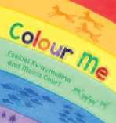

Don’t Let the Pigeon Drive the Bus
Author and illustrator: Mo Willems
ISBN: 9781844285136 Publisher: Walker Books Ltd Year published: 2005
Stage: Early Stage 1 to Stage 1
Supporting concepts: character; perspective
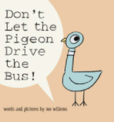

Footpath Flowers
Author: Jon Arno Lawson Illustrator: Sydney Smith
ISBN: 9781406362084 Publisher: Walker Books Year published: 2015
Stage: Early Stage 1 to Stage 3
Supporting concepts: narrative; context; perspective
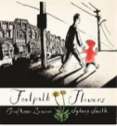

Gary
Author and illustrator: Leila Rudge
ISBN: 9781406368574 Publisher: Walker Books Year published: 2017
Stage: Early Stage 1 to Stage 1
Supporting concepts: character; perspective
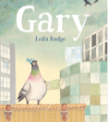

Goodbye House, Hello House
Author: Margaret Wild Illustrator: Ann James
ISBN: 9781911631514 Publisher: Allen and Unwin Australia Year published: 2019
Stage: Early Stage 1 to Stage 1
Supporting concepts: character; narrative
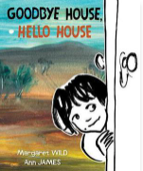

Imagine
Author and illustrator: Alison Lester
ISBN: 9781741147124 Publisher: Allen and Unwin Year published: 2005
Stage: Early Stage 1 to Stage 1
Supporting concept: context
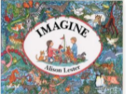

I Need My Monster
Author: Amanda Noll Illustrator: Howard McWilliam
ISBN: 9780979974625 Publisher: Flashlight Press Year published: 2009
Stage: Early Stage 1 to Stage 1
Supporting concepts: narrative; perspective; character
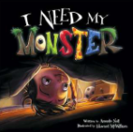

Kissed by the Moon
Author and illustrator: Alison Lester
ISBN: 9780670076758 Publisher: Penguin Books Australia Year published: 2013
Stage: Early Stage 1 to Stage 1
Supporting concepts: context
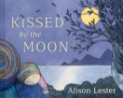

Mopoke.
Author and illustrator: Philip Bunting
ISBN: 9781742991658 Publisher: Omnibus Books Year published: 2017
Stage: Early Stage 1 to Stage 1
Supporting concepts: character
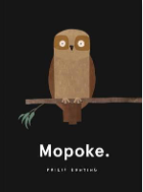

My Dog Bigsy
Author and illustrator: Alison Lester
ISBN: 9780670078936 Publisher: Penguin Books Australia Year published: 2015
Stage: Early Stage 1 to Stage 1
Supporting concepts: narrative
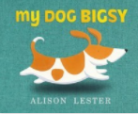

My Friend Fred
Author: Frances Watts Illustrator: A. Yi
ISBN: 9781760290948 Publisher: Allen and Unwin Children’s Year published: 2019
Stage: Early Stage 1 to Stage 1
Supporting concepts: character; context
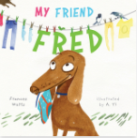

Olivia
Author and illustrator: Ian Falconer
ISBN: 9780689860881 Publisher: Atheneum Books Year published: 2000
Stage: Early Stage 1 to Stage 1
Supporting concepts: character; narrative
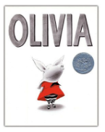

Once Upon an Alphabet: Short stories for all the letters
Author and illustrator: Oliver Jeffers
ISBN: 9780007514274 Publisher: HarperCollins Publishers Year published: 2014
Stage: Early Stage 1 to Stage 1
Supporting concept: character
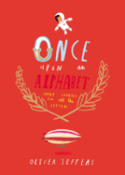

One Runaway Rabbit
Author: David Metzenthen Illustrator: Mairead Murphy
ISBN: 9781911631484 Publisher: Allen and Unwin Australia Year published: 2019
Stage: Early Stage 1 to Stage 1
Supporting concepts: narrative
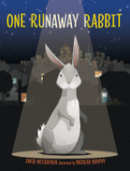

Peace: The invisible tree
Author: Kirrily Lowe Illustrator: Henry Smith
ISBN: 9781925139143 Publisher: Wombat Books Year published: 2013
Stage: Early Stage 1 to Stage 1
Supporting concepts: character; context
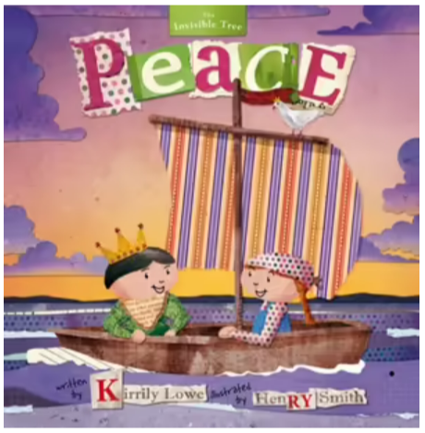

Scary Night
Author: Lesley Gibbes Illustrator: Stephen Michael King
ISBN: 9781921504617 Publisher: Working Title Press Year published: 2015
Stage: Early Stage 1 to Stage 1
Supporting concept: narrative
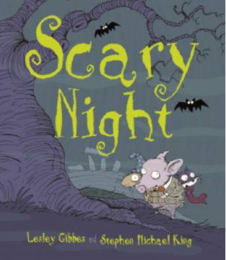

The Barn Owls
Author: Tony Johnston Illustrator: Deborah Kogan Ray
ISBN: 9780881069822 Publisher: Charlesbridge Year published: 2001
Stage: Early Stage 1 to Stage 1
Supporting concept: narrative
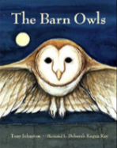

The Great Rabbit Chase
Author and illustrator: Freya Blackwood
ISBN: 9781743811641 Publisher: Scholastic Australia Year published: 2016
Stage: Early Stage 1 to Stage 1
Supporting concepts: character; narrative
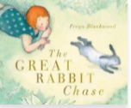

The Leaf Men
Author and illustrator: William Joyce
ISBN: 9781481489553 Publisher: Simon and Schuster Year published: 2017
Stage: Early Stage 1 to Stage 1
Supporting concept: narrative
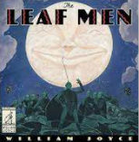

Perspective
‘Perspective is a lens through which we learn to see the world. It provides a dynamic basis for the relationship between composer, text and responder’ – English Textual Concepts and Learning Processes (2016).
To learn more, view Perspective video (3:37).

Identify perspective
To identify texts with the concept of ‘perspective’, look for texts that:
- enable students to have different opinions, preferences for and ideas about the text
- enable students to have different opinions, preferences for and ideas about the author
- enable students to share, develop and question their opinions
- enable students to understand that personal experiences and interests shape their opinions and choices
- enable students to express opinions about the content and issues
- reinforce ideas through images.

Recommendations
Use these books to teach students to:
- express likes and dislikes about a text
- identify favourite stories or characters in texts using verbal and or nonverbal modes
- compare opinions of a text or character with peers.

Chip
Author and illustrator: Kylie Howarth
ISBN: 9781760409623 Publisher: Hardie Grant Children’s Publishing Year published: 2018
Stage: Early Stage 1 to Stage 1
Supporting concepts: imagery, symbol and connotation; character
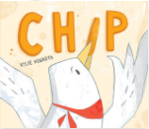

Home in the Rain
Author and illustrator: Bob Graham
ISBN: 9781406379785 Publisher: Walker Books Australia Year published: 2019
Stage: Early Stage 1 to Stage 1
Supporting concepts: narrative; imagery, symbol and connotation
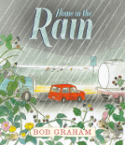

Mr Huff
Author and illustrator: Anna Walker
ISBN: 9780670078042 Publisher: Penguin Australia Year published: 2015
Stage: Early Stage 1 to Stage 1
Supporting concepts: character; imagery, symbol and connotation; context
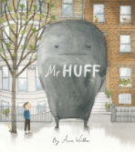

Norton and the Bear
Author and illustrator: Gabriel Evans
ISBN: 9780648785132 Publisher: Berbay Publishing Year published: 2020
Stage: Early Stage 1 to Stage 1
Supporting concepts: character; narrative
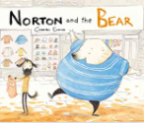

Silver Buttons
Author and illustrator: Bob Graham
ISBN: 9781406360882 Publisher: Walker Books Australia Year published: 2015
Stage: Early Stage 1 to Stage 1
Supporting concepts: character; narrative
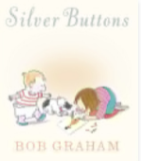

Thelma the Unicorn
Author and illustrator: Aaron Blabey
ISBN: 9781742764085 Publisher: Scholastic Australia Year published: 2017
Stage: Early Stage 1 to Stage 1
Supporting concepts: narrative; character
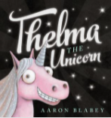

Three
Author and illustrator: Stephen Michael King
ISBN: 9781760664053 Publisher: Scholastic Australia Year published: 2019
Stage: Early Stage 1 to Stage 1
Supporting concept: character
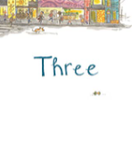

Tricky’s Bad Day
Author and illustrator: Alison Lester
ISBN: 9781925712513 Publisher: Affirm Press Year published: 2018
Stage: Early Stage 1 to Stage 1
Supporting concepts: character; context
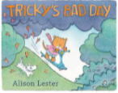

We’re Stuck
Author and illustrator: Sue deGennaro
ISBN: 9781760663476 Publisher: Scholastic Australia Year published: 2019
Stage: Early Stage 1 to Stage 1
Supporting concepts: narrative; character
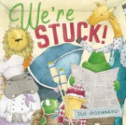

References
Links to third-party material and websites
Please note that the provided (reading/viewing material/list/links/texts) are a suggestion only and implies no endorsement, by the New South Wales Department of Education, of any author, publisher, or book title. School principals and teachers are best placed to assess the suitability of resources that would complement the curriculum and reflect the needs and interests of their students.
If you use the links provided in this document to access a third-party's website, you acknowledge that the terms of use, including licence terms set out on the third-party's website apply to the use which may be made of the materials on that third-party website or where permitted by the Copyright Act 1968 (Cth). The department accepts no responsibility for content on third-party websites.
Except as otherwise noted, all material is © State of New South Wales (Department of Education), 2021 and licensed under the Creative Commons Attribution 4.0 International License. All other material (third-party material) is used with permission or under licence. Where the copyright owner of third-party material has not licensed their material under a Creative Commons or similar licence, you should contact them directly for permission to reuse their material.
English K–10 Syllabus © 2022 NSW Education Standards Authority (NESA) for and on behalf of the Crown in right of the State of New South Wales.
© 2022 NSW Education Standards Authority. This document contains NSW Curriculum and syllabus content. The NSW Curriculum is developed by the NSW Education Standards Authority. This content is prepared by NESA for and on behalf of the Crown in right of the State of New South Wales. The material is protected by Crown copyright.
Please refer to the NESA Copyright Disclaimer for more information.
NESA holds the only official and up-to-date versions of the NSW Curriculum and syllabus documents. Please visit the NSW Education Standards Authority (NESA) website and the NSW Curriculum website.
Board of Studies NSW (2013) Suggested texts for the English K-10 syllabus [PDF 2.34MB], NESA, accessed 16 November 2022.
CBCA (Children’s Book Council of Australia) (2021) Previous winners, CBCA website accessed 16 November 2022.
ETA (English Teachers Association) and NSW Department of Education (2016) The Textual Concepts and Processes resource, English Textual Concepts website, accessed 16 November 2022.
NESA (NSW Education Standards Authority (2022) ‘Text requirements for English K-2’, NESA, accessed 16 November 2022.
NSW Department of Education (2022) NSW Premier's Reading Challenge, NSW Department of Education accessed 16 November 2022.

Further reading
Greene P, NSW Department of Education (2016) Finding the Heart of English [PDF 1.23MB], SCAN 35(1):26-31.
Hoffman J, NSW Department of Education (2017) Representation in English [PDF 4.14 MB], SCAN 36(3):4-13.
Roche M (2014) Developing Children’s Critical Thinking through Picturebooks: A guide for primary and early years students and teachers, Routledge, UK.
Serafini F and Moses L (2014) ‘The Roles of Children’s Literature in the Primary Grades’, The Reading Teacher, 67(6):465-468, doi10.1002/trtr,1236.
Thomson C, NSW Department of Education (2016) Text Selection [PDF 1.54 MB], SCAN 35(3):5-8.

