Connotation, imagery and symbol
English Early Stage 1 student workbook
Name:
Class:

Lesson 1
During this activity you will learn to:
- express feelings and opinions about things
- understand how images can carry connotations.

1.1 Reading and viewing
Watch the recording of Belinda, written and illustrated by Pamela Allen, published by Penguin Random House Australia.

1.2 Speaking and listening
Images hold connotations. A connotation is a feeling or idea created, that is more than just what you see.
Look at these images from the text Belinda. This text is written and illustrated by Pamela Allen, published by Penguin Random House Australia.
What connotations or feelings do you get when you look at each one?
Why?

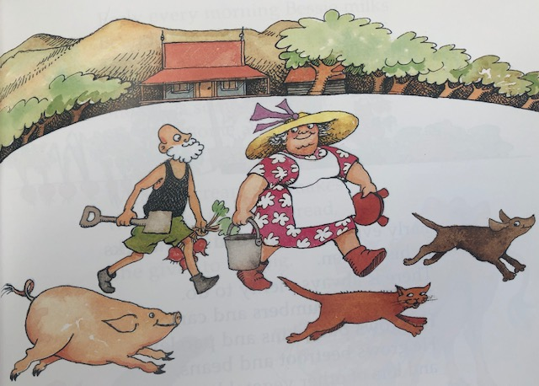
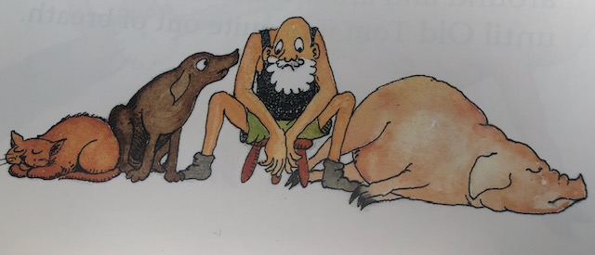
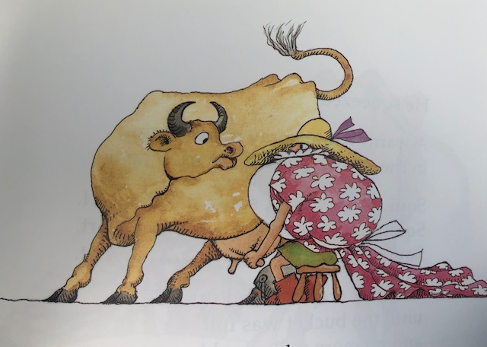
Three images are from Belinda, written and illustrated by Pamela Allen, published by Penguin Random House Australia.

1.3 Writing and representing
The worksheets to help you practise writing lowercase and uppercase ‘gG’ are found in the attachments.
Make sure you are sitting correctly with your feet on the floor.
Hold your pencil so it rests easy in the soft spot between your thumb and your pointer finger. Is your pencil sharp? You’re ready to start writing!
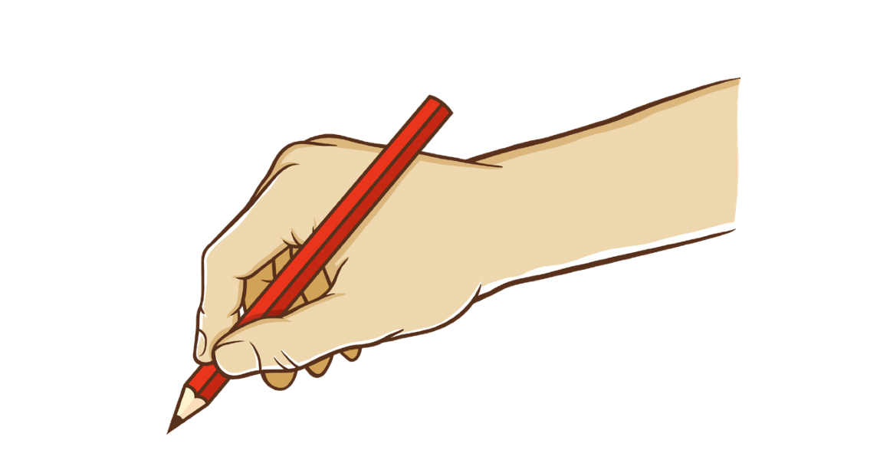 By CC0 1.0 Universal (CC0 1.0) Public Domain Dedication

1.4 Reflection
Can the same images create different feelings or connotations, for different people?

Lesson 2
During this activity you will learn to:
- use words to express your feelings
- think about how images can help you understand the meaning of the text, even when it’s not written on the page
- understand not everyone has the same feelings or responses that you do to certain words.

2.1 Speaking and listening
Words hold connotations. A connotation is a feeling or idea created, that is more than just what the word says.
Play: ‘Thumbs up, thumbs down’.
When each word is presented, indicate with a thumbs up if the connotation is positive, a thumbs down if the connotation is negative. Explain how it makes you feel, what connotations are created for you.
- winter
- beach
- forest
- birthday
- park
- home
- ice-cream
- flowers

2.2 Writing and representing
Choose two of the words from above and draw a picture reflecting the connotations or feelings created for you. You might like to surround the picture with words that describe your feelings.

2.3 Reading and viewing
Practise the new high frequency sight words! Add these to your growing bank:
- her
- his
- up
- my
- off
Write them out multiple times.
Play ‘Snap’! Divide the cards evenly. Take it in turns to reveal a card, saying the word aloud each time. When there’s a match – snap your hand on the cards to claim them.

2.4 Reflection
How can knowing about how words can have different layers of meaning to different people, help you when you are writing a story?

Lesson 3
During this lesson, you will learn to:
- recognise some familiar symbols in your environment
- read and write words with speed, accuracy and efficiency
- practise grapheme-phoneme relationships
- read decodable text independently.

3.1 Speaking and listening
Your teacher may share some other symbols that may not be included here, (such as a fast food symbol)
Why are symbols used, not words?
- What do you notice about the colours?
- Where do you often see these symbols?
- To whom are these symbols aimed?
- How does the size of the symbols impact the message?
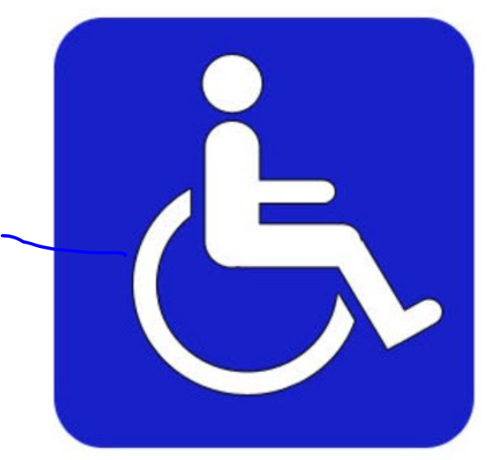
All images licenced under CC0. The original versions can be found on Pixabay

3.2 Reading and viewing
Here are the grapheme-phonemes to add to your growing bank! What common phonemes do these graphemes represent? G, O, C, K
- watch the video
- read the decodable text. Foldable decodable text 1 can be found in the attachments.

3.3 Writing and representing
Use this space to record the words your teacher will ask you to write.

3.4 Reflection
Why do we need to build up stamina when writing? How will writing quickly and being able to write for a longer period of time help me?

Lesson 4
In this lesson, you will learn to:
- retell a simple story, choosing words that make your story meaningful and interesting
- speak clearly, use the right amount of volume to be heard, gesture with your hands when needed and look at people appropriately when speaking.

4.1 Speaking and Listening
Retell a familiar or personal story. Remember to:
- speak clearly
- look at your audience
- speak in a loud enough voice
- remember the order that the story happened
- describe the characters and what happened so I can understand easily.

4.2 Reading and viewing
At last Old Tom stood up and strode into the house.
‘There’s a good girl,’ Old Tom crooned.
Discuss what these words mean.
Show me what they mean.
Use each word in a sentence.

4.3 Writing and representing
The worksheets to help you practise writing lowercase and uppercase ‘oO’ are found in the attachments.
Make sure you are sitting correctly with your feet on the floor.
Hold your pencil so it rests easy in the soft spot between your thumb and your pointer finger. Is your pencil sharp? You’re ready to start writing!

4.4. Reflection
Why should we improve our vocabulary? Do we ever stop learning new words?

Lesson 5
In this lesson you will learn to:
- use words that help express yourself
- engage in word play to have fun and be creative.

5.1 Speaking and Listening

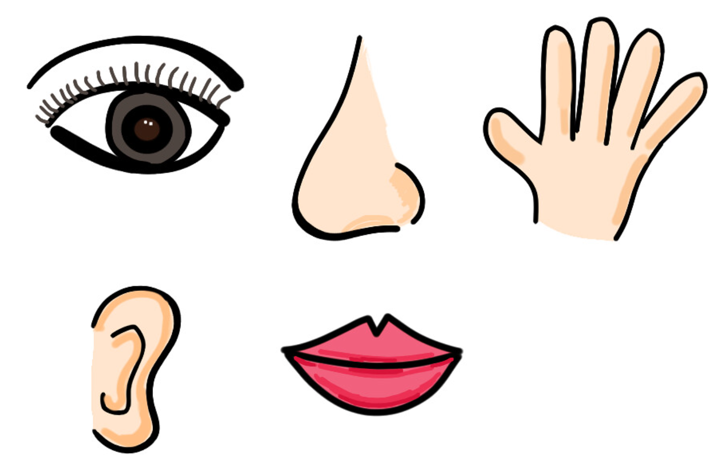
By (CC BY-SA 2.0)
Use your 5 senses and imagination, describe these as best you can:
- the beach
- a horse
- hairspray
- a roller-coaster
- the circus or a carnival
- a desert
- the main street of a city

5.2 Reading and viewing
Here are the phoneme-graphemes to add to your growing bank! What common phonemes do these graphemes represent? G, O, C, K
- watch the video
- read the decodable text. Foldable decodable text 2 can be found in the attachments.

5.3 Writing and representing
Look at the ‘Mooooooooo!’ in the text, Belinda. This is used a few times through the text. What impact does it have on us as readers? Can we use this technique in our own writing? Can you think of the sound these animals make and how we could write it?
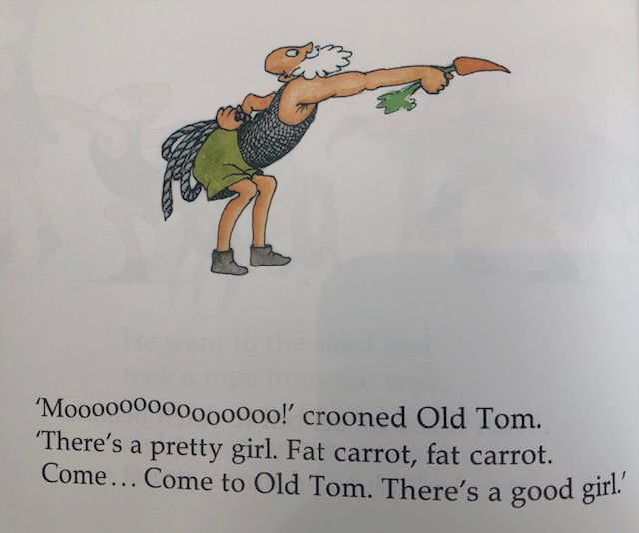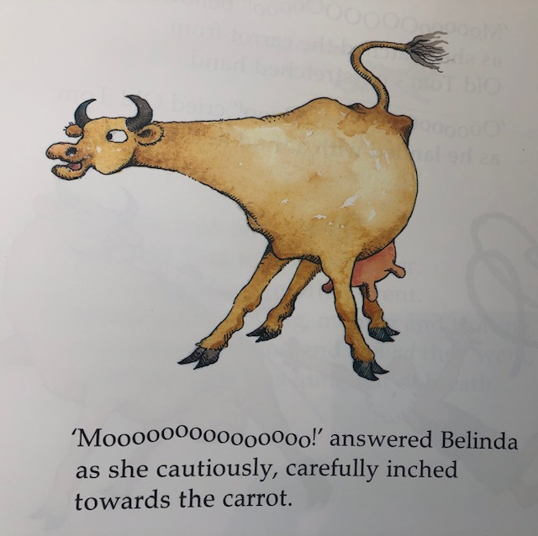
- a cat
- a dog
- an owl
- a kookaburra
- a horse
- a chicken
- a tiger
Say each animal sound aloud and have a go at writing the phonemes you can hear, just like Pamela Allen does.

animal | sound
cow | Moooooooooooo!
cat
dog
kookaburra
horse
chicken
tiger

5.4 Reflection
Can you think of other texts which use this technique? (For example: The Book with No Pictures by B.J Novak)
Why do you think authors use this technique?

Lesson 6
You are learning to:
- write letters correctly using foundation movements that underpin NSW Foundation Style
- understand texts can take many forms and serve different purposes
- describe an object of interest using increasingly descriptive language
- begin to consider author purpose and audience

6.1 Speaking and listening
Look at the two faces below. Choose one to describe to your partner. What colours are used? What shapes can describe elements of the face? Try not to give clues away with your hands!
All images licenced under CC0. The original versions can be found on Pixabay

6.2 Reading and viewing
Listen to or watch the video of Don’t Let the Pigeon Drive the Bus! It’s a funny story, written and illustrated by Mo Willems published by Walker Books,
After hearing the story, think about how the author has written this book. Is it different to other books? How?
How does this change the way it is read?

6.3 Writing and representing
The worksheets to help you practise writing lowercase and uppercase ‘Cc’ are found in the attachments.
Make sure you are sitting correctly with your feet on the floor.
Hold your pencil so it rests easy in the soft spot between your thumb and your pointer finger. Is your pencil sharp? You’re ready to start writing!
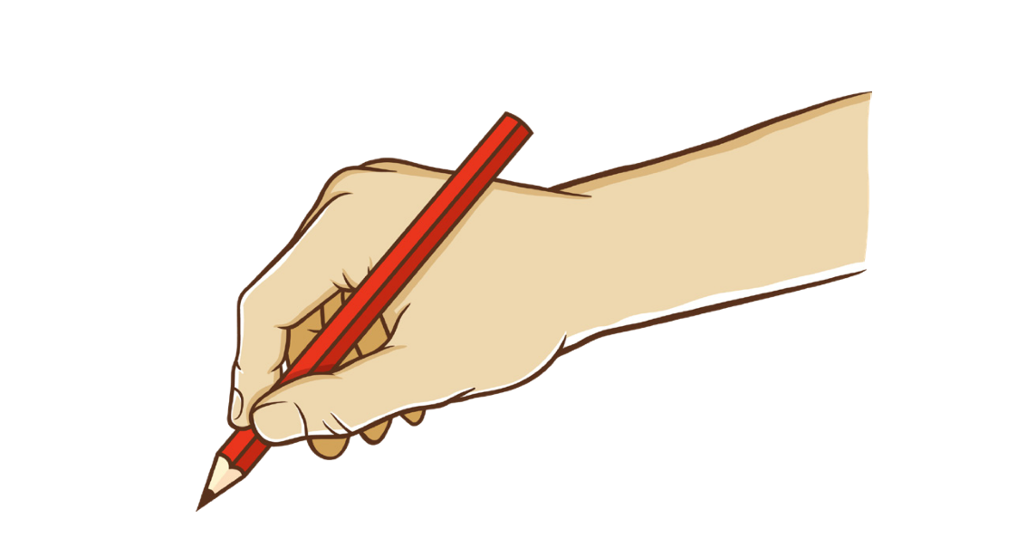Attribution: CC0 1.0 Universal (CC0 1.0) Public Domain Dedication

6.4 Reflection
Why are symbols important in our lives?
What symbols are universal and can be understood all over the world?
What is something that could symbolise you?

Lesson 7
During this lesson, you will learn to:
- engage in word play
- read a decodable text independently

7.1 Speaking and listening
Play ‘Silly Name Game’.
Name people with a kind, descriptive word that also starts with the same phoneme as their name, e.g. Magnificent Mel, Healthy Heather, Neat Natasha.

7.2 Reading and viewing
Here are the phoneme-graphemes to practise! What common phonemes do these graphemes represent? G, O, C, K
- watch the video
- read the decodable text. Foldable decodable text 3 can be found in the attachments.

7.3 Writing and representing
Look at this page from the book, Don’t Let the Pigeon Drive the Bus! By Mo Willems.
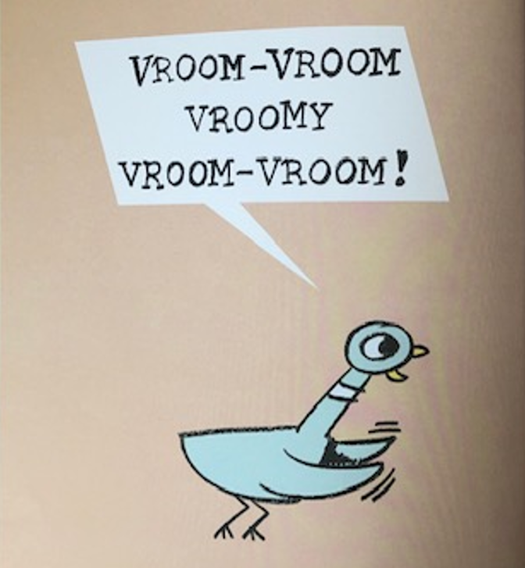
- What are these words representing?
- Are these real words?
- Should words that aren’t real be in a story?
- What do these words represent?
- What does the author want us to do?
Write ‘sounds’ to add description to these items. Your teacher may show you additional pictures.

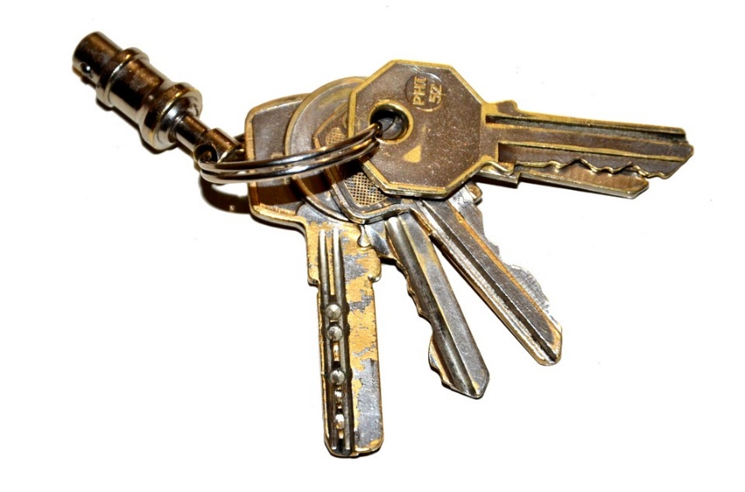
h

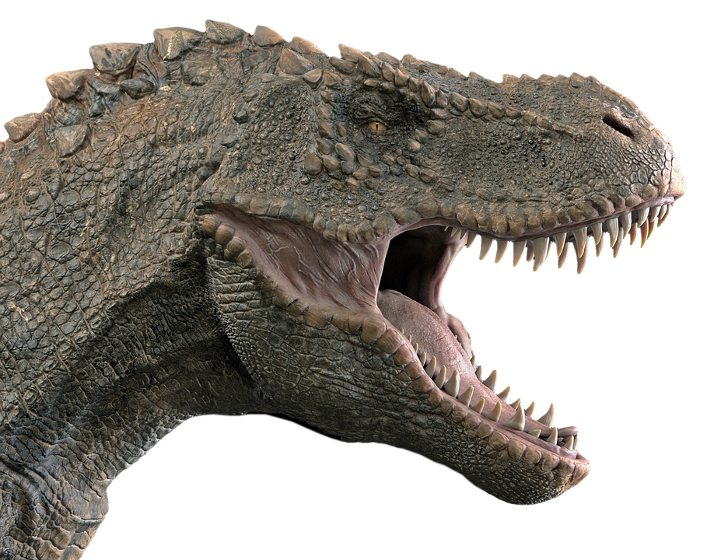

Previous four images in 7.3 licenced under CC0. The original versions can be found on Pixabay

7.4 Reflection
How do you think your reading of decodable texts is progressing? What can you do to improve your reading?

Lesson 8
During this lesson, you will learn to:
- think about words and the feelings we have towards certain words
- practise high frequency sight words
- practise handwriting to write faster and accurately

8.1 Speaking and listening
Words hold connotations. A connotation is a feeling or idea created, that is more than just what the word says.

8.2 Reading and viewing
Practise these high frequency sight words:
- her
- his
- up
- my
- off
Write them twice on cards so you have 2 sets. Lay them face-down on a flat surface and turn two over, trying to reveal a matching pair. Each time a card is turned, the player must say the word aloud. If a matching pair is revealed that player ‘keeps’ the cards. When 2 unmatched cards are revealed, turn them face-down again and keep playing!

8.3 Writing and representing
Practise writing the letter ‘kK’, both lowercase and uppercase. The worksheets can be found in the attachments.
Make sure you are sitting correctly with your feet on the floor.
Hold your pencil so it rests easy in the soft spot between your thumb and your pointer finger. Is your pencil sharp? You’re ready to start writing!
By CC0 1.0 Universal (CC0 1.0) Public Domain Dedication

8.4 Reflection
How do you think your handwriting is progressing? Why is it important we learn to write letters the right way and hold the pencil correctly?

Lesson 9
You are learning to:
- use persuasive language for impact
- read words using the skill of blending phonemes together
- think about stories deeply and interpret images.

9.1 Speaking and listening
Using persuasive language and about 3 convincing reasons, tell me why you should be allowed to:
- wear whatever you want to school
- determine what food and drink is available from the school canteen
- decide what time you go to bed.

9.2 Reading and viewing
Discuss the image using the prompts below:
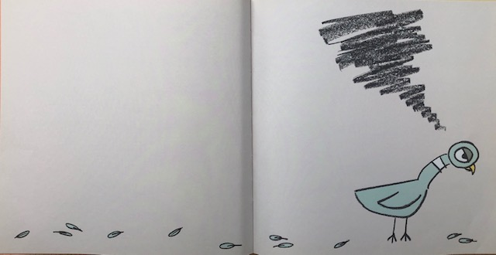
- What is NOT on the page? (print)
- What does this image ‘say’ to you?
- Look at the space around the pigeon, the blank page and the scattered feathers. What do these tell you?
- What does the black scribble above the pigeon’s head symbolise?
- When have you felt the same way as the pigeon? Explain what happened.

- watch the phonics video
- Read Foldable Decodable 4 to practise high frequency sight words and taught phonemes.

9.3 Writing and representing
Objects, colour and line can symbolise feelings.
Imagine the pigeon IS allowed to drive the bus! Draw the pigeon in the centre of the space below.
Brainstorm symbols (for example, a flowers, party hat), colours and lines you can use to connote excitement and happiness. Draw these around the pigeon.

9.4 Reflection
What colours can we use to symbolise all different kinds of emotions? For example, what colour could we use for anger, boredom, irritation, pride.

Lesson 10
You are learning to:
- engage with and appreciate word play

10.1 Speaking and listening
Try these funny tongue twisters!
Image from Pixabay
- What do you notice about tongue twisters?
- What is one major element of a tongue twister?
Tommy Turtle took a tumble turning towards the trees.
She sells sea shells by the sea shore.
Betty Bottler bought a bunch of berries.
The slithering snake slid sideways silently.
- Can you make one up yourself?

10.2 Reading and viewing
Here are the phoneme-graphemes to practise! What common phonemes do these graphemes represent?
- Read aloud foldable decodable text 5, which can be found in the attachments.

10.3 Writing and representing
Your teacher will say some phonemes, or words, or sentences for you to write.
Write neatly so I can read it. ☺

10.4 Reflection
Discuss: Why do we need to know how to spell words the same way?
Does it matter if we all spell words differently?
What problems can you see if we all spelt the same words in our own way?

My Record of Texts
‘Texts’ includes sound, print, film, digital and multimedia. It’s the way we communicate. So that means it can be a book, text message, podcast, play, website and even a movie. When we talk about text, it could be any of these communications.
Record the title of each text you engage with (or if it is a novel, you might like to record each chapter title).
Date | Title | Type of text | Independent or shared | Notes
1 April | The Barber Shop Scissor Twister | comic | Shared with dad | I recommend this comic because it is funny. Dad did funny voices.

