Past the Shallows

The Importance of the Sea
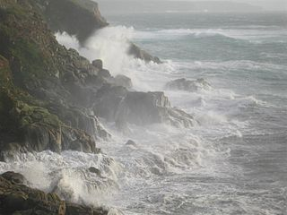
Retrieved from Tom Corser Wild Sea: https://commons.wikimedia.org/wiki/File:TomCorser_Wild_sea_IMG_5974.JPG
Consider the role the sea plays in the text as both a symbol and a stylistic feature. Look at the table below and read about the characteristics of the sea. Fill in the blanks in the table finding quotations from the text that encapsulate that characteristic.

Characteristic | Detail | Quotation/s
The sea and the coastline is old, it has always been present and permanent | Historical perspective provided the D’Entrecasteaux (explorer) logbook extract in the first prologue.  Harry gets a sense of the coastline’s age in the first section
The sea can be very threatening once you venture ‘Past the Shallows’ | 2nd prologue and then frequently throughout the novel | “Black and cold and roaring.”
The sea as a holder of “treasure” and material wealth.
The sea as a source of destruction and death
The sea can have different moods, just like a person or character | This is called anthropomorphism.  It is mainly Miles who seems to be aware of his quality.
The sea can be a source of both beauty and pleasure
It can be a source of mystery, because you can never be sure what lurks beneath the surface.
The sea can act as a macrocosm, for example, it can reflect the moods and emotions of characters | Note how the sea seems to change when Joe tells Miles that he is leaving.

