The story of displacement in Australian art

Reading Visual Texts
Visual literacy is the ability to decode, interpret, create, question, challenge and evaluate texts that communicate with visual images. These texts include film and television, advertisements, artworks, photographs, in fact any text which conveys meaning through images.
People interpret visual texts in many different ways. How a person ‘reads’ a visual text, whether it is a film or a photograph, may depend on several factors such as the person’s age, knowledge of the world, values, cultural background and gender.
To enable us to decode, interpret and evaluate visual texts, we need to use the appropriate language of visual literacy. To construct effective visual texts, we need to understand the impact we want the visual text to have on responders. The following unit introduces visual techniques used by composers which have intended or non-intended impacts on responders.

Subjective Frame
Personal Response: How do you respond to this painting by Robert Dowling?
- What do you feel?
- What is the composer intending to convey about the subject and the times?
- Do you think you are receiving a different message to that which the composer is intending to convey?

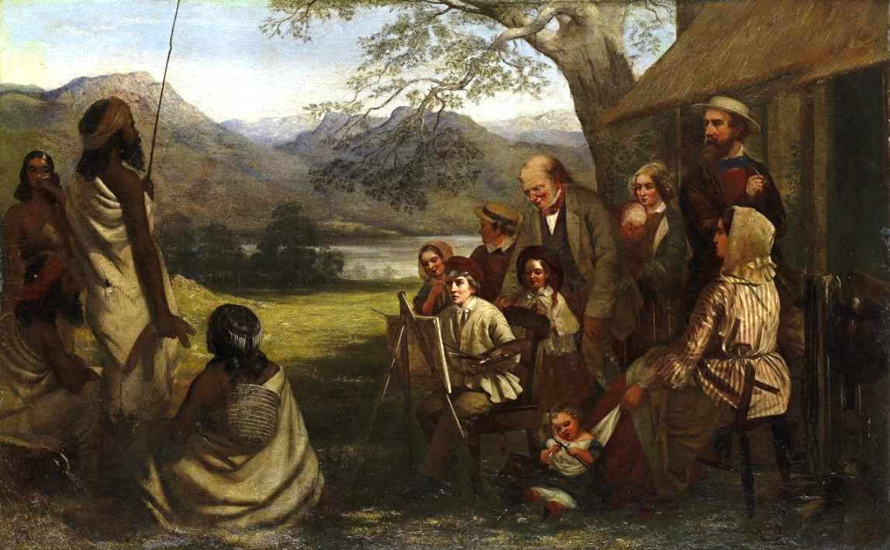
Source: http://www.ngv.vic.gov.au/essay/depictions-of-aboriginal-people-in-colonial-australian-art-settler-and-unsettling-narratives-in-the-works-of-robert-dowling/

Structural Frame
Techniques: How does the image make meaning?
- Framing or Composition
- Salience
- Gaze
- Vectors
- Demand and Offer
- Angles
- Shot
- Colour and lighting
- Contrast
- Symbolism and icons
Teacher to source appropriate images
Do these images convey a sense of ‘displacement’ or ‘belonging’? With reference to the techniques listed above, give reasons for your answer.

Cultural Frame
Context: How would this image have been received, and how does it reflect its times?
- Historical: When and where?
- Cultural:
- Political
- Social
- Responder’s context
- Impact on Meaning?

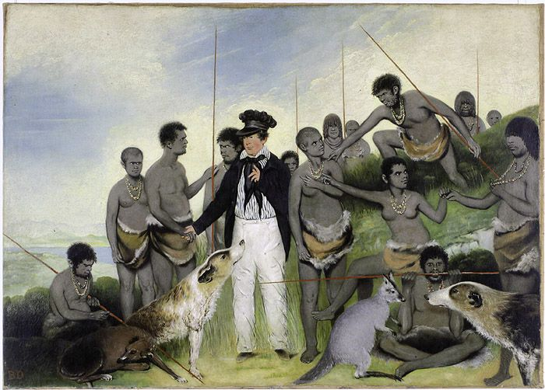
The Conciliation (c 1840) painting idealised the work of George Augustus Robinson, who was the Chief Protector of Aborigines in Port Phillip District, Tasmania, from 1839 to 1849. Source: http://shapingtasmania.tmag.tas.gov.au/object.aspx?ID=84

Critical Frame
Representation: How could this image be read?
- Gaps and silences
- Manipulation of image
- Positioning of responder

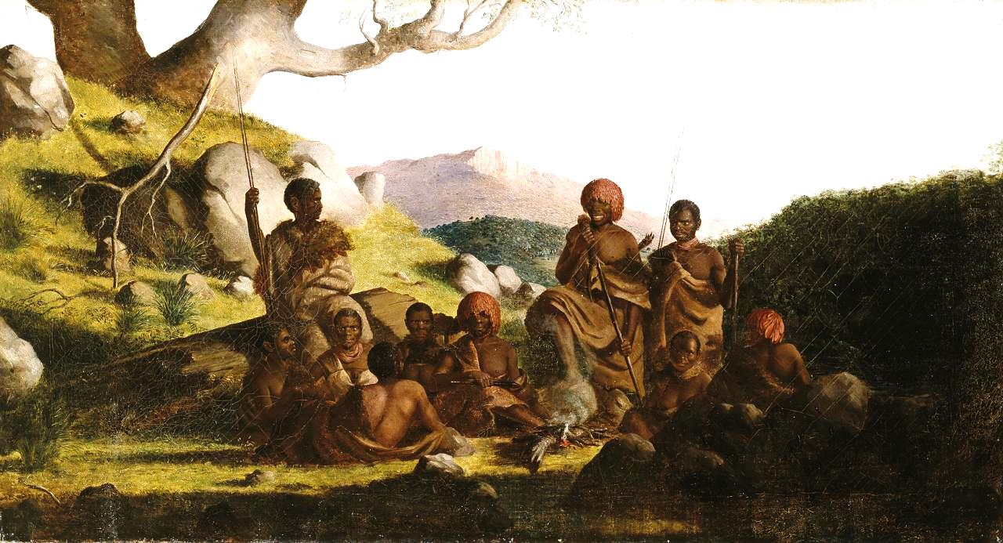
Robert Dowling – Tasmanian Aborigines 1856-1857. Source: https://www.ngv.vic.gov.au/explore/collection/work/5514/
- The composer appears to have manipulated the composition of the image in a way that may not have been natural? What is it about the image which suggests this?
- What is it in reality that the composer may not have been showing – the gaps in the message?
- How is the responder positioned and how does this affect our understanding of this scene?
- From the way this group of people has been presented to us, is there any evidence they have been displaced from the land? Give reasons for your answer.
Research information on the artist, Robert Dowling, and say how his cultural background and the time in which he was painting are likely to have influenced his ideas.

Composition

Layout
Mise-en-scene: What is placed deliberately in the frame?
Rule of thirds: Top third of frame empowered.
Background: Contextualised background is one which provides a place, time or setting for the viewers. Non-contextualised background is one which can be saturated colour or no colour and provides less contextual information for viewers.
- What messages are being conveyed in the two images below?
- How does the composition of each image contribute to our understanding of the message being conveyed?
- Consider the mise-en-scene of Dowling’s painting and suggest reasons for the positioning of the various elements within the frame.
Batman’s painting has very little in the background to give the subjects context whereas Dowling’s painting provides a contextualised background. What effects are produced by these two different techniques?

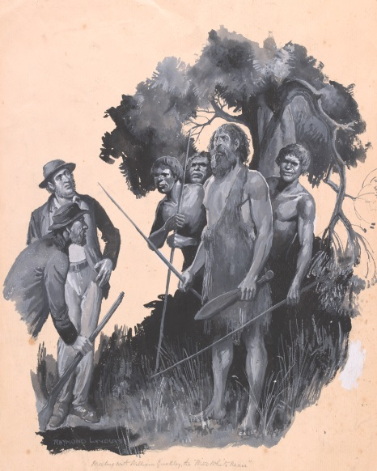
Buckley and the Aborigines by John Batman. Source: http://ergo.slv.vic.gov.au/sites/default/files/imagecache/download/h13582.jpg

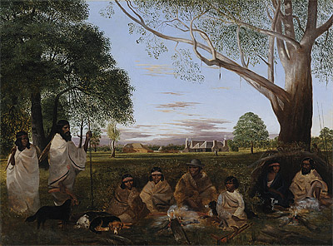
Robert Dowling: Minjah in the old time and the Mopor people at Minjah Station 1856. Source: https://nga.gov.au/Exhibition/DOWLING/Default.cfm?IRN=192024&MnuID=3&ViewID=2

Framing: Shots
Close up shot: Head and shoulders
Mid or medium shot: Upper part of a person’s body
Long distance shot: Full person showing long distance or depth
God’s or Bird’s eye view: From a great distance looking down)

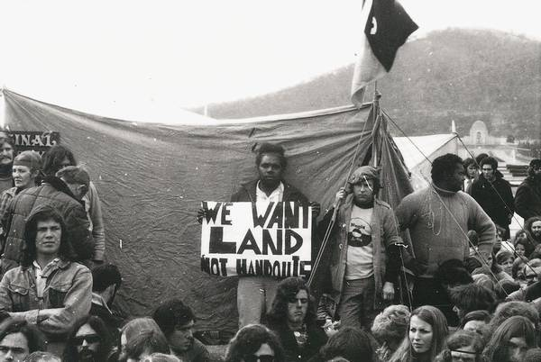
Aboriginal Tent Embassy, Canberra. Source: http://indigenousrights.net.au/land_rights/aboriginal_embassy,_1972

Aboriginal Tent Embassy, Canberra
Aboriginal people erected the Tent Embassy in 1972 in Canberra to protest against a court decision over mining operations on indigenous land.
Many struggles and battles later, the Embassy has become a heritage-listed landmark for Aboriginal protest.
How does the third image raise the subject of displacement?

Perspective: Camera Angle
High angle: Angled down from a high position - can show submission
Low angle: Angled up from a low position - can show dominance
Eye level: Can show equal power also a close connection to the viewer
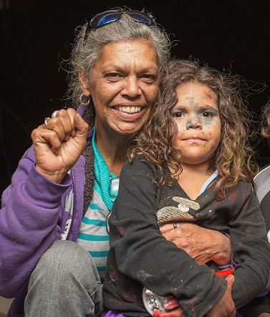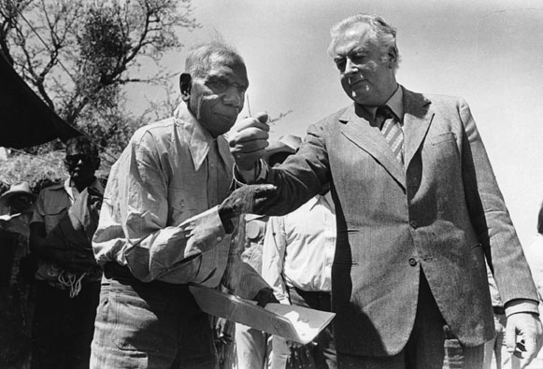
Prime Minister Mr Whitlam symbolically returning the land to the indigenous community represented by Vincent Lingiari. Source: http://www.sbs.com.au/nitv/article/2016/03/02/vincent-lingiari-gough-whitlam-story-behind-image
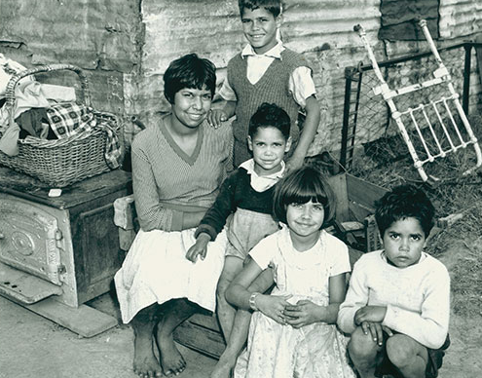
Source: http://www.newcastle.nsw.gov.au/Library/Heritage-History/Family-History/Indigenous-Resources

Body Language
Facial expression
Gestures
Posture
Position of body or hands
Proximity to others
Examine the following images from the film, “Rabbit Proof Fence” and explain how body language conveys meaning about place and displacement. (Teacher to source appropriate stills from the film).

Image | Explain how body language conveys meaning about place and displacement
Molly and her mother
Constable Riggs
Daisy with Molly and Gracie looking out the back window of a car
Mr Neville looking down at children
Daisy, Gracie and Molly together
Molly and Daisy as old women

Colour
- Symbolism: red = passion; blue = peace and tranquillity; black = death or fear
- Monochromatic: black and white or a single colour, for example; red and all shades of red
- Saturation: the intensity of colour in an image. As the saturation increases, the colours appear to be more pure. As the saturation decreases, the colours appear to be more washed-out or pale.
A lot of indigenous art and literature speaks to us of displacement however there are many works which convey a strong sense of place. Examine this statement in the light of Albert Namatjira’s work.
Teacher to source appropriate Albert Namatjira paintings.
Albert Namatjira (28 July 1902 – 8 August 1959), was a Western Arrernte-speaking Aboriginal artist and traditional custodian of the MacDonnell Ranges in Central Australia. As a pioneer of contemporary indigenous Australian art, he was the most famous indigenous Australian of his generation. His landscape paintings are iconic images synonymous with the Australian outback.
Unlike earlier images painted by colonial artists, Namatjira’s art does not show the need to place people prominently in the landscape. Instead these images convey a strong sense of place where the land is always dominant.
Examine his artwork in colour and apply your knowledge of visual imagery to describe how you feel about his images of the central Australian landscape.

Resources:
Visual techniques: http://unswict.wikispaces.com/file/view/Visual+Techniques.pdf
Film Techniques: http://www.psu.edu/dept/inart10_110/inart10/

