Model of communication - how we see the world?
Context is the influence of the real world on composer and responder. It affects how we make meaning of a text.
Perspective is a lens that we view the world from which may differ because it is framed by language, personal view and culture. The lens can clarify, magnify, distort or blur what we see. By changing the position of the lens, different aspects of the text may be foregrounded. In this way Textual Conversations explores how two texts studied together can illuminate aspects of, and offer insight into, each other, much like a conversation. Each rereading helps us break down the cultural and ideological frames that position us to accept certain views of the world and recognise how these lenses are working so that we can choose to accept or dismiss the values that they entail and become critical thinkers.
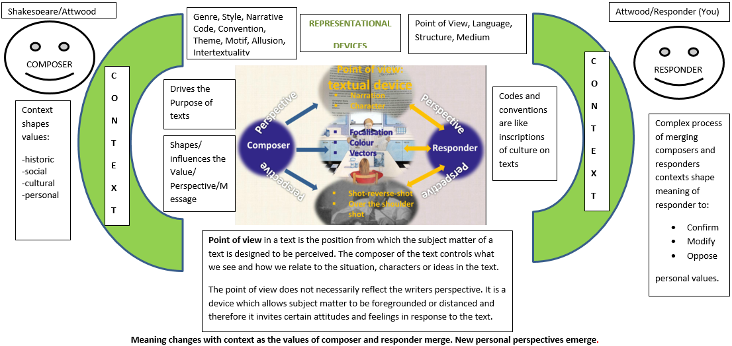
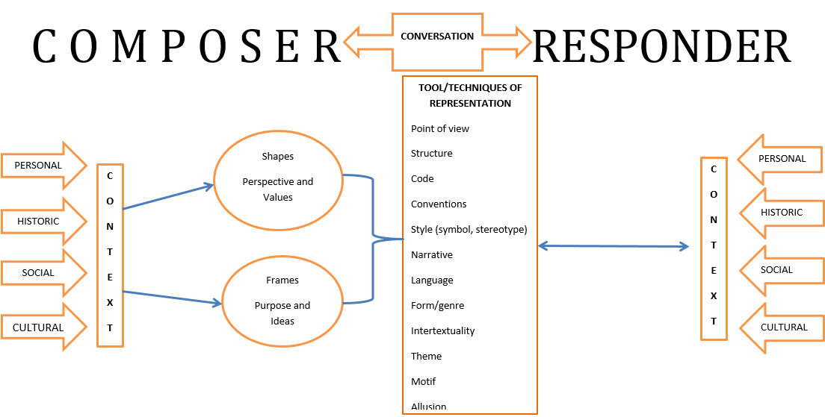
Composers represent people and the world through texts, and in so doing impart their perspective of the world. When merged with the responder’s context, perspective is reshaped and values are consolidated through alignment and mirroring, or abandoned as values are weakened through subversion and contradiction.
Examining two texts which reimagine or reframe each other sheds light on the vital role of context in shaping meaning and the complexity of representation which inscribes in our culture through textual codes and conventions complex and interdependent layers of meaning.

Commonality within these texts will reveal the binding codes and conventions of the canonical texts that still resonate as the universal and timelessly unresolved paradoxes of the human experience, whereas the disparity between the texts will reflect the unique perspectives that emerge through the changing effects of context on meaning.

