The Tempest: Shakespeare Uncovered documentary
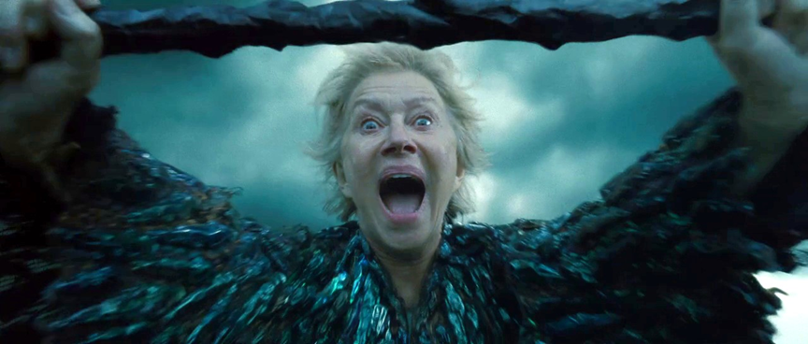
- What makes The Tempest ‘experimental’?

- What makes The Tempest unique from all of Shakespeare’s other plays?

- What ‘huge questions’ does the play ask its audience?

- What key relationships does the play explore, and what in particular about this relationship?

- How have we seen this already in what we have read?

- What theory does the documentary offer on where Shakespeare’s inspiration for the play comes from?

