The Tempest: Shakespeare Uncovered documentary
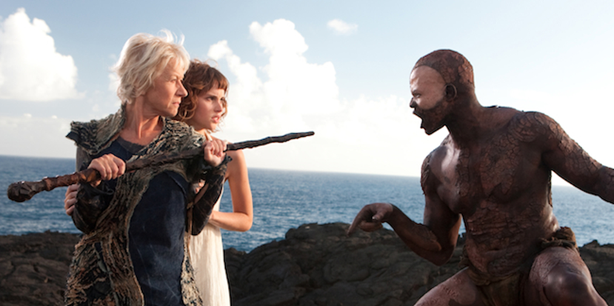
- The documentary states that in the play, “Prospero has brought his enemies ashore not only to settle an old score, but to secure a new future for his daughter”. What is this ‘new future’?
- to be Queen of Milan
- to be Ferdinand's wench (a Shakespearean synonym for 'woman'!)
- to be Queen of Naples
- to be the inheritor of Prospero’s island
- Prospero has raised Miranda on the island for twelve years. Miranda then becomes a key part of Prospero's plot for his enemies, as he encourages her to fall in love with Ferdinand, and vice versa. Do you believe Prospero is too controlling of Miranda's fate - yes or no? Why?

- The documentary asks, 'do we trust Prospero?' It states that "the play hinges on a moral question - what is he [Prospero] going to do with them [his enemies from the shipwreck]? ... Will Prospero be capable of forgiveness?" Having now started Act III, what do you think Prospero's plan involves? Will it include forgiveness, and why/why not?

- What important contextual information to do with Shakespeare's personal life is believed to possibly have had an influence on the play's plot, in particular with regards to Prospero's role as a father?
- The sudden death of Shakespeare’s wife
- Shakespeare's older age at the time of writing.
- Shakespeare's experience of being a castaway of a remote island
- The failed marriage of Shakespeare’s daughter
- Fill in the blanks:
The documentary states that Shakespeare leaves what the island 'looks like' to "our _________, so we can create our own __________ world, and magical it must be".
- Why is it important that the audience is left to 'imagine' what the setting of the play physically looks like? Think about the theme of 'imagination'! Be detailed in your answer.

- Which character in the play is most indigenous to the island that is its setting, and therefore has the most claim to it?
- Caliban
- Ariel
- Prospero
- Gonzalo
- The documentary talks about Gonzalo's utopian 'vision' for the island in detail. It describes how the vision, which involves a society free of violence, is "quickly dashed" by Antonio and Sebastian's conspiracy to murder the King and his men after they fall asleep. It states: "No sooner has he [Gonzalo] described it [the vision] when Shakespeare crushingly presents the obstacles there would be in achieving it". In other words, by having Sebastian and Antonio nearly murder the sleeping men for power, Shakespeare reminds us that humankind's natural tendency for violence makes 'utopia' impossible. To do this, he uses the technique:
- Juxtaposition
- Hyperbole
- Simile
- Metaphor
- The documentary goes on to describe that "even in a new land, if you create a human society, the worse human instincts will always emerge". How do these 'worse human instincts' emerge when Prospero first arrives on the island after he is banished (before the beginning of the play's plot)? What does Prospero do that makes him less of a 'good' character? Be specific.

- Match the following examples from the play with the correct techniques:

Examples | Matching | Techniques
Ferdinand: "Oh, [Miranda] is ten times more gentle than her father's crabbed".  Throughout the play, the audience is aware that the shipwreck was created by Prospero, and that all characters are still alive. All characters except Prospero do not know this.  Sebastian: "This is a strange repose, to be asleep with eyes wide open, standing, speaking, moving, and yet so fast asleep."  "A tempestuous noise of thunder and lightning heard." |  | Listing  Simile  Stage Direction  Dramatic Irony

