Resource 3

Character focus: John Proctor

Who is John Proctor?
The following narration is provided on page 27 when we are introduced to John Proctor:

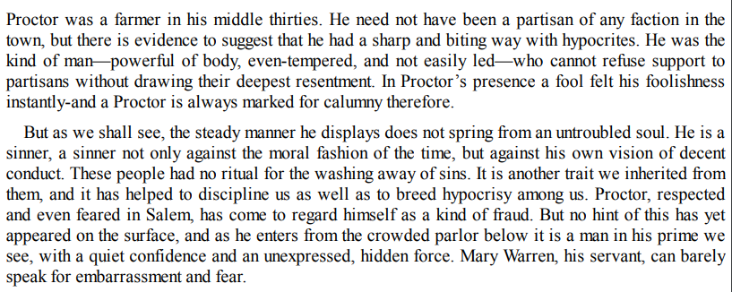
Please answer the following questions:
- What does this suggest about the man?
- Who is he publically and privately?
  - Publically:
  - Privately:
- Why would he fear these worlds becoming the same? What paradoxes are already evident in him as a man?

