A teacher’s lament … a story about a run-in with a wombat
by Lorri Bev
A few short years ago, I was teaching in country NSW, not far from our national capital, Canberra. My job involved travelling between schools, supporting teachers in the delivery of exciting English lessons for students.
One clear, chilly, winter morning, not long after daybreak, I was driving along a meandering country road. I felt a sense of deep peace with my surroundings, like I was one with the environment. I was almost hypnotised by shards of pale sunlight that glistened like jewels in the early morning light. Clearly, I should have been paying better attention to the road ahead…
In a seeming lightning flash, a hairy brown, moving brick was smack bang in front of the shiny, new government car that I was driving. It seemed to come from nowhere! I slammed on the brake suddenly, the car slid on the wet, slippery, icy road, then careered into a nearby tree. I reeled from the shock of the impact. At that moment, I glanced back over my shoulder, and glimpsed a large, furry, brown wombat disappear nonchalantly into the scrub on the other side of the road, a momentary flash out of the corner of my eye.
“What will I do now?” I pondered to myself. “The car is a write-off!” Fortunately, there was mobile phone coverage so I rang my trusty, understanding office manager Jess who commiserated with me and lamented, “Oh, you poor dear!”. Her voice dripped with concern as she inquired, “Are you OK?, ”and “Are you injured?” Jess was always good for tea and sympathy.
In next to no time, a tow-truck pulled up alongside me. In her usual efficient way, Jess had organised my safe rescue. “Howdy!”, boomed a friendly, burly tow truck driver out of the window of his rusty, dusty tow- truck. “I’ll wager you had a run-in with a wombat and the wombat won!”
On the drive back to town, the tow truck driver and I chatted about my accident. “Wombats on roads keep me in business out in these parts”, he grinned. “You’re lucky, they are solid like a concrete block and have even been known to flip over a car if hit at speed”.

In the weeks following my run-in with the wombat, I reflected on what the tow- truck driver had told me about wombats causing numerous car accidents on country roads. I was glad I had been driving slowly however I chided myself on not paying better attention to the road whilst driving. One thing that I was relieved about though… the wombat escaped unharmed, without a scratch. It was the car that came out worse for wear! Sadly, many wombats are not so lucky and are killed on our roads every year by unsuspecting motorists. We share a responsibility to keep these fascinating, precious, national symbols safe for future generations to enjoy.
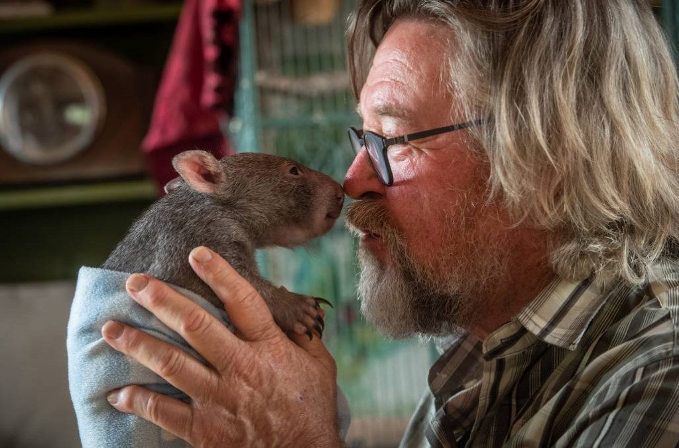
Permission granted Bill Waterhouse @MajorsCreekWombatRefuge.

