Conversations and appropriation in the artworld – Year 12 Visual Arts case study
Student resource booklet

Contents
Overview 3
Case study learning activities 5
Week 1 – Shadow cast over a painter’s legacy 5
Defining terms 6
Scavenger hunt 7
Changing perspectives 11
Summarising 14
Week 2 – Margaret Preston 15
Australia in the 1920s 15
Article review 16
Critical reflection 18
Summarising 18
Extension – Further research 19
Week 3 – ‘Aboriginalia’, Australian design history, and copyright law 21
Tony Albert on ‘Aboriginalia’ 21
Australian Aboriginal Decorative Art 22
Aboriginal artists and copyright law 24
Extension – Changing practices 27
Week 4 – Gordon Bennett 29
Gordon Bennett: concept and intention 29
Summarising 30
John Citizen – ‘Interiors’ and ‘Aboriginal art’ series 31
‘Home décor (after M. Preston)’ 33
Summarising 34
Week 5 – Tony Albert 35
‘Sorry’ 37
‘Conversations with Margaret Preston’ – Changing meanings 38
Exhibition review 39
Summarising 41
Week 6 – Putting it all together 42
Scaffolding 42
Extended response 43
References 44
Further reading 47

Overview
This case study focuses on an investigation of Australian artist Margaret Preston’s appropriation of Aboriginal motifs in her practice. Preston’s artmaking and critical writing are considered from modernist and contemporary, postmodern perspectives. Her practice is also considered through the lens of contemporary re-interpretations of her work by two Aboriginal artists – Gordon Bennett’s Home Décor series (1996 – 2014) and Tony Albert’s Conversations with Margaret Preston (2020). These artists have both appropriated and recontextualised Preston’s works to comment on issues of identity, authenticity, and the colonial lens through which Aboriginal people were viewed during Preston’s lifetime. This investigation is situated within the postmodern frame, and relationships between artists, artworks, world, and audience are examined to reveal challenges to historical narratives of art through an analysis of the intentions, choices, and actions of 3 artists who have used appropriation in their practice.
Tony Albert (b. 1981) is a contemporary artist descended from the Girrimay, Yidinji and Kuku Yalandji peoples of far north Queensland and a founding member of the proppaNOW collective. He has incorporated his collection of ‘Aboriginalia’ – kitsch 20th century design objects featuring representations of Aboriginal people – into his artmaking practice throughout his career. In his 2020 body of work Conversations with Margaret Preston he draws from his collection of ‘Aboriginalia’ fabric samples to appropriate Preston’s works to interrogate and critique her legacy.
Gordon Bennett (1955 – 2014) is considered one of Australia’s foremost postmodern artists. He became aware of his Aboriginal heritage when he was 11, but through his career he resisted being labelled or typecast as an Aboriginal artist, which he says, ‘both misrepresents me and denies my upbringing and Scottish-English heritage’. His extensive body of work examines the tensions between Aboriginal and non-Aboriginal Australia, exploring social, historic, and personal issues of race and identity. Home Décor is a body of work consisting of several series of paintings made between 1996 and 2014. The works range in complexity, from simple appropriations of Margaret Preston’s decorative works to densely layered compositions that quote from multiple art historical sources. Ultimately, Home Décor interrogates and critiques the ‘noble savage’ view of Aboriginal people perpetuated by the use of Aboriginal motifs by non-Aboriginal artists and designers.
Margaret Preston (1875 – 1963) is a much-celebrated Australian artist renowned for her painting and printmaking practice. Often credited as a leading figure in Australian modernism, Preston’s explorations of Australian flora and landscapes represent her desire to establish an independent Australian style, influenced by but distinct from European modernism. Inspired by the primitivist practices of European modernists like Paul Gauguin, Preston advocated that ‘a great national art’ in Australia could only be established by referencing traditional cultural designs from Aboriginal peoples. In her artmaking and critical writing in the 1920s and 1930s, Preston began to integrate these into her own practice, and encouraging other artists and designers to do the same.

Case study learning activities

Week 1 – Shadow cast over a painter’s legacy
One of Australia’s most significant artists, Margaret Preston was a key figure in the development of modern art in Sydney from the 1920s to the 1950s. Renowned for her paintings and woodcuts of local landscapes and native flora, she was an outspoken public voice on Australian culture and championed a distinctly Australian style, based on the principles and motifs of modernist, Aboriginal and Asian art.
Extract from Margaret Preston Biography – Margaret Preston | Art Gallery of NSW
Margaret Preston saw herself as a strong advocate for Aboriginal art, but her work has left a complicated legacy. Preston focused on the abstract visual qualities of the designs she appropriated, and specifically dismissed any recognition of the cultural and spiritual significance of the images she drew influence from. This superficial treatment of Aboriginal motifs as decorative elements for design application has had a lasting impact – traditional designs and primitivist depictions of Aboriginal people were used extensively for home décor, graphic design, and souvenirs in the mid-20th century. As art made by Aboriginal people came to prominence in the late 20th century, issues of theft and misuse of traditional designs by non-Aboriginal people continued. Whilst there is a growing resistance to this form of ‘cultural appropriation’ in the 21st century, issues of authenticity and design theft are ongoing.
Tony Albert and Gordon Bennett are 2 Aboriginal artists who have appropriated Margaret Preston’s works to respond to her practice of using Aboriginal motifs in her practice. Both artists have sought to ‘reclaim’ these images, challenge the outdated practice of non-Aboriginal artists and designers using Aboriginal images in their work, and to engage audiences in a ‘conversation’ about changing values and ideas about appropriation in the artworld.
Watch Tony Albert’s video where he discusses his exhibition ‘Conversations with Margaret Preston’ (2:40).
Video transcript:
Margaret Preston is certainly one of Australia’s greatest painters. However, there are many works that can be looked at, and remain quite problematic and unsettling. For her era, looking at ideas of a national identity was courageous. I understand the reasoning and thoughts behind her works. Whilst having the greatest of intentions, Margaret Preston played a part in opening the floodgates to appropriation and cultural pillaging of Indigenous imagery and cultural objects. There are a number of thoughts that I think need to be entered into the dialogue of what Margaret Preston’s works represented. They inadvertently gave artistic license to take without consent. Interior décor emblazoned with Aboriginal imagery became fashionable within the home and the built urban environment. This was something that mainstream Australians knew and understood as part of their national identity, but it was an identity that didn’t belong to them. It was only a very Western gaze which continued to perpetuate and own Aboriginal Australia.

Defining terms
Appropriation in visual arts refers to the intentional borrowing, sampling, copying, and alteration of existing images and objects (Appropriation | MoMA ).
Appropriation is a technique often used by postmodern artists to make their audiences re-consider their ideas relating to the original artwork or object, and generate new meaning by recontextualising familiar images or well-known artworks.
Forms of appropriation have occurred through art history, with artists copying or referencing elements of existing artworks to create new ones.
Cultural appropriation describes the taking over of creative or artistic forms, themes, or practices by one cultural group from another. It is in general used to describe Western appropriations of non‐Western or non‐white forms, and carries connotations of exploitation and dominance (cultural appropriation | Oxford Reference).
Use the Tate’s Art Terms glossary to find definitions for these terms.
Table 1 – Answer table for defining terms activity
Art term | Definition
Modernism | (Add definition)
Postmodernism | (Add definition)
Postcolonial art | (Add definition)

Scavenger hunt
Use the clues provided to match works by Gordon Bennett and Tony Albert with the Margaret Preston works they appropriated. In some cases, you will need to use a tool like ‘Snip & Sketch’ (built into Windows 10) to capture a screenshot of the image.
Record a citation for each artwork. This should include the artist’s name, the title of the artwork, the year made, and where possible the dimensions and materials. You should also include the name of the exhibition or publication the work was presented in.

Gordon Bennett – ‘Home Décor (after M. Preston)’ series, 2012-2013
Using the following 2 sources, match 4 of Gordon Bennett’s artworks to the Margaret Preston designs they appropriate by pasting a copy of each artwork into the table.
- Gordon Bennett – Home Décor (after M. Preston) – The National (2017).
- Margaret Preston – ‘The Indigenous Art of Australia’ – Art in Australia (1925) (images and article from page 42 to 55)
Students should be aware that this source contains language and descriptions that may be considered offensive towards Aboriginal people and other minority groups.
Table 2 – Gordon Bennett and Margaret Preston
Gordon Bennett | Margaret Preston
(Add image) | (Add image)
(Add image) | (Add image)
(Add image) | (Add image)
(Add image) | (Add image)

Tony Albert – Conversations with Margaret Preston (2020)
Refer to the exhibition website for ‘Conversations with Margaret Preston’.
Record images and citations for these 3 Tony Albert artworks using the provided links:
- Conversations with Preston: Christmas Bells
- Conversations with Preston: Kangaroo
- Conversations with Preston: Expulsion.
Then use the titles of Tony Albert’s appropriations to search online for the Margaret Preston works they refer to. In your search, try to use results from major art galleries like the Art Gallery of NSW (AGNSW) and the National Gallery of Australia (NGA).
Paste the artworks and citations into the table below.
Table 3 – Tony Albert and Margaret Preston
Tony Albert | Margaret Preston
(Add image and citation) | (Add image and citation)
(Add image and citation) | (Add image and citation)
(Add image and citation) | (Add image and citation)

Changing perspectives
Read the article Shadow cast over a painter’s legacy by the Sydney Morning Herald, and complete the glossary, quote bank, and summary question below:

Glossary
Find definitions for the following terms from the article. Where there are multiple definitions, select one or more that relates to visual arts. Make sure to include a reference to the source.
Add your own definitions for any unfamiliar words.
Table 4 – Glossary table
Term | Definition
Aesthetics | (Add definition)
Cultural | (Add definition)
Motif | (Add definition)
Nationalism | (Add definition)
Modernist | (Add definition)
Anthropology | (Add definition)
Prescient | (Add definition)
(Add term) | (Add definition)
(Add term) | (Add definition)

Quote bank
As you read the article Shadow cast over a painter's legacy, collect quotes that show Aboriginal and non-Aboriginal perspectives on Margaret Preston.
Table 5 – Aboriginal perspectives from 'Shadow cast over a painter's legacy'
Author | Background/role | Quotes | Impact/explanation
Hetti Perkins | (Add background/role) | (Add quotes) | (Add impact/explanation)
Gary Lee | (Add background/role) | (Add quotes) | (Add impact/explanation)
Djon Mundine | (Add background/role) | (Add quotes) | (Add impact/explanation)
Table 6 – Non-Aboriginal perspectives from 'Shadow cast over a painter's legacy'
Author | Role/background | Quotes | Impact/explanation
Sydney Morning Herald | (Add background/role) | (Add quotes) | (Add impact/explanation)
Margaret Preston | (Add background/role) | (Add quotes) | (Add impact/explanation)
Deborah Edwards | (Add background/role) | (Add quotes) | (Add impact/explanation)

Summarising
Postmodern art critics and historians reinvestigate and reinterpret artworld relationships to challenge art historical ideas and practices.
Write a short paragraph that explains what ideas and practices are challenged in this article, and why it was titled ‘Shadow cast over a painter’s legacy’. Refer to questions from the postmodern frame found in the frames scaffold to guide your response. The text box will expand when using a digital version of this document.

Week 2 – Margaret Preston
Margaret Preston wrote several articles in the 1920s and 1930s for the publication Art in Australia in which she encouraged Australian artists and designers to consider how to develop a ‘national identity’ in art and design by developing a uniquely Australian style and visual language. In her essays ‘The Indigenous Art of Australia’ (Art in Australia, March 1925) and ‘The Application of Aboriginal Designs’ (Art in Australia, March 1930), Preston strongly advocated for local designers to look to Aboriginal artefacts for inspiration, and to use Aboriginal motifs in their designs for carpets, curtains, bedding and other homeware items.
Preston believed that by looking to museum collections and the work of anthropologists for Aboriginal designs, local artists and designers could emulate the ‘primitivism’ of major European modernists like Paul Gauguin and Pablo Picasso who had already used motifs from indigenous peoples in French colonies in Africa and the Pacific in their artmaking practice. By doing so, Preston argued, Australian artists and designers could take their place on the world stage with a uniquely ‘Australian’ aesthetic. In her catalogue essay for a 1986 exhibition of Preston’s work, art historian Elizabeth Butel wrote:
‘Her championing of Aboriginal art was accompanied by a virulent artistic colonialism, which advocated the adoption of Aboriginal methods and ways of seeing but at the same time, denied the culture that gave them meaning.’
Barnard T (2016) 'Indigenised Souvenirs and Homewares in the Glenn Cooke collection'

Australia in the 1920s
Refer to the following 2 sources and consider what life in Australia was like for Aboriginal and non-Aboriginal people in the 1920s.
In the table provided, record 3 points for each perspective.
- Decade Overview 1920s – Decade Summary [PDF 37.05KB]
- Decade Overview 1920s – Indigenous Australians [PDF 37.05KB]
Table 7 – Answer table for 'Australia in the 1920s' activity
Aboriginal people | Non-Aboriginal people
(Add perspective) | (Add perspective)
(Add perspective) | (Add perspective)
(Add perspective) | (Add perspective)

Article review
Students should be aware that this source contains language and descriptions that may be considered offensive towards Aboriginal people and other minority groups.
In this activity, you will review a selection of quotes from Margaret Preston’s 1925 essay ‘The Indigenous Art of Australia’.
Think about Preston’s practice as an artist, designer, and writer – what intentions, beliefs, and actions are revealed in these extracts?
Read the extracts from the article, and comment on what intentions, beliefs, and actions are revealed. Refer to the practice scaffold to guide your response.
Table 8 – Answer table for article review activity
Quote | Intention, belief, action
In wishing to rid myself of the mannerisms of a country other than my own I have gone to the art of a people who had never seen or known anything different from themselves, and were accustomed always to use the same symbols to express themselves.  These are the Australian aboriginals, and it is only from the art of such people in any land that a national art can spring. | (Add response)
Would France be now at the head of all nations in art if her artists and craftsmen had not given her fresh stimulus from time to time by benefiting from the art of her native colonies, and not only her own colonies, but by borrowing freely from the colonies of other countries? | (Add response)
The Taphoglyphs* are particularly good and there are many of these in the Museum, one of which is illustrated in this article. I have designed from it for a material that needs an all-over pattern: for instance, people who sleep out of doors need their beds covered, and white coverlets are both ugly and unpractical.  * Taphoglyph. A carved tree indicating a grave. | (Add response)
One thing I have not pointed out in these aboriginal designs is their simple colours. As you will see they used only those provided directly by nature: red and yellow ochre and a burnt stick for outlining or blackening masses. And surely when you see the results you will admit that some of them are delightful, restful and simple. | (Add response)

Critical reflection
- Identify aspects of Preston’s writing that could be considered out-dated or offensive by today’s standards.
- Consider her use of language, terminology, and descriptions of Aboriginal peoples and cultural practices.
The text box will expand when using a digital version of this document.

Compare the intended use for the artefacts described in the article with Margaret Preston’s suggested application. An example has been completed for you:
Table 9 – Answer table for critical reflection activity
Aboriginal nation of origin intention | Margaret Preston design intention
Design from a Golmary shield – a painted shield that might have been used for ceremony or conflict. | “May be applied in mats, cushions, or splash mats”
(Add intention) | (Add intention)
(Add intention) | (Add intention)
(Add intention) | (Add intention)
(Add intention) | (Add intention)

Summarising
Use the conceptual framework scaffold and questions from the cultural frame found in the frames scaffold to record some notes about Margaret Preston.
Table 10 – Answer table for summarising activity
Content area | Notes
Artwork | (Add notes)
Artist | (Add notes)
Audience | (Add notes)
World | (Add notes)
Cultural frame | (Add notes)

Extension – Further research
The Art Gallery of NSW has a large range of Margaret Preston’s artworks in its collection. Find some further examples of Preston’s works that use Aboriginal designs or themes.
Table 11 – Answer table for the Extension – Further research activity
Artwork | Citation
(Add image) | (Add citation)
(Add image) | (Add citation)
(Add image) | (Add citation)
(Add image) | (Add citation)

Week 3 – ‘Aboriginalia’, Australian design history, and copyright law

Tony Albert on ‘Aboriginalia’
Explain Tony Albert’s changing views on the objects he refers to as ‘Aboriginalia’, referring to the 2 quotes and video below.
Quote 1
Aboriginalia is a term used by Tony Albert to describe ‘objects such as ash trays, drink coasters, velvet paintings, tea-towels and playing cards which include naïve images of Australian Aboriginal people and their culture.’
2nd National Indigenous Art Triennial: Undisclosed – NGA
Quote 2
The first time Tony Albert stumbled across a piece of Indigenous Australian ‘ephemera’, he was mystified. ‘I thought it was beautiful,” says the artist of his discovery in a suburban Brisbane secondhand shop. “I assumed these were famous Aboriginal people being transferred onto these objects, and there was some significance to the person in the imagery.’
Tony Albert explains: ‘I realised the [objects] weren’t made by Aboriginal enterprises, that this Indigenous iconography was being used to sell Australia to the rest of the world… It really reinforced this idea that Aboriginal people are meant to be seen and not heard. And that we’re owned by Australian society, not part of Australian society.’
Tony Albert Is Transforming Racist Ephemera Into Powerful Works Of Art – GQ
Video source
Why does Tony Albert collect Aboriginalia? (3:13)
How has Tony Albert’s perspective on these objects changed?
The text box will expand when using a digital version of this document.

Australian Aboriginal Decorative Art
Despite Margaret Preston’s 1925 invitation for artists and designers to use Aboriginal motifs in their work, it took until the 1940s and 1950s for Aboriginal home décor to become popular among Australian consumers. A significant influence was the anthropologist Frederick McCarthy from the Australian Museum in Sydney, who published a large collection of images of Aboriginal artefacts in his 1938 book Australian Aboriginal Decorative Art. This publication proved popular, and it was reprinted in 1948 due to increased demand, selling over 10,000 copies. The preface for the second edition notes:
Interest in the art of the aborigines has spread, and the subject has been incorporated in art courses of the Technical Colleges and Teachers’ College, students of these colleges visiting the Museum galleries regularly. Designs based on Australian aboriginal art motifs have been widely used by architects, interior decorators and commercial artists, and the Museum display of collections illustrating this primitive art is of service in this direction.
McCarthy F (1948) Australian Aboriginal Decorative Art.
The influence of this book can be traced by comparing particular images of artefacts that recur in home décor and other designs in the 1940s and 1950s. High-profile events like the Royal Tour (1954) and Melbourne Olympics (1956) further increased the demand for Aboriginal-themed souvenir items.

Tracing the appropriation of Aboriginal designs
Pick 2 of the designs from the list and match them to the images on the next page of Aboriginal artefacts published in Australian Aboriginal Decorative Art.
Copy and paste your images into the table provided.
Table 12 – Answer table for Tracing the appropriation of Aboriginal designs activity
Design use example | Design use image | Source artefact image
Fish, 1946 by Margaret Preston | (Add image) | (Add image)
Artwork design, 1950-53 by Dahl Collings | (Add image) | (Add image)
'Goannas' curtain set, 1950 by Annan Fabrics | (Add image) | (Add image)
Wall Hanging, 1954-58 by Donald Clark | (Add image) | (Add image)
Street decorations, Katoomba, the Royal Visit, 1954 | (Add image) | (Add image)

Selected source material published in Australian Aboriginal Decorative Art (1948)
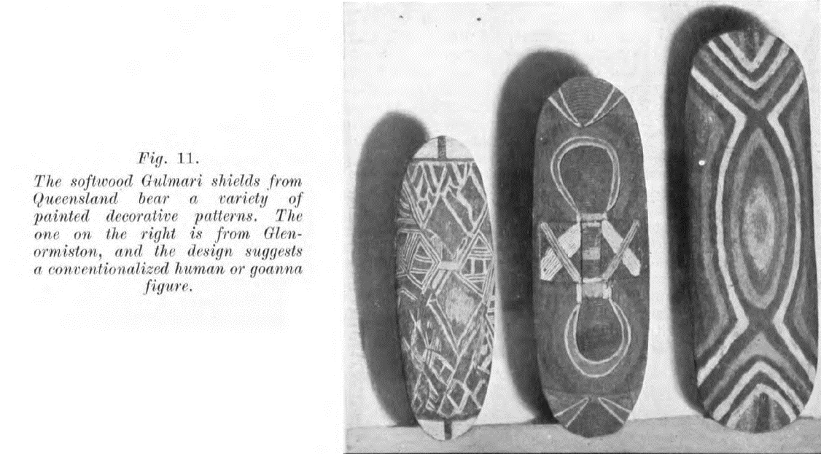
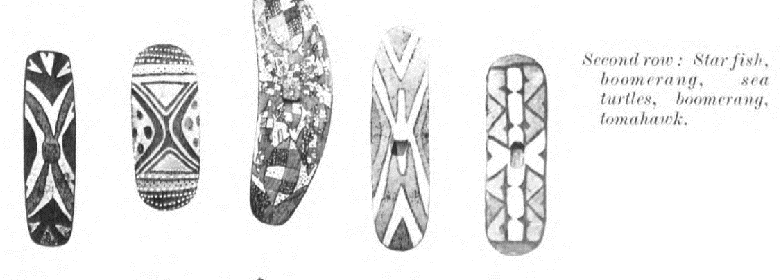
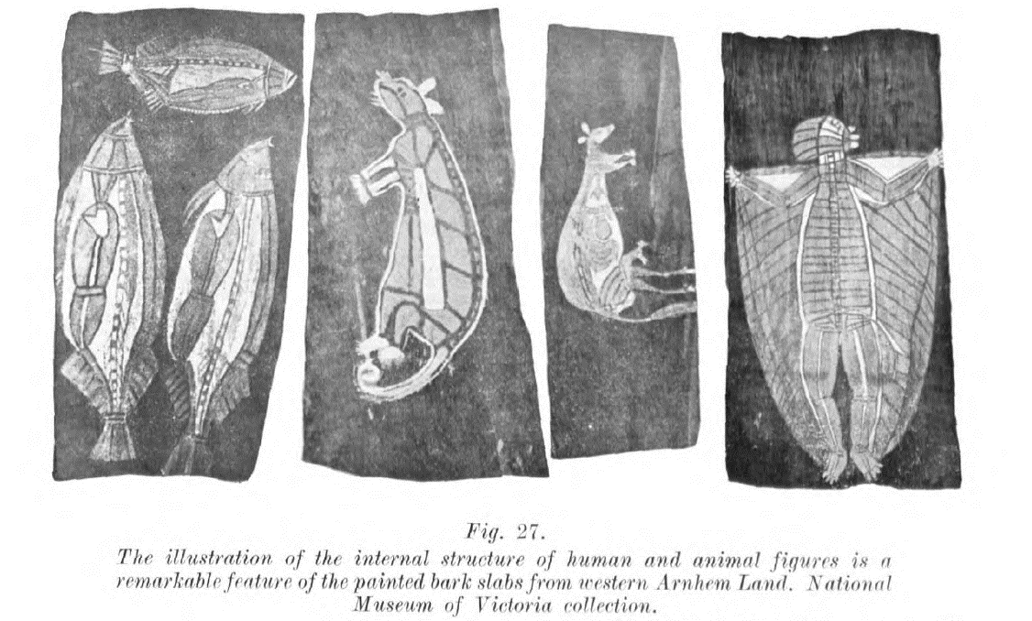
Images from Australian Aboriginal Decorative Art by Frederick David McCarthy.

Aboriginal artists and copyright law
As you read the sources in this activity, use different colours to highlight references to artist, artwork, world, and audience. For example, highlight all phrases and text associated with ‘artist’ in blue, all text associated with ‘artwork’ in yellow, all text associated with ‘world’ in green and all text associated with ‘audience’ in pink.

Milpurrurru v Indofurn Pty Ltd (‘The carpets case’, 1994)
Legal action was brought against an Australian company for copying artworks by 8 Aboriginal artists and printing them on carpets, without permission or compensation.
Terri Janke is a Wuthathi/Meriam woman, and a lawyer and leading international authority on Indigenous Cultural and Intellectual Property (ICIP). She wrote this analysis of the case for the Alternative Law Journal [PDF 323.13KB]:
According to some of the artists, permission would never have been granted because of the important cultural value of the artistic works and because of the secret and sacred nature of the stories represented in them. While the artists and the traditional owners of the images are pleased to have such works reproduced in culturally sensitive ways for the purposes of educating the wider community about Aboriginal art, it was not appropriate for their artwork to be reproduced without authorisation and in such a culturally offensive way.
Aboriginal artwork will often depict secret parts of a dreaming that will only be recognised and understood by those who are initiated into the relevant ceremonies, or at least have a close knowledge of the cultural significance of the story. It is therefore important that any reproduction is accurate in every respect and done with full, proper permission of the artist and community so as to not offend the traditional owners.
The images used by Banduk Marika in ‘Djanda and the Sacred Waterhole’ are associated with her ancestral creation place, Yelangbara. Her rights to use the image arise by virtue of her membership of the land owner group in that area. Although Banduk Marika owns the copyright in the artwork under Australian copyright law, under Aboriginal law she holds the image on trust for all other Yolngu who have an interest in the story. She cannot use an image in such a way as to undermine the rights of her beneficiaries.
Ms Marika created the work for display in culturally sensitive ways and for the purpose of educating others about Aboriginal arts and culture. The reproduction of the artwork on carpets, where it would be walked on, is totally opposed to the cultural use of the imagery employed in her artwork. Such misuse has caused her great upset.
The court found in favour of the artists and awarded damages totalling $188,640 – at the time this was the highest amount awarded to an Australian artist in a copyright case.
Notes from the decision of Milpurrurru, G. v Indofurn Pty Ltd further explain the artist’s perspective.
Ms Marika has endeavoured to conceal the unauthorised reproduction on carpets of Djanda and the Sacred Waterhole from her community as she will be held responsible. Her artwork expresses pictorially the creation when her ancestral creator Djang'Kawu and his two sisters, the Wagilag sisters, at the end of their journey from Burralku, landed at Yelangbara, south of Port Bradshaw, the site of their first journey. The image which she utilised in the artwork is associated with this place. Her rights to use the image arise by virtue of her membership of the land owner group in that area, and is an incident arising out of land ownership. She explained in an affidavit:
"As an artist whilst I may own the copyright in a particular artwork under western law, under Aboriginal law I must not use an image or story in such a way as to undermine the rights of all the other Yolngu (her clan) who have an interest whether direct or indirect in it. In this way I hold the image on trust for all the other Yolngu with an interest in the story."
Question: How is the ownership and use of culturally significant images in Aboriginal artworks considered differently in Australian copyright law and traditional Aboriginal law?
Table 13 – Answer table for 'carpets case' activity
Australian copyright law | Traditional Aboriginal law
(Record aspects) | (Record aspects)
Refer to Art and Indigenous rights – National Museum of Australia for images of Banduk Marika’s artwork, and the counterfeit carpet.
Compare the different meanings and impact of the original artwork ‘Djanda and the Sacred Waterhole’ and the counterfeit carpet.
Table 14 – Conceptual framework answer table for 'The carpets case' activity
Agency of the artworld | ‘Djanda and the Sacred Waterhole’ | Counterfeit carpet
Artist | (Add notes) | (Add notes)
Artwork | (Add notes) | (Add notes)
Audience | (Add notes) | (Add notes)
World | (Add notes) | (Add notes)
When the artists were informed that their works had been copied for use on carpets, they reacted with anger and distress.
Why might the use of a sacred design on a carpet be considered especially inappropriate? Refer to Banduk Marika’s quotes about who is allowed to use these designs, and what for.
Write a paragraph that explains your answer. The text box will expand when using a digital version of this document.

Extension – Changing practices

ICIP (Indigenous Cultural Intellectual Property)
Read the article What is Indigenous cultural intellectual property and copyright and how can I respect it? – ABC News to learn more about Indigenous cultural intellectual property (ICIP) and answer the following questions:
- What types of cultural material are covered by ICIP?

- The ABC article refers to ‘gaps in the law’. What types of ICIP are not protected by Australian copyright law? This ICIP information sheet from the Arts Law Centre of Australia may provide further insight.

Indigenous Art Code
Indigenous Art Code (IAC) is an organisation that promotes ethical trading in Indigenous art. Their guide How to buy ethically offers suggestions for making sure that Aboriginal artworks and design objects are ethically sourced, and that artists are appropriately compensated and credited for their work. Some strategies include buying artworks and design objects from reputable dealers, art centres galleries that are members of the Indigenous Art Code, or directly from Aboriginal artists themselves.
- Find an example of an artwork sourced from a gallery, dealer or art centre that is a member of the IAC.
- Find an example of a design object (like clothing or homeware) that is being sold by an Aboriginal owned business.
- Record an image and citation for your found art and design works in the table provided below.
Table 15 – Answer table for Indigenous Art Code activity
Example | Image | Citation
Artwork | (Add image) | (Add citation)
Design object | (Add image) | (Add citation)

Week 4 – Gordon Bennett

Gordon Bennett: concept and intention
Table 16 – Quote reference table
Gordon Bennett quote | Source
I am an Indigenous Australian. My mother is an Indigenous Australian and her mother before that and so on for countless generations. My father was English. My work comes out of small town and suburban Australia. I was socialised into an essentially Anglo-Saxon society where attitudes to Indigenous people still seemed entrenched to a social Darwinist level. From cocktail parties to workplace parties, predominantly derogatory opinions are exchanged about Indigenous people with unquestioning ease and assurance. | 1992, quoted in Gordon Bennett explored indigenous past through his conceptual art – SMH
My identity was shaped by the historical narratives of colonialism with all its romantic illusions and factual deletions. | Quoted in Gordon Bennett explored indigenous past through his conceptual art – SMH
If I were to choose a single word to describe my art practice it would be the word question. If I were to choose a single word to describe my underlying drive it would be freedom … To be free we must be able to question the ways our own history defines us. | 1996, extract from ‘Manifest Toe’. Quoted in Five things to know about Gordon Bennett – Tate
I have had my own experiences of being crowned in Australia, as an 'Urban Aboriginal' artist – underscored as that title is by racism and 'primitivism' - and I do not wear it well. My intention is in keeping with the integrity of my work in which appropriation and citation, sampling and remixing are an integral part, as are attempts to communicate a basic underlying humanity to the perception of 'blackness' in its philosophical and historical production within western cultural contexts. | 1998, extract from Bennett’s open letter to American artist Jean-Michel Basquiat. Quoted in Five things to know about Gordon Bennett – Tate
When I create a work, I am not thinking of an audience. My approach is very personal. You might even say that every work to date has been a self-portrait, in that what inspires each work is my own day-to-day experience of living in Australia - from my own life experience through to the speaking position of texts and orations about Australia and Australians in the past and present and their relationships and continuities. So, I am working through things in my own mind and on canvas and it is only later that I think of an audience, when the work is sent to a gallery for exhibition. | 2004, Bennett puts on brave face – The Age
I have no wish to be paraded on a stage as a spokesperson for anyone in particular. I lean towards the idea that an artist should be mute and let people get on with exploring the possibilities for interpretation in art for themselves. The word of the artist is not definitive and I don't chase publicity. | 2004, Bennett puts on brave face – The Age

Summarising
Read the Gordon Bennett quotes provided and answer the questions below. Refer to the practice scaffold to assist your interpretation.
What is revealed about Gordon Bennett’s artmaking intention and conceptual practice?
Write a paragraph that explains your answer. The text box will expand when using a digital version of this document.

Why do you think Gordon Bennett chose to appropriate works by Margaret Preston in his artmaking practice?
Write a paragraph that explains your answer. The text box will expand when using a digital version of this document.

John Citizen – ‘Interiors’ and ‘Aboriginal art’ series
John Citizen is a pseudonym for Gordon Bennett – an alter-ego devised as ‘a way of shifting the interpretation of art away from the artist to the artwork itself.’ (John Citizen | MCA Australia).
Developing this identity was part of his ongoing effort to avoid being typecast or stereotyped as an ‘Urban Aboriginal Artist’, and is consistent with his view that audiences should ‘get on with exploring the possibilities for interpretation in art for themselves’ (Bennett puts on brave face – The Age).

Research
Select one of Gordon Bennett/John Citizen’s paintings from the Interiors series(2009). Copy and paste the image and citation into the table provided.
Table 17 – Gordon Bennett/John Citizen painting
Artwork | Citation
(Add artwork) | (Add citation)

Look at Margaret Preston’s woodcut prints from the Australian Legend series (1957).
Identify which of these prints was appropriated for Gordon Bennett/John Citizen’s Interiors series (2009).
Record the image and citation in the table provided.
Table 18 – Margaret Preston’s woodcut print
Artwork | Citation
(Add artwork) | (Add citation)
Explain how Gordon Bennett has transformed visual elements of Margaret Preston’s artwork for his appropriated work in the Interiors series(2009). The text box will expand when using a digital version of this document.

Analysis
Consider the visual language of the image you chose from the Interiors series(2009).
Use the structural frame to explain what symbolic value or layered meaning each feature might have. Refer to the structural frame found in the frames scaffold to guide your response.
Table 19 – Answer table for analysis activity
Feature | Explanation
‘Aboriginal art’ shown on the wall | (Add explanation)
Colours used in ‘Aboriginal art’ | (Add explanation)
Furniture design | (Add explanation)
Other design objects | (Add explanation)
Interior design colours | (Add explanation)
How does Gordon Bennett’s appropriation of elements of Margaret Preston’s artwork in the Interiors series challenge audiences to reconsider their ideas about home décor, Aboriginal art, and Margaret Preston’s artworks?
Write a paragraph that explains your answer. The text box will expand when using a digital version of this document.

‘Home décor (after M. Preston)’
Gordon Bennett’s Home décor (after M. Preston) series (2012-2013) are direct reproductions of Margaret Preston’s illustrations accompanying her articles in ‘Art in Australia’ (1925 and 1930) that invited artists and designers to use Aboriginal motifs in their own work.
Review the Gordon Bennett and Margaret Preston works collected in the Week 1 ‘scavenger hunt’ activity and select one pair of images to write about. Refer to the gallery text and curator statement below, and the postmodern frame found in the frames scaffold to guide your response.
Gallery text – Unfinished Business, QAGOMA 2021
Enlarging and recontextualising Preston’s decorative designs allowed Bennett to turn the tables, ironically drawing attention to and reversing her appropriation of ‘primitivist art’. The shields are returned to a fine art context, albeit a Western one, and act as reminders of the dark history underlying the relationship between modernism and its periphery.
Extract from wall text for Gordon Bennett’s Home Décor (After M Preston) series, Unfinished Business – QAGOMA (2021)
Curator statement – The National, AGNSW 2017
Bennett brings back into circulation displaced echoes of the work of the unknown makers that were the original source for his and Preston’s work. He points to the troubled history of modernism’s search for an authentic national ‘self’ and shows how something as simple as home décor can resonate with nation-building ideologies and enterprises, as well as with unresolved issues and tensions around race relations and national identity in Australia today.
Extract from curator statement by Wayne Tunnicliffe for Gordon Bennett’s Home Décor (after M. Preston) – The National 4: Australian Art Now
How do Gordon Bennett’s paintings reconfigure the source images and give them new meaning as fine art objects, rather than material for interior design?
Write a paragraph to explain your answer. Refer to Bennett and Preston’s artworks, both text sources, and the postmodern frame found in the frames scaffold. The text box will expand when using a digital version of this document.

Summarising
Use the conceptual framework scaffold and the frames scaffold to record some notes about Gordon Bennett.
Table 20 – Answer table for summarising activity
Content area | Notes
Artwork | (Add notes)
Artist | (Add notes)
Audience | (Add notes)
World | (Add notes)
Postmodern frame | (Add notes)
Structural frame | (Add notes)

Week 5 – Tony Albert
‘Tony Albert is a politically-minded artist provoked by stereotypical representations of Aboriginal people and the colonial history that attempts to define him, and what Aboriginality is, in the present. Albert has spent the majority of his life in Brisbane, but has strong family connections further north to the Girramay and Kuku Yalanji people of the rainforest region.’ (Tony Albert | Art Gallery of NSW)
Tony Albert is a multidisciplinary artist, working across diverse media areas including mixed media, sculpture and installation, painting, and photomedia. The use of found objects are a central aspect of his practice, and he regularly draws on his vast collection of ‘Aboriginalia’ in his artmaking to prompt audiences to reconsider these representations of Aboriginal people and the colonial lens through which they were created.
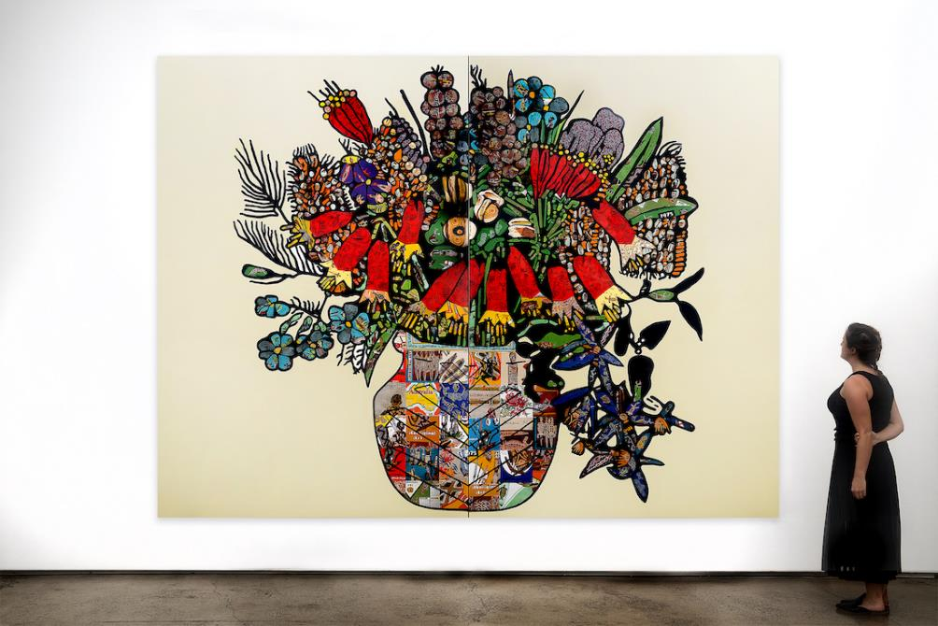
Tony Albert (2020 to 2021) Conversations with Preston: Christmas Bells [acrylic and vintage appropriated fabric on canvas], Sullivan + Strumpf Gallery, Sydney, © Tony Albert, courtesy: Sullivan + Strumpf Gallery, accessed 21 September 2022.
Tony Albert – ‘Conversations with Preston: Christmas Bells’, 2020-21 (exhibition view)
Acrylic and vintage appropriated fabric on canvas; 300 x 400cm.
Image and citation from sullivan+strumpf, reproduced with the artist’s permission.

‘Sorry’
Sorry (2008) is an installation consisting of 99 found objects attached to large black vinyl letters that spell the word ‘SORRY’, in reference to the 2008 National Apology to the Stolen Generations. In his artist statements, Tony Albert says that he intended the work to be installed in various configurations – since 2011 the work has been displayed in reverse as YRROS, prompting audiences to consider what change has occurred since the apology.

Artmaking practice – intentions, choices, and actions
Read/view the following sources, then complete the activity on artmaking practice on the following page.
Sources:
- Tony Albert discusses 'Sorry' created for the National Apology in 2008 (2:34)
- Why does Tony Albert collect Aboriginalia? (3:13)
- Tony Albert (2013) (quoted in Sorry – Tony Albert – QAGOMA Learning).
‘From its conception it was always intended to be installed in various formations. Sorry was originally commissioned by the Queensland Art Gallery in 2008 for the exhibition ‘Contemporary Australia: Optimism’; given that it coincided with the Australian Government’s Apology to the Stolen Generations, Sorry was intended to make a positive statement. Five years on, I have seen very little improvement for Aboriginal people in this country. Sorry is just a word which means nothing if it is not backed up by real outcomes. By turning the work on its head I’m asking the viewer to consider the very real situation that Aboriginal people still find themselves in today.’
- Chari Larsson (2018) (Tony Albert’s politically charged kitsch collection confronts our racist past)
Some of Albert’s works have gained a potent political urgency since their original creation. Sorry 2008 was a key installation in the Queensland Art Gallery’s 2008 exhibition Contemporary Australia: Optimism. Referring to then Prime Minister Kevin Rudd’s Apology to the Stolen Generations, the exhibition cautiously welcomed a new era of hope, healing and reconciliation.
Albert has since requested that Sorry be reversed to instead spell YRROS, effectively parodying and evacuating the sincerity of the Apology. Words and meaning exist as a series of conventions. In this act of reversal, Albert underscores how arbitrary and fragile these conventions are. Ten years have now elapsed and with discussions pertaining to Indigenous constitutional recognition reaching a political impasse, we are left to uneasily consider: what, if anything, has changed?
Write a paragraph discussing Tony Albert’s intentions, choices, and actions in the work Sorry (2008).
Use the practice scaffold to guide your response.

‘Conversations with Margaret Preston’ – Changing meanings
Refer to the Tony Albert and Margaret Preston artwork images collected in the scavenger hunt activity. Compare the different ideas and meanings present in the original and appropriated artworks.
Use the frames scaffold to guide your answers. Use the cultural frame to consider Margaret Preston’s artworks, and the postmodern frame to consider Tony Albert’s artworks.
Table 21 – Comparative meanings answer table
Margaret Preston artworks (cultural frame) | Tony Albert artworks (postmodern frame)
Christmas bells, 1925 by Margaret Preston | Conversations with Preston: Christmas Bells, 2020 by Tony Albert
Australian legend, number 3: The kangaroo hunt, circa 1957 by Margaret Preston | Conversations with Preston: Kangaroo, 2020 by Tony Albert
The expulsion, 1952 by Margaret Preston | Conversations with Preston: Expulsion, 2020 by Tony Albert

Exhibition review
Read Angela Goddard’s review of ‘Conversations with Margaret Preston’ and record some key quotes that further reveal the meaning and impact of Tony Albert’s artworks.
Using the download link will enable copy/pasting of text.
Table 22 – Answer table for exhibition review activity
Quote | Meaning/impact
(Add quote) | (Add meaning/impact)
(Add quote) | (Add meaning/impact)
(Add quote) | (Add meaning/impact)
(Add quote) | (Add meaning/impact)
(Add quote) | (Add meaning/impact)

Summarising
Use the conceptual framework scaffold and the frames scaffold to record some notes about Tony Albert.
Table 23 – Answer table for summarising activity
Content area | Notes
Artwork | (Add notes)
Artist | (Add notes)
Audience | (Add notes)
World | (Add notes)
Postmodern frame | (Add notes)
Cultural frame | (Add notes)

Week 6 – Putting it all together

Scaffolding
Pick 2 key artworks from each of the 3 artists in this case study and make some summary notes. Remember to record a full citation in the first column for your reference.
Refer to the conceptual framework scaffold to guide your response.
Table 24 – Answer table for scaffolding activity
Artwork citation | Notes
Margaret Preston artwork 1 | (Add notes)
Margaret Preston artwork 2 | (Add notes)
Gordon Bennett artwork 1 | (Add notes)
Gordon Bennett artwork 2 | (Add notes)
Tony Albert artwork 1 | (Add notes)
Tony Albert artwork 2 | (Add notes)

Extended response
The following questions can be used to practise writing an extended response under exam conditions. To simulate the conditions of the Visual Arts exam, you should complete a handwritten response using the recommended writing time of 45 minutes.
Additional exam resources, including past exams, marking guidelines, and feedback on the written exam, can be found on the NESA website for Stage 6 Visual Arts.

Practice
- An artist’s practice is shaped by their intentions, choices, and actions. Discuss this statement with reference to specific artists and artworks you have studied.
- Investigate the role of research in artmaking practice. In your answer, refer to specific artists and artworks you have studied.

Conceptual Framework
- Analyse how the values of a society are revealed through the art it produces. In your answer, refer to specific artists and artworks you have studied.
- Explain how artists employ different strategies to communicate meaning and intention to their audiences. In your answer, refer to specific artists and artworks you have studied.

Frames
- Analyse how artists draw on cultural understanding when making artworks. In your answer, refer to specific artists and artworks you have studied.
- Gordon Bennett describes ‘appropriation and citation, sampling and remixing’ as integral to his artmaking practice. Evaluate how approaches to appropriation in the artworld have evolved over time. In your answer, refer to specific artists and artworks you have studied.

References
Links to third-party material and websites
Please note that the provided (reading/viewing material/list/links/texts) are a suggestion only and implies no endorsement, by the New South Wales Department of Education, of any author, publisher, or book title. School principals and teachers are best placed to assess the suitability of resources that would complement the curriculum and reflect the needs and interests of their students.
If you use the links provided in this document to access a third-party's website, you acknowledge that the terms of use, including licence terms set out on the third-party's website apply to the use which may be made of the materials on that third-party website or where permitted by the Copyright Act 1968 (Cth). The department accepts no responsibility for content on third-party websites.
All material © State of New South Wales (Department of Education), 2021 unless otherwise indicated. All other material used by permission or under licence.
Visual Arts Stage 6 Syllabus © 2016 NSW Education Standards Authority (NESA) for and on behalf of the Crown in right of the State of New South Wales.
Albert T (2008) Sorry [Found kitsch objects applied to vinyl letters], Queensland Art Gallery and Gallery of Modern Art, Brisbane, accessed 20 September 2022.
Albert T (2020) Conversations with Preston: Expulsion [acrylic and vintage appropriated fabric on Arches paper], Sullivan + Strumpf, Sydney, accessed 20 September 2022.
Albert T (2020) Conversations with Preston: Kangaroo [acrylic and vintage appropriated fabric on Arches paper], Sullivan + Strumpf, Sydney, accessed 20 September 2022.
Albert T (2020 to 2021) Conversations with Preston: Christmas Bells [acrylic and vintage appropriated fabric on canvas], Sullivan + Strumpf, Sydney, accessed 20 September 2022.
Albert T (2021) ‘Conversations with Margaret Preston’, Exhibitions, Sullivan + Strumpf, Sydney, accessed 20 September 2022.
Annan Fabrics (circa 1950) 'Goannas' and 'Snakes and Turtles' curtain set [cotton], Museum of Applied Arts and Sciences, Sydney, accessed 20 September 2022.
Art Gallery of NSW (n.d.) ‘Margaret Preston’, Featured artists, Art Gallery of NSW website, accessed 20 September 2022.
Art Gallery of NSW (n.d.) ‘Tony Albert’, Featured artists, Art Gallery of NSW website, accessed 20 September 2022.
Arts Law Centre of Australia (2022) ‘Indigenous Cultural and Intellectual Property (ICIP)’, Information Sheets, Arts Law Centre of Australia website, accessed 20 September 2022.
Australian Children's Television Foundation and Education Services Australia Ltd (2011) Decade Overview 1920s: Decade Summary [PDF 37.05KB], My Place for Teachers, Australian Children's Television Foundation and Education Services Australia Ltd, accessed 20 September 2022.
Australian Children's Television Foundation and Education Services Australia Ltd (2011) Decade Overview 1920s: Indigenous Australians [PDF 37.05KB], My Place for Teachers, Australian Children's Television Foundation and Education Services Australia Ltd, accessed 20 September 2022.
Barnard T (2016) ‘Indigenised Souvenirs and Homewares in the Glenn Cooke Collection’, Queensland Museum, accessed 20 September 2022.
BarNetwork Pty Limited (2022) Milpurrurru G. v Indofurn Pty Ltd [1994] FCA 975; 130 ALR 659; 30 IPR 209, Jade website, accessed 20 September 2022.
Blue Mountains Library, Local Studies (1954) The Royal Visit [photograph], Flickr website, accessed 20 September 2022.
Campbell A (23 December 2020) ‘Tony Albert Is Transforming Racist Ephemera Into Powerful Works Of Art’, GQ Australia, accessed 20 September 2022.
Collings D (1950 – 1953) Artwork design by Dahl Collings [Artwork, textile design, gouache and ink on paper, mounted on board], Museum of Applied Arts and Sciences, Sydney, accessed 20 September 2022.
Donald Clark Handcrafts (1954 – 1958) Wall Hanging [textile, wood, screenprinted], Queensland Museum, Brisbane, accessed 20 September 2022.
Goddard A (2021) ‘Tony Albert: Conversations with Margaret Preston’, Sullivan+Strumpf Contemporary Art Gallery Sydney, Issuu website, accessed 20 September 2022.
Indigenous Art Code (2019) How to buy ethically, Indigenous Art Code website, accessed 20 September 2022.
Janke T (1995) ‘The carpets case’ [PDF 323.13KB], Alternative Law Journal/Aboriginal Law Bulletin, 20(1)/3(72):36–39, accessed 20 September 2022.
Larsson C (7 June 2018) ‘Tony Albert’s politically charged kitsch collection confronts our racist past’, The Conversation, accessed 20 September 2022.
MCA (Museum of Contemporary Art) Limited (2022) ‘John Citizen’, Artists, MCA website, accessed 20 September 2022.
McCarthy FD (1948) Australian Aboriginal Decorative Art, 2nd edition, Trustees of the Australian Museum, Sydney, State Library Victoria website, accessed 20 September 2022.
MoMA (Museum of Modern Art) (n.d.) ‘Appropriation’, Pop Art, MoMA Learning website, accessed 20 September 2022.
Moran A (11 May 2020) ‘What is Indigenous cultural intellectual property and copyright and how can I respect it?’, ABC News, accessed 20 September 2022.
NGA (National Gallery of Australia) (n.d.) ‘2nd National Indigenous Art Triennial: Undisclosed’, National Gallery Exhibition History, NGA website, accessed 20 September 2022.
NMA (National Museum of Australia) (n.d.) ‘Art and Indigenous rights’, Yalangbara: Art of the Djang’kawu, NMA website, accessed 20 September 2022.
Preston M (1925) Christmas bells [woodcut, printed in black ink, from one block, hand-coloured in gouache], NGA, Parkes ACT, accessed 20 September 2022.
Preston M (1925) ‘The Indigenous Art of Australia’, Art in Australia: A Quarterly Magazine, Third series, Number 11, Trove website, accessed 20 September 2022.
Preston M (1930) ‘The Application of Aboriginal Designs’, Art in Australia: A Quarterly Magazine, Third series, Number 31, Trove website, accessed 20 September 2022.
Preston M (1946) Fish [colour screenprint on buff wove paper], Art Gallery of NSW, Sydney, accessed 20 September 2022.
Preston M (1952) The expulsion [colour stencil, gouache on thin black card with gouache hand colouring], Art Gallery of NSW, Sydney, accessed 20 September 2022.
Preston M (circa 1957) Australian legend, number 3: The kangaroo hunt [colour woodcut on tan laid Japanese paper], Art Gallery of NSW, Sydney, accessed 20 September 2022.
Preston M (circa 1957) ‘Margaret Preston Australian Legend’, Collection, Art Gallery of NSW, accessed 21 September 2022.
Oxford University Press (2022) cultural appropriation, Oxford Reference website, accessed 20 September 2022.
QAGOMA (Queensland Art Gallery and Gallery of Modern Art) (31 May 2017) ‘Why does Tony Albert collect Aboriginalia?’ [video], QAGOMA, YouTube, accessed 20 September 2022.
QAGOMA (10 November 2017) ‘Tony Albert discusses “Sorry” created for the National Apology in 2008’ [video], QAGOMA, YouTube, accessed 20 September 2022.
Queensland Art Gallery Board of Trustees (2021) ‘Unfinished Business The Art of Gordon Bennett’, Exhibitions, QAGOMA website, accessed 20 September 2022.
Sullivan + Strumpf (15 February 2021) ‘Tony Albert – Conversations with Margaret Preston’ [video], Sullivan + Strumpf, Vimeo, accessed 20 September 2022.
Sutton Gallery (n.d.) ‘Gordon Bennett, John Citizen Gordon Bennett, Retro (Home Decor) Aboriginal Art / John Citizen, Interiors’, Exhibitions, Sutton Gallery website, accessed 20 September 2022.
Tate Gallery (n.d.) Art Terms, Tate website, accessed 20 September 2022.
Tate Gallery (n.d.) Five things to know about Gordon Bennett, Tate website, accessed 20 September 2022.
The Age (28 April 2004) ‘Bennett puts on brave face’, The Age, accessed 20 September 2022.
The National (2019) ‘Gordon Bennett’, Artists, The National 4: Australian Art Now website, accessed 20 September 2022.
SMH (The Sydney Morning Herald (25 July 2005) ‘Shadow cast over a painter's legacy’, The Sydney Morning Herald, accessed 20 September 2022.
The Sydney Morning Herald (27 June 2014) ‘Gordon Bennett explored indigenous past through his conceptual art’, The Sydney Morning Herald, accessed 20 September 2022.

Further reading
Preston M (1941) I lived at Berowra [oil on canvas], Art Gallery of NSW, Sydney, accessed 20 September 2022.
Preston M (1946) Native flowers of Australia [colour monotype on thin white laid tissue], Art Gallery of NSW, Sydney, accessed 20 September 2022.
Preston M (1955) Fish and blackboys [oil on canvas], Art Gallery of NSW, Sydney, accessed 20 September 2022.
Preston M (circa 1957) Australian legend, number 1: The superimposed feet [colour woodcut on tan laid paper], Art Gallery of NSW, Sydney, accessed 20 September 2022.
Preston M (circa 1957) Australian legend, number 2: The terrible story [colour woodcut on tan laid Japanese paper], Art Gallery of NSW, Sydney, accessed 20 September 2022.
Preston M (circa 1957) Australian legend, number 4: Kangaroo dance and pointing the bone [colour woodcut on buff Japanese paper], Art Gallery of NSW, Sydney, accessed 20 September 2022.
Preston M (circa 1957) Australian legend, number 5: End of the love story, Curing and flight of love [colour woodcut on tan laid Japanese paper], Art Gallery of NSW, Sydney, accessed 20 September 2022.
Preston M (circa 1958) Aboriginal glyph [colour stencil, gouache with gouache hand colouring on thin black card], Art Gallery of NSW, Sydney, accessed 20 September 2022.

