Creative arts workbook Stage 3
Name:
Class:

Overview
You will learn about the role of narrative in the creative arts to create meaning through music, artwork and drama.

Resources

Activity 1
- A copy of the lyrics to ‘Rubbish Rap’
- Your workbook

Activity 2
- Sharp coloured pencils or some other art materials such as paints or fabrics
- A piece of paper or your workbook to create your artwork on
- Your workbook

Activity 3
- A member of your household to watch your drama performance
- Your workbook

Activity 1 – narrative in a rap
Resources

Rubbish Rap
by Tracy and Paul Burjan with Zain Ousmand (includes rhythmic notation)
Key: | = one sound on a beat (‘ta’) or a one-syllable word such as ‘dog’ or ‘cat’
∏ = two sounds per beat (‘ti-ti’ or ‘ta-te’) or a two-syllable word such as ‘pup-py’ or ‘kit-ten’
Z = no sound on the beat (whisper ‘za’) or whisper any- one-syllable word such as ‘dog’ or ‘cat’
Please note there are significant rhythmic differences recorded below to the original recorded version of this rap. This has been intentionally done to enable the rhythmic notation reading of the rap appropriate for a Stage 3 level. Teachers and students may choose to modify this rhythm orally as required to suit their context.
Chorus
Ooo, ahhh, Rubb-ish Rap, | | ∏ |
Take that wrap and toss that scrap, ∏ ∏ ∏ |
Flip that lid right on the bin, ∏ ∏ ∏ |
Check, re-cycle, throw it in. ∏ ∏ ∏ |
Be pro-active, make a change, ∏ ∏ ∏ ∏
Re-think your ways, it’s not so strange. ∏ ∏ ∏ ∏
Ooo, Ahhh, Rubb-ish Rap, | | ∏ |
List-en to me, now let’s re-cap, ∏ ∏ ∏ ∏
It’s not a load of rubb-ish. (tag – spoken freely)
Verse 1
Crack down, back up, ∏ Z ∏ Z
Re-use that coff-ee cup. ∏ | ∏ |
Cups up, cups down, got one at home. ∏ ∏ ∏ ∏
It’s so easy to bring your own. ∏ ∏ ∏ ∏
Change, ex-change don’t throw it out, ∏ ∏ ∏ |
Re-use those clothes with-out a doubt. ∏ ∏ ∏ ∏
Don’t toss those threads, sew them again, ∏ ∏ ∏ ∏
Cut them up and start a trend. ∏ ∏ ∏ |
It’s not a load of rubb-ish. (tag – spoken freely)
Verse 2
Plast-ic bags aren't so cool, ∏ | ∏ |
Take your own bag as a rule. ∏ ∏ ∏ |
Think of the fut-ure down the track, ∏ ∏ ∏ ∏
You’ll get the knack so don’t be slack. ∏ ∏ ∏ ∏
Crunch-y plast-ics can be re-used, ∏ ∏ ∏ ∏
It’s not so hard, don’t look con-fused. ∏ ∏ ∏ ∏
Think be-fore you throw it in, ∏ ∏ ∏ |
Re-use, re-cycle that’s a win! ∏ ∏ ∏ |
It’s not a load of rubb-ish. (tag – spoken freely)
Verse 3
Save our plan-et from all that waste, ∏ ∏ ∏ |
Use your bins, at home base ∏ | ∏ |
Red for rubb-ish, yell-ow for pap-er. ∏ ∏ ∏ ∏ (the word ‘for’ has been removed from the rhythmic notation)
Green to mulch up all that nat-ure. ∏ ∏ ∏ ∏
Com-post-ing can be so cool, ∏ ∏ ∏ |
Start a com-post at your school. ∏ ∏ ∏ |
Watch the worms as they are fed, ∏ ∏ ∏ |
Chuck it on the gard-en bed. ∏ ∏ ∏ |
It’s not a load of rubb-ish. (tag – spoken freely)
Chorus (twice)
Ooo, ahhh, Rubb-ish Rap, | | ∏ |
Take that wrap and toss that scrap, ∏ ∏ ∏ |
Flip that lid right on the bin, ∏ ∏ ∏ |
Check, re-cycle, throw it in. ∏ ∏ ∏ |
Be pro-active and make a change, ∏ ∏ ∏ |
Re-think your ways, it’s not so strange. ∏ ∏ ∏ ∏
Ooo, ahhh, Rubb-ish Rap, | | ∏ |
List-en to me, and, that’s that! ∏ ∏ ∏ |

Rubbish Rap (shortened version)
by Tracy and Paul Burjan with Zain Ousmand (includes rhythmic notation)
Key: | = one sound on a beat (‘ta’) or a one-syllable word such as ‘dog’ or ‘cat’
∏ = two sounds per beat (‘ti-ti’ or ‘ta-te’) or a two-syllable word such as ‘pup-py’ or ‘kit-ten’
Z = no sound on the beat (whisper ‘za’) or whisper any- one-syllable word such as ‘dog’ or ‘cat’
Please note there are significant rhythmic differences recorded below to the original recorded version of this rap. This has been intentionally done to enable the rhythmic notation reading of the rap appropriate for a Stage 3 level. Teachers and students may choose to modify this rhythm orally as required to suit their context.
Chorus
Ooo, ahhh, Rubb-ish Rap, | | ∏ |
Take that wrap and toss that scrap, ∏ ∏ ∏ |
Flip that lid right on the bin, ∏ ∏ ∏ |
Check, re-cycle, throw it in. ∏ ∏ ∏ |
Be pro-active, make a change, ∏ ∏ ∏ ∏
Re-think your ways, it’s not so strange. ∏ ∏ ∏ ∏
Ooo, Ahhh, Rubb-ish Rap, | | ∏ |
List-en to me, now let’s re-cap, ∏ ∏ ∏ ∏
It’s not a load of rubb-ish. (tag – spoken freely)
Verse
Crack down, back up, ∏ Z ∏ Z
Re-use that coff-ee cup. ∏ | ∏ |
Cups up, cups down, got one at home. ∏ ∏ ∏ ∏
It’s so easy to bring your own. ∏ ∏ ∏ ∏
Change, ex-change don’t throw it out, ∏ ∏ ∏ |
Re-use those clothes with-out a doubt. ∏ ∏ ∏ ∏
Don’t toss those threads, sew them again, ∏ ∏ ∏ ∏
Cut them up and start a trend. ∏ ∏ ∏ |
It’s not a load of rubb-ish. (tag – spoken freely)
Chorus
Ooo, ahhh, Rubb-ish Rap, | | ∏ |
Take that wrap and toss that scrap, ∏ ∏ ∏ |
Flip that lid right on the bin, ∏ ∏ ∏ |
Check, re-cycle, throw it in. ∏ ∏ ∏ |
Be pro-active, make a change, ∏ ∏ ∏ ∏
Re-think your ways, it’s not so strange. ∏ ∏ ∏ ∏
Ooo, Ahhh, Rubb-ish Rap, | | ∏ |
List-en to me, now let’s re-cap, ∏ ∏ ∏ ∏

Warm up (perform a rap)
Perform the ’Rubbish Rap’ using speech only. Use the rhythmic notation as a guide. It is important that the number of beats per line stays the same. Practice keeping the beat with the music as you learn it. Try altering and interpreting the rhythm in your own way. You may wish to add an accompaniment such as tapping a beat or having someone beat box for you!

Understanding the narrative (learn about the rap)
Think about what you know about narrative. What is the rap about? Think about these questions:
- What is the meaning of the story that ‘Rubbish Rap’ tells? Why is it important?
- What is the argument that inspires the rap text?
- Does rapping help you to understand both the narrative and the meaning of the argument it is presenting about waste?
Discuss the issues raised through this rap with your household. What steps are your household taking to reduce waste in the environment?
Summarise the steps your household are taking to reduce waste.
_______________________________________________________________________
_______________________________________________________________________
_______________________________________________________________________
Try altering and interpreting the rhythm in your own way. Practice different ways of performing this rap including using different vocal tone colours (or sounds) to make the voice more interesting and to match the meaning of each verse and chorus.
Discuss other examples of rap music which tell a story. Family members, caregivers and friends may know different raps, chants or poems which tell a story or create a narrative. Discuss the role the music has in supporting this narrative.
List the name and composer (if possible) of a rap, chant or poem your household knows which teaches us something or conveys a message. Write a sentence to describe how the music helps tell the story.
Title: __________________________________________________________________
Composer: _____________________________________________________________
How does the music help tell the story? _______________________________________
_______________________________________________________________________
_______________________________________________________________________
Practice the shortened version below of ‘Rubbish Rap’. What do you notice about the structure of this shortened version?
Describe how the shorter version is different to the longer version.
_______________________________________________________________________
_______________________________________________________________________
_______________________________________________________________________
_______________________________________________________________________
Practice keeping the beat with this shortened version of ‘Rubbish Rap’. How many beats do you notice are in each line of the chorus and then the verse? Look at the guide below if unsure. The beats are marked in the brackets in bold as they fall. How many beats are in each line? (four) How many lines are there in the chorus and the verse? (eight plus a tag line – no tag on final chorus). Practice this version several times until you are confident with the beat and rhythm.

Rubbish rap (shortened version)
Chorus
Line 1 - (1) Ooo, (2) ahhh, (3) Rubb-ish (4) Rap,
Line 2 - (1) Take that (2) wrap and (3) toss that (4) scrap,
Line 3 - (1) Flip that (2) lid right (3) on the (4) bin,
Line 4 - (1) Check, re- (2) cycle, (3) throw it (4) in.
Line 5 - (1) Be pro- (2) act-ive, (3) make a (4) change,
Line 6 - (1) Re-think your (2) ways, it’s (3) not so (4) strange.
Line 7 - (1) Ooo, (2) Ahhh, (3) Rubb-ish (4) Rap,
Line 8 - (1) Listen to (2) me, now (3) let’s re- (4) cap,
It’s not a load of rubb-ish. (tag line – not a part of the chorus and can be said in whatever way you would like)
Verse 1
Line 1 - Crack (1) down, (2) (rest), back (3) up, (4) (rest)
Line 2 - Re- (1) use that (2) coff-ee (3) cup (4) (rest).
Line 3 - Cups (1) up, cups (2) down, got (3) one at (4) home.
Line 4 - (1) It’s so (2) easy to (3) bring your (4) own.
Line 5 - (1) Change, ex- (2) change don’t (3) throw it (4) out,
Line 6 - (1) Re-use those (2) clothes with- (3) out a (4) doubt.
Line 7 - Don’t (1) toss those (2) threads, sew (3) them a- (4) gain,
Line 8 - (1) Cut them (2) up and (3) start a (4) trend.
Tag - It’s not a load of rubb-ish. (tag line – not a part of the chorus and can be spoken freely)
Think of an issue that concerns you, or a story you think needs to be told. Brainstorm words to do with the issue or story.
_______________________________________________________________________
_______________________________________________________________________
_______________________________________________________________________
Use the words about the issue or story to experiment writing a rap. Use the format from ’Rubbish Rap' (eight lines per verse and a chorus with four beats in each line). You may wish to create your own backing for the rap. A household member could keep the beat, or you could use beat boxing.
Write the lyrics to your rap.
Chorus:
Beat Number | 1 | 2 | 3 | 4
Line 1
Line 2
Line 3
Line 4
Line 5
Line 6
Line 7
Line 8
Tag line: ________________________________________________________________
Verse:
Beat Number | 1 | 2 | 3 | 4
Line 1
Line 2
Line 3
Line 4
Line 5
Line 6
Line 7
Line 8
Optional: you may wish to record your rap. You could use software to record your rap such as GarageBand.

Activity 2 – narrative in music and visual arts
During this activity you will explore environmental sounds, musical styles and artworks that tell a story.
Listen to the sounds of your local environment. It may be a busy city street or a quiet place in the country. Compare the sounds you heard with another member of your household. Did they hear the same or different sounds?
Describe the sounds you heard.
_______________________________________________________________________
_______________________________________________________________________
_______________________________________________________________________
Think about creating a musical composition from the sounds you heard.
What might it sound like?
Describe the style of the music, such as jazz, popular or classical. Identify the instruments that would be heard in the composition such as flutes, saxophones, trumpets, pianos, drums or guitars.
How might the audience feel when they listen to this musical composition? For example, consider the use of dynamics (volume), tempo (speed), instruments, rhythms and so on.
How might you create a story or some type of image in the heads of the audience when they listen to your music? What would you as the composer do to make the audience feel this way?
Briefly summarise what style your musical composition could use, what instruments it could feature and what musical concepts you might use to communicate your meaning to your audience.
_______________________________________________________________________
_______________________________________________________________________
_______________________________________________________________________
______________________________________________________________________
_______________________________________________________________________
_______________________________________________________________________
Optional: you might wish to create and record your own composition using the environmental sounds you heard. This would be a great project to collaborate with other household members.
View artworks
View the images of the three artworks by Piet Mondrian:
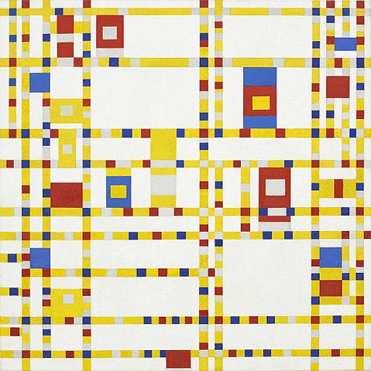
‘Broadway boogie woogie’ by Piet Mondrian, 1944 - Gemeentemuseum Den Haag, Public Domain, https://commons.wikimedia.org/w/index.php?curid=37614350
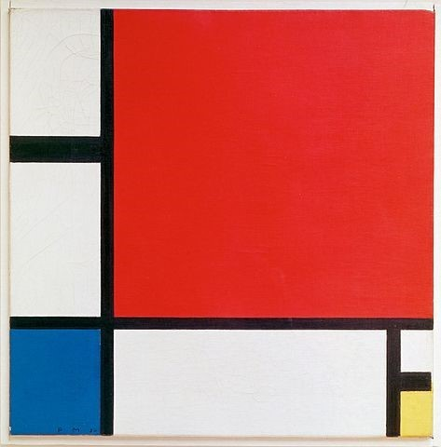
‘Composition II in red, blue and yellow’ by Piet Mondrian, 1930 - [1], Public Domain, https://commons.wikimedia.org/w/index.php?curid=37642803

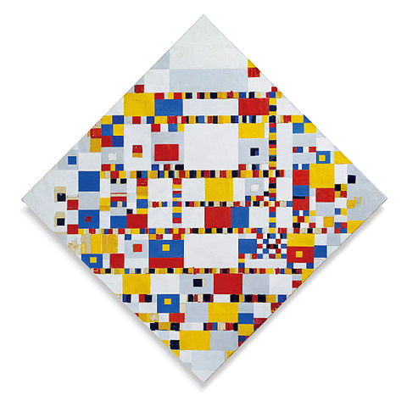
'Victory Boogie Woogie’ by Piet Mondrian - Gemeentemuseum Den Haag, Public Domain, https://commons.wikimedia.org/w/index.php?curid=37614350

How does art tell us a story?
Reflect on these artworks and discuss your response to the artworks with someone in your household. How does Mondrian use colour to create meaning in his artworks? Is your point of view similar or different to someone else in your household?
Broadway is an area in New York City, USA. (If you can, look at a map of New York City.) The roads of New York City are built in a crisscross or grid pattern (like the artwork). Broadway is usually a very busy part of New York City. Lots of local people and tourists go to Broadway to watch plays and theatre productions. It is usually a very crowded place, both daytime and night-time.
Think about your response to the artwork ’Broadway Boogie Woogie’. Can you see how Mondrian’s ‘Broadway Boogie Woogie’ artwork reflects the grid pattern of New York City streets, blinking lights, traffic, the city hustle?
The title of the artwork refers to the jazz style known as boogie woogie. Research and/or discuss this type of jazz music with household members. Discuss how the characteristics of this painting relate to the music of the boogie woogie style and the feel of Broadway. Boogie woogie music is very jazzy and features a repetitive, shuffling rhythm with frequent, loud interruptions from brass instruments. Discuss how this musical style is reflected in Mondrian's painting? (it feels like it is in motion and the larger squares of colour are like brass interruptions or car horns and has repeated patterns). What do you think the narrative is in Mondrian’s artwork?
Reflection
Summarise your response to the artwork ’Broadway Boogie Woogie’. What story does the artwork tell you? What techniques has the artist used to make you think this?
Story of the artwork: ______________________________________________________
_______________________________________________________________________
_______________________________________________________________________
How do you know: ________________________________________________________
_______________________________________________________________________
_______________________________________________________________________

The next page has been left blank for your artwork or you can use your own paper instead.
Create your own artwork connected to the sounds in the environment or the music you were thinking of earlier as inspired by your street. This may connect to the style of Mondrian or you may create your own style. Think about the narrative of your street or city in your artwork.
You might include textas, coloured pencils, squares of paper, mosaic squares or paints (according to availability). Include your own artist intent statement. This should include the title and a 1-2 sentence summary of what the artwork is about if it were to be hung in a gallery.
Title of artwork: __________________________________________________________
Statement about your work: _________________________________________________
_______________________________________________________________________
_______________________________________________________________________

Blank page for artwork.

Activity 3 – narrative in drama
During this activity you will explore how narrative is used in dramatic performances.
Think about a film you have watched, preferably a short film or show. You may have watched one in class, on television or at the cinema. For example, ’The Lion King‘, ’Harry Potter’ or ’Star Wars’.
Summarise the narrative of the film in three sentences.
_______________________________________________________________________
_______________________________________________________________________
_______________________________________________________________________
_______________________________________________________________________
_______________________________________________________________________
_______________________________________________________________________
Describe the role music has in telling the story. For example, describe how the music might change to reflect different characters or plot developments. It may also use silence.
_______________________________________________________________________
_______________________________________________________________________
_______________________________________________________________________
_______________________________________________________________________
_______________________________________________________________________
_______________________________________________________________________
What other techniques are used by the film maker to communicate their meaning to the audience? For example, lighting, perspective, backdrops, props, sets, costumes or colour.
_______________________________________________________________________
_______________________________________________________________________
_______________________________________________________________________
_______________________________________________________________________
_______________________________________________________________________
_______________________________________________________________________
Understanding narrative – in drama
Choose a character from the film or show. Pose as this character and take a photo of yourself (either a selfie or taken by someone else). If possible, include the photo in this workbook. If you can’t take a photo, draw and label a picture of a character in a pose from the book. (labelled drawing or labelled photo)
Character name:
Choose an object from a scene in the film or show. Try to make your body into the shape of the object such as a book, a globe, a bus, a tree or even a chair. Take a photo (either a selfie or taken by someone else). If possible, include the photo in this workbook. If you can’t take a photo, draw and label a picture of you in the shape of the object from the book. (labelled drawing or labelled photo)
Object name:
Choose a scene (the one you think is most important) and create a postcard. Take a photo (either a selfie or taken by someone else). If possible, include the photo in this workbook. If you can’t take a photo, draw and label a postcard of the scene from the book (labelled drawing or labelled photo). Who would you send this to?
Scene name:

Who I would send it to: ____________________________________________________

Create a drama – using mime
Make your own silent ‘film’. Think of a story you could tell about your daily life without using any words (mime). The story will have one scene and if it was made into a movie it would only be one shot with no cuts. The silent ‘film’ should document one simple activity such as playing a game of handball, walking the dog or putting out the bin. Your ‘film’ should be no more than a minute long. The focus should be on the action, movement, body language and facial expressions. Some students may wish to have background music to accompany their performance.
Think about mime artists that you may have seen in the past or that members of your household may know. For example, Marcel Marceau or Rowan Atkinson (particularly in character as ‘Mr Bean’). Much of the movement by these artists is exaggerated to reinforce the narrative.
Practice miming some everyday activities and perform these for your households. For example, picking a rose, throwing a ball, or answering a phone call (use no noise or words). A household game of charades to mime a book, movie, or event title is also a terrific miming activity and great fun for everyone.
Think of an event in your day that you could make into a silent ’film’ or mimed story. Practice your silent ‘film’ (or mimed story) and perform it for your household. It should be no more than a minute long. Try to convey the narrative through the dramatic technique of mime like a silent film. Optional: you could have a member of your household film your performance.
Summarise the narrative of your mimed story. Include a title for your silent ’film’.
Title:___________________________________________________________________
Artist:__________________________________________________________________
_______________________________________________________________________
_______________________________________________________________________
_______________________________________________________________________
_______________________________________________________________________
_______________________________________________________________________
_______________________________________________________________________
Reflection
Students should reflect on how well their mimed stories were understood by their household. This could include how well their dramatic interpretations and discussions were understood by their household or peers.
Explain how well your audience understood the narrative. _______________________________________________________________________
_______________________________________________________________________
_______________________________________________________________________
_______________________________________________________________________
_______________________________________________________________________
_______________________________________________________________________
Do you think a silent film is a strong way to tell a narrative? Explain your answer.
_______________________________________________________________________
_______________________________________________________________________
_______________________________________________________________________
_______________________________________________________________________
Optional: You could ask a member of your household to write their response to your mimed story.
_______________________________________________________________________
_______________________________________________________________________
_______________________________________________________________________

