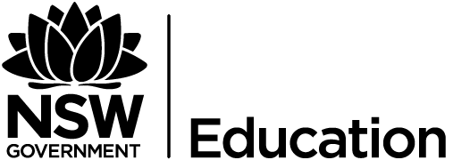 HSC Ceramics CEC

Scope and sequence
HSC | Module 8, term 4  Casting  “Moulds and Slip Casting” | Module 9, term 2  Surface treatment  “Surfacing” | Task 3, term 2  Examination | Module 11, term 3  Ceramics Project  “Individual project”
Practice (making) | Students are to create a range of ceramic vessels from moulds. They will investigate slump moulds and slabs, stamps and slip casting. | Create a series of ceramic vessels that investigate a wide range of surface treatments including incising, sgraffito, wax resist, decals, impressing, scraping, stamping, oxide use and glazing. |  | Student developed final works for CAPA showcase exhibition. They are to independently investigate their ceramic practice.
Critical and Historical Studies | Students will explore ceramic images, concepts and technical information relating to the frames with reference to key ceramic artists.  Students will research key artists and hand in an assignment. | Students will explore ceramic images, concepts and technical information relating to the frames with reference to key ceramic artists.  Students will research key artists and hand in an assignment. | All topics studied including technical information and conceptual (frame questions) on aspects of artist/designers they have studied and/or unseen works. | Students will investigate key ceramic designers that have similar ideas and forms to the student selected individual project.
Forms | Plaster moulds, ceramic slabs, ceramic slip casting, ceramic surfacing. | Hand building, ceramic slabs, ceramic surfacing. | Technical aspects of forms studied.
Frames | Structural, Cultural and Post Modern | Structural, Subjective, Cultural and Post Modern. | Structural, Cultural, Subjective and Post Modern. | Structural, Cultural, Subjective and Post Modern.
Key Artists/ Examples | Gwyn Hanssen Pigott- key works  Australian ceramic designers: Benjamin Hubert, Bridget Bodenham, Cone 11's Colin Hopkins and Ilona Topolcsanyi. | Jun Kaneko- Japanese ceramic artist who lives in America. Australian ceramic designers: Helen Earl, Tania Rollond and Ulrica Trulsson. | All to date. | Individually selected.
Outcomes | M1-6, CH1-5 | M1-6, CH1-5 | CH1-5 | M1-6, CH1-5
Assessment | 20%  Produce a series of ceramic vessels and display them in a mini exhibition. | 15%  Create a series of ceramic objects that investigate surface treatment. | 30%  Complete an examination. | 35%  Produce an independent series of images and display them in the CAPA showcase.

