Art criticism and historical assessment

Task 2
Task title: In class written assessment
Due date: day/month/week/year
Weighting: 20%
Outcomes assessed: H7, H8, H9, H10

Section 1
25 marks
Attempt Questions 1-3
Allow about 45min for this section
Allow about 8min for Question 1
Allow about 15min for Question 2
Allow about 20min for Question 3
Answer each question in a separate writing booklet.
Your answer will be assessed on how well you:
- write in a concise and well-reasoned way
- present an informed point of view
- use the plates and any source material provided to inform your response.

Question 1
5 marks
- Examine how cultural events can influence an artist. In your answer, refer to the specific art work “Undiscovered 4” by artist Michael Cook, with reference to the text extract.
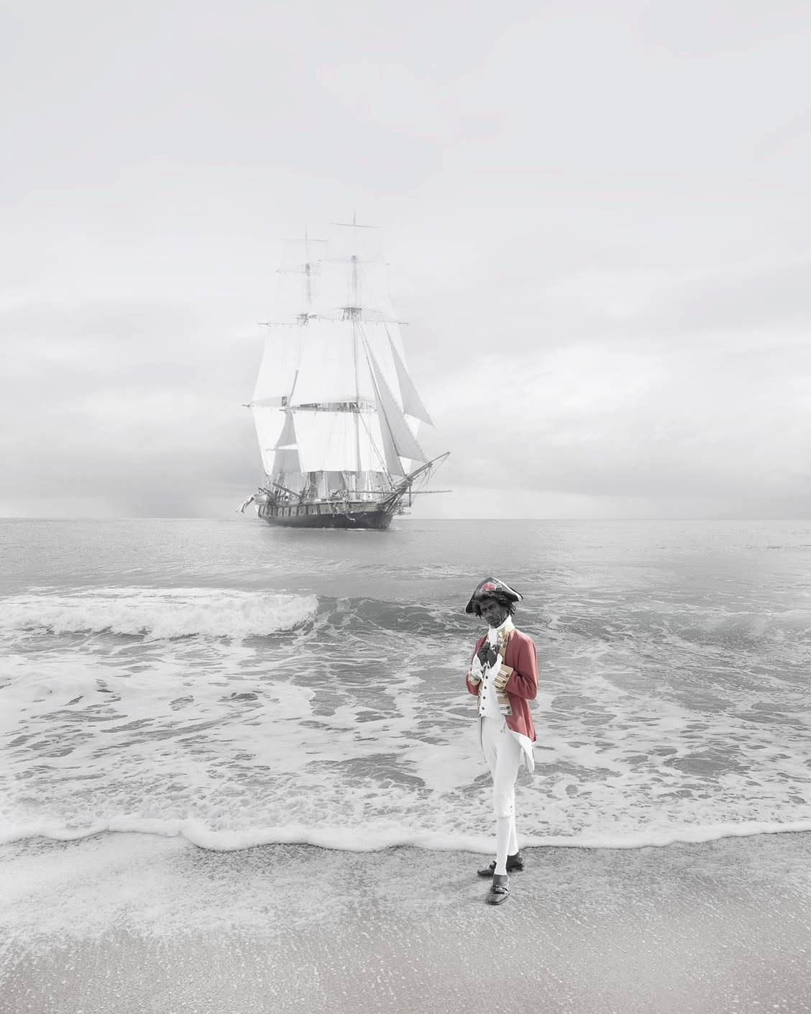
Michael Cook (b. 1968)
“Undiscovered 4”
2010
inkjet print on Hahnemuhle paper
124.0 x 100.0 cm
Australian National Maritime Museum
(Cook, 2010).
A selection of works from a series of ten photographs in which Michael Cook contests the idea of ‘discovery’ that underpins narratives of the British settlement of Australia… Cook depicts the historic Cook as an Aboriginal man replete in his British naval officers attire. His ship, the famed Endeavour, is anchored in the sea behind him. By mimicking the moment of first discovery Cook subverts deeply ingrained understandings of settlement and asks us to consider what type of national Australia would be if the British had acknowledged Aboriginal people’s prior ownership
Written by Dr Marcus Bunyan (Bunyan, 2016).

Question 2
8 marks
Artists reference history to inform the present. Discuss this statement. Refer to Leanna Tobin’s artwork (below) in your answer.
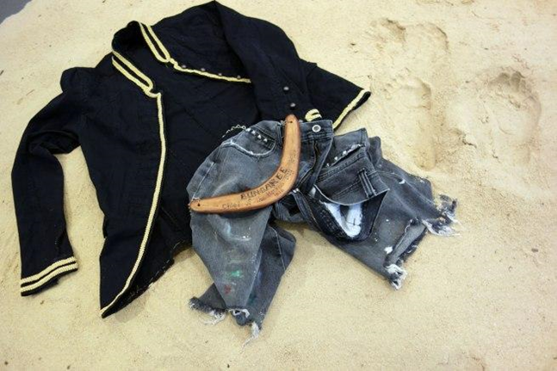
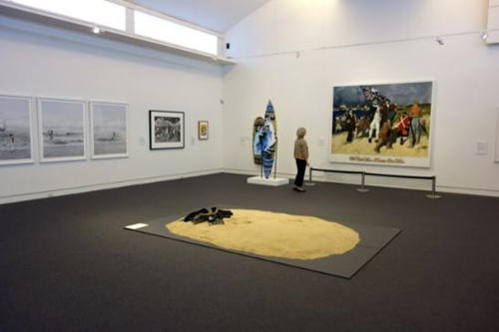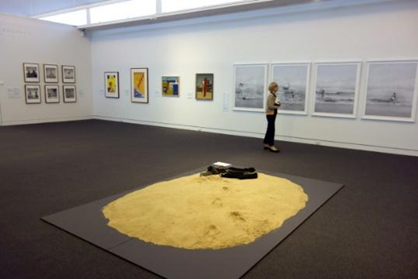
Leanne Tobin (b, 1961)
"Clothes don’t always maketh the man" and (details of installation)
2012
Sand, textile, wood
All images (Tobin, 2012).
Bungaree (c. 1755-1830) was a Garigal man who circumnavigated the continent of Australia with Matthew Flinders on the H.M.S. Investigator between 1802-03. Unlike Bennelong, who attempted to assimilate with British ways and Pemulwuy, who resisted, Bungaree made the decision to navigate a relationship with the British while still maintaining his cultural traditions. He played an important role as an envoy on Flinder’s voyages, negotiating with the different Aboriginal groups they encountered. A skilled mediator, Bungaree was adept at living between both worlds. When coming ashore he would shed his white man’s clothes so that he could conduct protocol relevant to the local elders. In this respect the beach became a zone of transformation and exchange.
Written by Dr Marcus Bunyan (Bunyan, 2016).

Question 3
12 marks
- Investigate the ways in which artists/photographers capture the links between art and society. Refer to the three photographers below in your answer.
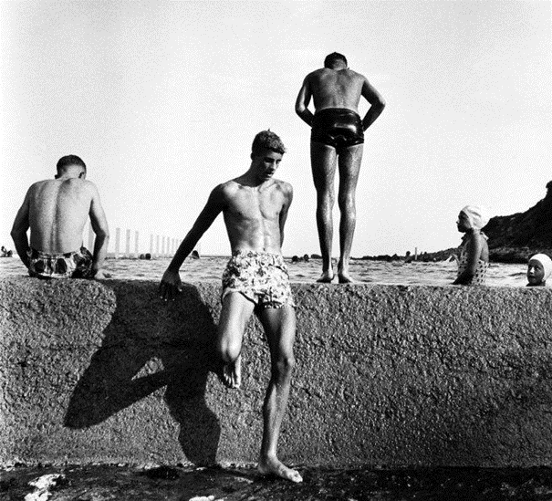
Max Dupain (1911-1992)
“At Newport”
1952, Sydney
Silver gelatin photograph
(Dupain, 1952).
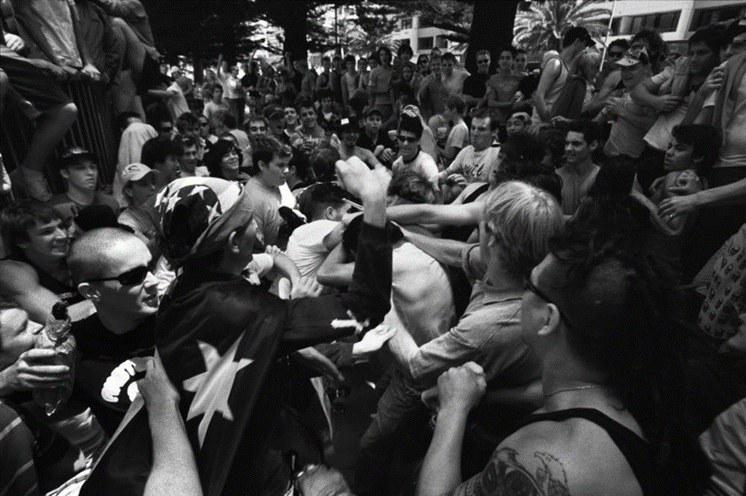
Andrew Quilty
“Cronulla Riots”
2005, Sydney
C-type Print
(Quilty, 2005).
Question 3 continues on the next page (5).
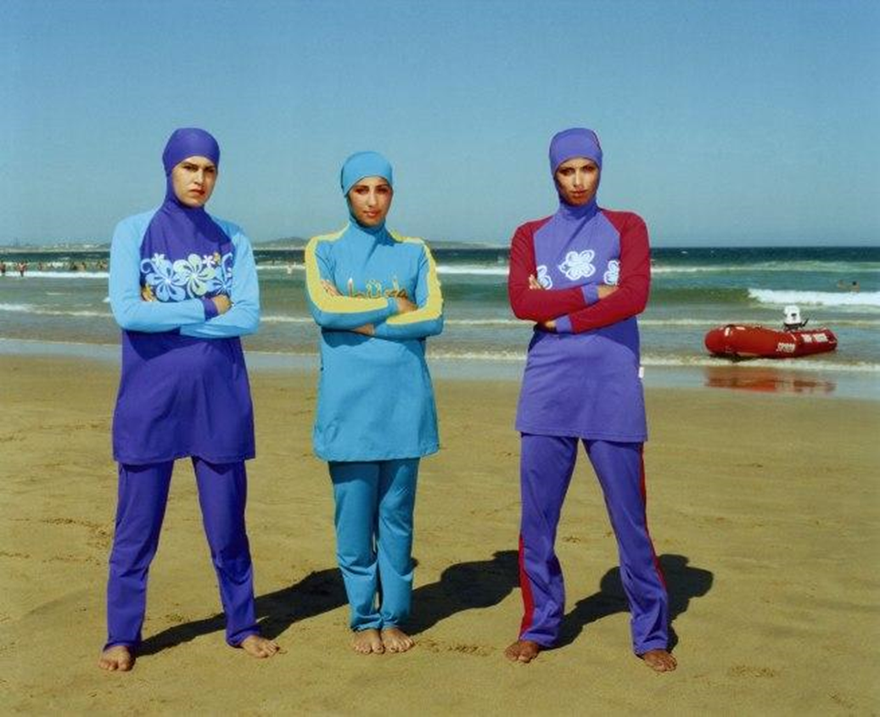
Anne Zahalka (b. 1957)
“The girls #2, Cronulla Beach”
2007
From the series Scenes from the Shire 2007
Type C photograph
(Zahalka, 2007).

References to test
Bunyan, D. (2016). Cronulla beach | Art Blart. Retrieved from https://artblart.com/tag/cronulla-beach/
Cook, M. (2010). Undiscovered 4 [Inkjet print on Hahnemuhle paper]. Sydney: Australian National Maritime Museum.
Dupain, M. (1952). At Newport [Silver gelatin photograph]. Mornington: Mornington Peninsula Regional Art Gallery.
Quilty, A. (2005). [C-Type Print]. Sydney: https://www.andrewquilty.com/
Tobin, L. (2012). Clothes don’t always maketh the man [Sand, textile, wood]. Melbourne: Mornington Peninsula Regional Art Gallery.
Zahalka, A. (2007). The girls #2, Cronulla Beach [Type C photograph]. Mornington: Mornington Peninsula Regional Art Gallery.

