HSC PVDI CEC Stage 6

Photography, video and digital imaging program
Module DI 5: The Arranged Image
Unit title: “Appropriation of Hockney”
Duration: 10 weeks.
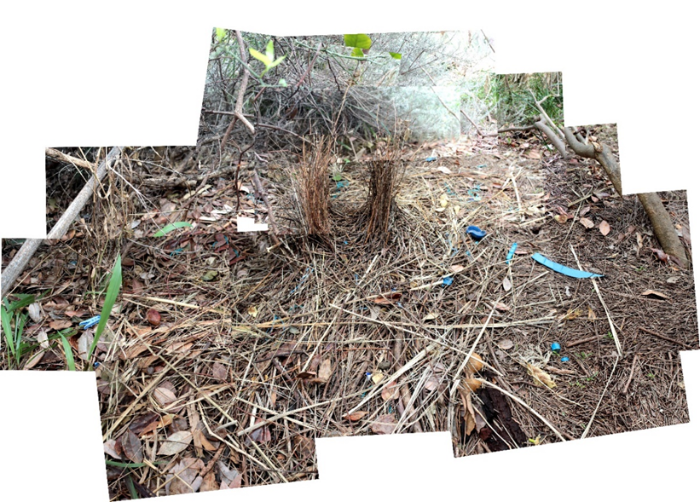
(McAuley, 2018).

Photography, video and digital imaging
Module DI 5: The Arranged Image

Unit Title: “Appropriation of Hockney”
Date:
Teachers name:
Term:

Key Content Areas
Focus areas in table below are bold

Frames | Subjective | Cultural | Post- Modern | Structural
Conceptual Framework | Artist | Artwork | World | Audience
Practice | Artist | Movements | Society | Events

Objectives and outcomes
The student will develop knowledge, skills and understanding through the making of photographs, and/or video and /or digital images, that lead to and demonstrate conceptual and technical accomplishment.
Students will develop knowledge, skills and understanding that lead to increasingly accomplished critical and historical investigations of photography and/or video and/or digital imaging.

Module
- 1-11

Outcomes- Practical  A student: | Outcomes- Criticism and Historical Studies  A Student:
M1: generates a characteristic style that is increasingly self-reflective in their photographic and/or video and/or digital practice. | CH1: generates in their critical and historical practice ways to interpret and explain photography and/or video and/or digital imaging.
M2: explores concepts of artist/photographer, still and moving works, interpretations of the world and audience response, in their making of still and/or moving works. | CH2: investigates the roles and relationships among the concepts of artist, work, world and audience in critical and historical investigations.
M3: investigates different points of view in the making of photographs and/or videos and/or digital images. | CH3: distinguishes between different points of view and offers interpretive accounts in critical and historical studies.
M4: generates images and ideas as representations/simulations in the making of photographs and/or videos and/or digital. | CH4: explores ways in which histories, narratives and other accounts can be built to explain practices and interests in the fields of photography and/or video and/or digital imaging.
M5: develops different techniques suited to artistic intentions in the making of photographs and/or videos and/or digital images. | CH5: recognises how photography and/or video and/or digital imaging are used in various fields of cultural production.
M6: takes into account issues of Work Health and Safety in the making of photographs and/or videos and/or digital works.
Photography, Video and Digital Imaging CEC Stage 6 Syllabus © NSW Education Standards Authority (NESA) for and on behalf of the Crown in right of the State of New South Wales, 2000.

Key competencies
Key competencies encouraged to help develop and foster high-order thinking skills which can then be applied to the outside world.

Competency | Application
Collecting, analysing and organising Information. | Students are to collect information about their own art making practice and that of others. They are encouraged to sort through information, placing it into appropriate categories such as frames. It is mandatory for them to keep a sequential record in their photographic arts process diary that reflects the collecting, sorting, analysing, organising and problem solving of ideas towards the practical component of this course. The art criticism and history component requires ongoing collecting, analysing and organising on information given and researched.
Using mathematical ideas and techniques (numeracy). | Students develop mathematical skills in relation to space. Their body of work is restricted in size and scale, weight and cubic volume and thus requires mathematical consideration in the design and layout of their works of art. Measuring, judging and analysing art works from a timeline and relating the specific work to a scale encourages the development of mathematical problem solving.  Extensive mathematical problem solving is also part of any digital photographic software and animation platforms.
Solving problems. | Problem solving is a central focus of this course. Students are encouraged to learn from their mistakes and examine old and new techniques to help redefine their art making practice. They also look at other historical and contemporary artists that problem solve materially and conceptually.
Key competency topic headings provided by:
Visual Arts Stage 6 Syllabus © NSW Education Standards Authority (NESA) for and on behalf of the Crown in right of the State of New South Wales, 2000.

Literacy
Developing a diverse range of literacy strategies is paramount to this course.
An extensive range of literacy strategies are employed to help assist students in writing, analysing and understanding art critical and historical content of this course. This can include comparisons, text selection, expression and viewpoints of opinions, fact interpretation and recording that is informed by evidence including photographer, historian or critic quotes. Focus on text types and essay styles including explanation, description, investigation and analysis of artworks. Developed responses that express ideas through comprehension and interpretation of images and information, metalanguage and developing an argument. Refining skills in grammar, vocabulary and the structure, content and purposes of an introduction, body and conclusion in formal writing. Development of mind maps and responses to media publications, for example a brochure and magazine interview.
Explicit, complex and specific metalanguage is taught to help with the understanding and use of symbolism, visual elements, principles and technical considerations. Focus on the understanding and application of basic photographic metalanguage and terminology.

Assessment
School based, internal assessment 30 % theory, 70 % practical.

PVDI Stage 6 program
Module DI 5: The Arranged Image
Unit Title: “Appropriation of Hockney”

Lesson sequence and content. | Assessment  Photography, Video and Digital Imaging -criticism and history. | Assessment  Photography, Video and Digital Imaging – Practical.
Ongoing registration of completed activities in the program. | Assessment for criticism and history can be in their end of year examination which is based around the technical content learnt and conceptual considerations.  Technical questions can be in the form of multiple choice or short responses.  It can reflect questions that address aspects of concept (frames), relating to specific photographic artists students have studied and / or unseen images.  It can be given to them as an online test in a program such as Google forms. This works really well and marks most of it for you.  However, they also can be given class assignments (not to then be included in final assessment marks) to do as part of their class work. This is a way to engage students with the theory part of the course and can also be completed if you are ever away. | This is assessed internally (by the class teacher)  - An example of a PVDI assessment task sheet – practical  - An example of a stage 6 life skills (photography) assignment sheet –modified
Module D1 5: The Arranged Image  Appropriation of Hockney  Sign off registration in this column when / if completed with an initial and date completed.  Can be signed off digitally or on a hard copy and stored. | Term 1: Theory research and study  Main goals of this unit are to prepare students to:  - Increase their knowledge of the art world to improve their critical/historical and art making practice.  - Grow confident at responding to the frames.  - Increase their skills in Photography and digital media including Photoshop and advanced creative approaches.  - Prepare them for possible work in the photographic industry or continue further study at another institution. | An example of what you can write in the practical part of the program.  All practical ideas and techniques are explored though screening you-tube clips, displaying images, giving students access to photography books, articles, personal web searches, individual and group technical demonstrations by the class teachers and specialist visitors and critiques.  Students are to create at least 10 images that appropriate the style of David Hockney.  The first 6 ones are mandatory, they then are encouraged to experiment on their own images and compositions after that.  The teacher supplies practice images first and demonstrates this in class using Adobe Photoshop. Giving them a sample of the finished work first, helps students understand easily what to do.  Over the term they are to look at:  - landscape  - portrait  - interior  - urban  - a structure  - an animal  - four of their own.
Weeks 1 & 2  30% teaching time on critical and historical studies.  70% teaching time on the practical component. | Start with the Introduction to the topic via google classroom linked to a google site  Students can access the interactive aspects (download videos and other extension information) for this platform.  Discuss developments into early Modern Photography  ("An Introduction to Photography in the Early 20th Century", 2018)  Key photo artist: David Hockney  Topic: Module DI5- the arranged image.  Click and explore David Hockney’s web site with the class  With the class watch, listen, interpret and discuss the following video ( or part of it depending on time):  Watch some or all of this video introduction to Hockney, (Hockney, 2018)  After looking at David Hockney’s folio online discuss the following:  - What makes his works successful?  - What technical considerations has he focused on? ( look at aperture, focus, light, movement, composition)  - How is he capturing a reflection of his world? | Creating a multiple photo image using Adobe Photoshop  Students are to first practice using the teacher supplied images. The technique is very quick and easy to learn, however, students are encouraged to be selective in their composition and tweak individual layers in the whole image. This can be in the form of colour enhancements of individual components or enhancing textures and so on through the use of various filters.  - Creating a landscape in the style of Hockney using Photoshop.  Students are to download the images supplied by the teacher from google classroom then follow these steps:  - open photoshop, file- automate- photomerge- collage- untick blend images together, select the images and press enter.  - if it becomes one layer then they need to re do it, unticking the blend images together box (if they forgot that step).  Students are then encouraged to individually adjust single photos using Ctrl U (hue saturation) and many more filter options.  Find these on the layers palette on the top bar under image –adjustments or filters.  - Creating a portrait in the style of Hockney (teacher supplied images) using Photoshop.  Follow the above steps.
Weeks 3 & 4 | Class room research assignment.  To be produced in Google Slides and handed in through google classroom.  Students are to research David Hockney  They must include the following:  - His life history  - His ideas and concepts, ( written information)  - Links to interesting sites and videos  - Students must include a range of photographic images with a comment about each one, what is the artist’s purpose? What makes it interesting?  - Relate his images to these elements and principles:  Emphasis, Rhythm/Pattern, Unity/Harmony  - Are there other artists that multiple photos in a similar way to Hockney? | Student photographs  They are to photograph selected scenes standing in the same spot but moving their camera up and down, over lapping the images as they go. They are encouraged to take at least 20 photographs of the one scene/ portrait.  Important to remind the student to select the camera setting to take smaller images first.  An example of how to change the image settings on a Canon camera.  (Canon Rebel tutorial: Image format and size options | lynda.com, 2018)  - Creating an interior in the style of Hockney using Adobe Photoshop.  - Creating Urban (think graffiti , alley) or country ( think dams, farm equipment) outside view in the style of Hockney using Photoshop.  Encourage students to enhance their images, working on individual layers.
Weeks 5 & 6 |  | - Creating an image of a structure (windows, architecture, town monument, train station, shop )  - Creating an image of an animal, if not available look at shadows or people.
Weeks 7 & 8 | Look at contemporary photographic and film artists Broersen & Lukács ("Broersen & Lukács", 2018)  Look at “Establishing Eden”, nominated for the IFFR Tiger Awards.  How have they extended Hockney’s idea of multiple images? | 7-10 images:  They are then to create their own images (final 4) using the same technique.
Weeks 8-10 | Hand in assignment through google classroom. | Student are to set up for their photographic exhibition. They can print off their final images for the show.  Students can also print off individual images from a scene, A3 size and create a large installation on the wall as part of the show. Individual images can be re worked using various art media such as pencil and paint.

Feedback
It is an essential tool to provide timely, specific, meaningful feedback to students.
See an example below (please amend to suit your specific needs):
- oral feedback from the teacher which included individual student discussions and group discussions and critiques.
- criteria sheets
- reinforcement cues, comments and ideas written in their process diary by the class teacher.
- peer assessment
- mind mapping
- progress mini exhibitions
- self-progress reports.

Program evaluation
A written statement from the teacher about the overall success of the program.

Implementation and review
Program implementation in end of term…, date.
Future modification recommended?

Registration: This unit was completed:
Term:
Week:
Date:
Class teacher signature:

References:
An Introduction to Photography in the Early 20th Century. (2018). Retrieved from https://www.khanacademy.org/humanities/art-1010/beginners-guide-20-21/a/an-introduction-to-photography-in-the-early-20th-century
Broersen & Lukács. (2018). Retrieved from https://www.pmpmpm.com/
Canon Rebel tutorial: Image format and size options | lynda.com. (2018). [Image]. Retrieved from https://www.youtube.com/watch?v=_mQxJXMtiYI
Hockney, D. (2018). Photographic Collages: Photos: Works | David Hockney. Retrieved from http://www.davidhockney.co/index.php/works/photos/photographic-collages
McAuley, A. (2018). Bowerbird Crib [Digital photograph]. Coffs Harbour.
Photography, Video and Digital Imaging (CEC) | NSW Education Standards. (2018). Retrieved from https://educationstandards.nsw.edu.au/wps/portal/nesa/11-12/stage-6-learning-areas/stage-6-creative-arts/photography-video-and-digital-imaging
Visual Art Stage 6 Syllabus. (2018). Retrieved from https://educationstandards.nsw.edu.au/wps/wcm/connect/dfd8d346-73a1-4fee-9665-50ab6ca5a872/visual-arts-st6-syl-amended-2016.pdf?MOD=AJPERES&CVID=

