8. Grids, rules, roles and zines
Duration: 5-6 weeks

Driving question
How can we improve the use of space in visual design?

Overview
Students will be introduced to three different grid systems created to enhance graphic design work.They will compare the work of Jan Tschiochold and his typography rules used for designing the style of Penguin books, to that of David Carson. Students will also explore the use of grids in modern design and architecture throughout history. They will discover how the rules of design have broken and adapted through alternative and emerging subculture scenes of early postmodernism. Students will explore the roles of graphic design and complete a zine portfolio which exhibits their body of work throughout sequeunces 1-8.
Stage 5 outcomes
A student:
5.4 investigates and responds to the world as a source of ideas, concepts and subject matter for visual design artworks
5.6 selects appropriate procedures and techniques to make and refine visual design artworks
5.7 applies their understanding of aspects of practice to critically and historically interpret visual design art works
5.8 uses their understanding of the function of and relationships between artist – artwork –world – audience in critical and historical interpretations of visual design artworks
5.9 uses the frames to make different interpretations of visual design artworks
Visual Design 7-10 Syllabus © NSW Education Standards Authority (NESA) for and on behalf of the Crown in right of the State of New South Wales, 2004.

Content
Students will explore the use of the grid in graphic design. They will investigate and create, by examining the grids function for readability and consistency on the printed page and websites. They will study historical changes in graphic design and typography that occurred following the desktop publishing revolution and the development of digital layout programs. Students will explore and participate in various roles in the graphic design industry and showcase a body of work through the publication of a zine.
Focus areas
- Layout, composition and balance
- Structural and cultural frames
- Design and audience.

Cross-curriculum content and key competencies
Work, employment and enterprise
Information and communication technology
Literacy
Numeracy

Assessment
All activities require students to demonstrate their learning and are all assessment for learning activities.

Teaching and learning activities

Introduction
Students will:
- work through the Grid Systems PowerPoint as a class, completing the exercises below:
  - slide two - watch the video Beginning Graphic Design: Layout & Composition (00:05:14) taking notes in your visual design journal or blog. Write definitions and provide examples on the following terms
    - layout
    - composition
    - proximity
    - white Space
    - alignment
    - contrast
    - repetition
  - slide three – research and describe:
    - find an example of Tschichold’s work.
    - in their visual design journal/blog explain the layout and composition addressing each element as per your definitions.
  - slide four – activity
    - write a list of a compositor’s tools from the Letterpress commons website.
    - using the internet, write a blog listing the composition rules for Penguin books design by Tschichold.
  - slide seven - use the websites Thinking with type and Envatotuts+ Design Theory, research and answer the following questions in their visual design journal or blog:
    - What is the purpose of a Hang line?
    - Define and describe the function of the Modular Grid.
    - How does the Baseline Grid differ to the Hang line or Modular Grid?
- work through the David Carson sway, taking notes through the interview on the last page
  - Alternatively, you can download a copy of the sway as a handout.
- visit David Carsons website and write a blog reflection on his career, processes and art. Answer the question
  - How has David Carson managed to advance graphic design by breaking the rules?
- research and write definitions for the following terms in their visual design journal/blog
  - balance
  - tension
  - unity
  - juxtaposition
- design and make a page that demonstrates each of the design principals from above (an example is shown below). Experiment with collage and different textured backgrounds.
Image from i.pinimg.com/564x, accessed 10/12/2017

Design roles and zine publications
Students will:
- research and complete a table set out like the image below
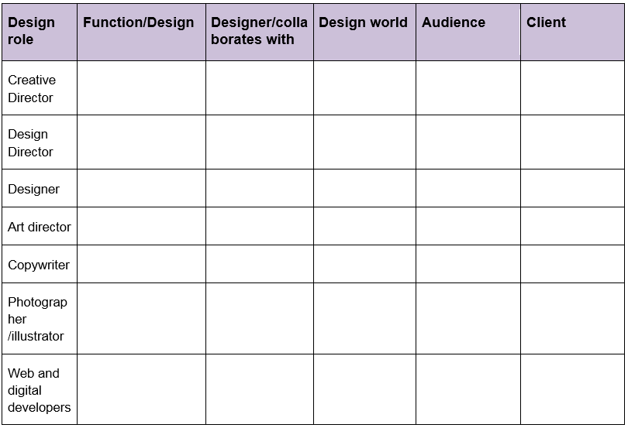
- complete the Design roles kahoot quiz
- research and compose a blog post dedicated to one of designers below, providing examples of their work
  - Vaughan Oliver
  - Simon Larbalestier
  - Marc Atkins
  - Nigel Grierson
- read the article Bedroom zine culture still thriving the internet age and watch the included video
- using the internet, answer the following questions
  - What is a zine?
  - How are they made?
  - When did they originate?
  - Are their rules for zine making?
  - Define DIY publishing.
  - What role can zines have in creating closer communities?
  - Is Pinterest a zine? Why?
- locate and paste examples of the following components of a zine:
  - a hand drawn and coloured publication
  - any alternative formats.

Design making
Materials required
- white paper
- coloured paper
- scissors
- phones or cameras
- printed text examples
- cardboard
- glue
- visual design journal/blog.

Making Grids
Students will:
- draw a 1cm border on a piece of paper that is 20cm x 20cm
- divide the centre square into 3cm x 6cm columns and rows with 5 cm gutters (the border around each of the 9 squares)
- cut squares and rectangles from coloured paper and make as many new variations of a multigrid with hang lines (see the example below)
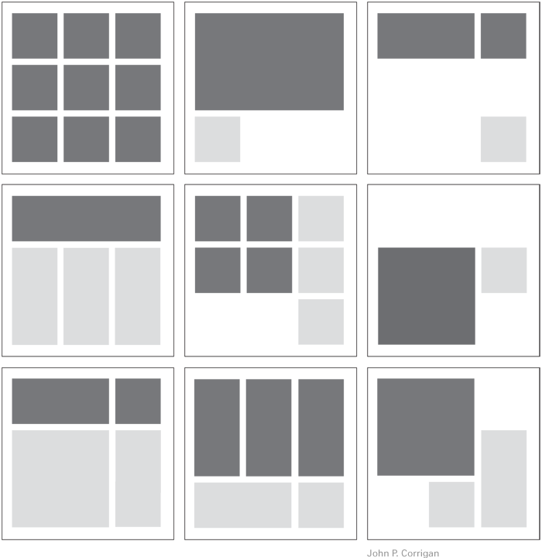
Image from gdblogs.shu.ac.uk, accessed on 24/01/2018.

- photograph and reflect on the design process in their visual design journal/blog.
It is important to remind students that the best layouts contain white space.

Carson photoshop magazine and album covers
Using a computer and a software such as Photoshop, students will:
- design a grid to structure a magazine font cover
- layer various images of type or examples from their illustrative text sequence, on another layer add images on top of this. Play with the transparency
- follow the steps above to design an album cover for their favourite song
- reflect on the design process in their visual design journal/blog.

Zine publication
Using a computer, students will design a zine publication showcasing all of their completed designs. Students will:
- photograph any work or text that has not been uploaded into their online blog
- save in a folder on the computer desktop for easy access
- using illustrator, photoshop, publisher or InDesign, create a master page for multipage document
- set margins, gutters and columns to make a flexible modular grid
- add experimental typography designs and colour to each page
- design each page as a unique piece of art
- create a new image for the front cover and give their zine publication a title
- print and bind using a staple or an alternative binding technique
- exhibit their zine publication.

Communicate
Students will complete a digital blog/visual design journal documenting the ideas and processes used throughout this sequence. This can be completed through one-note, Class Notebook or Google classroom.
The blog/visual design journal should contain:
- the process and technical skills used in practical classes
- personal reflections about the practical activities
- information gained through investigations or class discussions
- answers to questions asked in class
- a glossary of new words and terminology with graphic examples
- thoughts of the different techniques and types explored.

Differentiation

Extension
Teachers are encouraged to provide students with acceleration activities if required.
Students could:
- track the development of the Penguins book covers
- write an article and design an accompanying magazine spread
- write a blog post addressing the driving question
- design a poster advertising their zine publication
- create a stop-motion short video advertising the publication.

Life skills
Life skills outcomes
LS.1 experiences a variety of visual design procedures to make visual design artworks
LS.2 explores a variety of materials, techniques and processes
LS.6 makes a variety of visual design artworks that reflect experiences, responses or a point of view
LS.7 explore a variety of subject matter that can be represented in visual design artworks
Visual Design 7-10 Syllabus © NSW Education Standards Authority (NESA) for and on behalf of the Crown in right of the State of New South Wales, 2004.
Students could:
- discuss where they have seen grids used in their day to day life
- complete the grid activity from above with assistance
- print out a grid template from online and get them to colour the different sections in varying colours
- trace over a magazine inlay, identifying where the main lines fall
- create a Carson style collage:
  - collage different examples of printed text onto a piece of cardboard, cut and tear
  - cut out simple shapes of animals on black or white paper
  - glue the animal cut-outs over the text collage.
Students could:
- photograph other students work
- import their pictures into a word document or powerpoint
- add tites and descriptive text for each page
- export the document as a PDF or print it out
- bind it together and share with the class.

Evaluate
Formative assessment can be used to determine learning progress throughout the lesson sequences. Teachers should informally assess a student’s level of understanding and adapt accordingly.

Reference list and resources
Visual Design 7-10 Syllabus © NSW Education Standards Authority (NESA) for and on behalf of the Crown in right of the State of New South Wales, 2004.
ABC – Bedroom zine culture still thriving in the internet age, abc.net.au/news, accessed 12/02/2018.
Beginning Graphic Design: Layout & Composition (00:05:14) youtube.com/watch?v, accessed 24/01/2018.
Collage image i.pinimg.com, accessed 24/01/2018.
Letterpress commons website letterpresscommons.com/compositors-tools, accessed 24/01/2018.
David Carson design, davidcarsondesign.com, accessed 10/12/2017.
David Carson: Design, discovery and humour youtu.be/tFpANOqSdi8, accessed 24/01/2018.
DoE David Carson Sway sway.com, created and accessed on 24/01/2018.
Layouts design magazine, i.pinimg.com, accessed 10/12/2017.
Thinking with type http://thinkingwithtype.com/grid/, accessed 24/01/2018.
Envatotuts+ Design Theory webdesign.tutsplus.com/articles, accessed 24/01/2018.
Grid images gdblogs.shu.ac.uk, accessed 24/01/2018.

