4. Graffiti type and symbols
Duration: 2-3 weeks

Driving question
Is Graffiti a legitimate form of Art and Typography?

Overview
Students will investigate how symbols and codes are used by communitites as information systems. They will create type forms and symbols that serve as a comtemporary form of graphic expression and communication. Students will design for personal objects such as skateboards and mobile phones.
Stage 5 outcomes
A student:
5.4 investigates and responds to the world as a source of ideas, concepts and subject matter for visual design artworks
5.5 makes informed choices to develop and extend concepts and different meanings in their visual design artworks
5.6 selects appropriate procedures and techniques to make and refine visual design artworks
5.8 uses their understanding of the function of and relationships between artist – artwork –world – audience in critical and historical interpretations of visual design artworks
Visual Design 7-10 Syllabus © NSW Education Standards Authority (NESA) for and on behalf of the Crown in right of the State of New South Wales, 2004.

Content
Students will design a series of works based on appropriated traditional typography and reinvent as an identity influenced by the study of varied subcultures.
Focus areas
- Shape, colour, form and layout
- Historical and postmodern frames
- Design, design world and audience.

Cross-curriculum content and key competencies
Civics and citizenship
Work, Employment and Enterprise
Information and communication technology
Numeracy
Literacy

Assessment
All activities require students to demonstrate their learning and are all assessment for learning activities.

Teaching and learning activities

Introduction
Students will:
- through a class discussion explore the questions:
  - What is a sub-culture?
  - Why are the appearances and fashions of a sub-culture so important?
- make a list of sub-cultures in their process diaries/blog. For example, surfies, soccer fans, goths, punks, hip hop etc.
- work through the Graffiti type and symbols PowerPoint as a class, completing the exercises below:
  - slide four – answer questions 1 & 2 in their visual design journal or blog
  - slide five – answer questions 1 & 2 in their visual design journal or blog
- answer in their progress diary/blog:
  - what influences do sub-cultures have on the mainstream?
  - compare and contrast hobo glyphs and graffiti culture through a Venn diagram.

Design making
Materials required
- MDF board, cardboard or skateboard design template – hard and soft copy
- access to paint, coloured pencils and felt tip makers
- mobile phones, video cameras or laptops.

Skateboard design
Students will:
- watch the videos
  - How to: Create custom skateboard graphics (00:01:45)
  - Painting on a skate desk for Waffurusōru (00:03:08)
- choose a word as an ‘identity’
- write the word in the font they developed in the ligatures sequence
- develop the word into a graffiti looking street design
- transfer the designs on a MDF board cut in the shape of a skateboard deck
- paint the design
- exhibit.

Symbols and video
Students will:
- create a chart of symbols and meanings to a particular sub-culture of their creation. A copy of the Hobo Code can be found here as an example: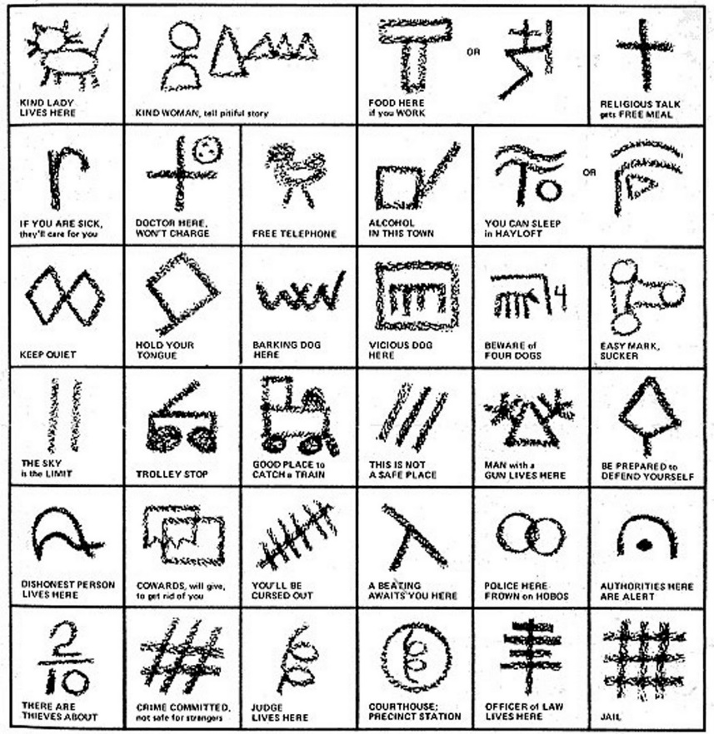
- create a short video using their phones about ‘A day in the life of a Hobo’. Play and discuss as a class.

Communicate
Students will complete a digital blog/visual design journal documenting the ideas and processes used throughout this sequence. This can be completed through one-note, Class Notebook or Google classroom.
The blog/visual design journal should contain:
- the process and technical skills used in practical classes
- personal reflections about the practical activities
- information gained through investigations or class discussions
- answers to questions asked in class
- a glossary of new words and terminology with graphic examples
- and thoughts of the different techniques and types explored.

Differentiation

Extension
Teachers are encouraged to provide students with acceleration activities if required.
Students could:
- create a brand poster by adding text and a company slogan
- develop an advertising campaign for a skateboard company
- using photoshop only, design 3 different skateboard decks using the layer technique. A png template for photoshop has been provided. For help with layers go the Adobe About photoshop layers website.
- write a blog post addressing the driving question.

Life skills
Life skills outcomes
LS.1 experiences a variety of visual design procedures to make visual design artworks
LS.4 explores ways in which experiences of the world can be communicated in visual design artworks
LS.6 makes a variety of visual design artworks that reflect experiences, responses or a point of view
LS.7 explores a variety of subject matter that can be represented in visual design artworks
Visual Design 7-10 Syllabus © NSW Education Standards Authority (NESA) for and on behalf of the Crown in right of the State of New South Wales, 2004.
Students could:
- draw their names in block letters onto the skateboard deck template or wood
- with paint, colour the letters
- outline in black and add lighting bolts or other symbols to the design
- discuss why they used the colours and symbols used in their design.

Evaluate
Formative assessment can be used to determine learning progress throughout the lesson sequences. Teachers should informally assess a student’s level of understanding and adapt accordingly.

Reference list and resources
Visual Design 7-10 Syllabus © NSW Education Standards Authority (NESA) for and on behalf of the Crown in right of the State of New South Wales, 2004.
The Hobo Code nowiknow.com, accessed 15/01/2018.

