Visual literacy – An introduction
Visual literacy is the ability to look at, or read, images so that you can understand the meaning that is being conveyed.
In modern society, images are everywhere! From advertisements to memes, the power of the image is more important than ever.
Images have their own sort of grammar, like written language. In order to understand the images in our picture books, we will look at the following techniques: shape, line, colour, gaze, symbols, salience, juxtaposition and angles
Shape
There are lots of ways that shape can affect how we react to an image. People tend to react differently to sharp, angled shapes as opposed to rounded shapes. Some common emotions or ideas brought on by shapes include:
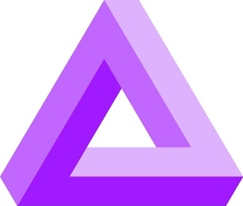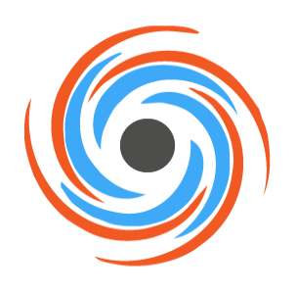

Triangles | Squares | Circles | Spirals
Conflict or action. It also refers to science or religion in some images. | Stability, equality, security, honesty | Protective, infinite, eternal. It also references community and wholeness or wellness | Creativity, growth and spirituality
Line
There are lots of different lines in an image. Their size can change, or their direction. Thin lines often mean something is delicate or soft. Thick lines suggest strength or boldness.
Colour
The colours that are used in an image give us an idea about what is happening as well. Colours help us to develop different feelings or emotions. These can be different though, depending on which country you are from. Generally though, colours are often used to build these emotions:

White | Green | Blue | Red | Pink
Purity and cleanliness | The environment, peacefulness or jealousy | Sadness, depression, coldness | Strength and passion, anger | Romance, love, caring
Gaze
When a character in the image stares directly at the viewer, making eye contact, it is called a demand. The character is demanding something from the viewer.
Looking away from the viewer and not making eye contact is called an offer. It is an invitation for the viewer to look around the image for more information.
Symbols
Symbols can be used to represent a particular idea in an image. They usually represent abstract ideas. One example is the symbol for peace. Peace can also be represented by the symbol of a dove.
Salience
This is when a character, animal or object in an image deliberately captures our attention and holds our eye. There has to be something that makes it stand out in the image and makes it more obvious than the rest of the image around it.
Juxtaposition
This is when we put characters and/or objects side by side or close together. This technique is used to show contrast or to compare things.
Angles
The viewer’s relationship with image is affected by the angles used in the image. Angles can also show who has the power in an image.
If the viewer looks up from a low angle, the character is usually powerful or evil.
If the viewer looks down from a high angle, the character in the image is usually weak or vulnerable.
If the viewer looks at the image from eye-level, there is an equal relationship.

