Artmaking

Part 3 – Sculpture
Duration: 3 weeks

Overview
Students investigate public art, identifying areas that are current and relevant, to enable them to create a 3D sculpture for a school exhibition.
Stage 4 outcomes | Stage 5 outcomes
A student: | A student:
4.1 uses a range of strategies to explore different artmaking conventions and procedures to make artworks  4.2 explores the function of and relationships between the artist – artwork – world – audience  4.3 makes artworks that involve some understanding of the frames | 5.1 develops range and autonomy in selecting and applying visual arts conventions and procedures to make artworks  5.2 makes artworks informed by their understanding of the function of and relationships between the artist – artwork – world – audience  5.3 makes artworks informed by an understanding of how the frames affect meaning
Visual Arts 7-10 Syllabus © NSW Education Standards Authority (NESA) for and on behalf of the Crown in right of the State of New South Wales, 2003.

Content
Students will explore Sculpture building practices creating a sculpture that reflects current issues in their school environment.
Cross-curriculum content and key competencies
Environment
Civics and citizenship
Information and communication technology
Gender

Assessment
All activities require students to demonstrate their learning and are all assessment for learning activities.

Teaching and learning activities
Students will:
- use the internet to research the April Pine, exhibitor in the 2017 Sculpture by the Sea ‘People’s choice prize’ at Bondi
- discuss the human form as subject matter for art making.

Tableau
‘An arrangement of people who do not move or speak, especially on a stage, who represent a view of life, an event, etc.’
Cambridge dictionary, date accessed 27/03/2018.
In groups of 4-5, students will:
- discuss the definition of a Tableau
- in one minute intervals, form a series of tableaux’s in the scenarios called out by the teacher. Some teacher examples have been provided below.
  - at the beach
  - a game of cricket
  - family picnic
  - water skiing on the river
  - high tea with the queen
  - the human body,
- photograph each groups frozen 3D tableau of the human body
- answer the following questions in their book/blog
  - What is sculpture?
  - Discuss the divide between performance art and sculpture? How did it feel to perform?
  - How important is the role of the audience when creating a sculpture? Why?
  - create a flow chart of the roles and relationships which exist within the school environment and community. If you were proposing the design and construction of a sculpture for the school, why would this flow chart be important?
- research and write an online blog about the artist John Dahlsen and his contributions to Australian sculpture.

Sculpture
Students will:
- write a pitch/proposal selling their sculpture design to the class. In their proposal they must address
  - show the design concepts
  - say how it relates to the chosen environment
  - identify any issues that may occur through the process
  - provide environmental considerations for the location,
  - select a theme that relates to the area
  - write a budget for the proposed cost of the artwork
  - create a live feed and voting section on their class blogs, detailing their proposals
- present to the class
- vote on each groups proposal, providing a comment on the criteria above. This could be done through google forms, survey monkey, polls on Edmodo or any other live polling/voting system online.
- construct a miniature version of their proposed sculpture.

Communicate
Written responses are documented and shared within collaborative discussion facilitated by the teacher.

Multimedia blog
Students will:
- document the process of their artmaking within a journal. This can be their visual arts process diary, or an online blog through sites such as Google classroom
- photograph or sketch the process used
- write a response to the process used following literacy structures, language forms and features, as seen in the DoE text type support document.

Differentiation

Extension
Students could:
- create and decorate an exhibition that reflects the intentions of their miniature sculptures somewhere in the school
- research innovative ways of incorporating technology for sculpture development and exhibitions. Write a blog post about the findings.

Life skills
Life skills outcomes
A student:
LS.1 experiences a variety of art making activities
Visual Arts 7-10 Syllabus © NSW Education Standards Authority (NESA) for and on behalf of the Crown in right of the State of New South Wales, 2003.
Students could:
- create a series of 3D human form sculptures using only three selected recycled materials such as newspaper, tape and string.
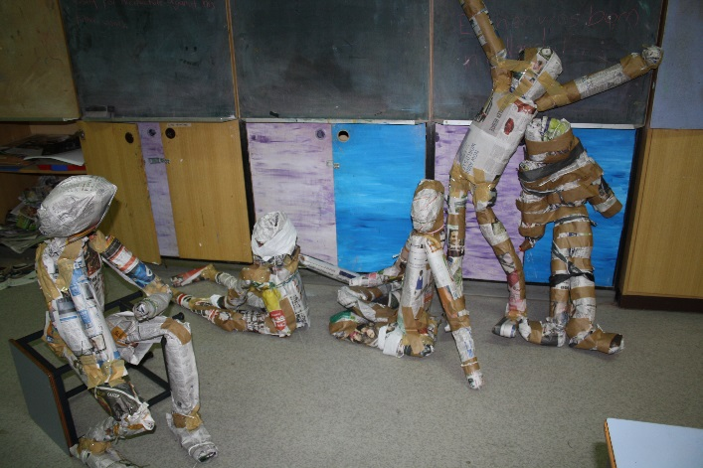
Students art work in the classroom, Elizabeth Macarthur High School, 2011. Photo C.Redmond

Evaluate
Feedback is formative for the duration of the project.

Reference list and resources
Cambridge dictionary, date accessed 27/03/2018.
Edmodo, date accessed 27/03/2018.
Google forms Google forms, date accessed 27/03/2018.
Survey Monkey, date accessed 27/03/2018.
Visual Arts 7-10 Syllabus © NSW Education Standards Authority (NESA) for and on behalf of the Crown in right of the State of New South Wales, 2003.

