Satire – more than laughs
Satire is traditionally a form of comedy, but can often be found in political theatre as a vehicle for social commentary on current social, historical or political events. Essentially it means to ‘send-up’. Satire will often mock an individual, group of people or, more broadly, an institution. Satire uses a range of techniques to create humour and dramatic meaning, including:
- exaggeration – Representing something (action, voice, slogan) beyond normal boundaries so that it becomes larger allowing for faults to be seen (e.g. a caricature).
- reversal – To swap the roles of a situation and present them out of the usual order (e.g. male versus female gender roles).
- parody – to imitate the techniques, actions and language of a person, place, or thing.
Satirical comedy is made even more powerful when the topics are well known to the audience. Often the more relevant or famous the person, event or institution is, the funnier the satire will be for the audience as it feels more relevant to their lived experience. However, if done without care or thought, satire can be deemed as offensive or insulting, consequently care must be taken to ensure the dramatic meaning is clear and consistent.
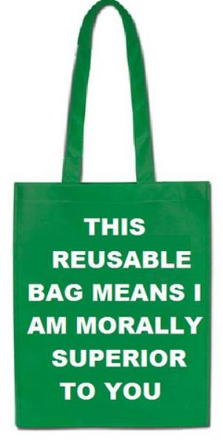Image of reusable shopping bag with phrase “This reusable bag means I am morally superior to you”. Accessed on the 13th November 2017 from https://www.flickr.com/photos/notionscapital/3407696476 .
While satire can often feel contemporary, it is important to note that its origins were in ancient Greek satyr plays and some of the works of Shakespeare. More recently, it was used by German theatre practitioner Bertolt Brecht who used theatre to highlight aspects of the government in 1930’s Germany. Presently, satire is all around us in contemporary culture with almost every facet of the media employing it, including: newspapers, magazines, theatre, arts, television, radio and film. It is a way of engaging audiences and an opportunity to provide a social commentary on social, political or cultural events in a comic or humorous means.

