Greek theatre

Part 2 – History and context
Duration: 1 week

Driving questions
What is the purpose of theatre in Ancient Greece? What are the conventions of ancient Greek theatre? How is theatre in ancient Greece similar and different to contemporary theatre?

Overview
Students develop skills in analysing the creditability of web sources and using the Internet to research a given topic. They use Socrative to compete against their peers in a space race showing their research skills, understanding of the history and socio-cultural context of ancient Greek theatre and the conventions of ancient Greek theatre.
Stage 4 Outcomes | Stage 5 Outcomes
A student: | A student:
4.3.1 identifies and describes elements of drama, dramatic forms, performance styles, techniques and conventions in drama | 5.3.1 responds to, reflects on and evaluates elements of drama, dramatic forms, performance styles, dramatic techniques and theatrical conventions
4.3.2 recognises the function of drama and theatre in reflecting social and cultural aspects of human experience. | 5.3.2 analyses the contemporary and historical contexts of drama.
Drama 7-10 Syllabus © NSW Education Standards Authority (NESA) for and on behalf of the Crown in right of the State of New South Wales, 2003.

Content
Through interactive digital technology, students gain skills in searching for credible sources online, research skills and develop an understanding of the socio-cultural context of ancient Greek theatre.
Through research they explore how Greek theatre provided the foundation of contemporary theatre. Students study the development of Greek theatre from ritual ceremonies in celebration of the God Dionysus to ancient Greek theatre, including: masked performance, song and dance.
Cross-curriculum content and key competencies
Information and communication technology

Embedded elements of drama
- Structure
- Symbol
- Dramatic Meaning

Assessment
All activities require students to demonstrate their learning and are all assessment for learning activities.

Teaching and learning activities
The following learning experiences are structured to provide students with a practical and theoretical understanding of Greek Theatre.

Analysing web sources
Students will:
- review the Analysing web sources resource
- discuss why assessing the creditability of an online source is important?

Space race
Students are divided into research teams between 2-4 students. They will use the internet to research the questions being presented using the skills/knowledge gained in the previous task to access reliable sources.
Students will then respond to questions on Socrative.

Teachers instruction
- Go to www.socrative.com.
- Create a teacher account with Socrative.com or log-in.
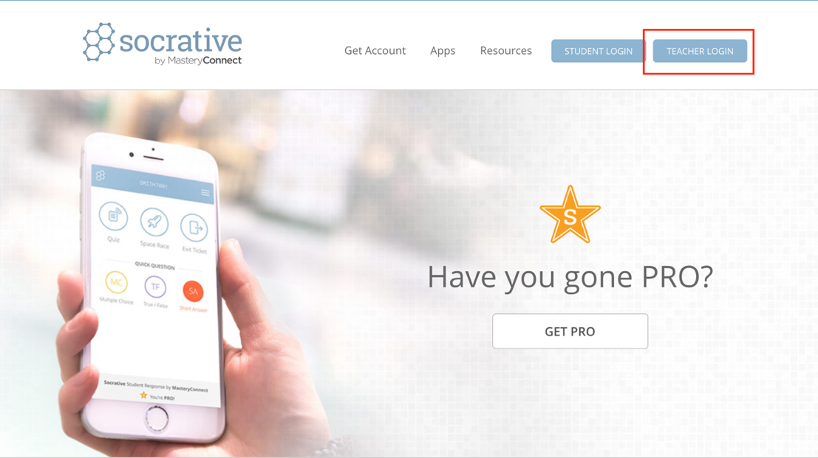
- Search for the quiz with the number 31827109.
- In the quizzes section the ‘Greek Theatre History KASCA’ quiz should appear.
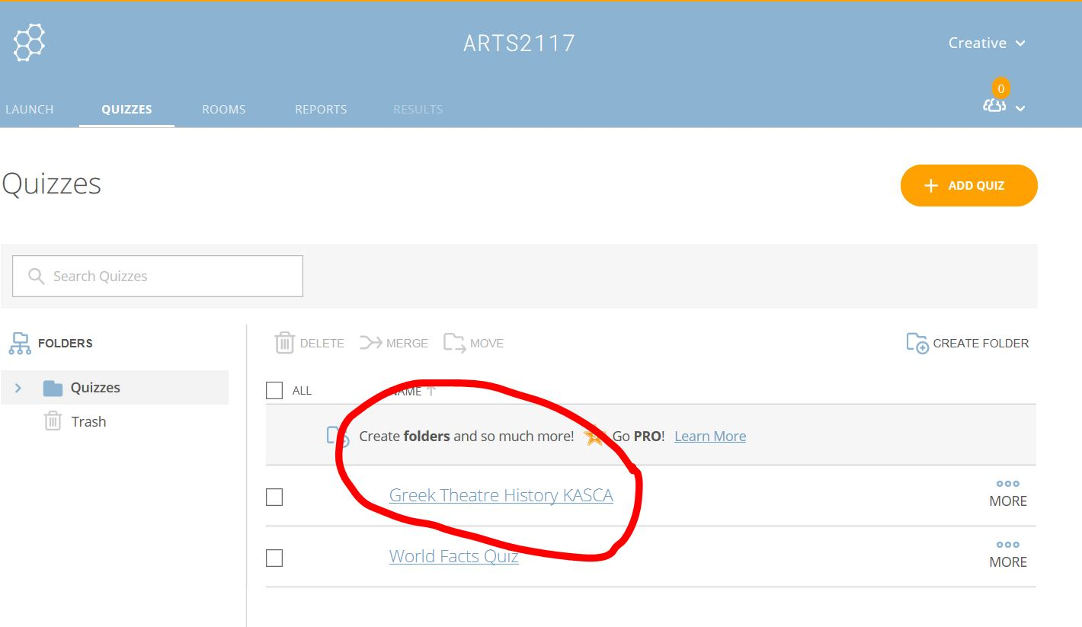

- Select ‘Launch’, then ‘Space Race’.
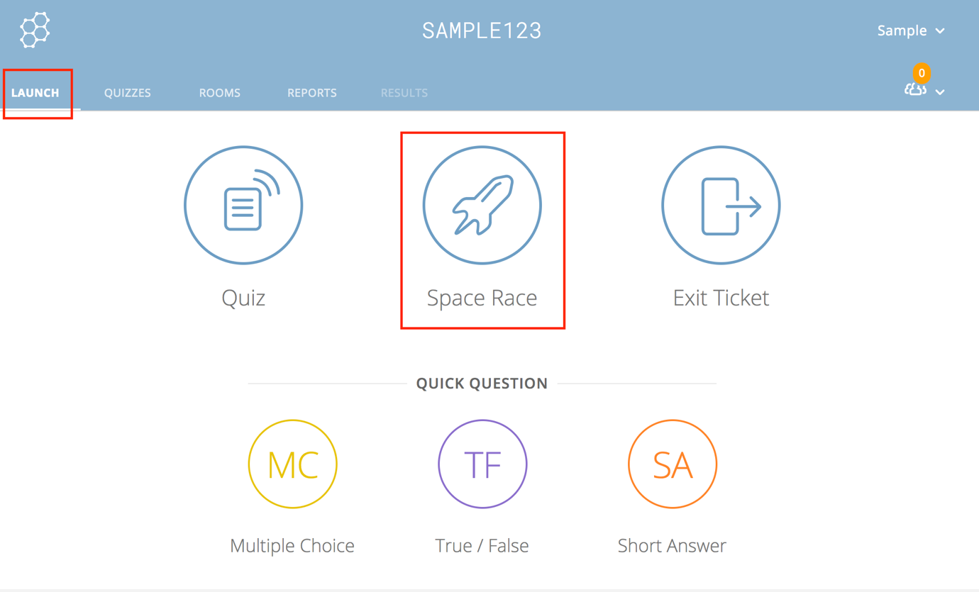

- Select the quiz you would like to use.
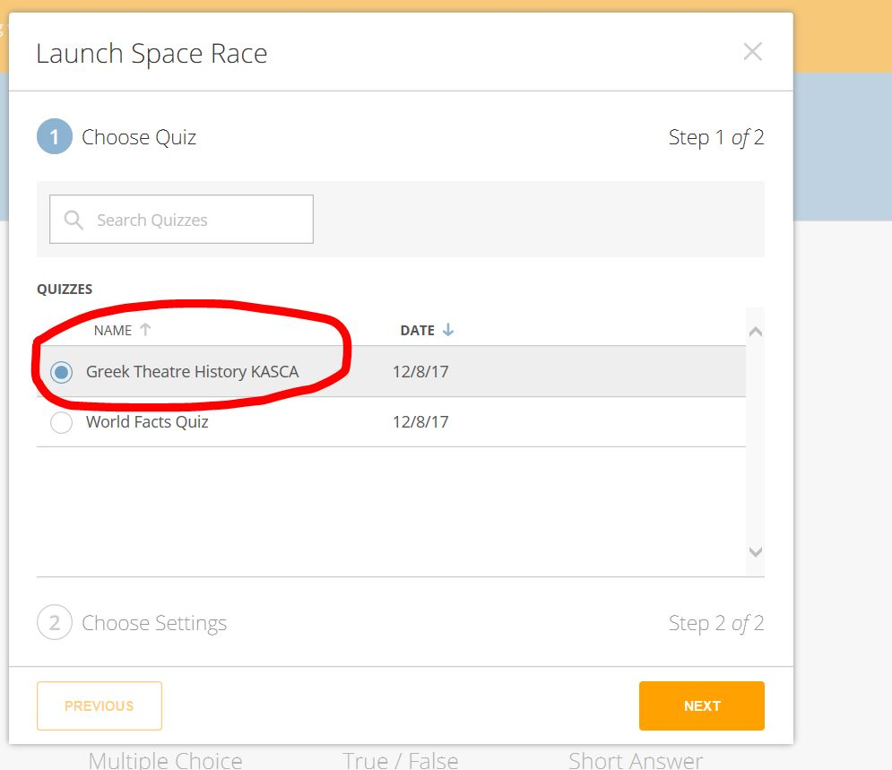

- Decide whether you would like questions shuffled and click ‘Start’.
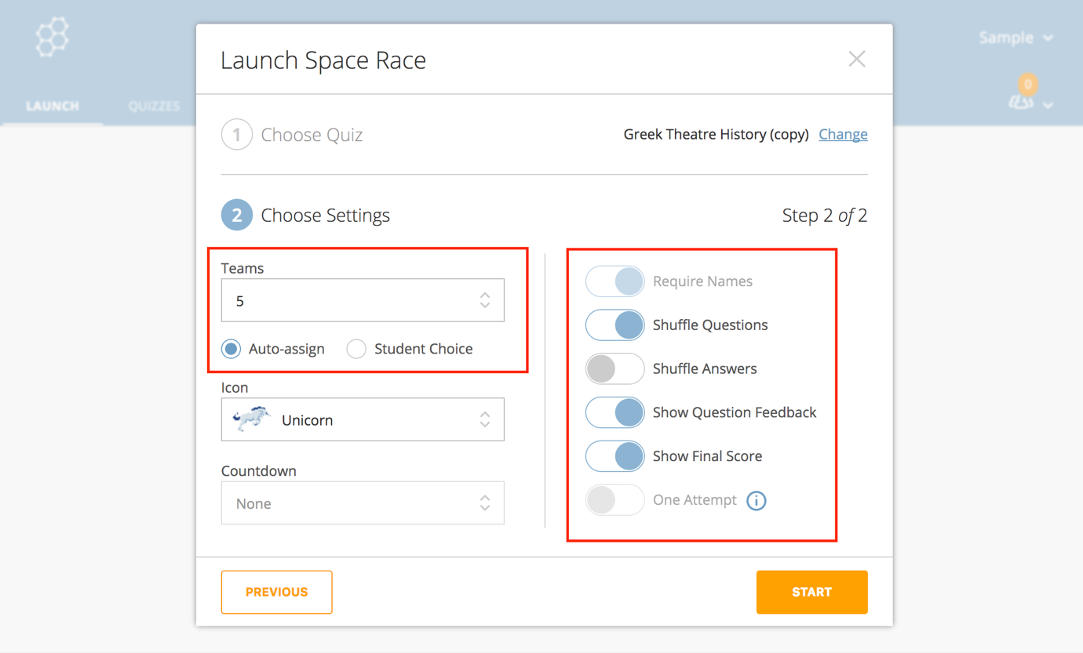

- You will now be provided with the space race dashboard that allows you to track students’ progress. Provide students with the room number located in the top centre of your screen and allow them to begin.
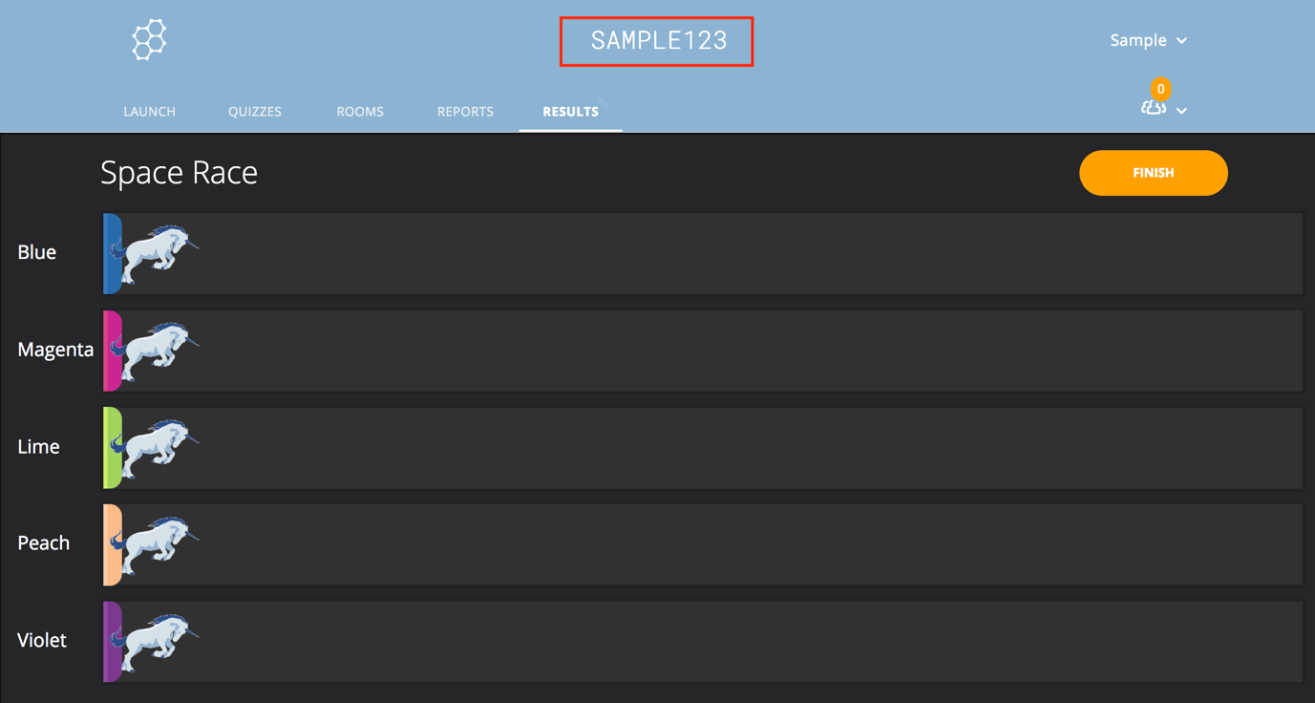
- When all students have completed, select ‘Finish’.
- As a class, review student responses, highlighting the correct answers.

Students instructions
- Go to www.socrative.com .
- Select ‘student login’.
- Enter the room number provided by the teacher.
- Respond to questions as they arise, ensuring they record answers in their logbooks as they go.

Differentiation

Extension
Students could:
- analyse a website using the information on the Analysing web sources resources
- write a report using information from the website above
- continue to research ancient Greek theatre and create their own quiz questions and answers.

Life skills
Life skills Outcomes
A student:
LS 3.1 experiences a variety of drama or theatre performances.
Drama 7-10 Syllabus © NSW Education Standards Authority (NESA) for and on behalf of the Crown in right of the State of New South Wales, 2003.
Students could:
- Use the following websites to support them in locating the information:
  - The British Museum – Greek Theatre
  - Ancient Greece – University Press

Evaluate
Feedback is formative during the lessons.

Reference list and resources
Drama 7-10 Syllabus © NSW Education Standards Authority (NESA) for and on behalf of the Crown in right of the State of New South Wales, 2003.

Handout: Analysing web sources handout
Account for www.socrative.com
Online Quiz: Ancient Greek Theatre Quiz

