Structuring stories
Various story structure models exist. However, for thousands of years, the leading guide writers had to plot, and story structure was Aristotle’s book, Poetics. Aristotle’s concept of story structure was based on his study of classical Greek theatre. Aristotle’s key findings regarding plot structure were:
- every good story has a beginning, a middle, and an end
- cause and effect link the incidents that make up the plot
- a story is about a ‘change of fortune’ for the protagonist.
Aristotle’s theories were taken a step further in the 19th century by Gustav Freytag, who had more examples to draw on than Aristotle, including the plays of Shakespeare.

Freytag’s analysis
According to Freytag, a drama can be divided into separate sections. This is called a dramatic arc and is made up of an exposition, rising action, climax, falling action, and dénouement.
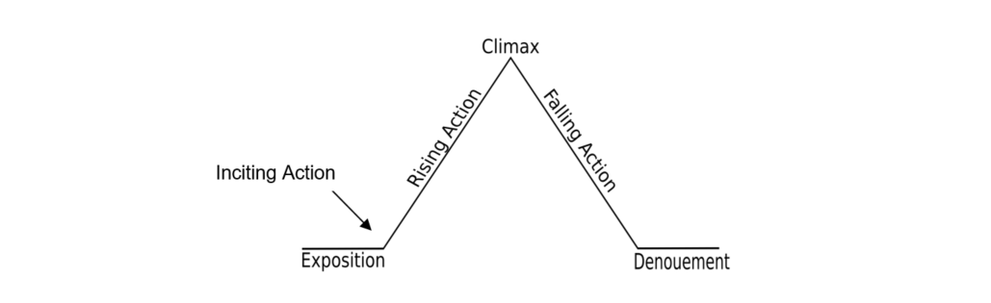
Freytag’s analysis may be difficult to apply to modern/contemporary plays, which are diverse in their dramatic structure. Each section is outlined below.
- Exposition. The exposition is the portion of a story that introduces necessary background information to the audience; for example, information about the setting, events occurring before the main plot, characters' back stories, etc. Exposition can be conveyed through dialogues, flashbacks, character's thoughts, background details, in-universe media, or the narrator telling a back-story.
- The Inciting Incident. Every story begins with an event that gets the story moving and introduces the main problem or conflict.
- Rising Action. The story’s tension builds through a series of additional events. (Aristotle called this the “complication” phase.) In a tragedy, things seem to be going well for the protagonist during the rising action. In a comedy (meaning a story with a happy ending), things seem to be going badly for the protagonist at this stage.
- Climax, Crisis, or Turning Point. The climax is the turning point, which changes the protagonist’s fate. If the story is a comedy, things will have gone badly for the protagonist up to this point; now, the plot will begin to unfold in his or her favour, often requiring the protagonist to draw on hidden inner strengths. If the story is a tragedy, the opposite state of affairs will ensue, with things going from good to bad for the protagonist, often revealing the protagonist's hidden weaknesses.
- Falling Action. The change that occurs at the Climax results in a new series of events which illustrate the consequences of the change. In a tragedy, everything starts to go wrong for the protagonist; in a comedy, everything starts to go right. (Aristotle called this the ‘unravelling’.)
- Denouement. The story ends with a Catastrophe (in the case of a tragedy) or some other Resolution (such as a happy ending) which shows the protagonist’s downfall or triumph. This section of the story comprises events from the end of the falling action to the actual ending scene of the drama or narrative. Conflicts are resolved, creating normality for the characters and a sense of catharsis, or release of tension and anxiety, for the reader. A comedy ends with a dénouement (a conclusion), in which the protagonist is better off than at the story's outset. The tragedy ends with a catastrophe, in which the protagonist is worse off than at the beginning of the narrative.

