Anatomy of type
Typography is an essential part of communication and is everywhere in our lives.Typographers create new typefaces for commercial use by designers and individuals. They also revive old typefaces to make new families of font and new styles.

Examples
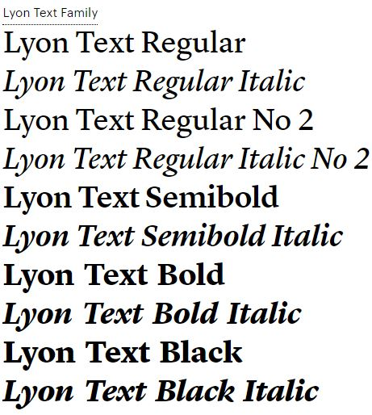
Image: Lyon from Commercial Type, accessed 11/01/2018.
Image: Interlock from the Ed Benguiat Collection by House Industries, accessed 11/01/2018.
Since the invention of movable type in the 15th century, type foundries manufactured a variety of font styles for publications. When printed and online computer-based publications emerged, small and large type foundries began making and selling typefaces and designs.

Image: Anatomy of Typography, accessed 10/12/2017.

Drawing and painting by Jasper Johns
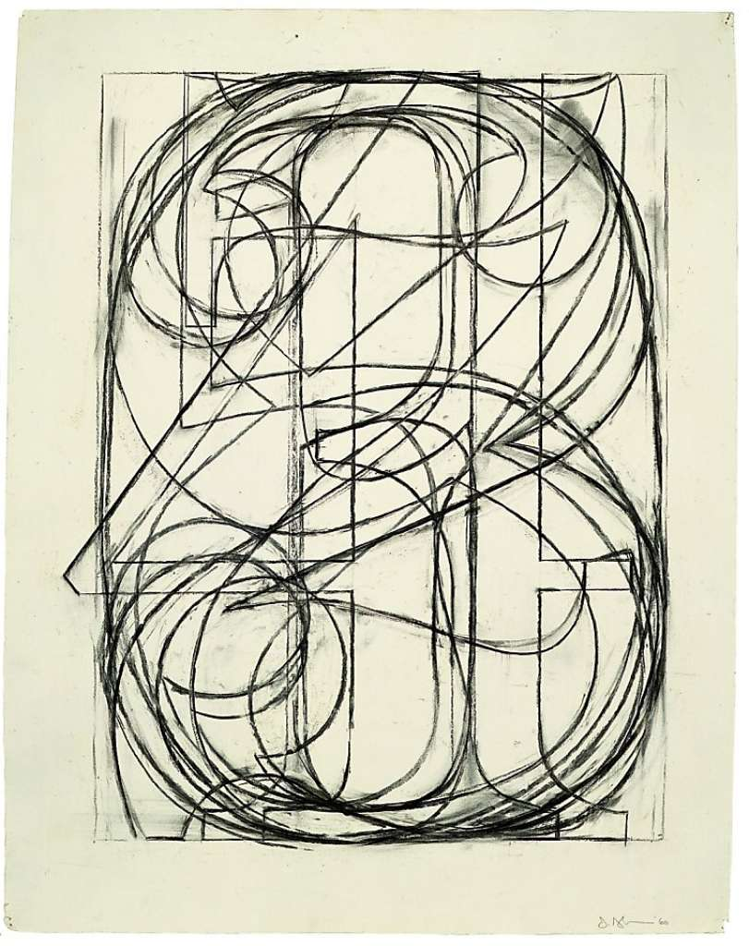
Image: By Jasper Johns, accessed ww1.hdnux.com/photos.

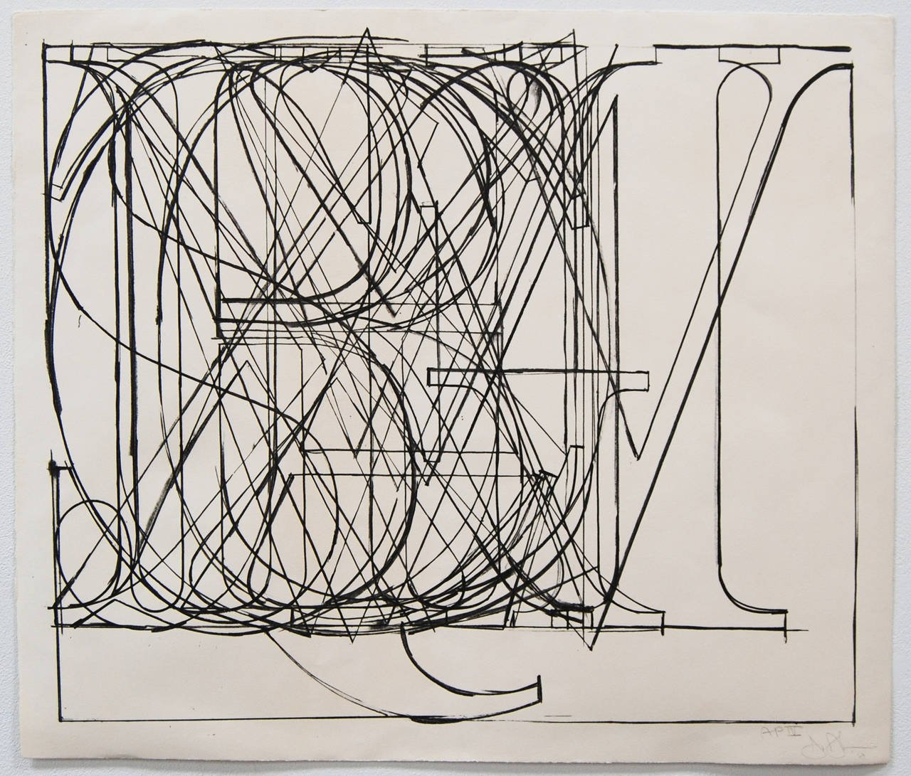
Image: by Jasper Johns, accessed a.1stdibscdn.com/archivesE 10/12/2017.

Reference list and resources
Lyon from Commercial Type, accessed commercialtype.com 11/01/2018.
Interlock from the Ed Benguiat Collection by House Industries, accessed houseind.com 11/01/2018.
Anatomy of Typography, accessed openclipart.org 10/12/2017.
Image 1 by Jasper Johns, accessed ww1.hdnux.com/photos.
Image 2 by Jasper Johns, accessed a.1stdibscdn.com/archivesE 10/12/2017.

