Creative arts workbook S3
Name:
Class:

Overview
You will learn about the role of character in the creative arts. Character is the way people are represented in a narrative or story. Characters can help to create meaning in music and visual artworks.

Resources

Lesson 1
- movie themes about a character such as ‘Star Wars’ or ‘Harry Potter’
- space for some bush dancing
- some sort of audio or visual recording device such as a phone, tablet or computer
- access to the internet on a device if possible
- personal objects or sounds of a person you are close to (perhaps someone from your household).

Lesson 2
- paper (or use the paper provided)
- paints or a few colours or crayons (textas or coloured pencils are also fine)
- a lead pencil
- portrait artworks (probably included by your teacher)
- camera or device to take a photograph.

Lesson 1
Character in a music
Resources
- movie themes about a character such as ‘Star Wars’ or ‘Harry Potter’
- space for some bush dancing
- some sort of audio or visual recording device such as a phone, tablet or computer
- access to the internet on a device if possible
- personal objects or sounds of a person you are close to (perhaps someone from your household).

Warm up your mind
Character is an important component of texts in English and in the arts. Discuss with students how characters in both literary texts and movies have their own unique behaviours, looks and personalities. These characteristics can also be described using words and pictures.
Listen, think and draw
Many ‘Classical’ composers used music to represent characters in stories. The characters were often mythical creatures such as dwarves, trolls, fairies and dragons like those in Edvard Greig’s Peer Gynt suite
Listen to this music and use it as inspiration to create a drawing of a mythical creature. This is a timed activity (‘speed art’) so you only run the course of the music (approximately 3:14 minutes only). The next page has been left blank for your artwork.
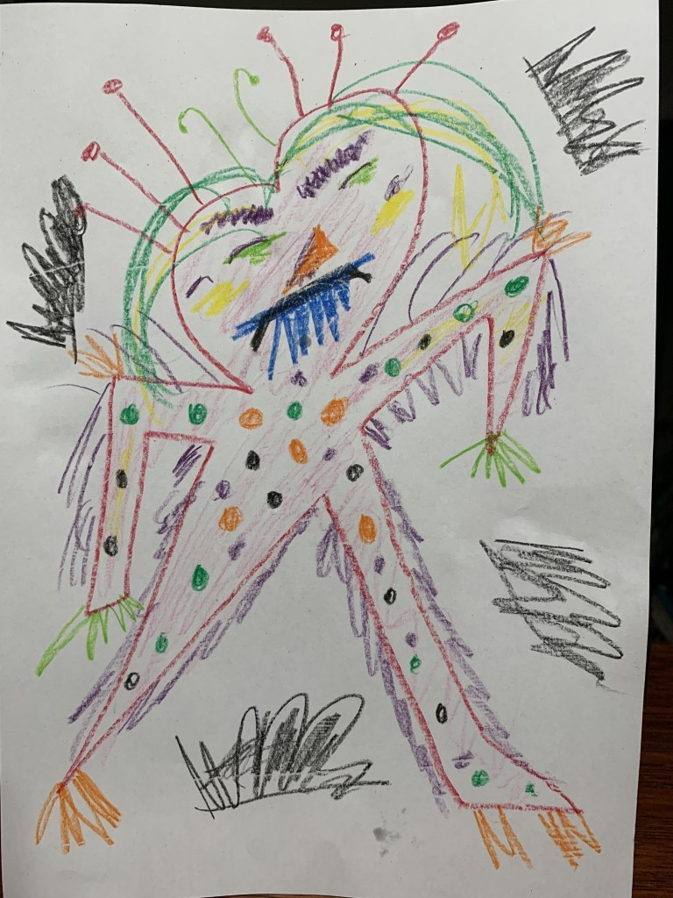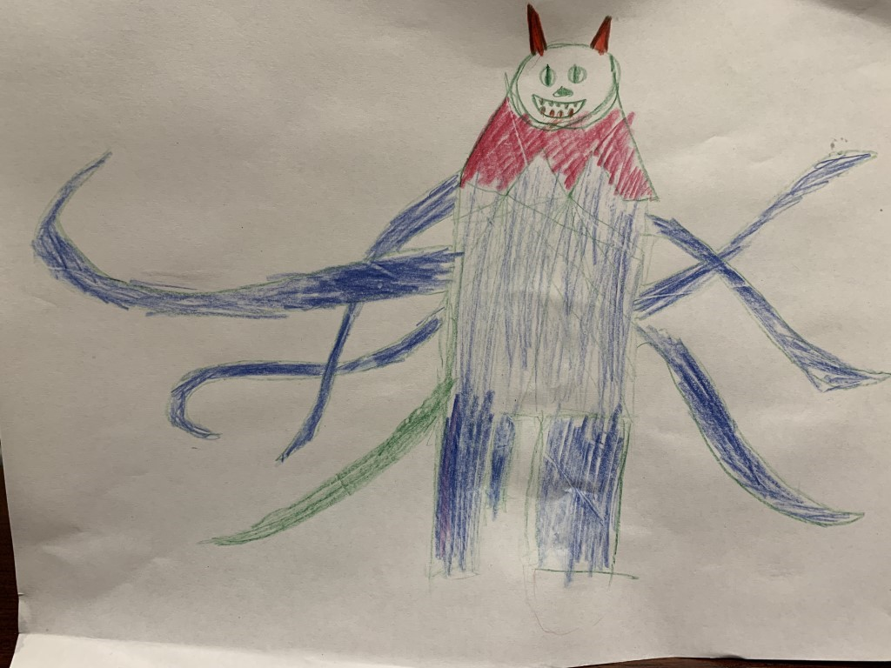
Write about your choices
Describe the musical features that led you to create these creatures. For example, the strings were pizzicato (short and plucked) which lead to the conclusion that my creature should be spiky and so on. Write your answer below:
Features of my artwork: ____________________________________________________
________________________________________________________________________
Why I chose these things: __________________________________________________
_______________________________________________________________________
_______________________________________________________________________
_______________________________________________________________________

Blank page for your mythical creature artwork:

Listen and watch
If possible, listen to and watch Paul Dukas’ The Sorcerer’s Apprentice from the ‘Fantasia’ movie.
After listening to this piece, answer these questions:
What do we know about the character of the sorcerer’s apprentice?
________________________________________________________________________
________________________________________________________________________
________________________________________________________________________
Comment on the use of musical concepts (pitch, dynamics, tone colour, structure and duration) to reinforce aspects of the character:
Musical concept | How it is used to help tell the story and something about the characters
Duration (rhythm, beat, tempo)
Dynamics (louds and softs)
Tone colours (instruments)
Pitch (high, low or melody)
Structure (how is it put together)
Think and write about movie characters
Think about characters in movies that have been represented by music. Often in movies, composers ‘paint’ musical pictures, called themes or motifs to represent characters.
John Williams is a renowned modern film composer, well-known for using musical themes and motifs to represent characters in movies. Reflect on some examples of his compositions for movies you may know such as ‘Star Wars’, ‘Raiders of the Lost Arc’, ‘Jurassic Park’, ‘Home Alone’, ‘E.T’, ‘Hook’ and ‘Harry Potter’.
Choose 4 characters from the selection of ‘Star Wars’ (and some ‘Harry Potter’) that you know or use character motifs links included below (you might also like to find your own) and identify what musical features capture the main aspects of that character. Answers should be written in the table below.
Luke Skywalker’s theme
Princess Leia’s theme
Darth Vader’s theme
Yoda’s theme
Obi Wan Kenobi’s theme
Ewoks theme
Jawas theme
Jar Jar Binks’ theme
Anakin Skywalker’s theme
Padme’s theme
If you would prefer to comment on ‘Harry Potter’, some key characters include:
Hedwig’s theme
Lily and Snape
Ron Weasley
Harry Potter

Movie character | What or how does the music tell us about that character?
Other character music
Reflect on other music and songs that students know about character. This may be film music, ‘Classical’ music or may be a pop song. For example, ‘Dance of the Sugar Plum Fairy’ (Tchaikovsky), ‘Eleanor Rigby’ (The Beatles), ‘Soon You’ll Get Better’ (Taylor Swift), ‘Ben’ (Michael Jackson), ‘A Little Too Much’ (Shawn Mendes), ‘First Man’ (Camila Cabello), ‘Bohemian Rhapsody’ (Queen) and so on.
Create a list of pieces with their household or peers below and learn to sing one or play it to a family member.
Some songs about character that I know:
________________________________________________________________________
________________________________________________________________________
________________________________________________________________________
________________________________________________________________________
________________________________________________________________________
Ask the students to learn to sing one of these songs and reflect on how the characters are portrayed through the music, not just the lyrics. For example, is the song gentle or harsh, smooth or jerky and so on? What does this tell us about the character involved in the song and potentially the way that the composer feels about that character?
Learn a new song
Follow the music that you might have learnt with your teacher of ‘Bob the farmer’s dog’ by Tracy and Paul Burjan from Vocal Ease MORE (Module 2) or use this link https://vimeo.com/345606943
This song was written about their personal reflections of the life of a working dog. Learn to sing the song using the animated score or the lyrics below. What do you think the composers thought of Bob when they were writing it?
Sing and dance
Enjoy some movement and free dancing by yourself or with your family during the dance section of the song or use the dance you learnt at school that goes with it.
Watch and listen
Watch the video of Andrew Huang where he is composing using the sounds of a much-loved character, a guide dog. In this piece ‘Guide dog and braille’ Andrew creates sounds based upon the owner’s love of her guide dog, using only sounds related to his friend’s life as a visually impaired person.
Find a special character
Think about someone (or a pet) that is special to you. Preferably someone in your household. Consider some of the sounds related to that person (or animal). Create a list below of the sounds related to them such as their walk, their high heels, a laugh, a cough, their phone ringtone, cooking, jewellery clinking, coughing and so on.
Name of special person (or animal): __________________________________________
Some sounds they make: __________________________________________________
_______________________________________________________________________
_______________________________________________________________________
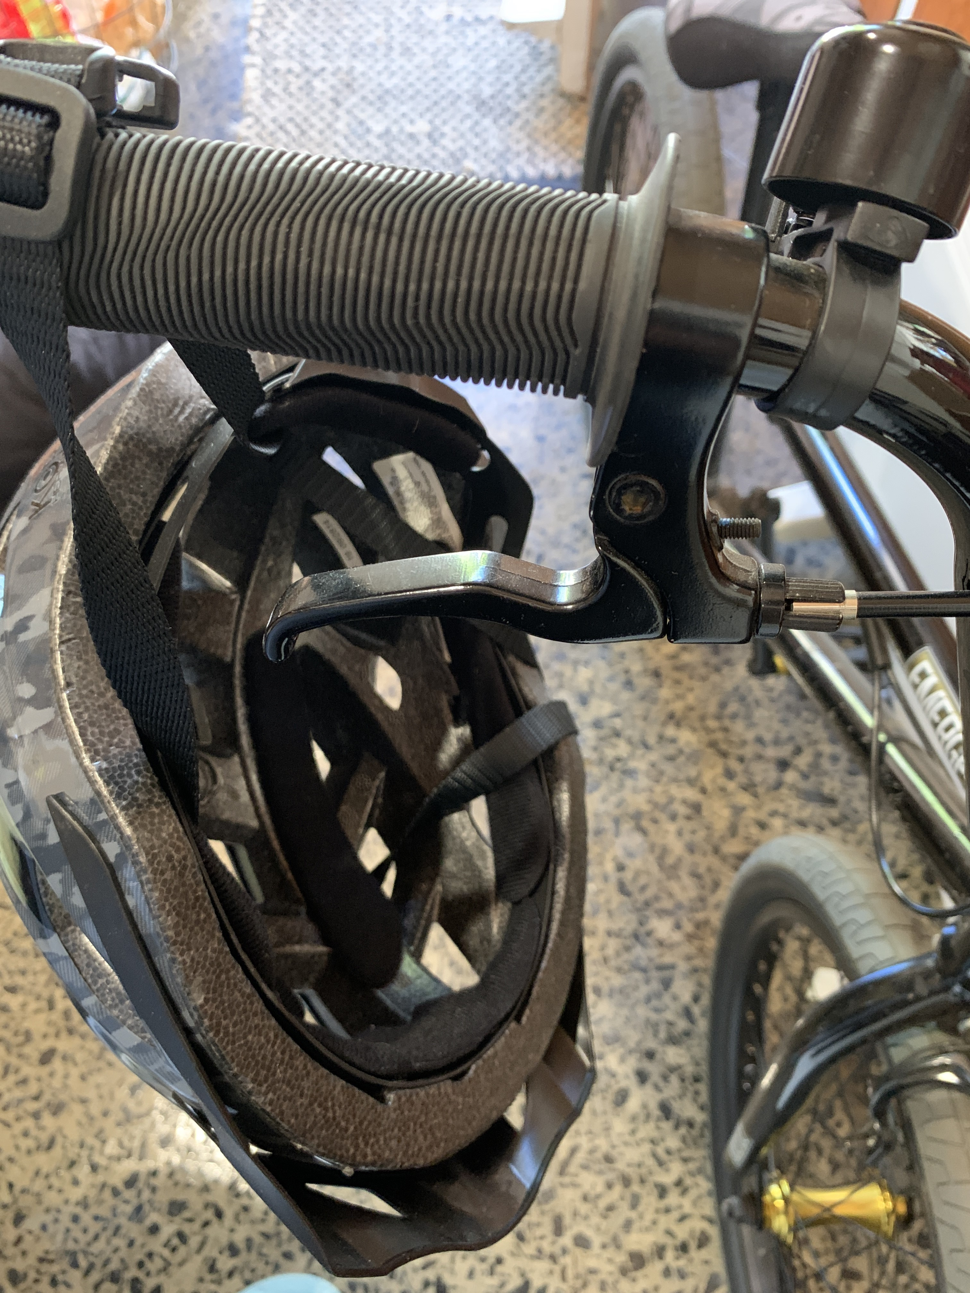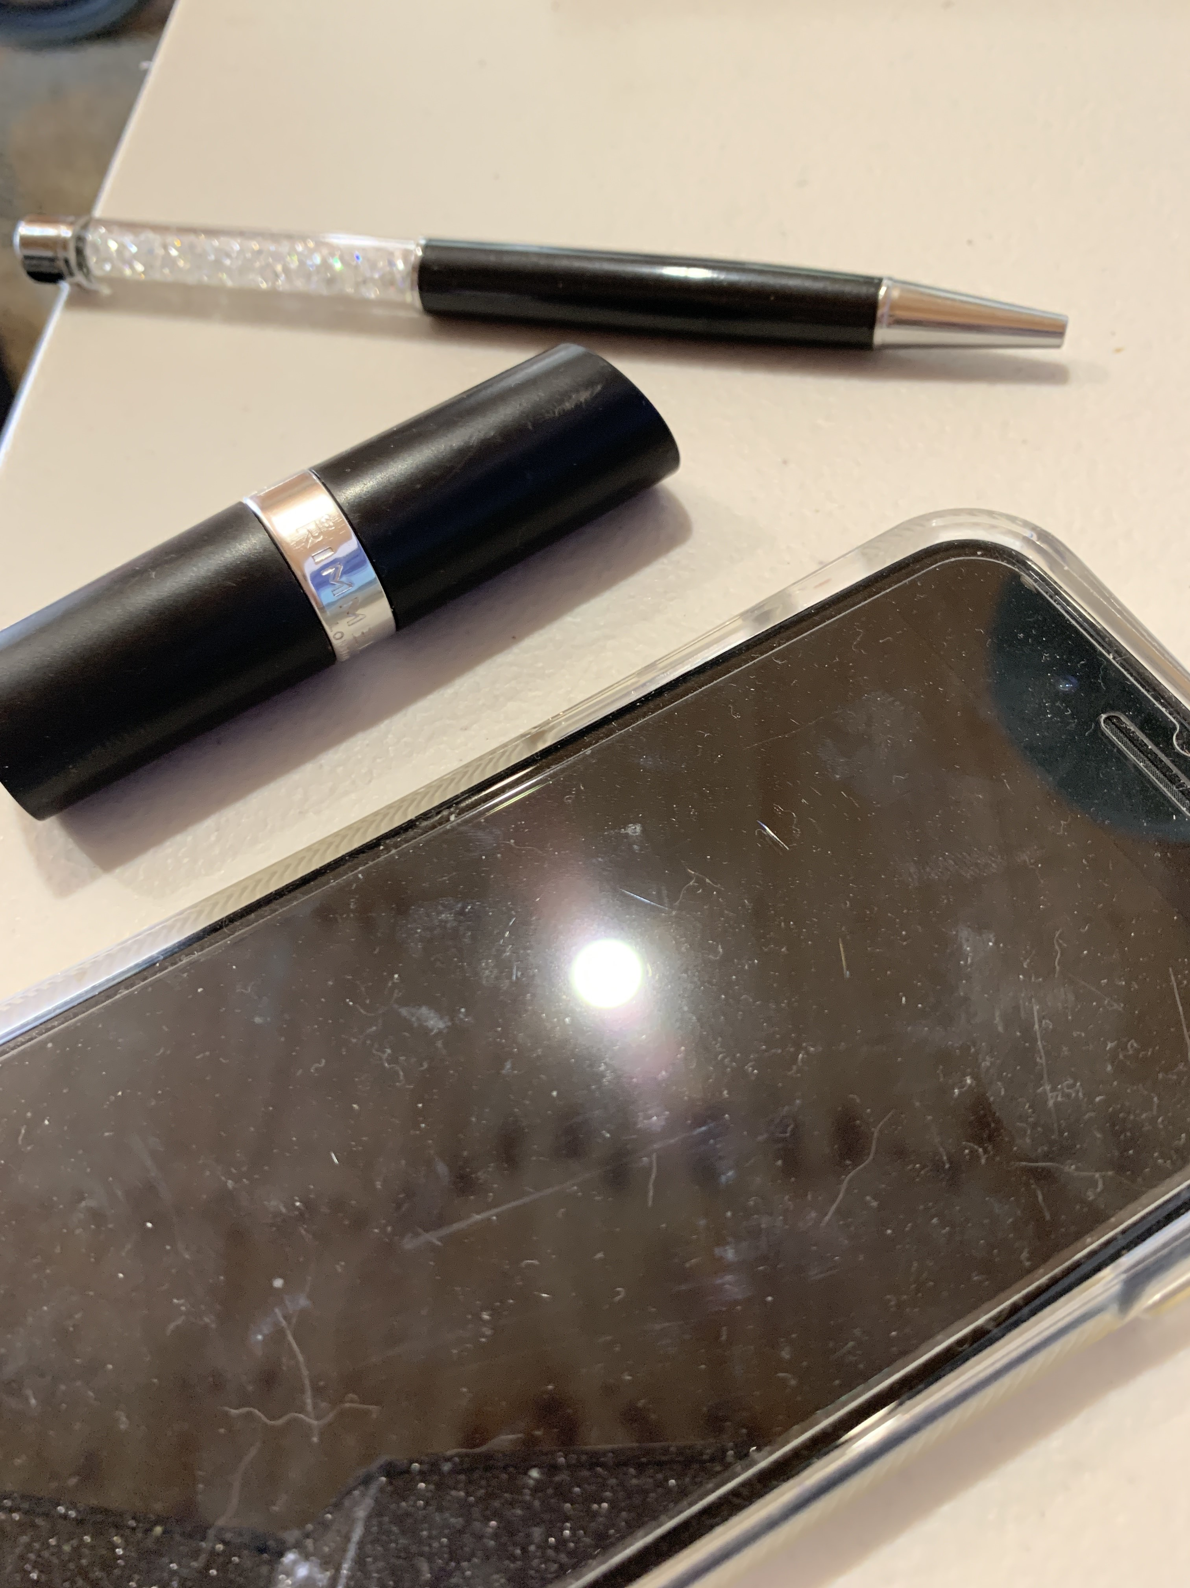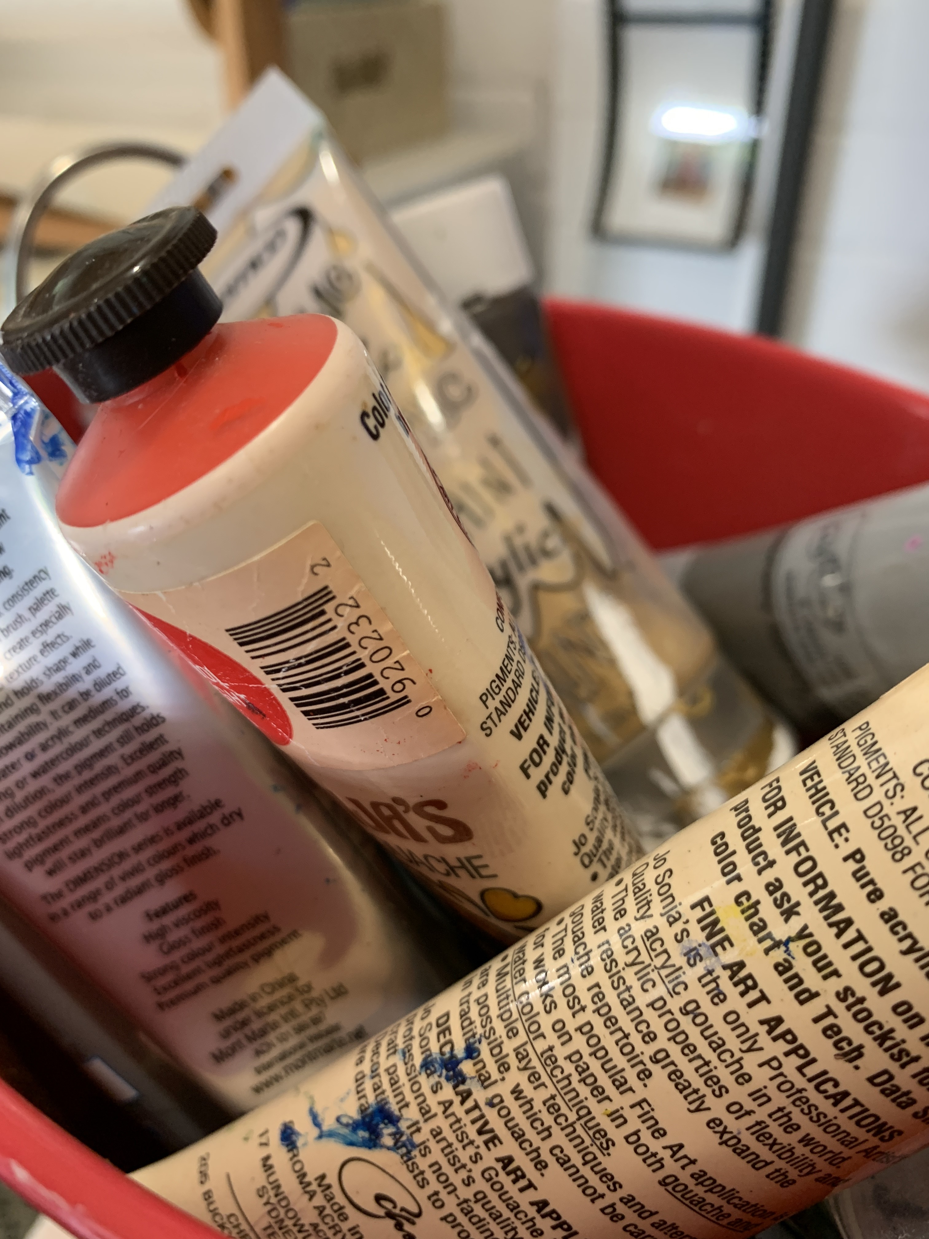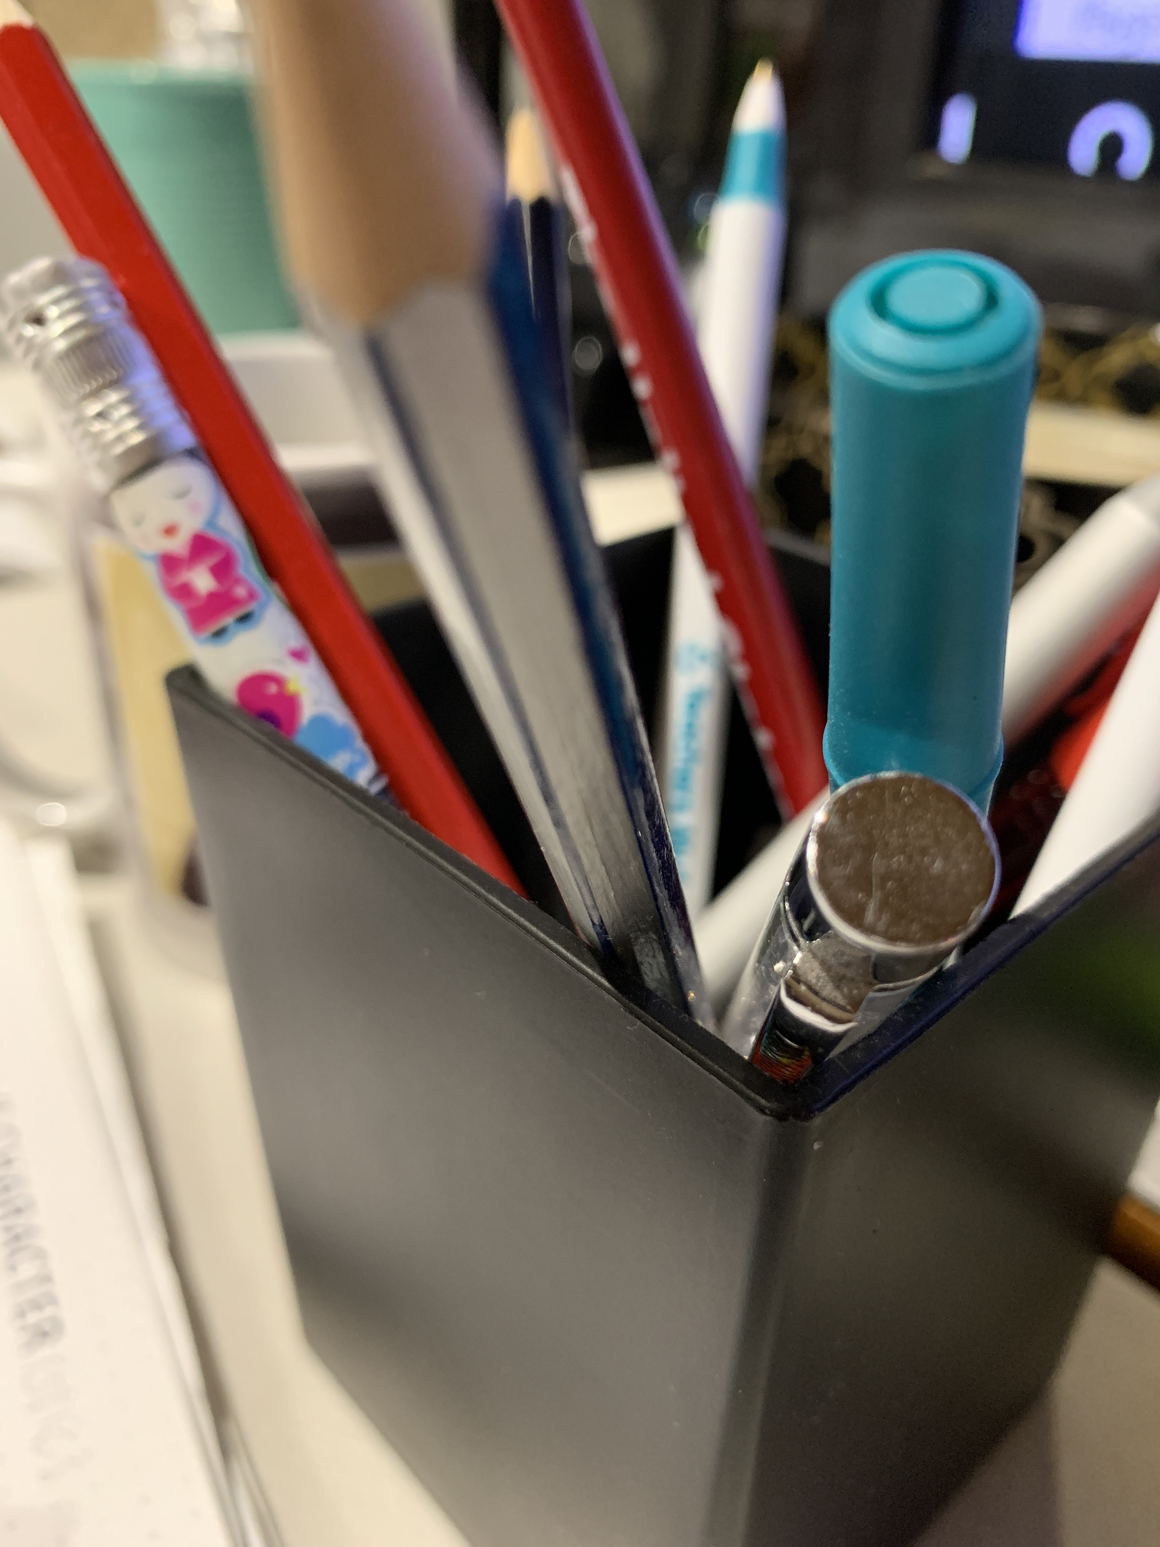
Make a composition
Consider how you could use these sounds in a composition. There are several ways that you could do this. For example, you could imitate the sounds, you could record the sounds using voice memos, GarageBand, recording apps such as Loopy HD, a website such as ‘Soundtrap’ or using the actual sounds from the person themselves.
Think of ways of combining or organising these sounds into a composition. You may choose to play them live or choose to record the sounds through a recording app or website.
Make a recording
Record the overall piece using either audio or video recording. Be ready to share this composition with your teacher or peers.
Consider the musical concepts in your composition including:
- Structure - how will you put it together?
- Tone colours – what will you use to imitate or be the sounds?
- Dynamics – should it be loud or soft?
- Duration – think about what rhythm, beat and tempo would work best
- Pitch - will it have a melody or is the person’s voice high or low and so on?
Prepare a statement about who or what your composition is about and why you chose the sounds or musical concepts that you did. Write it below:
Person my composition is about: _____________________________________________
What I did with the music to ‘show’ that person: _________________________________
________________________________________________________________________
________________________________________________________________________
________________________________________________________________________

Lesson 2
During this activity you will explore character in visual artworks.
Resources
- paper (or use the paper provided)
- paints or a few colours or crayons (textas or coloured pencils are also fine)
- a lead pencil
- portrait artworks (probably included by your teacher)
- camera or device to take a photograph.

Look at and talk about portraits
There are numerous examples of portraiture in artworks throughout history. Perhaps you have some in your home or you can think of some you have seen in other places?
Your teacher may have included some portraits from the Archibald Portrait Prize of 2019 from the Art Gallery of NSW below or you could click on or look at the links yourself below. These are examples of modern Australian portraiture and were all finalist portraits from the 2019 Archibald Prize collection from the Art Gallery of NSW. This selection is a sample of many that are on the Art Gallery’s website. These have been chosen for their diverse styles and subjects.
- ‘Self-portrait sitting in a red chair, Avalon’ (Shane Bowden) https://www.artgallery.nsw.gov.au/prizes/archibald/2019/30104/
This portrait was created about the artist’s reflections on life after being unwell. He found a red wooden chair at a second-hand store across the street from his home in Avalon, NSW and then started his self-portrait.
Discuss with a household member of a peer about the artist’s use of colour and line. How hss the artist implied that he is moving? What aspects of the artwork suggest happiness and excitement? What is the role of the chair in the self-portrait? Would you describe this work as abstract?
- ‘Dylan’ (Kirpy) https://www.artgallery.nsw.gov.au/prizes/archibald/2019/30125/
The artist Kirpy created this work about Dylan Alcott who at such a young age had accomplished so much. Dylan is a three-time Paralympic gold medallist, a grand slam tennis champion, a disability ambassador, the recipient of an Order of Australia, the founder of both the musical festival Ability Fest and the Dylan Alcott Foundation, a published author and an all-round media personality.
What does the artwork tell us about the Dylan’s life and character? Examine the use of colour – what does this setting tell us about Dylan? The artist uses aerosol and acrylic paints to create this works. Where can you see this?
- ‘All hail Greg Inglis’ (Imants Tillers) https://www.artgallery.nsw.gov.au/prizes/archibald/2019/30145/
The artist Tillers created this work about his Rabbitohs football hero, Greg Inglis. He describes Inglis playing as like seeing ‘poetry in motion’. Tillers also points out that Inglis is a hero and role model to Indigenous communities all around Australia, especially those living with disadvantage.
Examine the use of foreground and background in this artwork. Explore the shapes used and how they add to the work. What symbols can you see through both text and images? What is symbolic about the colours too?
Tillers’ said about this work that, ‘every human being is the greatest work of art ever created’. Discuss this with your household.
- ‘Kid Congo on the island of the pink monkey birds' (Michael Vale) https://www.artgallery.nsw.gov.au/prizes/archibald/2019/30146/
The subject of this portrait is American rock guitarist and singer Kid Congo Powers. Vale describes the musician as a ‘very flamboyant performer with a heightened sense of theatre’. What does this mean? What other performers do you know that are like this?
Examine the setting of the artwork and the use of colours, light and darkness to achieve a full picture of this musician. Where is the focus of this artwork and where are our eyes drawn? Is this a place you’d like to visit?
- ‘Benjamin Law: happy sad’ (Keith Burt) https://www.artgallery.nsw.gov.au/prizes/archibald/2019/30105/
This artwork is about Benjamin Law, a Sydney-based author and journalist. Law sat for this portrait. The artist felt that Law’s face was both happy and sad because he had suffered from discrimination but remained positive and fun.
What features show the ‘happy sad’ feelings? Examine the artist’s use of colour and different colour values, shadow and shading and how this contributes to the sense of unity and balance within the work.
Choose one of these portraits. Ask the students to write their responses in their student workbooks. Explore the surrounding environment of the portrait’s subject. How do specific objects or factors in the settings inform us about the sitter and their world?
Be a judge
Choose the portrait you would have selected to be the winner of the Archibald Prize. Alternatively think of a portrait you prefer that you have seen somewhere else. Consider the subject’s body language, facial expressions and the way they are looking in your decision. Also think about what these things tell us about the subject and how they make us feel as the audience?
Write about which one you chose and why.
The winner is: ___________________________________________________________
Why did you choose this one? _______________________________________________
_______________________________________________________________________
_______________________________________________________________________
_______________________________________________________________________
Be an artist
Experiment with 2 styles of portraits to capture a character.
Firstly, make a physical portrait of a subject’s face by creating a single continuous line portrait using pencil and paper.
The key to a continuous line drawing is that the pencil must never leave the page and you must not stop drawing until the picture is complete. You will need some paper (or you can use the blank page below) and a pencil but no eraser is allowed. You also need a subject who can sit still and maintain a facial expression or you can use a photo instead of a live subject.
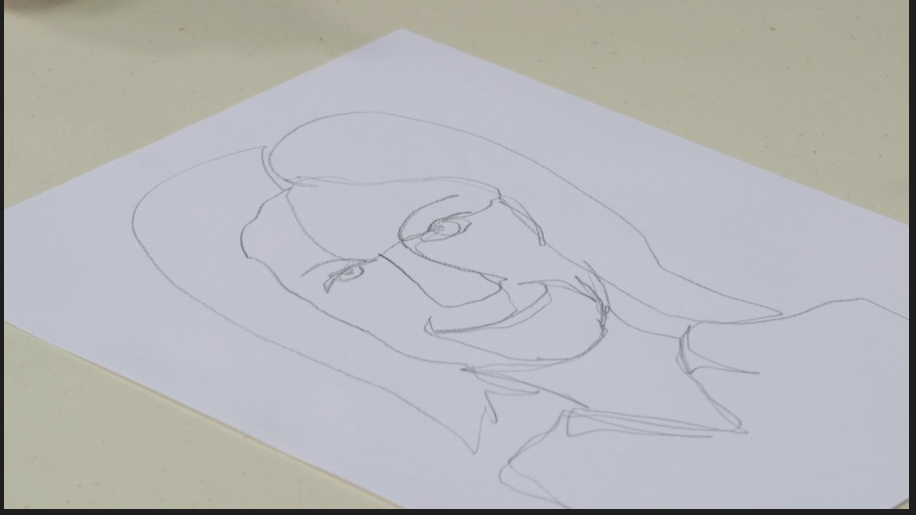

Blank page for your continuous line drawing:

Next, experiment further with expressive portraiture. Create a simple face drawing and then use paint to show different expressions.
You will need a piece of paper folded into quarters (or use the page below) and some different colours of paints or crayons which you think symbolise different emotions such as blue for sad and so on. Draw four simple faces – one in each box and using paint, fill in the expressions on the face. Choose a different emotion for each box and so a different colour each time as well.
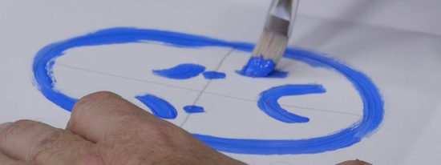

Blank page for your 4 emotion portraits:

Photographic portraits

Reflect on the role of photography in portraiture. What are the similarities and differences between painted and photographic portraits? Have you ever had a family portrait photographed or painted? What did you like or dislike about the process and the finished product?
Look at a photographic portrait
Explore the photographic portrait artwork ‘Nancy Wright and Dog’ by Michael Riley from the series a common place: portraits of Moree Murries (1990) that your teacher may have included for you. Alternatively, you can access it at www.artgallery.nsw.gov.au/artboards/home/representation/item/h1k8i4/
This work comes from the Aboriginal art collection at the Art Gallery of NSW.
In ‘Nancy Wright and dog’ what do we learn about the relationship of the woman and her dog?
Michael Riley was a Wiradjuri artist who was integral to the establishment of Australia’s Indigenous photography movement, which changed the way in which Indigenous culture is seen and understood.
Think and talk about photos
Discuss the role of photography in capturing characters through their expression, environment, clothing, and any objects (such as pets or hobbies) that they may have with them.
Do you have any photo portraits in your home? What do they tell you or remind you about the characters in them when you look at the photo?
Take a vote
Do you prefer photographed or painted portraits and why? Write your answer below.
Your preference (circle one): photographed portrait / painted portrait
Why? _________________________________________________________________
______________________________________________________________________
______________________________________________________________________

Create a portrait
Create a portrait of a family member, friend or classmate through a photograph. The image should be of a person (or animal) who is important to you and should explore different ways of capturing their emotion through the photograph. Is there a story about them that needs to be told? Think about how this can that be done?
Make choices about your subject’s pose, expression, clothing, environment and whether to include any other objects. Take time to capture them and their expression.
Consider using editing functions within your camera to edit the photograph, such as changing it to black and white, grunge, grainy or vivid colours or blurring the background if desired.
Finish and show it off
Reveal your portrait to the subject. Do they think they have been captured accurately and expressively?

Blank page for your photographic portrait if you decide to include it here:

Write like an artist
Write an artist intent statement to accompany your work as though it would hang next to it in a gallery. Explain who this person is, a little of their background, what can be seen through the photo and why this person (or animal) was chosen.
________________________________________________________________________
________________________________________________________________________
________________________________________________________________________
________________________________________________________________________
________________________________________________________________________

