Creative arts Stage 3 learning sequence – the character of the arts
Learning sequence description
In this learning sequence students will explore the role of character in helping to understand and interpret the creative arts. Students will investigate and learn to make compositions and artworks with an emphasis on character.

Syllabus outcomes and content

Music

MUS3.1 - sings, plays and moves to a range of music, individually and in groups, demonstrating a knowledge of musical concepts.
- Plays a variety of music, individually and in groups, using a range of vocal and instrumental sound sources to explore musical concepts
- Explores aspects of musical concepts in singing, playing and moving activities to heighten musical understanding and perform music with a greater sense of style.

MUS3.2 - improvises, experiments, selects, combines and orders sound using musical concepts.
- Explores ways of varying musical material
- Organises musical ideas into compositions demonstrating compositional intentions.
MUS3.4 - identifies the use of musical concepts and symbols in a range of musical styles.
- Identifies the use of musical concepts and changes that occur in relation to music that they perform, compose and listen to
- Listens to repertoire of various styles and discusses features of the music and the differences between different repertoire.

Visual arts

VAS3.1 - investigates subject matter in an attempt to represent likenesses of things in the world.
- Closely observes details of things in the world and seeks to make artworks about these using various techniques such as proportion, perspective, composition, foreshortening.
- Uses different artistic concepts (such as colour, tone, light, scale, abstract), and explores how symbols may be used in their interpretation of selected subject matter.
- Explores subject matter of personal and social interest from particular viewpoints including issues, activities and events in the community and global environment, places and spaces, people, objects and fantasies.

VAS3.2 Makes artworks for different audiences, assembling materials in a variety of ways.
- Examines a range of concepts and their relationships to selected forms and experiments with such things as the expressive use of colour in painting or drawing.
- Discusses the conditions and requirements of artworks that are made for particular purposes, sites or events and how those conditions and requirements can affect how they might go about their own artmaking.

VAS3.3 - acknowledges that audiences respond in different ways to artworks and that there are different opinions about the value of artworks.
- Talks about and writes about the meaning of artworks recognising how artworks, can be valued in different ways by themselves as audience members, and by others.
- Identifies some of the reasons why artworks are made.

VAS3.4 - communicates about the ways in which subject matter is represented in artworks.
- Identifies and describes the properties of different forms, materials and techniques in artworks and comments on how these are employed in the representation of subject matter.
- Discusses the artist’s intention and/or the use of styles and techniques in selected works and considers the possible meanings of these works.
- Suggests how subject matter can mean different things in artworks and seeks to explain meanings by developing reasoned accounts that take into account such things as the artist, work, world and audience.
- Considers a range of artworks and their subject matter including paintings, drawings, photographs.

Creative Arts K-6 Syllabus © (2006) NSW Education Standards Authority (NESA) for and on behalf of the Crown in right of the State of New South Wales.

Lesson 1 – what role does character play in musical compositions?
Students are learning to:
- identify the ways in which composers explore and represent different characters in their compositions
- explore the ways in which composers use musical concepts to convey aspects of a character through music
- identify the sounds in their environment that can be organised to represent a character.
Item | Learning experience | Differentiation strategies and/or adjustments | Resources
1.1 | Character is an important component of texts in English and in the arts. Discuss with students how characters in both literary texts and movies have their own unique behaviours, looks and personalities. These characteristics can also be described using words and pictures.  Many ‘Classical’ composers used music to represent characters in stories. The characters were often mythical creatures such as dwarves, trolls, fairies and dragons like those in Edvard Greig’s Peer Gynt suite. Listen to this music and use it as inspiration to create a 2D artwork of a mythical creature. This should be a timed activity (‘speed art’) and run the course of the music only (approximately 3:14 minutes only).  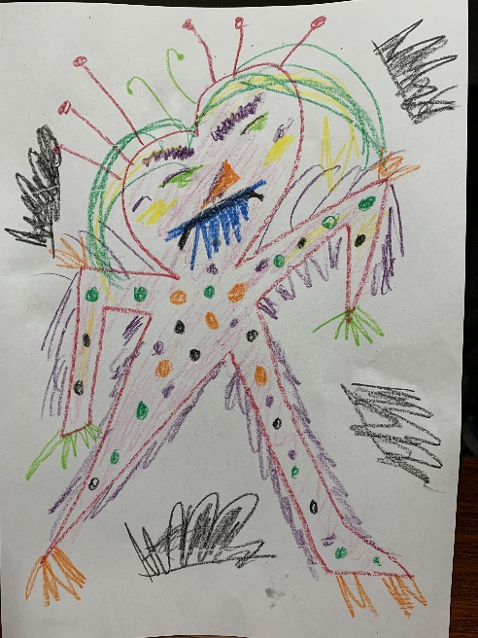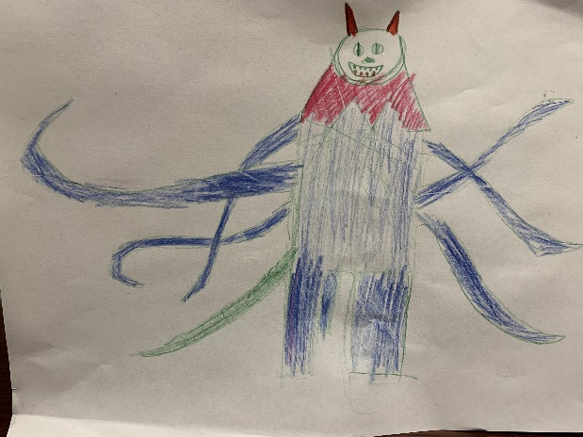  Students should then describe the musical features that led them to create these creatures. For example, the strings were pizzicato (short and plucked) which lead to the conclusion that the creature should be spiky and so on.  Listen to and watch Paul Dukas’ The Sorcerer’s Apprentice from the ‘Fantasia’ movie. What do we know about the character of the sorcerer’s apprentice? How does the music tell us this? What instruments are used to tell the story (bassoon, brass and strings particularly)? How do the dynamics assist with this (softs with several crescendos getting louder to emphasise the drama)? Comment on the use of musical concepts (pitch, dynamics, tone colour, structure and duration) to reinforce aspects of the character in the table within the student workbook.  Discuss how characters in movies can be represented by music. In movies, composers often use tone colour, rhythm and melody to ‘paint’ musical pictures, called themes or motifs of characters.  John Williams is a renowned modern film composer, well-known for using musical themes and motifs to represent characters in movies. Discuss examples of his compositions for movies such as ‘Star Wars’, ‘Raiders of the Lost Arc’, ‘Jurassic Park’, ‘Home Alone’, ‘E.T’, ‘Hook’ and ‘Harry Potter’.  Ask the students to choose 4 characters from the selection of ‘Star Wars’ character motifs included below and identify what musical features capture the main aspects of that character. Answers should be recorded in the student workbooks. What makes these motifs memorable and how do they make us think of the characters.  Luke Skywalker’s theme  Princess Leia’s theme  Darth Vader’s theme  Yoda’s theme  Obi Wan Kenobi’s theme  Ewoks theme  Jawas theme  Jar Jar Binks’ theme  Anakin Skywalker’s theme  Padme’s theme  For students who are unfamiliar with ‘Star Wars’ and would prefer to comment on ‘Harry Potter’, some key characters include:  Hedwig’s theme  Lily and Snape  Ron Weasley  Harry Potter | Ask students to think of themes songs from movies or shows that are about particular people.  Students discuss their likes and dislikes about music that represents characters. Is this opinion based on the music or the character itself? | Student workbook (DOCX 9.8MB)  Music resources:  Edvard Greig’s Peer Gynt suite  Paul Dukas’ The Sorcerer’s Apprentice  Star Wars music:  Luke Skywalker’s theme  Princess Leia’s theme  Darth Vader’s theme  Yoda’s theme  Obi Wan Kenobi’s theme  Ewoks theme  Jawas theme  Jar Jar Binks’ theme  Anakin Skywalker’s theme  Padme’s theme  Harry Potter music:  Hedwig’s theme  Lily and Snape  Ron Weasley  Harry Potter
1.2 | Reflect on other music and songs that students know about character. This may be film music, classical music or may be a pop song. For example, ‘Dance of the Sugar Plum Fairy’ (Tchaikovsky), ‘Eleanor Rigby’ (The Beatles), ‘Soon You’ll Get Better’ (Taylor Swift), ‘Ben’ (Michael Jackson), ‘A Little Too Much’ (Shawn Mendes), ‘First Man’ (Camila Cabello), ‘Bohemian Rhapsody’ (Queen) and so on. Students should create a list of pieces with their household or peers in their student workbooks.  Ask the students to learn to sing one of these songs and reflect on how the characters are portrayed through the music, not just the lyrics. For example, is the song gentle or harsh, smooth or jerky and so on? What does this tell us about the character involved in the song and potentially the way that the composer feels about that character?  Follow the animated score of ‘Bob the farmer’s dog’ by Tracy and Paul Burjan from Vocal Ease MORE (Module 2) which was written about their personal reflections of the life of a working dog. Follow the animated score and consider the notation as it is playing. Learn to sing the song using the animated score or the lyrics below. What do you think the composers thought of Bob when they were writing it? Enjoy some movement and free dancing during the dance section of the song or use this video of bush dancing that accompanies ‘Bob the farmer’s dog’.  Watch this video of Andrew Huang composing using the sounds of a much-loved character, a guide dog. In this piece ‘Guide dog and braille’ Andrew creates sounds based upon the owner’s love of her guide dog, using only sounds related to his friend’s life as a visually impaired person.  Ask the students to think about someone that is special to them. Preferably someone in their household. Consider some of the sounds related to that person. Ask the students to create a list of the sounds related to them such as their walk, their high heels, a laugh, a cough, their phone ringtone, cooking, jewellery clinking, coughing and so on.  Ask the students to consider how they could use these sounds in a composition. There are several ways that students could do this. For example, they could imitate the sounds themselves, they could record the sounds using voice memos, GarageBand, recording apps such as Loopy HD, a website such as ‘Soundtrap’ or using the actual sounds from the person themselves.  Ask the students to think of ways of combining or organising these sounds into a composition. They may play them live or choose to record the sounds through their recording app or website. The students should then record the overall piece either audio or video, ready to share with their peers. Consideration of the musical concepts must be included in the composition including structure, tone colours, dynamics, duration (rhythm, beat and tempo particularly), pitch (will it have a melody, is the person’s voice high or low and so on).  Students should also prepare a statement about who or what their composition is about and why they chose the sounds or musical concepts that they did. | Students could attempt a bush dance or folk dance from another culture.  Students experiment with combinations of sound and the way things can be represented through sound.  Students could sing a song that reminds them of a character who is special to them or one that was taught to them by that person. | Student workbook (DOCX 9.8MB)  Animated score of ‘Bob the farmer’s dog’  Bush dancing video that accompanies ‘Bob the farmer’s dog’.  Andrew Huang’s piece ‘Guide dog and braille’  Sound recording capability on a device such as voice memo, GarageBand, recording apps such as Loopy HD, a website such as ‘Soundtrap’
1.3 | Opportunity for monitoring student learning  Musical composition – practical activity  Students recreate the sounds of a character they know and care about. They use these sounds as either sound samples in a recording or live to create a tribute to that person through a musical composition. Students should record their complete compositions.  What to look for  - The musical concepts must be included in the composition including structure, tone colours, dynamics, duration (rhythm, beat and tempo particularly), pitch (will it have a melody, is the person’s voice high or low and so on).  - Does the work reflect a particular character and how?  - The organisation of sound should be clear in the composition. |  | Student workbook (DOCX 9.8MB)  Recording of student compositions

Lesson 2 – how do we understand and interpret character in visual arts
Students are learning to:
- examine the ways in which artists capture a character through a portrait (or self-portrait)
- identify artmaking practices within portraits and the ways in which these assist the audience to interpret the artwork
- create portraits as a way of exploring character through artmaking practices using a variety of techniques.
Item | Learning experience | Differentiation strategies and/or adjustments | Resources
2.1 | There are numerous examples of portraiture in artworks throughout history. Encourage students to examine familiar and unfamiliar works as part of this process. Focus here is particularly on contemporary Australian portraiture. This is not meant to be restrictive but rather a suggested focus.  Explore some of the finalist portraits from the 2019 Archibald Prize collection from the Art Gallery of NSW. This selection is a sample of many that are on the Art Gallery’s website. These have been chosen for their diverse styles and subjects.  ‘Self-portrait sitting in a red chair, Avalon’ (Shane Bowden) - created about the artist’s post-heart surgery reflections on life. He found a red wooden chair at a second-hand store across the street from his home in Avalon, NSW and then started his self-portrait.  Discuss the artist’s use of colour and line. Examine the use of rhythm and movement in the artwork to suggest that the artist was implying movement. What aspects of the artwork suggest happiness and excitement? What is the role of the chair in the self-portrait? Would they describe this work as abstract?  ‘Dylan’ (Kirpy) - the artist Kirpy created this work about Dylan Alcott who at such a young age had accomplished so much. Dylan is a three-time Paralympic gold medallist, a grand slam tennis champion, a disability ambassador, the recipient of an Order of Australia, the founder of both the musical festival Ability Fest and the Dylan Alcott Foundation, a published author and an all-round media personality.  What does the artwork reveal about the subject’s life and character? Examine the use of colour – what does this setting tell us about Dylan? Explore the artist’s use of aerosol with acrylic paints as his key technique and style. Where is this evident and how could this be achieved so accurately?  ‘All hail Greg Inglis’ (Imants Tillers) - Tillers created this work about his Rabbitohs football hero, Greg Inglis. He describes Inglis playing as like seeing ‘poetry in motion’. Tillers also points out that Inglis is a hero and role model to Indigenous communities all around Australia, especially those living with disadvantage.  Examine the use of foreground and background in this artwork. Explore the shapes used and how they add to the work. Examine the symbolism within and what each square reveals, with the mixture of consistent text and images. This is also apparent in the symbolic use of colour throughout. Tillers’ quote, ‘every human being is the greatest work of art ever created.’ is worthy of discussion and highlighting.  ‘Kid Congo on the island of the pink monkey birds' (Michael Vale) - the subject of this portrait is American rock guitarist and singer Kid Congo Powers. Vale describes the musician as a ‘very flamboyant performer with a heightened sense of theatre’.  What do we learn about the subject of the artwork through this portrait? Examine the setting of the artwork and the use of colours, light and darkness to achieve a full picture of this musician. Where is the focus of this artwork and where are our eyes drawn? Is this a place worthy of visiting? Why is the subject there?  ‘Benjamin Law: happy sad’ (Keith Burt) - this artwork is about Benjamin Law, a Sydney-based author and journalist. Law sat for this portrait. The artist felt that Law’s face revealed both happy and sad emotions because he had confronted discrimination and injustice but remained positive and fun.  Examine the emotions in the subject’s face. What features reveal the ‘happy sad’ feelings? Examine the artist’s use of colour and different colour values, shadow and shading and how this contributes to the sense of unity and balance within the work.  Choose one of these portraits. Ask the students to write their responses in their student workbooks. Explore the surrounding environment of the portrait’s subject. How do specific objects or factors in the settings inform us about the sitter and their world? If they had to be a judge which artwork would have won the prize?  Ask the students to choose another one of these portraits or another familiar portrait of own choice and consider the subject’s body language, facial expressions and the way they are looking. What do these things tell us about the subject? How do they make us feel as the audience and how is this achieved?  Ask the students to experiment with at least two styles of portraits as listed below to capture a character physically through initially drawing them and then creating another image emotionally through painting.  Firstly, ask the students to create a single continuous line portrait using pencil and paper. This footage will assist with the process of the drawing. The key is that the pencil must never leave the page. Students need some paper and a pencil but no eraser. They also need a subject who can sit still and maintain a facial expression. Alternatively, a photo can be used instead of a live subject.  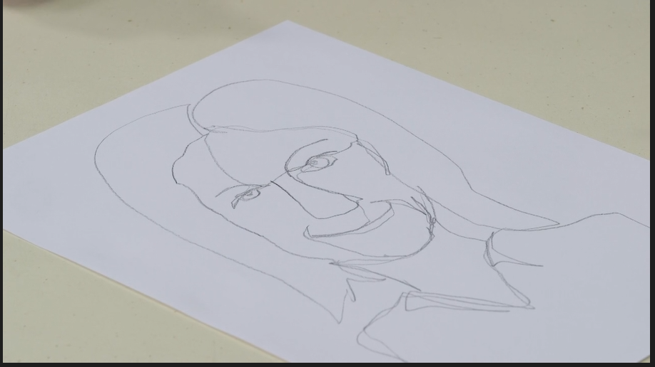  Next, ask the students to experiment further with expressive portraiture. Create a simple face drawing and then use paint to show their expression. The students will need a piece of paper folded into quarters (this is included in the student workbook with lines drawn) and some colours of paints or crayons which to them symbolise different emotions such as blue for sad and so on.  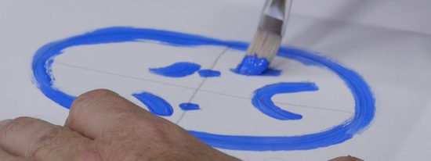 | Examine portraits of family members or artworks of people within the home. What do they teach us about the particular character?  Think of some more traditional portraits that the students may have seen. What are the similarities and differences to these very contemporary portraits?  Create own styles of portraits considering the subject and the setting to reveal information about the character. Use some of the selected portrait styles as a guide. | Student workbook (DOCX 9.8MB)  Artworks from the Art Gallery of NSW’s Archibald Prize collection:  ‘Self-portrait sitting in a red chair, Avalon’ (Shane Bowden)  ‘Dylan’ (Kirpy)  ‘All hail Greg Inglis’ (Imants Tillers)  ‘Kid Congo on the island of the pink monkey birds' (Michael Vale)  ‘Benjamin Law: happy sad’ (Keith Burt)  Paper and pencil  Paper, pencil and a selection of coloured paints or crayons
2.2 | Reflect with the students on the role of photography in portraiture. What are the similarities and differences between painted and photographic portraits? Have any students ever had a family portrait photographed or painted? What did they like or dislike about the process and the product?  Explore the artwork ‘Nancy Wright and Dog’ by Michael Riley from the series a common place: portraits of Moree Murries (1990). This work comes from the Aboriginal art collection at the Art Gallery of NSW.  Michael Riley was a Wiradjuri artist who was integral to the establishment of Australia’s Indigenous photography movement, which changed the way in which Indigenous culture is seen and understood. He was part of a group of NADOC ’86 artists who changed the way their communities were portrayed. Many Indigenous artists began to document their communities, families and friends and for the first time the reality of Indigenous Australia was shown.  Discuss with the students the important role photography has in capturing characters through their expression, environment, clothing, and any objects (such as pets or hobbies) that they may have with them. For example, in ‘Nancy Wright and dog’ what do we learn about the relationship of the woman and her dog? Discuss student preference for photographed or painted portraits and why.  Create a portrait of a family member, friend or classmate through a photograph. The image should be of a person (or animal) who is important to the student and should explore different ways of capturing their emotion through the photograph. Is there a story about them that needs to be told? How can that be done?  Encourage the students to make choices about the subject’s pose, expression, clothing, environment and whether to include any other objects, as well as the style of the work and the medium. Take time to capture them and their expression. Consider using editing functions within your camera to edit the photograph, such as changing it to black and white, grunge, grainy or vivid colours. Consider blurring the background or manipulating it somehow if desired.  Ask the students to write an artist intent statement to accompany the work as though it would hang next to it in a gallery. Through this, students should explain who this person is, a little of their background, what can be seen through the photo and why this person (or animal) was chosen.  Ask students to reveal their portrait to the subject. What are the subject’s impressions? Do they think they have been captured accurately and expressively, or do they have an alternative view? | Draw or paint the picture instead and discuss the reasons for this choice.  Create a collage or collection of images of a person to show more depth about their character. | Student workbook (DOCX 9.8MB)  Artwork ‘Nancy Wright and Dog’ by Michael Riley  Camera or device to take a photograph such as a smartphone
2.3 | Opportunity for monitoring student learning  Portrait (preferably photographic) – collection of student work  Create a portrait of a family member, friend or classmate through a photograph. The image should be of a person (or animal) who is important to the student and should explore different ways of capturing their emotion and telling their story through the photograph.  What to look for  - Has the student clearly made choices about the subject’s pose, expression, clothing, environment, any objects in their possession and so on?  - Has any editing function been used within the camera (or computer) to edit the photograph (if necessary)?  - Does the artist intent statement accurately inform the artwork and reveal important information about the subject and the composition process (how the photograph was made)? |  | Student workbook (DOCX 9.8MB) or photograph

Bob the farmer’s dog

By Tracy and Paul Burjan
Verse 1
Just before the sun is up and the moon is still about,
The farmer gives a whistle, it’s time to come on out.
“Come on Bob let’s go to work, there’s a paddock full of ewes”,
Well he doesn’t have to ask me twice I’m there, not a moment to lose
Verse 2
Some people think at night I curl up and I go to sleep,
I close my eyes and then I start to count those sheep.
But before I hit the sack there’s one thing I like to do,
I’ll have a dance around the fire with a mate or two.
Chorus
Gee, it’s great to be a farmer’s dog
I work I dance, then sleep just like a log
The farmer yells my name when I’m chasing that big mob
From dawn to dusk I’m Bob the farmer’s dog.
Dance
Verse 3
The work of a farmer’s dog is never done,
But let me tell you, gee it’s lots of fun!
Jumping fences, riding quads, nipping heels and barking lots
Working in the dust and midday sun.
Chorus (twice)
Gee, it’s great to be a farmer’s dog
I work I dance, then sleep just like a log
The farmer yells my name when I’m chasing that big mob
From dawn to dusk I’m Bob the farmer’s dog.

Reflection and evaluation
These simple questions may help you reflect on your students’ learning and plan for next steps.
What worked well and why?
What didn’t work and why?
What might I do differently next time?
What are the next steps for student learning based on the evidence gathered?

