Still life with flowers

Unit overview
Students record information about objects through drawing and printing. They learn about still life represented in artworks by looking at paintings by different artists. The theme of still life is then further explored in collages and paintings.

Subject matter
Objects.

Forms
Drawing, printmaking, painting.

Duration
5 to 8 weeks.

Resources
Image
- Cubist artworks by George Braque, Juan Gris or Pablo Picasso
  - Artchive page on Georges Braque
  - Artchive page on Juan Gris
  - Artchive page on Pablo Picasso
- Paintings by Vincent Van Gogh featuring images of flowers
Enter art
- Abstract – the kitchen stove, Eric Wilson, image no.16
Beyond the frame
- Gum Blossom and Drapery, Grace Cossington Smith, image no.5
Other
- charcoal
- pencils (3B or 4B)
- drawing paper
- black felt pens
- black ink and soft hair brushes
- solid objects or containers such as bottles, fruit, jugs, musical instruments, cups, vegetables
- textured papers
- glue
- cardboard
- colour wheel
- soft pencils
- oil pastels
- flowers and leaves
- art paper
- floral arrangement
- paint
- sheets of plastic

Outcomes and indicators

Making
VAS2.1 – represents the qualities of experiences and things that are interesting or beautiful by choosing among aspects of subject matter.
- Closely observes details of objects.
VAS2.2 – uses the forms to suggest the qualities of subject matter.
- Uses a range of drawing, printmaking and painting media to represent objects in artworks
- Uses various techniques that create texture, depth and 3D shape (form).

Appreciating
VAS2.3 –acknowledges that artists make artworks for different reasons and that different interpretations are possible.
- Recognises that artists organise objects in artworks in particular ways to express ideas.
VAS2.4 – identifies connections between subject matter in artworks and what they refer to, and appreciates the use of particular techniques.
- Identifies and describes the properties of different forms, materials and techniques in the representation of still life.
Outcomes and other elements of the syllabus used in this document are copyright.
Creative Arts K-6 Syllabus © NSW Education Standards Authority (NESA) for and on behalf of the Crown in right of the State of New South Wales, 2006

Learning experience 1

Making drawings and rubbings of objects and surfaces
- Discuss still life as subject matter.
- What is a still life?
Note – explain that artworks composed of simple objects arranged on tables or benches are referred to as still life.
- Draw individual objects with felt pens and soft brush and ink. Show the linear outlines and details of the objects.
Note – direct students to make several drawings, focusing on different elements such as 3D form, line or texture. Encourage them to use appropriate media for recording these qualities such as felt pen or ink and brush for line and soft pencil for shading and roundness.
- Draw individual objects using a soft (3B or 4B) pencil or charcoal.
- Look at the parts of the objects that are light and those that are dark and in shadow.
- Use shading from light to dark to create roundness.
- Enhance one of the drawings by using coloured ink or washes of coloured paint.
- Make rubbings of different surfaces around the classroom and school using paper and a soft graphite pencil.
Note –the drawings and rubbings will be used in learning experience 2.

Learning experience 2

Appreciating artworks
- Look at Cubist artworks by George Braque, Juan Gris or Pablo Picasso and Abstract – the kitchen stove by Eric Wilson.
- What objects do you recognise?
- Describe the different shapes and textures that can be seen.
- Are the objects represented in a realistic way?
Note – cubism was an attempt to reduce natural forms to a geometric basis. It is not necessarily a realistic representation. Cubist artists analysed, cut and rearranged parts of objects into a geometric composition. The object could be viewed from multiple positions, made partially transparent and overlapped. Pasting pieces of coloured paper, cloth, newspaper, etc, on the picture (collage) was a technique first used by Picasso and Braque. Not all Cubist paintings are still life.
- Select words to describe them (flat, simple, geometric, distorted).
Note – explain the meaning of distorted and overlapping by referring to the images.
- Identify where objects have been overlapped. This helps to create space or depth in the works.

Making collages about still life
- Collect textured papers such as old wall paper sample books, newspaper, brown paper and doilies.
- Make a collage about still life objects by cutting and re-arranging parts of the drawings made previously. Include sections of the rubbings and textured papers. Use overlapping.
Note – for inspiration, refer students to the artworks by Cubist artists George Braque, Juan Gris and Pablo Picasso and the Australian artist Eric Wilson.
- Try several arrangements before gluing parts to the surface of art paper. Consider the concepts of harmony and balance to create an aesthetically considered composition.
Note – use just one colour and its harmonies (a limited colour range) alongside black, white and grey shapes that are neutral in colour.
- To enhance the feeling of depth of overlapped shapes, some shapes could be raised by gluing them to layers of corrugated cardboard or foam (traced and cut to the same shape). The raised objects will create shadows.
Note – explain harmonious colours using a colour wheel.
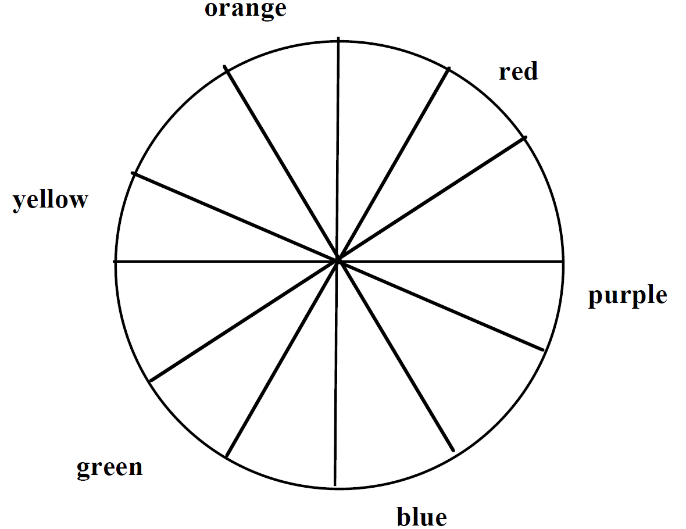
Intermediate colours are a mixture of the primary and the secondary colour, e.g. red-orange, red-purple.
Colours beside each other on the colour wheel are harmonious, e.g. red, red-orange, and orange.
Colours opposite each other are contrasting or complementary e.g. red and green.

Appreciating – reflecting
- Display and discuss the artworks.
- How is a feeling of depth or space created?
- Which parts of your work stand out? Why (size, shape, contrast of tone)?
- Is there a feeling of balance and harmony in the work? Why?

Learning experience 3

Making drawings, prints and rubbings of flowers and leaves
- Make sketches of flowers and leaves.
- Observe detail, noting texture, colour and shape.
- Use a variety of media such as soft pencils, oil pastels and ink and pen or sticks.
- Use different techniques to acquire textures such as smudging, scratching, using the side or edge of the implement and combining two media. Experiment with media and try unusual techniques.
- Make rubbings of the leaves.
- Make prints of the leaves by using a brush to apply paint to one side of the leaf, then pressing the leaf onto the surface of the art paper to make an impression. Use repetitions of the same print to create a decorative pattern.

Appreciating – reflecting
- Refer to the artworks.
- Which textures were the most effective (what stands out) and why?
- Discuss how unusual textures were created (techniques and media).

Learning experience 4

Appreciating artworks
- Refer to the representations of floral arrangements by Van Gogh and Cossington Smith.
- What colours and textures have the artists used to express the special qualities of flowers?
- What kinds of brushstrokes have the artists used to create textures?
Note – the aesthetic qualities of the flowers are created by varying subtle changes of colour and texture in one flower and in the whole arrangement.

Making a print or painting of a floral arrangement
- Draw a representation of the floral arrangement.
Note – construct a still life floral arrangement for students to draw.
- Paint the arrangement onto a sheet of plastic.
- Cover the painting with a sheet of paper, rub gently onto the back of it then lift the paper to reveal the print.
Note – demonstrate this mono-printing technique.
- When the print is dry, develop and build up this work by using oil pastel, paint, ink or felt tip pens to enrich the textures and intensify the colours.

Appreciating artworks
- Display and discuss the works.
- How have colour and texture been used to represent the qualities of flowers?
- What techniques were used to enrich the textures and add detail?

