Creative arts Stage 2 learning sequence – connotation, imagery and symbol in the arts
Learning sequence description
In Lesson 1 students explore the symbolic role of images in communicating understandings about Australian and global environments and cultures. In Lesson 2 they investigate selected visual artworks and musical compositions to examine the imagery and hidden meanings within. Students will then identify and interpret these hidden meanings across the creative arts, particularly through connecting music and visual arts.

Syllabus outcomes and content
VAS2.1 – represents the qualities of experiences and things that are interesting or beautiful by choosing among aspects of subject matter.
- talks about and thinks about their intentions for artmaking and recognises how these affect their selection of ideas, materials, tools and techniques and methods of working.
VAS2.2 - uses the forms to suggest the qualities of subject matter.
- experiments with techniques in painting, drawing, photography, digital and video to create particular effects to suggest such things as close-ups, middle distance and long-distance views, mood and atmosphere, light and dark suited to how subject matter may be interpreted
- emphasises or exaggerates certain qualities of selected subject matter by focusing on details, using distortion and elongation, changing viewpoint or enlarging or reducing the scale (eg in drawing, painting, digital works, video, sculpture)
VAS2.3 – acknowledges that artists make artworks for different reasons and that various interpretations are possible.
- recognises that people have different views about artworks and their meanings that are informed by their understanding of such things as the circumstances of the work, the artist’s intentions and skill, and what the work is about.
VAS2.4 – identifies connections between subject matter in artworks and what they refer to, and appreciates the use of particular techniques.
- talks and writes about the meaning of artworks in terms of how subject matter realistically represents things in the world.
MUS2.1 - sings, plays and moves to a range of music, demonstrating a basic knowledge of musical concepts.
- moves to music maintaining a constant beat, identifying structure, identifying changes in pitch, elements of duration and dynamics.
MUS2.2 – improvises musical phrases, organizes sounds and explains reasons for choices.
- improvises and explores musical ideas based on rhythmic or melodic patterns and incorporates these into own compositions.
- organises own musical ideas into simple compositions, eg by improvising, creating, exploring and selecting materials to form compositions, and giving reasons for making these choices.

MUS2.4 – identifies the use of musical concepts and musical symbols in a range of repertoire.
- identifies basic musical features of the music that is performed and listened to, eg rhythm, tempo, pitch, structure, dynamics, tone colour.
Creative Arts K-6 Syllabus © (2006) NSW Education Standards Authority (NESA) for and on behalf of the Crown in right of the State of New South Wales.

Lesson 1 – how do artists help us to understand their works through images and hidden meanings?
Students are learning to:
- explore the use of symbols within artworks to communicate meaning and expression of self
- think about different techniques and forms that artists use to tell their story and share their thoughts
- make and explain their own use of symbols in artworks
- create artworks for different purposes.

Item | Learning experience | Differentiation strategies and/or adjustments | Resources
1.1 | Begin with a discussion of Aboriginal culture in Australia and the importance of reflecting on the original owners of the land in your community. Highlight that Aboriginal peoples have looked after this land for a long time and we all have the responsibility to continue this practice.  Use this video as a guide to the process of a form of symbolic abstract painting (which was also used in the previous learning sequence). Go outside to a special place within your school or local environment. Where possible take a plastic surface, some cardboard, a paver or alternatively find some concrete or into a tiled or paved area. Take some water in a container and a paintbrush for each student.  Ask the students to look around at their immediate environment in silence. Ask them to identify something that they perceive as important about their environment – either natural or man-made.  Ask the students to create artworks to reflect a symbol of something in this environment that is important to them. Once it has vanished, repeat with another symbolic image. Discuss that artworks don’t always need to be permanent but that they do represent a meaning to the artist, and when permanent can be used to keep that meaning for audiences to consider.  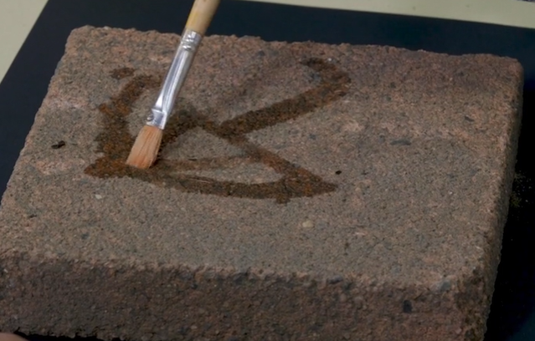  Explore this further by examining the work ‘Centrepoint Tower’ by Aboriginal artist Esme Timbery from the collection at the Art Gallery of NSW. Timbery is a Bidjigal artist whose family were shell workers from the Aboriginal mission community of La Perouse in Sydney. La Perouse women artists have been working with and earning an income from shell work for generations, with one of the earliest reports from the late 1800s.  Ask the students to look at this work and think about how this work was created and what it symbolises. Discuss the meaning of the shells as traditional materials and a technique used by the artist and to think about why they would be placed on a man-made structure like Centrepoint Tower. Consider the meaning of the work in terms of a mixture of traditional methods, natural and man-made and the importance of Aboriginal culture.  Students should then think again about their environment and consider an item that symbolises Australia to them. Students should talk about their intentions for artmaking and recognise how these affect their selection of ideas, materials, tools and techniques and methods of working. Emphasise that they should not take from nature such as shells from the beach permanently – it must be returned once the work is complete.  The student should then create a symbolic sculpture artwork and photograph it. For example, this may include leaves, shells or flowers and may also include cultural aspects of symbolic importance to their community to represent an aspect of their Australia. In the example below, a sculpture was created about a classic Australian symbol, the gum leaf. This footage of the process of creating a symbolic sculpture may be used to support this process.  In this example paper clay was used. This can either be purchased or handmade. Airdry clay is also a good alternative which can be easily handmade. In the absence of either alternative, using playdough, dough or blutak without painting is a viable option. The planning and making process is the most important component.  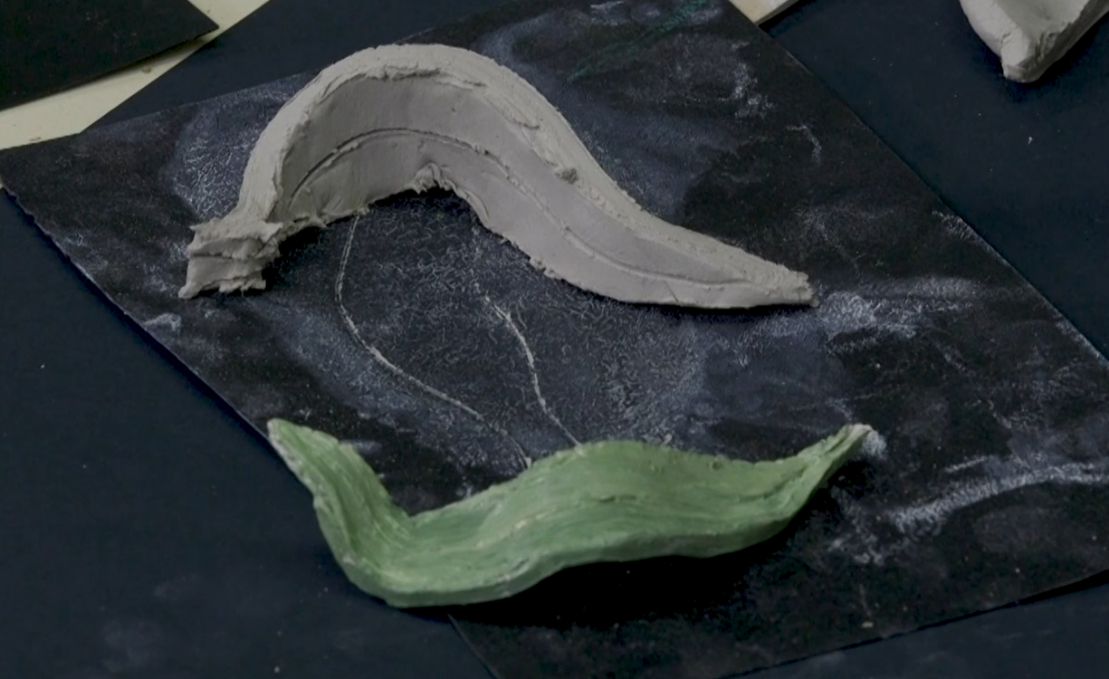 | Where equipment is unavailable, draw symbolic images on paper or in the air.  If sculpting equipment is unavailable for symbolic sculptures, consider other alternatives such as drawing or painting.  Consider creating sculptures inspired by Timbery’s work. | Student workbook including image of ‘Centrepoint Tower’ by Esme Timbery or link to website of Art Gallery of NSW  Demonstration video:  Process of a form of symbolic abstract painting  Paintbrush  Container of water  Paver, plastic lid or cardboard  Demonstration video:  Process of creating a symbolic sculpture  Paper clay, airdrying clay, playdough, dough or blutak  Paints of different colours
1.2 | Discuss with the students how artists represent ideas and meanings of their world through their works. Link this directly to the work they previously did in exploring their own symbolic works. Point out that artists have been doing this throughout history. Examine how ‘Pop art’ represents likenesses of things in the world, and how artists represent subject matter in pop artworks. Explain that Pop art began in the 1960s and is characterised by popular culture. Similarly, pop music also began in the 1960s.  The following works demonstrate pop art. Many these are from the collections at the Art Gallery of NSW.  ‘The future is now’ – Robert Rauschenberg: used collage and assemblage (sculpture) to incorporate everyday materials into his work. Create a collage titled ‘The future is now’. Include objects that represent student’s own every-day life.  ‘The first real target’ – Peter Blake: targets often appear in pop art. In this work, Blake purchased an archery target from a story and stuck it to a canvas. Ask students to think about something they could buy from a shop and stick to a canvas.  ‘Football players’ – Konrad Lueg: used flat, bright colours in the style of a graphic advertisement. The lack of detail in players’ faces contributes to the stylised graphic nature of the artwork. Ask students to design their own sports uniform or adapt their favourite sport team jersey in the style of Lueg.  ‘Triple fronted’ – Howard Arkley: uses bold, bright colours and thick outlines to draw normal Australian street houses. Ask students to draw their own house in pop art style.  Marcel Duchamp used everyday objects such as toilet bowls, bicycle wheels and furniture to make sculptures. Ask students to create a sculpture in the style of Ranschenberg or Duchamp.  Explain that people have different views about artworks and their meanings that are informed by their understanding of such things as the circumstances of the work, the artist’s intentions and skill, and what the work is about.  Ask the students to complete the table included in their workbooks to indicate their understanding and interpretation of the meaning of the selected works. This table is also included below with some sample answers. Remove any works you do not wish to use and supply the students with any answers you think will guide them. | There are multiple alternatives of artwork with imagery and symbolism. Explore others if desired.  If written tasks are not ideal, discuss artworks rather than completing written tasks. | Student workbooks with some of the images below included where possible (you will need to include these yourself):  'The future is now’ – Robert Rauschenberg  'The first real target’ – Peter Blake  'Football players’ – Konrad Lueg  'Triple fronted’ – Howard Arkley  Information about the works of Marcel Duchamp
1.3 | Opportunity for monitoring student learning  Student created temporary symbolic art - teacher observation  Students draw a symbol of something important to them about their environment using water, a paver or equivalent and a paintbrush.  What to look for:  - Is the student able to represent an aspect of their surroundings through a symbol?  - Is the student able to discuss the meaning of their work?  - Was the student able to engage in this technique and able to accept its temporary nature?  - Is the student able to discuss how different people may have different points of view about their art works?  Student art appreciation activity – collection of student work  Students complete some aspects of a table to gain their understanding of the way artists can make meaning through their works.  What to look for:  - Is the student able to identify or discuss the features of an artwork?  - Is the student able to communicate their intentions for artmaking?  - Does the student accurately identify techniques used by the artist to create meaning?  - Is the student able to explain what the artist is trying to represent through their artwork?  - Is the student able to communicate their ideas about their selection of ideas, materials, tools and techniques, and methods of working? |  | Student workbook  Artwork presented as appropriate.

Lesson 2 – how have the arts helped us make meaning of the things we see and hear?
Students are learning to:
- identify the ways in which artists make us think differently about things we think are ordinary in our society
- identify the role of the ways in which artists connote meaning for an audience
- techniques that artists use to stimulate our interest and thought
- explore and understand a variety of musical concepts through listening to and participating in music
- identify the ways in which the arts such as nursery rhymes have helped us make meaning of our culture throughout history.

Item | Learning experience | Differentiation strategies and/or adjustments | Resources
2.1 | Composers often use music to tell a story. There are several ways that this can be done either through words or through the way the instruments sound (their ‘tone colour’) and the music they play. Listen to each piece (or a section of it) and complete some aspects of the table below which is also in the student workbook. Remove or add to the table for the pieces you listen to.  Start by listening to ‘My Island Home’ by the Aboriginal Warumpi Band. What is the meaning the singer is trying to portray through his song? Listen to the introduction with the watery sounds and the folk style instruments throughout. These connote a deep connection to Country. Identify the different feel around 02:40 when the tempo speeds up and the music sounds much brighter and the dynamics get louder as the singer implies, he is getting home (portraying happiness).  Heinrich Biber made the violin sound like animals in his ‘Sonata Representiva’, composed in 1669. Listen and compare the violin imitations with the real animal sounds. How does the composer make the instruments sound like each animal?  00:00 Introduction  01:11 Nightingale  02:14 Cuckoo  02:54 Frogs  04:16 Chicken, Rooster  04:54 Quail  05:54 Cat  Explore the ‘Flight of the Bumblebee’ which is a piece for orchestra by Rimsky-Korsakov. Ask the students to hum the melody or buzz like a bee as they move around the beat with the tempo, following their own path just like a bee. Discuss with the students how it sounds just like a bee flying. Explain that the composer has achieved this meaning through increasing in speed (or tempo).  Listen to a sample of Australian composer James Ledger’s ‘Indian Pacific’. This piece sounds like the journey of this famous Australian iconic train across the country. Identify through moving to the beat and then discuss how Ledger has achieved this through repetitive rhythms that sound just like a train driving (pushing) along a track with countryside view out the window.  Although there are many other examples of this type of music (called programme music) finally, listen to ‘Ballet of the chicks in the shells’ by Mussorgsky. In this movement (or section) the composer uses tone colour, rhythm and pitch to symbolise young chicks as they hat. Listen carefully for the chicks hatching, trying to fly (0:35) and pecking (0:46).  Ask the students to think of one sound in their environment that is of interest to them and which instrument or available item they could use to imitate that sound. For example, a whistle for a bird, a glass like the wind, hitting something strongly with their hands like a storm, a paint brush on a table like sand or water, a book slamming like thunder, tissue coming out of a box like brushing your hair, clicking a ring pull like a frog and so on.  Ask the students to either play, record or write about (in their student workbooks) the sound they have chosen and what it represents.  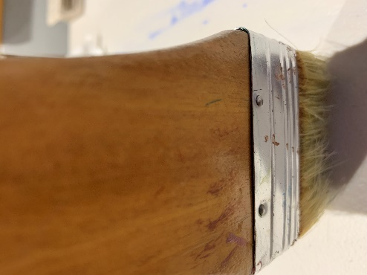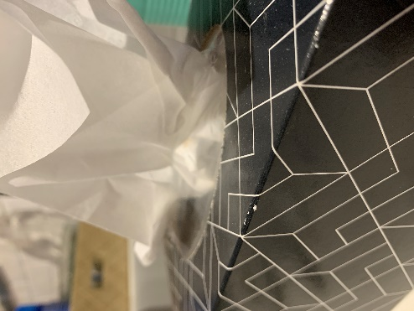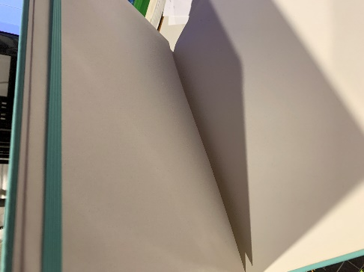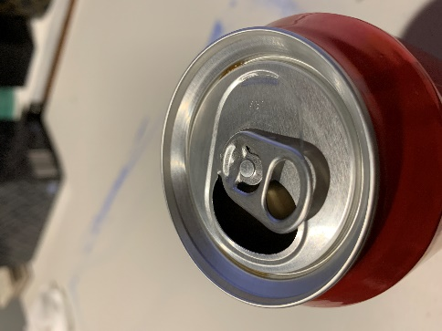 | Substitute other pieces or songs as known.  Discuss rather than write responses.  Compose an entire piece such as a soundscape using the sound samples created. Put them together as a class composition or individually. | Student workbooks  Audio samples:  ‘My Island Home’ by the Aboriginal Warumpi Band.  Biber’s ‘Sonata Representativa’  Comparison animal sounds:  Nightingale  Cuckoo  Frogs  Chicken, Rooster  Quail  Cat  James Ledger’s ‘Indian Pacific’  ‘My Island Home’ by the Aboriginal Warumpi Band.  Rimsky-Korakov's ‘Flight of the Bumblebee’  James Ledger’s ‘Indian Pacific’  Ballet of the chicks in the shells’ by Mussorgsky  A variety of items or instruments (if available)
2.2 | Point out to the students that often artworks are inspired by pieces of music. Sometimes musicians get meaning from artworks and other times artists construct works based upon what they hear in a composition. This can be a way that both artists and musicians imply meaning through their works.  Watch a video of the composition ‘Water walk’ by John Cage. In this timed piece, Cage creates a piece of music using a piano along with a variety of natural sounds using household items such as pots, pans, lids, vase, watering can. Explain that this is a deliberately and carefully composed piece of music. While students are watching, ask them to think about the purpose of the composition. Ask students to consider how the various household objects are used to make sound. For example, by hitting, scraping or blowing. Ask students to think about how composers produce art to evoke different audience responses. Watch a video of the composition ‘4:33’ by John Cage. Ask students to think about the elements that were discussed for ‘Water walk’.  Listen to John Williams ‘Tatooine theme’ from Star Wars. This piece portrays the baking sun in a hot desert. Listen for creatures scuttling about across the hot sand as they seek shade. There are also larger desert animals wandering from water hole to water hole. Discuss the musical features which imply these images. For examples, repetitive and lilting rhythms, soft dynamics (piano) and a gentle mood and instrumental tone colours such as the flute to imply birds and so on.  Play the music again and ask the students to paint or draw a picture which evokes the meaning of the music. They should consider which colours to use, such as pastels and water colours.  The students should carefully consider the appropriate content such as a desert, hot sun, sand dunes, desert animals, an oasis. Decide as a class whether to sketch first and paint later. Make part of the process about appropriate methods or setting up, behaving and cleans when painting.  It is also important to discuss and determine the success criteria. For example, artistic techniques and forms, use of landscape view, colours and so on. Does the work convey the ‘sound’ of Williams’ work and the implied meaning, including the gentility of sand dunes in the desert?  After the completion of this artwork, the students should discuss their work and describe the features of the work to either the teacher or peers.  As a conclusion to this unit, the students should complete an exit slip a sample of which is concluded at the end of this document and in their student workbook. | Draw the desert scene rather than painting it.  Create artworks for other movements in Star Wars. | Student workbook  ‘Water walk’ by John Cage  ‘4:33’ by John Cage  John Williams ‘Tatooine theme’ from StarWars  Art paper and paintbrushes of a variety of tip sizes  Watercolour paints, pencils or paints in pastel colours
2.3 | Opportunity for monitoring student learning  Star Wars inspired artwork– presentation  Students paint or draw a picture which evokes the meaning of the music of John Williams’ desert city ‘Tatooine’. They should consider which colours to use, such as pastels and water colours. The students should carefully consider the appropriate content such as a desert, sand dunes, hot sun, dessert animals, shade and an oasis.  What to look for:  - use symbols, line, shapes and colours in artworks to enhance meaning  - use of landscape view and other appropriate artistic techniques such as pastel colours  - inclusion of a sand dune and water hole with shade trees and other symbols implying a desert oasis  - student describes the features of their work and the implied meaning as evoked from Williams’ work  - create artworks that revoke appropriate lonely mood and feel for the scene. |  | Student workbook  Artworks completed by students

Reflection and evaluation
These simple questions may help you reflect on your students’ learning and plan for next steps.
What worked well and why?
What didn’t work and why?
What might I do differently next time?
What are the next steps for student learning based on the evidence gathered?

Table for discussing and answering questions about artworks as indicated in Lesson 1.2:
Artwork title and artist | What is its hidden meaning about culture or country? | How does it tell us that?
‘Bailed up’ – Tom Roberts | Australia’s rugged bush, heat and bushrangers. | Colours and images.
‘The future is now’ – Robert Rauschenberg | Every-day life. | Everyday objects and materials.
‘The first real target’ – Peter Blake | Focusing on popular culture | A ‘real’ archery target pasted to a canvas.
‘Football players’ – Konrad Lueg | Advertising in sport. | Stylistic graphic nature or the artwork using bright, flat colours as well as the lack of detail in the players faces – no team in particular.
‘Triple fronted’ – Howard Arkley | Brightening the view of drab and ordinary everyday houses. | Bright colours and thick bold lines. Houses are typical suburban style.
Table for guiding discussion and answers to Lesson 2.1 as above.
Title of piece and composer | Musical concepts used and what do they mean?
‘My Island Home’ by the Warumpi Band. | Introduction with the watery sounds and the folk style instruments throughout. These connote a deep connection to Country.  Identify the different feel around 02:40 when the as the singer implies, he is getting home (portraying happiness).  Tempo speeds up, the music sounds much brighter and the dynamics get louder like a home arrival.
‘Sonata Representiva’ by Heinrich Biber | Violin tone colour and sounds are like animals he is portraying.
‘Flight of the Bumblebee’ by Sergei Rachmaninoff. | Violin is high and shrill which sounds just like a bee flying.  Increasing speed (or tempo) as the bee flight gets faster.
‘Indian Pacific’ by James Ledger | Repetitive rhythms sound just like a train driving (pushing) along a track with countryside view out the window.
Ballet of the chicks in the shells’ by Mussorgsky. | In this movement (or section) the composer uses tone colour, rhythm and pitch to symbolise young chicks as they hat. Listen carefully for the chicks hatching, trying to fly (0:35) and pecking (0:46).  Instrumental tone colours sound like chickens hatching, eating and flying.  High pitches like birds and so on.

Sample exit slip

Student name: ____________________________________________________ Date: _____________________________________

One thing I now know better about the way artists share meaning through their artworks _____________________________________

____________________________________________________________________________________________________________

____________________________________________________________________________________________________________

One thing I am still puzzled about _________________________________________________________________________________

____________________________________________________________________________________________________________

____________________________________________________________________________________________________________

