Creative arts workbook ES1
Name:
Class:

Overview
You will learn about the role of connotation, imagery and symbol in the creative arts. This is the way meaning is hidden in a story, song, performance or artwork.

Resources

Lesson 1
- Image of ‘Centrepoint tower’ https://www.artgallery.nsw.gov.au/collection/works/214.2010/ by Esme Timbery from the website of Art Gallery of NSW (your teacher may have included this image for you)
- Image of ‘Triple fronted’ https://www.artgallery.nsw.gov.au/collection/works/1.2014/ by Howard Arkley from the Art Gallery of NSW (your teacher may have included this image for you)
- Demonstration video which may be used to help: ‘Process of a form of symbolic abstract painting' https://vimeo.com/user98607695/review/342180410/86dfdeb6c3?sort=lastUserActionEventDate&direction=desc
- Black texta, artline pen or marker
- Coloured textas, paints or crayons.
- Paintbrush
- Container of water
- Paver, plastic lid or cardboard or concreted outdoor area
- Locally sourced materials such as leaves, grass or dirt (dependent upon where you live)

Lesson 2
- Image of ‘Campbell’s Soup Cans’ https://www.moma.org/collection/works/79809 by Andy Warhol (your teacher may have included this image for you)
- Black pencil, artline pen or texta
- Coloured pencils
- Household or school equipment that can be used to make a sound like a saucepan or wooden spoon
- Magazine cuttings or empty food packaging, glue, scissors and coloured pencils
- Link to music lesson about ‘Pease Pudding’ https://vimeo.com/415391812/6da6d2fed7

Lesson 1
Look at and make artworks that show meaning about your local environment.
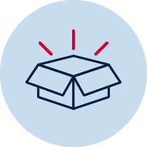 Resources
- Image of ‘Centrepoint tower’ https://www.artgallery.nsw.gov.au/collection/works/214.2010/ by Esme Timbery from the website of Art Gallery of NSW (your teacher may have included this image for you)
- Image of ‘Triple fronted’ https://www.artgallery.nsw.gov.au/collection/works/1.2014/ by Howard Arkley from the Art Gallery of NSW (your teacher may have included this image for you)
- Demonstration video which may be used to help: ‘Process of a form of symbolic abstract painting' https://vimeo.com/user98607695/review/342180410/86dfdeb6c3?sort=lastUserActionEventDate&direction=desc
- Black texta, artline pen or marker
- Coloured textas, paints or crayons.
- Paintbrush
- Container of water
- Paver, plastic lid or cardboard or concreted outdoor area
- Locally sourced materials such as leaves, grass or dirt (dependent upon where you live)

Acknowledgement of Country
Discuss with your class or household about how Aboriginal people in Australia are the original owners of the land in your community. They have looked after this land for a long time and we all have the responsibility to continue this practice.
Reflect and make symbolic art
Go outside to a special place within your school or local environment. Where possible take a plastic surface, some cardboard, a paver or alternatively find some concrete or into a tiled or paved area. Take some water in a container and a paintbrush.
Look around at the environment in silence. Find something important about the environment – either natural or man-made.
Create a quick symbol of something in this environment that is important to you. Once it has vanished, repeat with another symbol. Here is an example to look at. It is a symbol (umbrella) of a wet area:
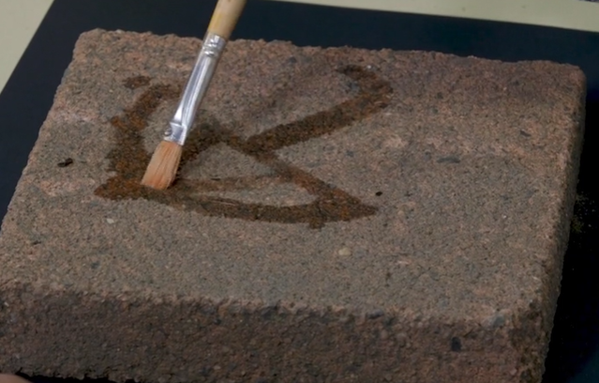

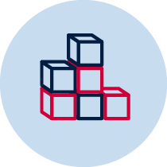 Make some temporary art
Did you know that artworks don’t always need to be permanent to make meaning for audience? Talk to someone about any examples that you can think of such as clouds.
Think again about your environment and consider some materials that you may be able to gather to create a different form of temporary artwork. Do not take from nature such as shells from the beach permanently you are only borrowing.
Create a temporary artwork to reflect your local environment and photograph it. For example, leaves, sticks, dirt, shells, seaweed, pebbles or grass to represent the landscape. Your photo can go on the next page or you can do a drawing of what you made.
You might choose to do one like this one where the items were placed on a piece of paper without gluing and then replaced back where they came from.
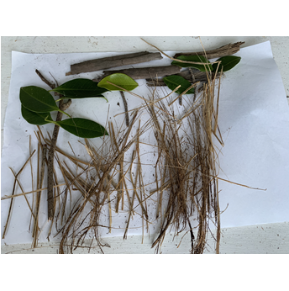
This page is blank for a photo or drawing of your temporary artwork

Write about your art
You might need to ask an adult for help to write about your artwork.

What is the title of your artwork? _____________________________________________

What is your artwork about? ________________________________________________

________________________________________________________________________
Look at some art
Look at the work ‘Centrepoint Tower’ by Aboriginal artist Esme Timbery from the collection at the Art Gallery of NSW. https://www.artgallery.nsw.gov.au/collection/works/214.2010/
Timbery is a Bidjigal artist whose family were shell workers from the Aboriginal mission community of La Perouse in Sydney.
How do you think this work was made?
Did you notice how the artist used traditional materials (the shells) that are important to Aboriginal culture to show a modern city symbol (the tower)?
Look at some more art
Look at a different image of the Australian landscape ‘Triple fronted’ by Howard Arkley from the Art Gallery of NSW https://www.artgallery.nsw.gov.au/collection/works/1.2014/
It is about suburban city streets and houses in Australia. He loved decorating magazines and advertising. How does it look similar to most streets, but how does it look different?
Arkley’s style is called ‘pop art’ because he takes something ordinary like this house and changes it with bright colours.
Draw your house
Draw your home using a pencil on the next blank page.
Trace over your drawing with a black pencil, marker or texta.
Transform your drawing using different colours, not the colours that you can see, to make it a pop art style. You might choose to use textas, crayons or paints to give this bright effect.
Tell someone about why you chose the colours you did.
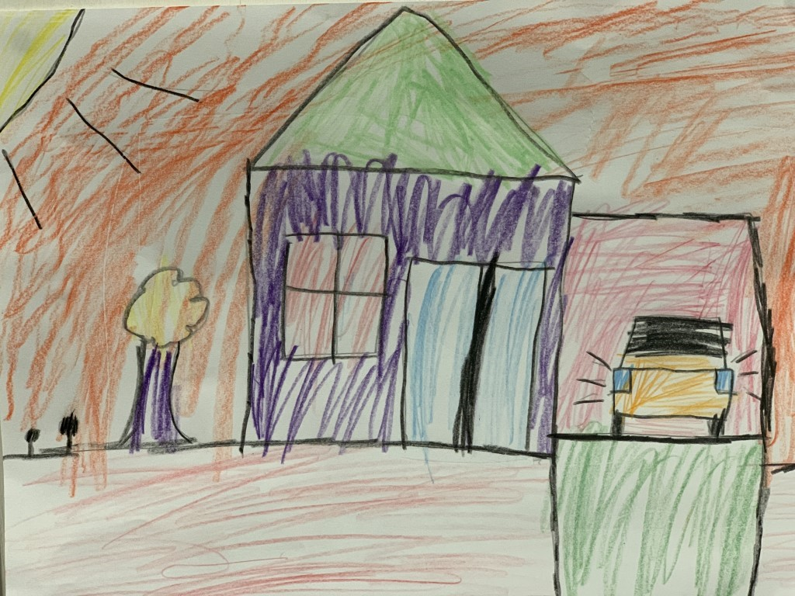
There is also an outline provided at the end of this student workbook. This is for special circumstances only because all homes should be seen as unique like your art.

This page is blank for your pop art home drawing

Lesson 2
In this lesson you will learn about how artists can make us think differently about ordinary things through their artworks. You will also learn how songs have provided meaning throughout history.
Resources
- Image of ‘Campbell’s Soup Cans’ https://www.moma.org/collection/works/79809 by Andy Warhol (your teacher may have included this image for you)
- Black pencil, artline pen or texta
- Coloured pencils
- Household or school equipment that can be used to make a sound like a saucepan or wooden spoon
- Magazine cuttings or empty food packaging, glue, scissors and coloured pencils
- Link to music lesson about ‘Pease Pudding’ https://vimeo.com/415391812/6da6d2fed7

Look at some art
Look at the artwork ‘Campbell’s Soup Cans’ https://www.moma.org/collection/works/79809 by Andy Warhol. This is another example of pop art – a bit like ‘Triple fronted’ by Howard Arkley. Think about how they are similar and how they are different?
Looking at ‘Campbell’s Soup Cans’, are the cans all the same?
How are they different?
Andy Warhol made this artwork because he ate a type of Cambell’s soup every day for lunch. He wanted to show the cans looking like a supermarket shelf but also to show that although they are the same – they are also different.
Draw something from your supermarket
What items do you notice or look at in rows in the supermarket? Draw your answer here:
Create a tin of soup that is the same but different!
On the blank page below draw a tin of soup like Warhol’s 'Campbell’s Soup Can’.
- Start by drawing a cylinder. Create an oval on the top and then the lines for the sides. Use as much of the page as possible.
- Go over the shape with a black marker or pencil.
- Draw a line and a circle through the middle of the can.
- Decide on your own soup flavour by choosing your favourite food.
- Colour and write the name of your soup to match the flavour of your choice.
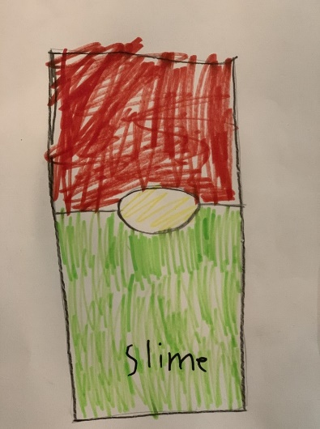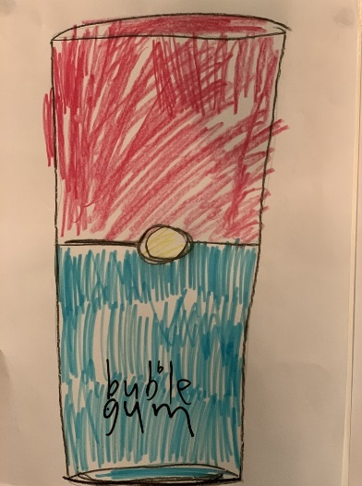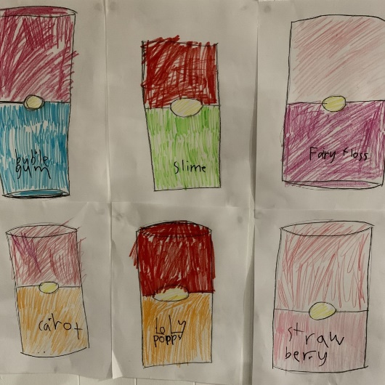
The next page is blank for you to draw and decorate your soup can. Use as much of the page as you can. There is no title on the page so your teacher can display this in the classroom.
There is an outline at the end of your workbook for emergencies only. Try to draw first or use it as a guide only.

Play some rhythms
Think about how you make soup from a can. You would need a wooden spoon and a saucepan.
What sound would they make when hit together? If you can, get them and experiment. If not find something that might sound similar.
Experiment with available items that make sounds like a wooden spoon and saucepan. Play a few rhythms then have someone clap some rhythms for you to echo and then to change. Musicians call this ‘call and response’. A bit like a musical conversation.

Watch and play
Watch the music lesson about ‘Pease Pudding’ https://vimeo.com/415391812/6da6d2fed7 (18 minutes).
The real meaning of nursery rhymes
This song was originally used as an early advertisement for a soup like food known as ‘Pease Pudding’. It was ‘mass produced’ and was sold in the market by a person calling out ‘Pease pudding hot or cold’ and this then became a song.
Discuss with someone how this was an early form of advertising. What ads do you know now?
Make a pudding
Create your own ‘pease’ pudding artwork (a bit like a still life artwork) to represent all your favourite ingredients that you might put in a pudding bowl. Use the bowl on the next page. You can stick images as a collage or draw them. Icons or logos are good symbols of these foods too.
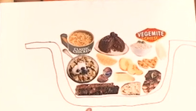
Blank page for your pudding artwork:

Write about art
Complete this exit slip to show what you have learnt.
Exit slip
Student name: ____________________________________ Date: _________________

I know artists share ideas by using

________________________________________________________________________

________________________________________________________________________

One thing I wonder

________________________________________________________________________

________________________________________________________________________

Outline of an apartment for special circumstances only. Preference is for you to create your own drawing first.

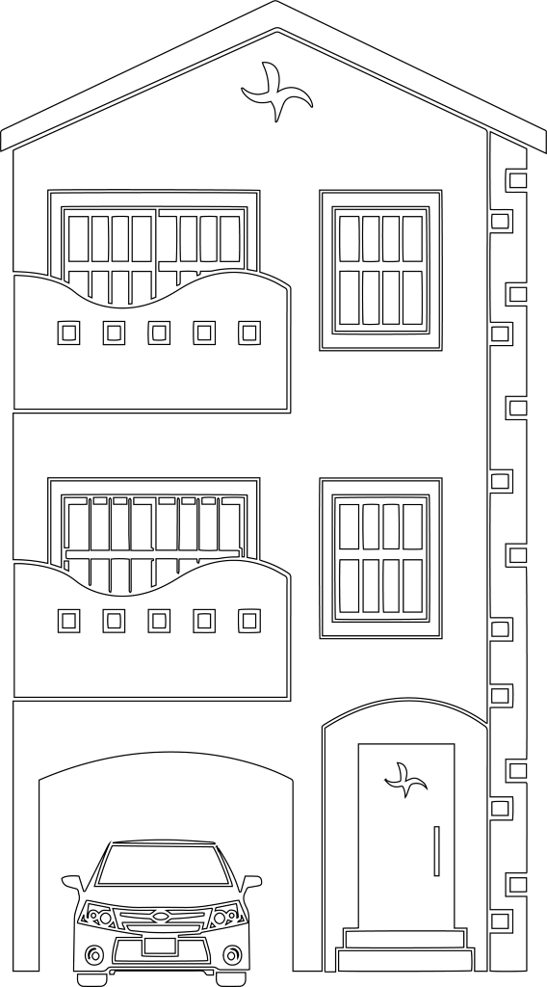
Outline of a house for special circumstances only. Preference is for you to create your own drawing first.

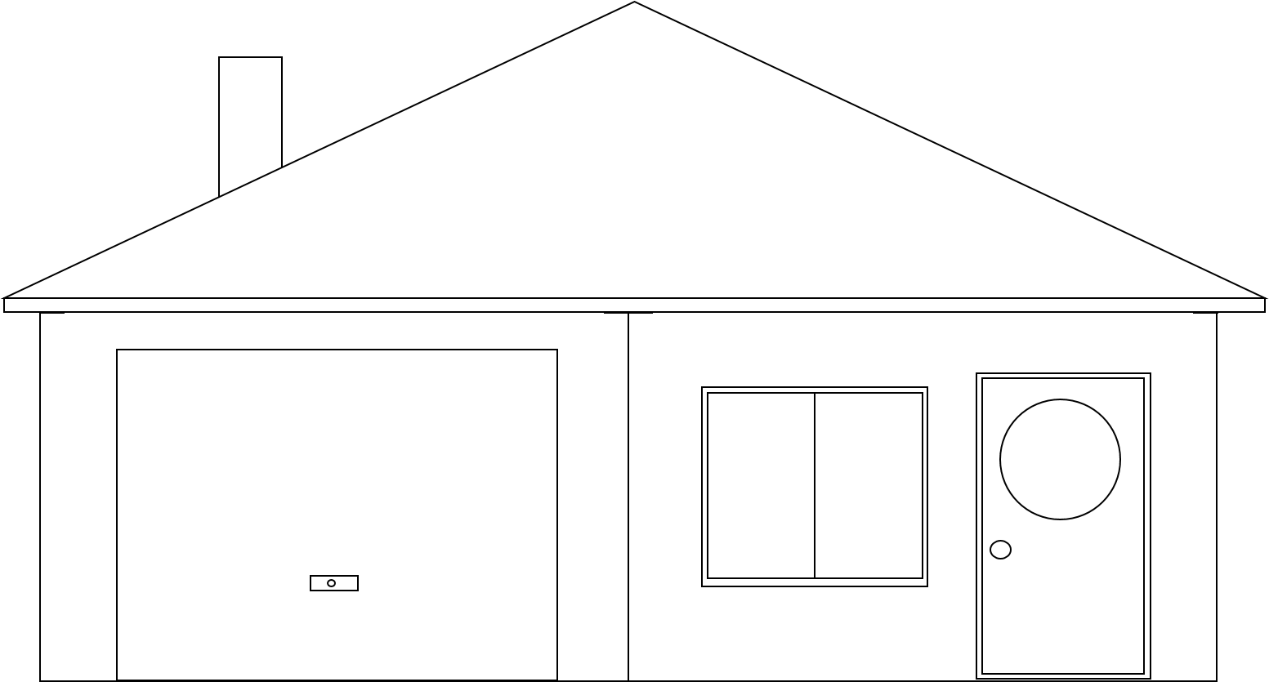
Outline of soup can for special circumstances only. Preference is for you to create your own drawing first.
