Waste as art – precious plants and animals
This document references Creative Arts K-6 Syllabus © NSW Education Standards Authority (NESA) for and on behalf of the Crown in right of the State of New South Wales, 2006. The illustrations used in this document are copyright © Cara MacLeod, 2011.
The precious plants and animals resource kit, funded by the NSW Environmental Trust, is a generic version of resources developed by Woollahra Municipal Council for their Environmental Schools Sculpture Prize (2010). This resource should be used in conjunction with ‘A guide to implementing waste as art and environmental art projects in schools’.
The NSW Environmental Trust welcomes the use of these resources within the restraints imposed by the Copyright Act 1968 (Commonwealth). Provided acknowledgement is made of the source, Australian school staff, community groups and council staff are permitted to copy this material freely for the purpose of teaching students in schools or communicating with parents and others in the community.
Contents
Waste as art – precious plants and animals 0

Lesson 1 – web of life
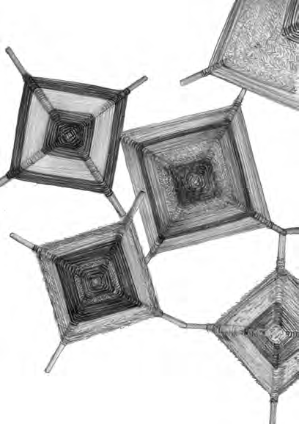

Lesson overview
Students discuss the meaning of biodiversity and view images of different Australian ecosystems. Students create woven forms to represent the diversity of Australia using a range of reused and recycled materials. Individual weavings are hung together to represent the diversity and interconnectedness of different environmental aspects.

Lesson outcomes
VAS1.1, VAS2.1, VAS3.1

Cross curriculum links
Science and technology (values and attitudes, knowledge and understanding), HSIE (Geography)

Resources
- interactive whiteboard or projector and screen
- the definition of biodiversity
- images of different Australian ecosystems such as the Great Barrier Reef, Simpson Desert, Midlands of Tasmania, Kangaroo island, Northern Kimberly region or the Pilbara
- smooth sticks (collected from green waste) or bamboo skewers (sticks or skewers need to be at least 20cm long), each student needs two sticks
- wool, twine, raffia, natural strings and fibres, reused fabric cut into strips, this could be second hand shirts or t-shirts
- pins, bulldog clips, tape, wool or wire for display.

Activities

Introduction
Introduce the class to the term biodiversity, by explaining the meaning as best suited to the stage of the class. Show students images of different Australian ecosystems on the white board or projector. Start a class discussion by asking students
- What interesting environments like these have you visited?
- Did you see any plants or animals there?
- What interesting plants and animals do we have living near our school area?
- What type of habitats do these plants and animals require to survive?
Conclude the discussion by explaining that all plants and animals are connected and rely on each other for survival, even us humans. For example, magpies need trees to nest and roost in as well as grass to forage in where they find small beetles and lizards hiding. Remove the trees and the grass, there will no longer be suitable habitat for the magpie. Find a suitable example for your area.

Artmaking
Students respond to the rich biodiversity of Australia by weaving mixed media ojo de dios weavings. Allocate each student an ecosystem type, for example rainforest, bush, desert, ocean, river, coast, as the basis for their weaving. Students work individually on their weaving but can share suitable materials and develop their ideas in small groups with those who share their ecosystem.
Encourage your students to choose appropriate materials. Ensure there is a wide range of materials with various colours and textures for them to choose from that will help them represent their ecosystem. For example, blue plastic bags, sparkly blue wool and old blue umbrellas cut into strips could represent the beauty of the ocean. A rainforest weaving might include green wool mixed with natural twine or raffia to give the rough texture of vines. Encourage students to mix different colours and tones. Contrasts such as placing bright colours next to pastels can add interest. For example, if they have chosen mostly greens, they could try adding light yellow and dark brown or add a splash of pink or red, to represent flowers, branches and so on. If they have chosen mainly light, earthy colours to represent the desert, rows of bright yellow for the sun and sky blue around the outside might be effective.
To construct an ojo de dios follow these simple steps, there are many short video clips available online that could be shown to the class to aide in communicating these steps.
Tie a knot at the mid-point of one of the sticks. Place the centre of the second stick over the centre of the first stick, at a right angle. Secure the two together by criss-crossing yarn around both sticks two or three times in each direction. You should now have a secure cross frame.
Start the weaving by bringing the yarn up over the front of the vertical stick. Wind it all the way around the stick and then bring it back up over the front.
Take the yarn over to the horizontal stick on your left, wrapping it over the top, around the back of the stick, and then back over the top. Moving counter-clockwise, continue the process until you have made the trip around all four sticks twice.
Now you’ve finished the centre, continue in the same direction, but show students how to wrap the yarn around the stick twice before they take it over to the next stick. Keep the wool wrapped tightly around each stick and pulled in close to the centre.
When students are ready to change to a new colour, they should count the number of rows in that section of their weaving to make sure they are the same, for example, they might change to a new colour after 4 rows. Cut the yarn they have been working with to a length of about 10cm. Join the new wool to the old with a knot at the back of the stick. Then trim the ends of yarn after tying the knot. Students begin wrapping the wool just as before with their new colour. They continue wrapping, changing colours as they wish. Stop wrapping about 2cm from the end of the stick, and tie a knot at the back to secure the end of the yarn. Make loops for each weaving and tie them to the back so they can be hung up and displayed.
Display the classes weavings together by hanging them from wool or twine in an interesting pattern, alternatively they could be pinned to a wall.

Extension
Students could collect and hang found objects from their weavings such as leaves and feathers to represent some of the plants and animals found in the ecosystem their weaving represents.

Lesson 2 – Wildlife walk
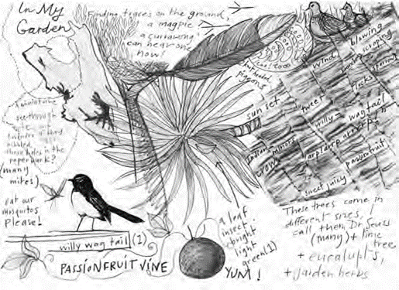

Lesson overview
Students explore the school grounds on a wildlife walk and learn more about the biodiversity of their school by observing and interacting with the natural environment. Students draw the living things they find and describe their sensory experiences, including sounds, smells and textures. Students view artworks by John Wolseley and discover new ways to represent the environment using their senses and a range of drawing techniques.

Lesson outcomes
VAES1.1, VAS1.1, VAS2.1, VAS3.1, VAES1.3, VAS1.3, VAS2.4, VAS3.4

Cross curriculum links
Science and Technology (Values and attitudes, Knowledge and understanding)

You will need
- a range of graphite pencils, 2B and 4B are good for shading, and wax crayons
- white black and brown pastels
- sharpeners, erasers, scissors and glue
- A4 sheets of cartridge paper, brown paper and other drawing paper available
- magnifying glasses
- examples of John Wolseley’s paintings and drawings
- digital cameras and a colour printer for the extension activity.

Activities

Introduction
Review the definition of biodiversity and explain to students that they will be learning about the biodiversity of the school grounds by going on a nature walk. Alternatively, a nature walk could be conducted at a local park, reserve or garden.

Artist case study
Show students some examples of John Wolseley’s art works that are based on exploration of some of the flora and fauna connected to a place. Discuss how the artist uses different drawing techniques in his recent body of work heartlands and headwaters.
Of his artwork, the artist says; “My practice often springs directly from the land or environment in which I find myself. Usually I do masses of looking, investigating, and listening to what is special about that place. I continue my interest in the nature of marks made by rubbing paper against burnt trees and shrubs.”
Read this quote to the class and discuss how they could take on these practices as they are walking through the school grounds. Ideas could include close sketches, making notes about how an environment looked or sounded, listening, looking under leaves and exploring textures and colours in their own drawings.
Demonstrate different drawing techniques to the class such as:
- observational sketching using lines, for example, look closely at a leaf and lightly sketch the shape, draw all the fine lines you can see in the direction they go in and add darker lines or cross hatching to represent darker areas;
- observational sketching using shading, for example, sketch an insect in pencil onto brown paper and use white pastel highlights to highlight lighter areas;
- make a frottage of a texture, for example, place paper over a thick leaf or the bark of a tree and rub over the texture with a large wax crayon or graphite pencil until the texture comes through onto the paper, this texture could be used as a background to be drawn over and
- write descriptive words of a place, for example, descriptions such as cool, shady, mossy, dry, red, hot can be integrated into the artwork.

Artmaking activity
Identify an area such as garden or bush area in your school grounds to explore. Remind students that they need to take care not to damage the environment as they walk. Find a place to sit quietly, observe and listen as a group for the first couple of minutes. Discuss what can be seen and heard at the place and if this can give a clue as to what plants and animals may be found in this environment.
Explain where students can go on their wildlife walk to complete their observational sketches. Students take clipboards with white and brown paper, a pencil and a wax crayon. They then make observational sketches of plants and animals within the garden boundaries. Students can also explore the area to collect interesting textures and listen carefully to record any sounds such as bird calls, the wind or rustling leaves. They could use a camera or magnifying glasses if available. Discuss ways to build up their pictures by filling in spaces, adding detail or trying a different pencil, crayon or piece of paper and using the drawing techniques discussed earlier.
Review the different plants and animals that have been drawn and the sounds and observations recorded. Discuss the activity with the class including any challenges or highlights, ask students if they found evidence of wildlife living in the school such as nests, feathers or footprints. Ask students to finish off their drawings back in the classroom adding any further details such as shading or descriptive words.

Extension
Give students more time to carefully rub out smudges, add notes and work into their drawings with pencil or pen to achieve greater detail. If students created multiple drawings these could be cut up to create collaged layers creating one final artwork from many drawings. A camera could be used to photograph the plants and animals found on the wildlife walk, print out the photos and collage them to sketched drawings of frottage backgrounds

Lesson 3 – A special home
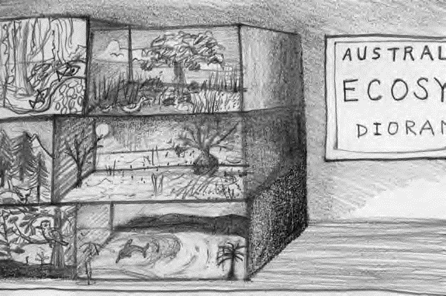

Lesson overview
Students learn about different habitats and make their own miniature diorama of an Australian habitat. They experiment with a range of natural and recycled sculpture materials to represent the characteristics of the habitat, including the plants and animals which live there.

Lesson outcomes
VAES1.2, VAS1.2, VAS2.2, VAS3.2

Cross curriculum links
Science and Technology (Values and attitudes, Knowledge and understanding), HSIE (Geography)

You will need
- pencils and markers;
- a collection of different recycled materials for making dioramas such as, fabric offcuts, bottle lids, corks, plasticine or clay, pipe cleaners, cut up foam packaging, wooden sticks, skewers, small bottles, wool, twine;
- sand or sandpaper, rocks or bark for ground cover;
- cellophane, tissue paper, crepe paper or coloured paper, nature magazines for backgrounds;
- a shoebox or small box for each student;
- scissors, glue, sticky tape, masking tape and a staple gun;
- paint and brushes and
- a copy of Where the Forest Meets the Sea by Jeanie Baker or access to the internet.

Activities

Introduction
Explain to the class that a habitat is the natural home or environment of an animal, plant or other organism. Read the class Where the Forest Meets the Sea or for older students explore the habitat requirements of specific animals relevant to the area. For example, the Spotted-tail quoll is mainland Australia’s largest carnivorous marsupial, ask students to research their range and distribution, habitat requirements and where they make breeding dens.

Artmaking
Help students to decide on a habitat type or an animal to focus on for the theme of their diorama. Before the start of the lesson set up a resource area, with a large collection of recycled materials that can be used in the dioramas. Explain to students how different materials can show the colours and textures of the different habitats, for example, brown crepe paper for bark or dried leaves for a forest floor. Give students a chance to look at the materials and plan how they could be used creatively. Once students have a plan or theme, they can collect materials and a box each.
Ask students to draw a background in pencil inside the box and then collage over the drawing on the inside walls and bottom of the box to build up the background in three dimensions. Encourage students to show biodiversity within the habitat by adding different colours, textures, and shapes of the various plants, animals and insects that live there. Encourage students to add elements that stand up, pop out or hang inside the diorama to make it three-dimensional. Students could model forms in plasticine, or make plants, animals and habitats out of pipe cleaners, foam and fabric. One way to create a three-dimensional effect is to print photos, or draw or collect small pictures, glue them on stiff cardboard and cut them out. By adding a tab at the bottom, students can fold it back to make them pop up or stand by taping or gluing it to the bottom of the box.
To conclude, ask students write a brief artist’s statement of their diorama, including information about the artist’s name, title, date, materials and techniques used and subject matter represented. Students could type up their artist statements, insert an image of the habitat or animal represented in their artwork, then print and mount it on cardboard to present with the artwork.
Finally, discuss ideas for how to display your dioramas. Consider the audience for your work. How could you use your artworks to let people know about the importance of protecting these habitats? Where would be a good place for a public diorama display?

Lesson 4 – Indigenous perspectives
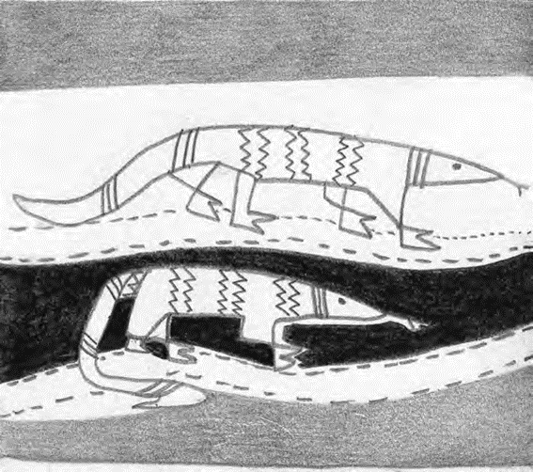

Lesson overview
In this lesson students appreciate diverse artistic styles of contemporary Aboriginal and Torres Strait Islander artists across Australia and learn about their artistic practices. Students make their own recycled sculpture of a selected native Australian animal. They consider the animal’s characteristics and behaviours and develop an original design which represents the qualities and personality of their chosen animal using simple construction techniques.

Lesson outcomes
VAES1.2, VAS1.2, VAS2.2, VAS3.2, VASES1.4, VAS1.4, VAS2.4, VAS3.4

Cross curriculum links
Science and Technology (Values and attitudes, Knowledge and understanding), HSIE (History)

You will need
- access to Yarrenyty Arltere Artists group web page
- access to native Australian animal fact sheets
- a collection of small recycled boxes and bottles
- different fabric offcuts in various colours and textures, bottle lids, plasticine and left-over paper clay, recycled foam packaging, buttons, sticks, twine, corks, wool, felt, raffia and feathers
- coloured paper and pencils
- scissors, glue or a hot glue gun and masking tape

Activities
Artist case study and introduction
Introduce students to the sculptural works of the Yarrenyty Arltere Artists by visiting their webpage for examples of their work. For older students, show the Yarrenyty Arltere YouTube clip (4:00) explaining some of the social and cultural aspects to the artmaking by these artists.
Students can either research an Australian native animal they would like to focus on for their sculpture or younger students could be given a choice of three or four options such as goanna, echidna, quoll or snake. Make sure there are plenty of photographs either online or printed out to use as reference for body shapes and elements for the selected animals.

Artmaking
Each student should sketch a plan of their sculpture, focusing on the main body shape and what types of materials they will need to construct their sculpture. For example, if making an echidna you would need a round body, a pointy beak and sharp spikes.
Once plans have been drawn students should select materials to work with to start their construction. Bottles make good bodies, as does scrunched up newspapers wrapped up in thick masking tape. Bamboo skewers make good spikes and fabrics can be wrapped around bodies to create form and shape. Left over paper clay can be rolled into eyes or faces and hot glued to bodies when the clay has dried.
Once students have completed their sculptures, ask them to make a short presentation to the class explaining the techniques and materials they have used, as well as provide some information about their chosen animal and the threats it faces if they conducted their own research and animal choice.

Lesson 5 – butterflies and birds

Lesson overview
Students appreciate and discuss an artwork by Eddie Puruntatameri. Students learn why butterflies are important, the role they play in ecosystems and what attracts them to a habitat. Students make their own cardboard sculpture of a butterfly.

Lesson outcomes
VAES1.1, VAS1.1, VAS2.1, VAS3.1, VAES1.1, VAS1.3, VAS2.3, VAS3.3

Cross curriculum links
Science (Knowledge and understanding)

You will need
- image of Bird and Butterfly by Eddie Puruntatameri
- images of some different butterflies found in Australia
- images of Rainbow Bee-eater bird
- sheets of A3 coloured cardboard and black card
- pencils, glue, tape and scissors
- fabric offcuts in bright colours and various textures, bottle lids, plasticine, pipe cleaners, sheets of foam packaging, wooden sticks, buttons, skewers, corks, wool, felt, raffia and feathers
- long strips of cane about 1 to 2 metres long.

Activities

Introduction
Display an image of Bird and Butterfly on a smartboard or projector and discuss the artwork with the class. Talk about the ecological relationship being depicted in Puruntatameri’s artwork. Ask the class if they have ever seen a bird eating a butterfly, show the class a picture of a Rainbow Bee-eater, these birds prey on bees and butterflies. Talk about predator and prey relationships and the fact that while the bird eats the butterfly there will be another animal that relies on the bird as a source of food. This is known as food web. Talk about the colours of both the butterflies and the bird with students.

Artmaking
Each student will need a piece of coloured A3 cardboard and a pencil to start. Fold a landscape orientated piece of A3 coloured cardboard in half so it creates an A4 portrait card with a fold down the left side. Keeping the card folded, and starting from the left side, students draw the outline of one half of a butterfly or a bird. Encourage them to fill the page, with the widest point of the forewing, and tips of the lower wing, going all the way out to the edge of the page and the antennae or beak touching the top of the page.
Remind students to draw a shape they can cut out easily, and to make sure the body is big enough, so their butterfly or bird can stay in one piece when they cut out their outline.
Once students have drawn an outline, demonstrate how to keep the cardboard folded and cut around their half butterfly or bird outline (without cutting up the fold itself). They should be careful to cut so that the outline stays in one piece. If a student cuts their shape in half, join the pieces with sticky tape or add an extra piece of cardboard where it has been cut for support.
To make the shapes to decorate each wing, students should fold a second piece of cardboard in half, then draw each spot, line or shape needed on one side so when they cut through the folded card, they end up with two, identical shapes. This ensures the wings remain symmetrical in their decoration. Students arrange the shapes on the butterfly or bird and glue them down. Students continue arranging shapes and patterns and different collage materials such as fabric scraps on their sculptures until they have achieved a design showing some of the observed features of butterflies or birds.
Attach the finished collaged sculptures to long strips of cane. Tape the cane along the fold in the middle of the animal body. Finished sculptures can be held up high to look like they’re flying or your class might like to see how their sculptures look outdoors. Students could plant their sculptures in a garden containing lawn, trees or flowers and take some photos of their sculptures in the school grounds.

Lesson 6 – Our place
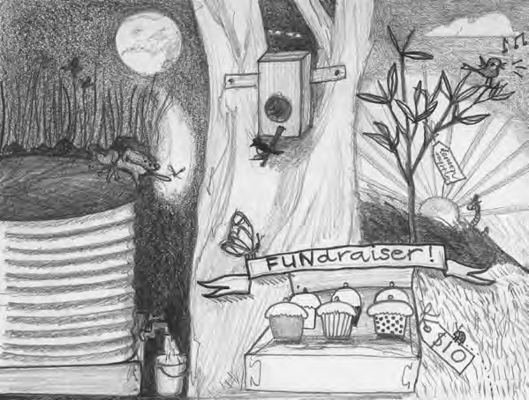

Lesson overview
Students read or are read My Place, by Nadia Wheatley and consider how a local suburb has changed over time. As a class, students discuss different ways they could improve biodiversity and sustainability in their own school grounds and choose a project to implement.

Lesson outcomes
VAES1.1, VAS1.1, VAS2.1, VAS3.1

Cross curriculum links
Science and Technology (Skills), HSIE (History)
You will need
• a copy of My Place by Nadia Wheatley and Donna Rawlins;
• coloured pencils, graphite pencils, A4 paper and
• watercolour paints and small round paint brushes.

Activities

Discussion
Read students My Place and discuss the changes that took place in the story. Ask students to relate this to their own community and to identify how changes to the local area may have affected the natural bush or environment. Ask students to recall if any native gardens or bush regeneration have been created in the local area. Further discuss threats to local environment, this could be pollution, logging, litter, loss of habitat.

Project planning
Ask the class to think about their school and playground. What could be made or planted to help provide habitat or support for our precious plants and animals?
Hand out sheets of scrap paper and graphite pencils and give each student time to draw or design a garden or feature that could be installed at the school to support biodiversity. This could include a pond, bird bath, nest boxes, butterfly or bird attracting gardens, a worm farm or native gardens.
When students have finished sketching, they could use watercolours to complete the design of their idea for the school grounds. Discuss the different ideas that students have developed and display them in the classroom.

Extension
Resources permitting, students then consider the available space in the school and choose a project to be undertaken by the class. Once a project is underway, the class could make a series of posters to educate the rest of the school about the ecological benefits of the project. This might include raising awareness about the environmental project you are embarking on, advertising fund raising activities, and encouraging the school community to get involved in a working bee or another event.

