The character of the arts
Creative arts learning sequence Early Stage 1
Learning sequence description
In Lesson 1 students explore music and drama using nursery rhymes as an initial stimulus. In Lesson 2 they investigate selected visual artworks and examine the role of character and place in creating identity. Students interpret the role of character across the creative arts to help shape meaning in compositions and artworks.

Syllabus outcomes and content
Music
MUES1.1 - participates in simple speech, singing, playing and moving activities, demonstrating an awareness of musical concepts.
  - performs simple speech rhymes and songs maintaining a sense of beat and rhythm based on nursery rhymes
  - moves to music maintaining a constant beat
  - performs music using body percussion, percussion instruments and self-made sound sources
  - explores simple aspects of musical concepts in their singing, playing and moving activities.

MUES1.4 - listens to and responds to music.
  - listens to music and responds by moving to the beat, doing simple actions when different sections are played
  - responds to music through movement.
Drama
DRAES1.1 - uses imagination and the elements of drama in imaginative play and dramatic situations.
  - investigates aspects of the human experience in dramatic play
  - participates in imaginative play by taking on basic roles.
DRAES1.3 - dramatises personal experiences using movement, space and objects.
  - communicates the depiction of real-life and fantasy situations in imagined dramatic contexts.

Visual arts

VAES1.1 - makes simple pictures and other kinds of artworks about things and experiences.
- investigates relationships in their artmaking, including people who are important to them such as parents, grandparents, brothers and sisters, friends, and others in their local area
- talks about significant features and relationships within their artworks.
VAES1.2 - experiments with a range of media in selected forms.
- explores the qualities of different drawing media and tools such as graphite (‘lead’) and colour pencils, fibre tip pens, crayons, brushes and sticks in drawing
- recognises how qualities such as colour and shape can assist them to depict various things.

VAES1.3 - recognises some of the qualities of different artworks and begins to realise that artists make artworks.
- identifies different colours, shapes, textures and other things of interest in artworks.
VAES1.4 - communicates their ideas about pictures and other kinds of artworks.
- talks about the artist who made the work and suggests that the artist has similar feelings to the things they represent in their artworks.
NSW Creative Arts K-6 Syllabus © 2006 NSW Education Standards Authority (NESA) for and on behalf of the Crown in right of the State of New South Wales.

Lesson 1 – How can a nursery rhyme teach us about character and music?
Students are learning to:
- Explore and understand a variety of musical concepts through nursery rhymes.
- Sing a variety of musical compositions with both lyrics and without to discover the music concepts that composers and performers use.
- Identify the role of character in the creative arts to evoke meaning for an audience.
Item | Learning experience | Differentiation strategies and/or adjustments | Resources
1.1 | Sing a warm-up song or move around to warm-up bodies and voices.  Sing some nursery rhymes that you are familiar with. Select a nursery rhyme from this list or others as known: ‘Baa, Baa, Black Sheep’, ‘Itsy Bitsy Spider’, ‘Little Miss Muffet’, ‘Humpty Dumpty’.  Read the nursery rhyme and mime the actions on the spot (non-locomotor). Discuss what the nursery rhyme is about. Researching nursery rhymes often shows very complex and unexpected stories. Does it tell a story or is it mainly focussed on the characters in the nursery rhyme? Who are the main characters and what do we learn about them through the nursery rhyme?  Focus on ‘This Old Man’. There are several interpretations of this nursery rhyme and many unfamiliar words. Discuss some of the language used within. For example, ‘knick-knacks’ are small trinkets or ‘knick-knacking’ also means tapping out a rhythm using spoons. A whack means to hit something once, hard and forcefully.  Revise writing and saying the numbers 1 to 10 or moving on to ‘Friends of 10’. Collect objects that represent each number.  Practice singing or saying ‘This Old Man’. Listen to the song and keep the beat on laps. Explore some action using mime and movement initially to unpack the lyrics and then to support the singing of the song. For example, imagine the way that you would move if you were holding a shoe, on the door and so on. Freeze in each pose like you are a photograph.  Use two spoons together to ‘knick-knack’ to the beat of the song. This can be as simple as hitting spoons (or even sticks) together or can expand to the original and highly complex version of knick-knacking. Other spoon playing techniques can also be explored.  Create an ostinato (repeated pattern) to accompany the song using the spoons to ‘knick-knack’. Take some of the lyrics of the song to use as this ostinato. For example, saying ‘Knick knack paddy whack’ as an ostinato over and over again, then transferring this rhythm to the spoons. Attempt to perform this whilst singing the song.  Discuss rhyming words. What are they? Practice some rhyming words for each of the numbers 1 to 10. For example, 1 and sun, 2 and glue and so on. Most songs have a rhyming word at the end of each line. Experiment, with other possibilities for example, one and drum, two and glue, three and tree, four and drawer, five and chive, six and Netflix, seven and Kevin, eight and mate, nine all the time, ten and pen. | Play instruments along with the songs or nursery rhymes.  Explore different songs with rhyming words or even consider completely changing the lyrics of ‘This Old Man’ to reflect completely different objects and rhyming words.  Draw pictures of a number of objects or simply collect numbers of objects.  Add or remove verses depending on requirements. | Student workbook (DOCX 764KB)  Nursery rhyme samples:  ‘Baa, Baa, Black Sheep’  ‘Itsy Bitsy Spider’  ‘Little Miss Muffet’  ‘Humpty Dumpty’  General equipment:  2 spoons per child  Paper and pencil  Random household item for counting or gathering  Possible demonstration video:  Knick-knacking video
1.2 | Ask the students to watch the footage of ‘This Old Man’ and participate in the activities within the video.  Discuss afterwards and sing some of your newly learnt songs. Play instruments along with the songs in the video. Explore different songs with rhyming words or even consider completely changing the lyrics of ‘This Old Man’ to reflect completely different objects and rhyming words.  Try some of the songs and activities within the film with other nursery rhymes or songs that are known.  Practice chanting and singing the song ‘Ardi Do Da Day’ (included in the film footage) which also reinforces the numbers to ten, through repetition, verses, rhythm and beat. It also allows for the experimentation of tone colours of vocal timbre depending on the focus of the characters within each verse. | Pause and replay the video. Watch and participate with the students or encourage household members to also join in.  Try some of the songs and activities within the film with other nursery rhymes or songs that are known. | Student workbook  Film footage:  ‘This Old Man’
1.3 | Opportunity for monitoring student learning  Singing and demonstrating a sense of pulse – teacher observation or peer and self-assessment.  Practice singing or saying ‘This Old Man’. Listen to the song and keep the beat on laps. Accompany the song with a simple ostinato or the beat with ‘instruments’ (such as spoons) or body percussion.  What to look for:  - Does the student respond to music through movement? For example, are they able to maintain the beat and then the rhythmic ostinato accompaniment?  - Is the student able to identify the features in the musical composition that are significant to them and make links with their own experiences through spoken, written, artistic or dramatic communication? |  | Nursery rhyme:  ‘This Old Man’  2 spoons or equivalent

Lesson 2 – What visual arts techniques can we use to help learn more about character?
Students are learning to:
- Reflect on character and meaning within their own and others’ artworks.
- Explore the use of symbols, shapes and colours in artworks.
- Create artworks for different purposes.
Item | Learning experience | Differentiation strategies and/or adjustments | Resources
2.1 | Revise ‘This Old Man’. Sing it or say it preferably with a household member or peer. Practice keeping the beat through body percussion or using spoons or other instruments.  Discuss who this nursery rhyme is about. What did the character do? What do we know about how he travelled?  This supporting video is useful to demonstrate drawing and printmaking techniques to help create an artwork inspired by the stencilling techniques of abstract printmaking.  Create an artwork by using different bottle tops and stencilling the different numbers. Use the example included here to help get started:  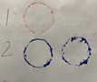 | Explore further numbers and different objects to print-make with.  Create other abstract artworks by printmaking. Think about the ways in which the shapes can overlap and what colours can be used. Layer the shapes and colours over each other to make a more interesting artwork. | Student workbook  Film footage:  Supporting video of Abstract Printmaking  Art equipment:  Paper  Paints  Bottle tops
2.2 | Use this video as a guide to the process of a form of symbolic abstract painting. Take some water in a container and a paintbrush. Go outside to some concrete or into a tiled or paved area. Create artworks to reflect a symbol of a character that is important to the student. For example, an image of a pet or a person. Once it has vanished, repeat with a different topic such as a symbol of a journey or a trip and so on such as that below:  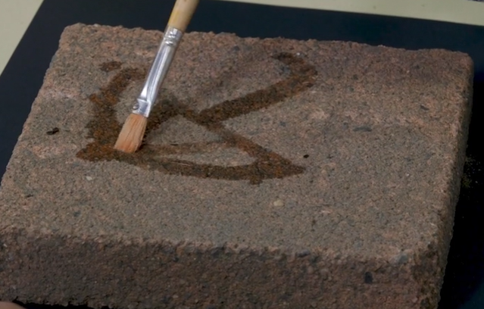  Examine the Aboriginal artwork ‘Minyma Tjuta Tjukurpa’ (‘Seven Sisters Creation Story’) from the collection of the Art Gallery of NSW. It is sometimes referred to as ‘dancing across country’ and was painted by Pitjantjatjara artist Wingu Tingima in 2007.  Wingu Tingima painted this story about seven sisters travelling and then dancing in her country. Discuss the colours, shapes and patterns used in the artwork. Describe the mood of the painting. You may notice that although there are no portraits of people it is about characters and is shown through symbols, colours and shapes.  Use this as an inspiration to create a portrait of family or friends. This may be a painting or a drawing. Encourage students to think carefully about their use of colour just as Wingu Tingima did. Use colours and shapes that express student feelings or that remind them of the place in which these people exist. Just as in ‘dancing across country’ these people may be dancing and celebrating or may be completing other usual routines.  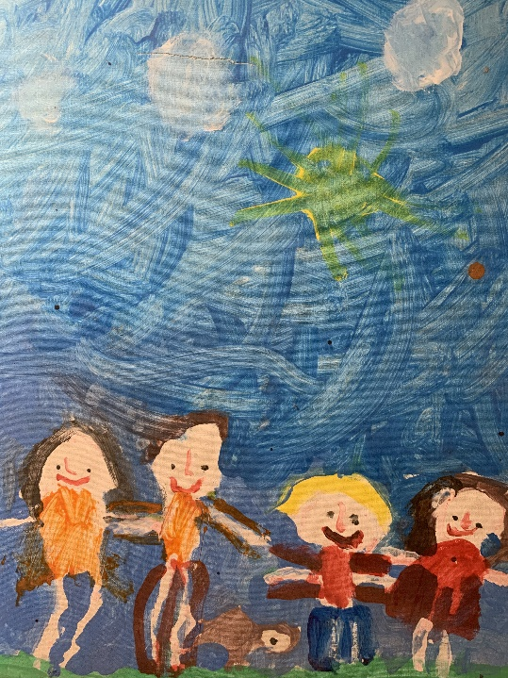  An artist intent statement, delivered either verbally or in writing should accompany the work where possible. | Use chalk or charcoal to create artworks outside. Photograph if required.  Portraits need not be of people but may be of an area or interest, a situation, family story or journey. | Student workbook  Art supplies:  Water in a container  Paintbrush  Paver, brick or outdoor area  Coloured paints or coloured pencils  Paper (art or other)  ‘Minyma Tjuta Tjukurpa’  This artwork referred to with thanks to the Art Gallery of NSW. Please note that this artwork will need to be prepared for students in a non-digital environment for their student workbook.
2.3 | Opportunity for monitoring student learning  Creating a family or friend portrait – teacher observation or peer and self-assessment.  Create a portrait of family or friends. This may be a painting or a drawing. Encourage students to think carefully about their use of colour. Use colours and shapes that express their feelings or that suit a particular character and remind them of the place in which these people exist. An artist intent statement, either verbal or written should accompany the work where possible.  What to look for:  - Does the artwork reflect some consideration of colour, shapes and symbols to relate to the characters in their artwork?  - Have the students thought about the characters and places in their artworks and how to show these?  - Does their artist intent statement (verbal or written) reflect the content of their work? |  | Student artworks and verbal or written artist intent statement.  Student workbook (DOCX 764KB)

Reflection and evaluation
These simple questions may help you reflect on your students’ learning and plan for next steps.
What worked well and why?
What didn’t work and why?
What might I do differently next time?
What are the next steps for student learning based on the evidence gathered?

