Tamara Dean resource booklet

Table of contents
Tamara Dean resource booklet 1
Table of contents 2
The Moran Contemporary Photographic Prize 3
Tamara Dean interview extract 11
Activity 1 – engaging with texts 12
Source 1 – Extract from ‘Art and the Sublime’ – Tate 13
Source 2 – Extract from 'Truth to Nature' - National Gallery of Australia 15
Source 3 – Tamara Dean quotes
Activity 2 – Interpreting and analysing 18
Artwork 1 18
Artwork 2 19
Activity 3 – Interpreting and analysing 20

The Moran Contemporary Photographic Prize
‘Established in 2007, the Moran Contemporary Photographic Prize (MCPP) is a national competition that awards and promotes Australian contemporary photography and excellence in all forms of still, photo based artwork – including analogue and digital photography or staged and directorial photo-media work.
The Moran Arts Foundation invites photographers to tell a story of how they experience living in Australia; places, people and lifestyle that make our lovable country quintessentially Australian. It may be a landscape, portrait or action shot.
There are many ways to interpret this brief, but we are after your perspective on contemporary Australian society, your life, your dreams, your abilities, your inabilities, your mates, your loves, your environment & your landscape. We want the good, the bad, the ugly, the beautiful and the everyday.’
Text and all images sourced from The Moran Prize on the 17/12/20.

Image | Citation
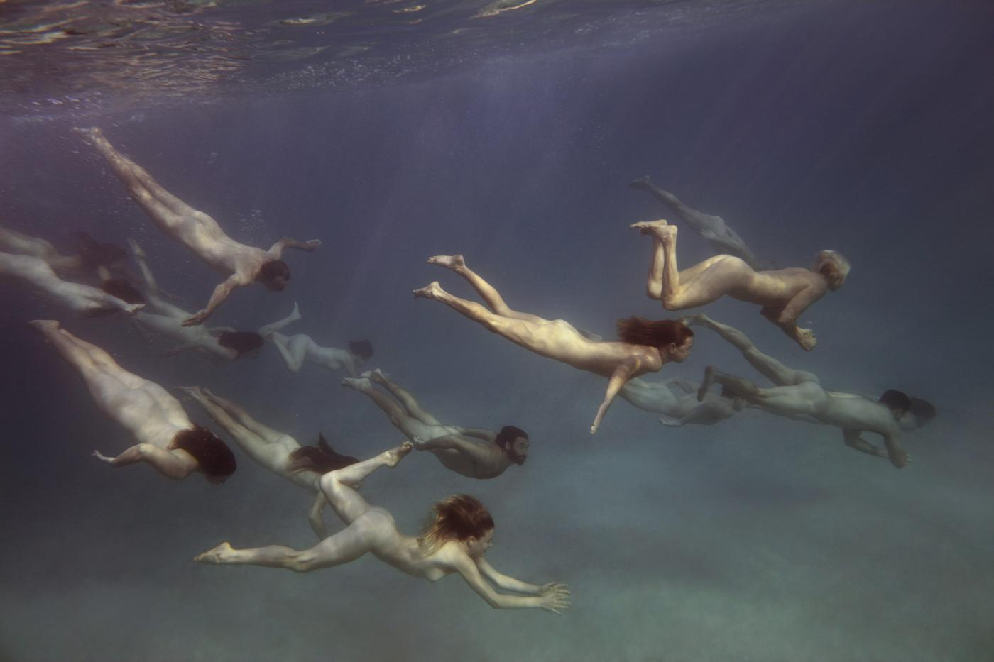 | Tamara Dean  ‘Endangered’  2019 Winner  Moran Contemporary Photographic Prize
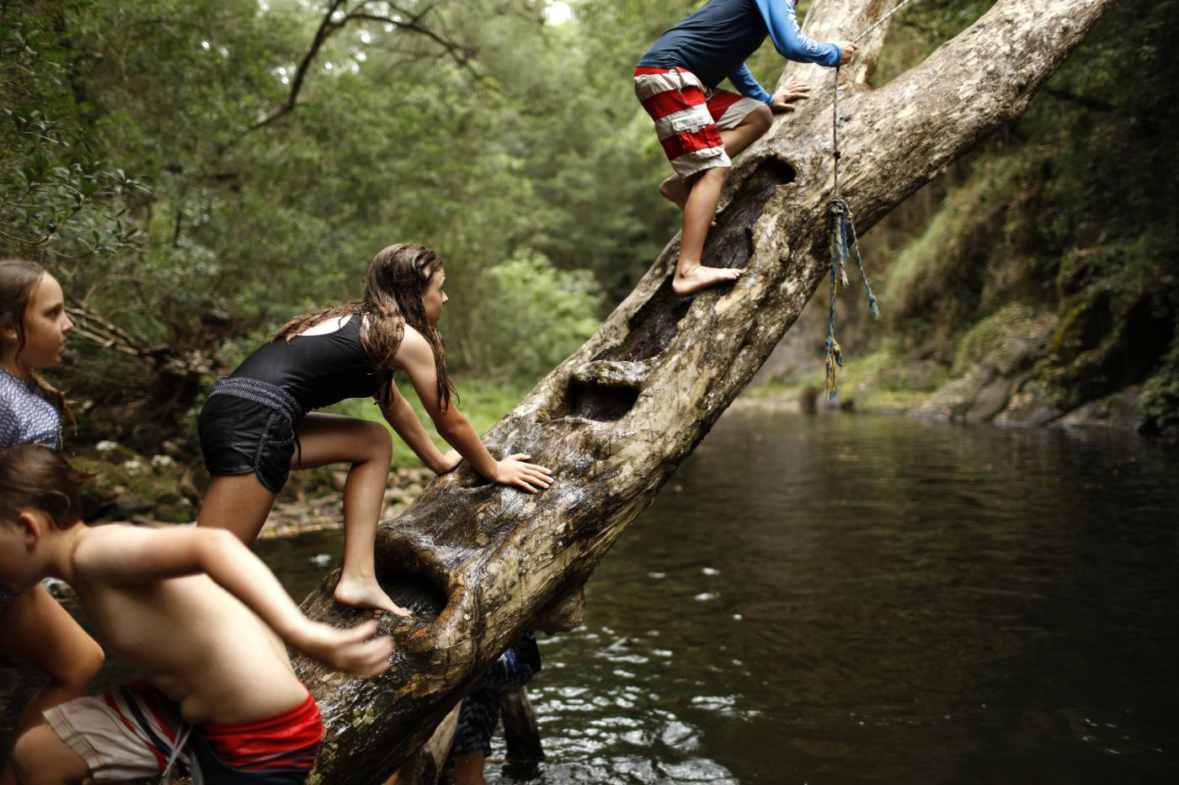 | Tamara Dean  ‘Tree Notches’  2019 Finalist  Moran Contemporary Photographic Prize
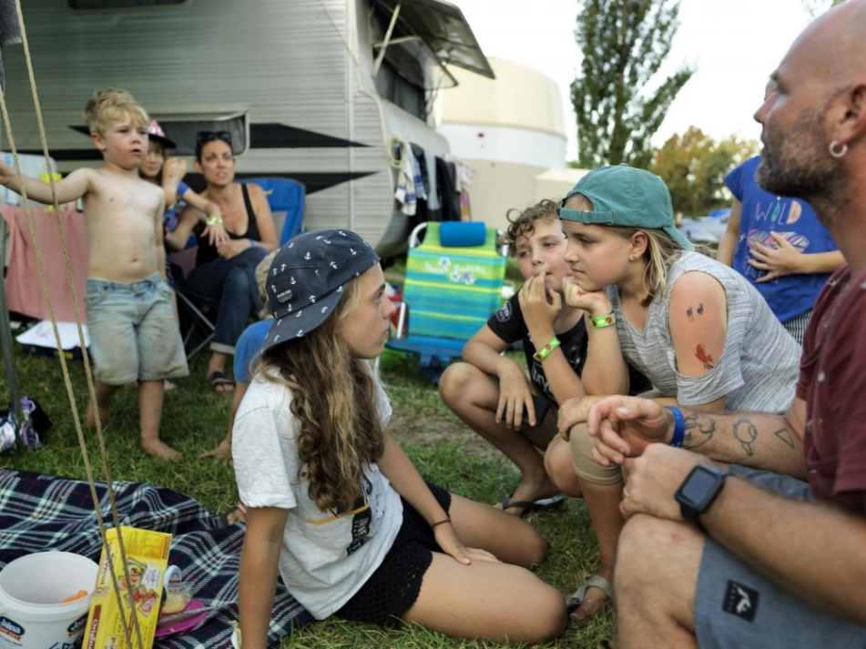 | Tamara Dean  ‘Staring Competition’  2019 Semi-finalist  Moran Contemporary Photographic Prize
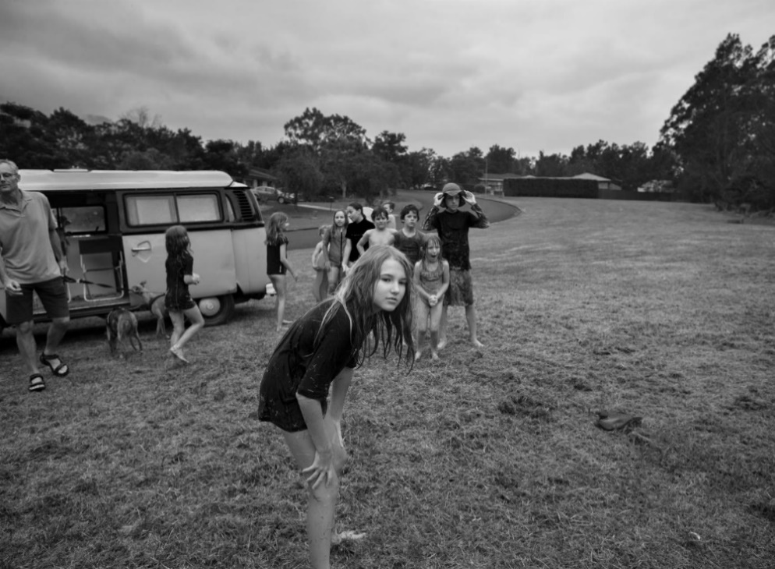 | Tamara Dean  ‘Next in line’  2019 Semi-finalist  Moran Contemporary Photographic Prize
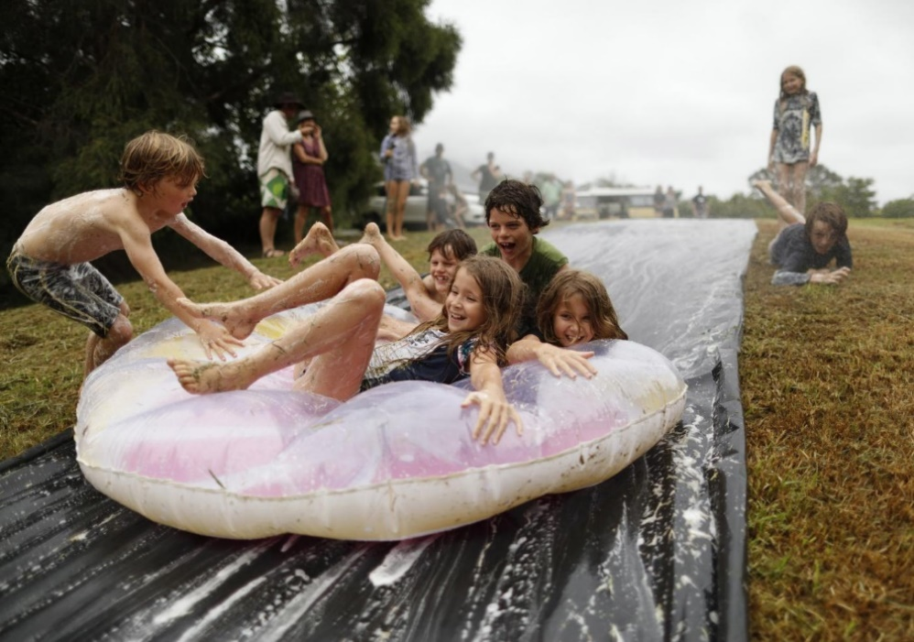 | Tamara Dean  ‘Slip n slide’  2019 Semi-finalist  Moran Contemporary Photographic Prize
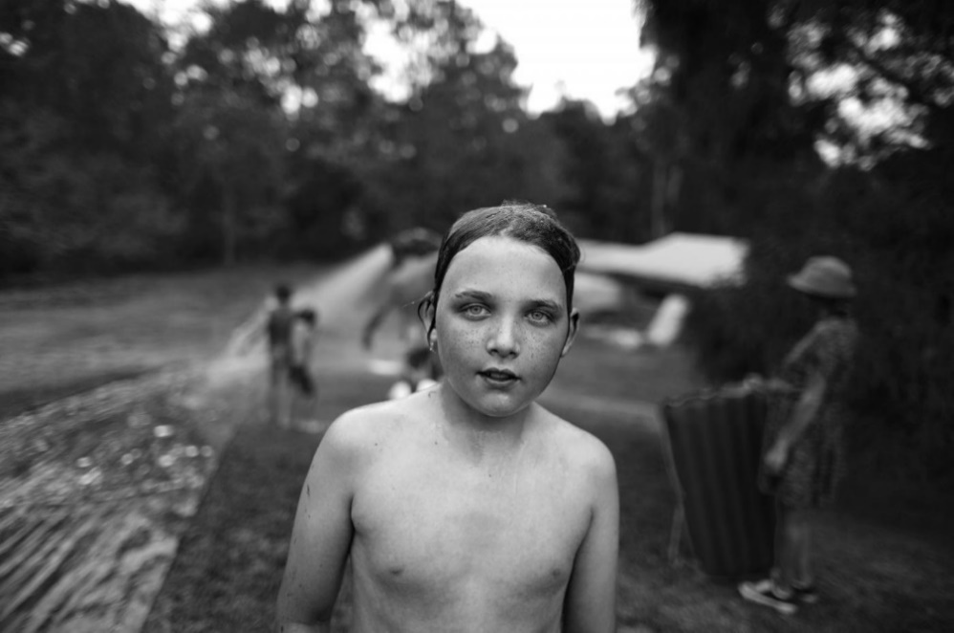 | Tamara Dean  ‘Jack’  2019 Semi-finalist  Moran Contemporary Photographic Prize
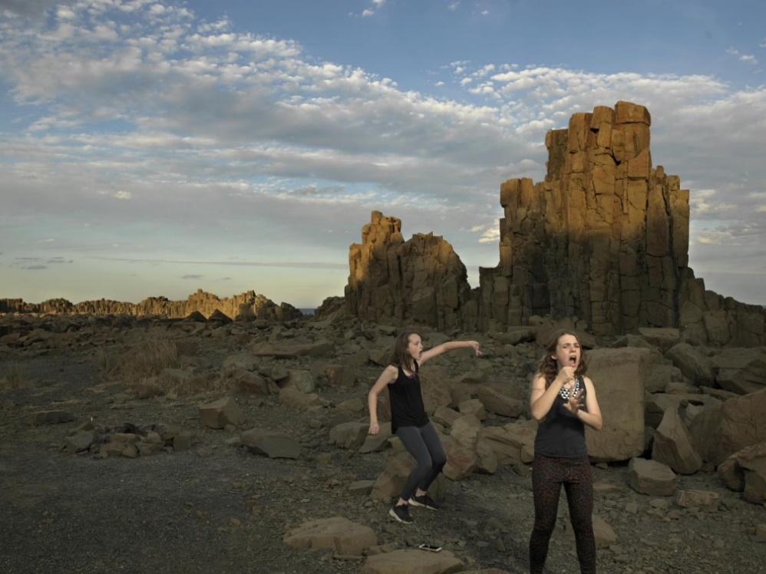 | Tamara Dean  ‘Howl’  2019 Semi-finalist  Moran Contemporary Photographic Prize
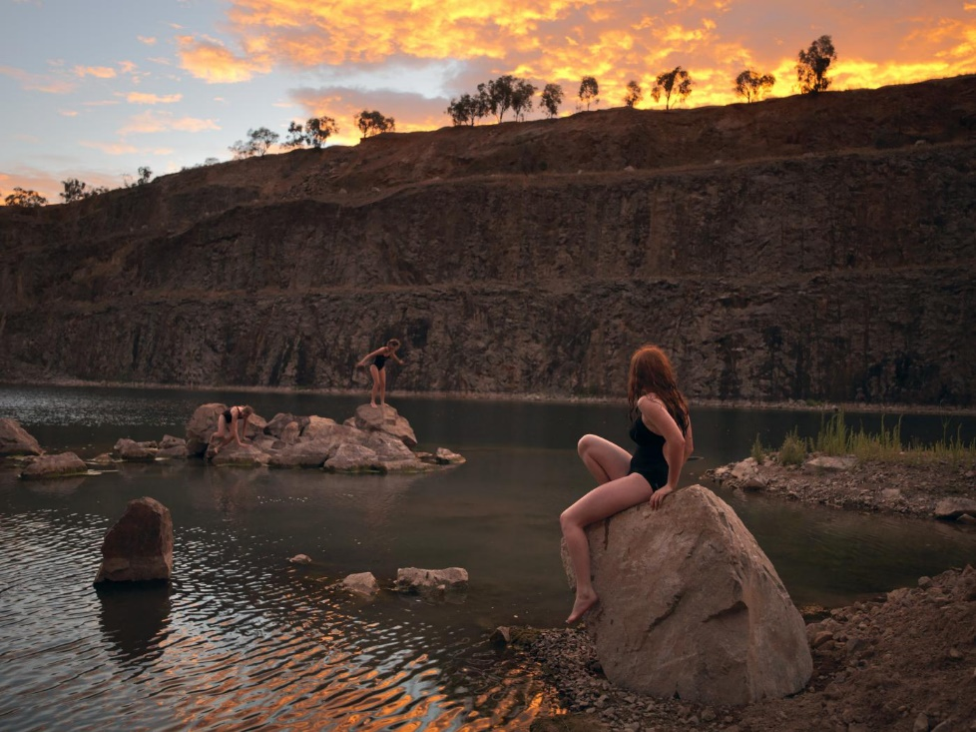 | Tamara Dean  ‘The Quarry’  2018 Finalist  Moran Contemporary Photographic Prize
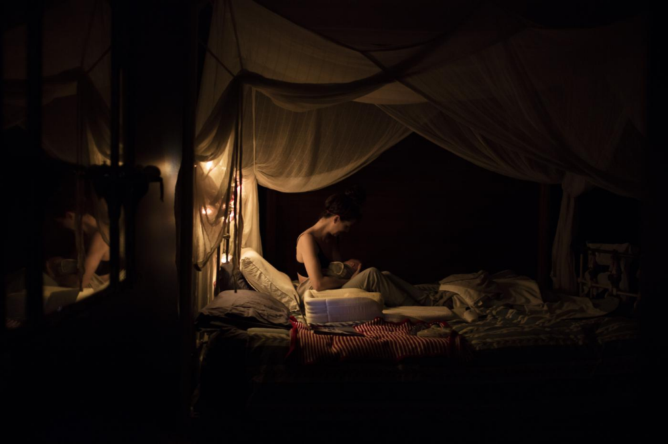 | Tamara Dean  ‘The Night Feed’  2018 Semi-finalist  Moran Contemporary Photographic Prize
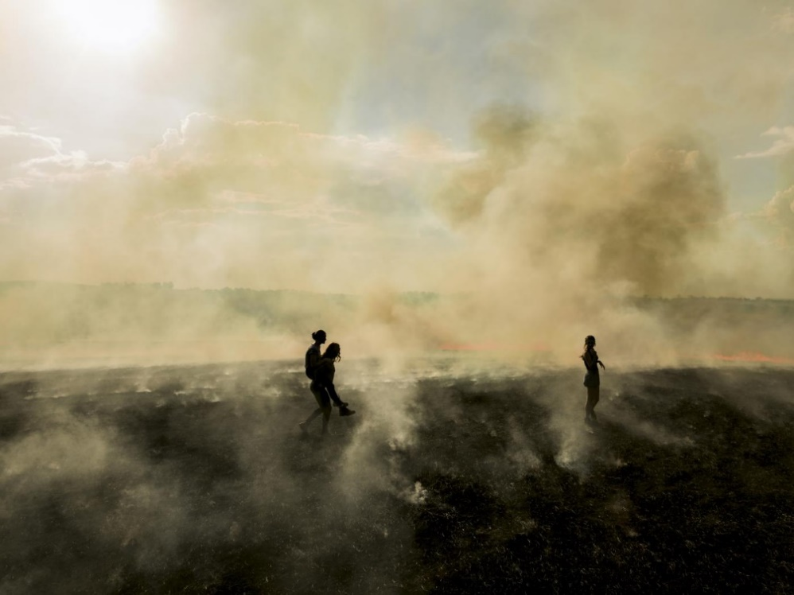 | Tamara Dean  ‘The Burn’  2018 Semi-finalist  Moran Contemporary Photographic Prize
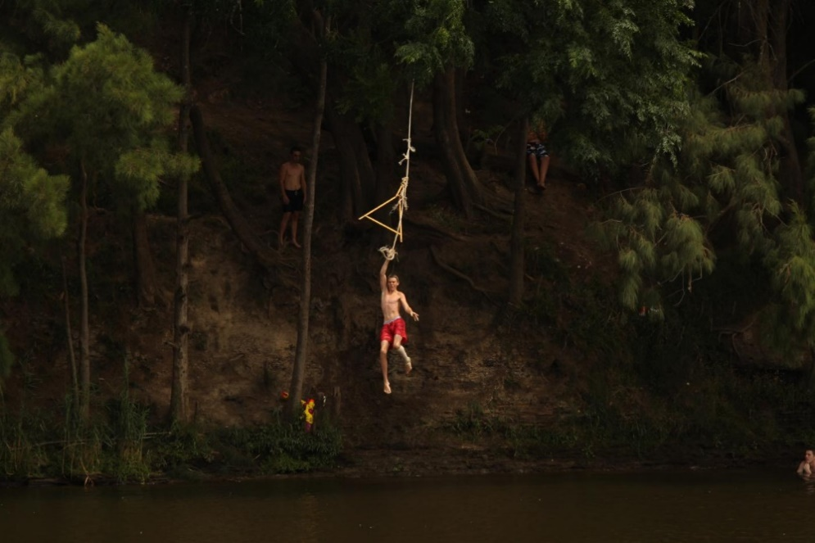 | Tamara Dean  ‘The River’  2013 Finalist  Moran Contemporary Photographic Prize
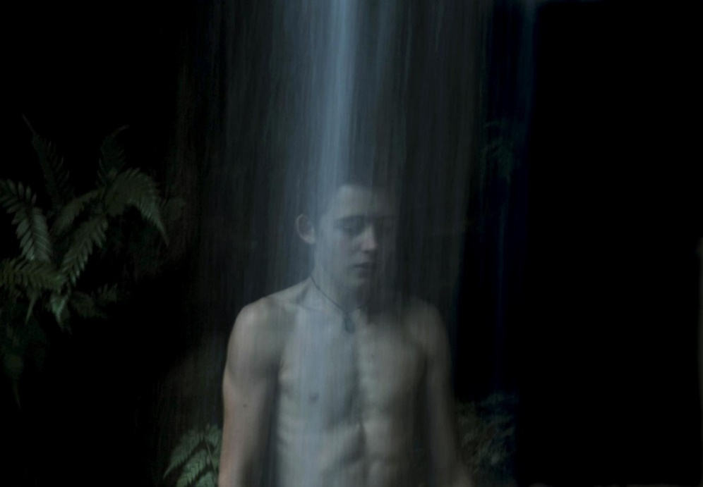 | Tamara Dean  ‘The Edge’  2013 Finalist  Moran Contemporary Photographic Prize
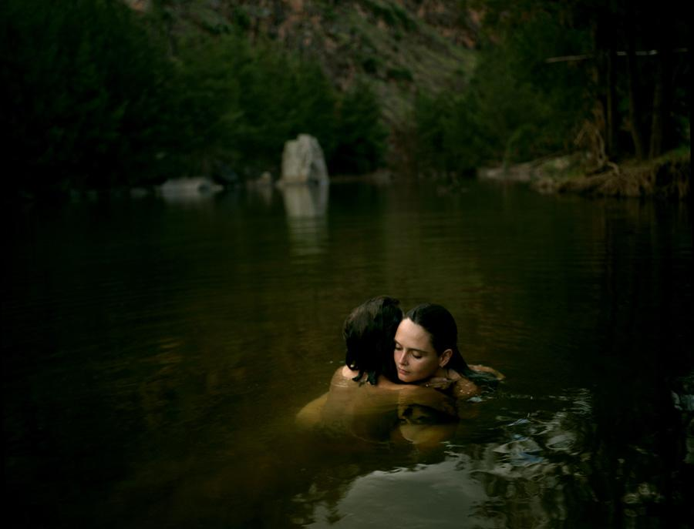 | ‘Ladies of the Canyon #2’  2011 Finalist  Moran Contemporary Photographic Prize
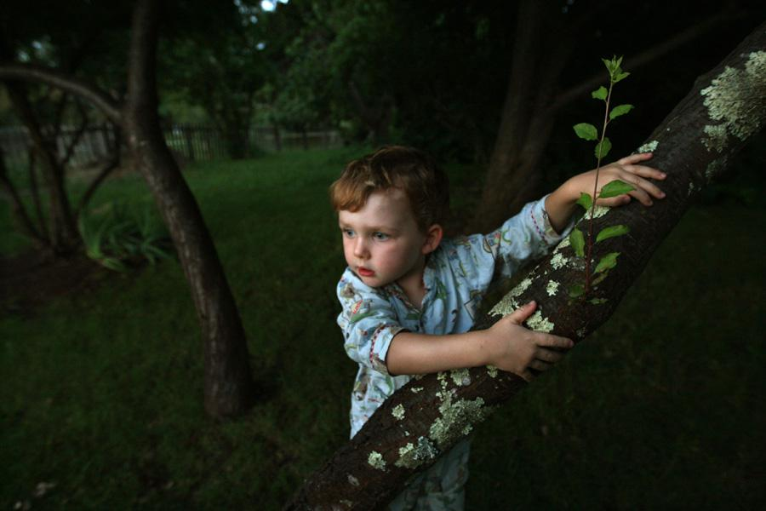 | ‘Jack in the Enchanted Garden’  2011 Finalist  Moran Contemporary Photographic Prize
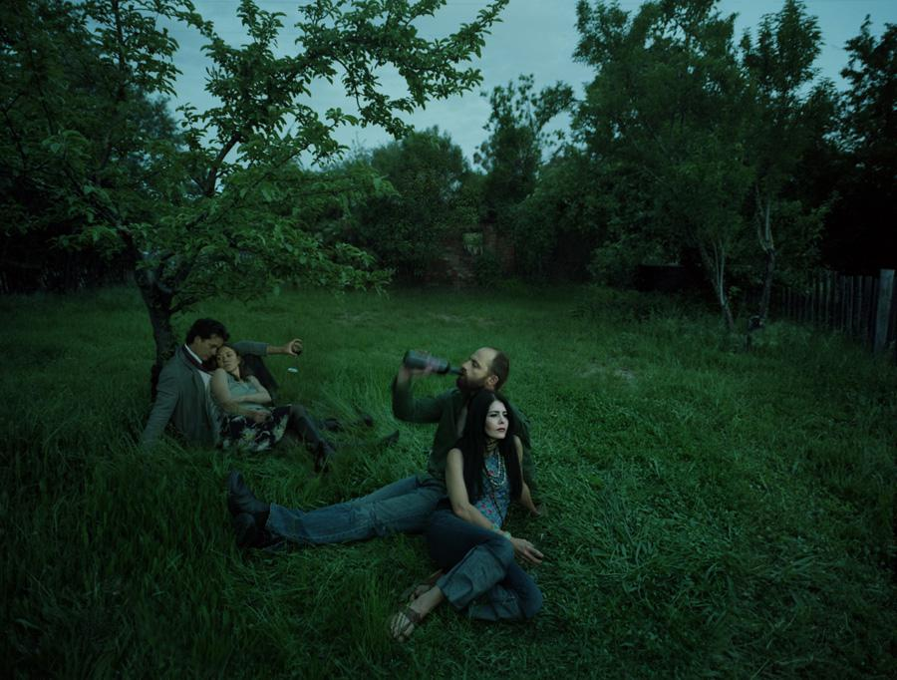 | ‘Intoxication, Ritualism series’  2009 Finalist  Moran Contemporary Photographic Prize

Tamara Dean interview extract
Edited extract of online printed interview from Capturemag accessed on 17/12/20.
Tamara Dean – I turned my focus to conceptual photography. I went from spending my whole time shooting to spending months planning and about an hour shooting.
Capture – Have your roots in photojournalism affected the way you approach your fine art practice and the way you shoot? How do they complement each other?
Tamara Dean – Absolutely. I feel that my recent series The Edge straddles documentary and conceptual photography. This series is about the informal rites of passage that young people create with the natural world, experiences which are sought out instinctively - things we are familiar with, like rock jumps and rope swings by the river, and places that we all know of where we push our physical and emotional limits as we become more independent and discover our sense of self. What was exciting for me in this series was that I asked people to take me to their secret places and to show me what they do there.
Capture – Your images give the impression that they are captured rather than constructed. They are almost omniscient in the way they are shot. Can you outline your approach to producing your fine art images?
Tamara Dean – ‘Ebenezer Rock Drop’ is a really good example of the way I am currently working. I put a call out on Facebook for teenagers around the age of 18 who would be interested in being involved in this body of work. Funnily enough, I didn’t get replies from young men but instead from their mothers and sisters, one of which was a colleague from work who offered to take me to this place on the river where she and her brother would go with their friends. We went down to this amazing hidden place where there were a number of pretty hairy rope swings and rock drops. I spent a couple of hours observing them interacting with each other and with the landscape and working out how I would approach the shot. The time of day in which I shoot is very limited so we arrived early and aimed to have the location and scenario worked out by the time the light was right. The place I ultimately chose was situated along a thin, high ridge. You had to walk through dense bush to get to it, so we all made our way across to the location with lights, stands, batteries and cameras. It was a logistical challenge, but well worth it. I observed them as they got their nerve up and a number of them jumped while I photographed them through this process of familiarising themselves with the cliff and the river. When I could see the light was right, I started placing them and directing their actions and gestures based on my observations of them over the previous couple of hours. By the time the photograph was taken, they were all in directed positions; they knew where to look while the boy was jumping. While it appeared to them that the photographic moment might be the jump itself, the strongest image was the pregnant moment before he took the plunge, conveying a sense of the emotional tussle he is going through.’

Activity 1 – engaging with texts
Read sources 1 - 3 and engage with the meaning of the texts by completing the tasks on the following pages. Text boxes expand when using a digital version of this document.
Consider questions and ideas from the Subjective and Cultural Frames.
Subjective Frame -  Personal psychological experience | Cultural Frame -  Cultural and social meanings
Is the artwork about imagination, dreams or subconscious thoughts?  Is the artwork about a human experience others can relate to?  Is the artist exploring personal experiences, events or their own deeply felt emotions?  Does the artist want the viewer to respond emotionally to the work?  Artists as naturally talented geniuses, or emotionally compelled individuals whose intentions are shaped by the free play of the imagination  Artworks as records of emotional outpourings, highly evocative reminders of personal memories and experiences  The world as the realm of experience, the imagination, fantasy, dreams and the subconscious  Audiences as viewers who interpret the meaning and value of art in relation to personal associations that can be made | Have social/cultural events happening in the world influenced this artist?  Does the artist belong to an art movement? Explain the key features of the art movement and the values it upholds.  Did science, technology, politics or world events influence the artist's ideas or the making of the artwork?  What secular or spiritual beliefs are revealed?  Artists as social agents who are influenced by and contribute to social, economic, and political conditions  Artworks as forms of cultural capital that reflect social, community and cultural interest  The world as shared and competing community interests and issues  Audiences as consumers, curators/judges, and the public who value art for its social meaning

Source 1 – Extract from ‘Art and the Sublime’
Scholars have debated the term ‘sublime’ in the field of aesthetics for centuries. Many more artists, writers, poets and musicians have sought to evoke or respond to it. But what is the sublime? Is it a thing, a feeling, an event or a state of mind? The word, of Latin origin, means something that is ‘set or raised aloft, high up’. The sublime is further defined as having the quality of such greatness, magnitude or intensity, whether physical, metaphysical, moral, aesthetic or spiritual, that our ability to perceive or comprehend it is temporarily overwhelmed.
The best-known theory published in Britain is Edmund Burke’s A Philosophical Enquiry into the Origin of Our Ideas of the Sublime and Beautiful (1757). Burke’s definition of the sublime focuses on such terms as darkness, obscurity, privation, vastness, magnificence, loudness and suddenness, and that our reaction is defined by a kind of pleasurable terror.
During the eighteenth and nineteenth centuries, the sublime was associated in particular with the immensity or turbulence of Nature and human responses to it. Consequently, in Western art, ‘sublime’ landscapes and seascapes, especially those from the Romantic period, often represent towering mountain ranges, deep chasms, violent storms and seas, volcanic eruptions or avalanches which, if actually experienced, would be life threatening.
Art and the Sublime | Tate (accessed 11/02/2021)
New words and their definition

Questions about the reading

Summarise key ideas about how artists and critics consider nature

A brief one or two sentence summary of the key points.

Source 2 – Extract from ‘Truth to Nature’
The Pre-Raphaelite principle of ‘truth to nature’ encouraged the artists to take nature as their teacher. Critic John Ruskin argued that truth, beauty and religion are inextricably bound. In Modern Painters he advised artists ‘to go to nature in all singleness of heart … rejecting nothing, selecting nothing and scorning nothing’.
In pursuit of accuracy the Pre-Raphaelites often painted outdoors, en plein air, later reworking canvases in their studios. This approach to landscape is linked with new scientific ideas and the rise of new disciplines in the nineteenth century: theories of evolution, geology, botany and meteorology all play a part.
Love & Desire: Pre-Raphaelite Masterpieces from the Tate (nga.gov.au) (accessed 11/02/2021)
Summarise key ideas about how Pre-Raphaelite artists and critics considered nature

Source 3 – Tamara Dean quotes

From ‘Tamara Dean – Nature’ (video resource)
Reconstruct the text below by filling in the missing words so that the information is complete.
foreboding, environment, detriment, invisible, narrative, home, tumbling, paramount, question
For me nature is ____________. It’s where I feel safe. I go into the bush and I feel like I’m in the right place. To be able to just walk out my front door and be able to enter a forest or a body of water and to create work in my own _____________________ – and to see it through new eyes each time I do it is just such a privilege.
When I go out bush, when I’ve gone out on those short periods during the self-isolation, I sort of feel like you don’t know where the virus is and I’m fleeing from this ______________ threat and I thought that could work quite nicely with me running through the landscape from this invisible threat. And so, I thought this sense of _________________ down the hill could work quite well. But it gives you an idea of how a scene which is quite still and it doesn’t have a lot of energy into it, by putting my figure in there and moving it throughout the image I’m starting to create a __________________.
… ultimately leading to this image which has this energy and fantastic element to it where I’m tumbling and looking like a – yeah it just has a playfulness and also a sense of ____________ for me.
The environment has been of __________________ importance to me for as long as I can remember.
The first step is really trying to create works that make people _______________ and think about humans in relation to nature and the fundamental point really, I’m trying to make with the works now and have been for a few years is that humans are a part of nature, we can’t continue to see ourselves as sitting outside of nature. To do that is to our own _______________ and if we can start to see ourselves as part of something that is living and organic and we rely on nature to live – I guess my work now is trying to make that point in different ways.

From ‘Tamara Dean: Relationships, Nature and Ritual’ (2018 interview)
“Wilderness represents eternity for me, a shared sense of time between our ancestors and our future. It is a space we can imagine ourselves in, as primitive beings and yet still find a place in the now. It’s an ancient space which we can revisit, to remember where we came from and to reflect on where we are going. It is as though time becomes both immediate and infinite when I place myself in the wilderness. I feel most alive when I am in nature.
The intoxication of the scents, sounds and textures brings me into myself and I feel as though I am able to arrive in the present moment.”
Tamara Dean: Relationships, Nature and Ritual (date accessed 15/02/2021)
Summarise three key ideas from Source 3 about how Tamara Dean considers and responds to nature

Activity 2 – Interpreting
Choose 2 photographs from Tamara Dean’s 2018 series ‘In Our Nature’.
Make some notes that explain how key features in these works explore relationships between humans and the natural world.

Artwork 1
Citation (artist, title, year)

Description

List 3 key features of the artwork and their meaning/impact

Overall meaning/impact of the work

Artwork 2
Citation (artist, title, year)

Description

List 3 key features of the artwork and their meaning/impact

Overall meaning/impact of the work

Activity 3 – Interpreting and analysing
Refer to your notes from Activities 1 and 2 and the structural and cultural frame scaffolds to answer the question below as an extended response.
Subjective Frame  Personal psychological experience | Cultural Frame  Cultural and social meanings
Is the artwork about imagination, dreams or subconscious thoughts?  Is the artwork about a human experience others can relate to?  Is the artist exploring personal experiences, events or their own deeply felt emotions?  Does the artist want the viewer to respond emotionally to the work?  Artists as naturally talented geniuses, or emotionally compelled individuals whose intentions are shaped by the free play of the imagination  Artworks as records of emotional outpourings, highly evocative reminders of personal memories and experiences  The world as the realm of experience, the imagination, fantasy, dreams and the subconscious  Audiences as viewers who interpret the meaning and value of art in relation to personal associations that can be made | Have social/cultural events happening in the world influenced this artist?  Does the artist belong to an art movement? Explain the key features of the art movement and the values it upholds.  Did science, technology, politics or world events influence the artist's ideas or the making of the artwork?  What secular or spiritual beliefs are revealed?  Artists as social agents who are influenced by and contribute to social, economic, and political conditions  Artworks as forms of cultural capital that reflect social, community and cultural interest  The world as shared and competing community interests and issues  Audiences as consumers, curators/judges, and the public who value art for its social meaning
How has Tamara Dean explored relationships between humans and the natural world in her series ‘In Our Nature’?

References
The frames scaffold date accessed 17/12/2020.
Visual Arts 7-10 Syllabus © NSW Education Standards Authority (NESA) for and on behalf of the Crown in right of the State of New South Wales, 2003. date accessed 17/12/2020
‘Art and the Sublime’ - Tate date accessed 17/12/2020
‘Truth to Nature’ - National Gallery of Australia date accessed 17/12/2020
Tamara Dean – Nature date accessed 17/12/2020
Tamara Dean: Relationships, Nature and Ritual date accessed 17/12/2020
Tamara Dean – In Our Nature date accessed 17/12/2020

