Joan Ross resource booklet

Table of Contents
Joan Ross resource booklet 1
Table of Contents 2
Joan Ross – pushing the limits 3
Activity 1 – conceptual framework 3
Activity 2 – Frayer diagram 5
Activity 3 – Colonial Grab, 2015 6
Activity 4 – The Claiming of Things, 2012 8

Joan Ross – pushing the limits

Activity 1 – conceptual framework
Watch the video Joan Ross – pushing the limits (10:32) and make notes answering the conceptual framework questions below.
Use the space on the following page to list any words that you are unfamiliar with or uncertain of, and record any questions you might have about Joan Ross.
Artist | Artwork
- What are the personal beliefs and values the artist shares in the interview? Consider her social values and her thoughts on creativity.  - What personal experiences are outlined in the video? Think about the artist’s engagement with the art world.  - What traditional values does she challenge? | - What materials does she work with? Make a list.  - What ideas does she explore?  - Outline some of the subject matter you see in her works.  - Explain some of the symbolism used by the artist in her works.  - How would you describe her use of colour?
Notes: | Notes:

New words | Questions about Joan Ross

Activity 2 – Frayer diagram
The teacher provides digital access to a blank modified Frayer diagram and explains how to complete it using the example provided below as a guide.
Steps:
- Record the new word you will define in the centre of the blank template.
- Use your device to research and provide a definition for the term.
- In the next box outline a fact or essential characteristic that relates to this word.
- Explain where and how you can see this concept/term evidenced in an artwork.
- Finally, cut and paste in a visual example of the concept/ technique from a Joan Ross artwork.
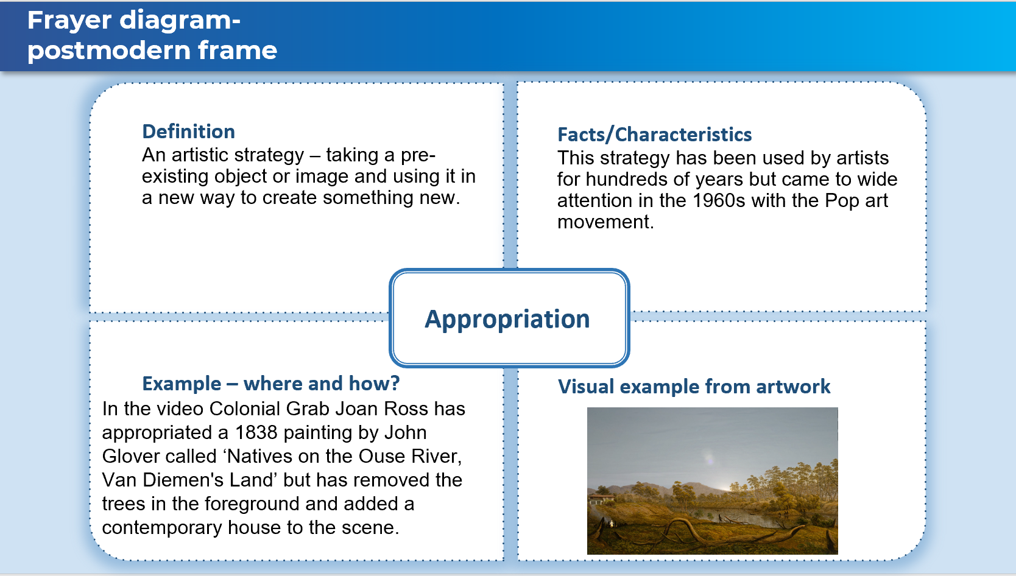Blank templates: Frayer diagram (nsw.gov.au) (date accessed 12/03/2021)

Activity 3 – Colonial Grab, 2015
Read this edited artwork description from Art Gallery of NSW (date accessed 10/03/21):
This video animation references a painting in the AGNSW collection, John Glover’s Natives on the Ouse River, Van Diemen’s Land (1838).
In this work Joan Ross utilises the device of a poker machine - the Colonial Grab - to access various scenarios, including a central Australian landscape buzzed by a dystopian surveillance-camera/insect, and an antique table upon which a lady in hi-vis coloured Regency costume arranges ikebana using John Glover’s Tasmanian trees. This she eventually places in a denuded Glover landscape, oblivious to the Indigenous people and mid-century suburban house to the side, as the vases shatter and her carefully arranged trees fall to the ground.
Fusing the historical and contemporary, Ross locates the symbols and desires of Australia’s colonial history firmly in the present in order to remind us of colonialism’s ongoing presence and effects.
Joan Ross – ‘In the video a colonial woman takes his trees and makes ikebana out of them. Aboriginal people are still in the trees, so it’s an act of total disrespect and disregard, which is how I see the impact of colonialism. One of the reasons that I make the work that I do is that I’m very aware, and I don’t think you can be anywhere in Australia and not be aware, that we’re on Indigenous land. And I’m constantly aware of the colonial influence, and the disjunction between that and nature’
Watch the video artwork Colonial Grab by Joan Ross (07:32, date accessed 13/02/2021), and refer to both the video and the reading to complete the table below.
In each box sketch a different scene that comments on colonial values and/or use of the land.
Use the structural frame to describe what is happening in the scene. Explain the use of subject matter, colour and symbolism. Also identify and explain the use of any postmodern techniques such as appropriation, pastiche, juxtaposition, parody and irony.
Sketch a scene from the artwork. | Describe what is happening in each scene.  Use the structural and postmodern frame to guide your note making.

Activity 4 – The Claiming of Things, 2012
Watch Joan Ross’ video artwork The Claiming of Things, Joan Ross, 2012 (07:36, date accessed 12/03/2021), and complete the see, think, wonder table.
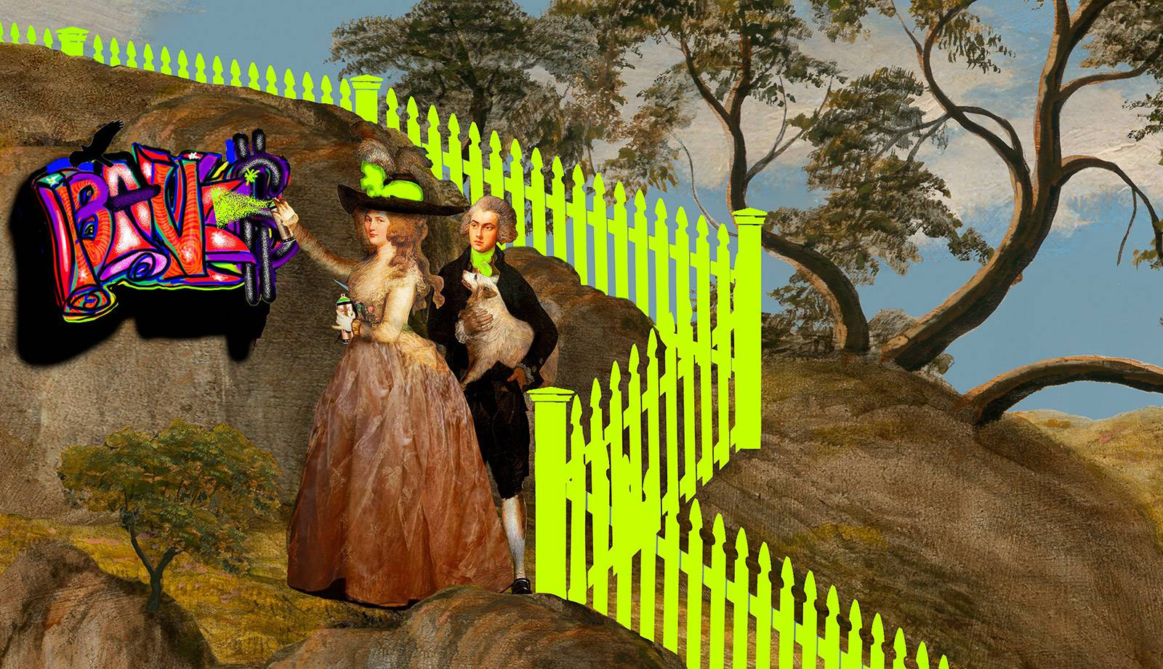
Still frame from The Claiming of Things by Joan Ross | MCA Australia (date accessed 13/02/2021)
See | Think | Wonder
Observe the video work and write down your initial response. List some of the objects Joan Ross has included to comment on the impact of colonisation. | Discuss what you think is happening. What are some of the ideas explored in this artwork? | What are you curious about? What more do you want to know? How can this inspire your own practice?

