English – Stage 1 – Unit 40
Contents
Unit overview and instructions for use 3
Teacher notes 4
Outcomes and content – Component A 5
Outcomes and content – Component B 7
Week 1 10
Component A teaching and learning 10
Component B teaching and learning 11
Lesson 1: Introduction to Snack Attack and narrative 12
Lesson 2: Understanding character patterns 14
Lesson 3: Using prepositional phrases in narratives 16
Lesson 4: Understanding character patterns 17
Lesson 5: Building character descriptions using compound and complex sentences 19
Week 2 21
Component A teaching and learning 21
Component B teaching and learning 22
Lesson 6: Using dialogue 23
Lesson 7: Planning a sequel to Snack Attack 24
Lesson 8: Writing a sequel to include dialogue 25
Lesson 9: Feedback, revise, edit and publish 26
Lesson 10: Share and reflecting on learning 27
Resource 1: Storyboard 29
Resource 2: FANBOYS 30
Resource 3: Dialogue checklist 31
Resource 4: Planning template 32
References 33

Unit overview and instructions for use
This two-week unit is comprised of Component A and Component B. Connecting learning across both components is encouraged.
Teaching and learning | Component A | Component B
Suggested duration | 60 minutes | 45 minutes
Explicit teaching focus areas | - Phonic knowledge  - Reading fluency  - Reading comprehension  - Spelling  - Handwriting | - Oral language and communication  - Vocabulary  - Reading comprehension  - Creating written texts  - Understanding and responding to literature
To prepare for teaching and learning: | - Refer to Outcomes and content – Component A, K-2 – Instructional sequence – grapheme–phoneme correspondences [PDF 825 KB], and the teaching advice documents (hyperlinked in Component A teaching and learning table).  - Based on student needs identified through ongoing assessment data, plan and document how you will sequence teaching and learning in whole class and targeted teaching groups across the two-week cycle. | - Familiarise yourself with Outcomes and content – Component B, Textual concepts information and videos, English Textual Concepts and Learning Processes (2016), and the teaching and learning sequence.  - Based on student needs identified through ongoing assessment data, determine how you will support students in whole class and targeted teaching groups across the two-week cycle as required.
English Syllabus K–10 © 2022 NSW Education Standards Authority (NESA) for and on behalf of the Crown in right of the State of New South Wales.

Teacher notes
- Narrative can refer to a story itself or how we communicate and understand it. It can be a part of everyday communication to convey a message and to connect people to information, values and ideas. Through narrative we explore human actions, interactions, motivations and reactions. – English Textual Concepts and Learning Processes (2016).
- Understanding of narrative can be supported through watching the department’s video: Narrative (3:51).
- While narrative is the mentor concept for the conceptual component of this unit, the supporting concept of character can be explored using the mentor video Snack Attack by Eduardo Verastegui and the supporting text The Twits by Roald Dahl.
- Character is a construct of verbal and visual statements about a fictional identity. Analysis of characters contribute to our own personal judgements about self, morals, and values. – English Textual Concepts and Learning Processes (2016).
- Understanding of character can be supported through watching the department’s video: Character (2:31).
- For information on noun groups, adjectives, verbs, adverbs and prepositional phrases refer to the NESA Glossary.
- Consider prior student knowledge regarding noun groups, adjectives, verbs, adverbs and prepositional phrases.
- The Draw, Talk, Write (and Share) strategy for emergent writers includes drawing as part of a meaning making process, while talking and sharing allows children to make sense of their ideas and to develop their vocabulary and oral language skills. Writing provides an opportunity to apply phonic and word knowledge into another context. Best practice in this strategy is modelled by Australian researcher Noella Mackenzie. For further information, refer to the website Draw, Talk, Write (and Share).
- Reflect on student learning and engagement in activities and record differentiation and adjustments within the unit to inform future teaching and learning. One way of doing this could be to add comments to the digital file.
- Content points are linked to the National Literacy Learning Progression version (3).
Levels and indicators sourced from National Literacy Learning Progression © Australian Curriculum, Assessment and Reporting Authority (ACARA), (accessed 3 April 2023) and was not modified. See references for more information.

Outcomes and content – Component A
The table below outlines the focus outcomes and content. Content is linked to the National Literacy Learning Progression version (3).
Focus area and outcome | Content points and National Literacy Learning Progression
Phonic knowledge  EN1-PHOKW-01 – uses initial and extended phonics, including vowel digraphs, trigraphs to decode and encode words when reading and creating texts | - decode words with less common consonant digraphs and apply this when reading texts  - blend and decode 2-syllable words with taught vowel graphs, digraphs, trigraphs and quadgraphs, including graphemes for r-controlled vowels and diphthongs and apply this when reading texts (PKW6, PKW7)
Reading fluency  EN1-REFLU-01 – sustains reading unseen texts with automaticity and prosody and self-corrects errors | - self-correct when fluency and/or meaning is interrupted  - adjust phrasing, intonation, volume or rate to maintain fluency when reading aloud (FlY4)
Reading comprehension  EN1-RECOM-01 – comprehends independently read texts that require sustained reading by activating background and word knowledge, connecting and understanding sentences and whole text, and monitoring for meaning | - identify how creative visual features are used to expand meaning  - identify when meaning is not complete and/or contradicts prior understanding  - re-read words, phrases or sentences to check and clarify precise meaning
Spelling  EN1-SPELL-01 – applies phonological, orthographic and morphological generalisations and strategies when spelling words in a range of writing contexts | - segment multisyllabic words into syllables and phonemes as a strategy for spelling (SpG5)  - use extended phonic code for taught consonant phonemes
Handwriting  EN1-HANDW-01 – uses a legible, fluent and automatic handwriting style, and digital technology, including word-processing applications, when creating texts | - form all letters with consistent size and slope in NSW Foundation Style from memory (HwK5)

Outcomes and content – Component B
The table below outlines the focus outcomes and content. Content is linked to the National Literacy Learning Progression version (3).
Focus area and outcome | Content points and National Literacy Learning Progression
Oral language and communication  EN1-OLC-01 – communicates effectively by using interpersonal conventions and language to extend and elaborate ideas for social and learning interactions | - understand that oral language can be used in combination with nonverbal communication  - recount narratives with key components (SpK3)  - adapt a narrative for a particular audience
Vocabulary  EN1-VOCAB-01 – understands and effectively uses Tier 1, taught Tier 2 and Tier 3 vocabulary to extend and elaborate ideas | - understand and intentionally choose subject-specific vocabulary to enhance precision and for effect
Reading comprehension  EN1-RECOM-01 – comprehends independently read texts that require sustained reading by activating background and word knowledge, connecting and understanding sentences and whole text, and monitoring for meaning | - identify how creative visual features are used to expand meaning  - use visual and/or auditory features in multimodal texts to build meaning (UnT5)  - recount relevant ideas from texts in the form of a written, visual or oral summary (UnT6)
Creating written texts  EN1-CWT-01 – plans, creates and revises texts written for different purposes, including paragraphs, using knowledge of vocabulary, text features and sentence structure | - use contextually precise prepositional phrases when creating texts (GrA4)  - use noun groups to build descriptions of people and things (CrT6)  - use adverbs to modify the meaning of verbs and adjectives (GrA3)  - write compound sentences using coordinating conjunctions (GrA4, CrT5)  - experiment with writing complex sentences which include a clause for the main message and dependent clause to elaborate or modify the message (GrA5)  - use quotation marks for simple dialogue (PuN5)  - make intentional word choices to enhance precision of meaning and ideas in a text (CrT5)  - re-read and edit their own texts after receiving feedback
Understanding and responding to literature  EN1-UARL-01 – understands and responds to literature by creating texts using similar structures, intentional language choices and features appropriate to audience and purpose | - identify patterns in narratives that set up expectation and aid prediction of actions and attitudes  - identify and appreciate how key messages in narratives evoke feelings  - create and re-create narratives using understanding of narrative features  - create and re-create characters in texts that demonstrate understanding of character traits

Week 1

Component A teaching and learning
The table below can be used to plan and document lessons that address Component A outcomes and content. Both the detailed example [DOC 529KB] of a two-week teaching and learning cycle and brief example [DOC 66KB] may support you in your planning.
Focus Areas | Lesson 1 | Lesson 2 | Lesson 3 | Lesson 4 | Lesson 5
Phonic knowledge
15 minutes
Spelling and Handwriting
15 minutes
Reading comprehension and Reading fluency
30 minutes

Component B teaching and learning
The following teaching and learning sequence has been designed to address Component B outcomes and content. Adapt the sequence as required to best meet the needs of your students.

Learning intention and success criteria
Learning intentions and success criteria are best co-constructed with students.

Learning intention
Students are learning to understand narrative and character by considering how visual elements and patterns within narratives add meaning.

Success criteria
Students can:
- include relevant ideas when orally recounting a narrative
- identify how patterns in characters can support predictions
- use noun groups to build descriptions
- use contextually precise prepositional phrases
- use compound and complex sentences.

Resources
- Dahl R (2022) The Twits (Blake Q, illus.), Puffin, United Kingdom. ISBN: 9780241578186
- Resource 1: Storyboard
- Resource 2: FANBOYS
- Video: Snack Attack (4:41)
- Chart paper, drawing materials

Lesson 1: Introduction to Snack Attack and narrative
- Play music from Snack Attack (0:15 to 0:45) without viewing the images. Ask students to describe their thoughts and feelings when they hear the music. For example, happy, jovial, scary, excited.
- Display a screen shot of the opening scene with the old lady and the vending machine. Ask students how this could support them to make a prediction about the video. Ask students to think about the music as an additional clue for predictions.
- Watch Snack Attack (0:15 to 4:10). In pairs, students turn and talk to discuss what the video was about. Share ideas with the class.
- Reinforce that the video is a kind of narrative and that narratives come in different forms such as books, videos, audio recordings, personal stories and short films. Ask students to provide examples of how they know it is a narrative and discuss any patterns they can identify. For example, most narratives follow a structural pattern and have an orientation, complication, series of events, resolution.
- Revise the structure of a narrative. For example, orientation, complication, series of events, resolution.
- On chart paper, write the 4 structural elements from activity 5.
- As a class brainstorm key words relating to each structural element. For example, orientation – characters introduced, setting described (train station), vending machine. In pairs, students write the key words on sticky notes and place under the correct narrative heading.
- Allocate small groups a structural element of the narrative to illustrate. For example:
- Orientation – students draw the old lady and the vending machine at the station
- Complication – students draw the boy taking the biscuits that the old lady believes to be hers.
- Share and display each illustrated element in the correct narrative sequence.
- Display Resource 1: Storyboard. Model how to complete the resource using drawings and key words to summarise the key structural elements of Snack Attack. Add titles to each section as needed.
- Students complete Resource 1: Storyboard. Remind students to use class display for support.
Too hard? Co-construct the storyboard in small groups.
Too easy? Students add their own ideas and further details to their storyboard.
- Using the completed storyboard, students present an oral retell of the Snack Attack narrative to a partner.
Stage 1 Assessment task 1 – Observations and work samples from this lesson allow students to demonstrate achievement towards the following syllabus outcomes and content points:
EN1-OLC-01 – communicates effectively by using interpersonal conventions and language to extend and elaborate ideas for social and learning interactions
- recount narratives with key components.
EN1-RECOM-01 – comprehends independently read texts that require sustained reading by activating background and word knowledge, connecting and understanding sentences and whole text, and monitoring for meaning
- recount relevant ideas from texts in the form of a written, visual or oral summary.

Lesson 2: Understanding character patterns
- Revisit Snack Attack and pause at a clear image of the old lady at the beginning.
- Ask students to think about why characters are important in narratives. Responses could include: they help to tell the story, evoke emotion and help to create a pattern of predictable events.
- Draw a sketch of the old lady on chart paper. Have students use adjectives to describe her appearance to assist the drawing. Students list the adjectives around their drawing.
- Play the video and revisit sections that display the old lady’s behaviour. Draw attention to the old lady’s facial expressions and explain how nonverbal communication adds to how viewers understand her character.
- Discuss how visual features show the old lady’s behaviour and help the audience make predictions about her personality and patterns of behaviour. For example, she is angry when the cookie packet does not come out of the machine, so she pounds and kicks the vending machine. This suggests that she could be a grumpy, aggressive character. When the old lady thinks the boy is eating her biscuits she stands on the seat and yells at him. She also gets upset and crushes the last biscuit. This shows a clear pattern that, whenever the old lady is angry, she displays aggressive behaviours.
- Ask students to list adjectives and verbs to describe the old lady’s behaviour. Add this to the character chart.
- Revise and model the use of noun groups. A noun group is a group of words relating to or building on a noun. Noun groups usually consist of an article plus one or more adjectives or adverbs. For example, ‘The cranky old lady was frustrated and kicked the vending machine.’
- Discuss the effect of the noun groups in building details and creating a vivid image of the old lady’s appearance and character. For example, ‘The greedy old lady was angry at the boy.’
- In pairs, students write a noun group to describe the old lady on a strip of paper. Ask students to use nonverbal communication forms as they read their noun group to the class. For example, cranky facial expressions, aggressive hand movements. Add students’ noun groups to the class character chart.
- Display a sentence about the text to revise how verbs and adverbs can add detail and precision. For example, ‘The old lady looked sharply at the boy who she thought was taking her biscuits.’ Ask students to identify the verb and adverb and explain the function of both words in the sentence. For example, looked is a verb describing what the character is doing, sharply is an adverb and it provides more detail about how the old lady was looking at the boy.
- Add verbs and adverbs to the character chart.
- Students use the character chart to write a short text to describe the old lady. Keep the character chart for upcoming lessons.
- Ask students to think about the old lady’s pattern of behaviour then predict something else she could do. Prompt students to use noun groups. For example, ‘The cranky old lady might kick a chair when she realises she made a mistake.’
Stage 1 Assessment task 2 – Observations and work samples from this lesson allow students to demonstrate achievement towards the following syllabus outcomes and content points:
EN1-OLC-01 – communicates effectively by using interpersonal conventions and language to extend and elaborate ideas for social and learning interactions
- understand that oral language can be used in combination with nonverbal communication.
EN1-VOCAB-01 – understands and effectively uses Tier 1, taught Tier 2 and Tier 3 vocabulary to extend and elaborate ideas
- understand and intentionally choose subject-specific vocabulary to enhance precision and for effect.
EN1-RECOM-01 – comprehends independently read texts that require sustained reading by activating background and word knowledge, connecting and understanding sentences and whole text, and monitoring for meaning
- identify how creative visual features are used to expand meaning
- use visual and/or auditory features in multimodal texts to build meaning.
EN1-CWT-01 – plans, creates and revises texts written for different purposes, including paragraphs, using knowledge of vocabulary, text features and sentence structure
- use noun groups to build descriptions of people and things
- use adverbs to modify the meaning of verbs and adjectives
- make intentional word choices to enhance precision of meaning and ideas in a text.

Lesson 3: Using prepositional phrases in narratives
- Revise prepositional phrases. Remind students that a prepositional phrase contains a preposition and indicates a circumstance such as time, place, manner or causality. For example, ‘The old lady angrily hit the front of the vending machine in frustration.’
- Discuss how prepositional phrases help to explain to where something is happening.
- Revisit the video and pause at certain scenes. Discuss what and where something is happening in the scene using prepositional phrases. For example:
- The old lady sat down on the bench beside the young boy.
- The old lady grabbed the top of the biscuit packet and pulled it towards her.
- The old lady stormed onto the train.
- In pairs, students draw a scene from the video. Students write sentences describing what the old lady is doing in the scene using a prepositional phrase to indicate where she is doing it.
Too hard? Students use a sentence stem to include a prepositional phrase. For example, ‘The old lady looked __ (into her bag). The old lady sat __ (on the seat).’
- Students share their drawing and sentences. Select some sentences to add to the old lady’s character chart from Lesson 2.
Stage 1 Assessment task 3 – Observations and work samples from this lesson allow students to demonstrate achievement towards the following syllabus outcome and content point:
EN1-CWT-01 – plans, creates and revises texts written for different purposes, including paragraphs, using knowledge of vocabulary, text features and sentence structure
- use contextually precise prepositional phrases when creating texts.

Lesson 4: Understanding character patterns
- Revisit the video and pause on a clear image of the boy character sitting on the train station bench. Ask students if they have positive or negative feelings about this character and to give reasons why.
- Ask students to brainstorm adjectives to describe the boy’s appearance and personality. List the adjectives on the board.
- Explain that students will refer to the old lady character chart from Lesson 2 and Lesson 3 as a model to create their own chart about the boy. Provide students with A4 or chart paper and ask students to draw a picture of the boy in the centre.
- Model writing a noun group about the boy’s personality. For example, the kind boy.
- Using the list of adjectives, students write noun groups about the boy around their drawing on their chart.
- Play the video Snack Attack (1:42 to 2:43) and revisit sections that display images of the boy and his behaviour. Discuss the boy’s behaviour and how that helps the audience to predict his personality and the pattern of behaviour. For example, he is kind because he shares the biscuits with the old lady. He is considerate and caring because he brushes the crumbs off the old lady’s skirt. He is nice because he places his biscuit packet closer to the old lady. He is respectful because he throws the rubbish in the bin.
- Students add any additional noun groups, adjectives or verbs to complete their chart about the boy.
- Students use their chart to write a short description about the boy using noun groups, verbs and adverbs. For example, the friendly boy kindly placed the biscuit packet next to the cranky old lady.
- Ask the students to think about the boy’s pattern of behaviour and think of something else the boy could do that would follow the pattern. For example, the boy is kind so he might help an older person onto the train.
Too hard? Students work in small groups to co-construct a character chart about the boy.
Too easy? Students complete the character chart descriptions and demonstrate their understanding of noun groups by swapping their writing with a partner to identify noun groups, verbs and adverbs.

Lesson 5: Building character descriptions using compound and complex sentences
- Revisit the old lady character chart from Lesson 2 and Lesson 3. Highlight the use of vocabulary to build a picture of the character.
- Write an example of a compound and complex sentence about the old lady. For example, ‘The old lady was angry and she kicked the vending machine’ (compound); ‘The old lady was aggressive when the biscuits didn’t come out of the vending machine’ (complex).
- Activate prior knowledge by asking students to explain the differences between the types of sentences.
- Revise compound and complex sentences.
A compound sentence contains 2 or more clauses that are coordinated or linked in a way that gives each clause equal status. In the following example ‘and’ is the coordinating conjunction – ‘We went to the movies and we bought an ice-cream’. A complex sentence contains a main (or independent) clause and one or more subordinate (or dependent) clauses. The subordinate clause is joined to the main clause through subordinating conjunctions such as when, while and before. For example, ‘We all went outside when the sun came out.’
- Reinforce the idea that conjunctions join 2 ideas in a compound sentence.
- Display a copy of Resource 2: FANBOYS and provide oral examples of how these conjunctions can be used in sentences. For example:
- The old lady was angry and she really wanted her biscuits.
- The old lady was angry, so she pounded the vending machine.
- Provide students with a sentence stem to complete compound sentences using a different a different coordinating conjunction. For example, The old lady was cranky, __.
- Select students to read their sentences and discuss how the choice of conjunction impacted the final clause.
- Write sentence stems for complex sentences to describe the old lady on the board. For example:
- __ the old lady was angry she __.
- __ the old lady was sitting on the bench __.
- __ the old lady hopped on the train she __.
- In pairs, students complete the sentence stems to create a complex sentence about the old lady using a different subordinating conjunction (when, while, before).
- Discuss the impact on sentences when different subordinating conjunctions are used.
Stage 1 Assessment task 4 – Observations and work samples from this lesson allow students to demonstrate achievement towards the following syllabus outcome and content points:
EN1-CWT-01 – plans, creates and revises texts written for different purposes, including paragraphs, using knowledge of vocabulary, text features and sentence structure
- write compound sentences using coordinating conjunctions
- experiment with writing complex sentences which include a clause for the main message and dependent clause to elaborate or modify the message.

Week 2

Component A teaching and learning
The table below can be used to plan and document lessons that address Component A outcomes and content. Both the detailed example [DOC 529KB] of a two-week teaching and learning cycle and brief example [DOC 66KB] may support you in your planning.
Focus Areas | Lesson 6 | Lesson 7 | Lesson 8 | Lesson 9 | Lesson 10
Phonic knowledge
15 minutes
Spelling and Handwriting
15 minutes
Reading comprehension and Reading fluency
30 minutes

Component B teaching and learning
The following teaching and learning sequence has been designed to address Component B outcomes and content. Adapt the sequence as required to best meet the needs of your students.

Learning intention and success criteria
Learning intentions and success criteria are best co-constructed with students.

Learning intention
Students are learning to understand narrative and character by considering how narrative patterns add meaning and evoke feelings.

Success criteria
Students can:
- use quotation marks for simple dialogue
- adapt and deliver a narrative for a particular audience
- write a narrative that includes dialogue
- re-read and edit their own texts after receiving feedback
- identify patterns in narratives
- identify how key messages in narratives evoke feelings.

Resources
- Dahl R (2022) The Twits (Blake Q, illus.), Puffin, United Kingdom. ISBN: 9780241578186
- Video: Snack Attack (4:41)
- Resource 3: Dialogue checklist
- Resource 4: Planning template
- Sticky notes

Lesson 6: Using dialogue
- Remind students that good writers apply rules to ensure punctuation is correctly used when writing dialogue. Display and discuss Resource 3: Dialogue checklist.
- Display a double page from The Twits that demonstrates the use of dialogue. Model using Resource 3: Dialogue checklist to highlight how each point is addressed.
- In pairs, students use Resource 3: Dialogue checklist to examine a different page from The Twits to be ‘dialogue detectives’. Students share findings with the class.
- Revisit Snack Attack (1:42 to 2:43). Students turn and talk with a partner about what dialogue could occur between the 2 characters.
- In pairs, students write sentences with dialogue to retell part of Snack Attack. For example, ‘“Give me back my biscuits!” yelled the angry old lady. “Hey lady, these are mine, but I will share them.” calmly replied the boy.’
- Students revise and edit their sentences using the dialogue checklist.
Stage 1 Assessment task 5 – Observations and work samples from this lesson allow students to demonstrate achievement towards the following syllabus outcome and content point:
EN1-CWT-01 – plans, creates and revises texts written for different purposes, including paragraphs, using knowledge of vocabulary, text features and sentence structure
- use quotation marks for simple dialogue.

Lesson 7: Planning a sequel to Snack Attack
- Refer back to the character patterns from The Twits. For example, the reader could predict what will happen by noticing the pattern where one character plays a trick on the other and this continues in the next chapter; both of the characters are horrible and in the end something terrible happens to them.
- Explain that students will write a sequel to the video Snack Attack using a linear narrative pattern using the structure, orientation, complication, series of events and resolution. Explain that a sequel continues or expands on the ideas in the original narrative. The sequel will include a new character and describe what will happen next to either the old lady or the boy.
- As the class discuss and decide if the sequel will follow a similar character pattern to The Twits where a mean character has a bad ending and the good characters have a positive ending.
- Using the Think-Pair-Share strategy, students brainstorm what could happen to the old lady or the boy in the sequel and record their ideas. For example:
- A dog (new character) snatches the biscuits out of the old lady’s hand. She chases it but does not get to eat the biscuits.
- The boy goes to buy a packet of biscuits from the vending machine, but realises he is 50 cents short. A station worker (new character) sees the boy upset because he doesn’t have enough money. The station worker offers the boy 50 cents and, when the boy buys a new packet, many extra packets come out.
- Ask students to share what could happen to the old lady or the boy. In the same pairs as activity 4, students add further details to their ideas.
- Select a student’s idea for a sequel to model completing Resource 4: Planning template. Explain that this plan will help to support writing in Lesson 8.
- Provide students with Resource 4: Planning template to plan their writing.

Lesson 8: Writing a sequel to include dialogue
- Remind students of the importance of the correct use of dialogue in a narrative. Revisit examples of dialogue from The Twits paying close attention to the layout. Revisit Resource 3: Dialogue checklist.
- Jointly construct a success criteria (for their writing) to keep on display to support students’ writing. For example:
I can write an interesting narrative that includes:
- correct narrative structure
- interesting characters
- visual features – illustrations
- descriptive noun groups
- a variety of sentences – compound, complex
- prepositional phrases
- dialogue.
- In pairs, students use the Draw, Talk, Write (and Share) strategy to illustrate and write a sequel to Snack Attack using the planning template and success criteria.
Stage 1 Assessment task 6 – Observations and work samples from this lesson allow students to demonstrate achievement towards the following syllabus outcome and content points:
EN1-UARL-01 – understands and responds to literature by creating texts using similar structures, intentional language choices and features appropriate to audience and purpose
- create and re-create narratives using understanding of narrative features
- create and re-create characters in texts that demonstrate understanding of character traits.

Lesson 9: Feedback, revise, edit and publish
- In pairs, students take turns to read their narrative and provide peer feedback using the success criteria and the 2 stars and one wish strategy.
- Students use feedback to revise and edit their writing.
- Students publish their narrative using a digital platform such as Microsoft Word, Book Creator or Canva.
- Optional: Students could work in pairs to act out the narrative and record it using a digital platform such as iMovie.
Stage 1 Assessment task 7 – Observations and work samples from this lesson allow students to demonstrate achievement towards the following syllabus outcome and content point:
EN1-CWT-01 – plans, creates and revises texts written for different purposes, including paragraphs, using knowledge of vocabulary, text features and sentence structure
- re-read and edit their own texts after receiving feedback.

Lesson 10: Share and reflecting on learning
- Discuss how character patterns help to communicate key messages and evoke feelings in the reader. For example, in The Twits, the characters that were horrible had something horrible happen to them in the end. The message here is that people should be kind to each other.
- Using the Think-Pair-Share strategy, ask students to identify key messages from Snack Attack and discuss if these messages evoke any feelings. For example, the old lady assumed that the boy stole her biscuits before checking her bag. This made the readers feel sorry for the boy and think that the lady is horrible and mean.
- Students share their narrative from Lesson 9 with other students. Asks the students listening to the narrative to identify any character patterns that the writers used.
- Ask students to think of a familiar text and discuss how the patterns helped with predictions and how key messages evoked feelings. For example, Pig the Rebel – Pig did many things that make readers think he is mischievous. The Boy Who Tried to Shrink his Name – the character keeps trying to use a short version of his name, which tells the reader he is embarrassed or worried.
- Students reflect on their learning about patterns in narratives and write something they learned during the unit on a sticky note as an exit slip.
Stage 1 Assessment task 8 – Observations and work samples from this lesson allow students to demonstrate achievement towards the following syllabus outcomes and content points:
EN1-OLC-01 – communicates effectively by using interpersonal conventions and language to extend and elaborate ideas for social and learning interactions
- adapt a narrative for a particular audience.
EN1-UARL-01 – understands and responds to literature by creating texts using similar structures, intentional language choices and features appropriate to audience and purpose
- identify patterns in narratives that set up expectation and aid prediction of actions and attitudes
- identify and appreciate how key messages in narratives evoke feelings.

Resource 1: Storyboard
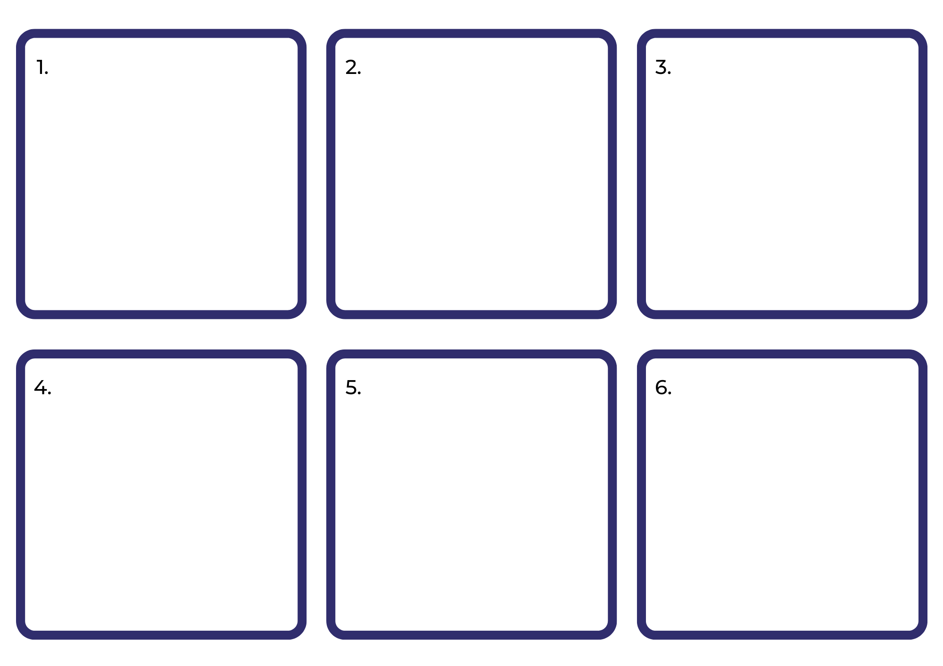

Resource 2: FANBOYS
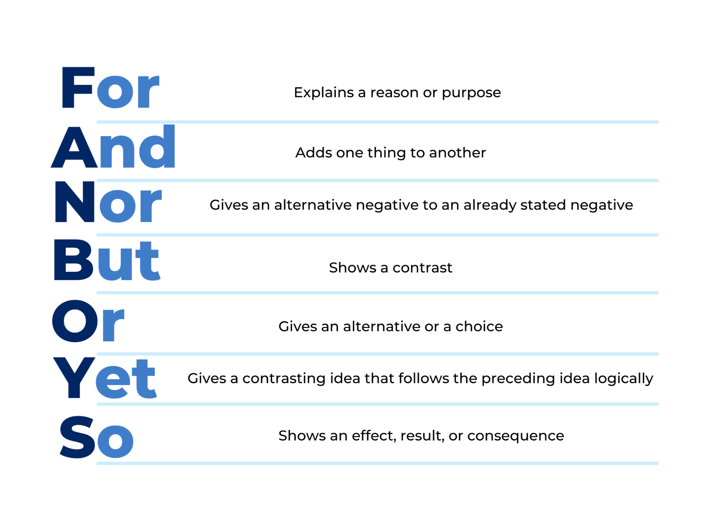

Resource 3: Dialogue checklist
Dialogue Checklist | Dialogue Checklist
☐ Speech marks go around exactly what is spoken.  ☐ A capital letter is used at the start of what is spoken.  ☐ There is a piece of punctuation before the close of quotation marks.  ☐ ‘Saying verbs’ are used to describe how the speech is spoken.  ☐ A new line is used when each new character speaks. | ☐ Speech marks go around exactly what is spoken.  ☐ A capital letter is used at the start of what is spoken.  ☐ There is a piece of punctuation before the close of quotation marks.  ☐ ‘Saying verbs’ are used to describe how the speech is spoken.  ☐ A new line is used when each new character speaks.

Resource 4: Planning template
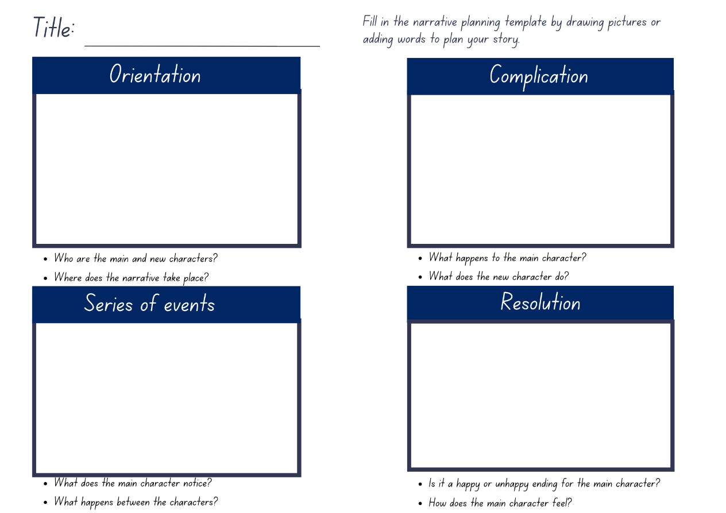

References
Links to third-party material and websites
Please note that the provided (reading/viewing material/list/links/texts) are a suggestion only and implies no endorsement, by the New South Wales Department of Education, of any author, publisher, or book title. School principals and teachers are best placed to assess the suitability of resources that would complement the curriculum and reflect the needs and interests of their students.
If you use the links provided in this document to access a third-party's website, you acknowledge that the terms of use, including licence terms set out on the third-party's website apply to the use which may be made of the materials on that third-party website or where permitted by the Copyright Act 1968 (Cth). The department accepts no responsibility for content on third-party websites.
Except as otherwise noted, all material is © State of New South Wales (Department of Education), 2023 and licensed under the Creative Commons Attribution 4.0 International License. All other material (third-party material) is used with permission or under licence. Where the copyright owner of third-party material has not licensed their material under a Creative Commons or similar licence, you should contact them directly for permission to reuse their material.
English K–10 Syllabus © 2022 NSW Education Standards Authority (NESA) for and on behalf of the Crown in right of the State of New South Wales.
© 2022 NSW Education Standards Authority. This document contains NSW Curriculum and syllabus content. The NSW Curriculum is developed by the NSW Education Standards Authority. This content is prepared by NESA for and on behalf of the Crown in right of the State of New South Wales. The material is protected by Crown copyright.
Please refer to the NESA Copyright Disclaimer for more information.
NESA holds the only official and up-to-date versions of the NSW Curriculum and syllabus documents. Please visit the NSW Education Standards Authority (NESA) website and the NSW Curriculum website.
National Literacy Learning Progression © Australian Curriculum, Assessment and Reporting Authority (ACARA) 2010 to present, unless otherwise indicated. This material was downloaded from the Australian Curriculum website (National Literacy Learning Progression (accessed 3 April 2023) and was not modified. modified. The material is licensed under CC BY 4.0. Version updates are tracked in the ‘Curriculum version history’ section on the 'About the Australian Curriculum' page of the Australian Curriculum website.
ACARA does not endorse any product that uses the Australian Curriculum or make any representations as to the quality of such products. Any product that uses material published on this website should not be taken to be affiliated with ACARA or have the sponsorship or approval of ACARA. It is up to each person to make their own assessment of the product, taking into account matters including, but not limited to, the version number and the degree to which the materials align with the content descriptions and achievement standards (where relevant). Where there is a claim of alignment, it is important to check that the materials align with the content descriptions and achievement standards (endorsed by all education Ministers), not the elaborations (examples provided by ACARA).
ETA (English Teachers Association) and NSW Department of Education (2016) The Textual Concepts and Processes resource, English Textual Concepts website, accessed 3 April 2023.
Dahl R (2022) The Twits (Blake Q, illus.), Puffin, United Kingdom.
Mackenzie N (22 October 2019) ‘Draw, Talk, Write (and Share)’, Noella’s Blog, accessed 3 April 2023.
Verastegui E (15 June 2016) ‘Snack Attack’ [video], Eduardo Verastegui, YouTube, accessed 3 April 2023.

