English – Stage 1 – Unit 39
Contents
Unit overview and instructions for use 3
Teacher notes 4
Outcomes and content – Component A 5
Outcomes and content – Component B 6
Week 1 10
Component A teaching and learning 10
Component B teaching and learning 11
Lesson 1: Characterisation through words and images 12
Lesson 2: Characterisation using noun groups and description 14
Lesson 3: Characterisation through action 15
Lesson 4: Using verbs and adverbs to add precision 16
Lesson 5: Wordplay in text 18
Week 2 20
Component A teaching and learning 20
Component B teaching and learning 21
Lesson 6: Understanding character through experiences and comparison 22
Lesson 7: Creating a new character for The Twits 25
Lesson 8: Planning a character profile 27
Lesson 9: Using a success criteria to edit 27
Lesson 10: Publishing writing and reflecting on learning 28
Resource 1: Trick planning sheet 29
Resource 2: Character profile planning template 30
Resource 3: Character profile exemplar 31
Resource 4: Character profile template 32
References 33

Unit overview and instructions for use
This two-week unit is comprised of Component A and Component B. Connecting learning across both components is encouraged.
Teaching and learning | Component A | Component B
Suggested duration | 60 minutes | 45 minutes
Explicit teaching focus areas | - Phonic knowledge  - Reading fluency  - Reading comprehension  - Spelling  - Handwriting | - Oral language and communication  - Vocabulary  - Reading comprehension  - Creating written texts  - Understanding and responding to literature
To prepare for teaching and learning: | - Refer to Outcomes and content – Component A, K-2 – Instructional sequence – grapheme–phoneme correspondences [PDF 825KB], and the teaching advice documents (hyperlinked in Component A teaching and learning table).  - Based on student needs identified through ongoing assessment data, plan and document how you will sequence teaching and learning in whole class and targeted teaching groups across the two-week cycle. | - Familiarise yourself with Outcomes and content – Component B, Textual concepts information and videos, English Textual Concepts and Learning Processes (2016), and the teaching and learning sequence.  - Based on student needs identified through ongoing assessment data, determine how you will support students in whole class and targeted teaching groups across the two-week cycle as required.
English K–10 Syllabus © 2022 NSW Education Standards Authority (NESA) for and on behalf of the Crown in right of the State of New South Wales.

Teacher notes
- Character is a construct of verbal and visual statements about a fictional identity. Analysis of characters contribute to our own personal judgements about self, morals, and values. – English Textual Concepts and Learning Processes (2016).
- Understanding of character can be supported through watching the department’s video: Character (2:31).
- While character is the mentor concept for the conceptual component of this unit, the supporting concept of narrative can be explored using the mentor text The Twits by Roald Dahl.
- Narrative can refer to a story itself or how we communicate and understand it. It can be a part of everyday communication to convey a message and to connect people to information, values and ideas. Through narrative we explore human actions, interactions, motivations and reactions. – English Textual Concepts and Learning Processes (2016).
- Understanding of narrative can be supported through watching the department’s video: Narrative (3:51).
- For information on noun groups, adjectives, verbs, adverbs and subject–verb agreement refer to the NESA Glossary.
- Consider prior student knowledge regarding noun groups, adjectives, verbs, adverbs and subject–verb agreement.
- Reflect on student learning and engagement in activities and record differentiation and adjustments within the unit to inform future teaching and learning. One way of doing this could be to add comments to the digital file.
- Content points are linked to the National Literacy Learning Progression version (3).
Levels and indicators sourced from National Literacy Learning Progression © Australian Curriculum, Assessment and Reporting Authority (ACARA), (accessed 21 March 2023) and was not modified. See references for more information.

Outcomes and content – Component A
The table below outlines the focus outcomes and content. Content is linked to the National Literacy Learning Progression version (3).
Focus area and outcome | Content points and National Literacy Learning Progression
Phonic knowledge  EN1-PHOKW-01 – uses initial and extended phonics, including vowel digraphs, trigraphs to decode and encode words when reading and creating texts | - decode words with less common consonant digraphs and apply this when reading texts  - blend and decode 2-syllable words with taught vowel graphs, digraphs, trigraphs and quadgraphs, including graphemes for r-controlled vowels and diphthongs and apply this when reading texts (PKW6, PKW7)
Reading fluency  EN1-REFLU-01 – sustains reading unseen texts with automaticity and prosody and self-corrects errors | - read aloud with an easy speech rhythm (FIY3)  - vary pace when reading according to the audience and purpose (FIY4)
Reading comprehension  EN1-RECOM-01 – comprehends independently read texts that require sustained reading by activating background and word knowledge, connecting, and understanding sentences and whole text, and monitoring for meaning | - understand vocabulary that signals humorous wordplay in texts  - re-read words, phrases or sentences to check and clarify precise meaning  - recount relevant ideas from texts in the form of a written, visual or oral summary (UnT6)
Spelling  EN1-SPELL-01 – applies phonological, orthographic and morphological generalisations and strategies when spelling words in a range of writing contexts | - segment multisyllabic words into syllables and phonemes as a strategy for spelling (SpG5)  - use extended phonic code for taught consonant phonemes
Handwriting  EN1-HANDW-01 – uses a legible, fluent and automatic handwriting style, and digital technology, including word-processing applications, when creating texts | - form all letters with consistent size and slope in NSW Foundation Style from memory (HwK5)

Outcomes and content – Component B
The table below outlines the focus outcomes and content. Content is linked to the National Literacy Learning Progression version (3).
Focus area and outcome | Content points and National Literacy Learning Progression
Oral language and communication  EN1-OLC-01 – communicates effectively by using interpersonal conventions and language to extend and elaborate ideas for social and learning interactions | - listen to or engage with texts for enjoyment and recognise that their own experience can shape their ideas and opinions of texts  - use adjectives and adverbs to elaborate and/or provide some supporting details or justifications and express causal relationships (SpK3)
Vocabulary  EN1-VOCAB-01 – understands and effectively uses Tier 1, taught Tier 2 and Tier 3 vocabulary to extend and elaborate ideas | - understand and communicate jokes and riddles that play on words  - identify, understand and use wordplay and rhyme in a range of texts
Reading comprehension  EN1-RECOM-01 – comprehends independently read texts that require sustained reading by activating background and word knowledge, connecting and understanding sentences and whole text, and monitoring for meaning | - understand vocabulary that signals humorous wordplay in texts  - identify how creative visual features are used to expand meaning  - use a mental model to confirm predictions  - use visual and/or auditory features in multimodal texts to build meaning (UnT5)
Creating written texts  EN1-CWT-01 – plans, creates and revises texts written for different purposes, including paragraphs, using knowledge of vocabulary, text features and sentence structure | - use subject–verb agreement across a text (GrA5)  - use noun groups to build descriptions of people and things (CrT6)  - use action, saying, relating and sensing verbs to add detail and precision to writing (GrA2, GrA5)  - use adverbs to modify the meaning of verbs and adjectives (GrA2)  - make intentional word choices to enhance precision of meaning and ideas in a text (CrT5)  - re-read and edit their own texts after receiving feedback
Understanding and responding to literature  EN1-UARL-01 – understands and responds to literature by creating texts using similar structures, intentional language choices and features appropriate to audience and purpose | - identify how characters can invite positive and negative responses  - identify the language, dialogue, actions, images or music that create a reader response to a character  - create and re-create characters in texts that demonstrate understanding of character traits  - identify patterns in narratives that set up expectation and aid prediction of actions and attitudes

Week 1

Component A teaching and learning
The table below can be used to plan and document lessons that address Component A outcomes and content. Both the detailed example [DOC 529KB] of a two-week teaching and learning cycle and brief example [DOC 66KB] may support you in your planning.
Focus Areas | Lesson 1 | Lesson 2 | Lesson 3 | Lesson 4 | Lesson 5
Phonic knowledge
15 minutes
Spelling and Handwriting
15 minutes
Reading comprehension and Reading fluency
30 minutes

Component B teaching and learning
The following teaching and learning sequence has been designed to address Component B outcomes and content. Adapt the sequence as required to best meet the needs of your students.

Learning intention and success criteria
Learning intentions and success criteria are best co-constructed with students.

Learning intention
Students are learning to build on their understanding of character and how authors create a desired reader response to characters in texts.

Success criteria
Students can:
- identify and understand how characters are constructed in texts
- use a noun group to build a description
- identify patterns to predict character actions
- use verbs and adverbs to add precision
- identify, understand and use wordplay and rhyme in a range of texts.

Resources
- Dahl R (2022) The Twits Penguin, United Kingdom. ISBN: 9780241578186
- Resource 1: Trick planning sheet
- Chart paper
- Enlarged copy Chapter 6 ‘The Frog’
- Highlighters, coloured pencils
- Mini whiteboards, whiteboard markers

Lesson 1: Characterisation through words and images
- Explain that students will create a mental model of a character from the story The Twits to draw later in the lesson. Without showing the illustrations from the text, ask students to close their eyes and read the descriptive paragraphs about Mr Twit from Chapters 1, 2 and 3. Ask students to draw Mr Twit. Repeat this activity using the descriptive paragraphs of Mrs Twit from Chapter 4.
Too hard? Read part of the description, or key words, pausing to allow students to draw.
- Display illustrations of Mr and Mrs Twit. Students compare and contrast their drawings with the illustrations from the text to discuss similarities and differences. Discuss if the mental model students created in activity 1 matched the illustrations.
- Ask students to reflect on the ideas they used to create the drawings. Reinforce the idea that listening for key information in the description, such as adjectives and adverbs, helped create a mental model and an inference about the characters.
- Ask students to consider and share connotations (feelings or ideas) about the characters. For example, horrible, dirty, mean. Discuss how the illustrations represent the personality traits and can elicit positive or negative responses.
- In pairs, students brainstorm and list adjectives or figurative language to describe the Twits. Students share ideas with the class.
- Co-construct a character chart using student ideas. This will be used again in Lesson 2 and Lesson 7.
- Students reflect on what they have learnt or can infer about the Twits. Some prompts could include:
- What kind of people are the Twits and how do you know?
- Explain why you would or would not like to have a Twit as your friend?
- Why do you think the author named the characters Mrs Twit and Mr Twit?
- What do you predict the rest of the book will be about?
- Revise the definition of characterisation and reinforce the idea that authors use words, images and actions to depict a character in a certain way.
Stage 1 Assessment task 1 – Observations and work samples from this lesson allow students to demonstrate achievement towards the following syllabus outcome and content points:
EN1-RECOM-01 – comprehends independently read texts that require sustained reading by activating background and word knowledge, connecting and understanding sentences and whole text, and monitoring for meaning
- identify how creative visual features are used to expand meaning
- use a mental model to confirm predictions
- use visual and/or auditory features in multimodal texts to build meaning.

Lesson 2: Characterisation using noun groups and description
- Read Chapters 1, 2, 3 and 4 in preparation for the lesson.
- Reinforce the idea that authors use words, illustrations or images and actions to depict a character in a certain way.
- Revise and model the use of noun groups. A noun group is a group of words relating to, or building on, a noun. Noun groups usually consist of an article (the, a, an, this, that, these), plus an adjective or adverb. Use examples from the text to explain how noun groups can be used to describe a character. For example, ‘Mr Twit was a foul and smelly old man. He was an extremely horrid old man.’
- Discuss the effect of using noun groups to describe Mr Twit’s appearance and character. For example, noun groups build a vivid image of Mr Twit. For example, ‘a foul and smelly old man’, ‘of maggoty green cheese’.
- In pairs, students draw Mr Twit and write noun groups, around the illustration, to describe his physical traits, attitude and personality.
- Students use the character chart from Lesson 1, to write a short description of one of the Twits. Encourage students to think about the character’s physical traits, attitude and personality. Remind students to include noun groups with adjectives. Students share their descriptions with a partner.
Too hard? Students complete a sentence stem about the character Mr Twit. For example, ‘Mr Twit was a horrible old man with _ _.’
Too easy? Students complete the description and demonstrate their understanding of noun groups by swapping their writing with a partner to identify noun groups.

Lesson 3: Characterisation through action
- Read Chapters 5, 6, 7, 8 and 9 in preparation for the lesson.
- Discuss how, throughout the last few chapters, The Twits have played horrible tricks on each other. Ask students to explain the characters’ actions and what it reveals about their personality traits. For example, horrible, mean, spiteful, vindictive.
- Explain how the author uses each character to plan a trick then enact it. The author shows how each character is pleased when the trick works. Revisit Chapter 5 ‘The Glass Eye’ and Chapter 6 ‘The Frog’ and discuss if the reader knows what will happen and how they know. For example, the reader could predict what will happen by noticing the pattern that one character plays a trick on the other, and this continues in the next chapter.
- Use Mrs Twit's trick in Chapter 5 to identify the pattern. Write the headings 'Plan, Trick, Result' on the board. Use key words under each heading to help students identify the pattern. For example:
- Plan – Mrs Twit thinks about the trick, looks for items
- Trick – glass eye dropped in Mr Twit’s drink
- Result – shocked Mr Twit, made him jump.
- Ask students to identify the trick in Chapter 6 and write key words under the headings listed in activity 4. Ask students to identify any patterns they notice. Discuss how the author's use of patterns allows the reader to make predictions about a character's actions and personality.
- Display a range of objects, for example, glue, marbles, string, balls. Ask students to discuss how The Twits might use one of these objects in a trick. List student ideas on a chart.
- Explain that students will use their ideas, or ideas from the class chart, to write about The Twits playing a trick.
- Display Resource 1: Trick planning sheet. Model how to complete the planning sheet using an idea from the chart.
- Provide students with a copy of Resource 1: Trick planning sheet. In pairs, students brainstorm ideas and complete the plan using key words.
Too hard? Students co-construct the planning sheet in small groups.
Stage 1 Assessment task 2 – Observations and work samples from this lesson allow students to demonstrate achievement towards the following syllabus outcome and content point:
EN1-UARL-01 – understands and responds to literature by creating texts using similar structures, intentional language choices and features appropriate to audience and purpose
- identify patterns in narratives that set up expectation and aid prediction of actions and attitudes.

Lesson 4: Using verbs and adverbs to add precision
- Read Chapters 10,11, 12, 13 and 14 in preparation for the lesson.
- Revise how, throughout the last few chapters, the Twits have played horrible tricks on each other and how that shows the characters’ personality traits. For example, horrible, mean, spiteful, vindictive.
- Display sentences from the text to revise and model how verbs and adverbs can add detail and precision. For example:
- Mr Twit decided (thinking verb) he would put a frog in Mrs Twit’s bed.
- He caught (action verb) a big one by the pond and carried (action verb) it back secretly (adverb) in a box.
- Help! screamed (saying verb) Mrs Twit.
- Now when something is growing (action verb) so slowly (adverb) it is almost impossible to notice it happening.
- You’re shrinking (action verb) dangerously (adverb) fast.
- Frogs love (feeling verb) water.
- Ask students to identify the verbs and/or adverbs in the sentences. Discuss the impact of word choice.
- Students refer to Resource 1: Trick planning sheet and brainstorm verbs and adverbs that could be used to enhance writing.
- Model using Resource 1: Trick planning sheet to write about a Twit playing a new trick.
- In pairs, students write about a Twit playing a new trick using their planning sheet. Remind students to use verbs and adverbs.
Too hard? Co-construct sentences about a new trick.
Too easy? Students demonstrate their understanding by highlight the verbs and circling the adverbs in their writing.
Stage 1 Assessment task 3 – Observations and work samples from this lesson allow students to demonstrate achievement towards the following syllabus outcome and content points:
EN1-CWT-01 – plans, creates and revises texts written for different purposes, including paragraphs, using knowledge of vocabulary, text features and sentence structure
- use action, saying, relating and sensing verbs to add detail and precision to writing
- use adverbs to modify the meaning of verbs and adjectives.

Lesson 5: Wordplay in text
- Read Chapters 15, 16, 17, 18, 19 and 20 in preparation for the lesson.
- Revise how wordplay is used to make a text interesting and entertaining by experimenting with and manipulating words. For example, in The Twits Roald Dahl invented words such as Skillywiggler, Hugtight, Gnozzle, Swazzle. He also uses rhyme and alliteration throughout the text.
- Revisit Chapter 18 and display an enlarged copy of the Rolypoly’s word rhyme on the board. Focus on the wordplay in the text. Ask students to identify and discuss how the author has made the text interesting. For example, the last words in each line rhyme – tree and free, high and pie; repetition of fly away; alliteration – sticky, stick, stuff.
‘There’s sticky stick stuff all over the tree!
If you land in the branches, you’ll never get free!
So fly away! Fly away! Stay up high!
Or you’ll finish up tomorrow in a hot Bird Pie!’
- Explain that students will create their own word rhyme using a similar style to the Rolypoly rhyme from the text.
- Brainstorm and create a list of words that rhyme with tree. Display the first line of the Rolypoly rhyme and model re-writing using a different final word. For example, ‘There’s sticky stuff all over the bee.’
- Co-construct the second line of the rhyme. For example, ‘Bee loves his honey, it’s clear to see.’
- Revisit the Rolypoly rhyme and ask students to identify and discuss the rhyming pattern. Brainstorm and list words that rhyme with high.
- Model writing the third line of the rhyme. For example, ‘So fly far away. Fly up to the sky!’
- Co-construct the final line to the rhyme. For example, ‘Or you’ll get stung and then you will cry.’
- In pairs, students complete their own word rhyme using the list of rhyming words to tree and high. Remind students to use co-constructed examples for support.
Too hard? Students work in small groups with teacher support.
Too easy? Students create their own rhyme without using the examples.
- Students share their rhymes in small groups.
Stage 1 Assessment task 4 – Observations and work samples from this lesson allow students to demonstrate achievement towards the following syllabus outcomes and content points:
EN1-VOCAB-01 – understands and effectively uses Tier 1, taught Tier 2 and Tier 3 vocabulary to extend and elaborate ideas
- understand and communicate jokes and riddles that play on words
- identify, understand and use wordplay and rhyme in a range of texts.
EN1-RECOM-01 – comprehends independently read texts that require sustained reading by activating background and word knowledge, connecting and understanding sentences and whole text, and monitoring for meaning
- understand vocabulary that signals humorous wordplay in texts.

Week 2

Component A teaching and learning
The table below can be used to plan and document lessons that address Component A outcomes and content. Both the detailed example [DOC 529KB] of a two-week teaching and learning cycle and brief example [DOC 66KB] may support you in your planning.
Focus Areas | Lesson 6 | Lesson 7 | Lesson 8 | Lesson 9 | Lesson 10
Phonic knowledge
15 minutes
Spelling and Handwriting
15 minutes
Reading comprehension and Reading fluency
30 minutes

Component B teaching and learning
The following teaching and learning sequence has been designed to address Component B outcomes and content. Adapt the sequence as required to best meet the needs of your students.

Learning intention and success criteria
Learning intentions and success criteria are best co-constructed with students.

Learning intention
Students are learning to create a fictional character to demonstrate their understanding of characterisation.

Success criteria
Students can:
- recognise that people’s experiences can shape ideas about characters
- compare characters in a text
- demonstrate an understanding of character traits to create a new character
- plan and write a character profile
- use a success criteria to edit their own work
- publish writing
- reflect on learning.

Resources
- Dahl R (2022) The Twits, Penguin, United Kingdom. ISBN: 9780241578186
- Resource 2: Character profile planning template
- Resource 3: Character profile exemplar
- Resource 4: Character profile template
- Two hoops
- Chart paper
- Markers
- Sticky notes

Lesson 6: Understanding character through experiences and comparison
- Read Chapter 21 through to Chapter 29 from The Twits in preparation for the lesson.
- Review the concept of character and revisit the idea that characters are constructed by drawing on common lived experiences. Ask students to brainstorm and share common experiences or connections the author, Roald Dahl, may have had with the characters in the Twits. For example, the author may have met horrible adults like Mr and Mrs Twit, or he knew terrible people who played tricks on him.
- Revisit various chapters of The Twits, pausing at different points to discuss how the character's actions made the reader feel. For example, when Mrs Twit put worms in Mr Twits spaghetti it made the reader feel that she was horrible. When Mr Twit added small pieces of wood to Mrs Twit’s walking stick and convinced her she was shrinking, it made the reader think he was mean. Allow students to share their own responses and ideas. Ask students how their experiences can shape their ideas and opinions of the characters in texts.
- Display an image of the Rolypoly bird from the text. As a class, discuss if the Rolypoly bird is portrayed as a good or bad character, using examples to explain. Students pass a soft toy or ball to one another, stating an adjective to describe the Rolypoly bird when they catch the toy. List adjectives on a chart. For example, brave, clever, helpful.
- As a class, discuss how the Rolypoly bird worked with the monkeys to play a trick on Mr and Mrs Twit. In pairs, students turn and talk to share if this changed their opinion of whether the Rolypoly bird is a good or bad character. Explain that personality traits and actions can change in response to lived experiences.
- Ask students to compare the Twits with the Rolypoly bird. Students write a similarity and a difference on sticky notes and place them inside a large Venn diagram made from placing 2 overlapping hoops on the floor.
- Revise that correct subject–verb agreement occurs when the writer or speaker selects the correct verb for the noun or noun group to which it is referring. For example, the bike was here (not the bike were here).
- Display sentences about a character from the The Twits using correct and incorrect subject–verb agreement. For example
- Mrs Twit was/were a horrible person because she drop/drops worms in Mr Twit’s spaghetti.
- The Twits are/is terrible people because they is/are mean to each other.
As a class, students identify the subject and the circle correct verb form in each sentence.
- Discuss and revise the following subject–verb agreement rules:
- was or is, are used after a singular noun
- were or are, are used after a plural noun
- an s is added to verbs after a singular noun
- no s is added to a verb after a plural noun.
- Ask students to create their own sentences about the 3 characters using the information from the Venn diagram and correct subject–verb agreement.
Too hard? Provide students with a sentence stem. For example, ‘The Rolypoly bird was/were _ _ because _ _.’
Too easy? Students provide more descriptive language in their responses.
Stage 1 Assessment task 5 – Observations and work samples from this lesson allow students to demonstrate achievement towards the following syllabus outcomes and content points:
EN1-OLC-01 – communicates effectively by using interpersonal conventions and language to extend and elaborate ideas for social and learning interactions
- listen to or engage with texts for enjoyment and recognise that their own experience can shape their ideas and opinions of texts.
EN1-CWT-01 – plans, creates and revises texts written for different purposes, including paragraphs, using knowledge of vocabulary, text features and sentence structure
- use subject–verb agreement across a text.
EN1-UARL-01 – understands and responds to literature by creating texts using similar structures, intentional language choices and features appropriate to audience and purpose
- identify how characters can invite positive and negative responses
- identify the language, dialogue, actions, images or music that create a reader response to a character.

Lesson 7: Creating a new character for The Twits
- Ask students to recall what they know about the characters Mr and Mrs Twit. Encourage students to think about the physical traits, attitudes and personalities of the characters. Revisit the constructed character chart from Lesson 1, activity 5 to support student thinking.
- Explain that students will work with a partner to create their own character for the text, The Twits. The new character will be a family member for the Twits. Brainstorm a list of characters students could create. For example, a daughter – Jenny Twit, son – Mateo Twit, Grandma Twit or Grandpa Twit.
- Select a character from activity 2 to create. Model completing Resource 2: Character profile planning template. Explain that this plan will help to support writing the character profile in Lesson 8. When creating a character, students need to consider the physical traits, attitude and personality they would like their character to depict and positive or negative responses they would like from readers.
- In pairs, students create their own Twit character and complete Resource 2: Character profile planning template.
- Remind students to:
- name and draw the character
- use noun groups with adjectives to describe the character’s appearance. For example, a massive nose; a weathered and wrinkly face.
- use adjectives to describe the character’s personality. For example, horrible, mean, revolting
- describe the character’s actions, using verbs and adverbs. For example, quickly caught slugs; eagerly delivered; screamed with horror.
Too hard? Students work with the teacher to co-construct a character profile.
- In pairs, students explain and elaborate on their choice of adjectives and adverbs to build a character description. For example, ‘horrible’ and ‘revolting’ help readers understand the character’s personality. Quickly and eagerly help the readers understand the character’s actions.
Stage 1 Assessment task 6 – Observations and work samples from this lesson allow students to demonstrate achievement towards the following syllabus outcomes and content points:
EN1-OLC-01 – communicates effectively by using interpersonal conventions and language to extend and elaborate ideas for social and learning interactions
- use adjectives and adverbs to elaborate and/or provide some supporting details or justifications and express causal relationships.
EN1-CWT-01 – plans, creates and revises texts written for different purposes, including paragraphs, using knowledge of vocabulary, text features and sentence structure
- use noun groups to build descriptions of people and things.
EN1-UARL-01 – understands and responds to literature by creating texts using similar structures, intentional language choices and features appropriate to audience and purpose
- create and re-create characters in texts that demonstrate understanding of character traits.

Lesson 8: Planning a character profile
- Revisit the character descriptions of Mr and Mrs Twit from Chapter 1 through to Chapter 4 of the text.
- Use Resource 3: Character profile exemplar to model the features of a character profile.
- Identify and discuss the language features used in the 3 sections.
- Co-construct writing criteria for students to refer to as they create their own character profile. For example, I can:
- write sentences to describe the physical features of a character
- write sentences to describe the personal traits of a character
- include noun groups in descriptions
- use adjectives and adverbs to build meaning
- use correct subject–verb agreement.
- Using Resource 2: Character profile planning template, students work in pairs to draft their own character profile.

Lesson 9: Using a success criteria to edit
- Students finalise their draft writing about their Twit character.
- Revise the co-constructed writing criteria from Lesson 8 and discuss points for peer and self-assessment. Facilitate book-on-book feedback, where students sit in pairs with one student’s writing book or writing sample sitting on top of the other. The writer talks about their own writing with reference to the writing criteria, outlining what they think they did well, and what they would improve on. Their partner then provides feedback. Students swap which book is on top and repeat the process. At the end of this process, debrief as a class about the success of the peer assessment and self-assessment process.
- Provide time for students to apply feedback to their character description.
Stage 1 Assessment task 8 – Observations and work samples from this lesson allow students to demonstrate achievement towards the following syllabus outcome and content point:
EN1-CWT-01 – plans, creates and revises texts written for different purposes, including paragraphs, using knowledge of vocabulary, text features and sentence structure
- re-read and edit their own texts after receiving feedback.

Lesson 10: Publishing writing and reflecting on learning
- Students publish their writing using Resource 4: Character profile template or using a digital platform and create a detailed illustration of their character.
- Students share their work in small groups or as a gallery walk.
- Students reflect on what they have learned about the textual concept of character. Using an exit slip, students respond to the prompts:
- Characters are important to a text because _ _.
- Authors create characters by _ _.
- Authors can create a certain (positive or negative) response to a character by _ _.

Resource 1: Trick planning sheet
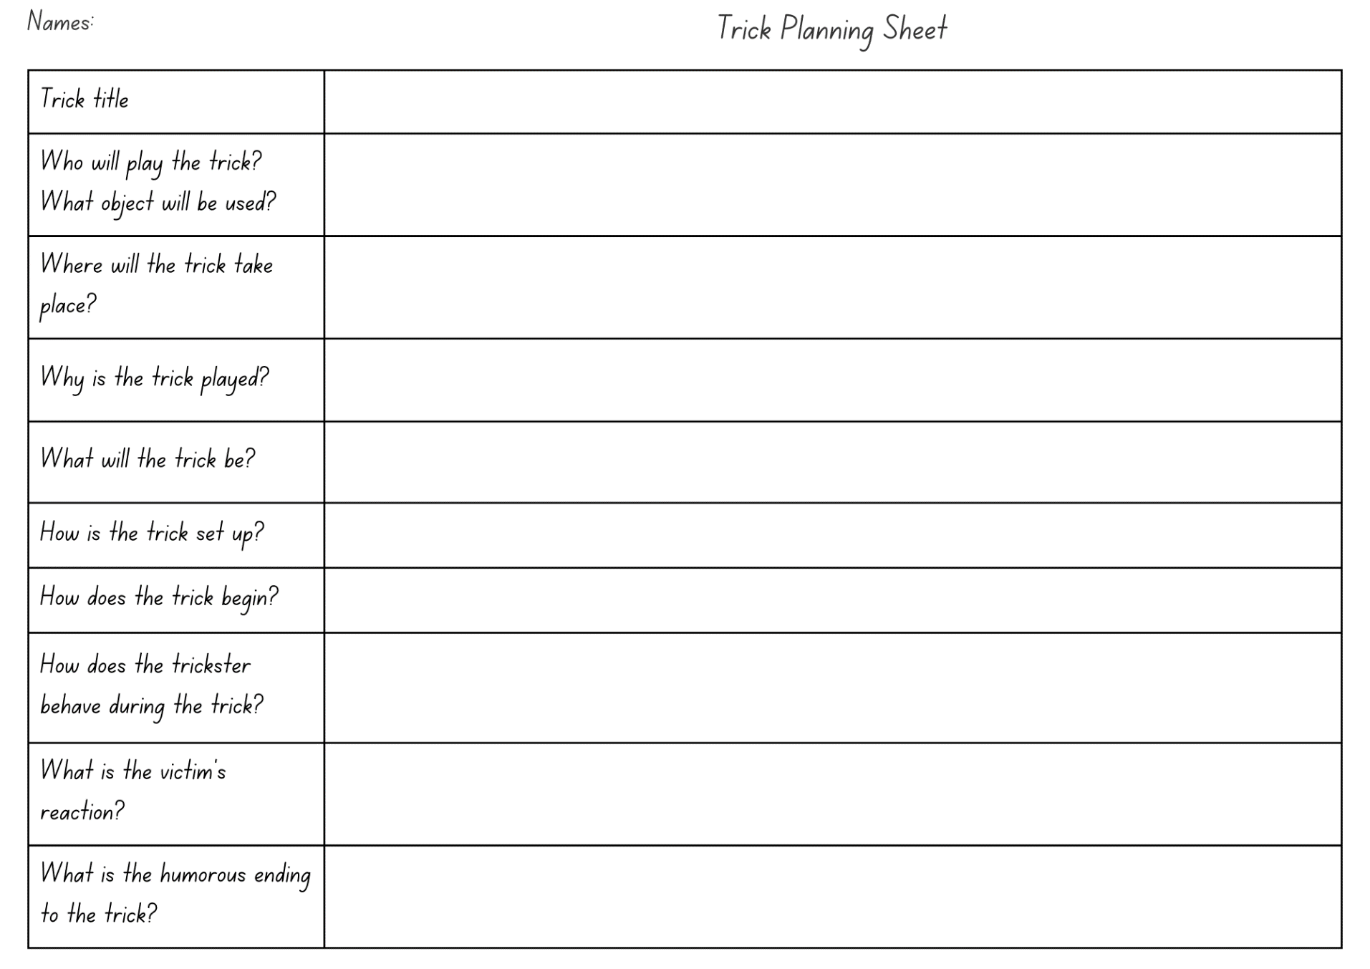

Resource 2: Character profile planning template
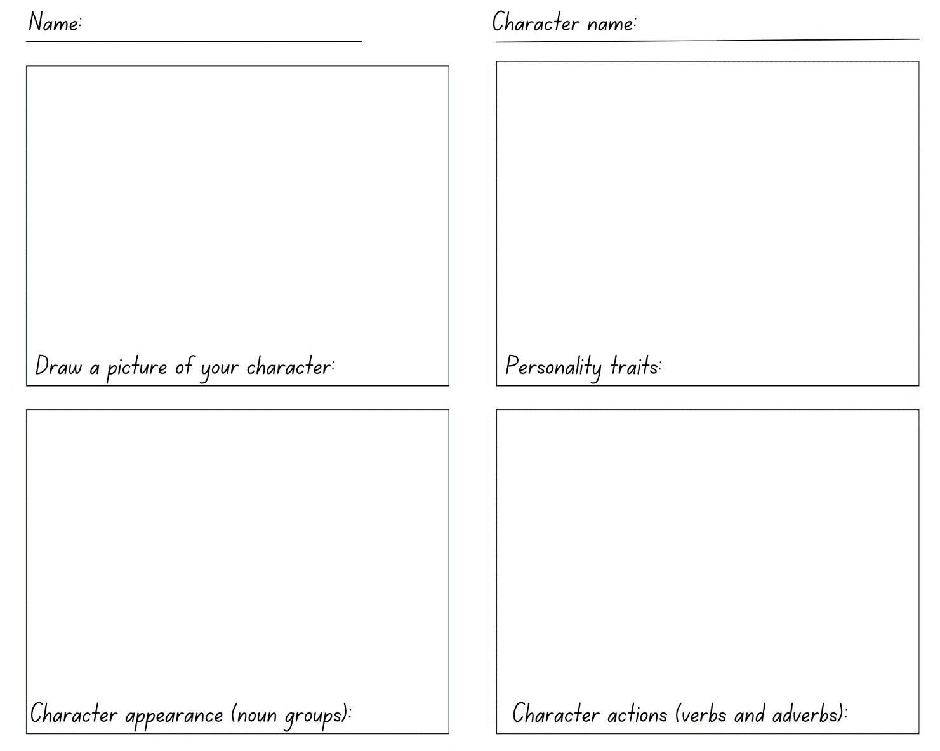

Resource 3: Character profile exemplar
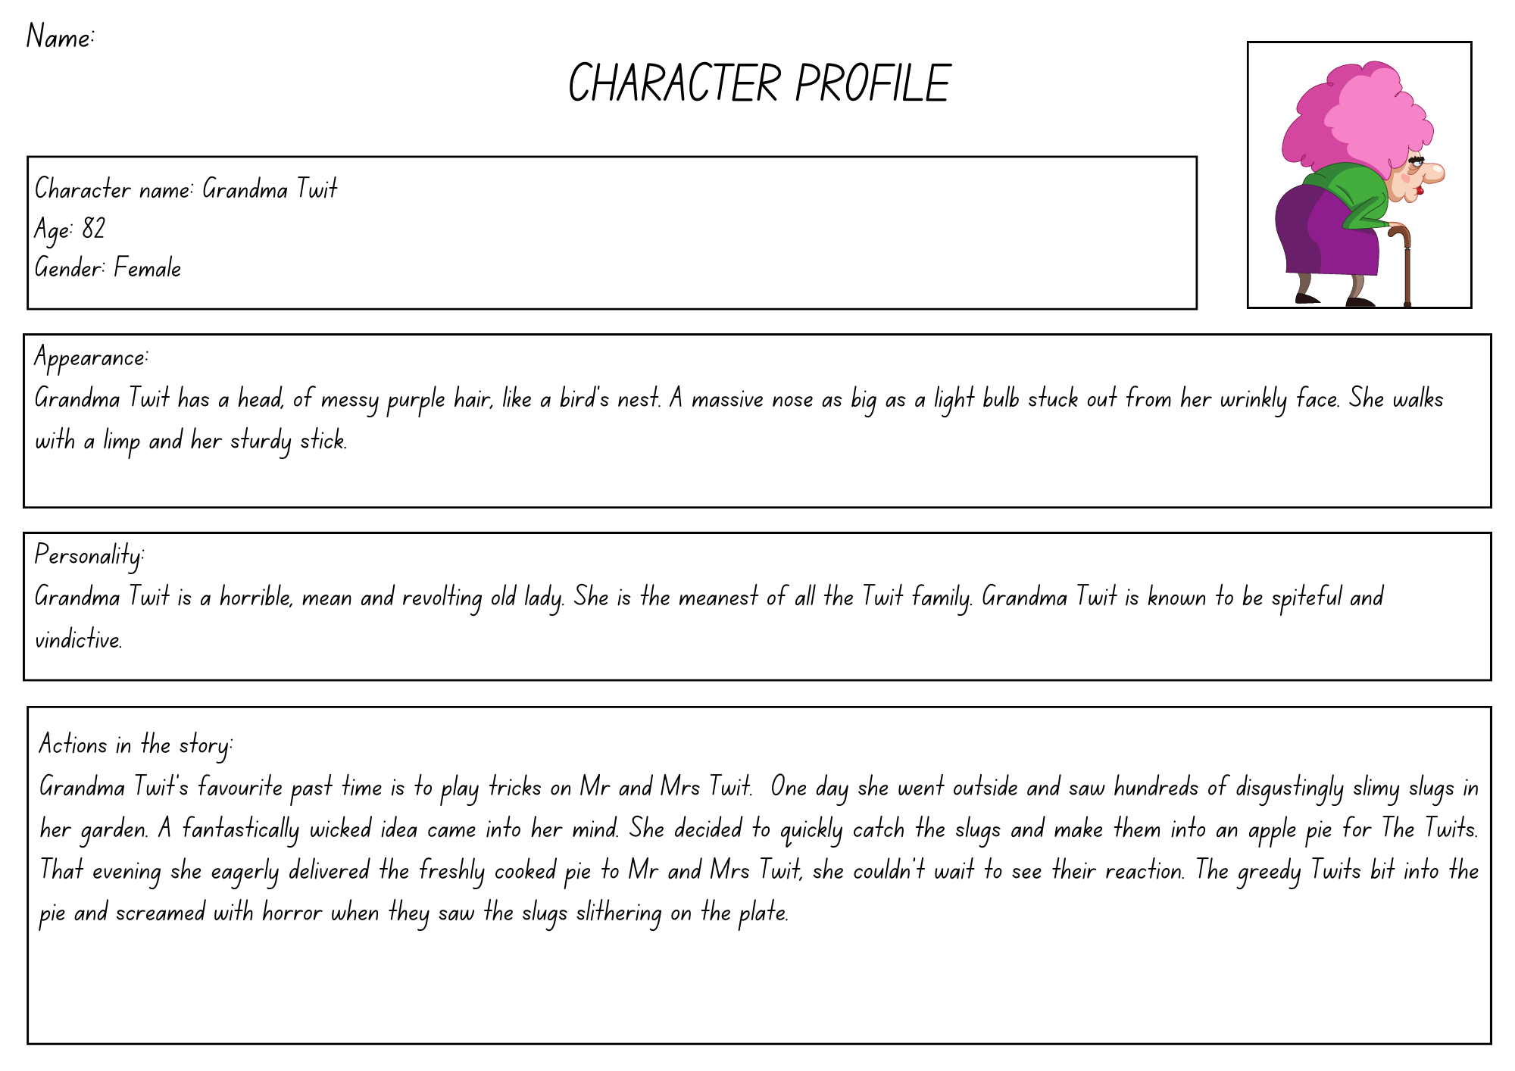
Images sourced from Canva and used in accordance with the Canva Content License Agreement

Resource 4: Character profile template
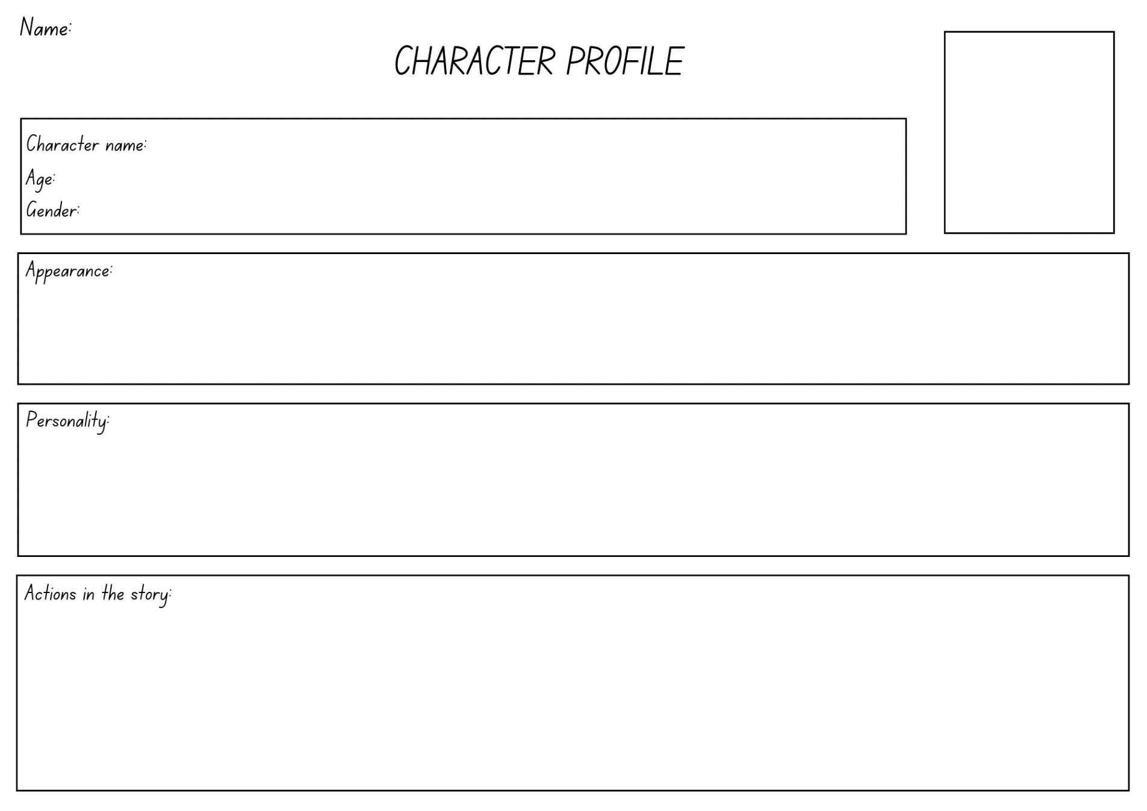

References
Links to third-party material and websites
Please note that the provided (reading/viewing material/list/links/texts) are a suggestion only and implies no endorsement, by the New South Wales Department of Education, of any author, publisher, or book title. School principals and teachers are best placed to assess the suitability of resources that would complement the curriculum and reflect the needs and interests of their students.
If you use the links provided in this document to access a third-party's website, you acknowledge that the terms of use, including licence terms set out on the third-party's website apply to the use which may be made of the materials on that third-party website or where permitted by the Copyright Act 1968 (Cth). The department accepts no responsibility for content on third-party websites.
Except as otherwise noted, all material is © State of New South Wales (Department of Education), 2023 and licensed under the Creative Commons Attribution 4.0 International License. All other material (third-party material) is used with permission or under licence. Where the copyright owner of third-party material has not licensed their material under a Creative Commons or similar licence, you should contact them directly for permission to reuse their material.
English K–10 Syllabus © 2022 NSW Education Standards Authority (NESA) for and on behalf of the Crown in right of the State of New South Wales.
© 2022 NSW Education Standards Authority. This document contains NSW Curriculum and syllabus content. The NSW Curriculum is developed by the NSW Education Standards Authority. This content is prepared by NESA for and on behalf of the Crown in right of the State of New South Wales. The material is protected by Crown copyright.
Please refer to the NESA Copyright Disclaimer for more information.
NESA holds the only official and up-to-date versions of the NSW Curriculum and syllabus documents. Please visit the NSW Education Standards Authority (NESA) website and the NSW Curriculum website.
National Literacy Learning Progression © Australian Curriculum, Assessment and Reporting Authority (ACARA) 2010 to present, unless otherwise indicated. This material was downloaded from the Australian Curriculum website (National Literacy Learning Progression) (accessed 11 April 2023) and was not modified. The material is licensed under CC BY 4.0. Version updates are tracked in the ‘Curriculum version history’ section on the 'About the Australian Curriculum' page of the Australian Curriculum website.
ACARA does not endorse any product that uses the Australian Curriculum or make any representations as to the quality of such products. Any product that uses material published on this website should not be taken to be affiliated with ACARA or have the sponsorship or approval of ACARA. It is up to each person to make their own assessment of the product, taking into account matters including, but not limited to, the version number and the degree to which the materials align with the content descriptions and achievement standards (where relevant). Where there is a claim of alignment, it is important to check that the materials align with the content descriptions and achievement standards (endorsed by all education Ministers), not the elaborations (examples provided by ACARA).
ETA (English Teachers Association) and NSW Department of Education (2016) The Textual Concepts and Processes resource, English Textual Concepts website, accessed (accessed 21 March 2023).
Dahl R (2022) The Twits, Penguin, United Kingdom.

