English – Stage 1 – Unit 38
Contents
Unit overview and instructions for use 3
Teacher notes 4
Outcomes and content – Component A 5
Outcomes and content – Component B 7
Week 1 10
Component A teaching and learning 10
Component B teaching and learning 11
Lesson 1: Connotation through images and symbols 12
Lesson 2: Deeper meaning of images and symbols 14
Lesson 3: Imagery and figurative language – Metaphors 16
Lesson 4: Figurative language – Similes 19
Lesson 5: Figurative language – Personification 20
Week 2 22
Component A teaching and learning 22
Component B teaching and learning 23
Lesson 6: Planning a text to include imagery, symbol and connotation 24
Lesson 7: Using figurative language 26
Lesson 8: Using imagery in the series of events 28
Lesson 9: Using symbols to add meaning 29
Lesson 10: Publishing, presenting and reflecting 31
Resource 1: Text analysis template 33
Resource 2: Narrative planning template 34
Resource 3: Picture book exemplar 35
Resource 4: Picture book template 42
References 44

Unit overview and instructions for use
This two-week unit is comprised of Component A and Component B. Connecting learning across both components is encouraged.
Teaching and learning | Component A | Component B
Suggested duration | 60 minutes | 45 minutes
Explicit teaching focus areas | - Phonic knowledge  - Reading fluency  - Reading comprehension  - Spelling  - Handwriting | - Oral language and communication  - Vocabulary  - Reading comprehension  - Creating written texts  - Understanding and responding to literature
To prepare for teaching and learning: | - Refer to Outcomes and content – Component A, K-2 – Instructional sequence – grapheme–phoneme correspondences [PDF 825KB], and the teaching advice documents (hyperlinked in Component A teaching and learning table).  - Based on student needs identified through ongoing assessment data, plan and document how you will sequence teaching and learning in whole class and targeted teaching groups across the two-week cycle. | - Familiarise yourself with Outcomes and content – Component B, Textual concepts information and videos, English Textual Concepts and Learning Processes (2016), and the teaching and learning sequence.  - Based on student needs identified through ongoing assessment data, determine how you will support students in whole class and targeted teaching groups across the two-week cycle as required.
English K–10 Syllabus © 2022 NSW Education Standards Authority (NESA) for and on behalf of the Crown in right of the State of New South Wales.

Teacher notes
- Imagery, symbol and connotation extend words and symbols beyond their literal meaning. They are used to provide deeper meaning, evoke emotion and enhance enjoyment in texts. – English Textual Concepts and Learning Processes (2016).
- Understanding of imagery, symbol and connotation can be supported through watching the department’s video: Understanding connotation, imagery and symbol video (6:06).
- Students will also learn how the relationships between and within texts (text-to-text connections) help deepen meaning through images and symbols using the texts A Child of Books by Oliver Jeffers and Into the Forest by Anthony Browne.
- The Draw, Talk, Write (and Share) strategy for emergent writers includes drawing as part of a meaning making process, while talking and sharing allows children to make sense of their ideas and to develop their vocabulary and oral language skills. Writing provides an opportunity to apply phonic and word knowledge into another context. Best practice in this strategy is modelled by Australian researcher Noella Mackenzie. For further information, refer to the website Draw, Talk, Write (and Share).
- For information on imagery, figurative language, simile, metaphor, personification, prepositions, coordinating conjunctions, compound sentences refer to the NESA Glossary.
- Consider prior student knowledge regarding imagery, figurative language, simile, metaphor, personification, prepositions, coordinating conjunctions and compound sentences.
- Reflect on student learning and engagement in activities and record differentiation and adjustments within the unit to inform future teaching and learning. One way of doing this could be to add comments to the digital file.
- Content points are linked to the National Literacy Learning Progression version (3).
Levels and indicators sourced from National Literacy Learning Progression © Australian Curriculum, Assessment and Reporting Authority (ACARA), (accessed 6 March 2023) and was not modified. See references for more information.

Outcomes and content – Component A
The table below outlines the focus outcomes and content. Content is linked to the National Literacy Learning Progression version (3).
Focus area and outcome | Content points and National Literacy Learning Progression
Phonic knowledge  EN1-PHOKW-01 – uses initial and extended phonics, including vowel digraphs, trigraphs to decode and encode words when reading and creating texts | - decode words with less common consonant digraphs and apply this when reading texts
Reading fluency  EN1-REFLU-01 – sustains reading unseen texts with automaticity and prosody and self-corrects errors | - self-correct when fluency and/or meaning is interrupted  - adjust phrasing, intonation, volume or rate to maintain fluency when reading aloud (FlY4)
Reading comprehension  EN1-RECOM-01 – comprehends independently read texts that require sustained reading by activating background and word knowledge, connecting and understanding sentences and whole text, and monitoring for meaning | - identify when meaning is not complete and/or contradicts prior understanding  - ask a clarifying question when more background knowledge is needed to make an inference  - interpret patterns in texts to enhance understanding
Spelling  EN1-SPELL-01 – applies phonological, orthographic and morphological generalisations and strategies when spelling words in a range of writing contexts | - segment multisyllabic words into syllables and phonemes as a strategy for spelling (SpG5)  - use extended phonic code for taught consonant phonemes  - use spelling conventions when adding plural-marking suffixes (SpG9)
Handwriting  EN1-HANDW-01 – uses a legible, fluent and automatic handwriting style, and digital technology, including word-processing applications, when creating texts | - position all letters correctly on the line with appropriate spacing between words (HwK5)

Outcomes and content – Component B
The table below outlines the focus outcomes and content. Content is linked to the National Literacy Learning Progression version (3).
Focus area and outcome | Content points and National Literacy Learning Progression
Oral language and communication  EN1-OLC-01 – communicates effectively by using interpersonal conventions and language to extend and elaborate ideas for social and learning interactions | - interact to evaluate ideas and refine meaning (InT4, InT5)  - link or compare ideas when interacting  - deliver a planned narrative to an audience for specific contexts and purposes (SpK4)
Vocabulary  EN1-VOCAB-01 – understands and effectively uses Tier 1, taught Tier 2 and Tier 3 vocabulary to extend and elaborate ideas | - understand and intentionally choose subject-specific vocabulary to enhance precision and for effect
Reading comprehension  EN1-RECOM-01 – comprehends independently read texts that require sustained reading by activating background and word knowledge, connecting and understanding sentences and whole text, and monitoring for meaning | - use known vocabulary to build a mental model of the content of the text  - identify how creative visual features are used to expand meaning  - make text-to-self, text-to-text or text-to-world connections when reading (UnT6)  - ask a clarifying question when more background knowledge is needed to make an inference  - interpret patterns in texts to enhance understanding
Creating written texts  EN1-CWT-01 – plans, creates and revises texts written for different purposes, including paragraphs, using knowledge of vocabulary, text features and sentence structure | - use visual elements to expand meaning in own texts  - select and use a range of conjunctions to create cohesive texts (GrA5)  - write compound sentences using coordinating conjunctions (GrA4, CrT5)  - use contextually precise prepositional phrases when creating texts (GrA4)  - use a variety of planning strategies and tools for creating texts  - re-read and edit their own texts after receiving feedback  - use different modes and media to enhance the presentation of texts they have created (CrT5, CrT6)
Understanding and responding to literature  EN1-UARL-01 – understands and responds to literature by creating texts using similar structures, intentional language choices and features appropriate to audience and purpose | - identify figurative language and wordplay in texts  - identify symbols and images in texts, and how they bring deeper meaning  - create texts that include symbols, wordplay and figurative language

Week 1

Component A teaching and learning
The table below can be used to plan and document lessons that address Component A outcomes and content. Both the detailed example [DOC 529KB] of a two-week teaching and learning cycle and brief example [DOC 66KB] may support you in your planning.
Focus Areas | Lesson 1 | Lesson 2 | Lesson 3 | Lesson 4 | Lesson 5
Phonic knowledge
15 minutes
Spelling and Handwriting
15 minutes
Reading comprehension and Reading fluency
30 minutes

Component B teaching and learning
The following teaching and learning sequence has been designed to address Component B outcomes and content. Adapt the sequence as required to best meet the needs of your students.

Learning intention and success criteria
Learning intentions and success criteria are best co-constructed with students.

Learning intention
Students are learning to develop a deeper understanding of imagery, symbol, and connotation.

Success criteria
Students can:
- understand that images convey ideas and feelings (connotation)
- identify that images and symbols bring a deeper meaning to a text
- identify figurative language and wordplay in texts
- write metaphors and similes
- use personification to enhance imagery.

Resources
- Winston S and Jeffers O (2019) A Child of Books, Walker Books, Australia. ISBN: 9781406386042
- Browne A (2005) Into the Forest, Walker Books, Australia. ISBN: 9781844285594
- Resource 1: Text analysis template
- Strips of white paper
- Teacher sourced images of a dark forest and a light, colourful forest

Lesson 1: Connotation through images and symbols
- Display a teacher sourced image of a dark forest. Give students time to think about how the image makes them feel (connotations). As a class, brainstorm and record the emotions associated with the image. For example, nervous, afraid, petrified.
- Display a teacher sourced image of a light, colourful forest. Ask students if and how their feelings have changed compared to the previous image. For example, bright, happy, joyful.
- Discuss how the images alone, even without any words, had meaning and prompted an emotion. Remind students that illustrators use different techniques, such as using images and symbols, to give a message or tell a story, and to make their audience feel different emotions (connotation).
- Introduce the text Into the Forest by displaying the front and back cover. In pairs, students decide on a question they could ask to support their understanding. For example, why the boy has red shoes on, or why there is a face in the tree. Ask students to share their questions.
- Read Into the Forest. Pause at certain points and ask students if they have made any text-to-text connections. For example, the woods in Little Red Riding Hood, Hansel and Gretel, or Goldilocks and the Three Bears. Discuss how the illustrator used different symbols and images to convey a deeper meaning.
- Select pages from the text to display. Ensure that at least one page has a symbol that links to a fairy tale. Remind students that images can hold deeper meanings and that identifying the ideas and feelings of images helps readers to understand the text.
- In pairs, students turn and talk about a displayed page. Some prompts to help scaffold the discussion could include:
- What ideas/feelings (connotations) are created when viewing each image/symbol?
- How do you interpret each image? Why?
- What leads you to this opinion or thought?
- For example, if you show students the image of the boy and girl huddled together by a fire, they might say that this image reminds them of the story about Hansel and Gretel. From looking at the children’s facial expressions and the way they are sitting, students might feel that the children are scared and cold.
- Students share their ideas with the class.
- Students illustrate and write a short paragraph to explain their ideas.
Too hard? Students record responses and understanding using a method of their choice. For example, by using assistive technology.
Too easy? Students include reasons why they think the illustrator has included certain images.
- Ask students to reflect on how or why the same images create different feelings for different people. Reinforce the idea that connotations come from connections to previous experiences or knowledge.
Stage 1 Assessment task 1 – Observations and work samples from this lesson allow students to demonstrate achievement towards the following syllabus outcomes and content points:
EN1-RECOM-01 – comprehends independently read texts that require sustained reading by activating background and word knowledge, connecting and understanding sentences and whole text, and monitoring for meaning
- make text-to-self, text-to-text or text-to-world connections when reading.
EN1-UARL-01 – understands and responds to literature by creating texts using similar structures, intentional language choices and features appropriate to audience and purpose
- identify symbols and images in texts, and how they bring deeper meaning.

Lesson 2: Deeper meaning of images and symbols
- Remind students that images and symbols hold connotations. Remind students that a connotation is an idea or feeling that can be connected to a word or image.
- Introduce the text A Child of Books.
- Display the front cover and ask students to look carefully at the images. In pairs, students turn and talk to discuss and compare ideas about the significance of the gold keyhole. Some prompts to help scaffold the discussion could include:
- What feelings or ideas are created when viewing the image/symbol?
- How do you interpret the image/symbol? Why?
- What leads you to this thought/inference?
- What do you predict this tells us about the story?
- For example, the image of the lock may prompt students to think that something valuable is being kept inside or there is a very special secret. Students may suggest that the image is a symbol that tells readers the story will be about a girl who will reveal or unlock secrets.
- Read A Child of Books. Prompt students to use the illustrations to make text-to-text connections with other fairy tales or stories. For example, on the double page with the globe, text connections could be made with Little Red Riding Hood (red hood), Snow White (apple), Alice in Wonderland (card).
- Discuss how readers can draw on familiar stories, such as fairy tales, to notice the imagery and symbols used in other texts.
- Show students the page of the text that has the key with the note attached. Ask students to explain why they think the illustrator used the symbol of the keyhole on the front cover and the key at the end of the book. Discuss how the use of images created feelings and how these can help readers to understand the text.
- Using the Think-Pair-Share strategy, students discuss the main idea of the story. Ask students to draw some symbols or images that could represent their ideas.
- Students design a book cover for the text using images and symbols that represent the main idea of the story.
- Students write a paragraph to explain the images and symbols on their book cover and why they were chosen.
Too hard? Students design the book cover and write keywords to explain images and symbols.
- Display both A Child of Books and Into the Forest to compare and discuss any similarities. Draw attention to how colour is used to add meaning. For example, connotations could include dark – scared, bright – happy, salience – to highlight the important part of the text such as the main character. Students could write a similarity and difference on 2 sticky notes and put them inside a large Venn diagram made from placing 2 overlapping hoops on the floor.
Stage 1 Assessment task 2 – Observations and work samples from this lesson allow students to demonstrate achievement towards the following syllabus outcomes and content points:
EN1-OLC-01 – communicates effectively by using interpersonal conventions and language to extend and elaborate ideas for social and learning interactions.
- interact to evaluate ideas and refine meaning
- link or compare ideas when interacting.
EN1-RECOM-01 – comprehends independently read texts that require sustained reading by activating background and word knowledge, connecting and understanding sentences and whole text, and monitoring for meaning
- identify how creative visual features are used to expand meaning
- ask a clarifying question when more background knowledge is needed to make an inference.
EN1-UARL-01 – understands and responds to literature by creating texts using similar structures, intentional language choices and features appropriate to audience and purpose
- identify symbols and images in texts, and how they bring deeper meaning.

Lesson 3: Imagery and figurative language – Metaphors
- Read the line ‘I have sailed across a sea of words’ from A Child of Books. Ask students to close their eyes to create a mental model. Share responses with the class.
- Activate student prior knowledge by asking students to brainstorm what they know about figurative language.
- Explain that imagery is created when sentences are written using figurative language to represent objects, characters, actions or ideas in such a way that they appeal to the senses of the reader or viewer.
- Explain that figurative language is used in both Into the Forest and A Child of Books to express ideas and create imagery in the reader’s mind.
- Re-read A Child of Books. Ask students to listen carefully for examples of figurative language.
- Revise that metaphors are a type of figurative language (Similes will be focused on in Lesson 4).
- Explain that metaphors are used for effect. They imply one thing by referring to another or describe an object or situation that can represent something else. For example, ‘He is a ray of sunshine.’ He is not really a ray of sunshine, but he is bright and happy like a ray of sunshine.
- Jointly identify and record examples of figurative language used in the text. Examples of metaphors include:
- ‘I come from a world of stories and on my imagination I float.’
- ‘I have sailed across a sea of words.’
- ‘We will travel over mountains of make believe.’
- ‘We can lose ourselves in forests of fairy tales.’
- Display an enlarged copy of Resource 1: Text analysis template. Model analysing a metaphor to explore and understand figurative language. For example:
- What it states – ‘We can lose ourselves in forests of fairy tales.’
- What it shows – A picture of the boy and girl characters playing hide and seek in a forest.
- What it means – When we read books it can transport us to different and imaginary places.
- Provide pairs of students with a copy of Resource 1: Text analysis template. Students select a metaphor from the list in activity 8 to complete.
- Explain that students will write a metaphor to describe a person they know. Model this using think-alouds. For example:
- I am going to write about my brother who is always making a mess at home. When I think of the mess he makes, it reminds me of the destruction made by a hurricane. I am going to write, ‘My brother is a hurricane, causing destruction wherever he goes.’
- I am going to write about my Mum who is loving, caring and warm. When I think about her, she reminds me of the sun. I am going to write, ‘My Mum shines brilliantly and always brightens up my day.’
- Students think about a person they know, what that person does and what the person reminds them of. Students write their own metaphors to describe them.
Stage 1 Assessment task 3 – Observations and work samples from this lesson allow students to demonstrate achievement towards the following syllabus outcomes and content points:
EN1-RECOM-01 – comprehends independently read texts that require sustained reading by activating background and word knowledge, connecting and understanding sentences and whole text, and monitoring for meaning
- use known vocabulary to build a mental model of the content of the text.
EN1-UARL-01 – understands and responds to literature by creating texts using similar structures, intentional language choices and features appropriate to audience and purpose
- identify figurative language and wordplay in texts.

Lesson 4: Figurative language – Similes
- Reinforce the idea that authors use figurative language to enhance the meaning of what is being described.
- Revise student understanding of similes.
- Display the double page from Into the Forest with the red coat hanging from the tree. Brainstorm and record a list of objects on the pages. For example, tall dark trees, red coat, glowing light, red shoes, young boy, basket. Keep this for Lesson 5.
- Remind students that a simile compares 2 things using the words ‘like’ or ‘as’. Model writing a simile using one of the items from activity 3. For example:
- select one of the brainstormed items – the tall dark trees
- think of something to describe what the trees did – grew, shadowed, dwarfed, surrounded, covered, reached
- compare the trees to something that surrounds – fog
- add the words ‘like’ or ‘as’ to create a simile – The tall dark trees, surrounded the boy like thick fog.
- Students write their own similes on a strip of paper, using the displayed double page and brainstormed items from activity 3.
- Display students’ similes under the double page.
Too hard? Provide sentence stems for students to complete a simile.
Too easy? Students add more detail and descriptive language to their simile.
- Ask students to explain the difference between a simile and a metaphor.
Stage 1 Assessment task 4 – Observations and work samples from this lesson allow students to demonstrate achievement towards the following syllabus outcome and content point:
EN1-VOCAB-01 – understands and effectively uses Tier 1, taught Tier 2 and Tier 3 vocabulary to extend and elaborate ideas
- understand and intentionally choose subject-specific vocabulary to enhance precision and for effect.

Lesson 5: Figurative language – Personification
- Read an example of personification. For example, ‘The wild wind ran through the village, causing destruction and mess.’
- Ask students to close their eyes and make a mental model or visualise the sentence. Students share responses with the class.
- Revise the meaning of personification. Explain that giving human characteristics to non-human ideas, objects or animals can make the story more engaging and make it easier for the reader to form connections, visualise and understand the text.
- Review the double page from Lesson 4 and the listed objects. For example, tall dark trees, red coat, glowing light, red shoes, basket.
- Model using personification to describe an object from the list. For example:
- select one of the brainstormed items – the red coat
- think of something about coats – people wear them to keep warm
- think of something humans do that is similar – hug tightly to keep warm
- The red coat hugged me tightly and kept me warm.
- Revisit the brainstormed list from Lesson 4, activity 3. Select one of the items and list the human characteristics that could be attached. For example, glowing light – danced, bounced, tiptoed, painted.
- Display the sentence starters below. Ask students to use the object and personification to complete the sentence with a prepositional phrase. Remind students that a prepositional phrase contains a preposition such as, into, across, throughout and indicates a circumstance such as time, place, manner or causality. For example:
- The glowing light tiptoed _ _ (into my bedroom).
- The glowing light bounced _ _ (across the lake).
- The glowing light danced _ _ (throughout the night).
- Discuss how the different personified word can change a reader’s mental model.
- Students write a sentence that uses personification on a strip of paper, using the displayed double page and a brainstormed object from Lesson 4.
Too hard? Support small groups of students to write a personification sentence.
Too easy? Students add more detail and descriptive language to their personification sentence.
- Students share their sentence and attach it to the double page from Into the Forest used in Lesson 4.
- Ask students what they have learnt about personification and figurative language and how they could apply this to their writing.

Week 2

Component A teaching and learning
The table below can be used to plan and document lessons that address Component A outcomes and content. Both the detailed example [DOC 529KB] of a two-week teaching and learning cycle and brief example [DOC 66KB] may support you in your planning.
Focus Areas | Lesson 6 | Lesson 7 | Lesson 8 | Lesson 9 | Lesson 10
Phonic knowledge
15 minutes
Spelling and Handwriting
15 minutes
Reading comprehension and Reading fluency
30 minutes

Component B teaching and learning
The following teaching and learning sequence has been designed to address Component B outcomes and content. Adapt the sequence as required to best meet the needs of your students.

Learning intention and success criteria
Learning intentions and success criteria are best co-constructed with students.

Learning intention
Students are learning to develop a deeper understanding of imagery, symbol, and connotation to create a text.

Success criteria
Students can:
- use a planning template to create a text
- use figurative language in a text
- use imagery to convey meaning
- use symbols to support understanding
- use a success criteria to write and provide feedback
- deliver a planned narrative to an audience.

Resources
- Winston S and Jeffers O (2019) A Child of Books, Walker Books, Australia. ISBN: 9781406386042
- Browne A (2005) Into the Forest, Walker Books, Australia. ISBN: 9781844285594
- Resource 2: Narrative planning template
- Resource 3: Picture book exemplar
- Resource 4: Picture book template
- Mini whiteboard
- Sticky notes
- Workbooks, paper

Lesson 6: Planning a text to include imagery, symbol and connotation
- Pose the statement, ‘Stories can take us to amazing places.’ In pairs, students turn and talk to discuss what this means. Some ideas could include, it allows readers to use their imagination to go to different worlds or places, the imagery can help deepen understanding.
- Revisit Into the Forest and A Child of Books. Ask students to explain which text allowed them to build a strong mental model. Support students to use examples from the text and correct terms, such as figurative language, metaphors, imagery, symbol, connotation.
- Ask students to identify the narrative pattern found in the 2 texts. Discuss how both texts follow the pattern of a narrative journey. This particular and predictable pattern tells how a character goes on an adventure and usually returns from the adventure transformed in some way. Ask students to explain why being able to identify patterns in a text can support understanding. If needed, explain that understanding patterns can support predictions. For example, in a narrative, readers know that there will usually be a resolution to a problem.
- Display the front cover of Into the Forest. List key terminology of a narrative, for example, character, setting, orientation, series of events, conclusion. Use the text to provide examples.
- Explain that students will work in pairs and use their understanding of narrative patterns, supported by imagery, symbol and connotation, to create a picture book. These stories will be published and collated as a multimodal or digital text in Lesson 10.
- Ask students to share their favourite characters from a traditional fairy tale or a familiar book and provide a reason for liking them.
- On mini whiteboards students:
- write the name of their favourite character(s)
- draw a symbol or image that could be used to represent the character(s).
- Students share their ideas with the class. Create a character chart to use for narrative writing.
- Display Resource 2: Narrative planning template. Explain that students will compose a narrative using the same idea as Into the Forest. One main character will become lost in a forest. Along the way, they will meet other familiar book characters. Eventually the main character will find their way out of the forest.
- Select some ideas from the character chart in activity 8 and model using the resource. Use drawings and list key words, including examples of figurative language and imagery, that will help to describe what may happen.
- Ask students to think about the characters they would like to include in their story and what may happen to them. In pairs, students turn and talk to discuss ideas with a partner.
- In pairs, students use the Draw, Talk, Write (and Share) strategy to complete a copy of Resource 2: Narrative planning template.
Too hard? Support small groups of students to plan a narrative.
Too easy? Students work independently to plan a narrative in a setting of their choice.
Stage 1 Assessment task 5 – Observations and work samples from this lesson allow students to demonstrate achievement towards the following syllabus outcomes and content points:
EN1-RECOM-01 – comprehends independently read texts that require sustained reading by activating background and word knowledge, connecting and understanding sentences and whole text, and monitoring for meaning
- interpret patterns in texts to enhance understanding.
EN1-CWT-01 – plans, creates and revises texts written for different purposes, including paragraphs, using knowledge of vocabulary, text features and sentence structure
- use a variety of planning strategies and tools for creating texts.

Lesson 7: Using figurative language
- Display Into The Forest and ask students to identify the orientation and complication.
- Jointly construct a success criteria to keep on display to support students’ writing. For example:
I can write an interesting narrative that includes:
- correct structure (orientation, complication, series of events, resolution, ending)
- figurative and descriptive language
- a variety of sentences – simple, compound, complex
- prepositional phrases.
- Remind students that, when writing an orientation of a narrative, it should be interesting so that it ‘hooks’ or catches the reader’s attention. Share strategies to do this, for example, starting with figurative language or starting with an action where the character is doing something interesting.
- Model how to compose the orientation of the story using the narrative planning template from Lesson 6 and Resource 3: Picture book exemplar. For example:
Kobi had been eagerly waiting for the moment to kick his prized soccer ball across the field (prepositional phrase). His excitement quickly vanished as the ball soared over the fence and disappeared into the nearby forest. With his heart pounding like a drum (figurative language), Kobi bravely ventured into the forest to find it. The forest was a mysterious and magical place, with trees stretching high into the sky (personification-figurative language). Kobi was scared, but he kept walking, determined to find his ball (compound sentence).
- Revise sentence-level grammar included in the writing success criteria, such as prepositional phrases, conjunctions, compound and complex sentences. Students identify these in the modelled orientation paragraph.
- Use think-alouds to explain how figurative language, such as pounding like a drum and trees stretching high into the sky, is used to create imagery and make the writing interesting.
- In pairs, students complete an orientation for their narrative using the planning template and the success criteria as a reference.
- Model how to compose a complication in the story using the planning template from Lesson 6 and Resource 3: Picture book exemplar. For example:
‘As he pushed past the prickly thorns and branches, the forest began to close in around him. Kobi realised that he was lost, and the once-familiar trees and landmarks now seemed unrecognisable. With his bravery guiding him, Kobi took a deep breath and called out for help.’
- Ask students to identify the use of figurative language.
- In pairs, students complete their own complication using the planning template and the success criteria as a reference.
Too hard? Students work in small groups to write the orientation and complication.
Too easy? Students include several different examples of figurative language or wordplay.
Stage 1 Assessment task 6 – Observations and work samples from this lesson allow students to demonstrate achievement towards the following syllabus outcome and content points:
EN1-CWT-01 – plans, creates and revises texts written for different purposes, including paragraphs, using knowledge of vocabulary, text features and sentence structure
- select and use a range of conjunctions to create cohesive texts
- write compound sentences using coordinating conjunctions
- use contextually precise prepositional phrases when creating texts.

Lesson 8: Using imagery in the series of events
- Identify the series of events in Into The Forest.
- Model how to compose one paragraph of the series of events using the planning template from Lesson 6 and Resource 3: Picture book exemplar. For example:
‘Suddenly, he saw a light as bright as the sun in the distance. He started running towards it, hoping to find someone who could help him. As he got closer, he saw a giant castle emerging on the horizon, with its turrets reaching for the sky. A loud cry pierced the silence. Kobi knew it was a cry for help, he ran inside to find a young girl. She said, “My wicked stepmother has locked me in the attic, can you please help me?” Kobi rammed his shoulder into the door with the wood splintering and cracking. The girl was overjoyed to be freed. Kobi helped her down the stairs and out of the castle.’
- Ask students to identify what sentences use imagery to help readers create a mental model. For example, ‘a giant castle emerging on the horizon, with its turrets reaching for the sky’; ‘Kobi rammed his shoulder into the door with the wood splintering and cracking.’
- In pairs, students identify where imagery could be used in the series of events.
- In pairs, students complete their own series of events using the planning template, success criteria and examples of imagery. Imagery could be added to the success criteria.
Too hard? Students draw and label detailed illustrations to convey the imagery of an event in their narrative.
Too easy? Students include more figurative language and complex sentences.

Lesson 9: Using symbols to add meaning
- Select students to read their writing from Lesson 7 and Lesson 8. Ask other students to predict a resolution.
- Model how to compose the resolution using the planning template from Lesson 6 and Resource 3: Picture book exemplar. For example, ‘Kobi sailed along the path and began to see familiar sights. As he got closer his ball appeared in front of him. Kobi was overjoyed that he had returned safely back to his local park.’
- In pairs, students complete their own resolution using the planning template and success criteria as a reference.
- Using the exemplar text, discuss what symbols could be used to bring a deeper meaning to the text. For example, a hidden or secret sign.
- In pairs, students discuss what symbols could be used to help convey meaning in their own text. Students draw the symbols to support their narrative.
- In pairs, students take turns to read their narrative and provide peer feedback using the success criteria and the Two stars and a wish strategy.
Too hard? Students work in small groups to write the series of events.
Stage 1 Assessment task 7 – Observations and work samples from this lesson allow students to demonstrate achievement towards the following syllabus outcome and content point:
EN1-CWT-01 – plans, creates and revises texts written for different purposes, including paragraphs, using knowledge of vocabulary, text features and sentence structure
- re-read and edit their own texts after receiving feedback.

Lesson 10: Publishing, presenting and reflecting
- Students publish their narrative in the form of a picture book using Resource 4: Picture book template or on a digital platform such as Book Creator or Canva.
- Students share their picture book with a student from another class.
- Students reflect on their learning and write something they learned during the unit on a sticky note as an exit slip.
Stage 1 Assessment task 8 – Observations and work samples from this lesson allow students to demonstrate achievement towards the following syllabus outcomes and content points:
EN1-OLC-01 – communicates effectively by using interpersonal conventions and language to extend and elaborate ideas for social and learning interactions
- deliver a planned narrative to an audience for specific contexts and purposes.
EN1-VOCAB-01 – understands and effectively uses Tier 1, taught Tier 2 and Tier 3 vocabulary to extend and elaborate ideas
- understand and intentionally choose subject-specific vocabulary to enhance precision and for effect.
EN1-CWT-01 – plans, creates and revises texts written for different purposes, including paragraphs, using knowledge of vocabulary, text features and sentence structure
- use different modes and media to enhance the presentation of texts they have created.
EN1-UARL-01 – understands and responds to literature by creating texts using similar structures, intentional language choices and features appropriate to audience and purpose
- create texts that include symbols, wordplay and figurative language.

Resource 1: Text analysis template
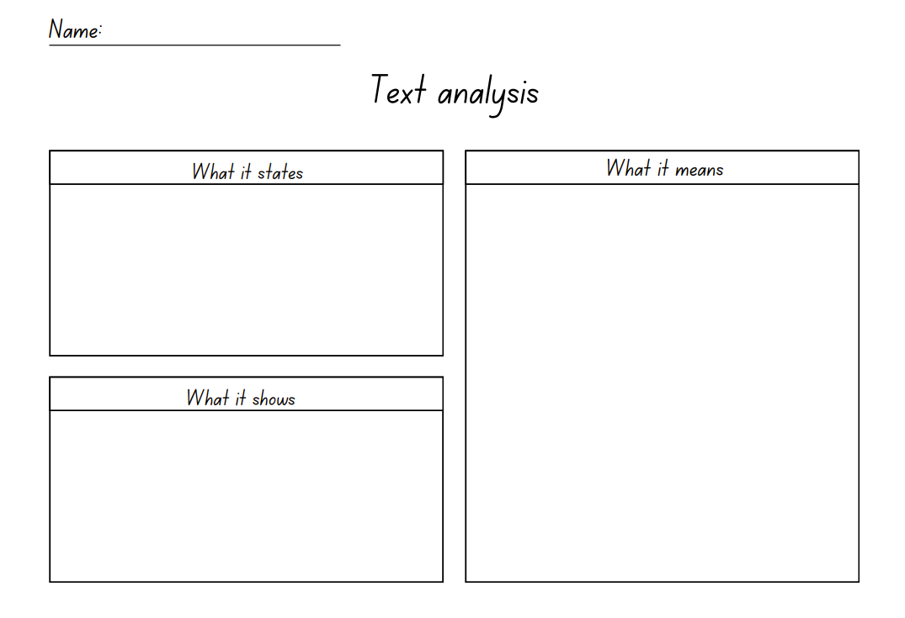

Resource 2: Narrative planning template
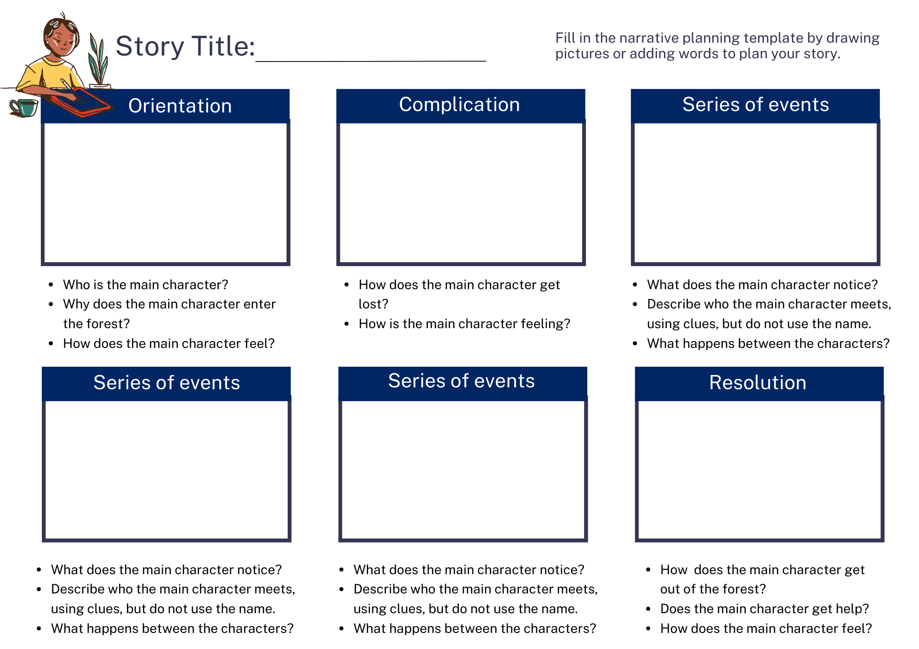
Images sourced from Canva and used in accordance with the Canva Content License Agreement.

Resource 3: Picture book exemplar
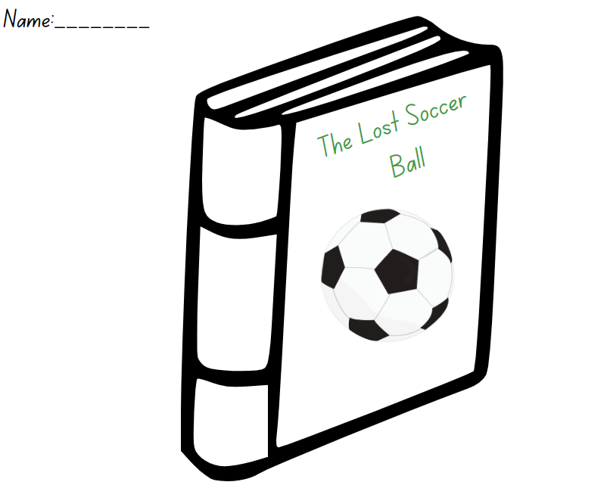
Images sourced from Canva and used in accordance with the Canva Content License Agreement.
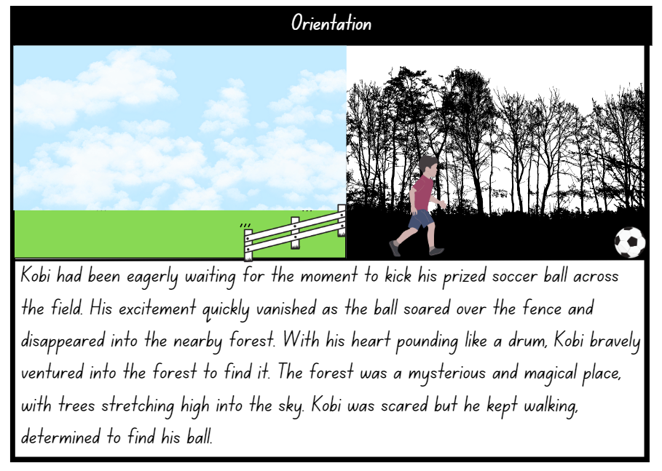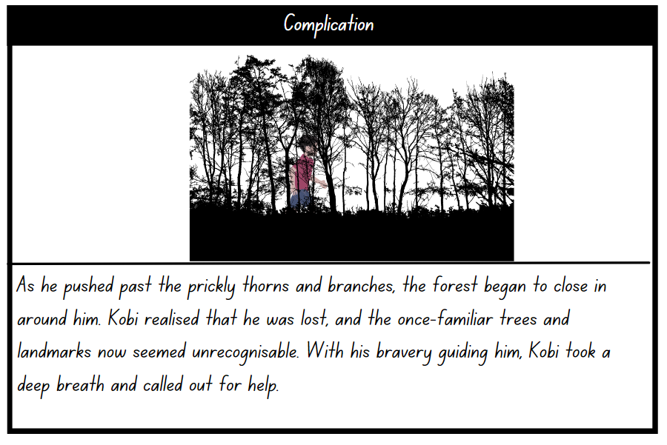
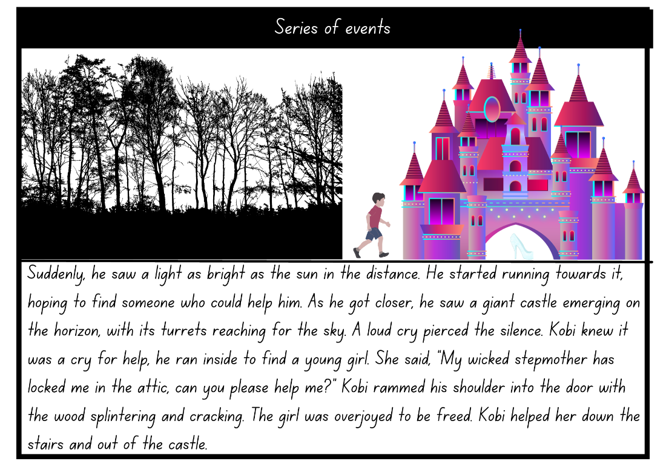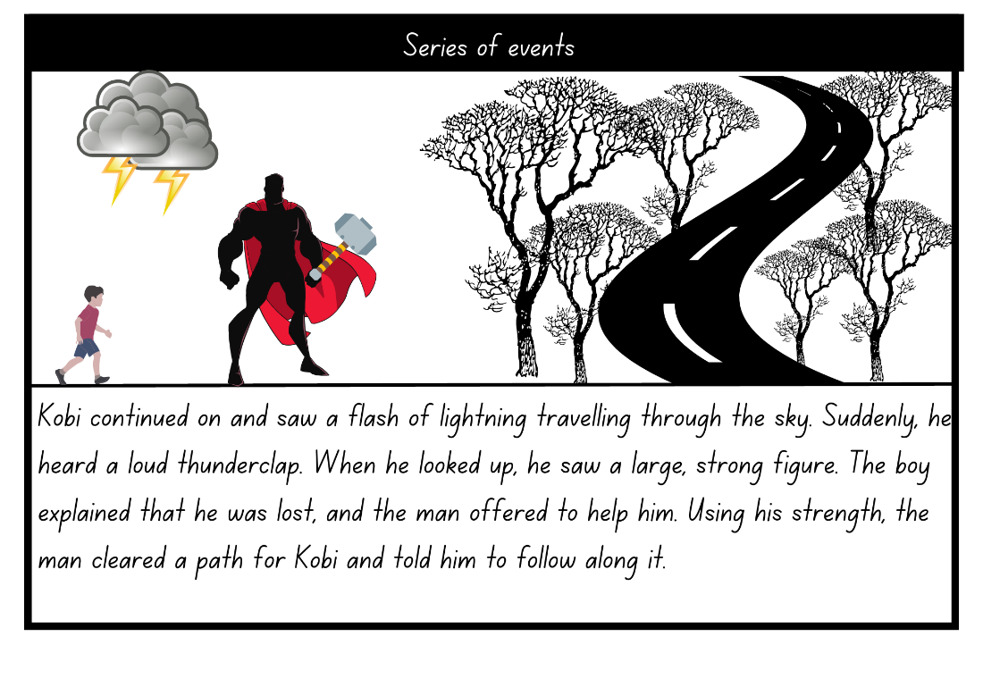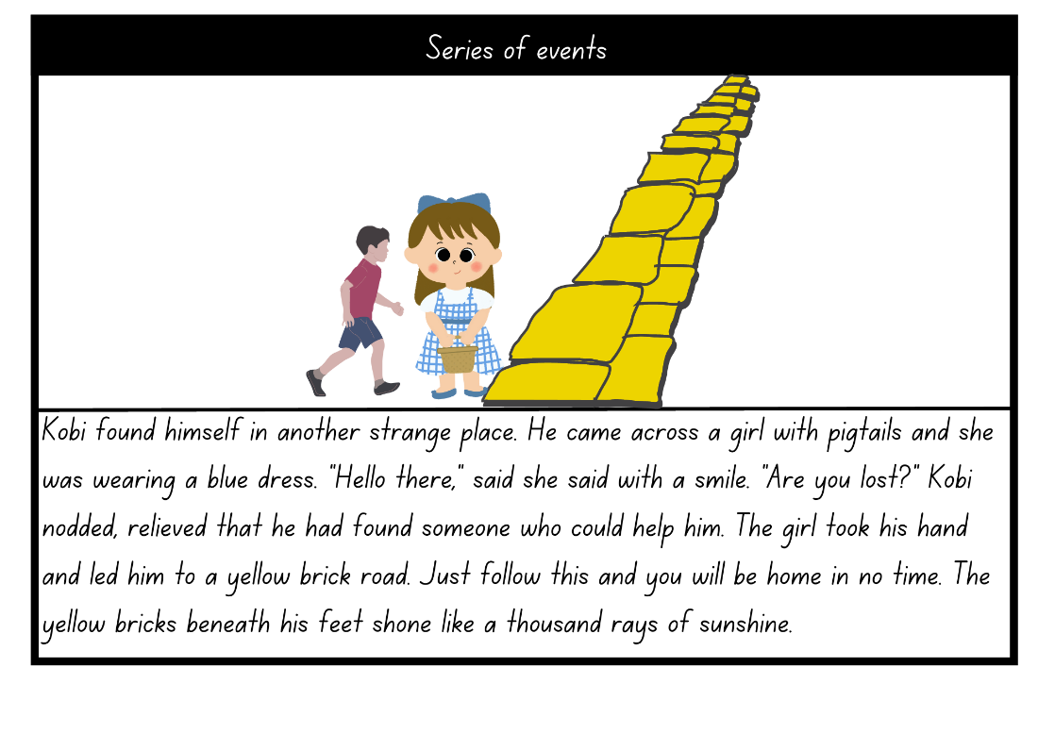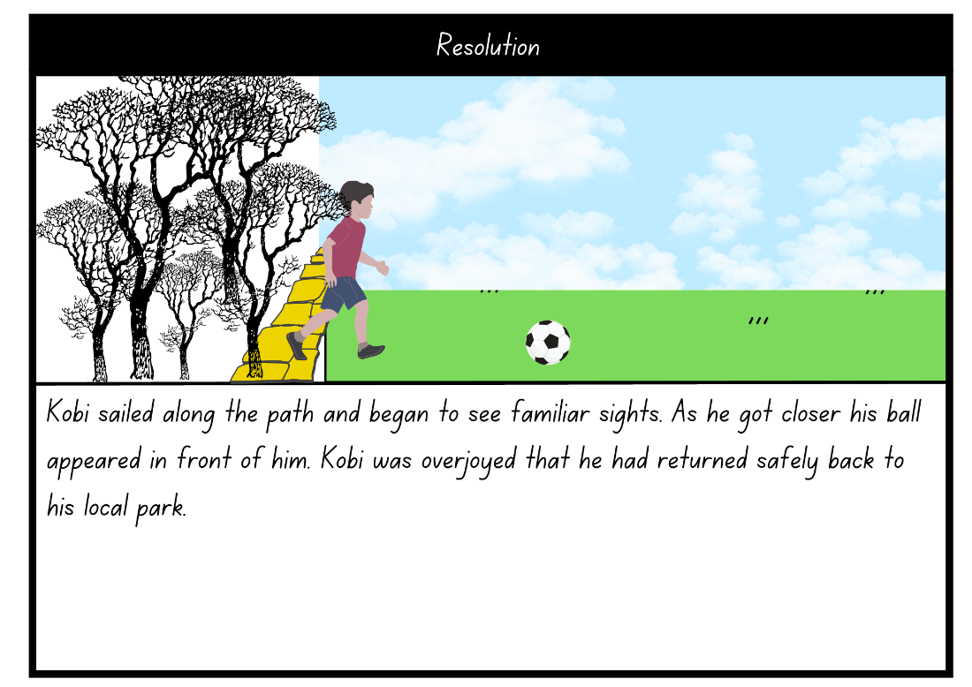
Images sourced from Canva and used in accordance with the Canva Content License Agreement.

Resource 4: Picture book template
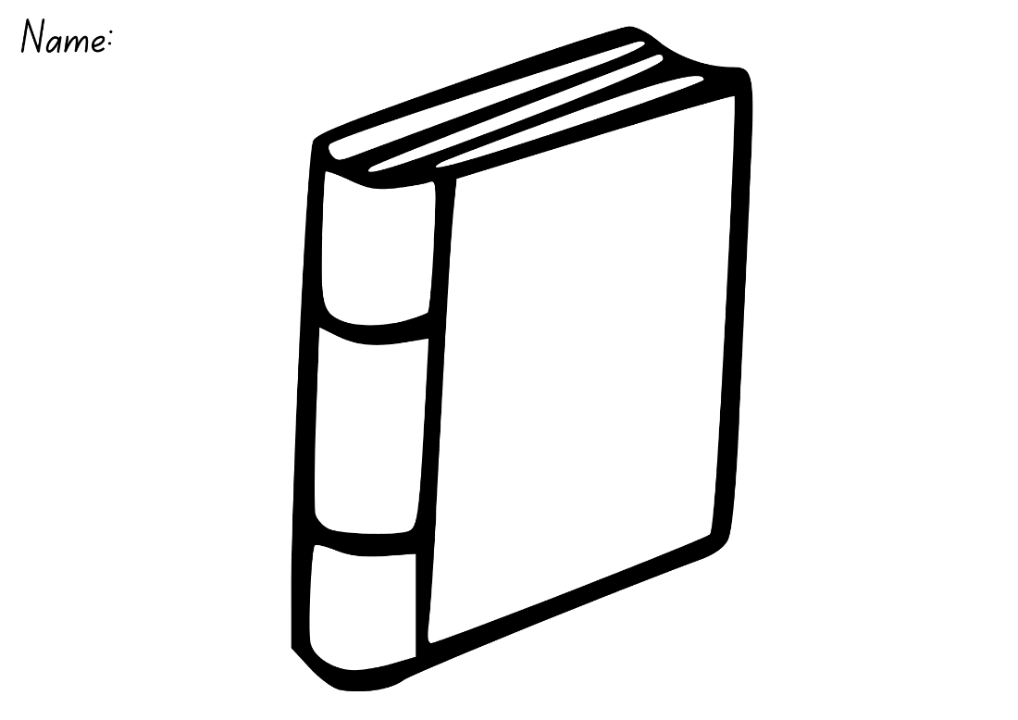
‘Illustration of a book’ by OpenClipart-Vectors sourced from Canva and used in accordance with the Canva Content License Agreement.

References
Links to third-party material and websites
Please note that the provided (reading/viewing material/list/links/texts) are a suggestion only and implies no endorsement, by the New South Wales Department of Education, of any author, publisher, or book title. School principals and teachers are best placed to assess the suitability of resources that would complement the curriculum and reflect the needs and interests of their students.
If you use the links provided in this document to access a third-party's website, you acknowledge that the terms of use, including licence terms set out on the third-party's website apply to the use which may be made of the materials on that third-party website or where permitted by the Copyright Act 1968 (Cth). The department accepts no responsibility for content on third-party websites.
Except as otherwise noted, all material is © State of New South Wales (Department of Education), 2023 and licensed under the Creative Commons Attribution 4.0 International License. All other material (third-party material) is used with permission or under licence. Where the copyright owner of third-party material has not licensed their material under a Creative Commons or similar licence, you should contact them directly for permission to reuse their material.
English K–10 Syllabus © 2022 NSW Education Standards Authority (NESA) for and on behalf of the Crown in right of the State of New South Wales.
© 2022 NSW Education Standards Authority. This document contains NSW Curriculum and syllabus content. The NSW Curriculum is developed by the NSW Education Standards Authority. This content is prepared by NESA for and on behalf of the Crown in right of the State of New South Wales. The material is protected by Crown copyright.
Please refer to the NESA Copyright Disclaimer for more information.
NESA holds the only official and up-to-date versions of the NSW Curriculum and syllabus documents. Please visit the NSW Education Standards Authority (NESA) website and the NSW Curriculum website.
National Literacy Learning Progression © Australian Curriculum, Assessment and Reporting Authority (ACARA) 2010 to present, unless otherwise indicated. This material was downloaded from the Australian Curriculum website (National Literacy Learning Progression) (accessed 6 March 2023) and was not modified. The material is licensed under CC BY 4.0. Version updates are tracked in the ‘Curriculum version history’ section on the 'About the Australian Curriculum' page of the Australian Curriculum website.
ACARA does not endorse any product that uses the Australian Curriculum or make any representations as to the quality of such products. Any product that uses material published on this website should not be taken to be affiliated with ACARA or have the sponsorship or approval of ACARA. It is up to each person to make their own assessment of the product, taking into account matters including, but not limited to, the version number and the degree to which the materials align with the content descriptions and achievement standards (where relevant). Where there is a claim of alignment, it is important to check that the materials align with the content descriptions and achievement standards (endorsed by all education Ministers), not the elaborations (examples provided by ACARA).
Browne A (2005) Into the Forest, Walker Books, Australia.
ETA (English Teachers Association) and NSW Department of Education (2016) The Textual Concepts and Processes resource, English Textual Concepts website, accessed (accessed 6 March 2023).
Mackenzie N (22 October 2019) ‘Draw, Talk, Write (and Share)’, Noella’s Blog, accessed 20 March 2023.
Winston S and Jeffers O (2019) A Child of Books, Walker Books, Australia.

