English – Stage 1 – Unit 36
Contents
Unit overview and instructions for use 3
Teacher notes 4
Outcomes and content – Component A 5
Outcomes and content – Component B 7
Week 1 10
Component A teaching and learning 10
Component B teaching and learning 11
Lesson 1: Introducing The Gentle Genius of Trees 12
Lesson 2: Persuasion and cause and effect 14
Lesson 3: Vocabulary 17
Lesson 4: Visual elements and features 18
Lesson 5: Identifying features of a paragraph 21
Week 2 24
Component A teaching and learning 24
Component B teaching and learning 25
Lesson 6: Navigation pathways and infographics 26
Lesson 7: Planning persuasive writing 29
Lesson 8: Writing paragraphs 30
Lesson 9: Poster creation 31
Lesson 10: Presenting 32
Resource 1: 6 Fun facts 34
Resource 2: Example opinion 35
Resource 3: Traffic light paragraphs 36
Resource 4: Perspective paragraph 37
Resource 5: Comparison stimulus 38
Resource 6: Information gathering 40
Resource 7: Planning tool 41
References 42

Unit overview and instructions for use
This two-week unit is comprised of Component A and Component B. Connecting learning across both components is encouraged.
Teaching and learning | Component A | Component B
Suggested duration | 60 minutes | 45 minutes
Explicit teaching focus areas | - Phonic knowledge  - Reading fluency  - Reading comprehension  - Spelling  - Handwriting | - Oral language and communication  - Vocabulary  - Reading comprehension  - Creating written texts  - Understanding and responding to literature
To prepare for teaching and learning: | - Refer to Outcomes and content – Component A, K-2 – Instructional sequence – grapheme–phoneme correspondences [PDF 825KB], and the teaching advice documents (hyperlinked in Component A teaching and learning table).  - Based on student needs identified through ongoing assessment data, plan and document how you will sequence teaching and learning in whole class and targeted teaching groups across the two-week cycle. | - Familiarise yourself with Outcomes and content – Component B, Textual concepts information and videos, English Textual Concepts and Learning Processes (2016), and the teaching and learning sequence.  - Based on student needs identified through ongoing assessment data, determine how you will support students in whole class and targeted teaching groups across the two-week cycle as required.
English K–10 Syllabus © 2022 NSW Education Standards Authority (NESA) for and on behalf of the Crown in right of the State of New South Wales.

Teacher notes
- Perspective is a lens through which we learn to see the world; it shapes what we see and the way we see it. The lens can clarify, magnify, distort or blur what we see. In this way, perspective provides a dynamic basis for the relationship between composer, text and responder – English Textual Concepts and Learning Processes (2016).
- Understanding of perspective can be supported through watching the department’s video: Perspective (3:37)
- Argument is using persuasion to produce a position or resolution supported by evidence. Argument does not need to be combative; it can build collaboration to solve complex problems – English Textual Concepts and Learning Processes (2016).
- Understanding of perspective can be supported through watching the department’s video: Argument (3:17)
- Perspective and argument are the mentor concepts for the conceptual component of this unit, which can be explored using the mentor text The Gentle Genius of Trees by Phillip Bunting.
- For information on adverbs, tiered words and word families refer to the NESA Glossary.
- This unit could enhance student learning towards achievement of science and technology outcomes.
- Consider prior student knowledge of modifying and qualifying words and prefixes and suffixes used to create word families.
- Reflect on student learning and engagement in activities and record differentiation and adjustments within the unit to inform future teaching and learning. One way of doing this could be to add comments to the digital file.
- Content points are linked to the National Literacy Learning Progression version (3).
Levels and indicators sourced from National Literacy Learning Progression © Australian Curriculum, Assessment and Reporting Authority (ACARA), (accessed 24 February 2023) and was not modified. See references for more information.

Outcomes and content – Component A
The table below outlines the focus outcomes and content. Content is linked to the National Literacy Learning Progression version (3).
Focus area and outcome | Content points and National Literacy Learning Progression
Phonic knowledge  EN1-PHOKW-01 – uses initial and extended phonics, including vowel digraphs, trigraphs to decode and encode words when reading and creating texts | - decode words with less common consonant digraphs and apply this when reading texts.
Reading fluency  EN1-REFLU-01 – sustains reading unseen texts with automaticity and prosody and self-corrects errors | - read aloud with an easy speech rhythm (FlY3)  - adjust phrasing, intonation, volume or rate to maintain fluency when reading aloud (FlY4).
Reading comprehension  EN1-RECOM-01 – comprehends independently read texts that require sustained reading by activating background and word knowledge, connecting and understanding sentences and whole text, and monitoring for meaning | - use navigation pathways, including hyperlinks, to extract essential information to support reading fluency and enhance meaning when reading digital texts  - identify when meaning is not complete and/or contradicts prior understanding  - re-read words, phrases or sentences to check and clarify precise meaning  - use information read in texts to enhance learning across key learning areas.
Spelling  EN1-SPELL-01 – applies phonological, orthographic and morphological generalisations and strategies when spelling words in a range of writing contexts | - segment multisyllabic words into syllables and phonemes as a strategy for spelling (SpG5)  - use extended phonic code for taught consonant phonemes  - use common prefixes such as un–, re– and dis– (SpG9)  - use the suffixes –ful, –y and –ly to spell taught high-frequency words (SpG9).
Handwriting  EN1-HANDW-01 – uses a legible, fluent and automatic handwriting style, and digital technology, including word-processing applications, when creating texts | - use taught software functions to create texts in a range of modes for different contexts, audiences and purposes.

Outcomes and content – Component B
The table below outlines the focus outcomes and content. Content is linked to the National Literacy Learning Progression version (3).
Focus area and outcome | Content points and National Literacy Learning Progression
Oral language and communication  EN1-OLC-01 – communicates effectively by using interpersonal conventions and language to extend and elaborate ideas for social and learning interactions. | - follow extended instructions that contain connectives and conjunctions (LiS5)  - interact to evaluate ideas and refine meaning (InT4, InT5)  - link or compare ideas when interacting.
Vocabulary  EN1-VOCAB-01 – understands and effectively uses Tier 1, taught Tier 2 and Tier 3 vocabulary to extend and elaborate ideas | - use taught morphemic knowledge to create word families  - use vocabulary to express cause and effect (SpK3)  - understand and intentionally choose subject-specific vocabulary to enhance precision and for effect.
Reading comprehension  EN1-RECOM-01 – comprehends independently read texts that require sustained reading by activating background and word knowledge, connecting and understanding sentences and whole text, and monitoring for meaning | - use navigation pathways, including hyperlinks, to extract essential information to support reading fluency and enhance meaning when reading digital texts  - identify how creative visual features are used to expand meaning.
Creating written texts  EN1-CWT-01 – plans, creates and revises texts written for different purposes, including paragraphs, using knowledge of vocabulary, text features and sentence structure | - group sentences into paragraphs commencing with a topic sentence, followed by other sentences with related ideas (CrT7)  - use visual elements to expand meaning in own texts  - use adverbs to modify the meaning of verbs and adjectives (GrA3)  - use modifying and qualifying words and words to indicate quantity  - make intentional word choices to enhance precision of meaning and ideas in a text (CrT5)  - re-read and edit their own texts after receiving feedback.
Understanding and responding to literature  EN1-UARL-01 – understands and responds to literature by creating texts using similar structures, intentional language choices and features appropriate to audience and purpose | - identify phrases in texts that project opinions  - identify how structure and images reinforce ideas  - create and re-create texts that include persuasive arguments, using knowledge of text and language features  - create paragraphs that contain a single idea, beginning with a topic sentence and including supporting evidence with elaborations (CrT7).

Week 1

Component A teaching and learning
The table below can be used to plan and document lessons that address Component A outcomes and content. Both the detailed example [DOC 529KB] of a two-week teaching and learning cycle and brief example [DOC 66KB] may support you in your planning.
Focus Areas | Lesson 1 | Lesson 2 | Lesson 3 | Lesson 4 | Lesson 5
Phonic knowledge
15 minutes
Spelling and Handwriting
15 minutes
Reading comprehension and Reading fluency
30 minutes

Component B teaching and learning
The following teaching and learning sequence has been designed to address Component B outcomes and content. Adapt the sequence as required to best meet the needs of your students.

Learning intention and success criteria
Learning intentions and success criteria are best co-constructed with students.

Learning intention
Students are learning to build on their understanding of perspective and argument and will consider how text structure and use of images can reinforce ideas.

Success criteria
Students can:
- follow instructions and provide opinions
- use cause and effect vocabulary to persuade the reader
- use subject-specific vocabulary and create word families
- identify and use visual elements to engage the reader
- identify features of a paragraph.

Resources
- Bunting P (2021) The Gentle Genius of Trees, Omnibus Books, Australia. ISBN: 9781760975173
- Resource 1: Six fun facts (enlarged copy or individual student copies)
- Resource 2: Example opinion
- Resource 3: Traffic light paragraphs
- Resource 4: Perspective paragraph (enlarged copy or individual student copies)
- Anthropomorphism In Children's Literature
- A3 paper or poster paper
- Sticky notes or paper leaves to add to a drawn tree

Lesson 1: Introducing The Gentle Genius of Trees
Note: Choose a tree close to your classroom for the following activities. Students take a mini-whiteboard, sticky notes or notebook for recording and sharing.
- Read or distribute Resource 1: Six fun facts. Ask students to identify the type of text the infographic is (informative text). Students justify their responses. For example, it provides facts about trees.
- Choose a tree close to your classroom to describe to students. Explain that students will try to identify the tree after hearing a series of instructions.
- Use extended instructions that contain connectives and conjunctions to locate the chosen tree. For example: ‘When you leave the classroom, turn left, then follow the path to the end. After that, go down the stairs and turn right. Next, look straight ahead and see if you can identify the tree.’
- In pairs, students use the See-Think-Wonder strategy to share their thinking about the tree, based on their prior knowledge and Resource 1: Six fun facts. For example:
- ‘I see a tall, strong tree’
- ‘I think that many creatures would call this tree home’
- ‘I wonder what type of trunk the tree has. How has this tree grown?’
- ‘I wonder why the branches reach for the sun?’
- As students are returning to the classroom, ask them to consider why they think trees are important.
- Revisit what an opinion is and explain that students will write an opinion about the importance of trees. Students write their opinion on a mini whiteboard. This will be used again in activity 10.
- Display and discuss the front and back cover of the text The Gentle Genius of Trees by Philip Bunting. Skim through the text, displaying the layout of some of the pages. Read the blurb. Ask students to predict the:
- type of text – informative, descriptive storytelling, persuasive
- content of the text – information and fun facts about trees
- audience for the text – primary aged children, anyone who has an interest in trees.
- Explain that the purpose of The Gentle Genius of Trees is to provide information and how the text can be used to persuade the readers of the importance of trees and how they can teach life lessons.
- Model writing an opinion about the importance of trees. Include a justification. Optional: Use Resource 2: Example opinion.
- Using the opinions from activity 6 and the modelled writing, students write a short text to justify their opinion about the importance of trees.
Too hard? Students draw a tree and write key words to support their opinion.
Too easy? Students refer to the text and Resource 1: Six fun facts to provide evidence to support their opinion.
Stage 1 Assessment task 1 – Observations from this lesson allow students to demonstrate achievement towards the following syllabus outcome and content point:
EN1-OLC-01 – communicates effectively by using interpersonal conventions and language to extend and elaborate ideas for social and learning interactions
- follow extended instructions that contain connectives and conjunctions.

Lesson 2: Persuasion and cause and effect
- Read The Gentle Genius of Trees and recall key ideas.
- Revisit what ‘argument’ and ‘perspective’ mean. Allow opportunity for students to discuss. Define an argument as a stated position about an idea, such as theme, perspective and style. A perspective is how someone perceives the world or understands something. Note that, when authors write using this style, they are writing persuasive text.
- Clarify that the author’s purpose is to share his perspective and convince readers to think in a particular way about an issue. The author, Philip Bunting, compares trees to humans because he wants the reader to think about how trees and humans grow best and what life lessons humans can learn from trees. He uses humour and anthropomorphism to make connections with the reader and to evoke feelings that may challenge opinions.
- Explain that perspective and argument can be expressed using cause and effect. When authors use cause and effect, it strengthens their perspective and argument as it explains or gives reason to something.
- Define that a ‘cause’ explains why something happens and an ‘effect’ explains what happened. For example, ‘Trees need to grow slow and strong so that we have shade to protect us from the sun.’
- cause – trees need to grow slow and strong
- effect – we have shade to protect us from the sun.
- Display the page that states ‘A slower pace of life suits trees very well.’ Read the sentence ‘The tree that grows slowly will push its energy into a strong trunk and deeper roots, giving it a lifetime of stability.’ Draw attention to the cause and the effect within the sentence. For example:
- cause – push its energy into the strong trunk and deeper roots
- effect – giving it a lifetime of stability.
- Select additional examples from the same page to use the cause and effect to highlight the perspective and/or argument.
- Display the double page that states ‘We hairy humans have a pretty special relationship with trees.’ Discuss the labelled illustrations. Co-construct sentences using cause and effect to state a perspective based on the illustrations. For example:
- food – ‘When trees are watered, they grow healthy and produce crisp, juicy apples.’
- fun – ‘When trees grow strong, thick branches, I can swing upside down.’
- books – ‘Trees can be turned into paper so that we have books to read.’
- Explain that students will select a word or label from the double page from activity 8 and draw their own picture to match. Students write a sentence using cause and effect to state their perspective. For example, Camp fires – logs from the trees can make a fire and I can toast marshmallows.
Too hard? Co-construct sentences using cause and effect. Students copy the sentence and add their own image.
Too easy? Students include multiple effects in their sentence. For example, ‘Trees can be made into paper so that I can read books and write letters.’
- Group students that selected the same label or word. Students read their sentences and discuss the different perspectives and ideas.
- Discuss the importance of recognising the opinions of others. As a class, share the different perspectives that used the same word or label.
Stage 1 Assessment task 4 – Observations and work samples from this lesson allow students to demonstrate achievement towards the following syllabus outcomes and content points:
EN1-OLC-01 – communicates effectively by using interpersonal conventions and language to extend and elaborate ideas for social and learning interactions
- interact to evaluate ideas and refine meaning
- link or compare ideas when interacting.
EN1-VOCAB-01 – understands and effectively uses Tier 1, taught Tier 2 and Tier 3 vocabulary to extend and elaborate ideas
- use vocabulary to express cause and effect.

Lesson 3: Vocabulary
- Revisit The Gentle Genius of Trees. Discuss how the author has used subject-specific (informative) and persuasive words and phrases throughout the text to inform and provide subtle arguments about the importance of trees. For example:
- subject-specific – petiole, water (H2O), nutrients
- persuasive – cleverly, wonderful, marvellous, must be, take notice.
- Display a large image of a tree or draw one on a large piece of poster paper. Re-read the double page that begins with ‘While we eat food to grow, trees fuel up in a slightly different way.’ Using pre-cut paper leaves or sticky notes, record some of the subject-specific words that trees use to ‘fuel up’ For example, oxygen, nutrients, photosynthesis.
- Add examples of persuasive words to the tree using a different colour leaf or sticky note. For example, beautifully, cleverly, wonderful.
- Place the subject-specific (Tier 3 words) higher in the tree and persuasive (Tier 2 words) lower.
Note: Tier 2 words– academic words that can be used across a variety of domains. They are of high utility for mature language users and are commonly used in written language. Tier 3 words – words that are used rarely (low frequency) and only in highly specific situations.
- Model selecting a word from the tree in activity 3. Explain that there are many sources for finding the definition of a word, for example, the text, asking someone, a dictionary, the internet. Select a source and write the definition under the word.
- Individually or in pairs, allocate students a word from the tree. Students write the word on a mini whiteboard then use a source to find and write the meaning.
- Co-construct a word family using the base word ‘grow’ (grow, grows, growing, grew). A graphic organiser such as a word web could be used. Add the words to the trunk of the tree, verbalising sentences to demonstrate correct use. For example, ‘The sunlight helps the tree grow. The tree grows because it uses photosynthesis. While the tree is growing, it uses nutrients from the air.’
- Select base words from the text and display. For example, sun, eat, live, breathe. Students independently create word families using a base word from the text.
- Students write sentences using words from activity 2 (subject-specific), activity 3 (persuasive) and activity 8 (word families). For example, ‘The sunlight gives the marvellous tree nutrients to help it grow.’
Too hard? Students use sentence starters to write.
Too easy? Students select several Tier 3 words to use in sentences and use a persuasive hook at the beginning of the sentence. For example, ‘take notice’, ‘just think’.
Stage 1 Assessment task 2 – Observations and work samples from this lesson allow students to demonstrate achievement towards the following syllabus outcome and content point:
EN1-VOCAB-01 – understands and effectively uses Tier 1, taught Tier 2 and Tier 3 vocabulary to extend and elaborate ideas
- use taught morphemic knowledge to create word families.

Lesson 4: Visual elements and features
- Revise the vocabulary from the text, subject-specific, informative, persuasive.
- Read the blurb on the back cover of the text and clarify that, when illustrators give illustrations human characteristics, it is called ‘anthropomorphism’. For example, the mushroom talking, the leaves and trees with eyes.
- Revisit The Gentle Genius of Trees by flicking through the pages. Discuss the visual elements and how these expand meaning and reinforce ideas. For example:
- subheadings – allow readers to look for specific information without reading the whole page
- diagrams – provide a visual image to explain the written text, this makes information easier to understand
- speech bubbles and eyes on images – give the animals and objects human characteristics.
- Explain that an illustrator arranges the illustrations or images just as carefully as an author places words in a sentence. Each illustration is planned and uses a range of visual elements and features to engage and persuade the reader. For example, the use of speech bubbles to draw the reader in to present the opinions of the characters.
- Explain that Philip Bunting (author and illustrator) also uses humour to engage the reader. For example, some characters are talking and some images are humourous, such as the passing deer on the connection diagram.
- Display the double page that depicts a variety of leaves, which states ‘Next time you take a wander through the woods’. Ask students what information is on the page. For example, the leaves are from different tree types, the leaves are a variety of shapes and sizes, the leaves are telling a joke about a type of tree – humour, anthropomorphism is being used. Discuss what this page might look like if these visual features were not used. For example, chunks of text describing the variety of leaves shown.
- Refer to the double page that states, ‘A slower pace of life suits trees very well.’ Draw attention to this sentence, noting the textual concept of persuasion and argument, as the author is stating his opinion. Explain that students will use visual elements to re-create the image on the double page.
- Model a drawing to re-create the image on the double page, referring to the visual elements and features used. For example, using anthropomorphism, speech bubbles and humour. Draw:
- facial expressions on the trees that the kookaburras are in
- the kookaburras having a conversation with each other, using speech bubbles
- any other features that may expand meaning.
- Discuss how the kookaburras might be feeling and what they could be saying to each other.
- Students use their writing from Lesson 3 and add further sentences to express an opinion. For example, ‘The sunlight gives the marvellous tree nutrients to help it grow. Trees are really clever as they use sunlight to make food!’
- Students add creative visual features to expand meaning. For example, applying human characteristics to trees, the sun, or animals.
Too hard? Students work in pairs to verbalise their opinions and share ideas about what visual features that could be used to support meaning.
Too easy? Students use visual elements to create a detailed additional image for the text.
Stage 1 Assessment task 3 – Observations and work samples from this lesson allow students to demonstrate achievement towards the following syllabus outcomes and content points:
EN1-RECOM-01 – comprehends independently read texts that require sustained reading by activating background and word knowledge, connecting and understanding sentences and whole text, and monitoring for meaning
- identify how creative visual features are used to expand meaning.
EN1-UARL-01 – understands and responds to literature by creating texts using similar structures, intentional language choices and features appropriate to audience and purpose
- identify how structure and images reinforce ideas.

Lesson 5: Identifying features of a paragraph
- Revisit The Gentle Genius of Trees. Revise the author’s purpose and how vocabulary, visual features and cause and effect support his perspective and project opinion.
- Ask and record:
- What was the author’s perspective? How do we know? For example, ‘He believes that trees are extremely important and provide humans with what they need to survive. The author wants humans to grow tough and strong so that they can deal with any situation, just like trees. He compares humans to trees and makes connections with the reader through his persuasive techniques.’
- What examples can we see to support the author’s opinion? For example, ‘When the deer munches on a tree, the tree sends signals to other trees to warn them’. Later, the author says, ‘Look out for those around you, and they will look out for you.’ The author has compared how trees protect each other to how humans can protect each other.’
- How did the author make you feel? Why? For example, the author makes connections with the reader and evokes feeling using persuasive language.
- Display the double page stating, ‘To communicate with one another in these ways, trees rely on a special relationship’. Ask what students notice about the text on these pages. Draw attention to the paragraphs.
- Display Resource 3: Traffic light paragraphs to explain and discuss the features of paragraphs.
- Deconstruct the last paragraph on the double page stating, ‘As a tree grows, its branches search out’. Identify the topic sentence, supporting examples or elaborations and concluding statement. For example:
- topic sentence – ‘As a tree grows, its branches search out and grow towards the light.’
- supporting examples or elaborations – ‘The more light, the more energy (and glucose) the leaves on that branch can produce.’
- concluding statement – ‘So branches growing in more light will receive the most nutrients from the tree and grow the strongest.’
- Revise how authors use words to add information and give readers a clearer picture of the texts’ subject. Revise cause and effect and discuss the purpose of:
- adverbs – a word that tells something about a verb, adjective or another adverb. It indicates things like manner, place or time. For example, quietly, slowly, soon. An adverb commonly ends in -ly.
- modifying and qualifying – words that can be used to indicate quantity and add detail to a sentence. For example, several, few, many.
- Use the displayed double page from activity 3 to identify examples of adverbs and modifying and qualifying words. For example:
- adverbs – mutually, lovely
- modifying and qualifying words – some, more, most.
- Model planning key ideas that could be used to write a paragraph about the author’s perspective. Refer to activity 2.
- Use the key ideas to co-construct a paragraph or refer to Resource 4: Perspective paragraph.
- In small groups, students deconstruct the paragraph from activity 9, then identify and discuss the use of:
- paragraph structure
- cause and effect (cause – humans grow tough and strong, effect – so they can deal with any situation)
- adverbs to modify meaning of verbs and adjectives (carefully, extremely)
- modifying and qualifying words to indicate quantity (some, most).

Week 2

Component A teaching and learning
The table below can be used to plan and document lessons that address Component A outcomes and content. Both the detailed example [DOC 529KB] of a two-week teaching and learning cycle and brief example [DOC 66KB] may support you in your planning.
Focus Areas | Lesson 6 | Lesson 7 | Lesson 8 | Lesson 9 | Lesson 10
Phonic knowledge
15 minutes
Spelling and Handwriting
15 minutes
Reading comprehension and Reading fluency
30 minutes

Component B teaching and learning
The following teaching and learning sequence has been designed to address Component B outcomes and content. Adapt the sequence as required to best meet the needs of your students.

Learning intention and success criteria
Learning intentions and success criteria are best co-constructed with students.

Learning intention
Students are learning to build on and apply their understanding of perspective and argument to create a multimodal text.

Success criteria
Students can:
- use navigation pathways
- plan persuasive writing
- write using correct paragraph structure
- create posters using persuasive techniques
- share persuasive posters and opinions.

Resources
- Bunting P (2021) The Gentle Genius of Trees, Omnibus Books, Australia. ISBN: 97817609751
- We All Need Trees
- Trees: the forgotten heroes of our health [PDF 48.9MB]
- Resource 5: Comparison stimulus
- Resource 6: Information gathering (individual student copies)
- Resource 7: Planning tool (individual student copies)
- Technology or A3 paper for poster creation

Lesson 6: Navigation pathways and infographics
- View Resource 5: Comparison stimulus. Ask:
- What can you see?
- How does it make you feel?
- What does it make you think?
- Model making a comparison between the 2 pictures by providing an opinion on the importance of trees. Draw attention to cause and effect. For example:
- cause – the devastation of bushfire; effect – animals have nowhere to live and no food to eat
- cause – trees are important; effect – many animals eat different parts of trees as their diet
- cause – trees have branches and tree hollows; effect – animals use them for shelter and build their homes.
- Students turn and talk, sharing their opinion about the stimulus.
- Ask students to recall different ways that information can be sourced. For example, texts, websites and knowledgeable others. Display the We all need trees web page from the WWF Australia website.
- Scroll down the webpage, ask students what they can see that tells them this is a reliable source of information. For example, the information at the bottom of the page providing the registered charity number and NSW licence number.
- Discuss the navigation pathways on the webpage and how to find information. Ask:
- What was the first thing that caught your eye? Why did your eyes go there first?
- How do you know when something on the screen will take you to a different page?
- Which parts of this webpage are useful for gaining information about trees?
- Scroll to locate the heading Learn more about the benefits of trees and select Find out more. Explain that this page provides information about why trees are important. Make text-to-text connections between the website, Resource 5: Comparison stimulus and The Gentle Genius of Trees by asking students to identify examples of persuasion, cause and effect, subject-specific vocabulary and visual elements. For example:
- persuasion – words such as champions, help, sadly; asking a question and supporting with reasons and facts; use of emotive language
- cause – trees purify our air by removing fine particles and pollutants; effect – trees clear our air and produce the oxygen we breathe
- subject-specific vocabulary – environmental, photosynthesis, oxygen
- visual elements – photographs, subheadings.
- Provide an example of a persuasive poster. Select Read the report here in point 4 of the Why are trees important? webpage. Scroll to the bottom to locate Trees: the forgotten heroes of our health [PDF 48.9MB]. Refer to pages 13, 14, 22 of the document. Refer to the sub-headings, images, diagrams, font size and use of text boxes to highlight important points. These pages will be used again in Lesson 7 and Lesson 9.
- Ask students to identify phrases from pages 13, 14 and 22 from The Forgotten heroes of our health that project opinions.
- Explain that students will create their own poster with a persuasive paragraph to present their opinion about the benefits of trees. Students will use elements including images and subject-specific vocabulary that show cause and effect, persuasion, and argument.
- Explain the importance of effective planning for writing. For example, supporting inspiration of ideas, selecting and sorting ideas to write about.
- Discuss which sources strengthen perspective or argument and identify phrases within the sources that support opinions. For example:
- The Gentle Genius of Trees
- WWF Australia website and associated pages
- Resource 1: 6 fun facts
- Resource 5: Comparison stimulus
- Model gathering information from a range of sources using Resource 6: Information gathering. Include subject-specific vocabulary, sub-headings, dot-points and cause and effect. Remind students that the information gathered and detailed planning will support their writing.
- Students complete Resource 6: Information gathering by gathering images and relevant information from a variety of sources.
Too hard? Write key words on a referral chart to prompt students to record the type of information required.
Stage 1 Assessment task 5 – Observations and work samples from this lesson allow students to demonstrate achievement towards the following syllabus outcomes and content points:
EN1-RECOM-01 – comprehends independently read texts that require sustained reading by activating background and word knowledge, connecting and understanding sentences and whole text, and monitoring for meaning
- use navigation pathways, including hyperlinks, to extract essential information to support reading fluency and enhance meaning when reading digital texts.
EN1-UARL-01 – understands and responds to literature by creating texts using similar structures, intentional language choices and features appropriate to audience and purpose
- identify phrases in texts that project opinions.

Lesson 7: Planning persuasive writing
- Revisit The Gentle Genius of Trees and display pages 13, 14 and 22 from Trees: the forgotten heroes of our health [PDF 48.9MB]. Revise aspects of the pages that provide persuasive information and show engaging visual features that persuade readers to agree that trees are beneficial.
- Explain that a persuasive text:
- expresses a point of view
- provides supporting evidence
- may conclude with a call to action.
- Remind students that they will be creating their own poster and persuasive argument. Students will present their opinion, about the benefits of trees, to their peers. Posters could be displayed outside the classroom for whole school engagement. Students will use elements including, images, subject-specific vocabulary that show cause and effect, persuasion and argument.
- Co-create success criteria for creating a poster and writing a paragraph to persuade. For example, I can:
- use correct paragraph structure
- include persuasion and opinion
- use subject-specific vocabulary
- write using cause and effect
- use modifying and qualifying words to indicate quantity
- use adverbs
- use visual elements to expand meaning.
- Model planning for writing using Resource 7: Planning tool, referring to selected images and information gathered from Lesson 6, activity 13. This will be used in Lesson 8.
- Students plan their writing using Resource 7: Planning tool and information gathered from Lesson 6, activity 13.

Lesson 8: Writing paragraphs
- Revise paragraphs from Lesson 5, referring to Resource 3: Traffic light paragraphs.
- Model writing a paragraph to persuade using Resource 7: Planning tool. For example, ‘Trees are extremely important and we could not survive without them. Trees help us breathe by actively producing oxygen that helps keep us puffing along. Many parts of a tree can also be used to provide delicious food for humans and animals. The wood from trees provides us with a lot of resources, such as timber for houses, furniture and paper. Trees also provide a habitat for animals like birds, possums and bees.’
- Students write (a) paragraph(s) to persuade about the importance of trees.
Too hard? Facilitate use of text-to-speech technology or audio recording to produce the paragraph.
- Students share their writing with a partner and provide and apply feedback using the success criteria and TAG feedback proforma.

Lesson 9: Poster creation
- Allow time for students to finish applying feedback to the paragraphs from Lesson 8.
- Remind students of the visual elements that were used to expand meaning in the text The Gentle Genius of Trees and the posters from Lesson 7.
- Students create a poster. Offer a choice publishing mediums. For example, digital form such as a poster template in Canva or written form on a piece of A3 paper.
Stage 1 Assessment task 6 – Observations and work samples from this lesson allow students to demonstrate achievement towards the following syllabus outcomes and content points:
EN1-VOCAB-01 – understands and effectively uses Tier 1, taught Tier 2 and Tier 3 vocabulary to extend and elaborate ideas
- understand and intentionally choose subject-specific vocabulary to enhance precision and for effect
EN1-CWT-01 – plans, creates and revises texts written for different purposes, including paragraphs, using knowledge of vocabulary, text features and sentence structure
- group sentences into paragraphs commencing with a topic sentence, followed by other sentences with related ideas
- use visual elements to expand meaning in own texts
- use adverbs to modify the meaning of verbs and adjectives
- use modifying and qualifying words and words to indicate quantity
- make intentional word choices to enhance precision of meaning and ideas in a text
- re-read and edit their own texts after receiving feedback.
EN1-UARL-01 – understands and responds to literature by creating texts using similar structures, intentional language choices and features appropriate to audience and purpose
- create and re-create texts that include persuasive arguments, using knowledge of text and language features
- create paragraphs that contain a single idea, beginning with a topic sentence and including supporting evidence with elaborations.

Lesson 10: Presenting
- Explain that students are going to act as an expert on trees and share their perspective and information from their research using their posters.
- Model:
- facing your partner and maintaining eye-contact
- using key words as a prompt to the conversation instead of reading information word-for-word
- avoiding digression
- asking questions.
- In pairs or small groups, students act as an expert on trees to share their perspective and information from their research. Remind students to use their posters as a prompt.
- As a class, provide a whole class opinion on the importance of trees. For example: ‘Class 2 believes …’
- Posters could be displayed outside the classroom for whole school engagement.

Resource 1: Six fun facts
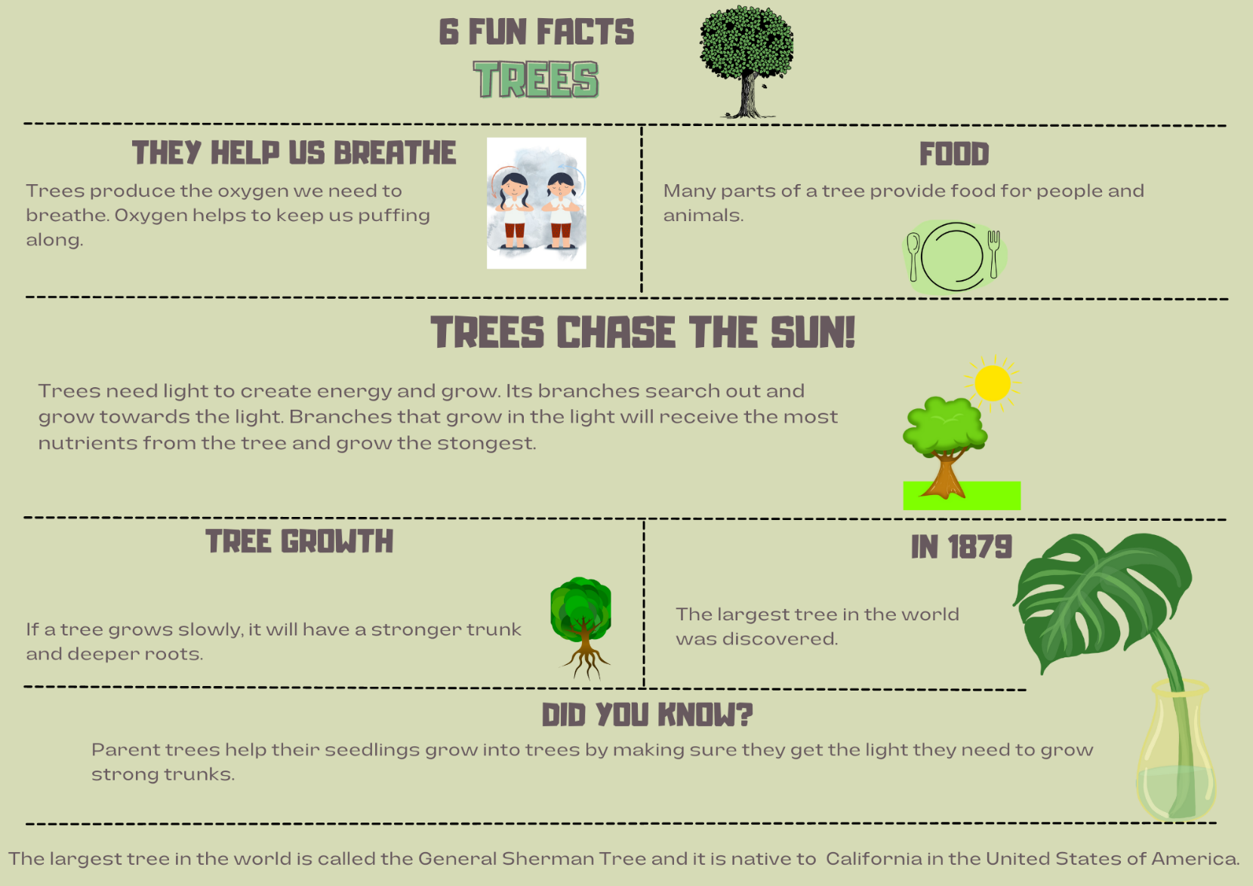
Images sourced from Canva and used in accordance with the Canva Content License Agreement

Resource 2: Example opinion
Trees are very important and I do not believe we could live without them!
Trees are important to us because they help us breathe by producing oxygen. Many parts of a tree can also be used to provide food for humans and animals. The wood from trees also provides us with lots of resources, like timber for houses, furniture and paper. Trees also provide homes for animals such as birds, koalas and possums.
Trees are truly amazing, and everyone should appreciate how important they are.

Resource 3: Traffic light paragraphs
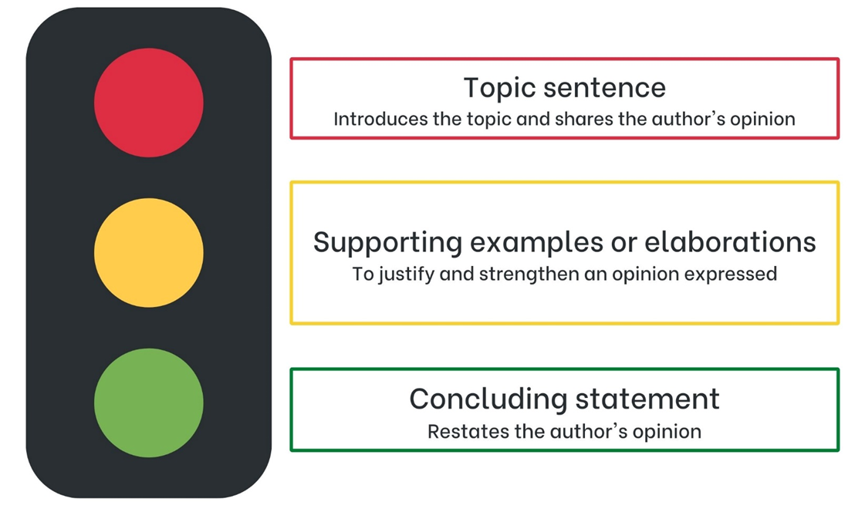
Images sourced from Canva and used in accordance with the Canva Content License Agreement.

Resource 4: Perspective paragraph
The text The Gentle Genius of Trees, written by Philip Bunting, compares trees to humans. The author wants the reader to carefully consider how trees and humans grow best and learn some life lessons. He uses many visual elements to make connections with the reader to evoke feelings. This is his way of trying to convince readers to agree with him. He believes that trees are extremely important and provide humans with what they need to survive. He wants humans to grow tough and strong so that they can deal with any situation, just like trees.

Resource 5: Comparison stimulus
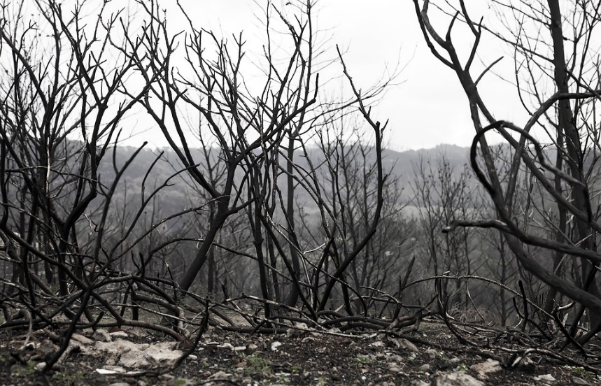
‘Forest Fire Bushfire Mountain’ by Alpinep is licensed under the Pixabay License.
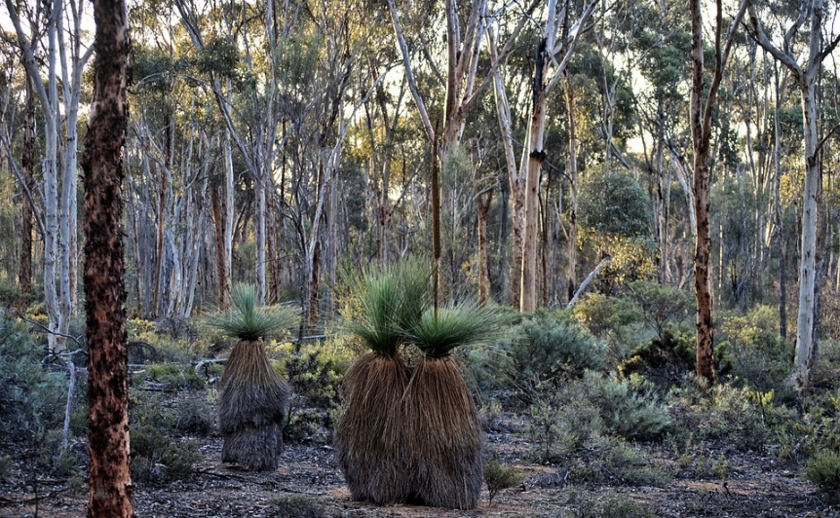
‘Bush Forest Nature’ by Terri Sharp is licensed under the Pixabay License.

Resource 6: Information gathering
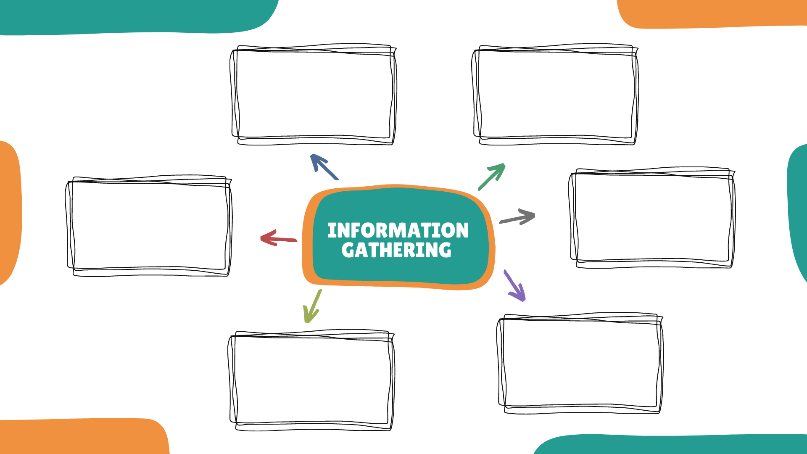
Images sourced from Canva and used in accordance with the Canva Content License Agreement.

Resource 7: Planning tool
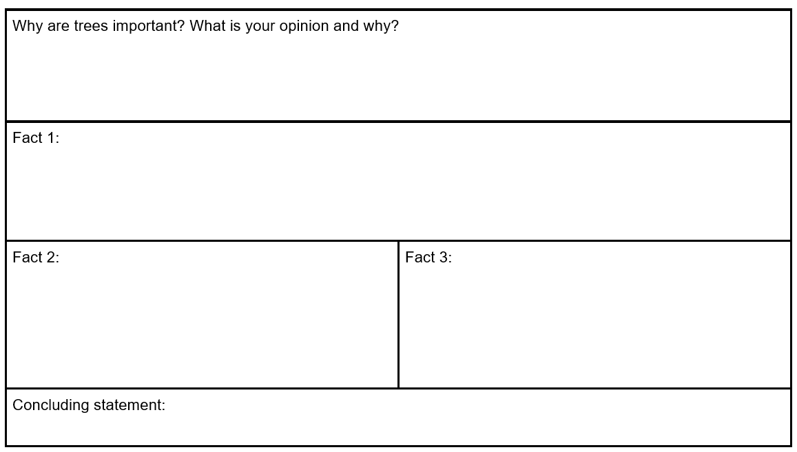

References
Links to third-party material and websites
Please note that the provided (reading/viewing material/list/links/texts) are a suggestion only and implies no endorsement, by the New South Wales Department of Education, of any author, publisher, or book title. School principals and teachers are best placed to assess the suitability of resources that would complement the curriculum and reflect the needs and interests of their students.
If you use the links provided in this document to access a third-party's website, you acknowledge that the terms of use, including licence terms set out on the third-party's website apply to the use which may be made of the materials on that third-party website or where permitted by the Copyright Act 1968 (Cth). The department accepts no responsibility for content on third-party websites.
Except as otherwise noted, all material is © State of New South Wales (Department of Education), 2023 and licensed under the Creative Commons Attribution 4.0 International License. All other material (third-party material) is used with permission or under licence. Where the copyright owner of third-party material has not licensed their material under a Creative Commons or similar licence, you should contact them directly for permission to reuse their material.
English K–10 Syllabus © 2022 NSW Education Standards Authority (NESA) for and on behalf of the Crown in right of the State of New South Wales.
© 2022 NSW Education Standards Authority. This document contains NSW Curriculum and syllabus content. The NSW Curriculum is developed by the NSW Education Standards Authority. This content is prepared by NESA for and on behalf of the Crown in right of the State of New South Wales. The material is protected by Crown copyright.
Please refer to the NESA Copyright Disclaimer for more information.
NESA holds the only official and up-to-date versions of the NSW Curriculum and syllabus documents. Please visit the NSW Education Standards Authority (NESA) website and the NSW Curriculum website.
National Literacy Learning Progression © Australian Curriculum, Assessment and Reporting Authority (ACARA) 2010 to present, unless otherwise indicated. This material was downloaded from the Australian Curriculum website (National Literacy Learning Progression) (accessed 24 February 2023) and was not modified. The material is licensed under CC BY 4.0. Version updates are tracked in the ‘Curriculum version history’ section on the 'About the Australian Curriculum' page of the Australian Curriculum website.
ACARA does not endorse any product that uses the Australian Curriculum or make any representations as to the quality of such products. Any product that uses material published on this website should not be taken to be affiliated with ACARA or have the sponsorship or approval of ACARA. It is up to each person to make their own assessment of the product, taking into account matters including, but not limited to, the version number and the degree to which the materials align with the content descriptions and achievement standards (where relevant). Where there is a claim of alignment, it is important to check that the materials align with the content descriptions and achievement standards (endorsed by all education Ministers), not the elaborations (examples provided by ACARA).
ETA (English Teachers Association) and NSW Department of Education (2016) The Textual Concepts and Processes resource, English Textual Concepts website, accessed 24 February 2023.
Bunting P (2021) The Gentle Genius of Trees, Omnibus Books, Australia. ISBN: 97817609751
Gray LC (2019) Anthropomorphism in Children’s Literature, May Gibbs website, accessed 2 March 2023.
WWF-Australia (2018) We All Need Trees, WWF Australia website, accessed 9 March 2023.
WWF-Australia and Doctors for the Environment Australia (2023) Trees: the forgotten heroes of our health, WWF-Australia, accessed 9 March 2023.

