English – Stage 1 – Unit 35
Contents
Unit overview and instructions for use 3
Teacher notes 4
Outcomes and content – Component A 5
Outcomes and content – Component B 6
Week 1 10
Component A teaching and learning 10
Component B teaching and learning 11
Lesson 1: Exploring character in ‘Bertha the Blubberer’ 13
Lesson 2: Using visual features and dialogue to show character traits 15
Lesson 3: Using noun groups to describe a character 17
Lesson 4: Verbs, conjunctions, simple and compound sentences 19
Lesson 5: Writing a character description using different sentence structures 20
Week 2 23
Component A teaching and learning 23
Component B teaching and learning 24
Lesson 6: Introduction to Grubby Gertrude 25
Lesson 7: Create a character 26
Lesson 8: Creating a character portrait 27
Lesson 9: Composing and editing a character description 28
Lesson 10: Publishing and presenting 29
Resource 1: Dialogue checklist 30
Resource 2: Verbs 31
Resource 3: FANBOYS 32
Resource 4: Sentences 33
Resource 5: Portrait frame template 34
Resource 6: Character profile template 35
References 36

Unit overview and instructions for use
This two-week unit is comprised of Component A and Component B. Connecting learning across both components is encouraged.
Teaching and learning | Component A | Component B
Suggested duration | 60 minutes | 45 minutes
Explicit teaching focus areas | - Phonic knowledge  - Reading fluency  - Reading comprehension  - Spelling  - Handwriting | - Oral language and communication  - Vocabulary  - Reading comprehension  - Creating written texts  - Understanding and responding to literature
To prepare for teaching and learning: | - Refer to Outcomes and content – Component A, K-2 – Instructional sequence – grapheme–phoneme correspondences [PDF 825 KB], and the teaching advice documents (hyperlinked in Component A teaching and learning table).  - Based on student needs identified through ongoing assessment data, plan and document how you will sequence teaching and learning in whole class and targeted teaching groups across the two-week cycle. | - Familiarise yourself with Outcomes and content – Component B, Textual concepts information and videos, English Textual Concepts and Learning Processes (2016), and the teaching and learning sequence.  - Based on student needs identified through ongoing assessment data, determine how you will support students in whole class and targeted teaching groups across the two-week cycle as required.
English K–10 Syllabus © 2022 NSW Education Standards Authority (NESA) for and on behalf of the Crown in right of the State of New South Wales.

Teacher notes
- Character is a construct of verbal and visual statements about a fictional identity. Analysis of characters contribute to our own personal judgements about self, morals, and values. – English Textual Concepts and Learning Processes (2016).
- Understanding of character can be supported through watching the department’s video: Character (2:31).
- For information on noun groups, adjectives, adverbs, compound, and complex sentences, refer to the NESA Glossary.
- Consider prior student knowledge regarding commas, proper nouns, and noun groups.
- This unit could enhance student learning towards the achievement of creative arts outcomes.
- Reflect on student learning and engagement in activities and record differentiation and adjustments within the unit to inform future teaching and learning. One way of doing this could be to add comments to the digital file.
- Content points are linked to the National Literacy Learning Progression version (3).
Levels and indicators sourced from National Literacy Learning Progression © Australian Curriculum, Assessment and Reporting Authority (ACARA), (accessed 8 February 2023) and was not modified. See references for more information.

Outcomes and content – Component A
The table below outlines the focus outcomes and content. Content is linked to the National Literacy Learning Progression version (3).
Focus area and outcome | Content points and National Literacy Learning Progression
Phonic knowledge  EN1-PHOKW-01 – uses initial and extended phonics, including vowel digraphs, trigraphs to decode and encode words when reading and creating texts | - decode words with less common consonant digraphs and apply this when reading texts  - blend and decode 2-syllable words with taught vowel graphs, digraphs, trigraphs and quadgraphs, including graphemes for r-controlled vowels and diphthongs and apply this when reading texts (PKW6, PKW7)
Reading fluency  EN1-REFLU-01 – sustains reading unseen texts with automaticity and prosody and self-corrects errors | - self-correct when fluency and/or meaning is interrupted  - vary pace when reading according to the audience and purpose (FIY4)
Reading comprehension  EN1-RECOM-01 – comprehends independently read texts that require sustained reading by activating background and word knowledge, connecting and understanding sentences and whole text, and monitoring for meaning | - coordinate information or events from different parts of the text to form an overall opinion  - re-read words, phrases or sentences to check and clarify precise meaning
Spelling  EN1-SPELL-01 – applies phonological, orthographic and morphological generalisations and strategies when spelling words in a range of writing contexts | - segment multisyllabic words into syllables and phonemes as a strategy for spelling (SpG5)  - use extended phonic code for taught consonant phonemes
Handwriting  EN1-HANDW-01 – uses a legible, fluent and automatic handwriting style, and digital technology, including word-processing applications, when creating texts | - position all letters correctly on the line with appropriate spacing between words (HwK5)

Outcomes and content – Component B
The table below outlines the focus outcomes and content. Content is linked to the National Literacy Learning Progression version (3).
Focus area and outcome | Content points and National Literacy Learning Progression
Oral language and communication  EN1-OLC-01 – communicates effectively by using interpersonal conventions and language to extend and elaborate ideas for social and learning interactions. | - use adjectives and adverbs to elaborate and/or provide some supporting details or justifications and express causal relationships (SpK3)
Vocabulary  EN1-VOCAB-01 – understands and effectively uses Tier 1, taught Tier 2 and Tier 3 vocabulary to extend and elaborate ideas | - understand and intentionally choose subject-specific vocabulary to enhance precision and for effect
Reading comprehension  EN1-RECOM-01 – comprehends independently read texts that require sustained reading by activating background and word knowledge, connecting and understanding sentences and whole text, and monitoring for meaning | - identify pronouns linked to nouns within and across sentences and/or paragraphs  - identify how creative visual features are used to expand meaning  - make text-to-self, text-to-text or text-to-world connections when reading (UnT6)
Creating written texts  EN1-CWT-01 – plans, creates and revises texts written for different purposes, including paragraphs, using knowledge of vocabulary, text features and sentence structure | - use noun/pronoun-referencing across a text (CrT7)  - use visual elements to expand meaning in own texts  - use a combination of simple and compound sentences to engage the reader when creating written texts (CrT6, GrA4)  - experiment with writing complex sentences which include a clause for the main message and dependent clause to elaborate or modify the message (GrA5)  - use noun groups to build descriptions of people and things (CrT6)  - use action, saying, relating and sensing verbs to add detail and precision to writing (GrA2, GrA5)  - use adverbs to modify the meaning of verbs and adjectives (GrA3)  - use commas to separate ideas, lists and/or dependent clauses in a sentence (PuN4, PuN6)  - use quotation marks for simple dialogue (PuN5)  - use possessive apostrophes in own writing (PuN4)  - make intentional word choices to enhance precision of meaning and ideas in a text (CrT5)  - use different modes and media to enhance the presentation of texts they have (CrT5, CrT6)
Understanding and responding to literature  EN1-UARL-01 – understands and responds to literature by creating texts using similar structures, intentional language choices and features appropriate to audience and purpose | - identify how characters are constructed through different modes and media and through a combination of modes  - identify how a character reflects their own or other lived experiences  - identify the language, dialogue, actions, images or music that create a reader response to a character  - create and re-create characters in texts that demonstrate understanding of character traits

Week 1

Component A teaching and learning
The table below can be used to plan and document lessons that address Component A outcomes and content. Both the detailed example [DOC 529KB] of a two-week teaching and learning cycle and brief example [DOC 66KB] may support you in your planning.
Focus Areas | Lesson 1 | Lesson 2 | Lesson 3 | Lesson 4 | Lesson 5
Phonic knowledge
15 minutes
Spelling and Handwriting
15 minutes
Reading comprehension and Reading fluency
30 minutes

Component B teaching and learning
The following teaching and learning sequence has been designed to address Component B outcomes and content. Adapt the sequence as required to best meet the needs of your students.

Learning intention and success criteria
Learning intentions and success criteria are best co-constructed with students.

Learning intention
Students are learning to build on their understanding of how characters are represented by authors.

Success criteria
Students can:
- identify and understand how characters are constructed in texts
- identify language, actions or images that create a reader response to a character
- infer and describe characters’ traits from illustrations, language and dialogue
- identify how creative visual features are used to expand meaning
- compare characters in a text
- use noun groups in their own writing
- make text connections and identify how a character can reflect lived experiences.

Resources
- Walliams D (2016) The World’s Worst Children, HarperCollins GB, Great Britain. ISBN: 9780008197032
- Resource 1: Dialogue checklist (enlarged copy)
- Resource 2: Verbs
- Resource 3: FANBOYS
- Resource 4: Sentences
- Resource 5: Portrait frame template
- 4 coloured hoops
- Chart paper
- Enlarged copy of passage from ‘Bertha the Blubberer’
- Mini whiteboards and markers
- Mini whiteboards and markers
- Soft toy or ball
- Sticky notes
- Coloured markers, coloured pencils, oil pastels and crayons.

Lesson 1: Exploring character in ‘Bertha the Blubberer’
- Review the term ‘character’ and ask students to describe what they know about this word. Explain that characters are an important feature of an imaginative text. Characters influence the storyline, illustrations and vocabulary selected by the author.
- Students Think-Pair-Share examples of characters they have read about. Create a character anchor chart with a co-constructed definition of character and student examples. Ask:
- Why do authors create fictional characters?
- Why are characters important in narratives?
- Discuss how characters in texts often reflect common lived experiences and explain that this helps readers connect to and understand the motivations of characters in books they read.
- Introduce The World’s Worst Children. View the front cover of the book. Flick through some of the pages from the beginning, middle and end. Ask students to identify how the book is different to a picture book. Explain that the book is a collection of short stories about different characters.
- Read the chapter title, ‘Bertha the Blubberer’, without displaying an illustration of Bertha. Discuss that characters’ names usually provide information about what they are like. Students predict what the character Bertha the Blubberer is like and provide reasons for their predictions. Ask students if they know what the word ‘blubberer’ means and if that helped with their predictions.
- Draw students’ attention to the alliteration in the title. In pairs, students turn and talk to create a name for themselves using alliteration. For example, Sarah the Superhero or Bouncing Benjamin. Students share their responses with the class and discuss how their own character traits influenced their word choices.
- Display the title page of the chapter with the labelled illustration of Bertha. Discuss Bertha’s physical attributes, for example, enormous tear ducts, big mouth for bawling, sticky fingers and what Bertha is doing. Draw on students’ responses and discuss how well the name of the text links with the illustration.
- Revisit students’ original character predictions. Ask if their predictions were accurate and how they might change their predictions after viewing the image of Bertha. Encourage students to consider how audiences learn more about characters in stories such as ‘Bertha the Blubberer’ through illustrations.
- Revisit the idea that characters are often constructed through common lived experiences. Ask students to brainstorm common experiences or connections the author David Walliams may have had with the character Bertha. Responses could include that the author was once a child, he may have a sibling who acted like Bertha, he has children like Bertha or he used to cry a lot as a child.
- Read ‘Bertha the Blubberer’. After reading, ask students to identify the main characters in this story. Record student responses.
- Revise the meaning of adjectives and adverbs. Discuss how authors use these types of words to provide information about the character and their behaviour. Create 2 columns on an anchor chart entitled ‘adjectives’ and ‘adverbs’ and brainstorm a list of words that would match the character Bertha. For example:
- Adjectives: wicked, horrid, greedy, blubberer, terrible, loud
- Adverbs: wickedly, horridly, terribly, loudly.
- Using think-alouds, model writing a compound sentence to describe Bertha using adjectives and adverbs from the anchor chart. For example, ‘Bertha is a wicked girl who tells terrible tales, and she bawls loudly whenever she does not get her way.’
- Students independently write a compound sentence to describe Bertha using words from the anchor chart.
Too hard? Students write a simple sentence about Bertha using an adjective from the anchor chart. For example, ‘Bertha is a wicked girl.’
Too easy? Students write compound sentences using commas to separate ideas or adjectives about Bertha. For example, ‘Bertha the Blubberer is a wicked, deceitful and sly girl, who is always bawling loudly.’
- Students share their descriptions of Bertha.

Lesson 2: Using visual features and dialogue to show character traits
- Revisit ‘Bertha the Blubberer’ by flicking through the pages, allowing students to provide an oral recount of the story and pausing to explore some of the visual elements in the text. For example, font, font size and direction, illustrations, frames and lists. As a class, brainstorm how these visual elements add to the meaning of the story and help the reader to develop an understanding of the characters. Discuss how the illustrations show what the characters are like and their actions.
- Without showing the text, read a short section from the text that describes the actions of a character. For example, ‘She reached up to her head and grabbed a clump of hair. Shutting her eyes, she yanked as hard as she could.’ Invite students to use visual features to re-create the text. This could include illustrations or writing the sentences using different fonts, font size and direction. Share responses.
- Read and display dialogue from the text. For example, ‘‘‘Why did you pinch your darling sister?’’ Mother would demand.’ Ask students to identify the punctuation used, including the quotation marks, and the verb that describes how the character spoke. Discuss and demonstrate how the punctuation affects the reader’s intonation and expression.
- Use Resource 1: Dialogue checklist to check the dialogue example in activity 3.
- In pairs, students co-create an appropriate response to the dialogue from activity 3. The response should align with the characters’ personality. Students use the dialogue checklist as a scaffold to write their response. Students then roleplay the interaction between Mum and William, demonstrating how punctuation affects intonation and expression.
Too hard? Students co-construct character dialogue with guided support from the teacher.
Too easy? Students innovate on another part of the story using dialogue appropriately.
- Students choose 2 characters from the text and imagine an interaction between them. They create a short text that conveys the characters’ traits using visual features (including illustrations) and dialogue in the same style as David Walliams. Students could complete more than one draft to produce a high-quality piece of work.
- Students share their work and discuss if they have had a similar experience with a person in real life, such as arguing with a sibling.
Stage 1 Assessment task 1 – Observations from this lesson allow students to demonstrate achievement towards the following syllabus outcomes and content points:
EN1-RECOM-01 – comprehends independently read texts that require sustained reading by activating background and word knowledge, connecting and understanding sentences and whole text, and monitoring for meaning
- identify how creative visual features are used to expand meaning.
EN1-CWT-01 – plans, creates and revises texts written for different purposes, including paragraphs, using knowledge of vocabulary, text features and sentence structure
- use quotation marks for simple dialogue.
EN1-UARL-01 – understands and responds to literature by creating texts using similar structures, intentional language choices and features appropriate to audience and purpose
- identify the language, dialogue, actions, images or music that create a reader response to a character
- identify how characters are constructed through different modes and media and through a combination of modes.
- identify how a character reflects their own or other lived experiences.

Lesson 3: Using noun groups to describe a character
- Review the concept of character. Revisit ‘Bertha the Blubberer’, pausing at different points to discuss how the character’s actions made the reader feel. Go to the section of the text where Bertha cried in her room and pretended that her brother had pinched her. Ask students if they have had a similar experience, then discuss how these connections enable them to form opinions about the characters, Bertha and William. Discuss and compare character traits of Bertha and William.
- Select several sentences from the story to provide a model of the use of pronouns. For example, on page 40, ‘Next Bertha sneaked back to her room. She looked at herself in the mirror and began phase one of her plan.’ Display the chosen sentences and ask students to identify the pronouns. Highlight and label them in one colour.
- Ask students why they think pronouns are used in books. Discuss student responses clarifying that pronouns give cohesion to a text and prevent it from becoming repetitive.
- Explain that a noun group is a group of words relating to or building on a noun. Noun groups usually consist of an article, for example, the, a, an, this, that or these. Noun groups contain one or more adjectives or adverbs, which help to build descriptions.
- Choose and display several sentences from the text that contain a noun group and pronoun. For example, ‘The wicked little girl tiptoed over to her brother’s room to check he was there.’ Ask students to identify the noun group and pronoun.
- Demonstrate how to use a comma to list using the noun group from activity 3. For example, ‘The wicked, naughty little girl tiptoed over to her brother’s room to check he was there.’
- Use a joint writing approach to practise using a comma to list more than one adjective in a noun group to describe Bertha.
- Students demonstrate their knowledge of noun groups, pronouns and the use of a comma (to list) to write a character description about William.
Too hard? Provide students with a sentence stem and guided support to label the sentence.
Stage 1 Assessment task 2 – Observations and work samples from this lesson allow students to demonstrate achievement towards the following syllabus outcomes and content points:
EN1-RECOM-01 – comprehends independently read texts that require sustained reading by activating background and word knowledge, connecting and understanding sentences and whole text, and monitoring for meaning
- identify pronouns linked to nouns within and across sentences and/or paragraphs.
EN1-CWT-01 – plans, creates and revises texts written for different purposes, including paragraphs, using knowledge of vocabulary, text features and sentence structure
- use noun/pronoun-referencing across a text
- use noun groups to build descriptions of people and things
- use commas to separate ideas, lists and/or dependent clauses in a sentence.

Lesson 4: Verbs, conjunctions, simple and compound sentences
- Revise different examples of verbs. Place 4 coloured hoops on the floor with a label in each titled ‘action verbs’, ‘saying verbs’, ‘relating verbs’ and ‘sensing verbs’. Provide pairs of students with 2 or 3 verbs from the text on Resource 2: Verbs. Students place their given verbs into the correct hoop. Discuss the placement of verbs and make corrections if needed.
- Display an enlarged copy of a passage about Bertha from the text, such as ‘The pain was so extreme that Bertha’s eyes were now stinging with tears. She could barely see what she was doing anymore. Yet still the girl yanked out more and more of her hair. Eventually wiping the tears from her face, she stared in the mirror. Bertha was now completely bald, except for one lonely strand of hair on the top of her head.’
- As a class, identify the verbs, nouns and adjectives. Discuss how the vocabulary (verbs, nouns and adjectives) used in the text enhances precision and has an emotional effect on a reader, which builds their understanding of characters.
- Write an example of a simple and compound sentence about Bertha or William to explain the differences between the different types of sentences. Highlight the use of vocabulary to build a picture of the character. For example, ‘Bertha is a mischievous girl (simple); Bertha is a mischievous girl and she likes to get William in trouble (compound).’
- In pairs, students identify the simple and compound sentences in the selected text from activity 2. Students share their responses.
- Revise that conjunctions join 2 ideas in a compound sentence. Display a copy of Resource 3: FANBOYS and provide oral examples of how these conjunctions can be used in sentences.
- In pairs, provide groups with a copy of Resource 4: Sentences and strips of paper. Students turn 2 simple sentences into a compound sentence using a conjunction. For example, ‘Bertha is a devious girl and she likes to cry; William is an innocent boy, but he gets into trouble.’
- Students share their newly formed compound sentences with another pair, discussing how the meaning of the sentences can change depending on the conjunction used.
- Remind students that a combination of simple and compound sentences can be used effectively in a text.

Lesson 5: Writing a character description using different sentence structures
- Students create a drawing of Bertha to match their understanding of the character’s physical traits and personality using Resource 5: Portrait frame template.
- Students share their portraits with the class, prompting a discussion about how character illustrations can be effective in expressing the physical and non-physical traits of a character. For example, the exaggerated teardrops framing Bertha’s face on the title page tells the reader that the character is dramatic and cried a lot.
- Revise student understanding of complex sentences; they are formed by adding one or more subordinate (dependent) clauses to the main (independent) clauses using conjunctions and/or relative pronouns. A clause is a group of words that contains a subject and predicate. Display examples of complex sentences from the text. Identify the dependent and independent clauses and point out how the comma is used to separate the dependent clauses. For example:
- On the day our story begins, the two children were left alone inside the house.
- When mother and father came running, the finger of blame was pointed at poor William.
- “Because, Mama and Papa, that beastly brother of mine pulled out all of my hair!”
- Use the text as a stimulus to experiment with co-constructing complex sentences, using a comma separating the dependent clause. Provide students with a dependent clause. For example:
- At the beginning of the story,
- When William was born,
- Because Bertha was such a devious girl,
- In pairs, students work together to construct an independent clause to complete the complex sentence.
Too easy? Students independently write complex sentences about a character and explain to a partner why it is a complex sentence.
- Co-construct a success criteria for a detailed character description. For example, I can write a character description that shows a character’s personality and what they look like, including:
- varied sentence structure (simple, compound, complex)
- noun groups with adjectives
- interesting verbs and adverbs.
- Jointly write a character description for William using the co-constructed success criteria.
- Students independently write a detailed character description about Bertha using the success criteria as a support. They could revisit their written descriptions from previous lessons to modify and elaborate on. Students could complete more than one draft to produce a high-quality piece of work.
Too hard? Provide students with a range of sentence stems. For example, Bertha the blubber was _ _. She had _ _. Because Bertha was horrible, _ _.
- Facilitate peer feedback for students to continue editing their writing before publishing.
Stage 1 Assessment task 3 – Observations and work samples from this lesson allow students to demonstrate achievement towards the following syllabus outcomes and content points:
EN1-VOCAB-01 – understands and effectively uses Tier 1, taught Tier 2 and Tier 3 vocabulary to extend and elaborate ideas
- understand and intentionally choose subject-specific vocabulary to enhance precision and for effect.
EN1-CWT-01 – plans, creates and revises texts written for different purposes, including paragraphs, using knowledge of vocabulary, text features and sentence structure
- use a combination of simple and compound sentences to engage the reader when creating written texts
- use adverbs to modify the meaning of verbs and adjectives.
- use action, saying, relating and sensing verbs to add detail and precision to writing.

Week 2

Component A teaching and learning
The table below can be used to plan and document lessons that address Component A outcomes and content. Both the detailed example [DOC 529KB] of a two-week teaching and learning cycle and brief example [DOC 66KB] may support you in your planning.
Focus Areas | Lesson 6 | Lesson 7 | Lesson 8 | Lesson 9 | Lesson 10
Phonic knowledge
15 minutes
Spelling and Handwriting
15 minutes
Reading comprehension and Reading fluency
30 minutes

Component B teaching and learning
The following teaching and learning sequence has been designed to address Component B outcomes and content. Adapt the sequence as required to best meet the needs of your students.

Learning intention and success criteria
Learning intentions and success criteria are best co-constructed with students.

Learning intention
Students are learning to apply their knowledge of how authors construct characters to create their own fictional character for a text.

Success criteria
Students can:
- create a character using an understanding of character traits
- use visual elements in a text to expand meaning
- use verbs, adverbs and adjectives to effectively describe a character
- write both simple and compound sentences
- experiment with writing complex sentences
- apply feedback to improve writing.

Resources
- Walliams D (2016) The World’s Worst Children, HarperCollins GB, Great Britain. ISBN: 9780008197032
- Resource 5: Portrait frame template
- Resource 6: Character profile template (enlarged copy and individual copies for each student)
- Mini whiteboards
- Whiteboard markers
- Coloured markers, coloured pencils, oil pastels and crayons.

Lesson 6: Introduction to Grubby Gertrude
- Introduce the short story ‘Grubby Gertrude’ from The World’s Worst Children. Make predictions about the text from her name and the framed picture. Ask students if they think she might be a similar character to Bertha the Blubberer, prompting them to explain why or why not.
- Read the text. Discuss the events in the story and justify students’ predictions using examples from the text.
- Create a character brainstorm about Gertrude and have students provide adjectives and adverbs that describe Gertrude’s physical traits and personality.
- Allocate students into small groups to discuss text-to-text, text-to-self or text-to-world connections that they can make with ‘Grubby Gertrude’.
- Students create a poster recording the different connections they have made with the text. Share student responses in a whole class discussion.
Stage 1 Assessment task 4 – Observations from this lesson allow students to demonstrate achievement towards the following syllabus outcomes and content points:
EN1-RECOM-01 – comprehends independently read texts that require sustained reading by activating background and word knowledge, connecting and understanding sentences and whole text, and monitoring for meaning
- make text-to-self, text-to-text or text-to-world connections when reading.
EN1-CWT-01 – plans, creates and revises texts written for different purposes, including paragraphs, using knowledge of vocabulary, text features and sentence structure
- use adverbs to modify the meaning of verbs and adjectives.

Lesson 7: Create a character
- Revisit the characters Grubby Gertrude and Bertha the Blubberer. Discuss students’ favourite physical and personality traits of the characters, prompting them to explain why. Consider how verbs support the audience to understand a character, including how they act and speak. For example, action: yanked, crying, blame, pinching; saying: plead, declare, demanded, protested.
- Ask students to imagine that they have been asked to write a chapter featuring a new character for The World’s Worst Children. Explain that students will develop this new character using their knowledge of how authors, like David Walliams, construct characters effectively.
- As a class, invent a new character, using an enlarged copy of Resource 6: Character profile template to record student ideas. Ensure students include physical and personality traits for the imagined character and possible events or actions that would make the text exciting.
- Display and discuss anchor charts from previous lessons to encourage students use of intentional language such as alliteration, adjectives, adverbs and verbs.
- Students use a copy of the character profile template to create a new character. Remind students to use their personal experiences to develop the character.
- In small groups, students share and discuss character profiles. Use Two Stars and a Wish to initiate peer feedback.

Lesson 8: Creating a character portrait
- Re-visit the text ‘Grubby Gertrude’. Write the sentence, ‘Gertrude’s bedroom was a disaster!’ Revise how apostrophes can be used to indicate possession. Use the Grubby Gertrude text as a stimulus to jointly construct sentences using an apostrophe for possession. For example, ‘The monster’s mouth was full of dirty socks. The monster loved Gertrude’s dirty socks.’
- Students use mini whiteboards to write sentences about their new character with an example of a possessive apostrophe.
- Students continue to develop their new character by drawing a detailed portrait that expresses its traits. Students share their illustrations with a partner, taking turns describing what their character is like using a range of adjectives and adverbs.
- Label the portrait using simple, compound or complex sentences incorporating adjectives, adverbs and verbs. Encourage students to include an example of a possessive apostrophe. For example, ‘Drew’s big nose constantly dribbles green snot’, ‘Martha’s wand shook and shuddered whenever it was used to make magnificent magic.’
Stage 1 Assessment task 5 – Observations and work samples from this lesson allow students to demonstrate achievement towards the following syllabus outcomes and content points:
EN1-OLC-01 – communicates effectively by using interpersonal conventions and language to extend and elaborate ideas for social and learning interactions
- use adjectives and adverbs to elaborate and/or provide some supporting details or justifications and express causal relationships.
EN1-CWT-01 – plans, creates and revises texts written for different purposes, including paragraphs, using knowledge of vocabulary, text features and sentence structure
- make intentional word choices to enhance precision of meaning and ideas in a text
- use possessive apostrophes in own writing
- use visual elements to expand meaning in own texts.
EN1-UARL-01 – understands and responds to literature by creating texts using similar structures, intentional language choices and features appropriate to audience and purpose
- create and re-create characters in texts that demonstrate understanding of character traits.

Lesson 9: Composing and editing a character description
- Review the co-constructed success criteria from Lesson 5 and discuss any additional criteria that could be included, such as possessive apostrophes.
- Model using a student’s work sample from Lesson 8 to create a detailed character description using the success criteria.
- Students use their sentences from Lesson 8 to write a character description paragraph.
- Set up editing stations around the classroom. Display the success criteria and have multiple copies at each station. Students self-assess their writing against the success criteria by identifying what they have achieved in their writing.
- Students edit their character descriptions using self-assessment and teacher feedback.

Lesson 10: Publishing and presenting
- Provide students with different ways to publish their character descriptions. This could include digital platforms, such as Canva for Education.
- Share and discuss published character descriptions with the class or an authentic audience. Ask students to discuss what they have learnt about characters using exit slips. For example, I have learnt that:
- characters in texts can be constructed by…
- I can relate to characters in texts because…
- Display the character descriptions alongside the portrait artworks from Lesson 8.
Stage 1 Assessment task 6 – Observations and work samples from this lesson allow students to demonstrate achievement towards the following syllabus outcome and content point:
EN1-CWT-01 – plans, creates and revises texts written for different purposes, including paragraphs, using knowledge of vocabulary, text features and sentence structure
- use different modes and media to enhance the presentation of texts they have.

Resource 1: Dialogue checklist
Dialogue Checklist | Dialogue Checklist
- Speech marks go around exactly what is spoken.  - A capital letter is used at the start of what is spoken.  - There is a piece of punctuation before the close of quotation marks.  - ‘Saying verbs’ are used to describe how the speech is spoken.  - A new line is used when each new character speaks. | - Speech marks go around exactly what is spoken.  - A capital letter is used at the start of what is spoken.  - There is a piece of punctuation before the close of quotation marks.  - ‘Saying’ verbs are used to describe how the speech is spoken.  - A new line is used when each new character speaks.

Resource 2: Verbs
yank | hate | swap | pack
cry | discover | spot | look
blame | blame | pull | began
pinch | burst | bawl | reach
sneak | fashion | run | grab
tiptoe | take | appear | yell
smirk | fall | prod | examine
sob | love | bite | made
was | were

Resource 3: FANBOYS
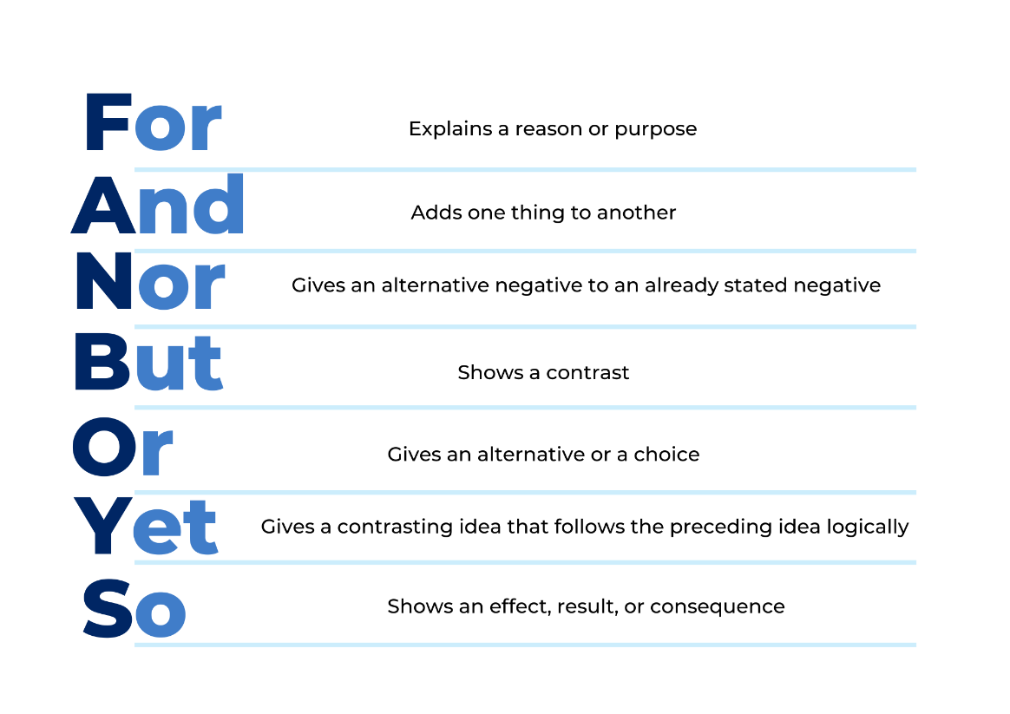

Resource 4: Sentences
Bertha was a blubberer. She sobbed all day.
Bertha was beastly to William. Her parents blamed William.
Bertha got attention when she cried. She thought up more wicked plans.
Bertha was extremely loud. William fashioned marshmallow earplugs.
William protested his innocence. His mother didn't believe him.
Bertha tiptoed to her brother's room. She saw him quietly working.
Bertha blamed William again. Her parents saw what really happened.

Resource 5: Portrait frame template
“Hand-Drawn Doodle Frame” by Nadzieja Porto sourced from Canva and used in accordance with the Canva Content License Agreement.

Resource 6: Character profile template
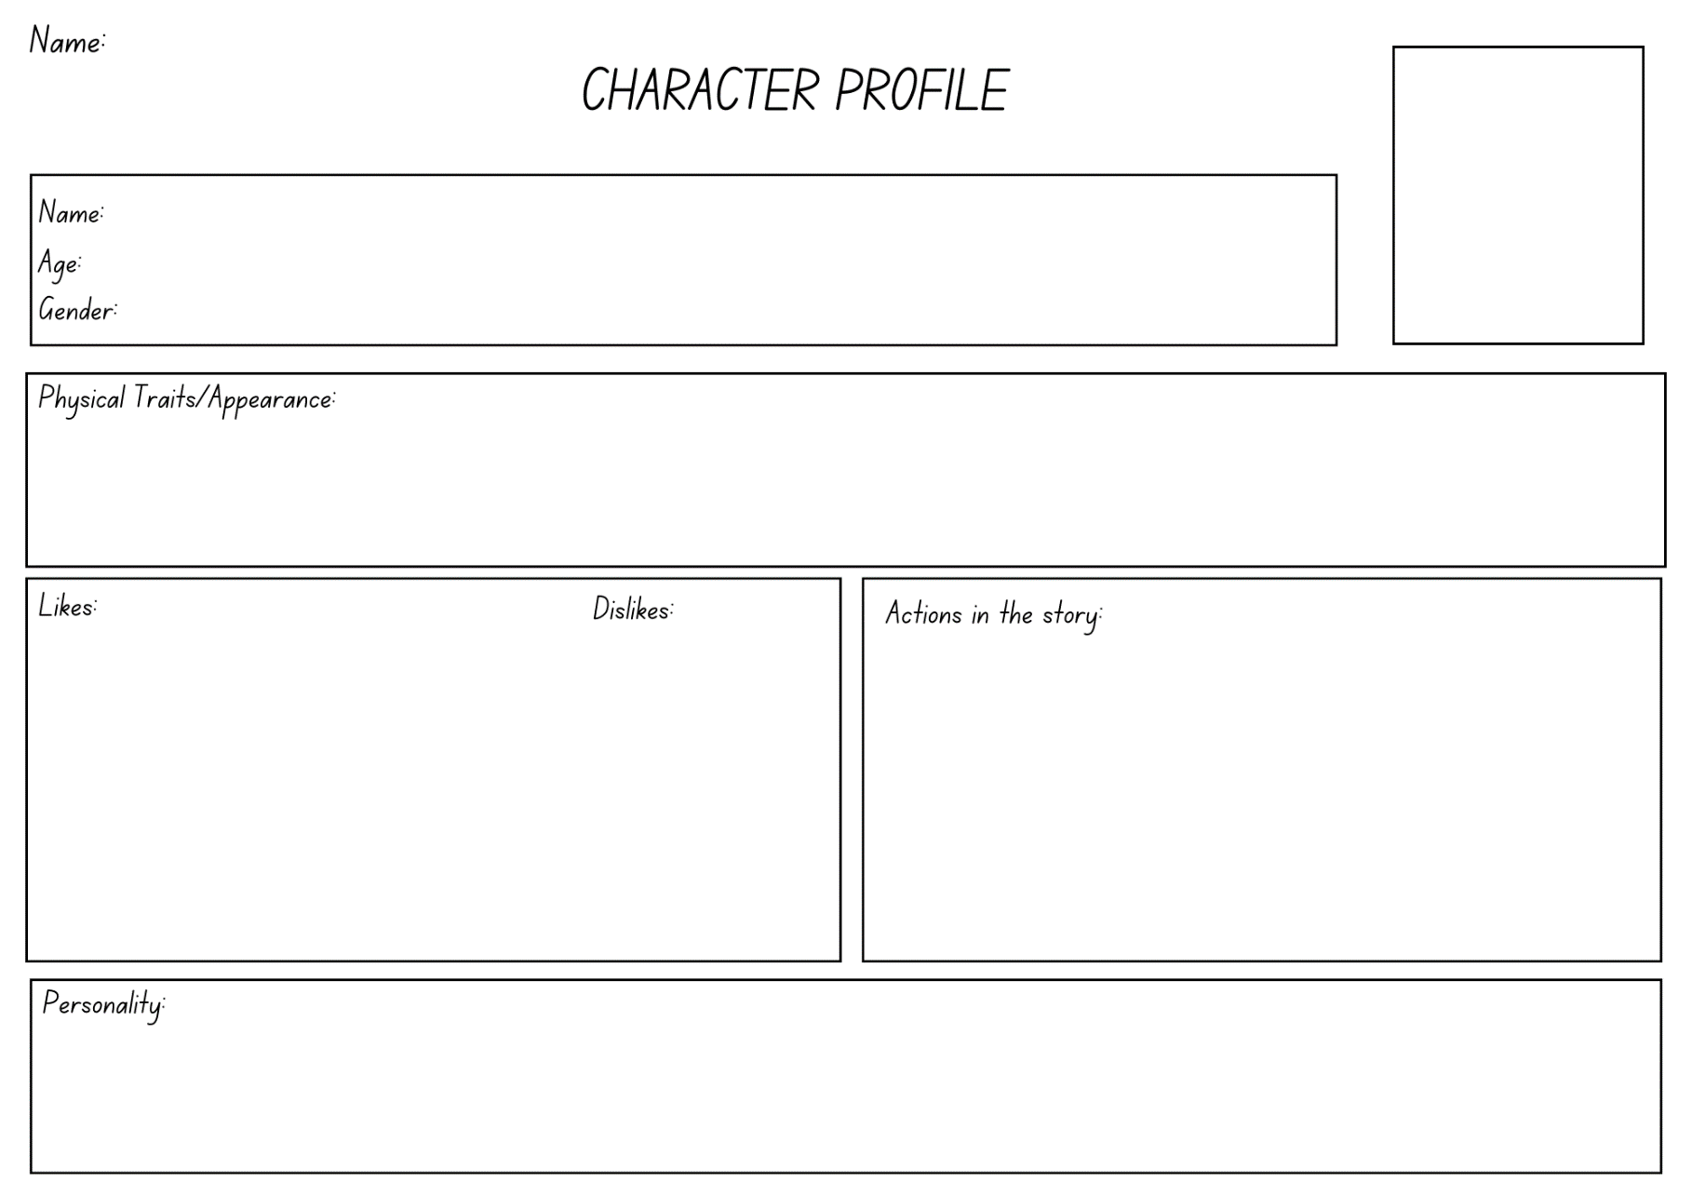

References
Links to third-party material and websites
Please note that the provided (reading/viewing material/list/links/texts) are a suggestion only and implies no endorsement, by the New South Wales Department of Education, of any author, publisher, or book title. School principals and teachers are best placed to assess the suitability of resources that would complement the curriculum and reflect the needs and interests of their students.
If you use the links provided in this document to access a third-party's website, you acknowledge that the terms of use, including licence terms set out on the third-party's website apply to the use which may be made of the materials on that third-party website or where permitted by the Copyright Act 1968 (Cth). The department accepts no responsibility for content on third-party websites.
Except as otherwise noted, all material is © State of New South Wales (Department of Education), 2023 and licensed under the Creative Commons Attribution 4.0 International License. All other material (third-party material) is used with permission or under licence. Where the copyright owner of third-party material has not licensed their material under a Creative Commons or similar licence, you should contact them directly for permission to reuse their material.
English K–10 Syllabus © 2022 NSW Education Standards Authority (NESA) for and on behalf of the Crown in right of the State of New South Wales.
© 2022 NSW Education Standards Authority. This document contains NSW Curriculum and syllabus content. The NSW Curriculum is developed by the NSW Education Standards Authority. This content is prepared by NESA for and on behalf of the Crown in right of the State of New South Wales. The material is protected by Crown copyright.
Please refer to the NESA Copyright Disclaimer for more information.
NESA holds the only official and up-to-date versions of the NSW Curriculum and syllabus documents. Please visit the NSW Education Standards Authority (NESA) website and the NSW Curriculum website.
National Literacy Learning Progression © Australian Curriculum, Assessment and Reporting Authority (ACARA) 2010 to present, unless otherwise indicated. This material was downloaded from the Australian Curriculum website (National Literacy Learning Progression) (accessed 8 February 2023) and was not modified. The material is licensed under CC BY 4.0. Version updates are tracked in the ‘Curriculum version history’ section on the 'About the Australian Curriculum' page of the Australian Curriculum website.
ACARA does not endorse any product that uses the Australian Curriculum or make any representations as to the quality of such products. Any product that uses material published on this website should not be taken to be affiliated with ACARA or have the sponsorship or approval of ACARA. It is up to each person to make their own assessment of the product, taking into account matters including, but not limited to, the version number and the degree to which the materials align with the content descriptions and achievement standards (where relevant). Where there is a claim of alignment, it is important to check that the materials align with the content descriptions and achievement standards (endorsed by all education Ministers), not the elaborations (examples provided by ACARA).
ETA (English Teachers Association) and NSW Department of Education (2016) The Textual Concepts and Processes resource, English Textual Concepts website, accessed 8 February 2023.
Walliams D (2016) The World’s Worst Children, HarperCollins GB, Great Britain.

