English – Stage 1 – Unit 34
Contents
Unit overview and instructions for use 3
Teacher notes 4
Outcomes and content – Component A 5
Outcomes and content – Component B 6
Week 1 10
Component A teaching and learning 10
Component B teaching and learning 11
Lesson 1: Text introduction 12
Lesson 2: Narrative patterns 14
Lesson 3: Noun Groups 16
Lesson 4: Verbs and adverbs 19
Lesson 5: Complex sentences and subordinating conjunctions 21
Week 2 24
Component A teaching and learning 24
Component B teaching and learning 25
Lesson 6: Figurative language 26
Lesson 7: Narrative letter planning 29
Lesson 8: Narrative letter writing 31
Lesson 9: Editing and publishing 32
Lesson 10: Message in a bottle 33
Resource 1: Bottle letter 34
Resource 2: Types of verbs – (reference only) 35
Resource 3: Basic retell 36
Resource 4: Subordinating conjunctions 37
Resource 5: Stimulus images 38
Resource 6: Narrative letter sample 39
Resource 7: Narrative letter plan 40
References 41

Unit overview and instructions for use
This two-week unit is comprised of Component A and Component B. Connecting learning across both components is encouraged.
Teaching and learning | Component A | Component B
Suggested duration | 60 minutes | 45 minutes
Explicit teaching focus areas | - Phonic knowledge  - Reading fluency  - Reading comprehension  - Spelling  - Handwriting | - Oral language and communication  - Vocabulary  - Reading comprehension  - Creating written texts  - Understanding and responding to literature
To prepare for teaching and learning: | - Refer to Outcomes and content – Component A, K-2 – Instructional sequence – grapheme–phoneme correspondences [PDF 825 KB], and the teaching advice documents (hyperlinked in Component A teaching and learning table).  - Based on student needs identified through ongoing assessment data, plan and document how you will sequence teaching and learning in whole class and targeted teaching groups across the two-week cycle. | - Familiarise yourself with Outcomes and content – Component B, Textual concepts information and videos, English Textual Concepts and Learning Processes (2016), and the teaching and learning sequence.  - Based on student needs identified through ongoing assessment data, determine how you will support students in whole class and targeted teaching groups across the two-week cycle as required.
English K–10 Syllabus © 2022 NSW Education Standards Authority (NESA) for and on behalf of the Crown in right of the State of New South Wales.

Teacher notes
- Narrative is fundamental to thinking. When we think, we think in narrative form. Narrative can refer to a story itself or to the conventions by which we communicate and understand it. – English Textual Concepts and Learning Processes (2016).
- Understanding of narrative can be supported through watching the department’s video: Narrative: (3:51).
- While narrative is the mentor concept for the conceptual component of this unit, the supporting concept of imagery, symbol and connotation can be explored using the mentor text The Uncorker of Ocean Bottles by Michelle Cuevas and the supporting text The Heart and the Bottle by Oliver Jeffers.
- For information on noun groups, verbs and adverbs, figurative language and complex sentences, refer to the NESA Glossary.
- Some of the content in this unit touches on loneliness and loss. Some activities may require sensitivity awareness.
- Reflect on student learning and engagement in activities and record differentiation and adjustments within the unit to inform future teaching and learning. One way of doing this could be to add comments to the digital file.
- Content points are linked to the National Literacy Learning Progression version (3).
Levels and indicators sourced from National Literacy Learning Progression © Australian Curriculum, Assessment and Reporting Authority (ACARA), (accessed 13 February 2023) and was not modified. See references for more information.

Outcomes and content – Component A
The table below outlines the focus outcomes and content. Content is linked to the National Literacy Learning Progression version (3).
Focus area and outcome | Content points and National Literacy Learning Progression
Phonic knowledge  EN1-PHOKW-01 – uses initial and extended phonics, including vowel digraphs, trigraphs to decode and encode words when reading and creating texts | - decode words with less common consonant digraphs and apply this when reading texts  - blend and decode 2-syllable words with taught vowel graphs, digraphs, trigraphs and quadgraphs, including graphemes for r-controlled vowels and diphthongs and apply this when reading texts (PKW6, PKW7)
Reading fluency  EN1-REFLU-01 – sustains reading unseen texts with automaticity and prosody and self-corrects errors | - self-correct when fluency and/or meaning is interrupted  - adjust phrasing, intonation, volume or rate to maintain fluency when reading aloud (FlY4)
Reading comprehension  EN1-RECOM-01 – comprehends independently read texts that require sustained reading by activating background and word knowledge, connecting and understanding sentences and whole text, and monitoring for meaning | - draw on sources to seek clarification for unknown words  - know that a complex sentence includes a clause for expressing a main message and one or more clauses that elaborate on that message  - monitor understanding to ensure meaning is sustained and expanded through the whole text (UnT6)
Spelling  EN1-SPELL-01 – applies phonological, orthographic and morphological generalisations and strategies when spelling words in a range of writing contexts | - segment multisyllabic words into syllables and phonemes as a strategy for spelling (SpG5)  - use extended phonic code for taught consonant phonemes
Handwriting  EN1-HANDW-01 – uses a legible, fluent and automatic handwriting style, and digital technology, including word-processing applications, when creating texts | - use taught software functions to create texts in a range of modes for different contexts, audiences and purposes

Outcomes and content – Component B
The table below outlines the focus outcomes and content. Content is linked to the National Literacy Learning Progression version (3).
Focus area and outcome | Content points and National Literacy Learning Progression
Oral language and communication  EN1-OLC-01 – communicates effectively by using interpersonal conventions and language to extend and elaborate ideas for social and learning interactions. | - incorporate extended sentences (simple, compound, complex) during dialogue (SpK3)
Vocabulary  EN1-VOCAB-01 – understands and effectively uses Tier 1, taught Tier 2 and Tier 3 vocabulary to extend and elaborate ideas | Plan for consolidation of content as required based on student need.
Reading comprehension  EN1-RECOM-01 – comprehends independently read texts that require sustained reading by activating background and word knowledge, connecting and understanding sentences and whole text, and monitoring for meaning | - know that a complex sentence includes a clause for expressing a main message and one or more clauses that elaborate on that message  - know the meaning and purpose of coordinating and subordinating conjunctions and identify them in a complex sentence  - make text-to-self, text-to-text or text-to-world connections when reading (UnT6)
Creating written texts  EN1-CWT-01 – plans, creates and revises texts written for different purposes, including paragraphs, using knowledge of vocabulary, text features and sentence structure | - select and use a range of conjunctions to create cohesive texts (GrA5)  - use noun groups to build descriptions of people and things (CrT6)  - use action, saying, relating and sensing verbs to add detail and precision to writing (GrA2, GrA5)  - use adverbs to modify the meaning of verbs and adjectives (GrA3)  - experiment with writing complex sentences which include a clause for the main message and dependent clause to elaborate or modify the message (GrA5)  - use commas to separate ideas, lists and/or dependent clauses in a sentence (PuN4, PuN6)  - make intentional word choices to enhance precision of meaning and ideas in a text (CrT5)  - re-read and edit their own texts after receiving feedback
Understanding and responding to literature  EN1-UARL-01 – understands and responds to literature by creating texts using similar structures, intentional language choices and features appropriate to audience and purpose | - identify patterns in narratives that set up expectation and aid prediction of actions and attitudes  - identify and appreciate how key messages in narratives evoke feelings  - create and re-create narratives using understanding of narrative features (CrT5)  - identify figurative language and wordplay in texts  - create texts that include symbols, wordplay and figurative language

Week 1

Component A teaching and learning
The table below can be used to plan and document lessons that address Component A outcomes and content. Both the detailed example [DOC 529KB] of a two-week teaching and learning cycle and brief example [DOC 66KB] may support you in your planning.
Focus Areas | Lesson 1 | Lesson 2 | Lesson 3 | Lesson 4 | Lesson 5
Phonic knowledge
15 minutes
Spelling and Handwriting
15 minutes
Reading comprehension and Reading fluency
30 minutes

Component B teaching and learning
The following teaching and learning sequence has been designed to address Component B outcomes and content. Adapt the sequence as required to best meet the needs of your students.

Learning intention and success criteria
Learning intentions and success criteria are best co-constructed with students.

Learning intention
Students are learning to recognise that language features and figurative language in narratives create rich descriptions and evoke feelings.

Success criteria
Students can:
- identify similarities and differences between texts
- recognise the key message and narrative structure of a text
- identify and use noun groups to describe a setting
- identify and use verbs and adverbs to add detail to setting descriptions
- identify and use figurative language to evoke feelings.

Resources
- Cuevas M (2016) The Uncorker of Ocean Bottles (Stead EE, illus) Penguin Group, USA. ISBN: 9780803738683
- Jeffers O (2010) The Heart and the Bottle, HarperCollins Publishers, Great Britain. ISBN: 9780007182343
- Resource 1: Bottle letter (one teacher copy)
- Resource 2: Types of Verbs (for reference only) (one teacher copy)
- Resource 3: Basic retell (one enlarged teacher copy, relevant student copies)
- Resource 4: Subordinating conjunctions (one enlarged copy)
- Empty bottle
- Mini whiteboards
- Scissors
- Sticky notes
- Strips of paper to write similes and metaphors

Lesson 1: Text introduction
- Display an empty bottle. Brainstorm what the bottle could be used for. After brainstorming, place the rolled-up Resource 1: Bottle letter into the bottle. Keep the contents of the letter secret. This will be referred to in activity 7.
- Present the front cover of The Uncorker of Ocean Bottles. Ask students what they see and what they think. Encourage discussion around:
- the title – what it could mean
- the illustration – image and colours
- what the text is about – prediction.
- Display the front cover of The Heart and the Bottle and place it next to The Uncorker of Ocean Bottles.
- Explain that students will be working in pairs or small groups to compare the covers of both texts. They will need to write 3 similarities and 3 differences between the texts, on individual sticky notes.
- Students complete the comparison activity by placing completed sticky notes on a two-column anchor chart labelled ‘similarities and differences’.
- Provide opportunities for students to share and discuss their ideas.
- Revisit the displayed bottle from activity 1. Students predict what the note could say and why it is in the bottle.
- Read and discuss Resource 1: Bottle letter.
- Read The Uncorker of Ocean Bottles. Deepen students’ understanding of the text by asking:
- Were the predictions on The Uncorker of Ocean Bottles anchor chart correct? How were they similar or different?
- What was the Uncorker’s job and why was it important?
- What do we know about the Uncorker?
- What did the Uncorker want? Why?
- What do you think the key message of this text could be?
- Identify and clarify vocabulary and possible unknown words within the text. For example, utmost, peculiar, curious, glint, stroll, suspected, script and claim.
- Prompt students to consider any personal experiences that relate to those of the Uncorker.
- Revisit the ending of the text, when the Uncorker says ‘Yes, perhaps I shall try to deliver this again tomorrow.’ Brainstorm what the Uncorker might have done with the bottle ‘tomorrow’ and how the story may have ended if it had more pages.
- Optional activity: students write an additional ending of the text to share with the class.
Too hard? Students illustrate the additional ending and add words and/or phrases to match.

Lesson 2: Narrative patterns
- Display and revisit The Uncorker of Ocean Bottles.
- Discuss how narratives have patterns. Explain that patterns help readers to understand the events and characters in a story and anticipate what might happen next. They provide readers with a sense of familiarity and predictability. In children’s literature, patterns are especially important because they help readers learn to identify and understand different elements of a story. This can help readers build their own narrative skills. Patterns can take different forms, such as the hero’s journey or the repetitive structure of traditional fairy tales. Using the text, The Three Little Pigs, discuss with students how narrative patterns can be understood through:
- character development, such as the pigs becoming smarter from each encounter with the wolf.
- causal relationship between events. For example, each time the wolf goes to a house he attempts to blow it down and the pigs run to the next house
- predictions of the text, including good versus evil and who will win in the end
- use of familiar text patterns, including the repetition of phrases ‘I’ll huff and I’ll puff and blow your house down!’
- Explain that there are patterns in The Uncorker of Ocean Bottles. Discuss the patterns in this text: The Uncorker of Ocean Bottles – ‘The Uncorker was lonely; he was looking for a sense of belonging, which he found at the party.’ The narrative pattern is the character faced a problem and he overcame it with the help of others.
- Discuss what clues the text gives students (in the words and images) to identify the narrative pattern. Ask how the letter found by the main character sets up what might happen in the rest of the story. For example, the letter poses a quest (overcoming an obstacle) for the character; it hints that multiple events are to take place because problems are rarely solved in the first instance. Discuss what type of ending is part of this predictable narrative pattern and if this ending occurs in the text.
- Ask students to choose one of the narrative patterns and draw a picture that shows how the narrative pattern is illustrated in the story. For example, if a student chooses the hero’s journey pattern, they might draw a picture of the Uncorker leaving his home and venturing out into the ocean, encountering challenges and obstacles along the way and ultimately achieving his goal of finding the intended recipient of the message in the bottle. Encourage students to be creative and use their imagination to depict the narrative pattern in a way that is meaningful to them.
- Students share how their drawing represents the narrative pattern they chose. Ask questions about the details in students’ drawing and how they relate to the story.
- Explain how patterns in narratives evoke feelings. Discuss that it is normal to have different feelings to others and that everyone has had different experiences that contribute to how they feel. People may respond to stories differently.
- In pairs, students discuss how the texts made them feel and why. Students select (a) face(s) to describe how they felt and draw it on mini whiteboards. For example, a happy face, a sad face, a surprised face.
- In pairs, students share text-to-self connections by revisiting a time they felt:
- lonely, like the Uncorker at the beginning of the text
- happy, like the Uncorker at the end of the text.
Stage 1 Assessment task 1 – Observations and work samples from this lesson allow students to demonstrate achievement towards the following syllabus outcomes and content points:
EN1-RECOM-01 – comprehends independently read texts that require sustained reading by activating background and word knowledge, connecting and understanding sentences and whole text, and monitoring for meaning
- make text-to-self, text-to-text or text-to-world connections when reading.
EN1-UARL-01 – understands and responds to literature by creating texts using similar structures, intentional language choices and features appropriate to audience and purpose
- identify patterns in narratives that set up expectation and aid prediction of actions and attitudes
- identify and appreciate how key messages in narratives evoke feelings.

Lesson 3: Noun groups
- Review that narratives have patterns (Lesson 2). Explain that patterns help readers to understand the events and characters in a story and anticipate what might happen next. They provide readers with a sense of familiarity and predictability. In children’s literature, patterns are especially important because they help readers learn to identify and understand different elements of a story. This can help readers build their narrative skills. Patterns can take different forms, such as the hero’s journey or the repetitive structure of traditional fairy tales.
- Revisit the two-column anchor chart from Lesson 1.
- Skim through the The Heart and the Bottle. Ask students what they notice about the character development of the girl and whether they can make predictions based on that.
- Read The Heart and the Bottle. Confirm predictions from activity 3.
- Display the double page showing the girl at the beach with the kite flying in the pink sky, stating ‘She took delight in finding new things…’ Explain that this illustration shows the girl during a time of happiness in her life, before she experienced loss. Note that this event is a life pattern. Life patterns, like narrative patterns, are predictable. For example, the experience of loss often leads to a period of unhappiness before one can regain happiness.
- Ask students to identify the nouns in this illustration. For example, sky, kite, girl, sand, waves, man.
- Review noun groups and explain that the author uses them to build descriptions that develop creative expression, characterisation and imagery. Noun groups are important for building a description of the who and what of the story world. Good descriptions can help readers establish patterns in the story.
- Remind students that a noun group contains an article, noun(s) and adjectives. For example:
- article: the, a, an, this, that, my
- nouns: sky, kite, girl, sand, waves, man
- adjectives: pink, purple, high-flying, red, happy, curious, golden, slow, rolling, tall, slim
- noun group: my high-flying red kite; a happy, curious girl; the golden sand; the slow, rolling waves; a tall, slim man.
- Model creating a noun group using a noun from activity 4. For example, ‘The pink and purple sky.’ Record the noun group on a sticky note. Place the sticky note on the illustration labelling the pink and purple sky.
- Using Think-Pair-Share, students build noun groups for the remaining nouns identified from the illustration. Record on sticky notes and label the illustration.
- Model writing a description of the drawing using noun groups from the sticky notes. For example, ‘The happy, curious girl was playing on the golden sand, while the slow, rolling waves lapped at the shore.’ ‘The tall, slim man was guiding his high-flying, red kite across the pink and purple sky.’
- Explain that students will make text-to-self connections using the Draw, Talk, Share, Write strategy. Students recall and draw a happy place such as a beach, a park, the bush or on Country.
- Students communicate their experience to a partner, creating noun groups to describe their drawing. Record noun groups on sticky notes and attach to the drawing. For example:
- the clear, blue ocean
- the hot, golden sand
- the fast-flowing waterfall
- the brown, dry paddocks.
Too hard? Co-construct a referral list of adjectives.
- Select a student to share a noun group from activity 13. Ask other students to make predictions about the setting (for example, beach, national park, farm). Explain that noun groups support readers to create a mental model, make predictions and identify patterns.
- Students write a detailed description of their happy place using the noun groups from their labelled drawing.
Too hard? Scaffold the description using sentence starters. For example, ‘I went for a swim (where).’
Stage 1 Assessment task 2 – Observations and work samples from this lesson allow students to demonstrate achievement towards the following syllabus outcome and content point:
EN1-CWT-01 – plans, creates and revises texts written for different purposes, including paragraphs, using knowledge of vocabulary, text features and sentence structure
- use noun groups to build descriptions of people and things.

Lesson 4: Verbs and adverbs
- Re-read The Uncorker of Ocean Bottles and ask questions to revisit important points. For example:
- What was the Uncorker’s job? He opened and delivered bottles that were found in the ocean containing letters.
- What do we know about the Uncorker? He lived on a hill and was lonely and wished for a letter to be sent to him.
- What was the main idea? The Uncorker was lonely, he was looking for a sense of belonging.
- Activate prior knowledge by revisiting verbs and exploring different types of verbs. Explain that people’s experiences include different things they do and how they feel, which students can describe using verbs. For example:
- action verbs – what someone does
- saying verbs – what someone says
- sensing verbs – what someone thinks, feels and perceives
- relating verbs – how someone creates links between pieces of information.
- Create a four-column table with the headings ‘action verbs’, ‘saying verbs’, ‘relating verbs’ and ‘sensing verbs’. See Resource 2: Types of Verbs (for reference only). Ask students to provide an example of each type of verb. Record examples on the table.
- Students identify the 4 types of verbs from the text and record in the four-column table. Refer to Resource 2: Types of Verbs (for reference only).
- Using Resource 3: Basic retell, model identifying each verb type by underling with different coloured markers.
- Students use their descriptions from Lesson 3 to identify verbs in their writing. Students use different colours to underline each verb type.
Note: Students can use Resource 3: Basic retell throughout the lesson if they do not have many verbs in their descriptions from Lesson 3.
Too hard? Students look at their drawing and identify verbs. Write the verb and identify the verb type.
Too easy? Students add verbs to their description, to ensure they have a variety of the 4 types of verbs.
- Explain that adverbs are words that modify the meaning of verbs and adjectives. Adverbs tell the reader something about a verb, adjective or another adverb and indicates things like manner, place or time. When modifying a verb, the adverb commonly ends in -ly. For example:
- modifying verbs – She walked slowly. The adverb states how she walked – slowly.
- modifying adjectives – He drove a very fast car. The adverb describes how fast his car was – very.
- Model modifying the meaning of verbs in Resource 3: Basic retell by adding an adverb. For example:
- verb – opened, adverb – carefully
- verb – rode, adverb – swiftly
- verb – delivered, adverb – promptly
- Students use their descriptions from Lesson 3 or Resource 3: Basic retell and use an adverb to modify their identified verbs.
Too hard? Students add adverbs to their drawing and identified verbs.
- Students share their descriptions. Record additional verbs in the four-column table.

Lesson 5: Complex sentences and subordinating conjunctions
- Reactivate prior learning by asking:
- Why do authors use a variety of sentences? To engage their readers. It makes the text more exciting and gives life and rhythm to the text.
- What types of sentences do authors use? They use a combination of simple, compound and complex sentences.
- Display the pages from the The Uncorker of Ocean Bottles where the Uncorker is walking through the seasons. Draw students’ attention to the use of repetitive sentence beginnings. Ask students to explain why they think the author chose to use this pattern.
- Refer to the page with the text ‘Sometimes to deliver a bottle, he needed only to stroll to the nearest village.’ Ask students to decide what type of sentence it is (complex) and how they know (the sentence starts with a subordinating conjunction, includes a dependent and independent clause).
- Use the text to identify other examples of complex sentences. For example, ‘As he fell asleep that night, the Uncorker decided to go to the seashore the next day.’
- Choose a sentence to record on the board. Support students to identify the subordinating conjunction, the dependent clause, the independent clause and the use of a comma in the complex sentence.
- Refer to the sentences in activity 2; discuss how the same subordinating conjunction has been used at the beginning of the sentence and the comma has been used to separate the clauses.
- Model writing 2 complex sentences using the same subordinating conjunction to demonstrate the use of a repetitive pattern. Refer to Resource 4: Subordinating conjunctions to support writing.
- Check the sentence to ensure all components of a complex sentence have been included.
- Students use ideas from the text to draw 2 pictures and provide an oral description to a partner.
- Students refer to Resource 4 to write complex sentences to match their drawings. Explain that students will use the same subordinating conjunction in both sentences to demonstrate a pattern similar to that used by the author.
Too hard? Co-construct sentence starters using repetitive subordinating conjunctions.
Too easy? Students use varied subordinating conjunctions to demonstrate repetitive patterns. For example, although, because, although, because.
- In pairs, students swap their work to check for repetitive patterns and the components of a complex sentence have been included.
Stage 1 Assessment task 3 – Observations and work samples from this lesson allow students to demonstrate achievement towards the following syllabus outcomes and content points:
EN1-OLC-01 – communicates effectively by using interpersonal conventions and language to extend and elaborate ideas for social and learning interactions
- incorporate extended sentences (simple, compound, complex) during dialogue.
EN1-RECOM-01 – comprehends independently read texts that require sustained reading by activating background and word knowledge, connecting and understanding sentences and whole text, and monitoring for meaning
- know that a complex sentence includes a clause for expressing a main message and one or more clauses that elaborate on that message
- know the meaning and purpose of coordinating and subordinating conjunctions and identify them in a complex sentence.
EN1-CWT-01 – plans, creates and revises texts written for different purposes, including paragraphs, using knowledge of vocabulary, text features and sentence structure
- select and use a range of conjunctions to create cohesive texts
- experiment with writing complex sentences which include a clause for the main message and dependent clause to elaborate or modify the message
- use commas to separate ideas, lists and/or dependent clauses in a sentence.

Week 2

Component A teaching and learning
The table below can be used to plan and document lessons that address Component A outcomes and content. Both the detailed example [DOC 529KB] of a two-week teaching and learning cycle and brief example [DOC 66KB] may support you in your planning.
Focus Areas | Lesson 6 | Lesson 7 | Lesson 8 | Lesson 9 | Lesson 10
Phonic knowledge
15 minutes
Spelling and Handwriting
15 minutes
Reading comprehension and Reading fluency
30 minutes

Component B teaching and learning
The following teaching and learning sequence has been designed to address Component B outcomes and content. Adapt the sequence as required to best meet the needs of your students.

Learning intention and success criteria
Learning intentions and success criteria are best co-constructed with students.

Learning intention
Students are learning to use narrative patterns and structures to write.

Success criteria
Students can:
- identify and use complex sentences and subordinating conjunctions
- plan for narrative letter writing by using correct layout, narrative structure and language features
- use a plan to write a narrative letter
- use feedback to edit and improve writing
- publish and share narrative letters.

Resources
- Cuevas M (2016) The Uncorker of Ocean Bottles (Stead EE, illus) Penguin Group, USA. ISBN: 9780803738683
- Jeffers O (2010) The Heart and the Bottle, HarperCollins Publishers, Great Britain. ISBN: 9780007182343
- Resource 5: Stimulus images (one enlarged copy)
- Resource 6: Narrative letter sample (one enlarged copy)
- Resource 7: Narrative letter plan (one for each student)
- One bottle per student
- Paper for publishing

Lesson 6: Figurative language
- Explain that The Uncorker of Ocean Bottles and The Heart and the Bottle have been written using some figurative language.
- Revise figurative language, similes and metaphors and discuss why these are used by an author:
- figurative language – word groups/phrases used differently from how they would be usually. They express an idea for a particular effect. For example, similes and metaphors.
- simile – compares the similarities of 2 different things using ‘like’ or ‘as’. Similes are often used in everyday language. For example, she is as fast as a cheetah, indicating that she runs extremely fast and so do cheetahs.
- metaphor – used for effect. Metaphors imply one thing by referring to another and describe an object or situation that can represent something else. For example, He is a ray of sunshine. He isn’t really a ray of sunshine, but he is bright and happy like a ray of sunshine.
- Explain that good writers use unique examples of similes and metaphors rather than commonly known ones. Jointly identify and display examples of figurative language from The Uncorker of Ocean Bottles and interpret their meaning. For example:
- simile – ‘he felt loneliness as sharp as fish scales.’ The Uncorker was a very lonely person and it hurt him to feel this way. If he were to touch fish scales the wrong way, they would hurt/cut him.
- simile – ‘Sometimes the messages were very old, crunchy like leaves in the fall.’ The letters were old, and the paper was starting to become coloured and hard from the weather, like the leaves do in autumn when they fall from the trees.
- simile – ‘this was about as likely as finding a mermaid's toenail on the beach.’ The Uncorker was hoping to find his name at the top of a letter. This simile means that it is not going to happen as mermaids have tails and not toes, so it is impossible to find a mermaid's toenail.
- metaphor – ‘Sometimes the messages were written by a quill dipped in sadness.’ The person writing the letter may be feeling deep emotions of loss or grief.
- metaphor – ‘The Uncorker's heart was a glass vessel filled to the brim.’ The Uncorker was a lonely and vulnerable man. The party made him feel happy and full of emotion. The glass vessel implies that this feeling of happiness and fullness could shatter and be gone in an instant.
- Use examples of figurative language to discuss how the author’s choice of words has enhanced the meaning of what is being described. For example, ‘Sometimes the messages were very old, crunchy like leaves in the fall.’ Note that in Australia, ‘fall’ is called ‘autumn’. Encourage students to make observations about the language. For example:
- The use of the word ‘crunchy’ enhances the sound leaves make when you step on them in the fall/autumn.
- 'Crunchy’ describes the paper and how it has changed from its original texture.
- If the word ‘crunchy’ was left out of the simile, the paper would be compared to the colour of leaves in the fall/autumn. The sound and texture may not be considered. Repeat with other text examples as required.
- Display the double page that states, ‘When the girl in green asked the Uncorker of Ocean Bottles to dance...’ Brainstorm and record a list of what can be seen on these pages. For example, orange cat, green dress, flying flags, dangling lights, musical instruments, the ocean.
- Remind students that a simile compares 2 things using the words ‘like’ or ‘as’. Explicitly model writing a simile. For example:
- select one of the brainstormed items – the dangling lights
- think of something the lights do – sparkled brightly
- compare the lights to something that sparkles – the night stars
- add the words ‘like’ or ‘as’ to create a simile – the dangling lights sparkled as bright as the night stars. Repeat with other brainstormed items in activity 5.
- Students write similes, using the displayed double page and brainstormed items from activity 5. Students will refer to these in future lessons.
Too hard? Students use a sentence frame, scaffold and/or sentence stems to write similes. For example, ‘As loud as …’, ‘The orange cat is like...’
- Remind students that a metaphor implies that something is or represents something else. Explicitly model writing a metaphor. For example:
- select one of the brainstormed items – the ocean
- think of something that could represent the item – calm blue carpet expanding to the horizon
- create a metaphor– the ocean is a calm blue carpet expanding to the horizon. Repeat with other brainstormed items in activity 5.
- Students write metaphors, using the displayed double page and brainstormed items from activity 5. Students will refer to these in future lessons.
Too hard? Students use a sentence frame, scaffold and/or sentence stems to write metaphors. For example, ‘The golden sand is...’, ‘The flowing, green dress is...’
- Students select and write a simile or metaphor on a strip of paper and cut it in half, after the linking words (for example, as, like, was, is). In pairs, students rearrange the strips with their partner to form different similes or metaphors, then read and discuss. Each student rearranges the strip with their partner to re-form the original simile or metaphor.

Lesson 7: Narrative letter planning
- Recap and allow students to provide examples of their learning during this unit. For example, narrative features, noun groups, verbs and adverbs, similes and metaphors, sentences.
- Explain that students will be writing a narrative letter to an older/grand friend or Elder telling them about a party or celebration. The purpose of the narrative letter is to make someone happy. Like The Uncorker of Ocean Bottles, students will be delivering their narrative letters. Optional: The letters could be delivered in a bottle.
Note: You can change the topic based on relevant context.
- Brainstorm and record ideas that students have for parties/celebrations, including what, where, when, why and how it made people feel. This will be used in the planning and writing phase.
- Display and discuss Resource 5: Stimulus images and add ideas to the brainstorm in activity 3.
- Display and read Resource 6: Narrative letter sample, drawing attention to the layout, narrative structure and language features. For example, orientation, series of events, conclusion. Explain that a narrative letter is structured in the same way as a letter, but it also tells a story.
- Model planning a narrative letter using Resource 7: Narrative letter plan, referring to the brainstorm in activity 3. Explain that another purpose of the letter is to encourage the older/grand friend or Elder to reply so that they can share something fun they have experienced.
- Provide students with Resource 7: Narrative letter plan. Students plan their narrative letter referring to the brainstorm in activity 3 and the purpose and structure in activity 6.
Too hard? Students draw and label pictures for planning.
- Revisit Resource 6: Narrative letter sample and co-construct success criteria for students’ narrative letter writing. For example:
- use figurative language
- use a range of verb types
- use adverbs
- make intentional word choices
- use narrative structure and features.
- Students use the success criteria to self-assess their planning. Remind students about the similes and metaphors they wrote in Lesson 5. Students edit and add to their plan.

Lesson 8: Narrative letter writing
- Share with the students a real or imagined story about receiving a letter – refer to Resource 6: Narrative letter sample if required. Explain who wrote the letter, what the letter was about and your feelings when you received the letter.
- Discuss alternate types of letters, for example, postcards, emails or text messages; and methods of delivery, for example, hand-delivered, postal delivery, courier delivery and digital delivery including text-to-voice.
- Ask students to turn and talk with a thinking partner about when they have received a letter, who the author was, what it was about, how it was delivered and how it made them feel.
- Revisit the teacher modelled Resource 7: Narrative letter plan and the co-constructed success criteria from Lesson 7. Discuss these features in the Resource 6: Narrative letter sample.
- Jointly construct the beginning of a narrative letter, referring to the teacher modelled Resource 7: Narrative letter plan and the co-constructed success criteria.
- Discuss what students should include in the remainder of the letter. For example:
- a narrative about a party/celebration they have experienced
- letter structure with a salutation/beginning and ending
- a sentence to encourage their older/grand friend or Elder to write a reply about something fun they have experienced.
- Students draft their narrative letter to an older/grand friend or Elder, referring to Resource 7: Narrative letter plan and the co-constructed success criteria.

Lesson 9: Editing and publishing
- Revise how authors make intentional word choices and use a variety of sentences to make their writing more interesting and engaging.
- Revise the teacher modelled Resource 7: Narrative letter plan, teacher narrative letter and the co-constructed success criteria.
- Model how to give and receive peer feedback in a respectful and constructive way using the Guided feedback chat proforma.
- Students use the success criteria as a checklist to provide peer feedback using the Guided feedback chat proforma. Encourage students ask for specific feedback and to ask questions to seek clarification from their peers.
- Provide time for students to apply feedback to edit and improve their writing.
Stage 1 Assessment task 4 – Observations and work samples from this lesson allow students to demonstrate achievement towards the following syllabus outcomes and content points:
EN1-CWT-01 – plans, creates and revises texts written for different purposes, including paragraphs, using knowledge of vocabulary, text features and sentence structure
- use action, saying, relating and sensing verbs to add detail and precision to writing
- use adverbs to modify the meaning of verbs and adjectives
- make intentional word choices to enhance precision of meaning and ideas in a text
- re-read and edit their own texts after receiving feedback.
EN1-UARL-01 – understands and responds to literature by creating texts using similar structures, intentional language choices and features appropriate to audience and purpose
- create and re-create narratives using understanding of narrative features
- identify figurative language and wordplay in texts
- create texts that include symbols, wordplay and figurative language.

Lesson 10: Message in a bottle
- Students finish publishing their letter.
- Optional: Students could write their letters on discoloured paper or scrunch it up and unfold the paper to make it look old and wrinkled.
- Provide time for students to reflect on their learning and identify an improvement goal that is linked to the co-constructed success criteria from Lesson 7. For example, a student may identify that they could use more figurative language in their writing.
- Optional: Provide each student with a bottle and a lid. Students roll up their letters and secure them in the bottles. Place all bottled letters in a class ‘pond’. For example, inside a large tub filled with water or blue paper to represent the water. Students select another student’s bottle and read the letter inside to a partner. Students return the letter to the owner who places it back inside the bottle and takes it home to deliver to their older/grand friend or Elder.

Resource 1: Bottle letter
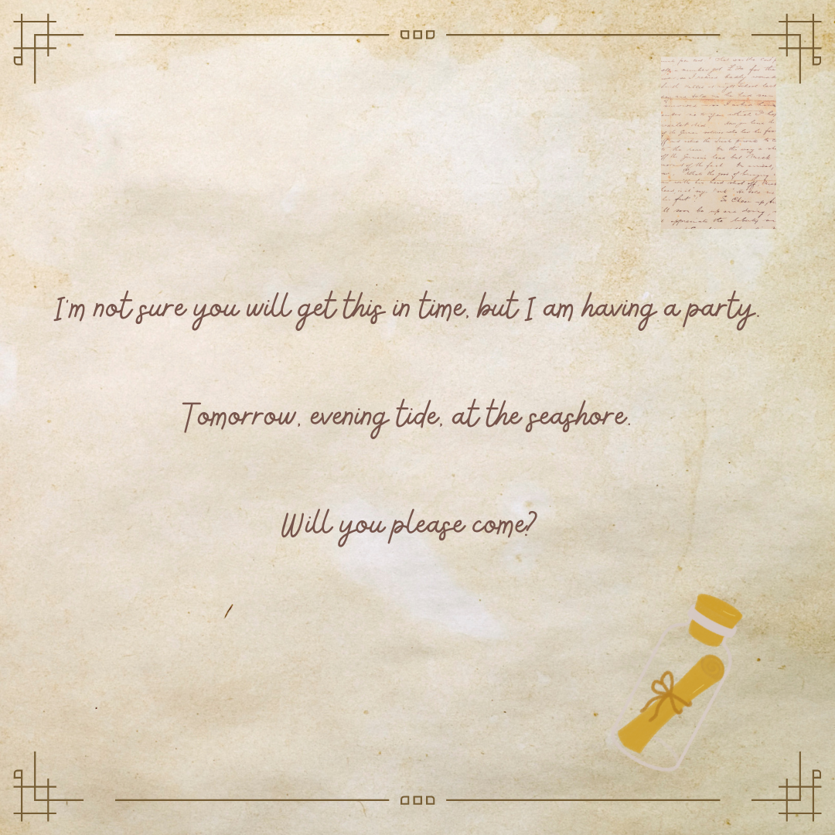
(Cuevas 2016). Images sourced from Canva and used in accordance with the Canva Content License Agreement.

Resource 2: Types of verbs – (reference only)
Types of verbs | action | saying | sensing | relating
Other verbs | skip  dance  swim  run  ride  walk | talk  whisper  shout  speak | think  dream  hear  feel | is  am
Verbs from The Uncorker of Ocean Bottles | open  deliver  stroll  journey  hold  winking | said  sighed  asked  apologise | hoped  loved  remembered  stank  wish  happy | has  was  am  having  had

Resource 3: Basic retell
The Uncorker of Ocean Bottles lived alone on top of a hill. He had a very important job, opening any bottles found at sea. He rode his bike to make sure that the messages he found were always delivered.
He loved his job, but he always wished one of the letters would be for him.
One day, he opened an invitation to a party and sighed because there was no name attached. The Uncorker went to the party to try and solve the mystery of who sent the invitation. He didn’t solve the mystery, but he made some friends and had a wonderful time.

Resource 4: Subordinating conjunctions
after  although  as  because  before  if  once  so that | than  that  unless  where  when  which  while

Resource 5: Stimulus images
Images sourced from Canva and used in accordance with the Canva Content License Agreement.

Resource 6: Narrative letter sample
Text structure | Sample letter | Language features
Date  Salutation/beginning (Dear)  Orientation  Events  Conclusion  Sentence asking for a reply  Ending (from) | 17th February 2023  Dear Grandma,  I had the best day ever! The excitement bubbled up inside me like a shaken-up soft drink ready to explode.  I was prepared for just another ordinary day. A normal school day but with a present and cake after dinner for my birthday. I didn’t expect my best friend would remember because she has the memory of a goldfish.  It started exactly the way I imagined it would. Mum and Dad greeted me with birthday wishes. I opened a present, had breakfast and then went off to school. My friends did not mention my birthday at all as I walked excitedly alongside them. I went through the day as quiet as a mouse. Did they really not remember? This was not a great birthday at all!  As I strolled slowly toward the school gate, mum was patiently waiting for me. This was not normal. She quickly took me to the car and told me to close my eyes. Not wanting to disappoint her, I immediately did as I was told.  I could hear the car door slam and a rustle in the back seat. A familiar voice yelled happy birthday. I opened my eyes with excitement, it was my best friend. Mum had planned an afternoon of fun for us. I could hardly contain myself; this was the most excited I had been on a birthday. We had the best afternoon, ever. They really did surprise me.  Have you had anything like that happen to you, Grandma? What is a happy story that you could share with me? I can’t wait to read your reply.  Love Billie | Sentence level grammar:  Adverbs  Verbs  Similes  Metaphors  Punctuation:  Commas to separate clauses  Vocabulary:  Subject-specific vocabulary

Resource 7: Narrative letter plan
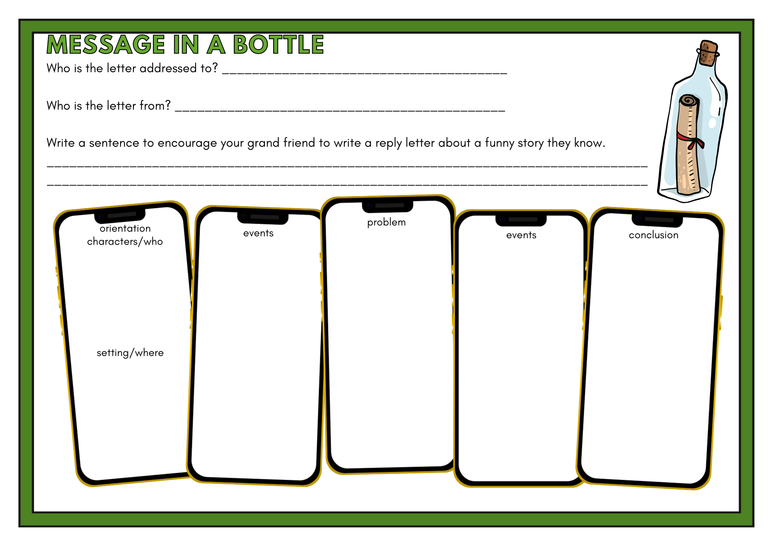
Images sourced from Canva and used in accordance with the Canva Content License Agreement.

References
Links to third-party material and websites
Please note that the provided (reading/viewing material/list/links/texts) are a suggestion only and implies no endorsement, by the New South Wales Department of Education, of any author, publisher, or book title. School principals and teachers are best placed to assess the suitability of resources that would complement the curriculum and reflect the needs and interests of their students.
If you use the links provided in this document to access a third-party's website, you acknowledge that the terms of use, including licence terms set out on the third-party's website apply to the use which may be made of the materials on that third-party website or where permitted by the Copyright Act 1968 (Cth). The department accepts no responsibility for content on third-party websites.
Except as otherwise noted, all material is © State of New South Wales (Department of Education), 2023 and licensed under the Creative Commons Attribution 4.0 International License. All other material (third-party material) is used with permission or under licence. Where the copyright owner of third-party material has not licensed their material under a Creative Commons or similar licence, you should contact them directly for permission to reuse their material.
English K–10 Syllabus © 2022 NSW Education Standards Authority (NESA) for and on behalf of the Crown in right of the State of New South Wales.
© 2022 NSW Education Standards Authority. This document contains NSW Curriculum and syllabus content. The NSW Curriculum is developed by the NSW Education Standards Authority. This content is prepared by NESA for and on behalf of the Crown in right of the State of New South Wales. The material is protected by Crown copyright.
Please refer to the NESA Copyright Disclaimer for more information.
NESA holds the only official and up-to-date versions of the NSW Curriculum and syllabus documents. Please visit the NSW Education Standards Authority (NESA) website and the NSW Curriculum website.
National Literacy Learning Progression © Australian Curriculum, Assessment and Reporting Authority (ACARA) 2010 to present, unless otherwise indicated. This material was downloaded from the Australian Curriculum website (National Literacy Learning Progression) (accessed 13 February 2023) and was not modified. The material is licensed under CC BY 4.0. Version updates are tracked in the ‘Curriculum version history’ section on the 'About the Australian Curriculum' page of the Australian Curriculum website.
ACARA does not endorse any product that uses the Australian Curriculum or make any representations as to the quality of such products. Any product that uses material published on this website should not be taken to be affiliated with ACARA or have the sponsorship or approval of ACARA. It is up to each person to make their own assessment of the product, taking into account matters including, but not limited to, the version number and the degree to which the materials align with the content descriptions and achievement standards (where relevant). Where there is a claim of alignment, it is important to check that the materials align with the content descriptions and achievement standards (endorsed by all education Ministers), not the elaborations (examples provided by ACARA).
Cuevas M (2016) The Uncorker of Ocean Bottles (Stead EE, illus) Penguin Group, USA.
ETA (English Teachers Association) and NSW Department of Education (2016) The Textual Concepts and Processes resource, English Textual Concepts website, accessed 13 February 2023.
Jacobs J (1890) English Fairy Tales, Oxford University.
Jeffers O (2010) The Heart and the Bottle, HarperCollins Publishers, Great Britain.

