English – Stage 1 – Unit 33
Contents
Unit overview and instructions for use 3
Teacher notes 4
Outcomes and content – Component A 5
Outcomes and content – Component B 7
Week 1 10
Component A teaching and learning 10
Component B teaching and learning 11
Lesson 1: Understanding illustrations and symbols in Out 12
Lesson 2: Complex sentences and commas 15
Lesson 3: Deconstructing paragraphs 17
Lesson 4: Writing paragraphs 18
Lesson 5: Comparing context and representations 19
Week 2 23
Component A teaching and learning 23
Component B teaching and learning 24
Lesson 6: Symbols, images and figurative language 25
Lesson 7: Using symbols 28
Lesson 8: Using symbols to enhance writing 29
Lesson 9: Editing and publishing 31
Lesson 10: Presenting writing 32
Resource 1: Traffic light paragraphs 34
Resource 2: Venn diagram 35
Resource 3: Figurative language 36
Resource 4: Blanket piece 38
Resource 5: Planning template 39
Resource 6: Slide example 40
References 41

Unit overview and instructions for use
This two-week unit is comprised of Component A and Component B. Connecting learning across both components is encouraged.
Teaching and learning | Component A | Component B
Suggested duration | 60 minutes | 45 minutes
Explicit teaching focus areas | - Phonic knowledge  - Reading fluency  - Reading comprehension  - Spelling  - Handwriting | - Oral language and communication  - Vocabulary  - Reading comprehension  - Creating written texts  - Understanding and responding to literature
To prepare for teaching and learning: | - Refer to Outcomes and content – Component A, K-2 – Instructional sequence – grapheme–phoneme correspondences [PDF 825 KB], and the teaching advice documents (hyperlinked in Component A teaching and learning table).  - Based on student needs identified through ongoing assessment data, plan and document how you will sequence teaching and learning in whole class and targeted teaching groups across the two-week cycle. | - Familiarise yourself with Outcomes and content – Component B, Textual concepts information and videos, English Textual Concepts and Learning Processes (2016), and the teaching and learning sequence.  - Based on student needs identified through ongoing assessment data, determine how you will support students in whole class and targeted teaching groups across the two-week cycle as required.
English K–10 Syllabus © 2022 NSW Education Standards Authority (NESA) for and on behalf of the Crown in right of the State of New South Wales.

Teacher notes
- Context refers to factors acting upon composers and responders that affect meaning. To understand context, we look beyond the text to consider the world in which it was produced and the worlds of its reception. Different contexts can affect the meanings and values of similar content. – English Textual Concepts and Learning Processes (2016).
- Understanding of context can be supported through watching the department’s video: Understanding context video (5:24).
- While context is the mentor concept for the conceptual component of this unit, the supporting concept of imagery, symbol and connotation can be explored using the mentor text Out by Angela May George and the supporting text My Two Blankets by Irena Kobald.
- For information on modifying and qualifying words, adverbs, complex sentences, commas, paragraphs and figurative language refer to the NESA Glossary.
- Consider prior learning and student knowledge of paragraphs and sentences.
- Some of the content in this unit requires sensitivity awareness. Access and provide support if needed.
- Ensure students have access to a shared Google Slides document on an appropriate device.
- Reflect on student learning and engagement in activities and record differentiation and adjustments within the unit to inform future teaching and learning. One way of doing this could be to add comments to the digital file.
- Content points are linked to the National Literacy Learning Progression version (3).
Levels and indicators sourced from National Literacy Learning Progression © Australian Curriculum, Assessment and Reporting Authority (ACARA), (accessed 24 January 2023) and was not modified. See references for more information.

Outcomes and content – Component A
The table below outlines the focus outcomes and content. Content is linked to the National Literacy Learning Progression version (3).
Focus area and outcome | Content points and National Literacy Learning Progression
Phonic knowledge  EN1-PHOKW-01 – uses initial and extended phonics, including vowel digraphs, trigraphs to decode and encode words when reading and creating texts | - decode words with less common consonant digraphs and apply this when reading texts  - decode 2-syllable base words with common double consonants when reading texts (PKW7)
Reading fluency  EN1-REFLU-01 – sustains reading unseen texts with automaticity and prosody and self-corrects errors | - self-correct when fluency and/or meaning is interrupted  - adjust phrasing, intonation, volume or rate to maintain fluency when reading aloud (FlY4)
Reading comprehension  EN1-RECOM-01 – comprehends independently read texts that require sustained reading by activating background and word knowledge, connecting and understanding sentences and whole text, and monitoring for meaning | - draw on sources to seek clarification for unknown words  - identify when meaning is not complete and/or contradicts prior understanding  - re-read words, phrases or sentences to check and clarify precise meaning  - monitor understanding to ensure meaning is sustained and expanded through the whole text (UnT6)  - interpret patterns in texts to enhance understanding
Spelling  EN1-SPELL-01 – applies phonological, orthographic and morphological generalisations and strategies when spelling words in a range of writing contexts | - use spelling conventions when adding plural-marking suffixes (SpG9)  - explain when to use double consonants to spell 2-syllable base words and apply this when spelling (SpG6)  - use extended phonic code for taught consonant phonemes
Handwriting  EN1-HANDW-01 – uses a legible, fluent and automatic handwriting style, and digital technology, including word-processing applications, when creating texts | - use word-processing program functions, including text-editing applications (HwK5)  - recognise and use keys to show more complex punctuation or symbols (HwK5)
English K–10 Syllabus © 2022 NSW Education Standards Authority (NESA) for and on behalf of the Crown in right of the State of New South Wales, 2022.

Outcomes and content – Component B
The table below outlines the focus outcomes and content. Content is linked to the National Literacy Learning Progression version (3).
Focus area and outcome | Content points and National Literacy Learning Progression
Oral language and communication  EN1-OLC-01 – communicates effectively by using interpersonal conventions and language to extend and elaborate ideas for social and learning interactions | - use a range of strategies for effective dialogue and manage digression from a topic (InT3, InT5)  - link or compare ideas when interacting
Vocabulary  EN1-VOCAB-01 – understands and effectively uses Tier 1, taught Tier 2 and Tier 3 vocabulary to extend and elaborate ideas | - understand and use words that have different meanings in different contexts
Reading comprehension  EN1-RECOM-01 – comprehends independently read texts that require sustained reading by activating background and word knowledge, connecting and understanding sentences and whole text, and monitoring for meaning | - draw on sources to seek clarification for unknown words  - ask a clarifying question when more background knowledge is needed to make an inference  - use visual and/or auditory features in multimodal texts to build meaning (UnT5)
Creating written texts  EN1-CWT-01 – plans, creates and revises texts written for different purposes, including paragraphs, using knowledge of vocabulary, text features and sentence structure | - group sentences into paragraphs commencing with a topic sentence, followed by other sentences with related ideas (CrT7)  - use visual elements to expand meaning in own texts  - experiment with writing complex sentences which include a clause for the main message and dependent clause to elaborate or modify the message (GrA5)  - use adverbs to modify the meaning of verbs and adjectives (GrA3)  - use commas to separate ideas, lists and/or dependent clauses in a sentence (PuN4, PuN6)  - use modifying and qualifying words and words to indicate quantity  - use different modes and media to enhance the presentation of texts they have created (CrT5, CrT6)
Understanding and responding to literature  EN1-UARL-01 – understands and responds to literature by creating texts using similar structures, intentional language choices and features appropriate to audience and purpose | - identify representations of groups and cultures in a range of texts  - recognise ways that settings and situations are represented within texts  - identify figurative language and wordplay in texts  - identify symbols and images in texts, and how they bring deeper meaning
English K–10 Syllabus © 2022 NSW Education Standards Authority (NESA) for and on behalf of the Crown in right of the State of New South Wales, 2022.

Week 1

Component A teaching and learning
The table below can be used to plan and document lessons that address Component A outcomes and content. Both the detailed example [DOC 529 KB] of a two-week teaching and learning cycle and brief example [DOC 66 KB] may support you in your planning.
Focus Areas | Lesson 1 | Lesson 2 | Lesson 3 | Lesson 4 | Lesson 5
Phonic knowledge
15 minutes
Spelling and Handwriting
15 minutes
Reading comprehension and Reading fluency
30 minutes

Component B teaching and learning
The following teaching and learning sequence has been designed to address Component B outcomes and content. Adapt the sequence as required to best meet the needs of your students.

Learning intention and success criteria
Learning intentions and success criteria are best co-constructed with students.

Learning intention
Students are learning how visual features support and deepen understanding of context.

Success criteria
Students can:
- use illustrations and symbols to expand meaning
- identify and experiment with complex sentences
- deconstruct paragraphs and identify language features
- group sentences into paragraphs
- stay on topic during discussion
- identify and compare representations of groups.

Resources
- George AM (2020) Out (Swan O, illus.), Scholastic Australia Pty Ltd. ISBN: 9781743629017
- Kobald I (2022) My Two Blankets (Blackwood F, illus.), English and Dari edn, Hardie Grant Children’s Publishing, Australia. ISBN: 9781761210976
- Resource 1: Traffic light paragraphs – (enlarged copy or individual student copies)
- Resource 2: Venn diagram (one enlarged copy and individual student copies)
- Video: What is a refugee? (3:43)
- A blanket or piece of material

Lesson 1: Understanding illustrations and symbols in Out
- Display the front and back cover of Out. Read the blurb on the back cover. Ask what students think an asylum seeker is. Students brainstorm ideas.
- Explain that students will watch a clip and the teacher will then ask the question from activity 1 again. Watch the video What is a refugee? (3:43) (up to 3:11).
- Revisit the front and back cover of Out. Ask students what they think an asylum seeker is. Students brainstorm ideas and add to responses from activity 1. Explain that an asylum seeker can come from any part of the world and be any age. They need to leave their home because it is not a safe place to be.
- Read Out.
- Support students to think of some questions that could be asked to help clarify meaning and vocabulary. For example:
- Why do you think the girl does not have a name?
- Why do you think the girl and her mother left their home?
- Why does the girl ‘drop to the floor’ when she hears a loud bang?
- What does the term refugee camp mean?
- Why do you think this text was titled Out? For example, the family left or got out of their country as it was not safe, they survived the journey from their home and are now flourishing in a new country.
- Explain that words sometimes have different meanings in different contexts and readers need to draw on other information in the text, such as illustrations, to help their understanding. Display the page that states, ‘We drank the water that collected in big drums.’ Ask what students think the term ‘big drums’ means in the text. For example, they are not musical drums that we play, they are containers/barrels that are used to collect water. Allow opportunity for students to analyse the page before giving responses.
- Ask students if there are any other words they may not have heard before or did not understand. Locate the word or phrase in the text and, where possible, model using content and illustrations to establish meaning.
- Explain that the class will browse through the text and look at the visual elements and illustrations on each page. Browse through the text and ask students what they notice about the illustrations. Students turn and talk with a partner about their observations.
- As a class, students share their ideas. Support student discussion with the following points. For example:
- The illustrations that show the girl and mum at home and travelling are shades of grey. When they reach the new country, the illustrations display more colour.
- The girl has a yellow ribbon. This ribbon is in almost every illustration throughout the text and is used for a range of purposes. Explain that the colour yellow is used to symbolise hope and happiness. This ribbon is used throughout the text as the family have hope that they will be happy one day.
- When the dad arrives, he is a silhouette and his face is not seen, unlike the other illustrations.
- Compare and discuss the different images, settings and situations within the text. For example, compare the page that states ‘We were surrounded with water, but it was too salty to drink’ to when the girl is in the car. Support students to notice:
- The colour of the sea surrounding the boat is dark blue. The white shows the movement and roughness of the waves and represents danger. The colour of the sea in the background of the car represents a welcoming and calm turquoise blue.
- The girl and mum are huddled together on the boat and are feeling scared and unsafe. The girl is looking out of the car window flying her yellow ribbon in the wind as she is feeling safe and free.
- The boat setting creates a sense of being insecure and confined. The car setting creates the sense of being safe, secure and free.
- Model drawing the ocean and car setting, referring to the visual elements discussed. Co-construct sentences under each drawing to describe how the setting and situation are represented in each. For example, ‘The boat is surrounded by dark blue water. The white shows that the sea is rough and dangerous.’
- Students draw each setting and write sentences under each drawing to describe how the setting and situation are represented.
- Provide students time to reflect on their learning and ask them to share new knowledge.
Stage 1 Assessment task 1 – Observations and work samples from this lesson allow students to demonstrate achievement towards the following syllabus outcomes and content points:
EN1-VOCAB-01 – understands and effectively uses Tier 1, taught Tier 2 and Tier 3 vocabulary to extend and elaborate ideas
- understand and use words that have different meanings in different contexts.
EN1-RECOM-01 – comprehends independently read texts that require sustained reading by activating background and word knowledge, connecting and understanding sentences and whole text, and monitoring for meaning
- ask a clarifying question when more background knowledge is needed to make an inference.
EN1-CWT-01 – plans, creates and revises texts written for different purposes, including paragraphs, using knowledge of vocabulary, text features and sentence structure
- use visual elements to expand meaning in own texts.
EN1-UARL-01 – understands and responds to literature by creating texts using similar structures, intentional language choices and features appropriate to audience and purpose
- recognise ways that settings and situations are represented within texts.

Lesson 2: Complex sentences and commas
- Re-read Out, revising vocabulary and visual elements from Lesson 1.
- Discuss how authors use a variety of sentences to make text more exciting so that readers are engaged. Explain that using a variety of sentence types can add life and rhythm to the text.
- Revise complex sentences and note that a complex sentence is formed by adding one or more dependent clauses to an independent clause using subordinating conjunctions. Review that each (independent) clause can stand alone as a complete sentence.
- Revise subordinating conjunctions and note that a subordinating conjunction is a word, or group of words, that link a dependent clause to an independent clause. Record a range of subordinating conjunctions for later reference.
- Use sentences or ideas from the text to write a range of sentence types. For example:
- ‘I feel different.’ (simple sentence)
- ‘I'm called an asylum seeker, but that’s not my name.’ (compound sentence)
- ‘When I’m at school, we dance and sing to the music.’ (complex sentence)
- Ask students to identify the sentence type and justify their response. For example:
- ‘I feel different.’ (This is a simple sentence because it a contains a subject, is a complete thought and can stand alone.)
- ‘I am called an asylum seeker, but that is not my name.’ (This is a compound sentence because it contains 2 independent clauses joined by a conjunction.)
- ‘When we drive to the beach, I remember the boat.’ (This is a complex sentence because it contains a subordinating conjunction, dependent clause and an independent clause.)
- Record the sentence from the text, ‘Now that we’re here, life on the boat seems so long ago.’ Explain that the independent clause holds the main message and can stand alone in the sentence. ‘Now that’ is the subordinating conjunction.
- Explain that the first clause ‘Now that we’re here’ is a dependent clause and cannot stand alone in a sentence. The second clause ‘life on the boat seems different’ is the independent clause, meaning it can stand alone as a sentence. The conjunction ‘Now that’ connects the 2 clauses and makes the sentence a complex sentence.
- Discuss how the subordinating conjunction can be more than one word – that it has been used at the beginning of the sentence and the comma has been used to separate the clauses.
- Explain that students will use ideas from the text to write complex sentences. Provide students with a list of subordinating conjunctions. For example, even though, before, although, unless, rather than, now that, as soon as, when.
Too hard? Provide students with sentence starters to build a complex sentence. For example, ‘When our tummies rumbled...’
- Select some student writing and copy sentences onto the board. Ask the class to use ‘thumbs up’ to indicate if the sentence is complex.

Lesson 3: Deconstructing paragraphs
- Ask students to share what they know about paragraphs. Explain that paragraphs are a group of sentences that focus on a specific theme or topic.
- Display Resource 1: Traffic light paragraphs. Review and discuss the features of a paragraph.
- Display the double page from the text Out, showing the girl in her bed with her mum sitting on the side. Read the page, pointing out the paragraphs.
- Deconstruct the first paragraph on the double page. Identify the topic sentence, supporting examples or elaborations and concluding statement. For example:
- topic sentence – ‘We are very lucky, Mum says.’
- supporting examples or elaborations – ‘She has a job now and we have a safe place to live.’
- concluding statement – ‘She protects me.’
- Students deconstruct the second paragraph from the same page, referring to Resource 1: Traffic light paragraphs.
- Explain that students will plan and write a paragraph about themselves. Model planning key ideas that could be used to write a paragraph. For example, Mrs Jones, Unicorn Public School, Year 2 teacher, reading to teddy bears, soccer, my family.
- Using the ideas from activity 6, model writing a paragraph titled ‘About Me’. For example, ‘My name is Mrs Jones. I am a teacher at Unicorn Public School, and I have wanted to be a teacher for most of life. I teach Year 2, which is my favourite year to teach. When I was little, I used to pretend I was a teacher by reading quietly to my teddy bears. I have many hobbies. While I enthusiastically play tennis, I prefer soccer. I also like to read books, so I am a great storyteller. There are 4 people in my family.’
- Revise how authors use words to add information and give the reader a clearer picture. Discuss the purpose of:
- adverbs – a word that tells something about a verb, adjective or another adverb. It indicates things like manner, place or time. An adverb commonly ends in -ly. For example, quietly, slowly, soon.
- modifying and qualifying words to indicate quantity – words that add detail to a sentence. Some modifying and qualifying words show quantity. For example, several, few, more.
- Deconstruct the paragraph from activity 7. Identify and discuss the use of:
- complex sentences
- commas to separate clauses in a complex sentence
- adverbs to modify meaning of verbs and adjectives (quietly, enthusiastically)
- modifying and qualifying words to indicate quantity (most, many).
- Using ideas discussed in activity 9, co-construct success criteria for writing. Display success criteria and modelled paragraph for the remainder of the unit.

Lesson 4: Writing paragraphs
- Revise that students will plan and write a paragraph about themselves. Students plan key ideas that could be used to write a paragraph.
- Re-read the modelled paragraph from Lesson 3 and remind students to use the success criteria to guide their writing.
- Students use their planned ideas to write a paragraph titled ‘About Me’.
Too hard? Provide sentence starters to support student writing.
Note: Keep this paragraph for Lesson 8, where writing will be edited and extended.
- In pairs, students provide feedback using the success criteria.

Lesson 5: Comparing context and representations
- Display a blanket, piece of material or something that can be wrapped around students. Ask the students what it is and what it can be used for.
- Demonstrate cuddling into the blanket and wrapping it around yourself. Ask the students what is happening and how might it make people feel. Provide opportunities for students to wrap themselves in something. For example, the blanket or piece of material, their school jumper or jacket. Ask students how it made them feel. For example, warm, sleepy, safe.
- Explain that the text My Two Blankets, relates to the feelings that students just experienced. Display the front and back cover of My Two Blankets. Ask students what they notice.
- Explain that My Two Blankets has been written in 2 different languages, English and Dari. Dari is a language spoken in Afghanistan. Draw attention to the 2 languages used on the front and back cover.
Optional: Locate Afghanistan on a map and show its location in relation to Australia.
- Read My Two Blankets. After reading, check students understanding. Ask:
- Why did Cartwheel and Auntie leave their home?
- How did Cartwheel feel throughout the different stages of the text?
- Why is it important to feel happy and safe?
- Why do you think the text was written in 2 different languages? Explain that the family in the text could have been from Afghanistan and went or moved to an English-speaking country.
Note: Refer to the notes at the front of the text for supporting information.
- Explain that students will discuss their own experiences with moving. Outline that students will use strategies to help manage digression to discuss this experience. Students brainstorm strategies to help stay on topic. For example, students start their contribution by stating the topic. Brainstorm strategies to help bring others back on topic respectfully. For example, students could say, ‘Let’s get back to...’, ‘Remember, we’re talking about...’
- In small groups, students discuss their own experiences with moving. For example, moving to a new country, town, house, school or classroom. Students use strategies to stay on topic and refer to the following discussion points:
- discuss the move and how it made them feel
- discuss what was different about the new environment and what made them feel comfortable and uncomfortable.
- Explain that students will be identifying the similarities and differences of the main characters’ experiences in Out and My Two Blankets.
- If needed, revisit and skim through Out.
- Display an enlarged Resource 2: Venn diagram. Begin discussions with students about the similarities and differences between both texts.
- Model writing the following points and discuss the context and representation within the texts:
- differences: My Two Blankets – family includes Auntie and Cartwheel. Out – family includes Mum and the girl and later Dad. Explain that all families are different. Family are the people that love and care for you, no matter who they are.
- differences: My Two Blankets – readers don’t know how the family arrived. Out – the family arrived by boat.
- similarities: Both families moved from their home to another country. The families were from another country. They were not born in Australia. They are lucky enough to experience 2 cultures: the culture in their homeland and the culture in the new place.
- similarities: Both children felt scared, unsafe, uncertain at first but then started to embrace the change and started feeling happy, safe and accepted in their new home.
- Students Think-Pair-Share ideas before completing their own copy of Resource 2: Venn diagram.
Too hard? Students work in small groups to complete and focus on feelings of the main characters.
- Students compare ideas from their completed diagram and add any additional ideas.
Stage 1 Assessment task 2 – Observations and work samples from this lesson allow students to demonstrate achievement towards the following syllabus outcomes and content points:
EN1-OLC-01 – communicates effectively by using interpersonal conventions and language to extend and elaborate ideas for social and learning interactions
- use a range of strategies for effective dialogue and manage digression from a topic
- link or compare ideas when interacting.
EN1-UARL-01 – understands and responds to literature by creating texts using similar structures, intentional language choices and features appropriate to audience and purpose
- identify representations of groups and cultures in a range of texts.

Week 2

Component A teaching and learning
The table below can be used to plan and document lessons that address Component A outcomes and content. Both the detailed example [DOC 529 KB] of a two-week teaching and learning cycle and brief example [DOC 66 KB] may support you in your planning.
Focus Areas | Lesson 6 | Lesson 7 | Lesson 8 | Lesson 9 | Lesson 10
Phonic knowledge
15 minutes
Spelling and Handwriting
15 minutes
Reading comprehension and Reading fluency
30 minutes

Component B teaching and learning
The following teaching and learning sequence has been designed to address Component B outcomes and content. Adapt the sequence as required to best meet the needs of your students.

Learning intention and success criteria
Learning intentions and success criteria are best co-constructed with students.

Learning intention
Students are learning to compose texts though personal experiences and explore how visual features support and deepen understanding.

Success criteria
Students can:
- identify symbols and images in texts
- identify figurative language and wordplay in texts
- use symbol and representations to enhance writing
- use different modes and media to enhance the presentation of their text
- present writing to peers.

Resources
- George AM (2020) Out (Swan O, illus.), Scholastic Australia Pty Ltd. ISBN: 9781743629017
- Kobald I (2022) My Two Blankets (Blackwood F, illus.), English and Dari edn, Hardie Grant Children’s Publishing, Australia. ISBN: 9781761210976
- Resource 3: Figurative language (one copy for each pair)
- Resource 4: Blanket piece (individual student copies)
- Resource 5: Planning template (individual student copies)
- Resource 6: Slide example
- ‘About Me’ paragraph from Lesson 4
- Mini whiteboards and markers
- Sticky notes

Lesson 6: Symbols, images and figurative language
- Remind students that My Two Blankets relates to the feelings that students experienced when they were wrapped in something, which they discussed in Lesson 5. Revisit some student responses.
- Revisit what an asylum seeker is and how the phrase connects to how characters felt in both texts.
- Explain that students will focus on the illustrations when reading My Two Blankets. Highlight that readers can use illustrations as a way to understand the text and work out the meaning of words and phrases. Ask students to look for symbols and images that have been used in illustrations.
- Re-read My Two Blankets. Brainstorm and record what students noticed about the illustrations.
- Display the double page that states, ‘When I was home, I wrapped myself in a blanket of my own words and sounds.’ Model how to discuss and answer questions on mini whiteboards or sticky notes which can be placed around the double page. Ask:
- What do you see on this page? (For example, different animals, water containers, windmill, warm tones)
- Where do you think Cartwheel is from and what was her life like? What gave you this idea? (For example, she lives somewhere hot because the blanket shows orange, brown and red colours which are warm colours. She might live on a farm, because there are lots of animals and tools and containers for cooking. I think she had to do lots of jobs)
- What do you think the sentence means?
- Display the double page that states, ‘Now my new blanket is just as warm and soft and comfortable as my old blanket.’ In small groups, students discuss and answer questions on mini whiteboards or on sticky notes that can be placed around the double page. Ask:
- What do you see on this page? (For example, a house, toilet, birthday cake, ice cream, butterflies, shells.)
- Where do you think Cartwheel lives now and what is her life like? (For example, she likes where she lives and she enjoys having a flushing toilet and toilet paper, nice clothes, playing in the park and celebrating her birthday. I think her life here is much nicer than where she used to live. The colours in her blanket are cool colours. Maybe she lives somewhere cooler.
- What do you think the sentence means?
- Explain that when reading texts, some focus should be placed on the illustrations as they bring deeper meaning to the words. Words can also be used to create strong imagery in a reader’s mind.
- Explain that the text has been written using some figurative language which helps create images in a reader’s mind. Revisit or define that figurative language consists of word groups or phrases that are used differently from how they would usually be used. These word groups or phrases express an idea for a particular effect, for example, similes and metaphors.
- Jointly identify and display examples of figurative language from the text and interpret the meaning. For example:
- simile: ‘When I went out, it was like standing under a waterfall of strange sounds.’ This means that Cartwheel felt overwhelmed and everything was strange to her. She felt uncomfortable.
- metaphor: ‘When I was home, I wrapped myself in a blanket of my own words and sounds. I called it my old blanket.’ This means that Cartwheel would surround herself with things from her old home such as photos, language, items that she brought with her.
- metaphor: ‘I whispered the new words again and again. Soon they didn’t sound so cold and sharp anymore. They started to sound warm and soft. I was weaving a new blanket.’ This means Cartwheel was starting to feel safe and comfortable learning about her new home. She was becoming more immersed in her new home.
- Display Resource 3: Figurative language Demonstrate looking at the first image to finish writing a simile and a metaphor. For example, green like a ripe avocado, the sky is a dark blanket draping between the valley.
- In pairs, students complete Resource 3: Figurative language.
Too easy? Students write similes and metaphors without the use of the prompts.
- Ask students to explain different ways an author can use to engage a reader and to communicate meaning. Students may need support to recall illustrations, symbols or figurative language. Ask students to share which ways they think are the most effective.
Stage 1 Assessment task 3 – Observations and work samples from this lesson allow students to demonstrate achievement towards the following syllabus outcomes and content points:
EN1-RECOM-01 – comprehends independently read texts that require sustained reading by activating background and word knowledge, connecting and understanding sentences and whole text, and monitoring for meaning
- draw on sources to seek clarification for unknown words
- use visual and/or auditory features in multimodal texts to build meaning.
EN1-UARL-01 – understands and responds to literature by creating texts using similar structures, intentional language choices and features appropriate to audience and purpose
- identify figurative language and wordplay in texts
- identify symbols and images in texts, and how they bring deeper meaning.

Lesson 7: Using symbols
- Explain that students will be creating their own piece of a ‘class blanket’. They will illustrate their piece using symbols and representations about their lives and experiences. Students will use visual elements to expand meaning, for example, shades of blue and yellow if they live near the beach, shades of red and orange if they live in the outback, shades of green and blue to depict a tropical or coastal environment.
- Refer to pages from My Two Blankets showing Cartwheel’s blankets. Discuss the symbols used in Cartwheel’s blankets and how they represent various aspects of her life. Explain how the symbols help readers to gain a deeper understanding of her experience.
- Read the teacher modelled paragraph from Lesson 4. Discuss and record symbols that could be used to represent the ideas in the paragraph. For example, a beach, a school, books and a soccer ball.
- Model deciding which additional symbols could be used to represent other important experiences by considering the following:
- What do I want others to know about me?
- What special memory do I want to share with others? This might include who, when, where, what, why.
- What artefact or symbol/picture will help me tell others more about my experiences?
- Using Resource 4: Blanket piece, model drawing symbols that represent your chosen experiences. Provide students with a brief explanation of each symbol and what it represents.
- Students use their paragraph from Lesson 4 to decide what symbols they will use to represent their lives. Students then add additional symbols based on the questions from activity 4.
- Provide students with a copy of Resource 4: Blanket piece. Students complete the resource by drawing their chosen symbols on the blanket. Explain that students will use this to support planning for writing in following lessons.
- In pairs or small groups, students share their Resource 4: Blanket piece and provide an oral explanation for their choice of symbols.

Lesson 8: Using symbols to enhance writing
- Re-read My Two Blankets. Discuss how Cartwheel expressed her experiences through pictures and symbols and how these allowed readers to gain a deeper understanding of her.
- Students revisit Resource 4: Blanket piece from Lesson 7 and their ‘About Me’ paragraph from Lesson 4. Explain that students will write about a special memory, adding to their existing paragraph.
- Display completed Resource 4: Blanket piece from Lesson 7 and identify and discuss the symbols. Use Resource 5: Planning template to model writing key ideas.
- Using Resource 5: Planning template, model writing a paragraph about a special memory referring to the success criteria. For example, ‘One summer, while on school holidays, I played soccer at the beach with some of my family. The sun smiled down on me and we excitedly waited to see who would win. It was a nail biter, but in the end, my team won. After the game, we all went for a swim because the sun was as hot as an oven. I will fondly remember that day in summer because we had so much fun.’
- Deconstruct the paragraph from activity 4. Identify and discuss the use of:
- complex sentences
- commas to separate clauses in a complex sentence
- adverbs to modify meaning of verbs and adjectives (excitedly, fondly)
- modifying and qualifying words to indicate quantity (some, all).
- Revise how authors use figurative language and visual elements to expand meaning in texts. Display the success criteria from Lesson 3.
- Using the paragraph from activity 4, identify and discuss statements that could be added to the success criteria. For example:
- figurative language (the sun smiled down on me, it was a nail biter, the sun was as hot as an oven)
- visual elements to expand on meaning in writing (completed Resource 4: Blanket piece).
- Students use completed Resource 4: Blanket piece and Resource 5: Planning template to plan key ideas about a special memory.
- Students use their planned ideas to write a paragraph about a special memory, referring to success criteria.
Too hard? Provide a paragraph template for writing.

Lesson 9: Editing and publishing
- Revisit success criteria and planning from Lesson 8.
- Students edit their special memory paragraph, referring to editing expectations and the co-constructed success criteria.
Note: Ensure students have access to a shared Google Slides document on an appropriate device.
- Display Resource 6: Slide example. Explain that students will publish their paragraphs and add the following to their slides:
- slide 1 – heading ‘About me’, their name, photo of completed Resource 4: Blanket piece
- slide 2 – publish their paragraphs.
- Create and share one class Google Slides document. Allocate 2 slides to each student. Students complete their slides by publishing their paragraphs and adding a photo of their completed blanket piece.
Optional: Students add their blanket piece to create a ‘class blanket’ wall display. Frame the ‘class blanket’ with a yellow ribbon. Make links between the class blanket, the yellow ribbon and the 2 texts.
Stage 1 Assessment task 4 – Observations and work samples from this lesson allow students to demonstrate achievement towards the following syllabus outcome and content points:
EN1-CWT-01 – plans, creates and revises texts written for different purposes, including paragraphs, using knowledge of vocabulary, text features and sentence structure
- group sentences into paragraphs commencing with a topic sentence, followed by other sentences with related ideas
- use visual elements to expand meaning in own texts
- experiment with writing complex sentences which include a clause for the main message and dependent clause to elaborate or modify the message
- use commas to separate ideas, lists and/or dependent clauses in a sentence
- use adverbs to modify the meaning of verbs and adjectives
- use modifying and qualifying words and words to indicate quantity
- use different modes and media to enhance the presentation of texts they have created.

Lesson 10: Presenting writing
- Students complete publishing their 2 slides on the class Google Slides document.
- Explain that, in pairs, students will present their ‘About Me’ Google Slides. On a sticky note or mini whiteboard, their partner will write 2 things they found interesting about their presentation. Their partner will then share the 2 things they found interesting with the class.
- Students present their Google Slides while their partner writes 2 things they found interesting about the 2 slides on a sticky note or mini whiteboard.
- Display the class ‘About Me’ Google Slides document. As a class, view the Google Slides document, allowing opportunity for the presenter’s partner to share their 2 interesting facts about the presentation.
- Ask students to reflect on their learning throughout the unit of work. Challenge students to identify one thing they will use to make their writing ‘even better’. Students could use what they identify as a goal and write this on a sticky note to keep on their desk as a reminder.

Resource 1: Traffic light paragraphs
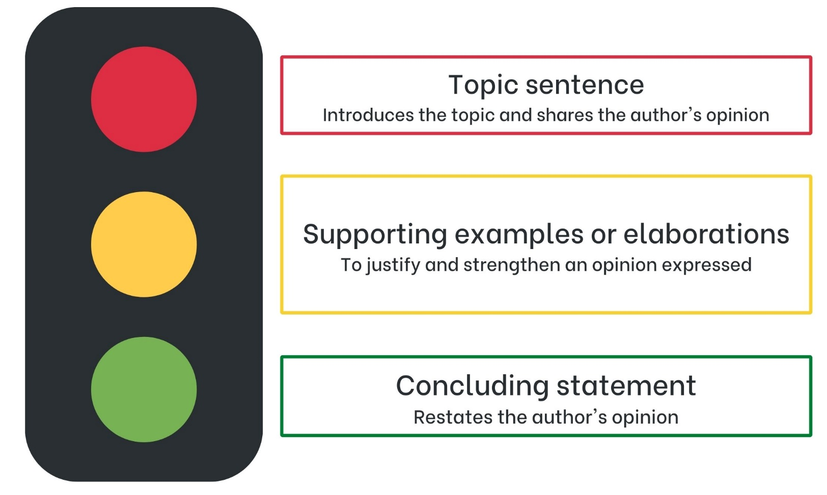

Resource 2: Venn diagram
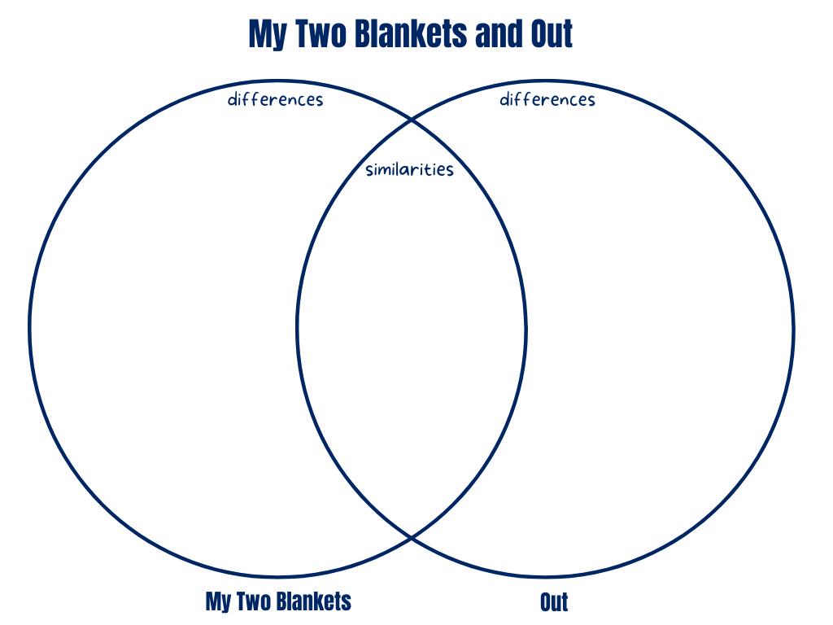

Resource 3: Figurative language
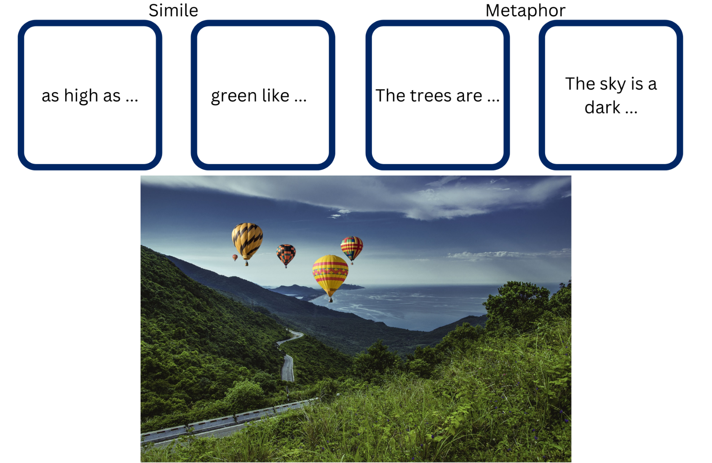
‘Mountains hot air balloons’ by tunghuta is licensed under the Pixabay Licence.
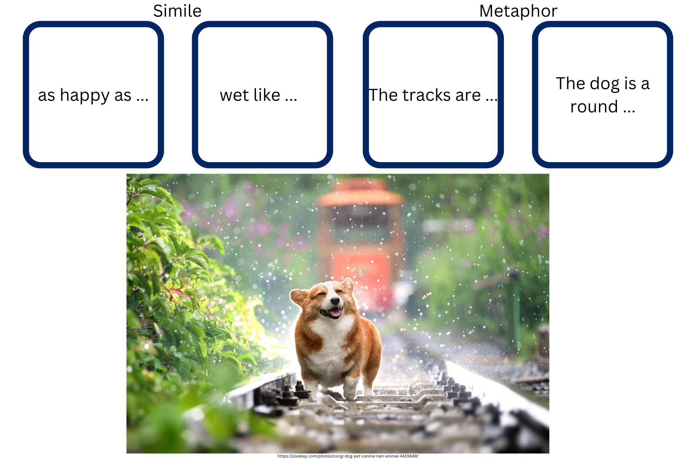
‘Corgi’ by huoadg5888 is licensed under the Pixabay Licence.

Resource 4: Blanket piece
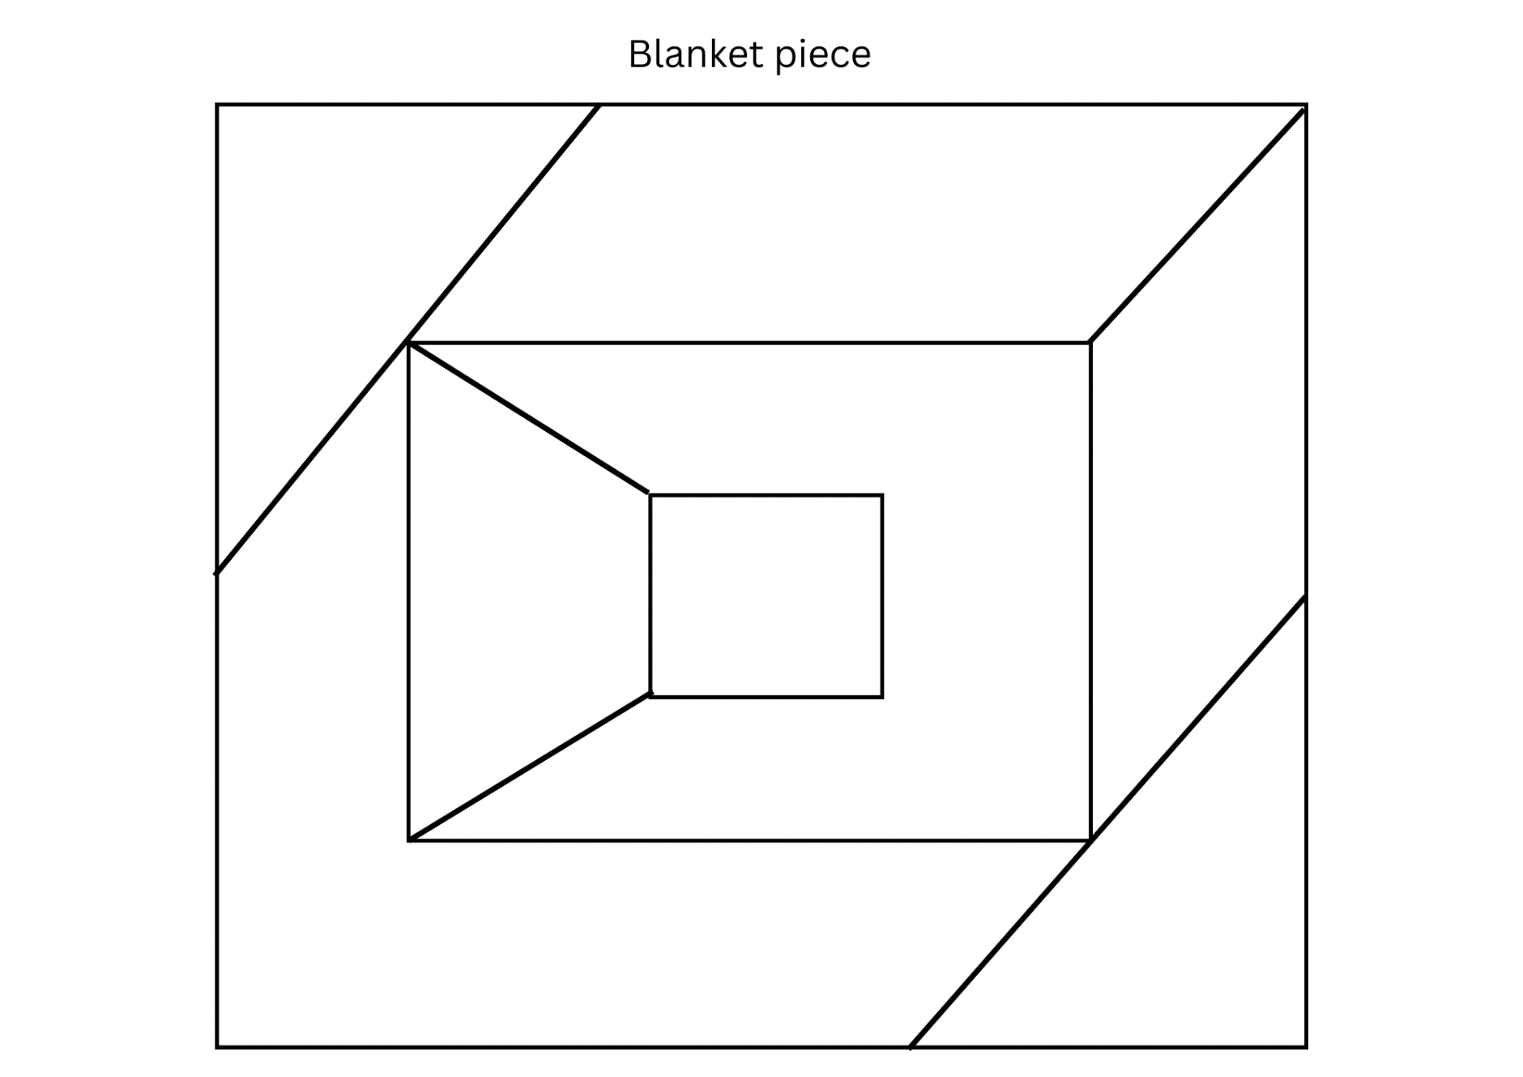

Resource 5: Planning template
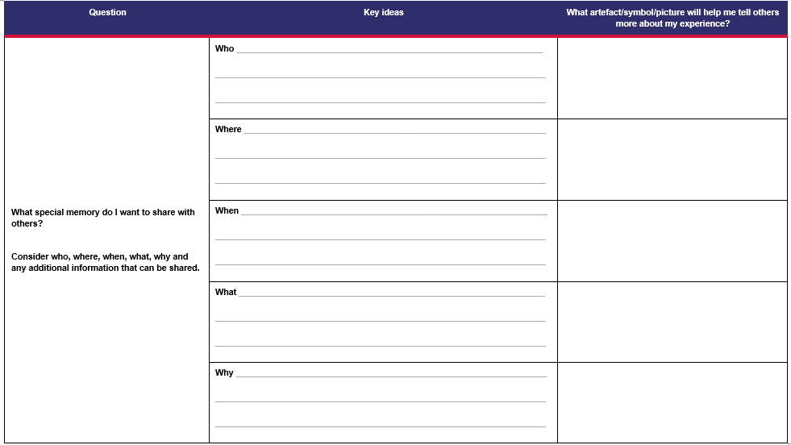

Resource 6: Slide example
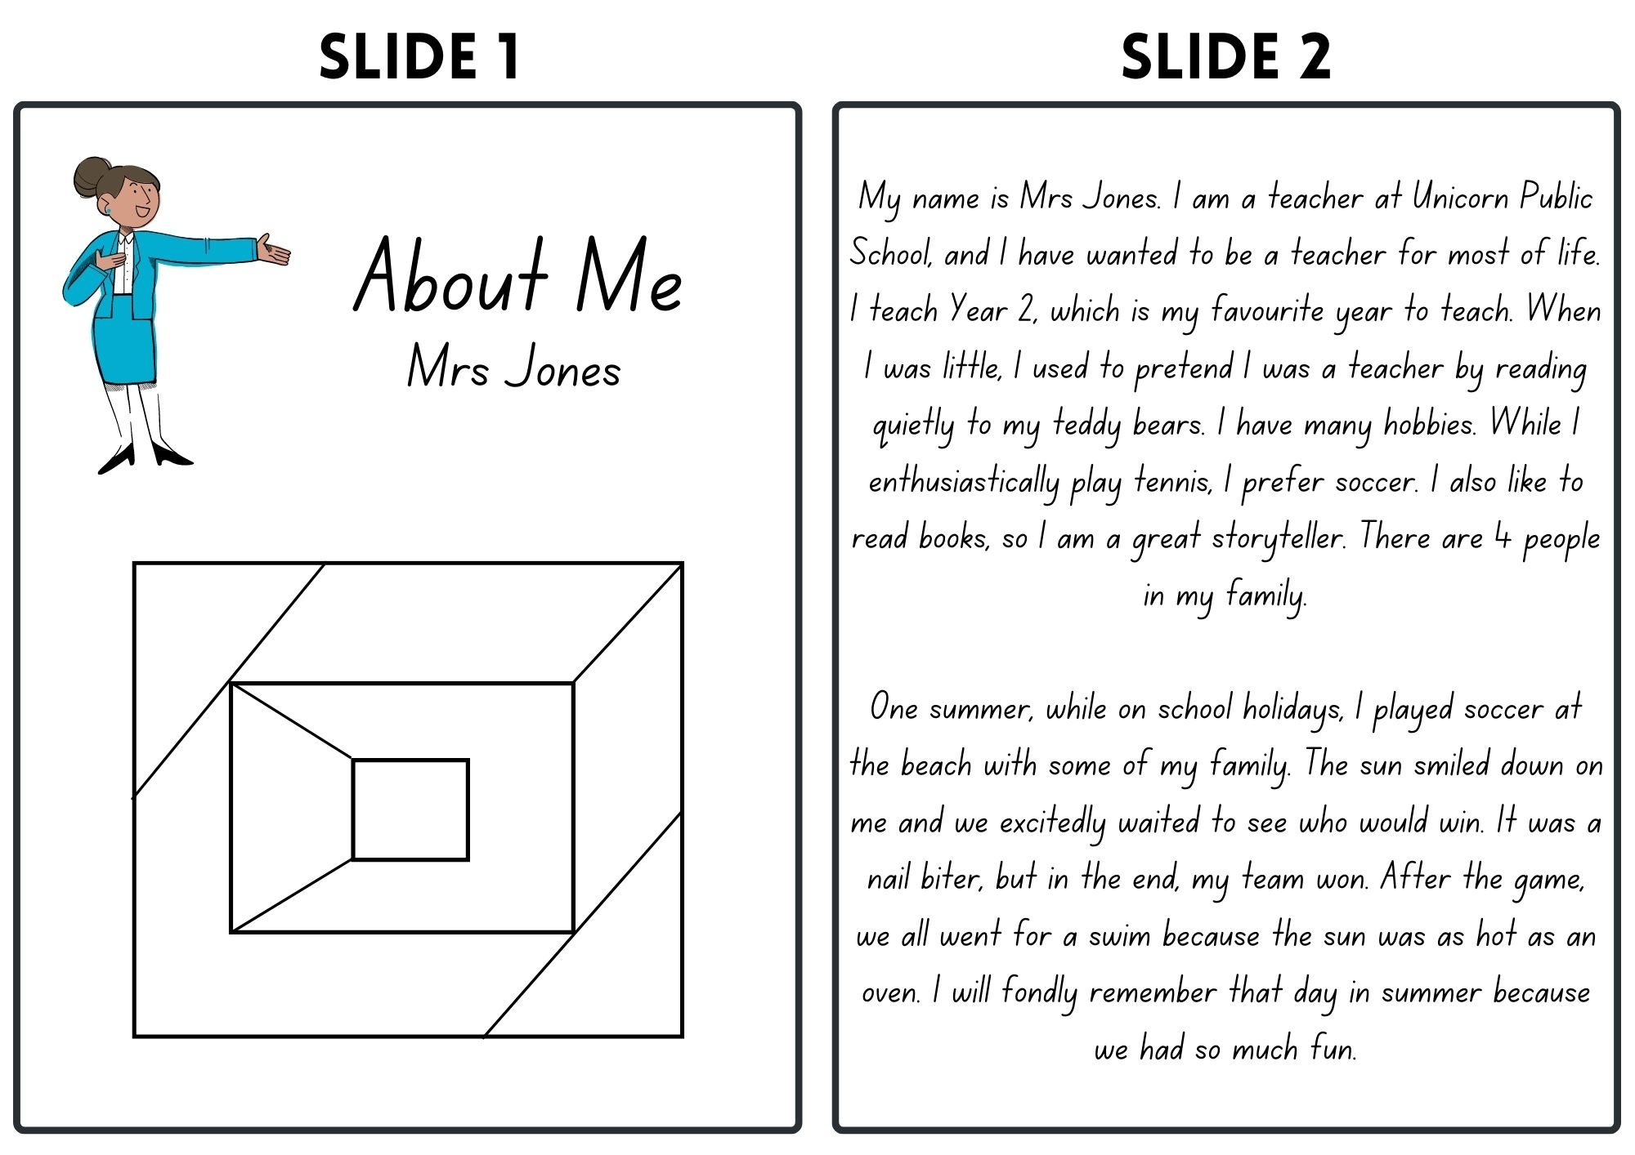
Images sourced from Canva and used in accordance with the Canva Content License Agreement.

References
Links to third-party material and websites
Please note that the provided (reading/viewing material/list/links/texts) are a suggestion only and implies no endorsement, by the New South Wales Department of Education, of any author, publisher, or book title. School principals and teachers are best placed to assess the suitability of resources that would complement the curriculum and reflect the needs and interests of their students.
If you use the links provided in this document to access a third-party's website, you acknowledge that the terms of use, including licence terms set out on the third-party's website apply to the use which may be made of the materials on that third-party website or where permitted by the Copyright Act 1968 (Cth). The department accepts no responsibility for content on third-party websites.
Except as otherwise noted, all material is © State of New South Wales (Department of Education), 2023 and licensed under the Creative Commons Attribution 4.0 International License. All other material (third-party material) is used with permission or under licence. Where the copyright owner of third-party material has not licensed their material under a Creative Commons or similar licence, you should contact them directly for permission to reuse their material.
English K–10 Syllabus © 2022 NSW Education Standards Authority (NESA) for and on behalf of the Crown in right of the State of New South Wales.
© 2022 NSW Education Standards Authority. This document contains NSW Curriculum and syllabus content. The NSW Curriculum is developed by the NSW Education Standards Authority. This content is prepared by NESA for and on behalf of the Crown in right of the State of New South Wales. The material is protected by Crown copyright.
Please refer to the NESA Copyright Disclaimer for more information.
NESA holds the only official and up-to-date versions of the NSW Curriculum and syllabus documents. Please visit the NSW Education Standards Authority (NESA) website and the NSW Curriculum website.
National Literacy Learning Progression © Australian Curriculum, Assessment and Reporting Authority (ACARA) 2010 to present, unless otherwise indicated. This material was downloaded from the Australian Curriculum website (National Literacy Learning Progression) (accessed 24 January 2023) and was not modified. The material is licensed under CC BY 4.0. Version updates are tracked in the ‘Curriculum version history’ section on the 'About the Australian Curriculum' page of the Australian Curriculum website.
ACARA does not endorse any product that uses the Australian Curriculum or make any representations as to the quality of such products. Any product that uses material published on this website should not be taken to be affiliated with ACARA or have the sponsorship or approval of ACARA. It is up to each person to make their own assessment of the product, taking into account matters including, but not limited to, the version number and the degree to which the materials align with the content descriptions and achievement standards (where relevant). Where there is a claim of alignment, it is important to check that the materials align with the content descriptions and achievement standards (endorsed by all education Ministers), not the elaborations (examples provided by ACARA).
ETA (English Teachers Association) and NSW Department of Education (2016) The Textual Concepts and Processes resource, English Textual Concepts website, accessed 25 January 2023.
George AM (2020) Out (Swan O, illus.), Scholastic Australia Pty Ltd.
Kobald I (2022) My Two Blankets (Blackwood F, illus.), English and Dari edn, Hardie Grant Children’s Publishing, Australia.
Save the Children Australia (2020) ‘What is a refugee?’, Our Stories: Impact of Our Work, Save the Children website, accessed 1 February 2023.
Save the Children Federation, Inc (2023) ‘Child Refugees, Asylum Seekers, Migrants and Immigrants: Who Are They?’, Latest News and Featured Stories, Save the Children website, accessed 8 February 2023.

