English – Stage 1 – Unit 32
Contents
Unit overview and instructions for use 3
Teacher notes 4
Outcomes and content – Component A 5
Outcomes and content – Component B 7
Week 1 10
Component A teaching and learning 10
Component B teaching and learning 11
Lesson 1: Introducing Drawn Together 13
Lesson 2: Identifying cultural representations in texts 14
Lesson 3: Symbols and the real and imagined worlds represented in a text 16
Lesson 4: Understanding how visual features add meaning to a text 17
Lesson 5: Creating a comic strip text 20
Week 2 22
Component A teaching and learning 22
Component B teaching and learning 23
Lesson 6: Introducing Born to Run and comparing to Drawn Together 24
Lesson 7: Writing compound sentences to describe settings and cultural representations 26
Lesson 8: Complex sentences and clarifying unknown words 28
Lesson 9: Writing with cohesion and logical order 30
Lesson 10: Using feedback to edit and publish a text and reflecting on learning 33
Resource 1: My significant person profile sheet 35
Resource 2: Question cards 36
Resource 3: Model paragraph – Fish 37
Resource 4: Grouping sentences into a paragraph – Dragons 38
Resource 5: Symbols 39
Resource 6: Real and imagined worlds 40
Resource 7: Comic strip template 41
Resource 8: Sample – Significant person profile 42
References 43

Unit overview and instructions for use
This two-week unit is comprised of Component A and Component B. Connecting learning across both components is encouraged.
Teaching and learning | Component A | Component B
Suggested duration | 60 minutes | 45 minutes
Explicit teaching focus areas | - Phonic knowledge  - Reading fluency  - Reading comprehension  - Spelling  - Handwriting | - Oral language and communication  - Vocabulary  - Reading comprehension  - Creating written texts  - Understanding and responding to literature
To prepare for teaching and learning: | - Refer to Outcomes and content – Component A, K-2 – Instructional sequence – grapheme–phoneme correspondences [PDF 825 KB], and the teaching advice documents (hyperlinked in Component A teaching and learning table).  - Based on student needs identified through ongoing assessment data, plan and document how you will sequence teaching and learning in whole class and targeted teaching groups across the two-week cycle. | - Familiarise yourself with Outcomes and content – Component B, Textual concepts information and videos, English Textual Concepts and Learning Processes (2016), and the teaching and learning sequence.  - Based on student needs identified through ongoing assessment data, determine how you will support students in whole class and targeted teaching groups across the two-week cycle as required.
English K–10 Syllabus © 2022 NSW Education Standards Authority (NESA) for and on behalf of the Crown in right of the State of New South Wales.

Teacher notes
Home task: Resource 1: My significant person profile sheet – to be completed during Week 1 for use in Week 2. Students will be writing about a significant person in their life using answers recorded on the profile sheet. The person may be a family member, a neighbour or community member or a staff member from the school.
- Representation is the depiction of a thing, person, or idea in written, visual, performed or spoken language. It can reflect the natural world realistically or convey people, objects, experiences and ideas in a more abstract way. – English Textual Concepts and Learning Processes (2016).
- Understanding of representation can be supported through watching the department’s video: Representation (02:46).
- While representation is the mentor concept for the conceptual component of this unit, the supporting concepts of connotation, imagery and symbol can be explored using the text Drawn Together by Minh Lê.
- For information on representation and connotation, imagery and symbol refer to the NESA Glossary.
- This unit could enhance student learning towards the achievement of creative arts outcomes.
- Reflect on student learning and engagement in activities and record differentiation and adjustments within the unit to inform future teaching and learning. One way of doing this could be to add comments to the digital file.
- Content points are linked to the National Literacy Learning Progression version (3).
Levels and indicators sourced from National Literacy Learning Progression © Australian Curriculum, Assessment and Reporting Authority (ACARA), (accessed 9 February 2023) and was not modified. See references for more information.

Outcomes and content – Component A
The table below outlines the focus outcomes and content. Content is linked to the National Literacy Learning Progression version (3).
Focus area and outcome | Content points and National Literacy Learning Progression
Phonic knowledge  EN1-PHOKW-01 – uses initial and extended phonics, including vowel digraphs, trigraphs to decode and encode words when reading and creating texts | - decode words with trigraphs and quadgraphs and apply this when reading texts  - blend and decode 2-syllable words with taught vowel graphs, digraphs, trigraphs and quadgraphs, including graphemes for r-controlled vowels and diphthongs and apply this when reading texts (PKW6) (PKW7).
Reading fluency  EN1-REFLU-01 – sustains reading unseen texts with automaticity and prosody and self-corrects errors | - read aloud with an easy speech rhythm (FlY3)  - vary pace when reading according to the audience and purpose (FlY4).
Reading comprehension  EN1-RECOM-01 – comprehends independently read texts that require sustained reading by activating background and word knowledge, connecting and understanding sentences and whole text, and monitoring for meaning | - know that a complex sentence includes a clause for expressing a main message and one or more clauses that elaborate on that message  - recognise how the position of a clause in a complex sentence influences the important idea for the reader
Spelling  EN1-SPELL-01 – applies phonological, orthographic and morphological generalisations and strategies when spelling words in a range of writing contexts | - segment multisyllabic words into syllables and phonemes as a strategy for spelling (SpG5)  - use common prefixes such as un–, re– and dis– (SpG9).
Handwriting  EN1-HANDW-01 – uses a legible, fluent and automatic handwriting style, and digital technology, including word-processing applications, when creating texts | - use taught software functions to create texts in a range of modes for different contexts, audiences and purposes.

Outcomes and content – Component B
The table below outlines the focus outcomes and content. Content is linked to the National Literacy Learning Progression version (3).
Focus area and outcome | Content points and National Literacy Learning Progression
Oral language and communication  EN1-OLC-01 – communicates effectively by using interpersonal conventions and language to extend and elaborate ideas for social and learning interactions. | - respond to information by asking relevant questions to extend their own and others' knowledge (LiS4) (LiSC6).
Vocabulary  EN1-VOCAB-01 – understands and effectively uses Tier 1, taught Tier 2 and Tier 3 vocabulary to extend and elaborate ideas | - understand and intentionally choose subject-specific vocabulary to enhance precision and for effect.
Reading comprehension  EN1-RECOM-01 – comprehends independently read texts that require sustained reading by activating background and word knowledge, connecting and understanding sentences and whole text, and monitoring for meaning | - recognise how the position of a clause in a complex sentence influences the important idea for the reader  - draw on sources to seek clarification for unknown words  - identify how creative visual features are used to expand meaning  - coordinate information or events from different parts of the text to form an overall opinion.
Creating written texts  EN1-CWT-01 – plans, creates and revises texts written for different purposes, including paragraphs, using knowledge of vocabulary, text features and sentence structure | - use a logical order to sequence ideas and events in sentences across a text (GrA4)  - use subject–verb agreement across a text (GrA5)  - group sentences into paragraphs commencing with a topic sentence, followed by other sentences with related ideas (CrT7)  - select and use a range of conjunctions to create cohesive texts (GrA5)  - use a combination of simple and compound sentences to engage the reader when creating written texts (CrT6) (GrA4)  - experiment with writing complex sentences which include a clause for the main message and dependent clause to elaborate or modify the message (GrA5)  - use commas to separate ideas, lists and/or dependent clauses in a sentence (PuN4) (PuN6)  - re-read and edit their own texts after receiving feedback  - use different modes and media to enhance the presentation of texts they have created (CrT5) (CrT6).
Understanding and responding to literature  EN1-UARL-01 – understands and responds to literature by creating texts using similar structures, intentional language choices and features appropriate to audience and purpose | - identify cultural representations in a range of texts  - express personal responses to the real and imagined worlds that are represented in texts  - identify symbols and images in texts, and how they bring deeper meaning.

Week 1

Component A teaching and learning
The table below can be used to plan and document lessons that address Component A outcomes and content. Both the detailed example [DOC 529KB] of a two-week teaching and learning cycle and brief example [DOC 66KB] may support you in your planning.
Focus Areas | Lesson 1 | Lesson 2 | Lesson 3 | Lesson 4 | Lesson 5
Phonic knowledge
15 minutes
Spelling and Handwriting
15 minutes
Reading comprehension and Reading fluency
30 minutes

Component B teaching and learning
The following teaching and learning sequence has been designed to address Component B outcomes and content. Adapt the sequence as required to best meet the needs of your students.

Learning intention and success criteria
Learning intentions and success criteria are best co-constructed with students.

Learning intention
Students are learning to identify how symbols and illustrations bring deeper meaning to texts and convey cultural representations.

Success criteria
Students can:
- ask questions about a text to gain a deeper meaning of a text
- identify cultural representations in a text
- identify how symbols add meaning to a text
- express personal responses to the real and imagined worlds represented in texts
- identify parts of a paragraph
- create a comic strip using symbols, illustrations and text.

Resources
- Lê M (2018) Drawn Together (Santat D, illus.) Hachette Children’s Books, US. ISBN: 9781484767603
- Resource 1: My significant person profile sheet (student copies)
- Resource 2: Question cards (small group copies)
- Resource 3: Model paragraph – Fish (enlarged copy)
- Resource 4: Grouping sentences into a paragraph – Dragons (student copies)
- Resource 5: Symbols (enlarged copy)
- Resource 6: Real and imaged worlds (small group copies)
- Resource 7: Comic strip template (multiple copies)
- Art supplies
- Sticky notes

Lesson 1: Introducing Drawn Together
- Display the front and back cover of the text Drawn Together by Minh Lê.
- Explain that students will use the ‘pause, question and predict’ strategy to support thinking about the text.
- Provide ‘pause’ time for students to look at and think about at the illustrations and other clues on the front and back cover of the text. The end papers may also be included.
- Organise students into small groups and provide them with a set of Resource 2: Question cards. Using the question cards as prompts for students to generate questions about the text. For example, who are the main characters, why is the text called ‘Drawn Together’, where might the story be set, what culture might be represented, what is the problem in the story, how is the problem resolved. Explain that through asking questions about a text, readers can deepen their understanding of a text and its key messages. As a class, share and compare questions.
- On strips of paper, students write their predictions about the text based on the questions generated. When responding, encourage students to use textual evidence, experiences with other texts and their own lives. Sentence stems may be provided to support student justifications and reasoning. For example
- I think _ will happen because _.
- I think the characters will _ because _.
- Since _, I think that _ will happen.
- Read Drawn Together.
- Compare what happened in the text with students’ written text predictions from activity 2.
- Go to Minh Lê Books. Read and discuss the 6 starred reviews about Drawn Together. Pay particular attention to the more detailed review, which describes the text as ‘A beautifully told and illustrated story about a grandson and grandfather struggling to communicate across divides of language, age and culture’.
Optional task: Invite students to express their personal responses to the text by writing a short book review using descriptive language.
- As a class, discuss the characters’ relationships in Drawn Together. Ask how they were related, why they found it difficult to communicate and what helped them bond. Prompt students to think about significant people in their lives.
Note: In Week 1, distribute and explain the home task: Resource 1: My significant person profile sheet. In Lesson 9 students will use the profile sheet as a scaffold to write a paragraph about a significant person in their life. The person may be a family member, a neighbour or community member.

Lesson 2: Identifying cultural representations in texts
- Refer to the information at the back of the book about the author, Minh Lê, and his description of being ‘a first-generation Vietnamese-American’ and how this influences the text.
- Listen to the audio interview of Minh Lê (5:00) which discusses the characters’ culture and relationship in the text. Ask students if they have had a similar situation with a family member or other significant person in their life.
- As a class, create a list of clues from the text that refer to the characters’ culture throughout the illustrations, including:
- characters bowing
- food and cutlery
- television program
- different text (Thai and English)
- cultural figures, such as the Thai warrior, dragon and fish.
- Display an enlarged copy of Resource 3: Model paragraph – Fish. Read the paragraph to build field knowledge of the text. Then clarify unfamiliar or subject-specific vocabulary and identify the parts of the paragraph on the model.
- Students cut and paste Resource 4: Grouping sentences into a paragraph – Dragons to demonstrate their understanding of paragraph formation and to build field knowledge of the text. The paragraph should include the following:
- Topic sentence: In Asian countries, including Thailand and Vietnam, dragons are mythical creatures that are often seen as a symbol of power, luck and strength.
- Supporting examples: In Asian artworks and stories, dragons are shaped like a serpent with scales over their body. They have 4 legs and sharp talons like an eagle. Dragons are seen to be a master of transformation and, although they do not have wings, they can fly magically through the air. In these countries, it is believed dragons can also take the form of a fish and move through water.
- Concluding statement: Dragons are an important symbol in many Asian countries.
- Display an enlarged copy of the complete paragraph. Discuss the combination of simple and compound sentences and the use of a comma to separate the dependent clause in the complex sentences.
- Ask students why it is important that different cultures are represented in texts. Invite students to make self or text connections by sharing about their own cultural identities or other texts they have read that represent another culture.
Too hard? Modify Resource 4: Grouping sentences into a paragraph – Dragons by writing simplified sentences onto strips of paper. Co-construct a paragraph by grouping sentences in a logical order.
Too easy? Students research another cultural representation in the text, for example, Thai warriors, and write a paragraph using the information they have sourced.

Lesson 3: Symbols and the real and imagined worlds represented in a text
- Display an enlarged copy of Resource 5: Symbols, which shows an image of a wand and paintbrush. In pairs, students brainstorm words and feelings that come to mind when they see the images (connotations). For example, magical, mystical, artistic, creative, hopeful, excited. Explain how symbols can make readers understand a text more deeply and evoke different emotions, without using words.
- Revisit the text Drawn Together. Highlight how the wand and paint brush are important symbols in the story. Examine each page to identify the changing roles of the wand and paintbrush throughout the story. Ask students what they think the wand and the paintbrush symbolise in the text.
- Explain that texts can represent real and imagined worlds. In Drawn Together, both the real and imagined worlds are depicted. For example, when the boy uses a red marker to draw the wand (real world) it turns into a wand, and he transforms into a warrior (imagined world).
- In small groups, students identify parts of the text that represent real and imagined texts. They record these on Resource 6: Real and imagined worlds and express their personal responses to these worlds.
- Model drawing a symbol that represents you, for example, a book. After drawing it, ask students to brainstorm words that they connote with the symbol, for example, reading, teaching, learning.
- Model writing an explanation of how the symbol is representative of you. For example, ‘My symbol is a book because I am passionate about teaching children how to read and enjoy books too!’
- Ask students to identify a symbol for themselves; it may be real or imagined. With a thinking partner, students discuss the symbol and why it is representative of them.
- Students draw symbols and write an explanation describing how they are representative of them. For example, a student may draw the Australian flag and a musical note and write, ‘My symbol is the Australian flag because this is the country where my family have made their home. I am passionate about music and the piano is my favourite instrument’. Keep copies of these and the model from activity 6, the class will revisit this work in Lesson 5 when creating a comic strip.

Lesson 4: Understanding how visual features add meaning to a text
- Revise how the visual features of Drawn Together play a significant role in the cultural representation of the text and help to unpack the key message of the story. Watch a video of the illustrator, Dan Santat discussing his artwork for Drawn Together (1:28). Discuss the importance of the traditional Thai style artwork. Ask students to imagine how the text would look and feel different if a different art style was used, for example, one that was more modern.
- Point out that Drawn Together relies less on text and more on the visual features to support and expand meaning. Re-read the text with a focus on the illustrations and layout of the text. After reading, ask students if they think there is correlation between the text not having many words and the language barrier between the characters.
- Discuss the comic style layout and how it allows the text to be ‘read’ sequentially. Notice that this layout is mainly used when representing the ‘real world’, whereas double page illustrations are used to represent the ‘imaginary world’.
- Display an enlarged copy the double page spread that shows the boy taking art supplies from his bag and starting to draw. Have students turn and talk to a partner, discussing what they interpret from the pages and why. Responses could include:
- use of a question mark and then lines around the characters’ heads to show their inner thoughts
- position of the characters (grandfather further away, then closer to his grandson)
- gestures, facial expressions and body language between characters
- use of colour, including the change in the colours from the ‘real’ to the ‘imagined worlds’
- close-ups of characters’ faces to show thoughts and feelings.
- Repeat with the double page illustration of the dragon between the 2 characters, which reads ‘comes roaring back’. Responses could include:
- size and position of characters to show power
- use of colour shown through the characters and background.
- Return to the page from activity 4. Using the visual features on the page, co-construct text to accompany the 6 scenes on the page. This can include dialogue. Encourage the use of descriptive language. For example:
- Scene 1: ‘Boy felt glum and dreary. It was so boring at his grandfather’s house. There was nothing to do and his grandfather couldn’t even speak to him!’
- Scene 2: ‘Grandfather looked at his beloved grandson, wondering what he was up to. He cherished his visits but since he wasn’t a baby anymore it was hard to find common ground. “What can we do together?” Grandfather pondered…’
- In pairs, provide students with different wordless pages from the text. Pages can be selected intentionally for differentiation purposes. Students will work together to write text for the illustrations on the given page.
- Students share their innovated texts.
Too hard? Lead targeted writing groups to co-construct a text.
Too easy? Students swap texts and provide feedback on each other’s writing. Students use the feedback to edit and publish texts.
Stage 1 Assessment task 1 – Observations and work samples from this lesson allow students to demonstrate achievement towards the following syllabus outcomes and content points:
EN1-RECOM-01 – comprehends independently read texts that require sustained reading by activating background and word knowledge, connecting and understanding sentences and whole text, and monitoring for meaning
- identify how creative visual features are used to expand meaning
- coordinate information or events from different parts of the text to form an overall opinion.
EN1-UARL-01 – understands and responds to literature by creating texts using similar structures, intentional language choices and features appropriate to audience and purpose
- identify cultural representations in a range of texts
- express personal responses to the real and imagined worlds that are represented in texts
- identify symbols and images in texts, and how they bring deeper meaning.

Lesson 5: Creating a comic strip text
Note: The visual arts elements of this lesson could be integrated in a creative arts program/lessons. This would provide more time for students to produce a high-quality piece of work.
- In this lesson students will experiment with different modes and media to create their own comic strip text in the style of Drawn Together. The text will express a cultural representation of themselves.
- Revisit the text to remind students about the features of a comic strip style text. For example, one event per frame, detailed illustrations and visual features to tell the story, as well as some text, which could include dialogue.
- Use the modelled example of a symbol from Lesson 3, activity 6, to create a storyline (with real and imagined events) for a comic strip styled text. Use an enlarged copy of Resource 7: Comic strip template and plan the story using sticky notes, placing one event for each box. For example, if using the book symbol idea, the storyline could be about a teacher and a new student who has arrived from another country, who does not speak much English. The teacher tries to engage with the student, but they do not understand each other. The student feels sad and lonely. One day, the teacher shows the student a beautiful picture book about animals. The animals begin to come alive and crawl, fly or swim off the pages. The teacher and student share a connection over their love of animals and they teach each other the names of different animals in each other’s language.
- Model converting the storyline (sticky notes) onto the comic strip (more than one template might be required) by sketching illustration and adding text. Use think alouds during this process.
- In pairs, students talk about their symbol from Lesson 3 and begin to develop a storyline.
- Students complete their plans and place them onto the comic strips (more than one template may be required and students may like to complete more than one draft).
- Provide students with art supplies to enhance their illustrations.
Too hard? Modify Resource 7: Comic strip template with less boxes. Students talk about each event and draws it. Scribe students’ events on sticky notes, which students can then use as a support for independent writing.
- Complete a gallery walk of the completed comic strips.
Stage 1 Assessment task 2: Collecting work samples from this lesson allow students to demonstrate achievement towards the following syllabus outcome and content point:
EN1-CWT-01 – plans, creates and revises texts written for different purposes, including paragraphs, using knowledge of vocabulary, text features and sentence structure
- use different modes and media to enhance the presentation of texts they have created.

Week 2

Component A teaching and learning
The table below can be used to plan and document lessons that address Component A outcomes and content. Both the detailed example [DOC 529KB] of a two-week teaching and learning cycle and brief example [DOC 66KB] may support you in your planning.
Focus Areas | Lesson 6 | Lesson 7 | Lesson 8 | Lesson 9 | Lesson 10
Phonic knowledge
15 minutes
Spelling and Handwriting
15 minutes
Reading comprehension and Reading fluency
30 minutes

Component B teaching and learning
The following teaching and learning sequence has been designed to address Component B outcomes and content. Adapt the sequence as required to best meet the needs of your students.

Learning intention and success criteria
Learning intentions and success criteria are best co-constructed with students.

Learning intention
Students are learning to respond to literature by creating texts using, intentional language choices and features appropriate to audience and purpose.

Success criteria
Students can:
- identify cultural representations in a text
- express personal responses to a text
- locate and match information from different parts of the text
- ask questions to extend their own and others’ knowledge
- find the meaning of words and use them correctly in sentences
- organise ideas in a logical order
- write a paragraph.

Resources
- Freeman C (2021) Born to Run (Ledden-Lewis C, illus.), Picture book edn, Puffin, Australia. ISBN: 9781761043802
- Resource 1: My significant person profile
- Resource 8: Sample – Significant person profile
- Drawing paper
- Pencils
- Student copies of printed dictionaries.

Lesson 6: Introducing Born to Run and comparing to Drawn Together
- Display the front and back cover of Born to Run. Read the biography of the author and the illustrator.
- Ask students to identify and discuss the cultural groups or people represented in the text and how they came to those conclusions – the descriptions in the biographies and the Australian and Aboriginal flags as symbols the back cover. Remind students that the Drawn Together is also a text that represents a certain cultural group. Ask students to think about this during the lesson and how Drawn Together is the same or different to Born to Run. This will be discussed at the end of the lesson.
- Students use Think-Pair-Share to record their responses on mini whiteboards, discussing:
- what they predict from the covers
- what they might already know about Cathy Freeman
- what they think the text is about.
- Explain that the text is long and that sections of it will be read each day. In this lesson, you will read the beginning and end of the text. These parts focus on representation. Start by reading the beginning of the text, up to and including the athletics day. Then, skip to the part where Cathy is at the Olympic Games Opening Ceremony and read through to the end. Draw attention to and discuss the significance of the text that reads ‘My desire to win wasn’t just about me. I wanted to represent my people. Being Aboriginal gives me strength and makes me proud.’ Ask students if this part of the book helps them form an opinion about the text and its intended message. Prompt students to explain why.
- Explain that the text shows the sequence of events that led to Cathy Freeman achieving her dream of winning an Olympic gold medal. Ask students to share their opinions about Cathy and her achievement. Use questioning to support students to elaborate on and extend their knowledge and ideas. The following questions and stems could be used:
- Could you tell us more about _ _?
- Why do you think _ _?
- Do you have any examples or evidence?
- Could someone else give their views on _ _?
- In pairs, students explore text-to-self connections by sharing and discussing a goal they have achieved or would like to achieve. For example, to be the winning player of the match in a soccer game or being on the Student Representative Council. Students write their goal on a sticky note.
- Read the blurb and unpack relevant the information in the text. For example:
- who – Cathy Freeman
- what – dream about winning a gold medal
- when – from childhood to adulthood
- where – 2000 Sydney Olympics
- cultural representations – Australian flag and Aboriginal flag.
- Model writing a paragraph about achieving a personal goal using a range of simple, compound and complex sentences. Start by listing the elements (who, what, when, where) as in activity 7 to scaffold the text. Add an illustration to provide a symbolic or cultural representation of the goal. For example, a trophy, sporting logo, badge or certificate.
- Students complete writing a paragraph about their personal goal and add an illustration to represent their achievement.
Too hard? Facilitate use of text-to-speech technology, audio or video recording to produce this text.
Too easy? Students write an additional paragraph explaining the symbolic or cultural representation of their achievement.
- Display a copy of Drawn Together. Use the Peer discussion and conferencing strategy to discuss how Drawn Together and Born to Run explore different cultures and how these are portrayed (visual and language). Ask why it is important for cultures to be represented in texts.

Lesson 7: Writing compound sentences to describe settings and cultural representations
- Locate Queensland and Mackay on a Map of Indigenous Australia. Refer back to Cathy Freeman’s biography and locate where her mother (of the Kuku Yalanji people) and father (of the Burri Gabba) people came from. Locate the school area on the map and make comparisons.
- Revisit Born to Run. Remind students that the text shows the sequence of events that lead to Cathy achieving her dream. Explain that some of these events will be explored in the lesson.
- Revise what students have read so far (the beginning and end of the text).
- Read the pages that describe the setting of where Cathy and her brothers ran (in a riverbed) and the local track (on the red dust).
- Identify and discuss the language used to describe the setting on the pages. For example, noun groups: dried-out riverbed, red dust, late-afternoon light. Draw attention to how the visual features of these pages support meaning.
- Distribute paper (folded in half) and pencils. On one half of the paper, students sketch the setting of where Cathy grew up.
- Re-read the text as students draw.
- Revisit some of the cultural representations from Drawn Together (the fish, dragon and Thai warrior). Explain that in Born to Run the references to the red earth symbolises Aboriginal peoples’ relationships to land and the Australian landscape.
- Brainstorm and discuss other cultural representations in Born to Run. For example, the Aboriginal and Australian flags.
- On the other half of the page, students draw their local setting (city, mountains, beach). In pairs, students take turns to share their drawings of their local setting. Encourage students to ask each other questions to elicit effective vocabulary and enhance the precision of their descriptions.
- Identify and discuss a compound sentence used in the text to describe the setting. For example:
- Compound sentence: ‘The dried-out riverbed was sandy and heavy to run in, so we had to pump our arms that little bit extra to get anywhere.’
- Conjunction to join 2 independent clauses: ‘so’.
- Model making connections to the text and writing compound sentences describing how you would run in a local setting. For example, ‘The steep hill is grassy and slippery, so I take a big run up to get some momentum’.
- Students review their drawings from activity 10 and write a compound sentence to describe them running in their local setting.

Lesson 8: Complex sentences and clarifying unknown words
- Ask students to think about the word ‘racism’. Think-Pair-Share what students think this means. Ask why it might be a word that they come across in Born to Run.
- Read the sections of the text that describe the challenges Cathy faced leading up to her achieving her goal. Read on from the pages covered in Lesson 7 (where she trained on the local track), up to and including the Commonwealth Games medal presentation.
- Ask students to share their opinions about how Cathy was treated at the country zone athletics titles. Use questioning to support students to elaborate on and extend their knowledge and ideas. The following questions and stems could be used:
- Why do you think _ _?
- Could someone else give their views on _ _?
- Revise complex sentences using the following examples from the text:
- ‘When they played the national anthem, I sang the words as loud as I could.’
- ‘When the flame arrived in the stadium, the first thing I had to do was jog up five flights of stairs covered in flowing water.’
- ‘When I was growing up, I didn’t feel that different to anyone else.’
- Identify the dependent and independent clauses in the sentences and note that the subordinating conjunction (when) helps to identify the dependent clauses.
- Point out that that the author has positioned the important idea at the start of each complex sentence and that the dependent clause is separated by a comma.
- Explain that good readers try to work out the meaning of an unknown word using in-text context clues. However, sometimes they need to draw on an external resource to check the meaning of words.
- Explicitly teach that students can use other sources of information to understand unknown words, such as ‘anthem’. For example, by using a dictionary or searching on the Internet.
- Demonstrate how a printed dictionary lists words in alphabetical order by locating the word ‘anthem’.
- Display a list of subject-specific words from the text, for example, athlete, Olympic Games, medal, anthem.
- Distribute copies of printed dictionaries to pairs of students. Students take turns to locate the words from the list and share their meaning.
- Model writing a complex sentence using 2 subject-specific words and a comma to separate the dependent clause. For example, ‘When Cathy Freeman won a gold medal, she felt proud to be an Aboriginal athlete.’
- Students use subject-specific words to write a complex sentence using a comma to separate the dependent clause.
Too hard? Students use subject-specific words from the text to jointly construct simple or compound sentences.
Too easy? Students write their own list of subject-specific words from the text, locate the definition of words and write complex sentences using them.
Stage 1 Assessment task 3 – Observations and work samples from this lesson allow students to demonstrate achievement towards the following syllabus outcome and content points:
EN1-RECOM-01 – comprehends independently read texts that require sustained reading by activating background and word knowledge, connecting and understanding sentences and whole text, and monitoring for meaning.
- recognise how the position of a clause in a complex sentence influences the important idea for the reader
- draw on sources to seek clarification for unknown words.
EN1-VOCAB-01 – understands and effectively uses Tier 1, taught Tier 2 and Tier 3 vocabulary to extend and elaborate ideas
- understand and intentionally choose subject-specific vocabulary to enhance precision and for effect.

Lesson 9: Writing with cohesion and logical order
- Complete reading the remainder of Born to Run, from the page where is reads ‘Being Aboriginal means everything to me’, up to and including the lighting of the cauldron.
- Review the page where Cathy Freeman and her mother are hugging. Ask students to identify the significant person in Cathy’s life. Ask why that person is significant.
- Make text-to-text connections with Drawn Together and ask who the significant person in the boy’s life is.
- Display and discuss the words ‘significant person’; recall and connect to the significant person home task.
- Jointly define the meaning of a significant person as someone that is special or important.
- Display the page that begins ‘When the flame arrived in the stadium.’ Re-read the text and note how the variety of sentence structure and effective use of conjunctions have been used to create text cohesion. For example:
- Variety of sentences: simple – Then everything became hauntingly quiet; compound – I turned around to salute the crowd and was nearly blinded by the light; complex – When I got to the top, I paused to catch my breath.
- Use of conjunctions: When the flame; but I had a huge grin; and I was nearly blinded; as the flashes.
- Distribute completed home task – Resource 1: My significant person profile sheet.
- Explain that students will use the profile sheet to write a paragraph about their chosen person, using a combination of simple, compound and complex sentences.
- Model writing a draft profile, drawing attention to the use of a topic sentence and how sentences are grouped cohesively. Resource 8: Sample – Significant person profile sheet can be used along with the following example:
My significant person is my grandad. His name is William Tran. He was born in 1953 and lives in Port Macquarie. He grew up in Vietnam. My grandad is special to me because he always listens to me. We talk a lot on the phone, and he is teaching me to speak Vietnamese. When it is a very hot day, he takes me to the beach and we swim together in the surf. It is lots of fun! Before our family went on a holiday, my grandad taught me how to fish. Then I caught a big bream. Whenever I see a fishing rod, I think of my grandad.
- In pairs, students share their profiles and ask each other relevant questions to learn more about their significant person. Provide students with Resource 2: Question cards to scaffold their thinking prior to writing. For example, students ask their partner who is your significant person and where are they from.
- Co-construct success criteria for student paragraphs. For example:
- include a variety of simple, compound and complex sentences
- use consistent subject–verb agreement across the text
- include a comma to separate the dependant clause in a complex sentence
- re-read and edit writing.
- Students draft their paragraph, ensuring they have addressed the success criteria.
Stage 1 Assessment task 4 – Observations and work samples from this lesson allow students to demonstrate achievement towards the following syllabus outcomes and content points:
EN1-OLC-01 – communicates effectively by using interpersonal conventions and language to extend and elaborate ideas for social and learning interactions.
- respond to information by asking relevant questions to extend their own and others' knowledge.
EN1-CWT-01 – plans, creates and revises texts written for different purposes, including paragraphs, using knowledge of vocabulary, text features and sentence structure
- use subject–verb agreement across a text
- group sentences into paragraphs commencing with a topic sentence, followed by other sentences with related ideas
- use a combination of simple and compound sentences to engage the reader when creating written texts
- experiment with writing complex sentences which include a clause for the main message and dependent clause to elaborate or modify the message
- use commas to separate ideas, lists and/or dependent clauses in a sentence
- use a logical order to sequence ideas and events in sentences across a text
- select and use a range of conjunctions to create cohesive texts.
Too hard? Support student to create a logical sequence of events. Students write simple and compound sentences using a list of conjunctions for support.
Too easy? In pairs, students use the questioning task from activity 10 to write more than one paragraph about their significant person.

Lesson 10: Using feedback to edit and publish a text and reflecting on learning
- Re-read the text from beginning to end.
- Students share their draft profile with a peer who provides feedback using the co-constructed success criteria from Lesson 9.
- Students apply feedback and publish their writing.
- Students complete the profile by drawing a portrait of their significant person.
Note: The visual arts elements of this lesson could be integrated in a creative arts program or lessons. This would provide more time for students to produce a high-quality piece of work.
- Students share their published profiles by posting or emailing to their significant person.
- Use exit slips to reflect on the textual concepts explored in the unit. For example:
- How do texts that represent different cultures teach us about other people and the world we live in? Why is this important?
- Why is it important that texts represent real and imagined worlds? How does this influence how we respond to (like or dislike) a text?
- Describe the significance of symbols and visual features in some texts.
- What can texts teach us about relationships and the significant people in our lives?
Stage 1 Assessment task 5 – Observations and work samples from this lesson allow students to demonstrate achievement towards the following syllabus outcome and content point:
EN1-CWT-01 – plans, creates and revises texts written for different purposes, including paragraphs, using knowledge of vocabulary, text features and sentence structure
- re-read and edit their own texts after receiving feedback.

Resource 1: My significant person profile sheet
Question | Response
Who is your significant person?
What is their name?
When and where were they born?
Where do they live?
Why is this person special to you?
Describe a special time you have shared with this person.
When you think of this person, what symbol would best represent them? For example, a fishing rod or guitar.

Resource 2: Question cards
Who? | Where? | When?
How? | Why? | What?

Resource 3: Model paragraph – Fish
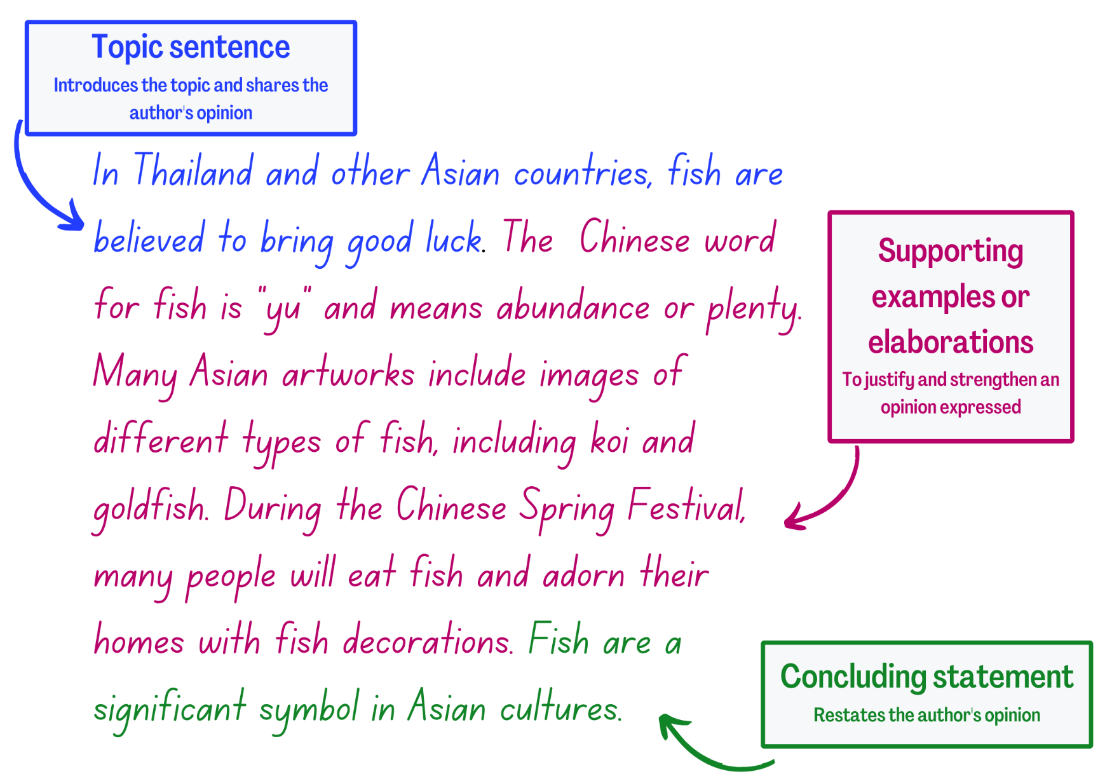

Resource 4: Grouping sentences into a paragraph – Dragons
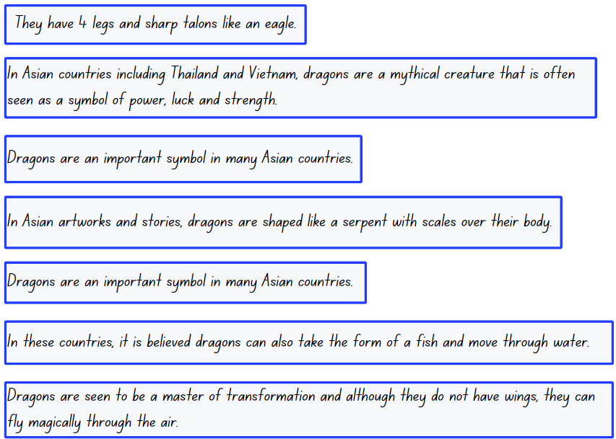

Resource 5: Symbols
Images sourced from Pixabay and used in accordance with the Pixabay License.

Resource 6: Real and imagined worlds
Real world | Imagined world

Resource 7: Comic strip template
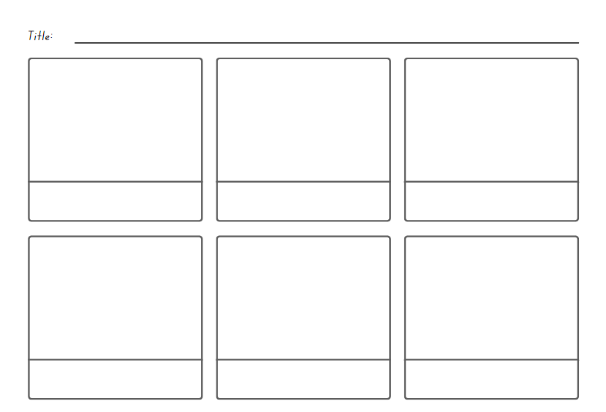

Resource 8: Sample – Significant person profile
Question | Response
Who is your significant person? | He is my grandfather
What is their name? | William Tran
When and where were they born? | Born in 1953 in Vietnam
Where do they live? | Lives in Port Macquarie
Why is this person special to you? | He always listens to me. We talk a lot on the phone. He is teaching me to speak Vietnamese.
Describe a special time you have shared with this person, for example, when where the person has helped you. | He taught me how to fish before our family went on holidays. I caught a big bream.
When you think of this person, what symbol would best represent them? For example, a fishing rod or guitar. | A fishing rod

References
Links to third-party material and websites
Please note that the provided (reading/viewing material/list/links/texts) are a suggestion only and implies no endorsement, by the New South Wales Department of Education, of any author, publisher, or book title. School principals and teachers are best placed to assess the suitability of resources that would complement the curriculum and reflect the needs and interests of their students.
If you use the links provided in this document to access a third-party's website, you acknowledge that the terms of use, including licence terms set out on the third-party's website apply to the use which may be made of the materials on that third-party website or where permitted by the Copyright Act 1968 (Cth). The department accepts no responsibility for content on third-party websites.
Except as otherwise noted, all material is © State of New South Wales (Department of Education), 2023 and licensed under the Creative Commons Attribution 4.0 International License. All other material (third-party material) is used with permission or under licence. Where the copyright owner of third-party material has not licensed their material under a Creative Commons or similar licence, you should contact them directly for permission to reuse their material.
English K–10 Syllabus © 2022 NSW Education Standards Authority (NESA) for and on behalf of the Crown in right of the State of New South Wales.
© 2022 NSW Education Standards Authority. This document contains NSW Curriculum and syllabus content. The NSW Curriculum is developed by the NSW Education Standards Authority. This content is prepared by NESA for and on behalf of the Crown in right of the State of New South Wales. The material is protected by Crown copyright.
Please refer to the NESA Copyright Disclaimer for more information.
NESA holds the only official and up-to-date versions of the NSW Curriculum and syllabus documents. Please visit the NSW Education Standards Authority (NESA) website and the NSW Curriculum website.
National Literacy Learning Progression © Australian Curriculum, Assessment and Reporting Authority (ACARA) 2010 to present, unless otherwise indicated. This material was downloaded from the Australian Curriculum website (National Literacy Learning Progression) (accessed 9 February 2023) and was not modified. The material is licensed under CC BY 4.0. Version updates are tracked in the ‘Curriculum version history’ section on the 'About the Australian Curriculum' page of the Australian Curriculum website.
ACARA does not endorse any product that uses the Australian Curriculum or make any representations as to the quality of such products. Any product that uses material published on this website should not be taken to be affiliated with ACARA or have the sponsorship or approval of ACARA. It is up to each person to make their own assessment of the product, taking into account matters including, but not limited to, the version number and the degree to which the materials align with the content descriptions and achievement standards (where relevant). Where there is a claim of alignment, it is important to check that the materials align with the content descriptions and achievement standards (endorsed by all education Ministers), not the elaborations (examples provided by ACARA).
AIATSIS (The Australian Institute of Aboriginal and Torres Strait Islander Studies) (2022) Map of Indigenous Australia, AIATSIS website, accessed 9 February 2023.
Disneybooks (4 October 2017) ‘Drawn Together | Dan Stantat’ [video], disneybooks, YouTube, accessed 9 February 2023.
ETA (English Teachers Association) and NSW Department of Education (2016) The Textual Concepts and Processes resource, English Textual Concepts website, accessed 9 February 2023.
Freeman C (2021) Born to Run (Ledden-Lewis C, illus.), Picture book edn, Puffin, Australia.
Lê M (2018) Drawn Together (Santat D, illus.) Hachette Children’s Books, US.
Minh Lê Books (n.d). Minh Lê Books [website], Minh Lê website, accessed 9 February 2023.
NPR (National Public Radio) (2023) Struggling For Words, A Boy And His Grandfather Are ‘Drawn Together’ At Last, NPR website, accessed 9 February 2023.

